某个箱区贝位数据
泊位信息
"berthesInfo": [{
"BTH_CODE": "10",//泊位编号
"BTH_NAME": "10号泊位",
"BTH_STPST": "1",//起始位置
"BTH_EDPST": "100"//结束位置

箱区信息
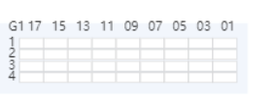
"yardAreasInfo": [{
"ARE_AREANO": "G1",//箱区编号
"ARE_EDBAY": "17",结束贝位
"ARE_ROWNUM": "4",行
"ARE_TIERNUM": "3",层数
"ARE_STARTX": "320",//起始X位置.配置信息读取
"ARE_STARTY": "50",//起始Y位置
//贝位信息
"yardBayesInfo": [{
"YBY_BAYNO": "01",贝位
"YBY_STATUS": "1",
"YBY_ROWNUM": "4",行数
"YBY_TIERNUM": "3",层数
"YBY_ARE_AREANO": "G1",//所属箱区
{
"YBY_ID": "720",
"YBY_ARE_ID": "306",
"YBY_BAYNO": "03",
"YBY_STATUS": "1",
"YBY_ROWNUM": "4",
"YBY_TIERNUM": "3",
"YBY_USEFG": "Y",
"YBY_ARE_AREANO": "G1",
"YBY_TER_ID": "2",
列信息
"yardRowsInfo": [{
"ARE_ID": "306",//箱区
"YBY_ID": "719",//贝位编号
"ROWNO": "1",//列
"ContainerNum": "0",//集装箱个数

"yardRowsInfo": [{
"ARE_ID": "306",
"YBY_ID": "719",
"ROWNO": "1",
"ContainerNum": "0",
"STATUS": "1"
}, {
"ARE_ID": "306",
"YBY_ID": "719",
"ROWNO": "2",
"ContainerNum": "0",
"STATUS": "1"
}, {
"ARE_ID": "306",
"YBY_ID": "719",
"ROWNO": "3",
"ContainerNum": "0",
"STATUS": "1"
}, {
"ARE_ID": "306",
"YBY_ID": "719",
"ROWNO": "4",
"ContainerNum": "0",
"STATUS": "1"
}]

某个贝位信息
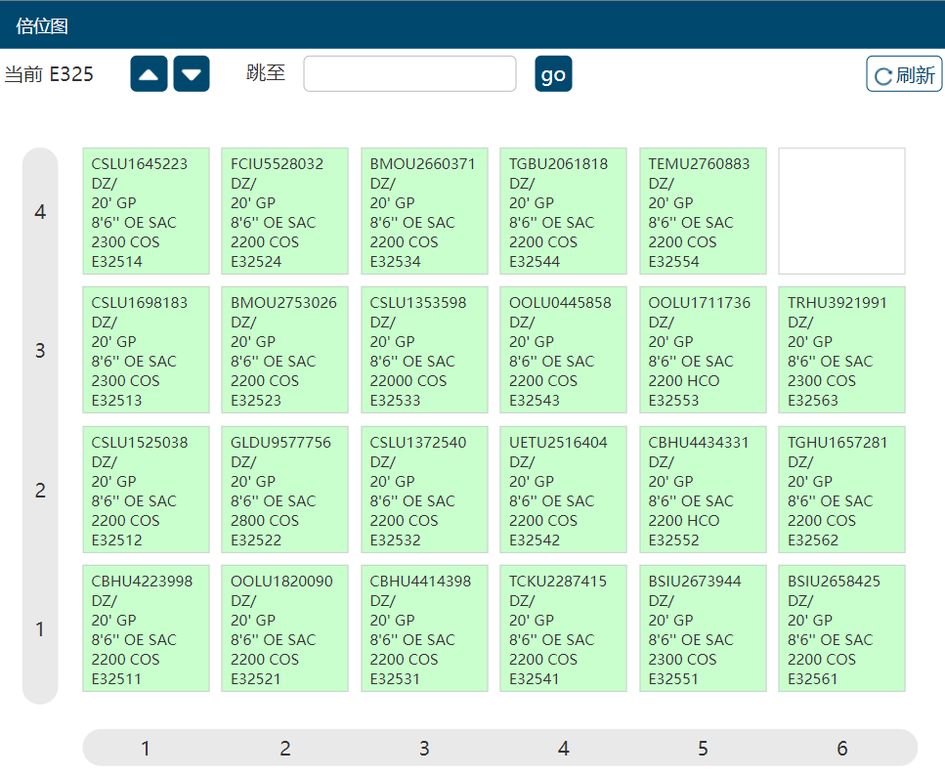
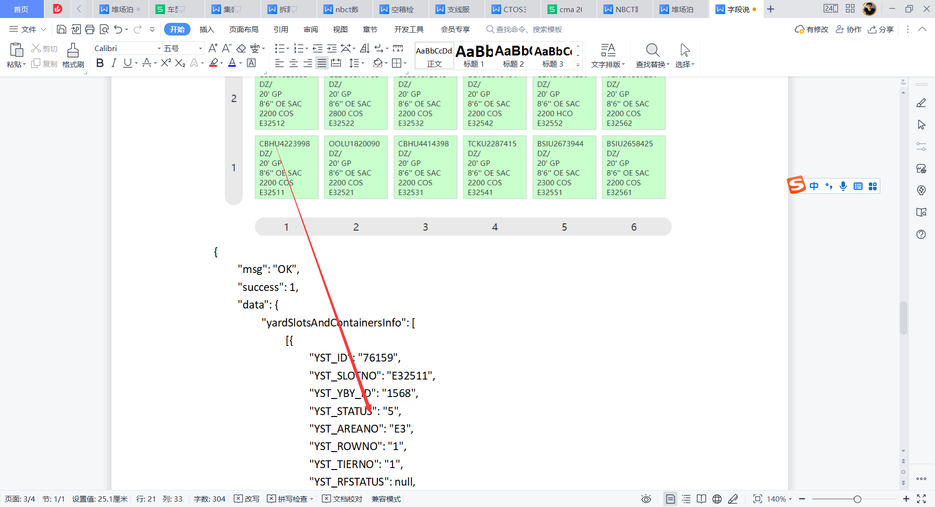
{
"msg": "OK",
"success": 1,
"data": {
"yardSlotsAndContainersInfo": [
[{
"YST_ID": "76159",
"YST_SLOTNO": "E32511",
"YST_YBY_ID": "1568",
"YST_STATUS": "5",
"YST_AREANO": "E3",
"YST_ROWNO": "1",
"YST_TIERNO": "1",

"YST_AREBAY": "E325",
"YST_TER_ID": "2",
"YST_IYC_CNTRID": "294817",
"IYC_CNTRID": "294817",
"IYC_CNTRNO": "CBHU4223998",
"IYC_CTI_CD": "00",

"IYC_HEI_CHEIGHTCD": "2",
"IYC_CSZ_CSIZECD": "2",
"IYC_POT_UNLDPORTCD": "DZ",

"IYC_TRANSMODE": "N",

"IYC_LOCANO": "E32511",
"IYC_CTP_COMMCODE": "GP",
"IYC_STS_CDCHANGE": "OE",
"IYC_CTAREWG": "2200",
"IYC_COPERCD": "COS",

"IYC_LOCANO_ROW": 0,
"IYC_LOCANO_TIER": 0,
"IYC_POT_LDPORTCD": "DZ",
"IYC_POT_DSTNPORTCD": "DZ",

"ROW_TIER": "11",

"CSZ_CSIZENM": "20\u0027",
"HEI_NAME": "8\u00276\u0027\u0027",
"IYC_TYPE": "SAC",
"STS_EFFG": "E"//空重，F表示重箱，E表示空
},]
]
}
}

箱详情数据

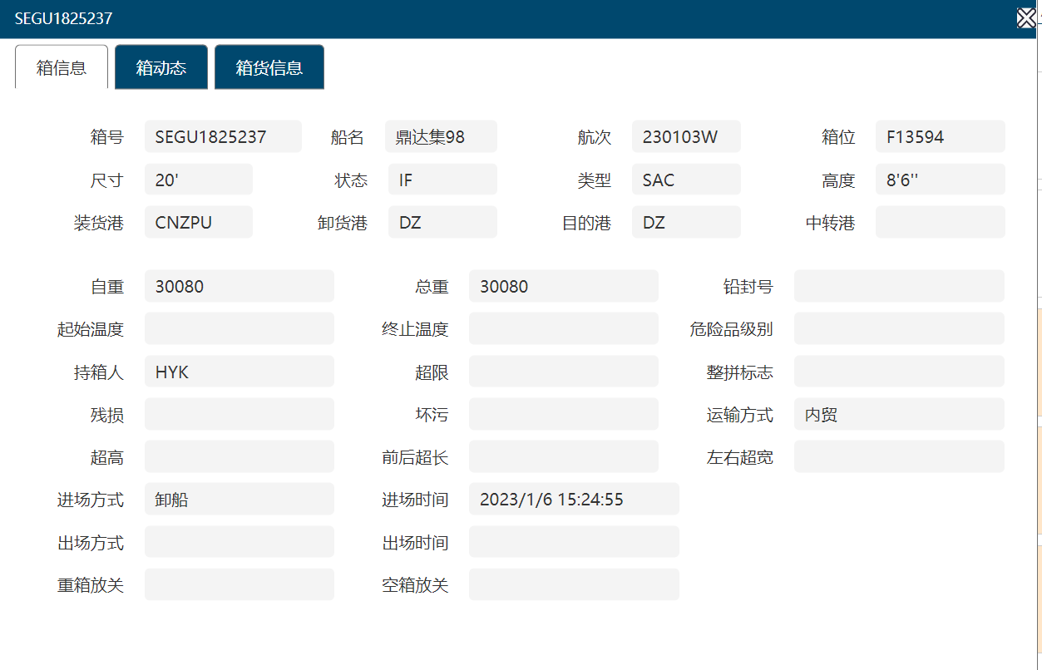
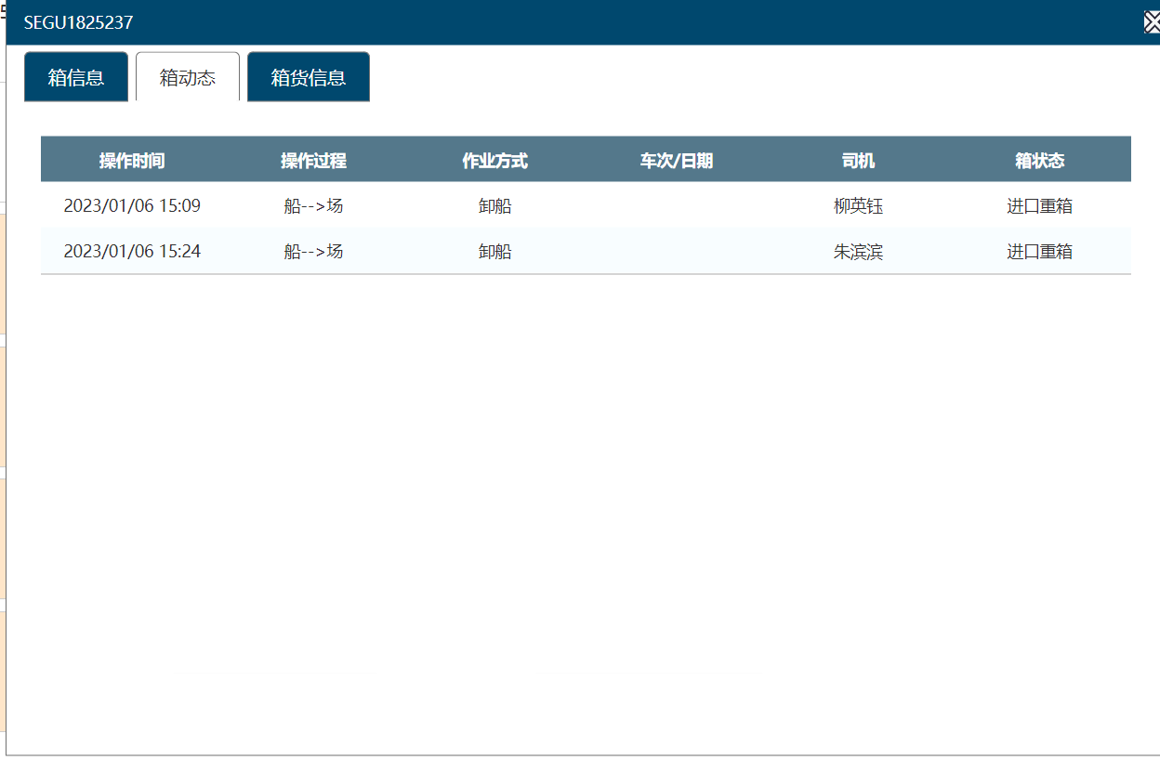
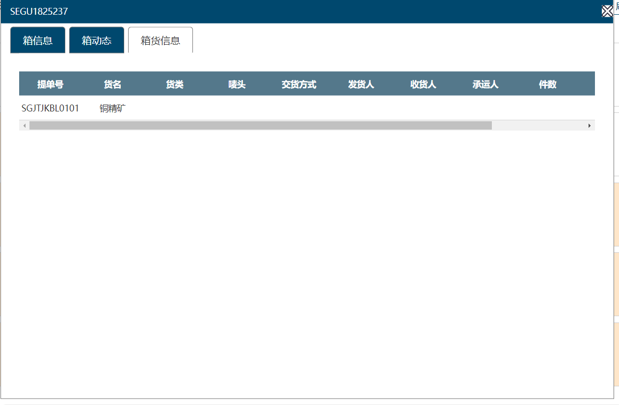

{
"msg": "OK",
"success": 1,
"data": {
"containerDetailsInfo": {
"IYC_CNTRNO": "SEGU1825237",
"IYC_POT_UNLDPORTCD": "DZ",
"IYC_FLFG": null,
"IYC_TRANSMODE": "内贸",
"IYC_EPASSFG": null,
"IYC_LOCANO": "F13594",
"IYC_STS_CDCHANGE": "IF",
"IYC_CTAREWG": "30080",
"IYC_COPERCD": "HYK",
"IYC_POT_LDPORTCD": "CNZPU",
"IYC_POT_DSTNPORTCD": "DZ",
"IYC_POT_TRANSPORTCD": null,
"CSZ_CSIZENM": "20\u0027",
"HEI_NAME": "8\u00276\u0027\u0027",
"IYC_TYPE": "SAC",
"VSL_CD": "鼎达集98",
"VSL_VOYAGE": "230103W",
"IYC_NETWG": "30080",
"IYC_SEALNO": null,
"IYC_STTMPT": null,
"IYC_EDTMPT": null,
"IYC_DTP_DNGGCD": null,
"IYC_OVLMTCD": null,
"IYC_OVHEIGHT": null,
"IYC_FOVLENGTH": null,
"IYC_BOVLENGTH": null,
"IYC_LOVWIDTH": null,
"IYC_ROVWIDTH": null,
"IYC_BDC_BKDMGCD": null,
"IYC_DIRTYFG": null,
"IYC_INYMODE": "卸船",
"IYC_INYTM": "2023/1/6 15:24:55",
"IYC_OUTYMODE": null,
"IYC_OUTTM": null,
"IYC_PASSFG": null,
"IYC_EXPORT_VSLNAME": null,
"IYC_EXPORT_VOYAGE": null
},
"containerActivitiesInfo": [{
"IYA_OPMODE": "卸船",
"IYA_OPPRC": "船--\u003e场",
"IYA_OPDT": "2023/01/06 15:09",
"IYA_DRIVER": "柳英钰",
"IYA_VSLVOY": null,
"STS_NAME": "进口重箱"
}, {
"IYA_OPMODE": "卸船",
"IYA_OPPRC": "船--\u003e场",
"IYA_OPDT": "2023/01/06 15:24",
"IYA_DRIVER": "朱滨滨",
"IYA_VSLVOY": null,
"STS_NAME": "进口重箱"
}],
"goodsInfo": [{
"GOD_BILLNO": "SGJTJKBL0101",
"GOD_GNAME": "铜精矿",
"GOD_GTYPE": null,
"GOD_MARKNO": null,
"GOD_GTWG": "30080",
"GOD_GTVOL": null,
"GOD_GTPKS": null,
"GOD_DELIVERYMD": null,
"GOD_SHIPPER": null,
"GOD_CONSIGNEE": null,
"GOD_NPERSON": null
}]
}
}

