**1、Data Preparation：**

Ecosystem type data：30-meter resolution, sourced from GLC_GCS30.

Vegetation index data: 30-meter resolution, obtained from Google Earth Engine (GEE).

Water cover data: 30-meter resolution, derived from GAMLSW30.

Species richness data: Accessed from <https://biodiversitymapping.org.>

Using the ecosystem type data as a reference, all datasets were resampled to ensure spatial consistency, followed by correlation analysis.

**2、Technical workflow：**

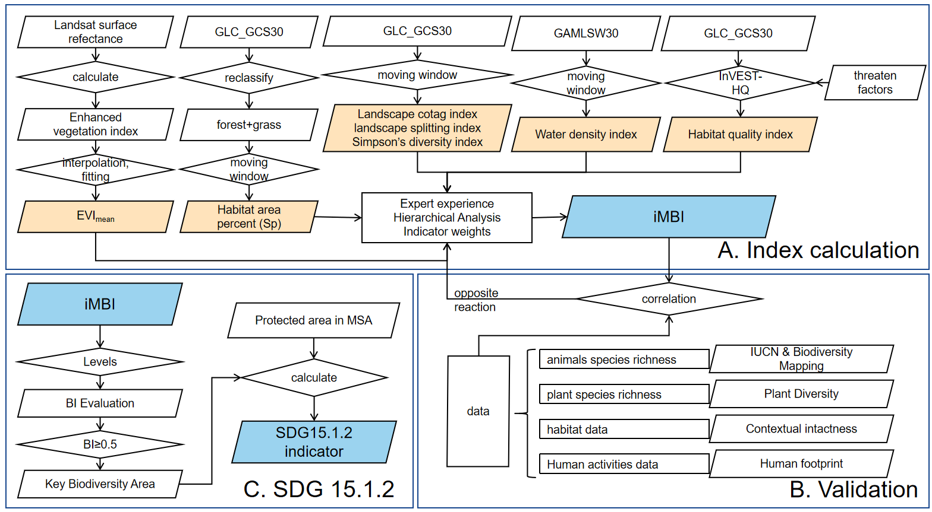

Figure 1. Technical workflow for assessing SDG15.1.2 based on Earth Big Data. Part A: Data and methodologies required for constructing the iMBI. Part B: Validation of BI accuracy using species richness data. Part C: Calculation process of the SDG15.1.2 indicator.

**3、Weights of sub-indicators and computational tools：**

Table 1 The definition and weight of the seven sub-indices for calculating iMBI.

|  |  |  |  |  |
| --- | --- | --- | --- | --- |
| Target | Facet | Indices | Weight | Method & Data |
| iMBI | Species diversity | Habitat Quality Index (HQI) | +0.35* | InVEST-HQ model by using land cover data(Sharp et al. 2016; Tarantino et al. 2023; Terrado et al. 2016) |
| Enhanced Vegetation Index (EVI) | +0.30 | Landsat/TM, Landsat/OLI data from GEE |
| Water Network Density Index (WNDI) | +0.11 | moving window  (calculate by MATLAB) by using land ecosystem data (Li et al. 2014; Liu and He 2023; Liu et al. 2021; MacGarigal and Marks 1995; Shehab et al. 2021) |
| Ecosystem diversity | Habitat area percent (Sp) | +0.09 |
| Landscape diversity | Simpson's Diversity Index (SIDI) | +0.16 |
| Landscape Contagion Index (CONTAG) | +0.09 |
| Landscape Splitting Index (SPLIT) | -0.10 |

**4、Classification criteria of iMBI：**

Table 2 **Classification criteria of iMBI**。

|  |  |  |
| --- | --- | --- |
| Levels | iMBI | Biodiversity status |
| High | BI≥0.6 | Characterized by a high abundance of plant and animal species, high and relatively stable habitat quality, diverse ecosystem types, high vegetation productivity providing ample energy for species survival, and minimal human disturbance, making it highly suitable for species survival and reproduction. |
| Medium | 0.4≤BI<0.6 | Features a relatively rich diversity of plant and animal species, good and stable habitat quality, diverse vegetation types with good coverage, and locally high species richness in certain areas. |
| Average | 0.25≤BI<0.4 | Exhibits fewer plant and animal species, fragmented and discontinuous landscape types, moderate habitat quality, and significant human disturbance. |
| Low | BI<0.25 | Marked by scarce plant and animal species, low vegetation coverage, homogeneous ecosystem types, poor habitat quality, limited energy availability for survival, ecological fragility, and low stability, resulting in extremely low biodiversity. |