2023 Fall

Optimization in Engineering

Project 1

系級：工工所碩二、機械碩一

學號：R11546014

姓名：劉怡葶、李京睿、王邑安

Adaptive cruise control(ACC)

Executive Summary

Since more than 90% of traffic accidents are related to human factors, this study aims to introduce advanced driver assistance systems (ADAS) and autonomous vehicles (AV) to improve driving safety. In this study, we focus on Adaptive Cruise Control (ACC), delving into its fundamentals and the application of Model Predictive Control (MPC) optimization algorithms. At the same time, the challenges faced in the simulation process are mentioned and possible directions for future improvements to the ACC system are discussed.

Introduction

Statistics show that more than 90% of traffic accidents are caused by human causes[1]. In order to effectively reduce the probability of accidents, advanced driver assistance systems (ADAS) and autonomous vehicles (AD) have been introduced in recent years, which partially replace the driver's driving tasks[2].

Adaptive Cruise Control (ACC) is an automotive driver assistance system designed to automatically control the vehicle's speed in response to the traffic ahead by utilizing advanced sensors and control technologies. The basic principle is to monitor the position and speed of the vehicle in front in real time, and automatically adjust the speed of the vehicle based on this information to maintain a safe distance, and automatically slow down or accelerate when needed, as shown in Figure 1.

The basic principles of ACC include the following key components:：

1. Sensor technology: Radar sensors are used in the system to perceive the road and vehicle ahead in real time, and to obtain the relative distance and speed of the vehicle in front. At the same time, the speed of the vehicle is obtained from the speed sensor on the car.
2. Algorithm: The collected sensor data is processed in real time by the Model predictive control (MPC) algorithm to calculate acceleration commands based on current traffic conditions to adjust vehicle speed.
3. Speed control: According to the output of the MPC, the ACC system automatically adjusts the speed of the vehicle through the electronic throttle or braking system. When the vehicle in front slows down or stops, ACC will automatically reduce the speed of the vehicle to maintain a safe distance; The ACC can also automatically accelerate to a set cruising speed when traffic conditions allow.

Importance of ACC[3]:

1. Improved driving safety: The controller responds to traffic changes in real time and automatically controls the speed to avoid collisions and reduce driver fatigue.
2. Improve ride comfort: Through the establishment of algorithms, frequent acceleration and deceleration are reduced, and the ride comfort is improved in a smooth driving mode.

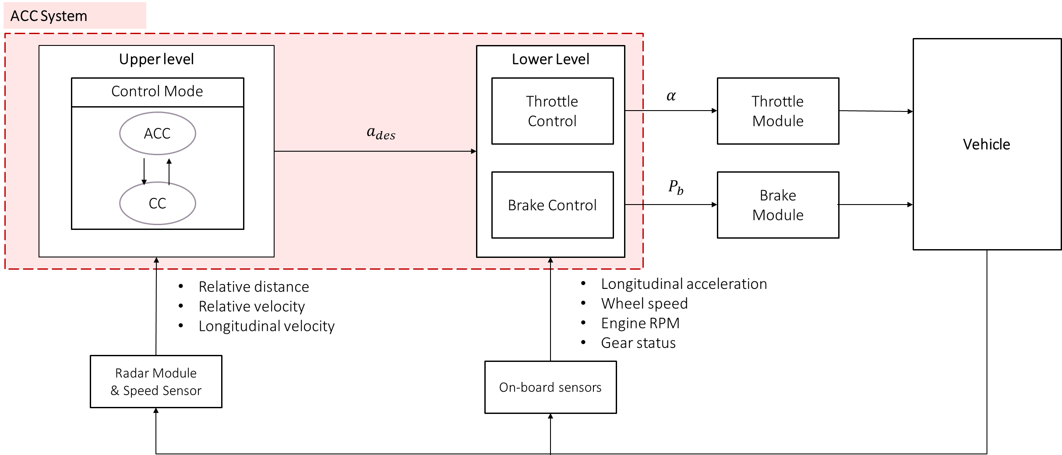

Figure 1 ACC system structure

Research method[4]

* Design variables

There are 4 design variables, distance error $Δd$, relative velocity $Δv$, the acceleration of host vehicle $a_{f}$ and control input $u$.

* Objective

The objectives of this system are:

1. Avoiding rear-end collision
2. Reduce energy consumption
3. Improves ride comfort

$$\min{L\left(Δd,Δv,af,u,Δu\right)+10 ϵ^{2}}$$

$$L\left(Δd,Δv,af, u,Δu\right)= \sum_{i=0}^{p-1}{5 Δ{d\left(k+i+1 | k\right)}^{2}+4 Δ{v\left(k+i+1 | k\right)}^{2}}+\sum_{i=0}^{P-1}{u{\left(k+i | k\right)}^{2}}+\sum_{i=1}^{p-1}{0.1 Δu{\left(k+i | k\right)}^{2}}+\sum_{i=0}^{p-1}{20 {\left[a_{f}(k+i+1|k)-u\left(k+i | k\right)\right]}^{2}}$$

* Constraints

1. I/O constraints
$$-0.01-ϵ≤Δu\left(k+i | k\right)≤0.01+ϵ$$

$$-4-ϵ≤u\left(k+i | k\right)≤1.5+ϵ$$

2. System output constraints
$$\begin{matrix}-5-ϵ≤Δd\left(k+i+1 | k\right)≤6+ϵ \\ -1-ϵ≤Δv\left(k+i+1 | k\right)≤0.9+ϵ \\ -4-ϵ≤a_{f}\left(k+i+1 | k\right)≤1.5+ϵ\end{matrix}; i=0,…, P-1;ϵ≥0$$

3. Rear-end safety constraint

$$a_{safe}\left[\begin{matrix}Δd\left(k+i+1 | k\right) \\ Δv\left(k+i+1 | k\right) \\ a_{f}\left(k+i+1 | k\right)\end{matrix}\right]≥d_{safe}+τ_{safe} v\left(k+i+1 | k\right), i=0, …, P-1$$

$$a_{safe}=\left[\begin{matrix}1 & 0.5 & 0 \\ 1 & -2.5 & 0 \\ 0 & 0 & 0\end{matrix}\right], d_{safe}=\left[\begin{matrix}-5 \\ 0 \\ 0\end{matrix}\right], τ_{safe}=\left[\begin{matrix}-2.5 \\ -2.5 \\ 0\end{matrix}\right]$$

$v$: The velocity of the host vehicle

1. Model of car-following constraint

$$x\left(k+1\right)=Ax\left(k\right)+Bu\left(k\right)+Gv\left(k\right)$$

$$x={\left[\begin{matrix}Δd & Δv & a_{f} \end{matrix}\right]}^{T}, A=\sum_{k=0}^{∞}{\frac{Φ^{k}T_{s}^{k}}{k!}}, B=\sum_{k=1}^{∞}{\frac{Φ^{k-1}T_{s}^{k}}{k!}Π}, C=\sum_{k=1}^{∞}{\frac{Φ^{k-1}T_{s}^{k}}{k!}Γ}$$

$$Φ=\left[\begin{matrix}0 & 1 & -2.5 \\ 0 & 0 & -1 \\ 0 & 0 & -1\end{matrix}\right], T_{s}=10\left(ms\right), Π=\left[\begin{matrix}0 \\ 0 \\ 1\end{matrix}\right], Γ=\left[\begin{matrix}0 \\ 1 \\ 0\end{matrix}\right],$$ $v=a_{p}$ (the acceleration of preceding vehicle)

* Bounds: None
* Algorithm: Model predictive control(MPC)

1. Introduction

Model Predictive Control (MPC) is an advanced process control method for process control that meets a range of constraints simultaneously. Since the 80s of the 20th century, MPC has been widely used in process industries such as chemical plants and petroleum refineries. It is an optimal control technique that minimizes the cost function of a constrained dynamic system within a finite, shrinking time window by calculating control actions.

In MPC, each time step receives or estimates the current state of the plant and controls it based on a dynamic model of the process. This dynamic model is usually a linear empirical model that is recognized by the system. The most prominent advantage of MPC is its ability to optimize the current time slot while taking into account the future time slot, which is achieved by optimizing a finite time window, which is significantly different from algorithms such as Linear Quadratic Regulator (LQR).

1. Why we choose this algorithm

Compared with other control algorithms, MPC has the ability to predict future events and adjust the control strategy accordingly. Conventional proportional-integral-derivative (PID) controllers lack this predictive performance. Overall, the application of MPC to the control process provides a powerful and flexible way to improve performance and meet complex constraints.

Programming

Software formulation

In this project, ACC is simulated using Carsim, MATLAB/Simulink, and Python. The whole process is as follows: First, Carsim, as a vehicle simulator, is responsible for obtaining key signals about the vehicle's movement in real time, such as the relative distance to the vehicle in front, the relative speed, and the longitudinal speed of the vehicle.

Carsim then transmits these real-time signals to MATLAB/Simulink. After receiving these signals, MATLAB/Simulink acts as a server to transmit these critical information to the Python client via the TCP protocol. In the Python client, the expected acceleration is calculated based on the received signal by employing a Model Predictive Control (MPC) algorithm.

Python then transmits the calculated expected acceleration back to MATLAB/Simulink via TCP. This process is repeated over and over again, and the ACC function is implemented, as shown in Figure 2.

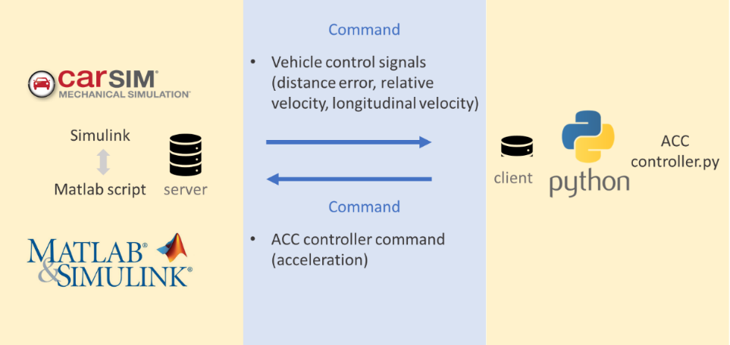

Figure 2 Software Structure

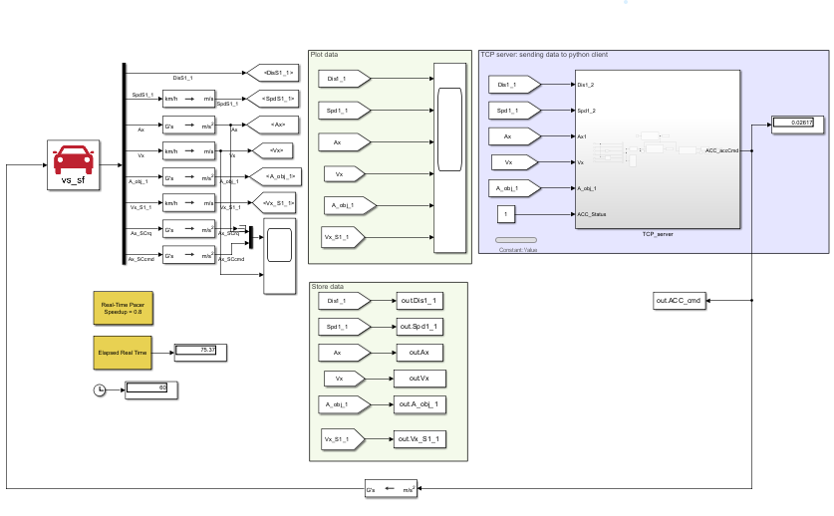

Figure 3 ACC system structure

Result

1. Experiment 1: Test the cruise speed mode and set the cruise speed to 80kph

In the first 30 seconds of the simulation, we set the vehicle to drive with an acceleration of 0.5 m/s². However, from Figure 4, it is observed that the acceleration command of the controller to the Carsim vehicle model actually does not drive according to the expected acceleration, and it is speculated that this discrepancy may be related to the settings of the Carsim internal vehicle model.

After 30 seconds of simulation, cruise mode is turned on. It is clear from Figure 4 that after this the vehicle travels in a stable manner, successfully maintaining the target cruising speed of 80 km/h.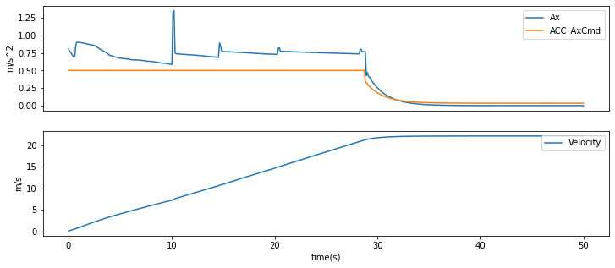

Figure 4 Cruise control mode result 1

Figure 5 shows that after 30 seconds of activation of cruise mode, the acceleration of the vehicle shows a largely smooth curve. The change in acceleration has remained at approximately 0.01 m/s² since 30 seconds, indicating that the introduction of cruise mode has optimized the driver's longitudinal ride comfort.

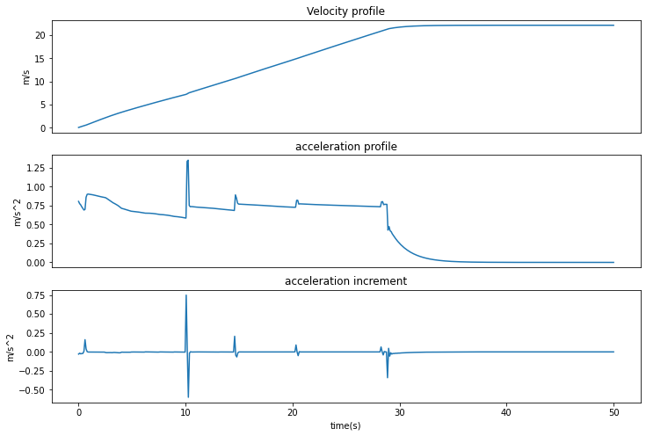

Figure 5 Cruise control mode result 2

* Experiment 2: Test following mode + cruise control mode, set the front car to drive at 60kph and the cruising speed to 70kph

About 25 seconds ago, the vehicle was traveling with an acceleration of 0.5 m/s². After this, the ACC system is activated, and the cruising speed is set to 70 km / h. Between about 25 and 42 seconds, the ACC system goes into cruise mode. As can be seen in Figure 6, during this time, the relative distance to the vehicle in front decreases and the absolute value of the relative velocity increases due to the acceleration of the vehicle. However, after 42 seconds, the ACC system successfully switched to following mode because the relative distance to the vehicle in front was less than a safe distance. As can be seen from the figure below, the main vehicle and the vehicle in front can maintain a safe distance stably, and the ACC mode conversion is successfully realized.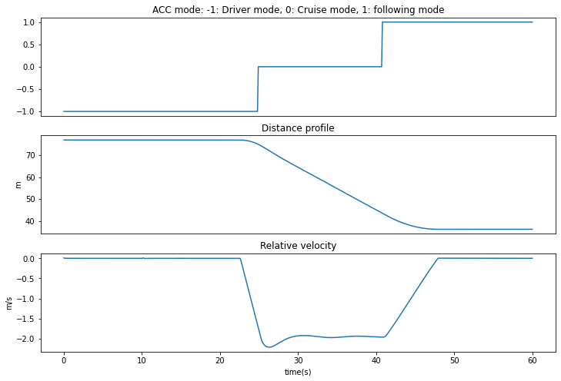

Figure 6 ACC result

Analyze activity

During the simulation, we conducted a series of tests to evaluate the impact of removing various constraints on the system. The test results show that each constraint is not a linear or non-linear combination of the others, so each constraint is considered active.

It is important to note that during the simulation, we observed that the constraints of the vehicle following model were hard constraints. In order to prevent the Model Predictive Control (MPC) system from being unsolvable, we introduced the slack variable to convert hard constraints into soft constraints. This helped the MPC system find a workable solution and ensure that there were no unrealistic situations during the simulation.

Conclusion

The observation results from Figure 3 show that the established adaptive cruise control (ACC) system successfully realizes the function of constant speed driving.

Throughout the programming and simulation process, we noticed that the performance of the Model Predictive Control (MPC) optimization algorithm was closely related to the set parameters. If the parameters do not match the parameters of the vehicle model, there is a possibility that a collision may be caused by the ACC system, although the ACC system may find a feasible solution. Therefore, in future in-depth research, the introduction of a step of automatic adjustment of MPC parameters can be considered. For example, Houssam[5] introduced Artificial Neural Network (ANN) into his research, which aims to automatically adjust MPC parameters. Such an approach can further optimize the ACC system to improve its performance and responsiveness.

1. Singh, Santokh. Critical reasons for crashes investigated in the national motor vehicle crash causation survey. No. DOT HS 812 115. 2015.
2. Khastgir, Siddartha, et al. “Towards increased reliability by objectification of Hazard Analysis and Risk Assessment (HARA) of automated automotive systems.” Safety Science 99 (2017): 166-177.
3. Li, Shengbo, et al. "Model predictive multi-objective vehicular adaptive cruise control." IEEE Transactions on control systems technology 19.3 (2010): 556-566.
4. Li, Shengbo, et al. "Model predictive multi-objective vehicular adaptive cruise control." IEEE Transactions on control systems technology 19.3 (2010): 556-566
5. Moumouh, Houssam, Nicolas Langlois, and Madjid Haddad. "A Novel Tuning approach for MPC parameters based on Artificial Neural Network." 2019 IEEE 15th International Conference on Control and Automation (ICCA). IEEE, 2019.