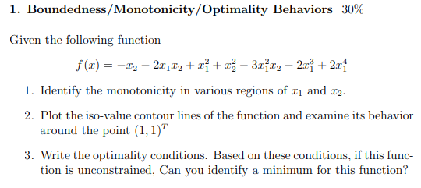

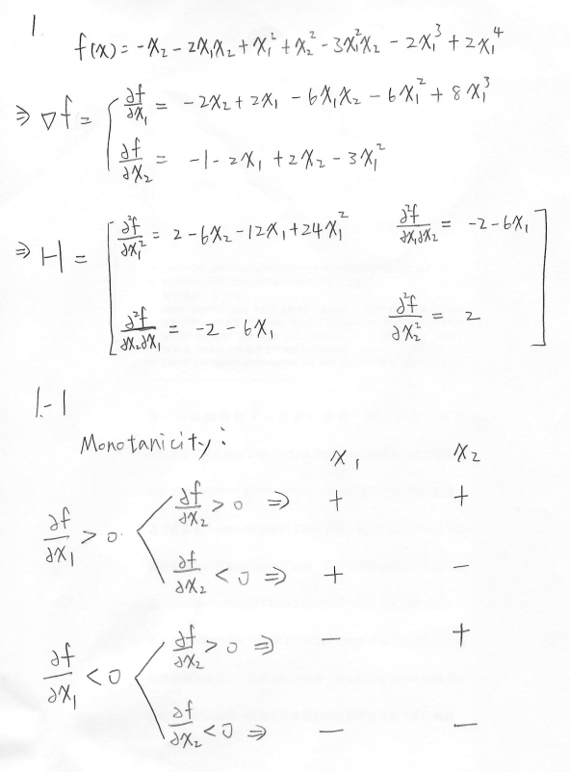1-1

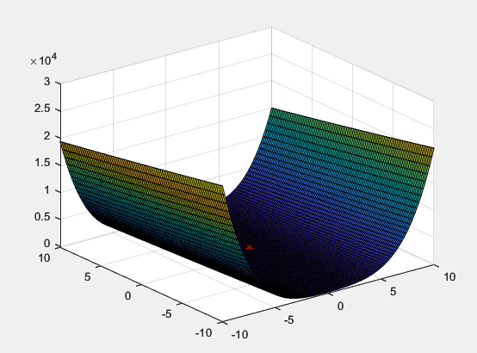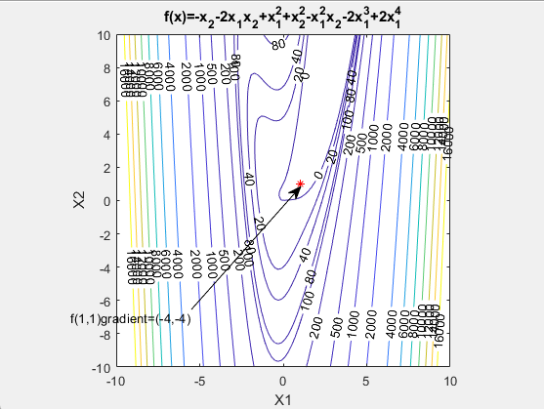1-2

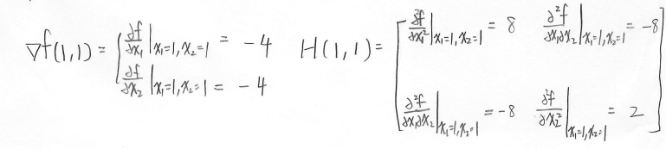

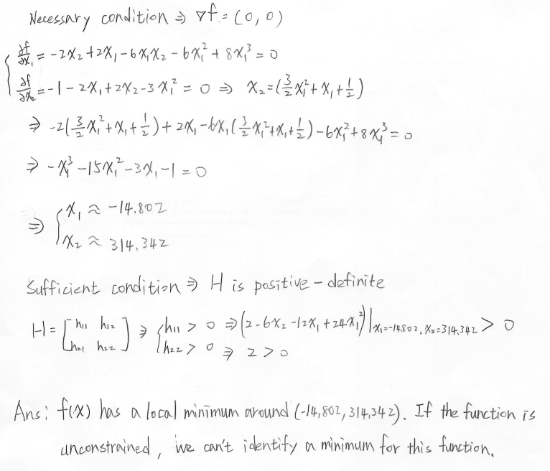1-3

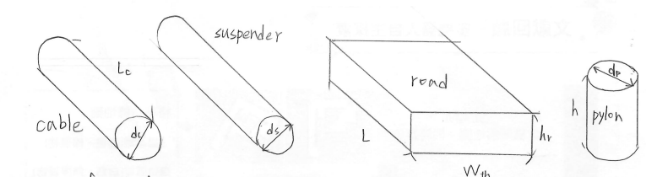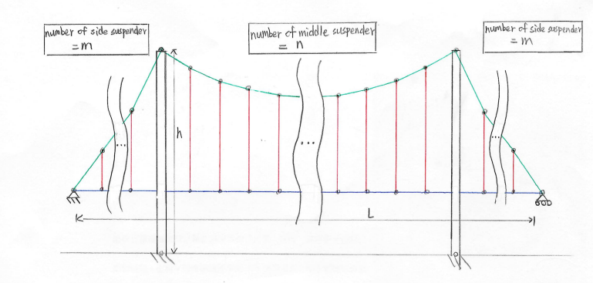

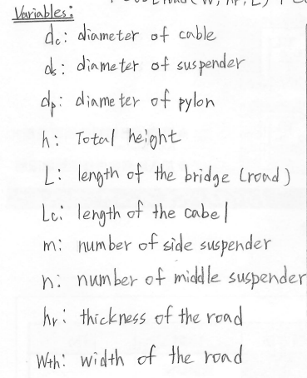

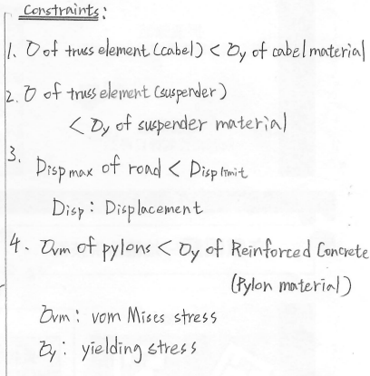

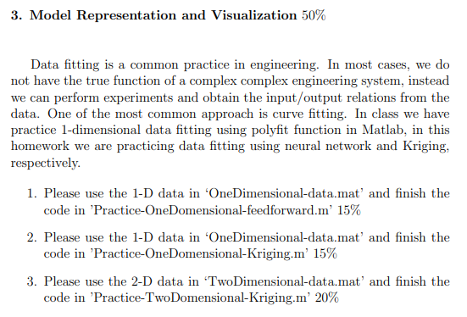

3-1

% feedforward net training and prediction demo for 1d problem

% NTU, ME, SOLab

% 2022/09/27

clc; clear; close all;

%% Step 0: Load data file

% x: 200 points between 0 and 2

% y: 200 points

load('OneDimensional_data.mat');

x=x';

y=y';

%% Step 1: Polt the original data

figure(1);

% ----- to do -----

plot(x,y,'r.')

hold on

%% Step 2: Modeling through the all data.

% Construct a feedforward network with one hidden layer of size 10.

% ----- to do -----

net=feedforwardnet(10);

% Train the network net using the training data.

% Hint: Input will be a row vector. (1*n matrix)

% ----- to do -----

net=train(net,x,y);

% Estimate the targets using the trained network.

% ----- to do -----

y_net=net(x);

% Plot the estimation in the interval [0,2].

% ----- to do -----

plot(x,y_net,'g')

hold off

%% Step 3: Estimate error (known model)

figure(2);

y_origin = (1.7*x.^5-6.2*x.^4+6.3*x.^3-2.3*x+1.1);

% Estimate error

% ----- to do -----

err=abs(y_net-y_origin)./y_origin*100;

% Plot error with respect to x

% ----- to do -----

plot(x,err,'.')

%% Step 4: Estimate error (unknown model, leave one out)

% Leave one out: Take out the 1 sample, and model through the remaining n-1 data.

% Generate 200 models.

error=zeros(200,1);

for i = 1:size(y,2)

% Take out the ith sample.

% ----- to do -----

if i==1

y_estimate=y(2:200);

x_estimate=x(2:200);

elseif i==200

y_estimate=y(1:199);

x_estimate=x(1:199);

else

y_estimate=[y(1:i-1) y(i+1:200)];

x_estimate=[x(1:i-1) x(i+1:200)];

end

% Modeling through the remaining 199 data. (similar Step 2)

% ----- to do -----

net=feedforwardnet(10);

net=train(net,x_estimate,y_estimate);

y_estimate_net=net(x);

% Estimate error between model prediction and provided data

% ----- to do -----

error(i)=abs(y(i)-y_estimate_net(i))/y(i)*100;

end

% Polt error with respect to each model

% ----- to do -----

figure(3)

plot(x,error,'b.')

figure(4)

histogram(error)

3-2

% kriging fitting and prediction demo for 1d problem

% NTU, ME, SOLab

% 2022/09/27

clc; clear; close all;

%% Step 0: Load data file

% x: 200 points between 0 and 2

% y: 200 points

load('OneDimensional_data.mat');

lb = 0;

ub = 2;

%% Step 1: Polt the original data

figure(1);

% ----- to do -----

plot(x,y,'r.')

hold on

%% Step 2: Modeling through the all data.

% Fitting kriging

% Hint: parameter = f_variogram_fit(data x, data y, lb, ub);

% ----- to do -----

parameter=f_variogram_fit(x,y,lb,ub);

% Kriging prediction.

% Hint: Kriging prediction = f_predictkrige(data x, parameter);

% ----- to do -----

[y_krige,sigma]=f_predictkrige(x, parameter);

% Plot the kriging average in the interval [0,2].

% ----- to do -----

plot(x,y_krige,'g')

%% Step 3: Estimate error (known model)

% figure(2);

y_origin = (1.7*x.^5-6.2*x.^4+6.3*x.^3-2.3*x+1.1);

plot(x,y_origin,'b--')

legend('y data','y krige','y origin')

hold off

% Estimate error

% ----- to do -----

err=abs(y_origin-y_krige)./y_origin*100;

% Plot error with respect to x

% ----- to do -----

figure(2);

plot(x,err,'.')

%% Step 4: Estimate error (unknown model, leave one out)

% Leave one out: Take out the 1 sample, and model through the remaining n-1 data.

% Generate 200 models.

error=zeros(200,1);

for i = 1:size(y,1)

% Take out the ith sample.

% ----- to do -----

if i==1

y_estimate=y(2:200);

x_estimate=x(2:200);

elseif i==200

y_estimate=y(1:199);

x_estimate=x(1:199);

else

y_estimate=[y(1:i-1) ; y(i+1:200)];

x_estimate=[x(1:i-1) ; x(i+1:200)];

end

% Modeling through the remaining 199 data. (similar Step 2)

% ----- to do -----

parameter=f_variogram_fit(x_estimate,y_estimate,lb,ub);

[y_est_krige,sigma]=f_predictkrige(x, parameter);

% Estimate error between model prediction and provided data

% ----- to do -----

error(i)=abs(y_est_krige(i)-y(i))/y(i)*100;

end

% Polt error with respect to each model

% ----- to do -----

figure(3)

plot(x,error,'b.')

figure(4)

histogram(error)

3-3

% kriging fitting and prediction demo for 2d problem

% NTU, ME, SOLab

% 2022/09/27

clc; clear; close all;

%% Step 0: Load data file

% x1,x2: 21*21 points between 0 and 2

% z: 21*21 points

load('TwoDimensional_data.mat');

lb = [0, 0];

ub = [2, 2];

% Reshape

x1_flatten = reshape(x1,[21*21 1]);

x2_flatten = reshape(x2,[21*21,1]);

z_flatten = reshape(z,[21*21,1]);

x_data = [x1_flatten, x2_flatten];

z_data = z_flatten;

%% Step 1: Polt the original data

figure(1);

% Hint: plot3

% ----- to do -----

plot3(x1_flatten,x2_flatten,z_data,'r.')

hold on

%% Step 2: Modeling through the all data.

% Fitting kriging

% Hint: parameter = f_variogram_fit(data x, data z, lb, ub);

% ----- to do -----

parameter = f_variogram_fit(x_data, z_data, lb, ub);

% Kriging prediction.

% Hint: Kriging prediction = f_predictkrige(data x, parameter);

% ----- to do -----

[z_krige,sigma]=f_predictkrige(x_data, parameter);

% Plot the kriging average in the interval [0,2].

% ----- to do -----

plot3(x1_flatten,x2_flatten,z_krige,'g')

%% Step 3: Estimate error (known model)

% figure(2);

z_origin = (x1_flatten.^2-5*x2_flatten.^2+x1_flatten.*x2_flatten-8*x1_flatten+9*x2_flatten-5);

plot3(x1_flatten,x2_flatten,z_origin,'b--')

xlabel 'x1'

ylabel 'x2'

zlabel 'z'

hold off

% Estimate error

% ----- to do -----

err=abs((z_origin-z_krige)./z_origin)*100;

% Plot error with respect to x1 and x2

% ----- to do -----

figure(2);

plot3(x1_flatten,x2_flatten,err,'.')

%% Step 4: Estimate error (unknown model, leave one out)

% Leave one out: Take out the 1 sample, and model through the remaining n-1 data.

% Generate 21*21 models.

error=zeros(21*21,1);

for i = 1:size(z_flatten,1)

% Take out the ith sample.

% ----- to do -----

if i==1

z_estimate=z_data(2:441,:);

x_estimate=x_data(2:441,:);

elseif i==441

z_estimate=z_data(1:440,:);

x_estimate=x_data(1:440,:);

else

z_estimate=[z_data(1:i-1,:) ; z_data(i+1:441,:)];

x_estimate=[x_data(1:i-1,:) ; x_data(i+1:441,:)];

end

% Modeling through the remaining 21*21-1 data. (similar Step 2)

% ----- to do -----

parameter = f_variogram_fit(x_estimate, z_estimate, lb, ub);

[z_est_krige,sigma]=f_predictkrige(x_data, parameter);

% Estimate error between model prediction and provided data

% ----- to do -----

error(i)=abs((z_est_krige(i)-z_data(i))/z_data(i))*100;

end

% Polt error with respect to each model

% ----- to do -----

figure(3)

plot3(x1_flatten,x2_flatten,error,'b.')

figure(4)

histogram(error)