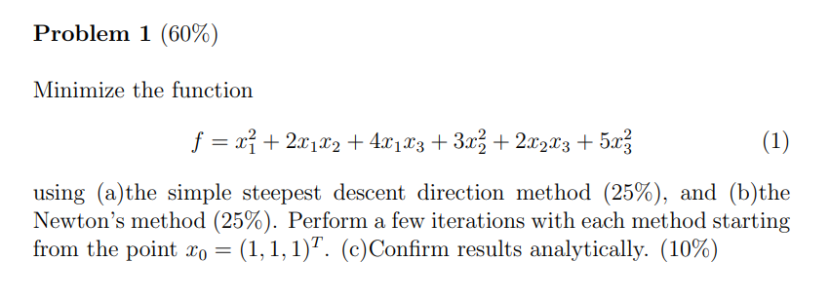

**Objective_function_hw2_1.m :**

function [f,df,H]=objective_function_hw2_1(x)

f=x(1).^2+2.*x(1).*x(2)+4.*x(1).*x(3)+3.*x(2).^2+2.*x(2).*x(3)+5.*x(3).^2;

df=zeros(3,1);

df(1)=2.*x(1)+2.*x(2)+4.*x(3);

df(2)=2.*x(1)+6.*x(2)+2.*x(3);

df(3)=4.*x(1)+2.*x(2)+10.*x(3);

H=[2 2 4; 2 6 2; 4 2 10];

(a)

**hw2_1_steepest_descent_direction_method.m :**

x0=[1;1;1];

max_step=100;

iteration_x=zeros(3,max_step);

iteration_f=zeros(1,max_step);

iteration_x(:,1)=x0;

for ii=1:max_step

[iteration_f(ii),df,H]=objective_function_hw2_1(iteration_x(:,ii));

if ii>1 && abs(iteration_f(ii)-iteration_f(ii-1))<1e-4 || ii==max_step

f=iteration_f(ii);

x=iteration_x(:,ii);

fprintf("steps = %d \n", ii-1)

fprintf("f = %s \n",f)

fprintf("x1 = %s , x2 = %s , x3 = %s \n",x(1),x(2),x(3))

break

end

iteration_x(:,ii+1)=iteration_x(:,ii)-df;

end

**result :**

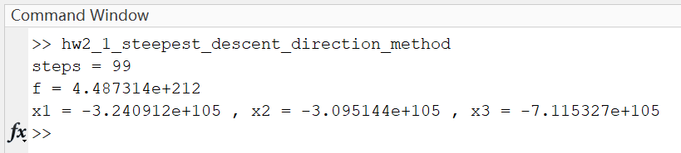

Without the coefficient α, we can’t find the optima in this objective function. Since the gradient is too big to make the step correct.

(b)

**hw2_1_Newtons_method.m :**

x0=[1;1;1];

max_step=100;

iteration_x=zeros(3,max_step);

iteration_f=zeros(1,max_step);

iteration_x(:,1)=x0;

for ii=1:max_step

[iteration_f(ii),df,H]=objective_function_hw2_1(iteration_x(:,ii));

if ii>1 && abs(iteration_f(ii)-iteration_f(ii-1))<1e-4 || ii==max_step

f=iteration_f(ii);

x=iteration_x(:,ii);

fprintf("steps = %d \n", ii-1)

fprintf("f = %s \n",f)

fprintf("x1 = %s , x2 = %s , x3 = %s \n",x(1),x(2),x(3))

break

end

iteration_x(:,ii+1)=iteration_x(:,ii)-df;

end

**result :**

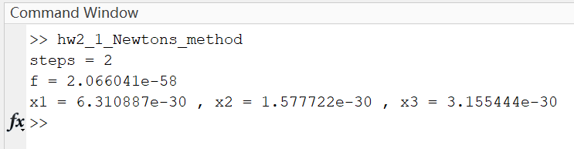

Since the objective function is quadratic, Newton’s method use only two steps to find the optima.

(c)

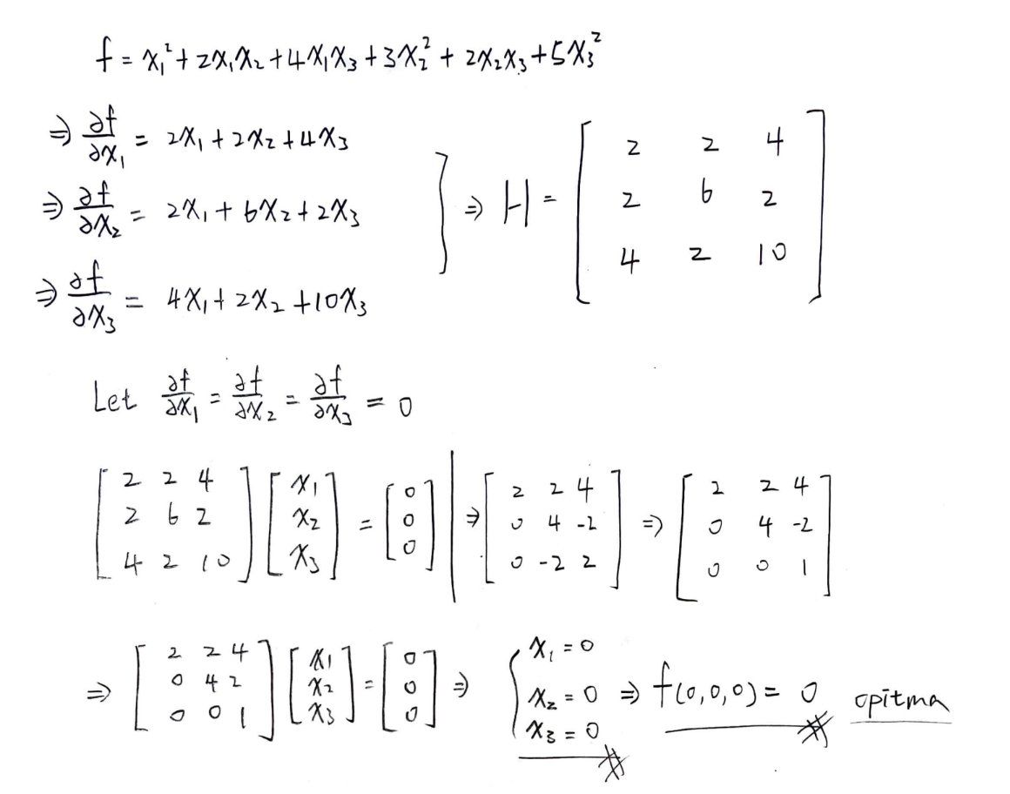

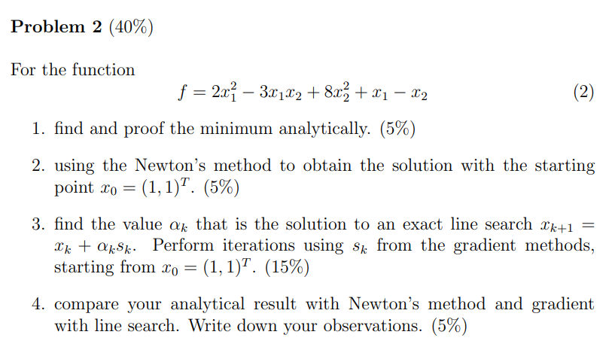

**objective_function_hw2_2.m :**

function [f,df,H]=objective_function_hw2_2(x)

f=2*x(1)^2-3*x(1)*x(2)+8*x(2)^2+x(1)-x(2);

df=zeros(2,1);

df(1)=4*x(1)-3*x(2)+1;

df(2)=-3*x(1)+16*x(2)-1;

H=[4 -3; -3 16];

(a)

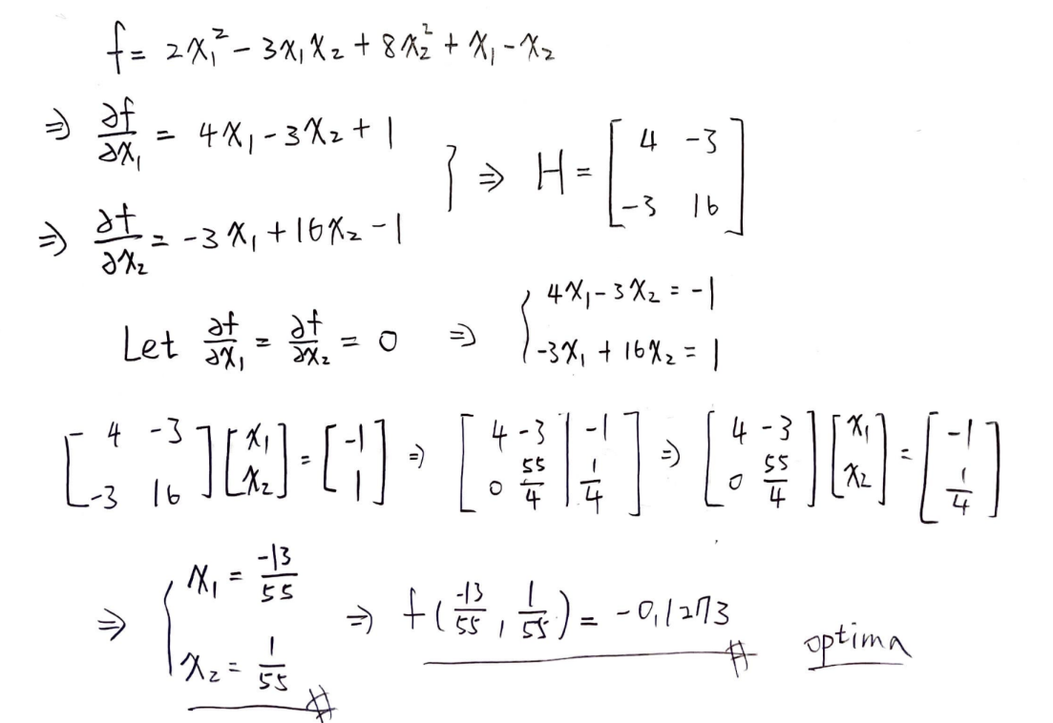

(b)

**hw2_2_Newtons_method.m :**

x0=[1;1];

max_step=100;

iteration_x=zeros(2,max_step);

iteration_f=zeros(1,max_step);

iteration_x(:,1)=x0;

f=0;

x=zeros(3,1);

for ii=1:max_step

[iteration_f(ii),df,H]=objective_function_hw2_2(iteration_x(:,ii));

if ii>1 && abs(iteration_f(ii)-iteration_f(ii-1))<1e-9 || ii==max_step

f=iteration_f(ii);

x=iteration_x(:,ii);

fprintf("steps = %d \n", ii-1)

fprintf("f = %s \n",f)

fprintf("x1 = %s , x2 = %s \n",x(1),x(2))

break

end

iteration_x(:,ii+1)=iteration_x(:,ii)-H^-1*df;

end

**result :**

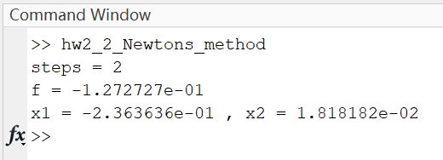

Since the objective function is quadratic, Newton’s method use only two steps to find the optima.

(c)

**hw2_2_optimize_apha_method.m :**

x0=[1;1];

max_step=100;

iteration_x=zeros(2,max_step);

iteration_f=zeros(1,max_step);

iteration_apha=zeros(2,max_step);

iteration_x(:,1)=x0;

a1=linspace(0,1,1000);

a2=linspace(0,1,1000);

n=size(a1,2);

try_apha=cell(n,n);

for aa=1:n

for bb=1:n

try_apha{aa,bb}=[a1(aa); a2(bb)];

end

end

for ii=1:max_step

[iteration_f(ii),df,H]=objective_function_hw2_2(iteration_x(:,ii));

if ii>1 && abs(iteration_f(ii)-iteration_f(ii-1))<1e-15 || ii==max_step

f=iteration_f(ii);

x=iteration_x(:,ii);

fprintf("steps = %d \n", ii-1)

fprintf("f = %s \n",f)

fprintf("x1 = %s , x2 = %s \n",x(1),x(2))

break

end

for jj=1:n*n

try_x=iteration_x(ii)-try_apha{jj}.*df;

try_f=objective_function_hw2_2(try_x);

if jj==1

step_f=try_f;

iteration_apha(:,ii)=try_apha{jj};

elseif jj>1 && try_f<step_f

step_f=try_f;

iteration_apha(:,ii)=try_apha{jj};

end

end

iteration_x(:,ii+1)=iteration_x(:,ii)-iteration_apha(:,ii).*df;

end

**result :**

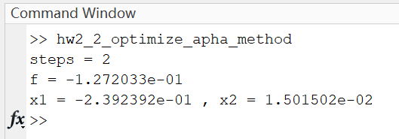

The starting point is really close to the optima point, so it didn’t iteration to many times but try to figure out the correct α to step forward.

(d)