

**Files:** *HW3_objective1*、*HW3_objective2*、*HW3_constrain*、*f1_value_at_x2_star*、*f2_value_at_x1_star*、*hw3_1*

*HW3_objective1*: objective function f1

*HW3_objective2*: objective function f2

*HW3_constrain*: nonlinear constrain {g1, g2, g3}

*f1_value_at_x2_star*: finding the point ${\{f}_{2}^{*},f_{1}(x_{2}^{*})\}$

*f2_value_at_x1_star*: finding the point ${\{f}_{1}^{*},f_{2}(x_{1}^{*})\}$

*hw3_1*: main scrip

*HW3_objective1* :

function f1=HW3_objective1(x)

f1=x(1)+x(2);

*HW3_objective2* :

function f2=HW3_objective2(x)

f2=-10*x(1)+x(2);

*HW3_constrain* :

function [c,ceq]=HW3_constrain(x)

c(1)=-(x(1).^2*x(2)/20-1);

c(2)=-((x(1)+x(2)-5).^2/30+(x(1)-x(2)-12).^2/120-1);

c(3)=-(80/(x(1).^2+8*x(2)+5)-1);

ceq=[];

*f1_value_at_x2_star* :

function [f2_str,f1_x2_str,x2_str]=f1_value_at_x2_star()

fun=@HW3_objective2;

x0=[5;5];

A=[];

b=[];

Aeq=[];

beq=[];

lb=[0;0];

ub=[10;10];

nonlcon=@HW3_constrain;

[x2_str,f2_str]=fmincon(fun,x0,A,b,Aeq,beq,lb,ub,nonlcon);

f1_x2_str=HW3_objective1(x2_str);

*f2_value_at_x1_star* :

function [f1_str,f2_x1_str,x1_str]=f2_value_at_x1_star()

fun=@HW3_objective1;

x0=[5;5];

A=[];

b=[];

Aeq=[];

beq=[];

lb=[0;0];

ub=[10;10];

nonlcon=@HW3_constrain;

[x1_str,f1_str]=fmincon(fun,x0,A,b,Aeq,beq,lb,ub,nonlcon);

f2_x1_str=HW3_objective2(x1_str);

*hw3_1* :

[f1_str,f2_x1_str,x1_str]=f2_value_at_x1_star(); % find {f^∗_2 ,f1(x^∗_2)}

[f2_str,f1_x2_str,x2_str]=f1_value_at_x2_star(); % find {f^*_1 ,f2(x^*_1)}

% plot three points

f1=[f1_str,f1_x2_str,f1_str];

f2=[f2_x1_str,f2_str,f2_str];

figure('position',[15,60,500,900])

subplot(2,1,1)

scatter(f1,f2);

axis square

hold on

text(f1_str,f2_str+2,"Utopia")

% devide (f^*_1) ~ (f2(x^∗_1)) into N points, dosen't include (f^*_1)

N=10;

f1i=zeros(1,N);

for ii=1:N

if ii==1

f1i(1)=f1_str+(f1_x2_str-f1_str)/N;

else

f1i(ii)=f1i(ii-1)+(f1_x2_str-f1_str)/N;

end

end

% using fmincon optimize algorithm find (f_2i)

f2i=zeros(1,N);

optima_x=zeros(2,N);

for ii=1:N

fun=@HW3_objective2;

x0=[5;5];

A=[1,1];

b=f1i(ii);

Aeq=[];

beq=[];

lb=[0;0];

ub=[10;10];

nonlcon=@HW3_constrain;

[optima_x(:,ii),f2i(ii)]=fmincon(fun,x0,A,b,Aeq,beq,lb,ub,nonlcon);

end

% plot Pareto set

scatter(f1i,f2i);

title ParetoSet

grid on

xlabel f_1

ylabel f_2

hold off

% plot the optima x at each Pareto set

subplot(2,1,2)

scatter([x1_str(1) optima_x(1,:)],[x1_str(2) optima_x(2,:)])

axis square

title OptimaSet

grid on

xlabel x_1

ylabel x_2

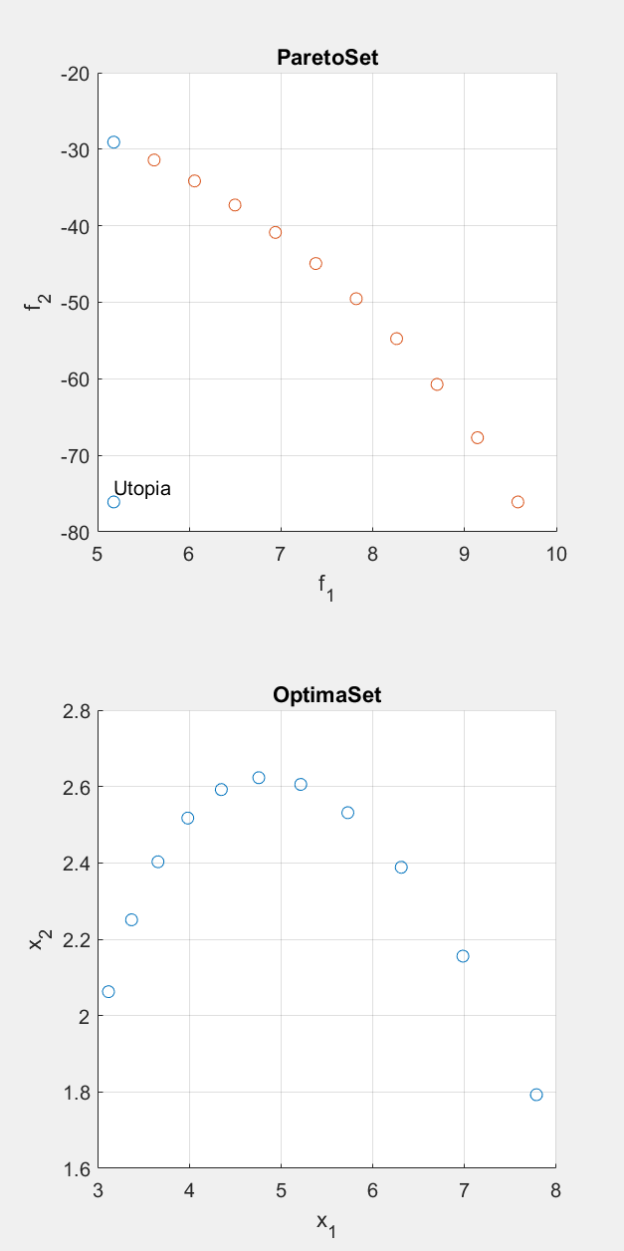



**Files:** *HW3_optimization*、*hw3_2_1*、*hw3_2_2*、*hw3_2_3*、*hw3_2_4*

*HW3_optimization* :

function x=HW3_optimization()

fun=@HW3_objective1;

x0=[5;5];

A=[];

b=[];

Aeq=[];

beq=[];

lb=[0;0];

ub=[10;10];

nonlcon=@HW3_constrain;

x=fmincon(fun,x0,A,b,Aeq,beq,lb,ub,nonlcon);

**2-1.**

*Hw3_2_1* :

optimal_design=HW3_optimization();

mux=optimal_design'; % you should change to the optimal design you obtained

stdx=[0.3, 0.3]; % you should change this value according to the homework descriptions

covX=[stdx(1)^2, 0; 0, stdx(2)^2];

% Basic MCS

N=10; % you should change this value according to the homework descriptions

RandX=mvnrnd(mux, covX, N);

X1=RandX(:,1);

X2=RandX(:,2);

%Y=zeros(N,1); % you should change Y to constraints, therefore you have three different function evaluations

%Y=5*X1-3*X2;

g1=1-X1.^2.*X2/20;

g2=1-(X1+X2-5).^2/30-(X1-X2-12).^2/120;

g3=1-80/(X1.^2+8.*X2+5);

Nf(1)=sum(g1<0); % you should have three Nf values w.r.t different constraints

Nf(2)=sum(g2<0);

Nf(3)=sum(g3<0);

pf=Nf./N; % you should have three pf values w.r.t different constraints

for ii=1:3

sprintf('g%d Failure probability using MCS with %d samples is %0.5g percent ', ii , N, pf(ii)*100)

end

**result:**

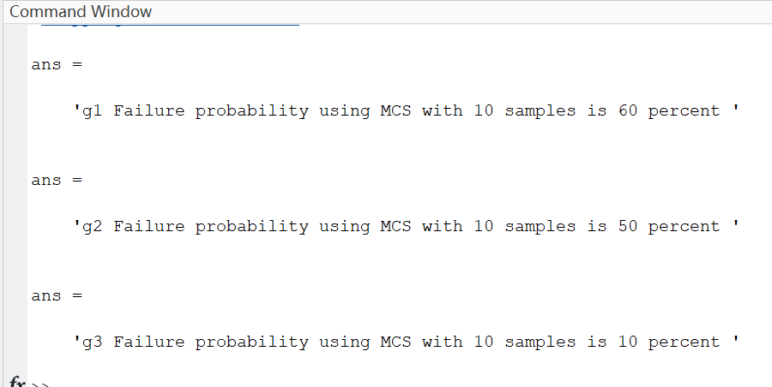

**2-2.**

*Hw3_2_2* :

optimal_design=HW3_optimization();

mux=optimal_design'; % you should change to the optimal design you obtained

stdx=[0.3, 0.3]; % you should change this value according to the homework descriptions

covX=[stdx(1)^2, 0; 0, stdx(2)^2];

% Basic MCS

N=10; % you should change this value according to the homework descriptions

percents=zeros(3,20);

for jj=1:20

RandX=mvnrnd(mux, covX, N);

X1=RandX(:,1);

X2=RandX(:,2);

%Y=zeros(N,1); % you should change Y to constraints, therefore you have three different function evaluations

%Y=5*X1-3*X2;

g1=1-X1.^2.*X2/20;

g2=1-(X1+X2-5).^2/30-(X1-X2-12).^2/120;

g3=1-80/(X1.^2+8.*X2+5);

Nf(1)=sum(g1<0); % you should have three Nf values w.r.t different constraints

Nf(2)=sum(g2<0);

Nf(3)=sum(g3<0);

pf=Nf./N; % you should have three pf values w.r.t different constraints

% for ii=1:3

% sprintf('Failure probability using MCS with %d samples is %0.5g percent ', N, pf(ii)*100)

% end

percents(:,jj)=pf';

end

figure(1)

histogram(percents(1,:)*100,0:10:110)

title g(1)FailurePercentage

xlabel percentage

figure(2)

histogram(percents(2,:)*100,0:10:110)

title g(2)FailurePercentage

xlabel percentage

figure(3)

histogram(percents(3,:)*100,0:10:110)

title g(3)FailurePercentage

xlabel percentage

RE=string(percents*100);

SULT=repmat("%",3,20);

RESULT=RE+SULT;

sprintf("the failure percentage of each constrains for 20 times:")

disp(RESULT)

**result:**

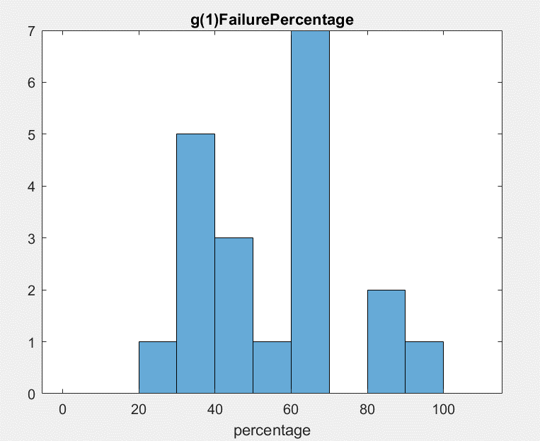

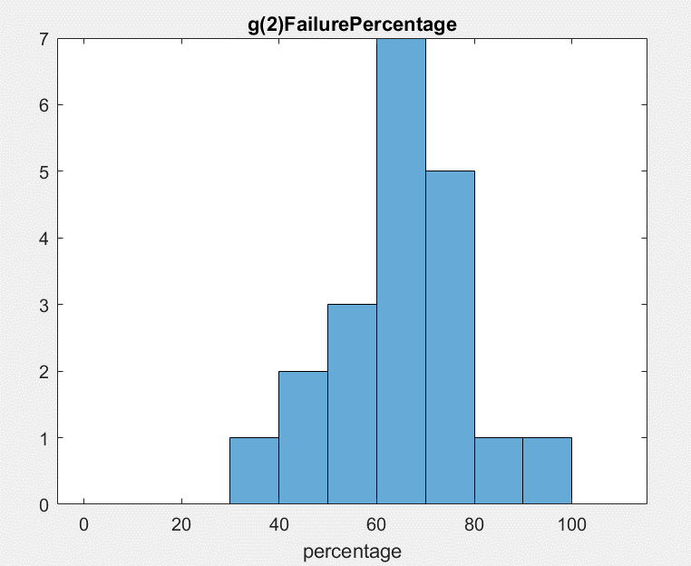

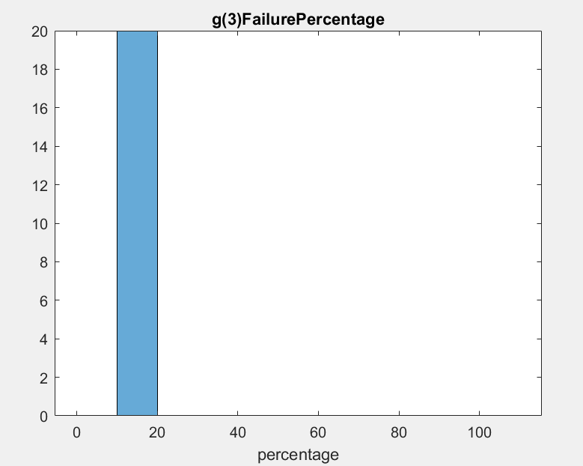

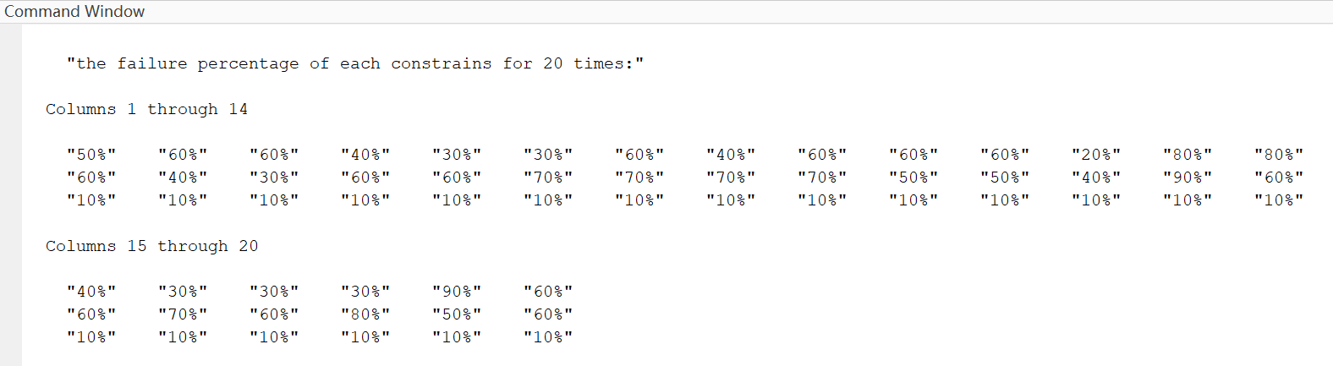

I did not get the same results every time. I think it is because that the quantity of samples is too small. 10 samples each simulation can’t completely demonstrate the probability of failure.

**2-3.**

*Hw3_2_3* :

optimal_design=HW3_optimization();

mux=optimal_design'; % you should change to the optimal design you obtained

stdx=[0.3, 0.3]; % you should change this value according to the homework descriptions

covX=[stdx(1)^2, 0; 0, stdx(2)^2];

% Basic MCS

N=10^6; % you should change this value according to the homework descriptions

RandX=mvnrnd(mux, covX, N);

X1=RandX(:,1);

X2=RandX(:,2);

%Y=zeros(N,1); % you should change Y to constraints, therefore you have three different function evaluations

%Y=5*X1-3*X2;

g1=1-X1.^2.*X2/20;

g2=1-(X1+X2-5).^2/30-(X1-X2-12).^2/120;

g3=1-80/(X1.^2+8.*X2+5);

Nf(1)=sum(g1<0); % you should have three Nf values w.r.t different constraints

Nf(2)=sum(g2<0);

Nf(3)=sum(g3<0);

pf=Nf./N; % you should have three pf values w.r.t different constraints

for ii=1:3

sprintf('g%d Failure probability using MCS with %d samples is %0.5g percent ', ii , N, pf(ii)*100)

end

**result:**

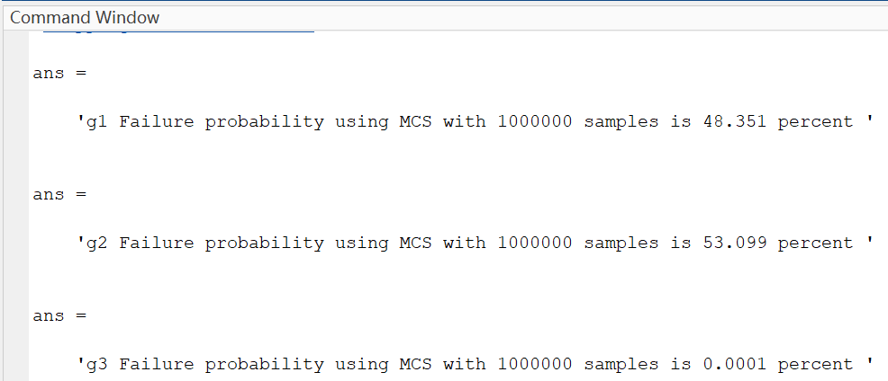

**2-4.**

*hw3_2_4* :

optimal_design=HW3_optimization();

mux=optimal_design'; % you should change to the optimal design you obtained

stdx=[0.3, 0.3]; % you should change this value according to the homework descriptions

covX=[stdx(1)^2, 0; 0, stdx(2)^2];

% Basic MCS

N=10^6; % you should change this value according to the homework descriptions

percents=zeros(3,20);

for jj=1:20

RandX=mvnrnd(mux, covX, N);

X1=RandX(:,1);

X2=RandX(:,2);

%Y=zeros(N,1); % you should change Y to constraints, therefore you have three different function evaluations

%Y=5*X1-3*X2;

g1=1-X1.^2.*X2/20;

g2=1-(X1+X2-5).^2/30-(X1-X2-12).^2/120;

g3=1-80/(X1.^2+8.*X2+5);

Nf(1)=sum(g1<0); % you should have three Nf values w.r.t different constraints

Nf(2)=sum(g2<0);

Nf(3)=sum(g3<0);

pf=Nf./N; % you should have three pf values w.r.t different constraints

% for ii=1:3

% sprintf('Failure probability using MCS with %d samples is %0.5g percent ', N, pf(ii)*100)

% end

percents(:,jj)=pf';

end

figure(1)

histogram(percents(1,:)*100,0:10:110)

title g(1)FailurePercentage

xlabel percentage

figure(2)

histogram(percents(2,:)*100,0:10:110)

title g(2)FailurePercentage

xlabel percentage

figure(3)

histogram(percents(3,:)*100,0:10:110)

title g(3)FailurePercentage

xlabel percentage

RE=string(percents*100);

SULT=repmat("%",3,20);

RESULT=RE+SULT;

sprintf("the failure percentage of each constrains for 20 times:")

disp(RESULT)

**result:**

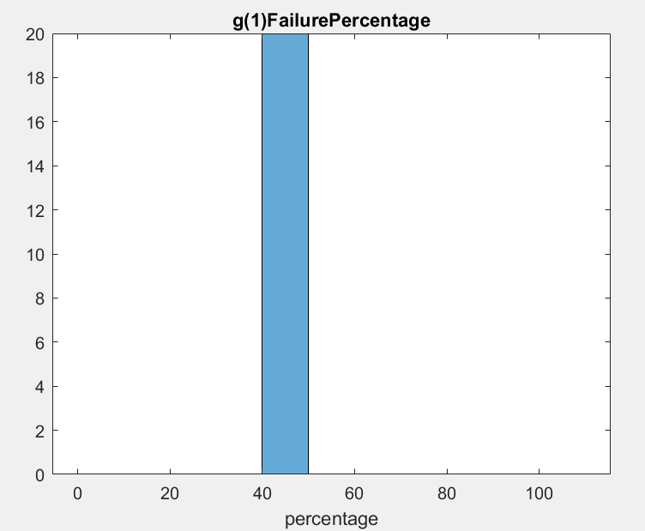

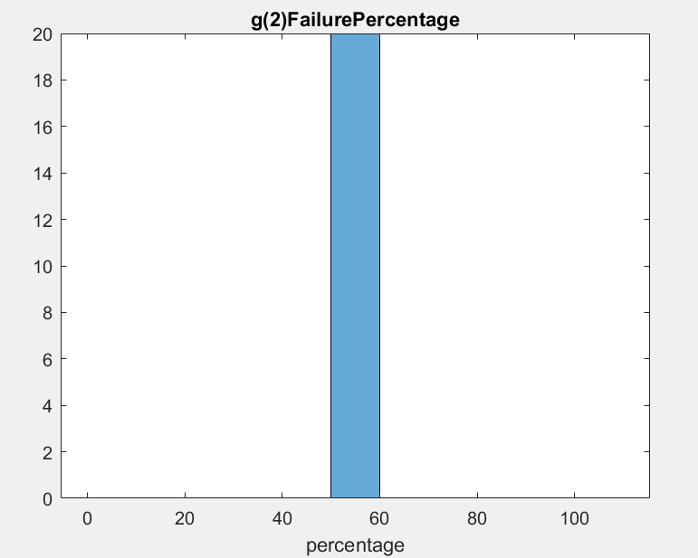

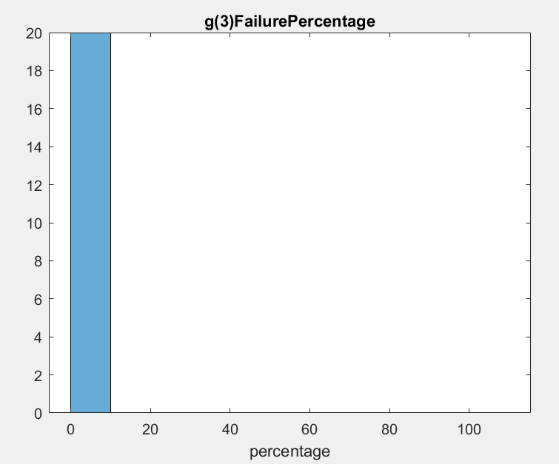

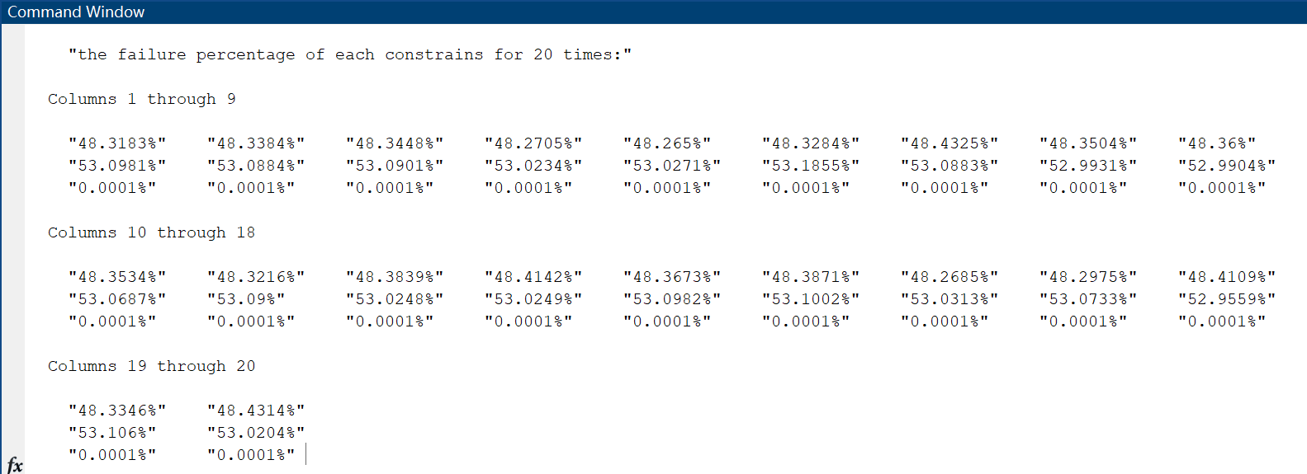

I almost got the same results every time. It is because that the quantity of samples is adequate to simulate the real probability of failure.

**2-5.**

The biggest difference between 10 sample MCS and 1 million sample MCS are the stability of results. 10 sample MCS results to different failure percentages each run, while 1 million sample MCS has almost same result each run.