**Introduction to statistical control and optimization**

Homework 1

機械所設計組 R12522615 王邑安 HW_ID:12

1. a.

The outcome space of Super Lotto 638 has totally outcomes. The winning set is the only one outcome in the outcome space.

Thus, the probability of first prize is:

Assumption:

* iid assumption in each term: Every winning set has identical probability to be chosen independently each term.
* iid assumption in choosing a number each a number: Every number has the identical probability to be chosen independently each time.

1. b.

* There are different outcomes in the first set.
* Five of the six numbers have to be the winning numbers, and the rest of the number is not the winning numbers. Thus, there are sets.
* The second number must be the winning number.

The probability to win the third prized is:

1. c.

* Event A and event B are independent.
* Event B and event C are independent.
* Event C and event D are mutually exclusive.

1. d.

* P(A):
* P(A|B):
* P(A|C): =0.010312
* P(C or D):
* P(C|D):

2.

Formula (n is the number of items.)

* Median: order the data from smallest to largest.
* Variance:

|  |  |  |  |  |  |  |
| --- | --- | --- | --- | --- | --- | --- |
| 50-draws frequencies | average | medium | max | min | range | sample variance |
| first numbers | 0.157895 | 0.16 | 0.28 | 0.06 | 0.22 | 0.002741394 |
| second numbers | 0.125 | 0.13 | 0.18 | 0.06 | 0.12 | 0.0018 |

|  |  |  |  |  |  |  |
| --- | --- | --- | --- | --- | --- | --- |
| 100-draws frequencies | average | medium | max | min | range | sample variance |
| first numbers | 0.157895 | 0.16 | 0.23 | 0.07 | 0.16 | 0.001379232 |
| second number | 0.125 | 0.13 | 0.15 | 0.09 | 0.06 | 0.0004 |

|  |  |  |  |  |  |  |
| --- | --- | --- | --- | --- | --- | --- |
| 500-draws frequencies | average | medium | max | min | range | sample variance |
| first numbers | 0.157895 | 0.157 | 0.182 | 0.126 | 0.056 | 0.000223556 |
| second number | 0.125 | 0.123 | 0.148 | 0.102 | 0.046 | 0.000306286 |

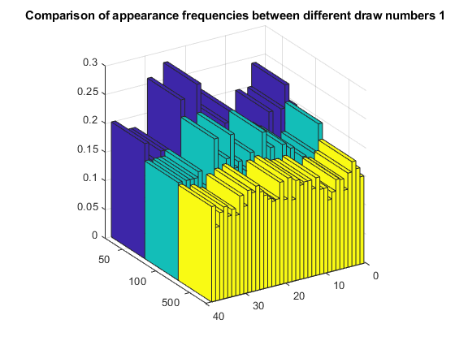

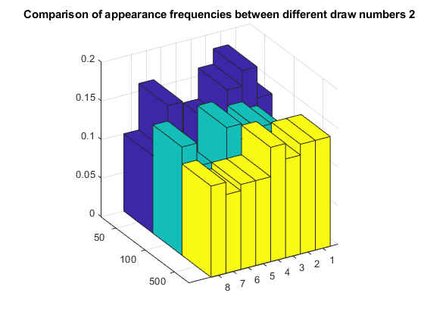

Those bar-chart tell us: As the data samples getting bigger and bigger, the difference of appearance frequencies between each number seems getting smaller and smaller. The tables also show that the sample variances are going down as the drawn number growing up. While the average of appearance frequencies of the first numbers and the second number are always the same. My observation tells me that the probability of each number being chosen is the same. I will choose numbers randomly.

3.

There are many types of RIDT. A paper which compared 6 kinds of RIDTs tested 177 clinical specimens. 49 were found to be positive for influenza A and 10 were found to be positive for influenza B. The influenza A sensitivity and specificity of those rapid test are about (67~73%) and (99~100%) respectively except Rockeby(a kind of RIDT). The influenza B sensitivity and specificity are about 30% and 100% respectively.

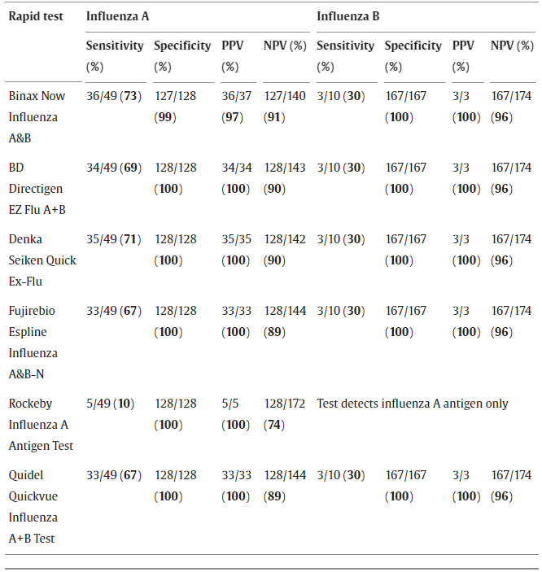

The probability for a person to be actually infected by the type A influenza given that person is tested positive the RIDT are about (97~100%). As the table shown.

Reference: (Aeron C. Hurt, Robert Alexander, Jan Hibbert, Nicola Deed, Ian G. Barr, Performance of six influenza rapid tests in detecting human influenza in clinical specimens, Journal of Clinical Virology, Volume 39, Issue 2,2007)