The humidity and temperature can have an interaction effect on the speed of sound. The speed of sound in dry air could have lo



can be found by the function :

is two times of :



Surface plot:

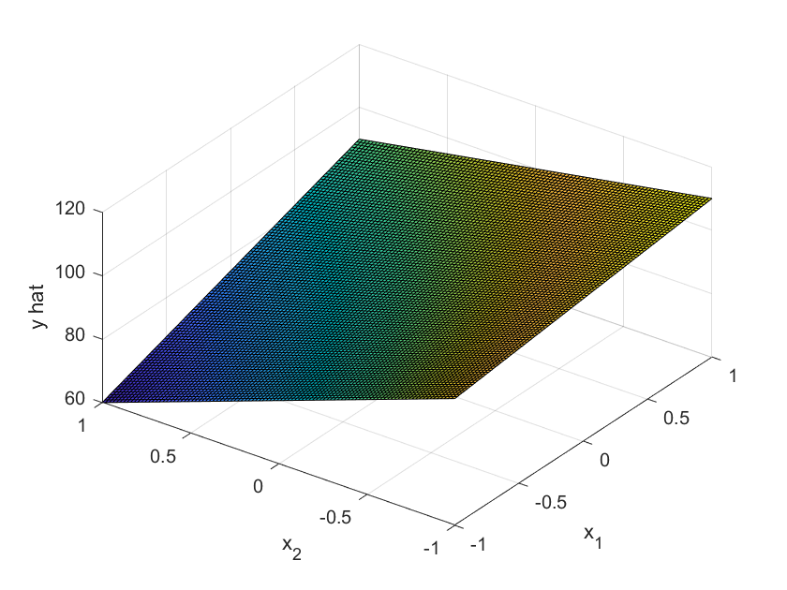

Contour plot:





Given different values of , the impact of on will vary accordingly.

Take the function in this question for example:



Provided varying , the slop of will be different.



Set 85 as the desired , the relation between and will be:

The relation on the contour plot in (c):



There are several possible combinations of x_1 and x_2. Here are a few examples:

|  |  |  |  |  |  |  |  |  |  |
| --- | --- | --- | --- | --- | --- | --- | --- | --- | --- |
|  | -1 | -0.75 | -0.5 | -0.25 | 0 | 0.25 | 0.5 | 0.75 | 1 |
|  | -4 | -2.6 | -1.66667 | -1 | -0.5 | -0.11111 | 0.2 | 0.454545 | 0.666667 |
|  | 85 | 85 | 85 | 85 | 85 | 85 | 85 | 85 | 85 |



* Set temperature(T) as , 120℃ make , 80℃ make
* Set pressure(p) as , 70psi make , 50psi make
* Set Reaction time as , 15min make , 5min make

|  |  |  |  |  |
| --- | --- | --- | --- | --- |
| test | x1(T) | x2(p) | x3(t) |  |
| 1 | -1 | -1 | -1 | 59.02767 |
| 2 | 1 | -1 | -1 | 76.31333 |
| 3 | -1 | 1 | -1 | 28.87 |
| 4 | 1 | 1 | -1 | 51.41 |
| 5 | -1 | -1 | 1 | 20.3 |
| 6 | 1 | -1 | 1 | 41.62667 |
| 7 | -1 | 1 | 1 | 48.34 |
| 8 | 1 | 1 | 1 | 73.06333 |

|  |  |  |  |  |  |  |
| --- | --- | --- | --- | --- | --- | --- |
| E1 | E2 | E3 | E12 | E23 | E13 | E123 |
| 21.46892 | 1.103917 | -8.07275 | 2.16275 | 28.63442 | 1.556083 | -0.46442 |



The parameters of coded predictive model:

|  |  |  |  |  |  |  |  |
| --- | --- | --- | --- | --- | --- | --- | --- |
| b0 | b1 | b2 | b3 | b12 | b23 | b13 | b123 |
| 49.86888 | 10.73446 | 0.551958 | -4.03638 | 1.081375 | 14.31721 | 0.778042 | -0.23221 |

Coded predictive model:



The regression model:

|  |  |  |  |  |  |  |  |  |
| --- | --- | --- | --- | --- | --- | --- | --- | --- |
| 摘要輸出 | |  |  |  |  |  |  |  |
|  |  |  |  |  |  |  |  |  |
| 迴歸統計 | |  |  |  |  |  |  |  |
| R 的倍數 | 1 |  |  |  |  |  |  |  |
| R 平方 | 1 |  |  |  |  |  |  |  |
| 調整的 R 平方 | 65535 |  |  |  |  |  |  |  |
| 標準誤 | 0 |  |  |  |  |  |  |  |
| 觀察值個數 | 8 |  |  |  |  |  |  |  |
|  |  |  |  |  |  |  |  |  |
| ANOVA |  |  |  |  |  |  |  |  |
|  | 自由度 | SS | MS | F | 顯著值 |  |  |  |
| 迴歸 | 7 | 2709.093 | 387.0133 | #NUM! | #NUM! |  |  |  |
| 殘差 | 0 | 0 | 65535 |  |  |  |  |  |
| 總和 | 7 | 2709.093 |  |  |  |  |  |  |
|  |  |  |  |  |  |  |  |  |
|  | 係數 | 標準誤 | t 統計 | P-值 | 下限 95% | 上限 95% | 下限 95.0% | 上限 95.0% |
| 截距 | 49.86888 | 0 | 65535 | #NUM! | 49.86888 | 49.86888 | 49.86888 | 49.86888 |
| x1(T) | 10.73446 | 0 | 65535 | #NUM! | 10.73446 | 10.73446 | 10.73446 | 10.73446 |
| x2(p) | 0.551958 | 0 | 65535 | #NUM! | 0.551958 | 0.551958 | 0.551958 | 0.551958 |
| x3(t) | -4.03638 | 0 | 65535 | #NUM! | -4.03638 | -4.03638 | -4.03638 | -4.03638 |
| x1x2 | 1.081375 | 0 | 65535 | #NUM! | 1.081375 | 1.081375 | 1.081375 | 1.081375 |
| x2x3 | 14.31721 | 0 | 65535 | #NUM! | 14.31721 | 14.31721 | 14.31721 | 14.31721 |
| x1x3 | 0.778042 | 0 | 65535 | #NUM! | 0.778042 | 0.778042 | 0.778042 | 0.778042 |
| x1x2x3 | -0.23221 | 0 | 65535 | #NUM! | -0.23221 | -0.23221 | -0.23221 | -0.23221 |



(100-yield) is a smaller-the-better performance measure. The SN ratio will be:

|  |  |  |  |  |  |  |  |  |  |  |
| --- | --- | --- | --- | --- | --- | --- | --- | --- | --- | --- |
| test | temperature | pressure | time | 1 | 2 | 3 | average | variance | σ | SN |
| 1 | 80 | 50 | 5 | 61.433 | 58.58 | 57.07 | 59.02767 | 4.909246 | 2.215682 | -32.2583 |
| 2 | 120 | 50 | 5 | 75.62 | 77.57 | 75.75 | 76.31333 | 1.188633 | 1.090245 | -27.4962 |
| 3 | 80 | 70 | 5 | 27.51 | 34.03 | 25.07 | 28.87 | 21.4576 | 4.632235 | -37.0533 |
| 4 | 120 | 70 | 5 | 51.37 | 48.49 | 54.37 | 51.41 | 8.6448 | 2.940204 | -33.7415 |
| 5 | 80 | 50 | 15 | 24.8 | 20.69 | 15.41 | 20.3 | 22.1571 | 4.707133 | -38.0393 |
| 6 | 120 | 50 | 15 | 43.58 | 44.31 | 36.99 | 41.62667 | 16.25723 | 4.032026 | -35.3381 |
| 7 | 80 | 70 | 15 | 45.2 | 49.53 | 50.29 | 48.34 | 7.5391 | 2.745742 | -34.2713 |
| 8 | 120 | 70 | 15 | 70.51 | 74 | 74.68 | 73.06333 | 5.005233 | 2.237238 | -28.6268 |



* Set temperature(T) as , 120℃ make , 80℃ make
* Set pressure(p) as , 70psi make , 50psi make
* Set Reaction time as , 15min make , 5min make

|  |  |  |  |  |
| --- | --- | --- | --- | --- |
| test | x1(T) | x2(p) | x3(t) | SN |
| 1 | -1 | -1 | -1 | -32.2583 |
| 2 | 1 | -1 | -1 | -27.4962 |
| 3 | -1 | 1 | -1 | -37.0533 |
| 4 | 1 | 1 | -1 | -33.7415 |
| 5 | -1 | -1 | 1 | -38.0393 |
| 6 | 1 | -1 | 1 | -35.3381 |
| 7 | -1 | 1 | 1 | -34.2713 |
| 8 | 1 | 1 | 1 | -28.6268 |

|  |  |  |  |  |  |  |
| --- | --- | --- | --- | --- | --- | --- |
| E1 | E2 | E3 | E12 | E23 | E13 | E123 |
| 4.104871 | -0.14027 | -1.431518 | 0.373253 | 5.3799089 | 0.067943 | 1.098389 |



The parameter of the SN ratio predictive model:

|  |  |  |  |  |  |  |  |
| --- | --- | --- | --- | --- | --- | --- | --- |
| d0 | d1 | d2 | d3 | d12 | d23 | d13 | d123 |
| -33.3531 | 2.0524355 | -0.07014 | -0.715759 | 0.186626 | 2.6899545 | 0.033972 | 0.549194 |

SN ratio predictive model:



|  |  |  |  |  |  |  |  |  |
| --- | --- | --- | --- | --- | --- | --- | --- | --- |
| 摘要輸出 | |  |  |  |  |  |  |  |
|  |  |  |  |  |  |  |  |  |
| 迴歸統計 | |  |  |  |  |  |  |  |
| R 的倍數 | 1 |  |  |  |  |  |  |  |
| R 平方 | 1 |  |  |  |  |  |  |  |
| 調整的 R 平方 | 65535 |  |  |  |  |  |  |  |
| 標準誤 | 0 |  |  |  |  |  |  |  |
| 觀察值個數 | 8 |  |  |  |  |  |  |  |
|  |  |  |  |  |  |  |  |  |
| ANOVA |  |  |  |  |  |  |  |  |
|  | 自由度 | SS | MS | F | 顯著值 |  |  |  |
| 迴歸 | 7 | 98.4254 | 14.06077 | #NUM! | #NUM! |  |  |  |
| 殘差 | 0 | 0 | 65535 |  |  |  |  |  |
| 總和 | 7 | 98.4254 |  |  |  |  |  |  |
|  |  |  |  |  |  |  |  |  |
|  | 係數 | 標準誤 | t 統計 | P-值 | 下限 95% | 上限 95% | 下限 95.0% | 上限 95.0% |
| 截距 | -33.3531 | 0 | 65535 | #NUM! | -33.3531 | -33.3531 | -33.3531 | -33.3531 |
| x1(T) | 2.052435 | 0 | 65535 | #NUM! | 2.052435 | 2.052435 | 2.052435 | 2.052435 |
| x2(p) | -0.07014 | 0 | 65535 | #NUM! | -0.07014 | -0.07014 | -0.07014 | -0.07014 |
| x3(t) | -0.71576 | 0 | 65535 | #NUM! | -0.71576 | -0.71576 | -0.71576 | -0.71576 |
| x1x2 | 0.186626 | 0 | 65535 | #NUM! | 0.186626 | 0.186626 | 0.186626 | 0.186626 |
| x2x3 | 2.689954 | 0 | 65535 | #NUM! | 2.689954 | 2.689954 | 2.689954 | 2.689954 |
| x1x3 | 0.033972 | 0 | 65535 | #NUM! | 0.033972 | 0.033972 | 0.033972 | 0.033972 |
| x1x2x3 | 0.549194 | 0 | 65535 | #NUM! | 0.549194 | 0.549194 | 0.549194 | 0.549194 |



There are two objective functions:

“Solver Options” in Excel can be used to find the optimal values in those functions:

|  |  |  |  |
| --- | --- | --- | --- |
|  | x1 | x2 | x3 |
| 76.31333 | 1 | -1 | -1 |

|  |  |  |  |
| --- | --- | --- | --- |
|  | x1 | x2 | x3 |
| -27.4962 | 1 | -1 | -1 |

Both of the result show that can achieve the highest, stable yield.