機械所設計組 R12522615 王邑安 HW_ID:2

**Introduction to statistical control and optimization**

Homework 4





We arrange the location measures from smallest to biggest:

We can observe that the four measures of thickness on the right are consistently the largest, while those on the left are consistently the smallest. There is a clear trend of thickness increasing from left to right.

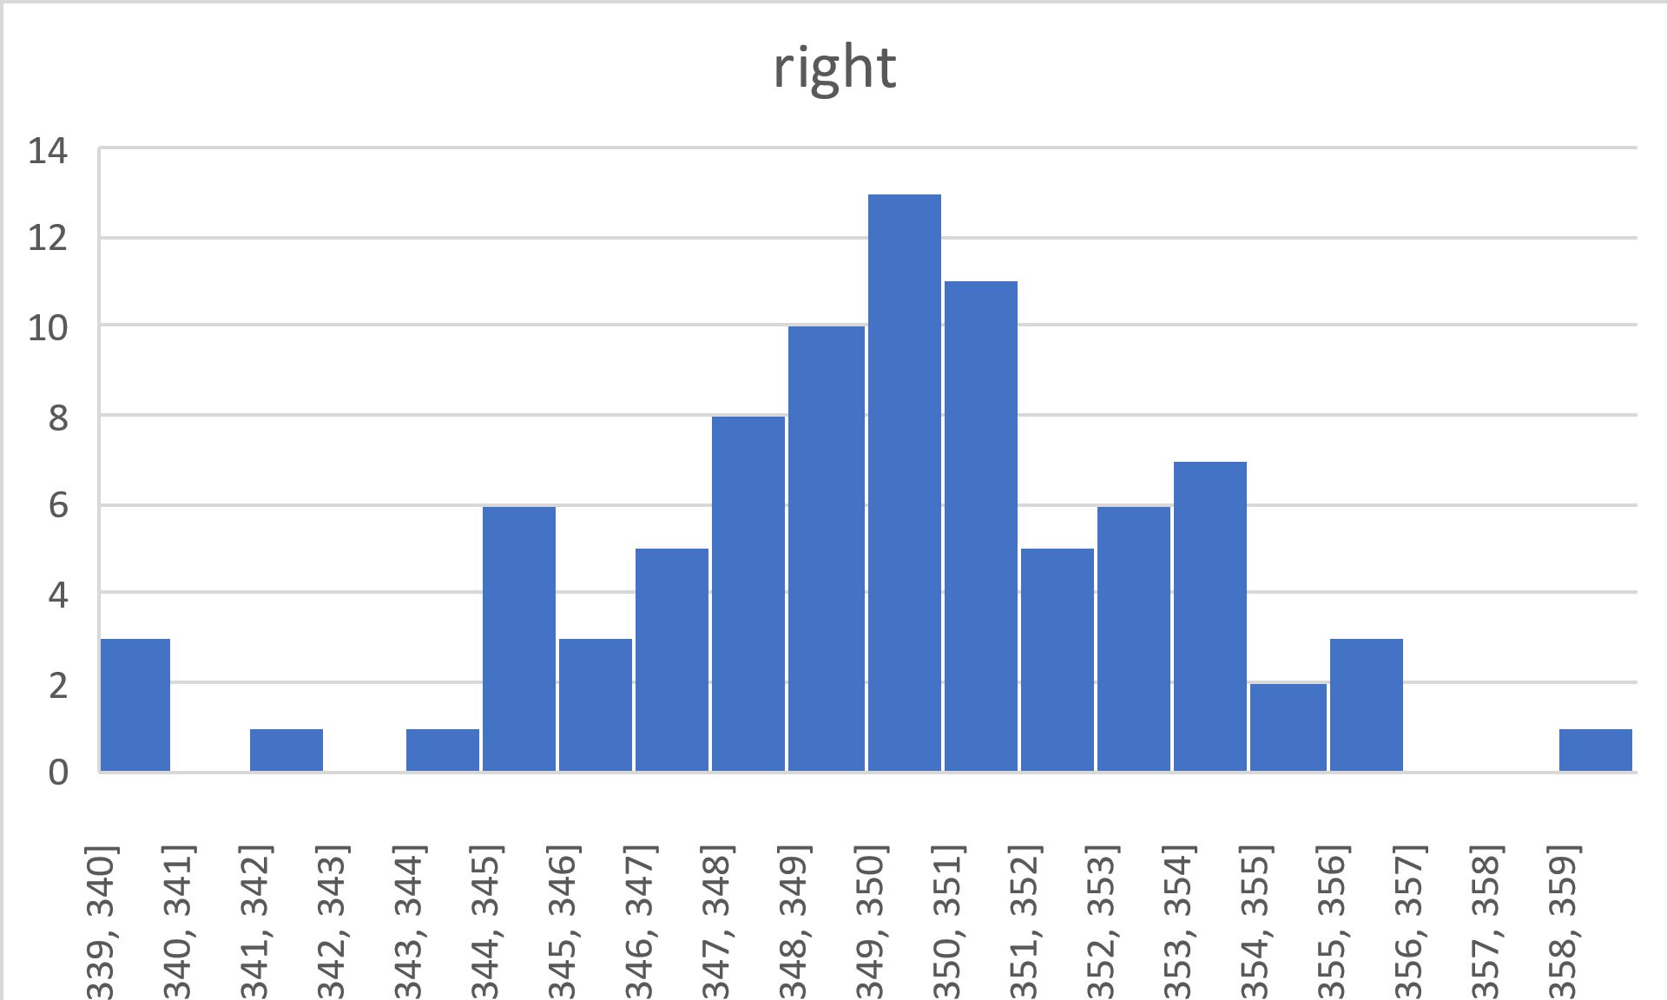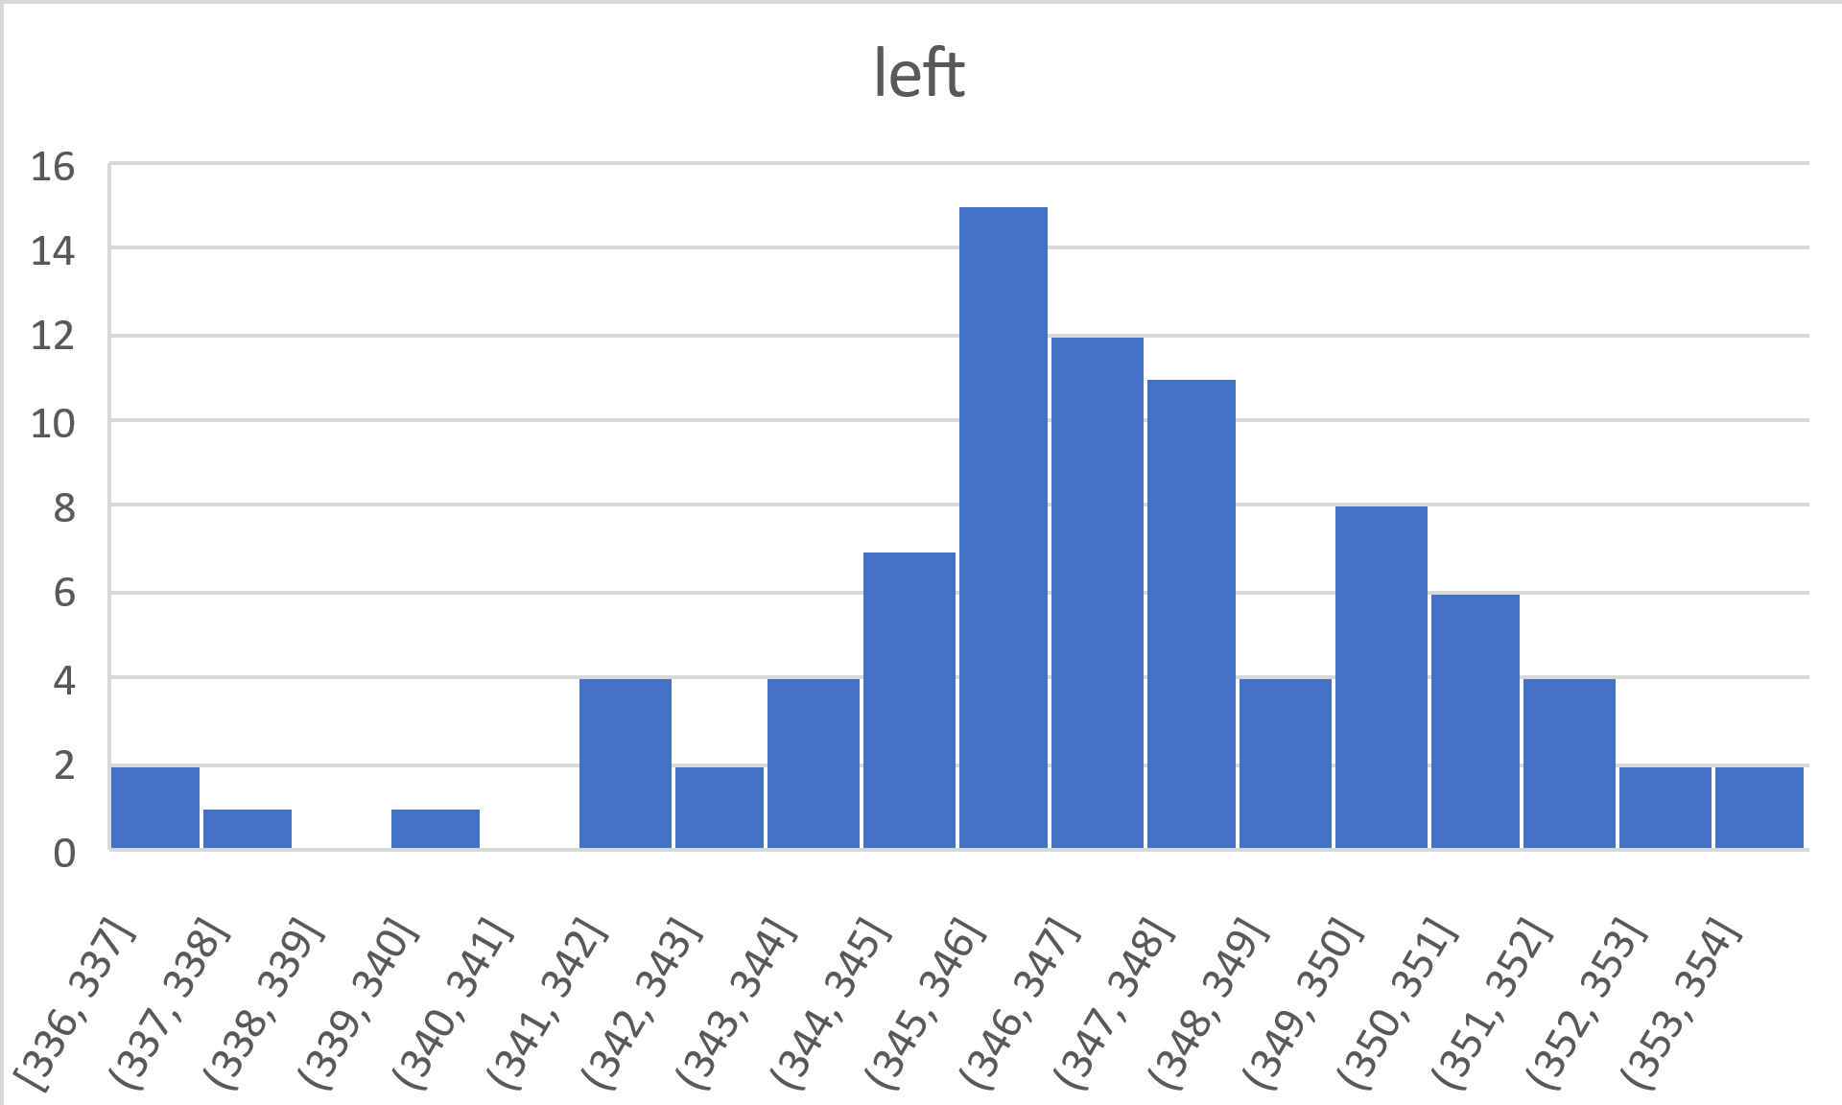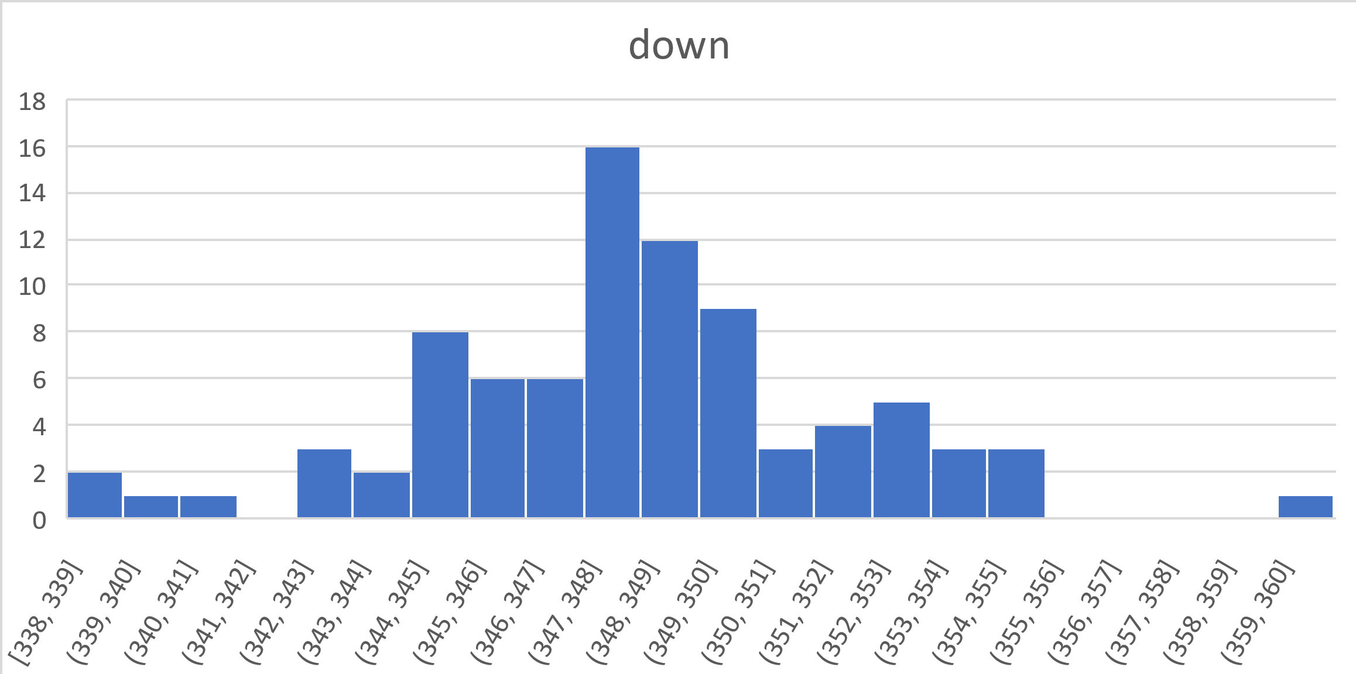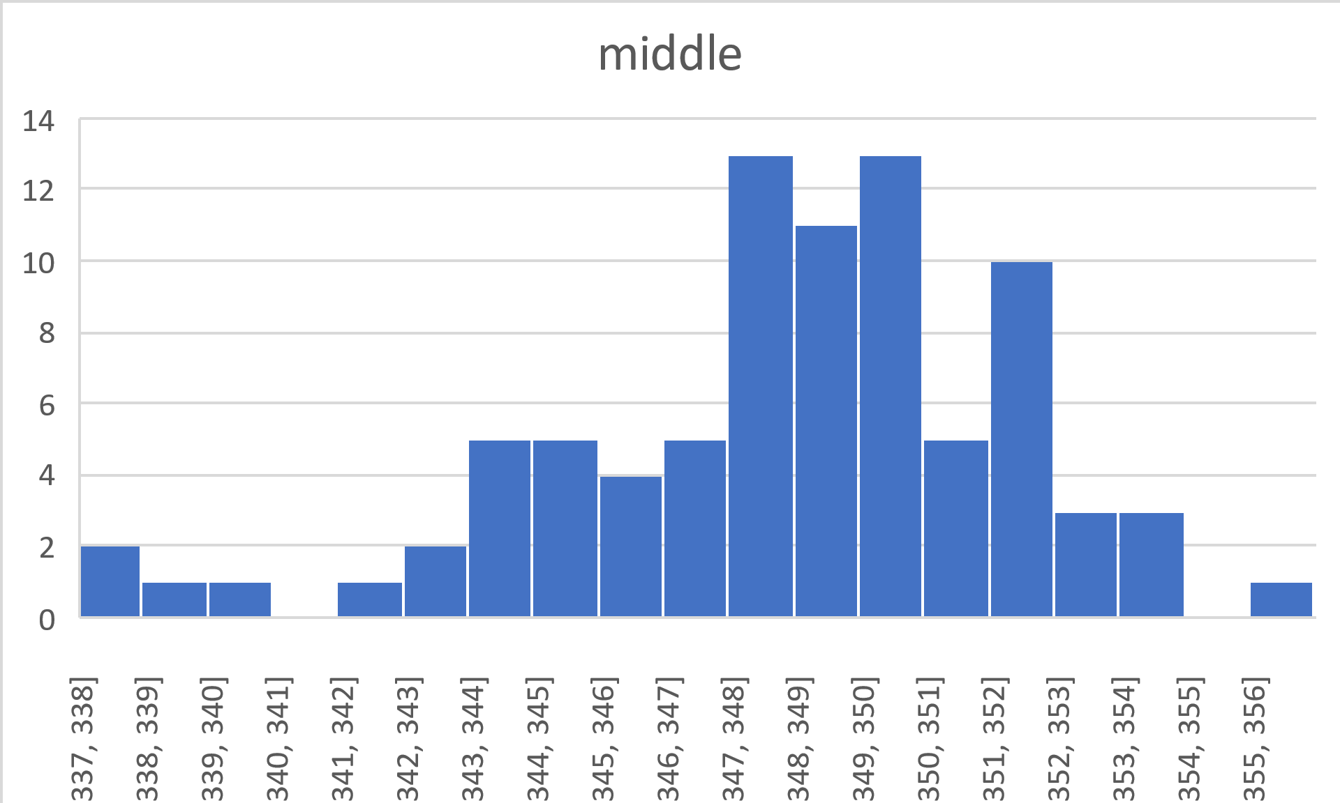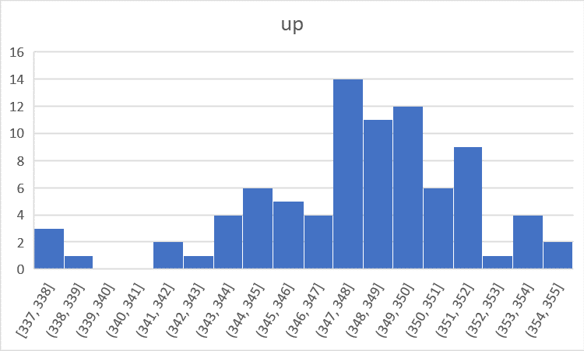We plot the thickness dispersion by histogram of the 5 positions:

We can observe that the thickness values at the bottom exhibit the widest spread. Additionally, both the sample standard deviation and range of the thickness at the bottom are the largest. However, the interquartile range (IQR) remains nearly consistent across all measurements.







