機械所設計組 R12522615 王邑安 HW_ID:2

**Introduction to statistical control and optimization**

Homework 7



$$H_{0}: μ_{right}=μ_{left} , H_{1}: μ_{right}≠μ_{left} , α=0.1$$

$$s_{p}=\sqrt{\frac{1}{2}s_{right}^{2}+\frac{1}{2}s_{left}^{2}}=3.604560603$$

$$t-test=\frac{μ_{right}-μ_{left}}{s_{p}\sqrt{\frac{1}{84}+\frac{1}{84}}}=4.787466254$$

$$t_{0.95,168}=1.653974208 , t_{0.05,168}=-1.653974208⇒t-test>t_{0.95,168}$$

$$reject H_{0} , p-value=3.685e-6$$

$$H_{0}: σ_{left}=12 , H_{1}: σ_{left}≠12 , α=0.1$$

$$\frac{\left(85-1\right)s_{left}^{2}}{{12}^{2}}=90.72556727$$

$$χ_{0.1,84}=100.98⇒90.72556727<100.98$$

$$accept H_{0} , p-value=0.288837966$$

$$H_{0}: σ_{right}=12 , H_{1}: σ_{right}≠12 , α=0.1$$

$$\frac{\left(85-1\right)s_{right}^{2}}{{12}^{2}}=106.5420355$$

$$χ_{0.1,84}=100.98⇒106.5420355>100.98$$

$$reject H_{0} , p-value=0.049007027$$

$$H_{0}: σ_{left}=σ_{right}, H_{1}: σ_{left}<σ_{right}, α=0.1$$

$$\frac{s_{right}^{2}}{s_{left}^{2}}=1.083277398$$

$$F_{0.1,84,84}=1.324386851⇒1.083277398<1.324386851$$

$$accept H_{0} , p-value=0.357396243$$

$$H_{0}:Gamma distribution , H_{1}:not Gamma distribution$$

$$by moment estimator: α=9658.933466 , β=0.0359326$$

$$thickness range:336\sim 354→k=19$$

|  |  |  |  |
| --- | --- | --- | --- |
| thickness | $$x_{i}$$ | Gamma $p_{i}$ | $$np_{i}$$ |
| 336 | 2 | 0.000770131 | 0.065461093 |
| 337 | 0 | 0.001840585 | 0.156449739 |
| 338 | 1 | 0.004040311 | 0.343426474 |
| 339 | 0 | 0.008150032 | 0.692752737 |
| 340 | 1 | 0.015114913 | 1.28476757 |
| 341 | 0 | 0.025785062 | 2.19173023 |
| 342 | 4 | 0.040481763 | 3.440949854 |
| 343 | 2 | 0.058518073 | 4.974036167 |
| 344 | 4 | 0.077923554 | 6.623502115 |
| 345 | 7 | 0.095631863 | 8.128708377 |
| 346 | 15 | 0.108217323 | 9.198472429 |
| 347 | 12 | 0.112967797 | 9.602262776 |
| 348 | 11 | 0.108837333 | 9.251173345 |
| 349 | 4 | 0.096820293 | 8.22972492 |
| 350 | 8 | 0.079564321 | 6.762967249 |
| 351 | 6 | 0.060426896 | 5.136286187 |
| 352 | 4 | 0.042432342 | 3.606749093 |
| 353 | 2 | 0.02756206 | 2.342775106 |
| 354 | 2 | 0.016567837 | 1.408266173 |



|  |  |  |  |
| --- | --- | --- | --- |
| thickness | $$x_{i}$$ | exponential $p_{i}$ | $$np_{i}$$ |
| 336 | 2 | 0.00109431 | 0.093016377 |
| 337 | 0 | 0.001091162 | 0.092748759 |
| 338 | 1 | 0.001088022 | 0.09248191 |
| 339 | 0 | 0.001084892 | 0.092215829 |
| 340 | 1 | 0.001081771 | 0.091950514 |
| 341 | 0 | 0.001078658 | 0.091685962 |
| 342 | 4 | 0.001075555 | 0.091422172 |
| 343 | 2 | 0.00107246 | 0.09115914 |
| 344 | 4 | 0.001069375 | 0.090896865 |
| 345 | 7 | 0.001066298 | 0.090635344 |
| 346 | 15 | 0.00106323 | 0.090374576 |
| 347 | 12 | 0.001060171 | 0.090114559 |
| 348 | 11 | 0.001057121 | 0.089855289 |
| 349 | 4 | 0.00105408 | 0.089596765 |
| 350 | 8 | 0.001051047 | 0.089338985 |
| 351 | 6 | 0.001048023 | 0.089081947 |
| 352 | 4 | 0.001045008 | 0.088825649 |
| 353 | 2 | 0.001042001 | 0.088570087 |
| 354 | 2 | 0.001039003 | 0.088315261 |



|  |  |
| --- | --- |
| first 45 data | |
| $$\overline{\overline{X}}$$ | 348.5067 |
| sample variance | 17.49382 |
| $$σ$$ | 4.182561 |
| CL | 350 |
| UCL | 362.5477 |
| LCL | 337.4523 |

1. 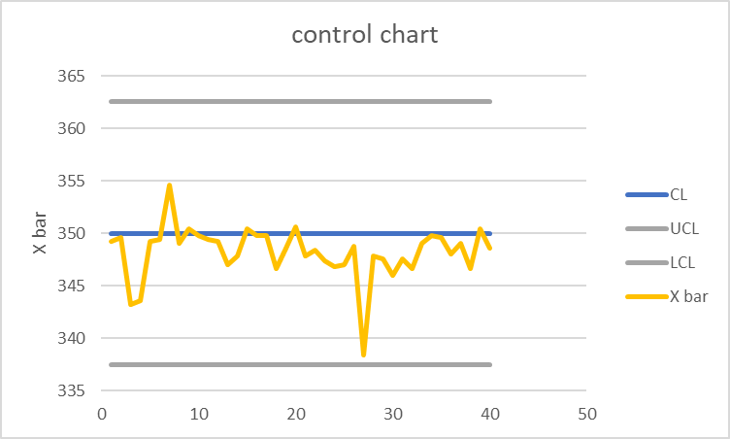

$$H_{0}:equal appearance chance\left(=\frac{6}{38}\right), H_{1}:unequal appearace chance\left(≠\frac{6}{38}\right)$$

$$x_{i}:appearance times of ith number , i=1,2,⋯,38$$

$$p_{i}:\frac{6}{38} , i=1,2,⋯,38$$

n=50:

$$c^{2}=\sum_{i=1}^{38}{\frac{{\left(x_{i}-np_{i}\right)}^{2}}{np_{i}}}=32.12 , χ_{0.1,37}^{2}=48.36340835$$

$$c^{2}<χ_{0.1,37}^{2}⇒accept H_{0} , p-value=0.697025088$$

n=100:

$$c^{2}=\sum_{i=1}^{38}{\frac{{\left(x_{i}-np_{i}\right)}^{2}}{np_{i}}}=32.32 , χ_{0.1,37}^{2}=48.36340835$$

$$c^{2}<χ_{0.1,37}^{2}⇒accept H_{0} , p-value=0.688071693$$

n=500:

$$c^{2}=\sum_{i=1}^{38}{\frac{{\left(x_{i}-np_{i}\right)}^{2}}{np_{i}}}=26.19333333 , χ_{0.1,37}^{2}=48.36340835$$

$$c^{2}<χ_{0.1,37}^{2}⇒accept H_{0} , p-value=0.907445501$$