1. The following table provides the design matrix for a certain tow-level fractional

factorial experimental design.

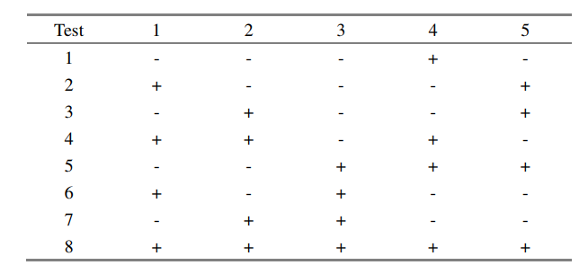

1. Write down the generators and the defining relation for this design.

Generators: $$4=12, 5=123, so I=124=1235$$

Relations:

$$I=124=1235=345$$

1. What is the resolution of this design?

The shortest term of the relations is 3, so it is a Resolution III design.

1. Write down all of the linear combinations of confounded effects that can be estimated from the result of this experiment. Assume that all interaction effects may be important.

The combination effect is listed in the chart:

|  |  |  |  |  |
| --- | --- | --- | --- | --- |
|  | **I** | **\*124** | **\*1235** | **\*345** |
| $$l_{0}$$ | mean |  |  |  |
| $$l_{1}$$ | 1 | 24 | 235 | 1345 |
| $$l_{2}$$ | 2 | 14 | 135 | 345 |
| $$l_{3}$$ | 3 | 1234 | 125 | 45 |
| $$l_{12}$$ |  | 4 | 35 | 12345 |
| $$l_{13}$$ |  | 234 | 25 | 145 |
| $$l_{23}$$ |  | 134 | 15 | 245 |
| $$l_{123}$$ |  | 34 | 5 | 1245 |

1. Suppose that it was decided to run only a four-variable experiment using eight tests. What generator would you propose for this design? How would the design resolution differ as compared with the original design?

For we know that the higher order interaction is often insignificant for systems, and resolution should be as larger as possible, we chose to put variable 4 to replace interaction 123. In this case, we will have:

$$4=123, so generator I=1234=relation$$

So we can see that the resolution is IV.

1. An import/export company is working with a construction engineering firm to study the tensile strength of various concrete formulations. Five variables of interest have been identified, and are given in the first table: 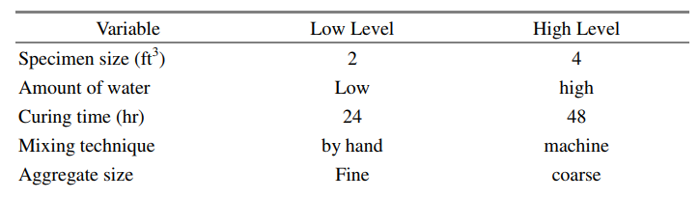

A replicated L8 (27) orthogonal array was performed to study the effects of these factors, and the results of this experiment are summarized in the second table:

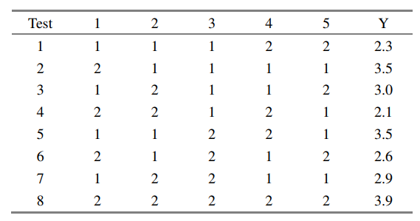

1. Assuming all interaction effects are insignificant, estimate all the main effects.

假設所有的interaction effect都是非顯著的，透過分析其interaction可得到：





透過回歸驗證，將interaction effect作為error可得到：



從圖表中可發現，除了截距項之外，每一個main factor都被檢定為insignificant，因此，若真的要建一個好的model，則需要調整原本的假設。  
將所有的effect視為significant，可得到回歸：



從表中可發現main effect其實才是相對很小的，因此，如果將main effect視為非顯著作為雜訊，將interaction effect視為顯著，可以得到regression model為：



可見在這個系統當中，123的interaction才是顯著影響的項。

1. Assuming all interaction effects are insignificant, construct an ANOVA table to identify which of the main effects determined in part (a) are significant and build a regression model.

假設只有主因素才是顯著項目，可得到ANOVA為：



有鑑於所有的effect都不顯著，這個model建出來會長這樣：

$$y=2.975$$

如果將interaction of 23及123作為顯著項，可得到：



根據ANOVA的結果，發現effect是顯著的，因此可建立model如下：

$$y=2.975+0.175x_{23}+0.5x_123$$

3.

1. Why is the statement above true? Carefully explain.

因為使用OA table時，在部點時就會討論到每個不同的變數之間高低水準對於影響的interaction，因此無論是generator family的哪一種都沒有辦法避開任兩個參數決不會同時出現高水準表現。



1. What members of the given family of generators does the specified estriction above allow?

所使用的是I = -135的generator，由於variable5所對應到的是13的interaction，因此將variable 5的這一項乘以-1，就不會同時讓Variable 1, 3, 5都出現high level.



1. What are the generators and defining relation for this design?

從表中我們可以發現，4=12，5=-13，6=23，因此可得到generator為：

$$I=124=-135=236$$

Relation為：

$$I=124=-135=236=-2346=1346=-1256=-456$$

1. Assuming that third- and higher-order interactions are negligible, write down the estimates obtained from this experiment and tell what they estimate (e.g.,“1+24-35 estimated to be 400”)

計算每個參數的effect，可以得到：



而每個EFFECT對應到的interaction effect組合為：



整理結果可得到：

$$l_{0}=mean \\ l_{1}=1+24-35=400 \\ l_{2}=2+14+36=-100 \\ l_{3}=3-15+26=200 \\ l_{4}=4+12-56=900 \\ l_{5}=5-13-46=-600 \\ l_{6}=6+23-45=300$$

1. What are the estimates obtained by combining the results of both fractions? 將第二組實驗的variable 4進行鏡射，所有level顛倒，可得到比較結果：





$$l_{0}=mean \\ l_{1}=1-24-35=-200 \\ l_{2}=2-14+36=-50 \\ l_{3}=3-15+26=-200 \\ l_{4}=-4+12+56=750 \\ l_{5}=5-13+46=-600 \\ l_{6}=6+23+45=-450$$

將兩次實驗結果合併，可得到：



1. Offer a brief conjecture that might explain the presence and direction of the

interactions involving Miss Freeny.   
46:

Dick和Miss Freeny雖然同時出現，但由於Dick始終專注於工作，比較少會與Miss Freeny有互動，也因此他們的出現與否並不會影響到當天的收入

45:

由於Miss Freeny喜好與客人互動，因此當Gypsy Band在表演時，Miss Freeny的出現反而會對想要享受音樂的客人感到不舒服，也間接影響到客人留在店裡消費的意願，進而影響了店內的收入

14:

interaction effect並不顯著

24:

當店內有免費的potato chips時，Miss Freeny可以很盡興的帶著potato chips與店內的客人互動，將有提供免費potato chips的服務品質提升更多，客人更喜歡留在店裡，也因此收入會比較高

4:

Miss Freeny喜歡與店內的客人互動，普遍可以增加客人光顧的印象，因此客人也喜歡在有Miss Freeny在店裡時一起來找他聊天互動，因此對於收入而言，是非常大的加分

1. Use a 26-p fractional factorial design with Resolution V to design a 6-factor CCD experiment. To minimize the number of the experimental tests, what would be p? How many experimental tests are required for this CCD design? Design a 6-factor BBD experiment and compare it with the CCD.

因為需要resolution V，因此需要有 $2^{5}$ 個組合，才能達成resolution=5。

因此，p只能=1。

考慮k=5，p = 1，

CCD需要的數量為

$$2^{5}+2×5+1=43$$

BBD需要的實驗數量為:

$$2^{2}×C_{2}^{5}+1=41$$