1. (1)  
   (a) the plot of gamma distribution

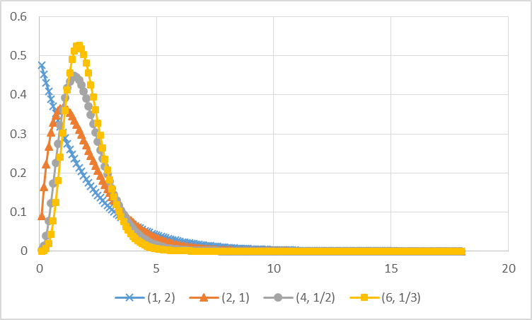

(b) cumulated distribution of gamma function.

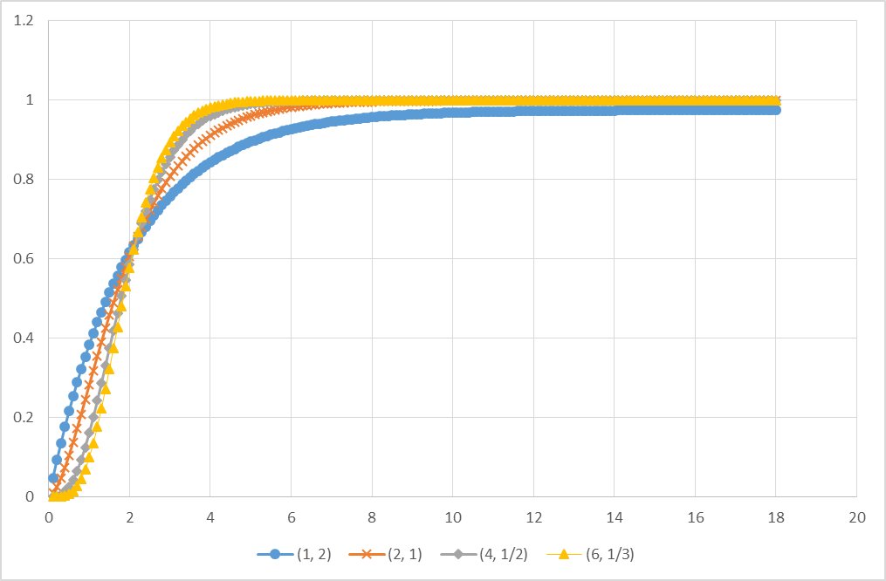

(c) the plot of normal distribution

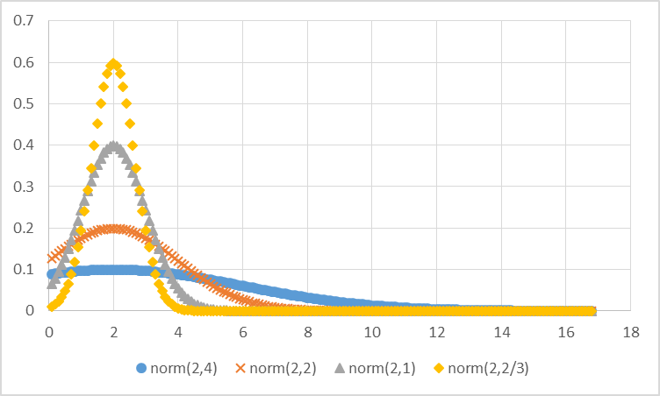

(d) Cumulated distribution of normal distribution

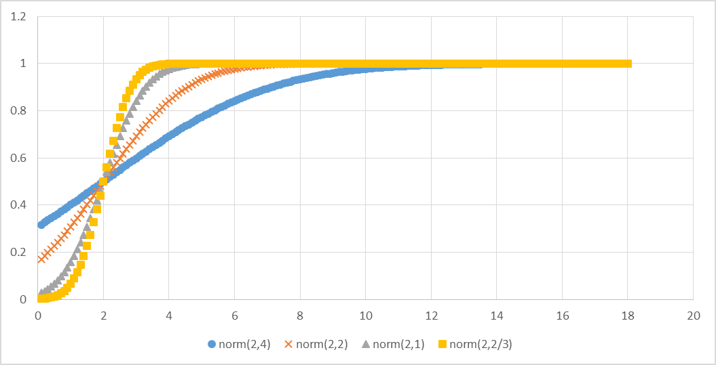

(2) compare the probability between norm(2,4) and norm(2,2), the result is shown in below:

|  |  |  |
| --- | --- | --- |
|  | norm(2,4) | norm(2,2) |
| $$P(X<μ-0.5σ)$$ | 0.308538 | 0.308538 |
| $$P(X<μ-1.5σ)$$ | 0.066807 | 0.066807 |
| $$P(X<μ-2.0σ)$$ | 0.02275 | 0.02275 |
| $$P(X<μ-2.5σ)$$ | 0.00621 | 0.00621 |
| $$P(X<μ-3.0σ)$$ | 0.00135 | 0.00135 |
| $$P(μ-3σ<X<μ+3σ)$$ | 0.9973 | 0.9973 |



$$f_{X_{1}}\left(x_{1}\right)=f_{X_{2}}\left(x_{2}\right)=\left\{\begin{aligned}\frac{1}{b-a}, if a<x<b \\ 0, otherwise\end{aligned}\right.$$

and the density function for the sum is given by

$$f_{y}\left(y\right)=\int_{-∞}^{∞}{f_{X_{1}}\left(y-x_{2}\right){f_{X}}_{2}\left(x_{2}\right)dx_{2}}$$

Since $f_{X_{2}}\left(x_{2}\right)=\frac{1}{b-a}$ if $a≤x_{2}≤b$ and 0 otherwise, this becomes

$$f_{y}\left(y\right)=\int_{-∞}^{∞}{f_{X_{1}}\left(y-x_{2}\right)\frac{1}{b-a} dx_{2}}$$

Now the integration is 0 unless $a≤y-x_{2}≤b$ and then it is 1. We can further found that $2a≤y≤2b$ because $a≤x_{2}≤b$. So if $a≤y≤b$, we have

$$f_{y}\left(y\right)=\int_{2a}^{y}{{\left(\frac{1}{b-a}\right)}^{2} dx_{2}={\left(\frac{1}{b-a}\right)}^{2}(y-2a)}$$

While if $b<y≤2b$, we have

$$f_{y}\left(y\right)=\int_{y-b}^{b}{{\left(\frac{1}{b-a}\right)}^{2}dx_{2}={\left(\frac{1}{b-a}\right)}^{2}(2b-y)}$$

And if $y<2a$ or 2b < y we have $f_{y}\left(y\right)=0$. Hence,

$$f_{y}=\left\{\begin{aligned}{\left(\frac{1}{b-a}\right)}^{2}\left(y-2a\right), if 2a≤y≤a+b \\ {\left(\frac{1}{b-a}\right)}^{2}\left(2b-y\right), if a+b≤y≤2b \\ 0, otherwise\end{aligned}\right.$$

1. (1) for geometric distribution, we know that $E\left(X\right)=\frac{1}{p}$ and $V\left(X\right)=\frac{1-p}{p^{2}}$. Based on the rule for the sum of R.V, we can see that for Negative Binomial distribution,

$$E\left(Y=y\right)=E\left(\sum_{1}^{n}{V\left(X_{i}\right)}\right)=\sum_{1}^{n}{E(X_{i})}=n×\frac{1}{p}=\frac{n}{p}$$

$$V\left(Y=y\right)=V(\sum_{1}^{n}{X_{i})=\sum_{1}^{n}{V\left(X_{i}\right)}}=n×\frac{1-p}{p^{2}}=\frac{n\left(1-p\right)}{p^{2}}$$

(2)

For p = 0.1, n = 1, $E\left(Y_{1}\right)=10, V\left(Y_{1}\right)=90$

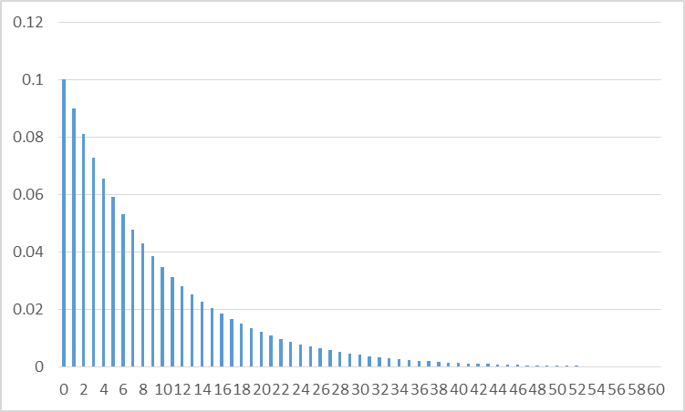

For p = 0.1, n=5, $E\left(Y_{5}\right)=50, V\left(Y_{1}\right)=450$

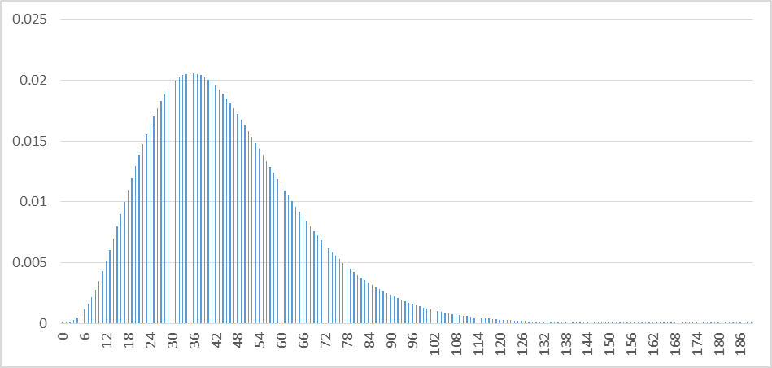

For p = 0.1, n=10, $E\left(Y_{5}\right)=100, V\left(Y_{1}\right)=900$

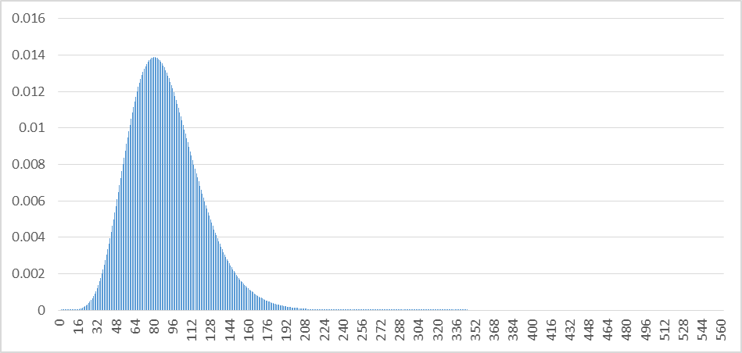

For p = 0.1, n=20, $E\left(Y_{5}\right)=200, V\left(Y_{1}\right)=1800$

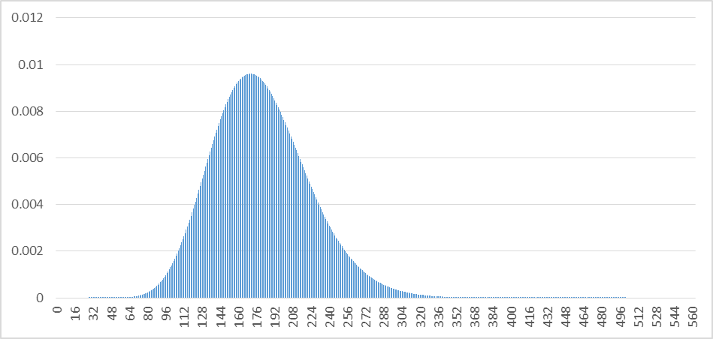

For p = 0.1, n=50, $E\left(Y_{5}\right)=500, V\left(Y_{1}\right)=4500$

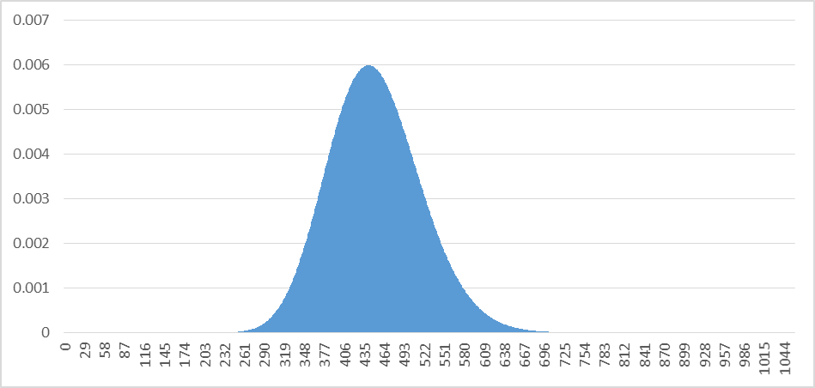

Plot all in the same figure we will get:

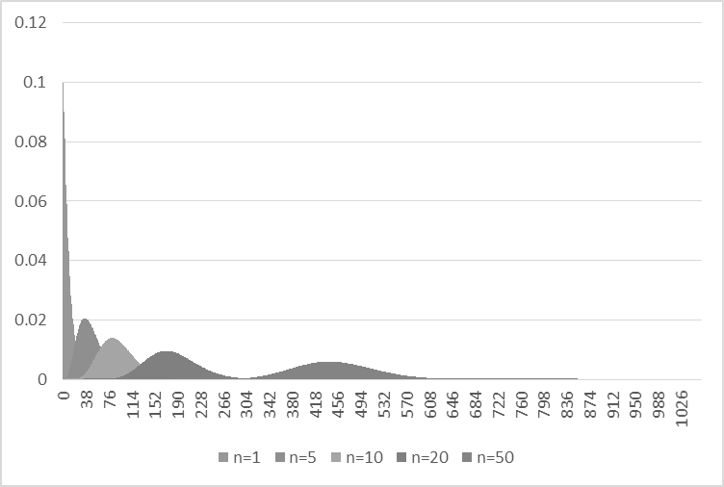

(3) From the plot as we can see, the corresponding sum of geometric distribution and normal distribution based on the calculated mean and variance are mostly the same, only that the mean of the negative binomial distributions as a little lack compare to normal distribution. From this plot, we can observe that the sum of geometric distribution would become close to normal distribution. When n is larger, the fitness of the two corresponding distribution are more alike.

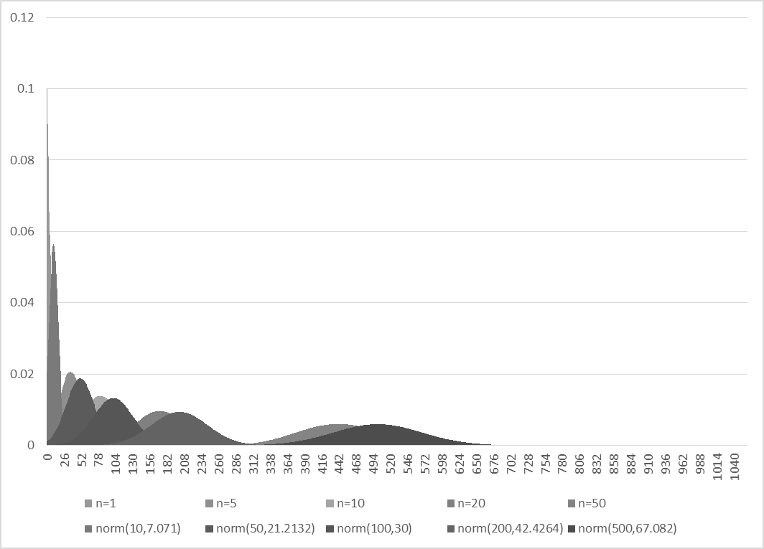

1. (1)

For we know exponential distribution = $f\left(X\right)= \left\{\begin{aligned}λe^{-λx}, x≥0 \\ 0, x<0\end{aligned}\right.$

For mean of exponential distribution, we have

$$\int_{0}^{∞}{xλe^{-λx}dx}=-xe^{-λx}|\begin{matrix}∞ \\ 0\end{matrix} -\int_{0}^{∞}{-e^{-λx}dx=0-\left(-\frac{1}{λ}\right)=\frac{1}{λ} }$$

For variance of exponential distribution, we have will use $Var\left(X\right)=E\left(x^{2}\right)-{\left(E\left(x\right)\right)}^{2}$

For $E(x^{2})$, we have

$$E\left(x^{2}\right)= \int_{0}^{∞}{x^{2}λe^{-λx}dx}=-x^{2}e^{-λx}|{∞ \atop 0}-\int_{0}^{∞}{-e^{-λx}2xdx}=0+\frac{2}{λ}\int_{0}^{∞}{-xe^{-λx}dx}=\frac{2}{λ^{2}}$$

For $E{\left(x\right)}^{2}$, we have

$$E{\left(x\right)}^{2}={\left(\frac{1}{λ}\right)}^{2}=\frac{1}{λ^{2}}$$

So, variant $Var\left(x\right)=E\left(x^{2}\right)-E{\left(x\right)}^{2}=\frac{2}{λ^{2}}-\frac{1}{λ^{2}}=\frac{1}{λ^{2}}$

1. (1)

For exponential distribution, we know that $E\left(X\right)=1/λ$ and $V\left(X\right)=\frac{1}{λ^{2}}$. Based on the rule for the sum of R.V, we can see that for Gamma distribution,

$$E\left(Y=y\right)=E\left(\sum_{1}^{n}{V\left(X_{i}\right)}\right)=\sum_{1}^{n}{E(X_{i})}=n×\frac{1}{λ}=\frac{n}{λ}=αβ$$

$$V\left(Y=y\right)=V(\sum_{1}^{n}{X_{i})=\sum_{1}^{n}{V\left(X_{i}\right)}}=n×\frac{1}{λ^{2}}=\frac{n}{λ^{2}}=αβ^{2}$$

(2)

For n = 1, the distribution would be as show:

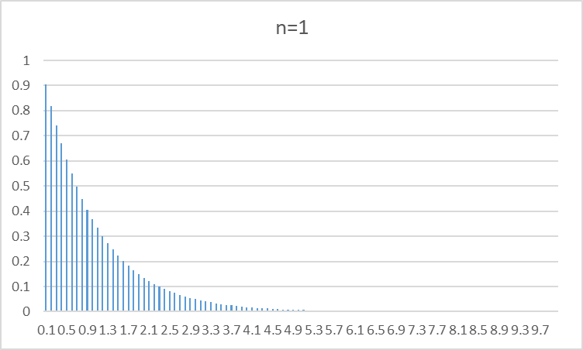

For n = 5, the distribution would be as show:

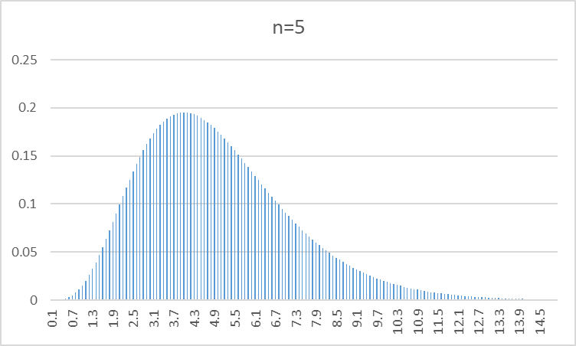

For n = 10, the distribution would be as show:

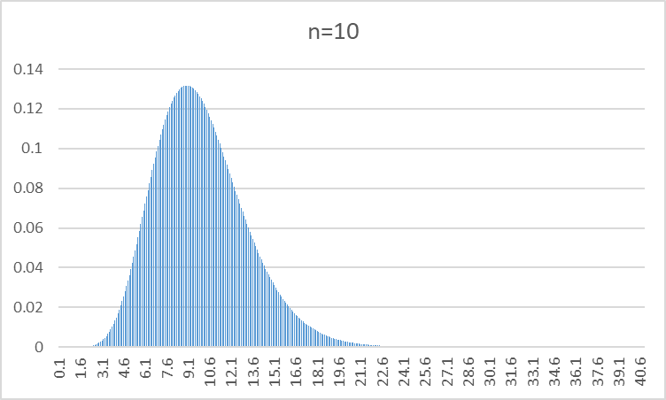

For n = 20, the distribution would be as show:

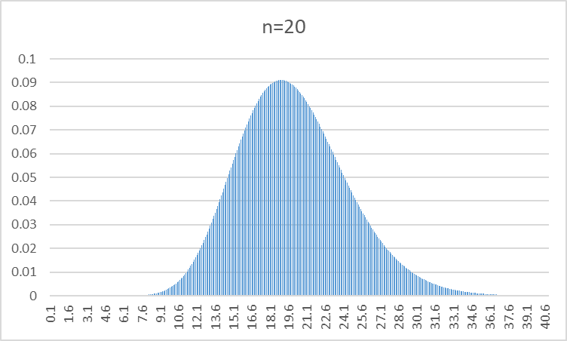

For n = 50, the distribution would be as show:

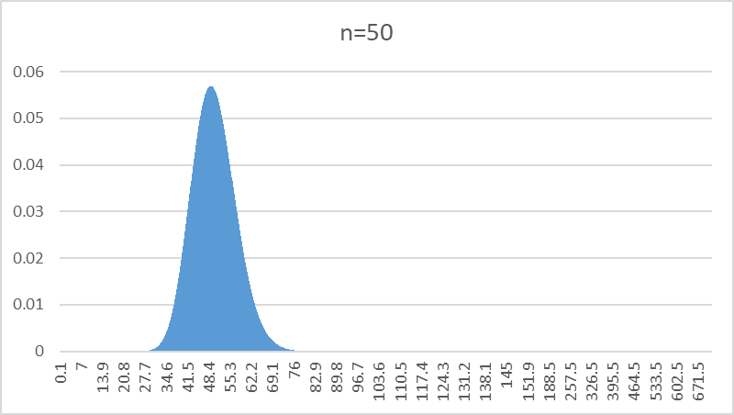

Plot all the distribution together, we will have

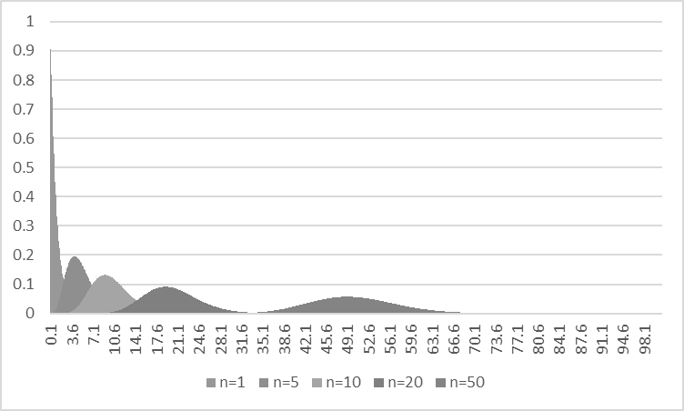

(3) the plot of the two distribution is shown as below. The corresponding sum of exponential distribution and normal distribution based on the calculated mean and variance are mostly the same. From this plot, we can observe that the sum of exponential distribution would become close to normal distribution. When n is larger, the fitness of the two corresponding distribution are more alike.

