1. Q-Q plots by using normal distribution for CD_1 ~ CD_5 is shown as below:

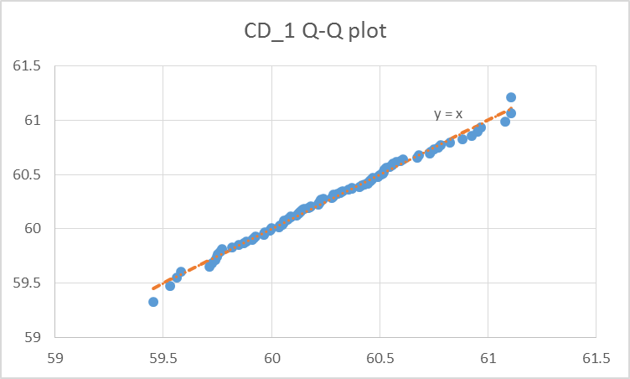

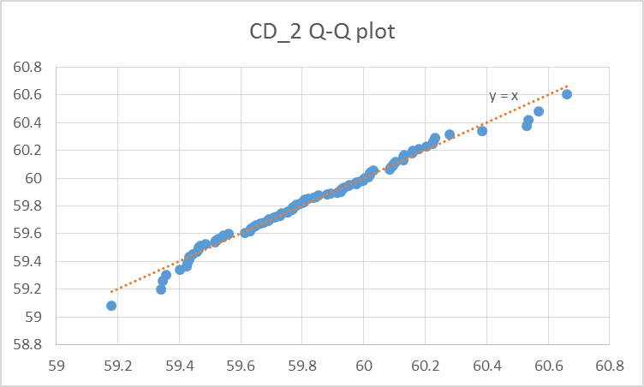

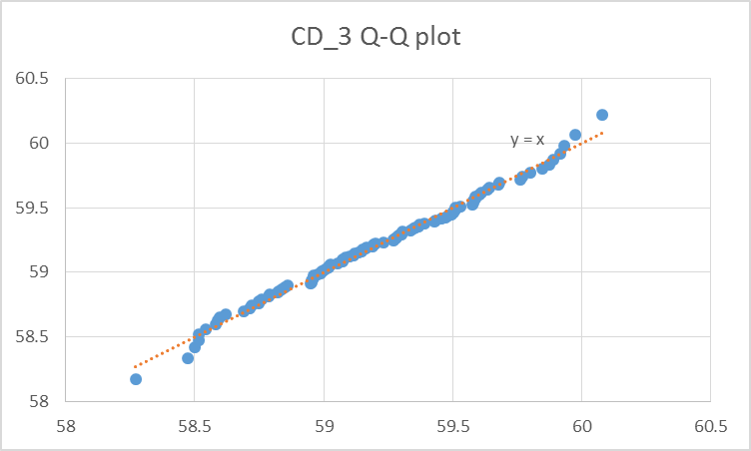

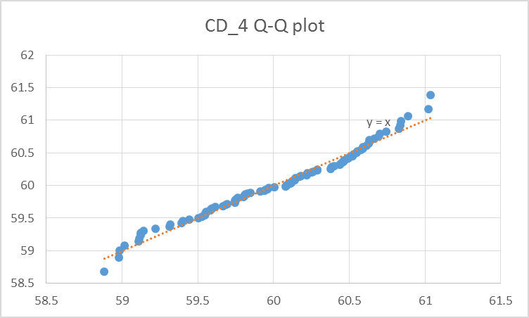

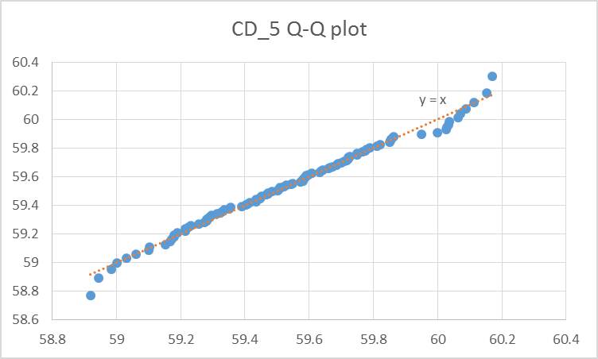

Q-Q plot by using gamma distribution, first is to find $α$ and $β$ by moment of estimates. The parameters for each sample are shown as below:

|  |  |  |  |  |  |
| --- | --- | --- | --- | --- | --- |
| alpha | 9930.627 | 12105.1 | 8829.739 | 6846.763 | 11894.88 |
| beta | 0.006069 | 0.004943 | 0.006704 | 0.008768 | 0.005005 |

The Q-Q plot accordingly are displayed:

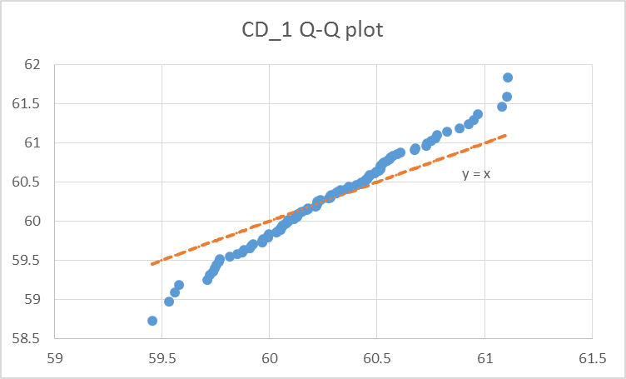

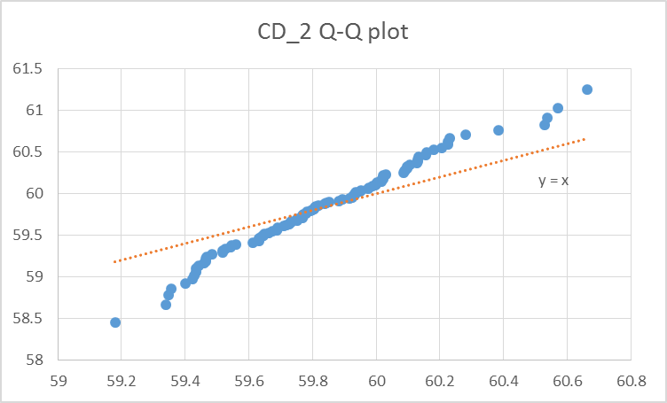

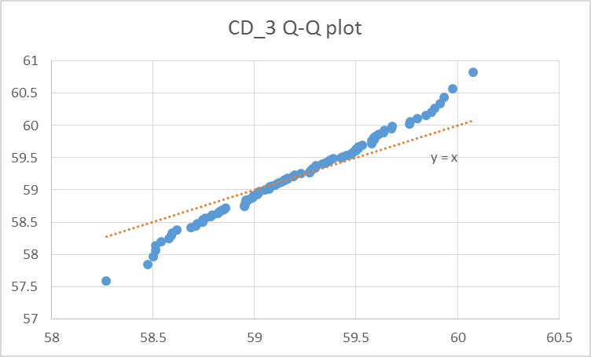

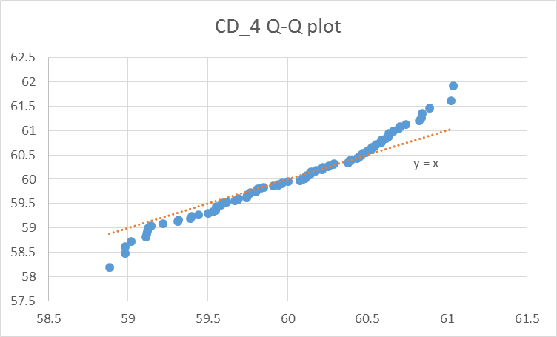

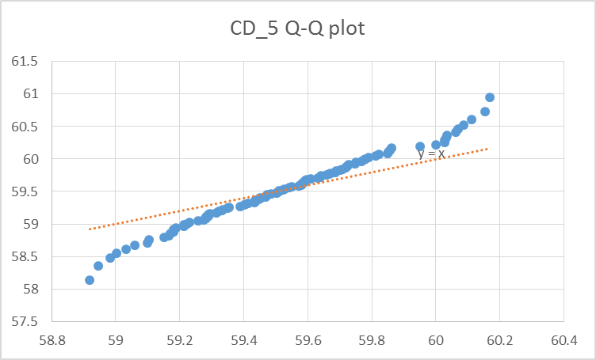

Compare the above, we can see that estimation under normal distribution, the errors to the ${45}^{0}$ line are smaller. By this observation, we can say that the sample is more fit by using normal distribution.

2. To do P-P plot under Geometric distribution, we first need to decide the parameter p in this distribution. By using MLE, we can see that Geometric distribution, $f\left(x;p\right)={\left(1-p\right)}^{x-1}p$, the likelihood function is:

$$L\left(p\right)={\left(1-p\right)}^{x_{1}-1}p×{\left(1-p\right)}^{x_{n}-1}p=p^{n}{\left(1-n\right)}^{\sum_{1}^{n}{x_{i}-n}}$$

$$lnL\left(p\right)=nln\left(p\right)+\left(\sum_{1}^{n}{x_{i}-n}\right)\ln\left(1-p\right)$$

$$\frac{d\left(lnL\left(p\right)\right)}{dp}=\frac{n}{p}-\frac{\sum_{1}^{n}{x_{i}-n}}{\left(1-p\right)}=0→p=\frac{n}{\sum_{1}^{n}{x_{i}}}$$

For this, we can have $p=\frac{227}{1827}=0.1242474$.

So, $P\left(X=x\right)=p{\left(1-p\right)}^{x-1} where p=0.1242474$, the cumulative distribution function for geometric distribution are $1-{\left(1-p\right)}^{k}=1-{0.8757526}^{k}$, where k = 1, 2, 3, ….. ,n.

The P-P plot under geometric distribution is shown in below:

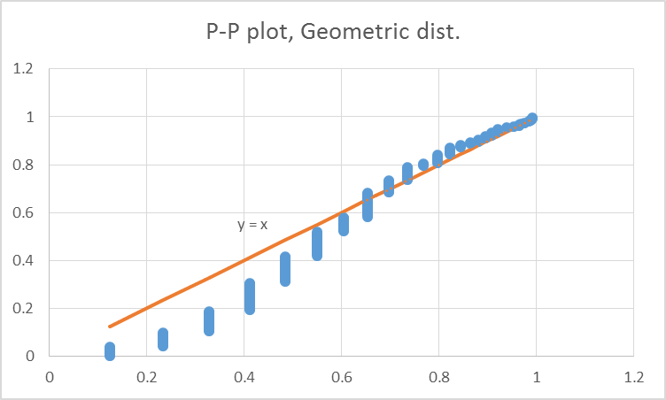

For negative binomial distribution,

$$P\left(X=x\right)=\left(\begin{matrix}x-1 \\ n-1\end{matrix}\right){\left(1-p\right)}^{x-n}p^{n}$$

so we have likelihood function

$$L\left(p,x\right)=\prod_{i=1}^{n}{\left(\begin{matrix}x_{i}-1 \\ k-1\end{matrix}\right)p^{k}{\left(1-p\right)}^{x_{i}-k}}$$

$$lnL\left(x,p\right)=l\left(p,x\right)=\sum_{i=1}^{n}{[\ln\left(\begin{matrix}x_{i}-1 \\ k-1\end{matrix}\right)+kln\left(p\right)+\left(x_{i}-k\right)log⁡(1-π)]}$$

to satisfy

$$\frac{dl\left(p,x\right)}{dp}=\sum_{i=1}^{n}{\left[\frac{k}{p}-\frac{x_{i}-k}{1-p}\right]}=0$$

We have

$$\hat{p}=\frac{\sum_{i=1}^{n}{x_{i}-nk}}{1-p}$$

For this, we have $E\left(x\right)=\frac{r\left(1-p\right)}{p}$ and $Var\left(x\right)=\frac{r\left(1-p\right)}{p^{2}}$. From moment of estimate, we have $p=0.199436$, and $r=2$. With these parameters, we can have P-P plot as shown in below. Note that p=0 when k<r.

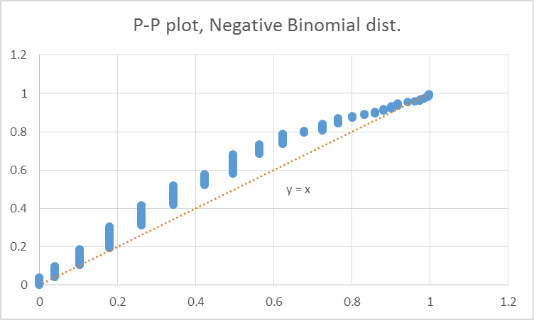

For Poisson distribution, taking MLE for Poisson distribution and we have

$$P_{x}\left(x_{i}\right)=\frac{e^{-λ}λ^{x}}{x!}$$

$$L\left(λ, x_{1}, x_{2},…\right)=\prod_{j=1}^{n}{e^{-λ}×\frac{1}{x_{j}!}λ^{x_{j}}}$$

$$\log\left(L\right)=-nλ-\sum_{=1}^{n}{\ln\left(x_{j}!\right)+\ln\left(λ\right)}\sum_{=1}^{n}{x_{j}}$$

$$\hat{λ}=argmax_{λ} l(λ,x_{1},x_{2},….x_{n})$$

$$\frac{dl(λ,x)}{dλ}=0=-n+\frac{1}{λ}\sum_{=1}^{n}{x_{j}}=0$$

$$λ=\frac{1}{n}\sum_{=1}^{n}{x_{j}}$$

in this problem, we have $λ=\frac{1827}{227}=8.048458$, and CDF = $e^{-λ}\sum_{=1}^{k}{\frac{λ^{i}}{i!}}$

According to the CDF, we can have the P-P plot in below:

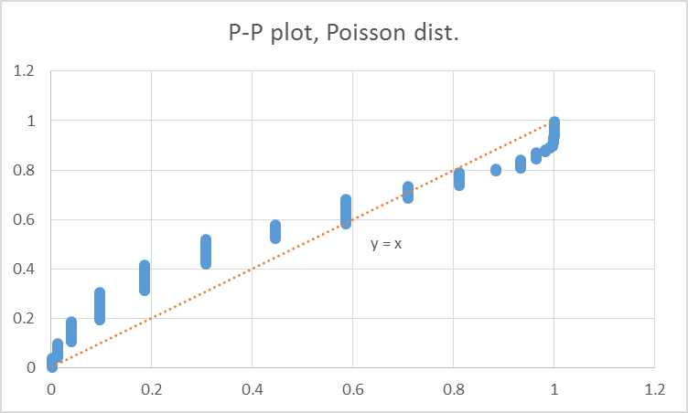

1. From the comparison between three chart, we can say that Geometric distribution fits best because the error between sample and the 45 degree line are the smallest.
2. Z value of 75% CI = P(-1.15035<Z<1.150349). For CD_1, the CI = $\left(\overline{x}-1.15035\frac{σ}{\sqrt{n}}, \overline{x}+1.150349\frac{σ}{\sqrt{n}} \right)=\left(60.27011-1.15035×\frac{0.36576}{10},60.27011+1.15035×\frac{0.36576}{10}\right)=(60.22804, 60.31219)$;  
   For CD_3, the CI = $\left(\overline{x}-1.15035\frac{σ}{\sqrt{n}}, \overline{x}+1.150349\frac{σ}{\sqrt{n}} \right)=\left(59.84056-1.15035×\frac{0.295817}{10},59.84056+1.15035×\frac{0.295817}{10}\right)=(59.80653, 59.87459)$
3. For t-statistic, internal for 75% CI = $\left(\overline{x}{-t}_{\frac{α}{2},ν}\frac{s}{\sqrt{n}} , \overline{x}+t_{\frac{1-α}{2},ν }\frac{s}{\sqrt{n}}\right)= \left(\overline{x}-1.157139\frac{σ}{\sqrt{n}}, \overline{x}+1.157139\frac{σ}{\sqrt{n}} \right)=\left(60.27011-1.15739×\frac{0.36576}{10},60.27011+1.15739×\frac{0.36576}{10}\right)=(60.22142, 60.60.3188)$;  
   For CD_3, the CI = $\left(\overline{x}-1.15739\frac{σ}{\sqrt{n}}, \overline{x}+1.15739\frac{σ}{\sqrt{n}} \right)=\left(59.84056-1.15739×\frac{0.295817}{10},59.84056+1.15739×\frac{0.295817}{10}\right)=\left(59.80118, 59.87994\right)$
4. The two means are not equal, because the CI will not overlap at all even when both the CI of mean have 99% confidence.
5. For CD_5, with $μ_{CD_5}=60$ and $H_{1}:μ_{CD_5}<60$ with $α=0.25,$ from t-distribution we can have critical value $t_{1-α, n-1}=-0.67698$, in other word, the tolerance for to pass $H_{0}$ is when the observed estimate $μ>60-0.67698=59.32302$. from this data, the sample mean = 59.5364, which is larger than the critical value. So we can say that CD_5 passed the hypothesis testing, and can say that $μ_{CD_5}=60$ is true with 75% confidence under single tail test.
6. For CD_1, with $μ_{CD_1}=60$ and $H_{1}:μ_{CD_1}>60$ with $α=0.25,$ from t-distribution we can have critical value $t_{1-α, n-1}=0.67698$, in other word, the tolerance for to pass $H_{0}$ is when the observed estimate $μ<60+0.67698=60.67698$. from this data, the sample mean = 60.27011, which is larger than the critical value. So we can say that CD_1 passed the hypothesis testing, and can say that $μ_{CD_7}=60$ is true with 75% confidence under single tail test.
7. Yes, we can say that under the estimate that $μ=60$, both CD_1 and CD_5 passed the hypothesis test, so the hypothesis is true with a CI of 75%.