1. 體溫資料如下表整理。Sample分組方式為：3/25第一時段為sample 1、第二時段為sample 2、第三時段為sample 3、3/26第一時段為sample 4……以此類推。由於每個時段的量測為同一時間進行，因此透過這樣分組所篩選出來的R chart可以用來判斷每一次的量測是否有效。若單次的量測差距較大，則可以判定該次量測無效。



從數據中可整理出 $\overline{R}=0.3$, $S_{R}=0.27634$。因此可列出：

$$CL=\overline{R}=0.3 \\ UCL=\overline{R}+3S_{R}=1.129019 \\ LCL=\max\left(\overline{R}-3S_{R},0\right)=0$$

建立R chart 如下圖：

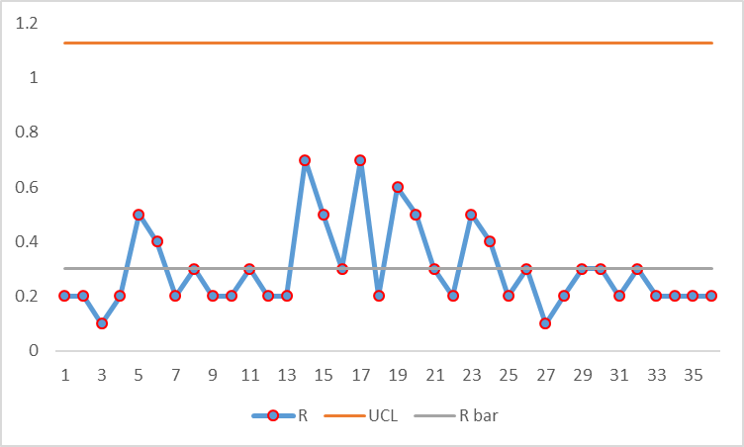

1. 1. R-chart為用來monitor Wafer的外圍四個CD_site是否平整，因此在產出R chart時將中心點的CD_site 3排除在外，僅使用CD_site 1, 2, 4, 5 產出R chart。在每一組Wafer中找出四個CD_site的最大與最小量測值的差做為R，將100組wafer的R取出 $\overline{R}$ 及 $S_{R}$，並使 $CL=\overline{R}$, $UCL=\overline{R}+3×S_{R}$, $LCL=MAX(0, \overline{R}-3×S_{R}$，並匯出R chart如下：  
      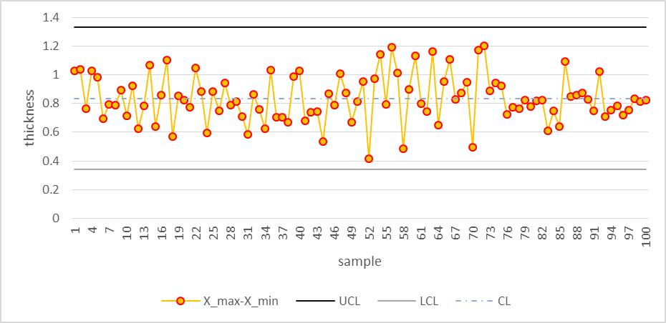
   2. 使用runs rule進行判斷時，則須加入1個標準差及2個標準差的界線做為判斷依據。修整後的R chart 如下：

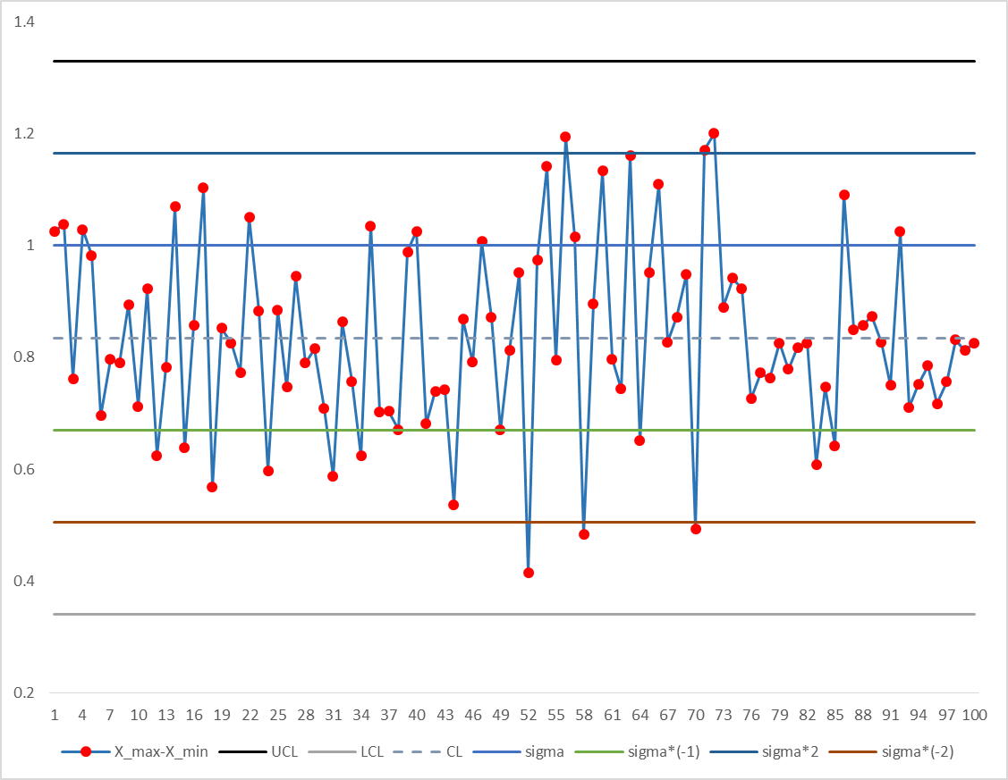

* + 1. Run rule 1: one point beyond the control limit—passed
    2. Run rule 2: two out of three point in zone 2-3 $σ$ or beyond – failed at sample number 72
    3. Run rule 3: four out of five points in zone 1-2 $σ$ or beyond – passed
    4. Run rule 4: eight points above or below the centerline – failed at 83, 100.
    5. Run rule 5: six points show a continuing increase or decrease – passed.
    6. Run rule 6: 14 points oscillate up and down – passed
    7. Run rule 7: 8 points avoid 0-1 $σ$—passed
    8. Run rule 8: 15 points fall in 0-1 $σ$ only – passed.
  1. CD_site 3的control chart分別以平均數作為mean=59.1975，並將所有的CD_site 3取樣本標準差，進而得到UCL=60.3882與LCL=58.0069，可畫出control chart如下：

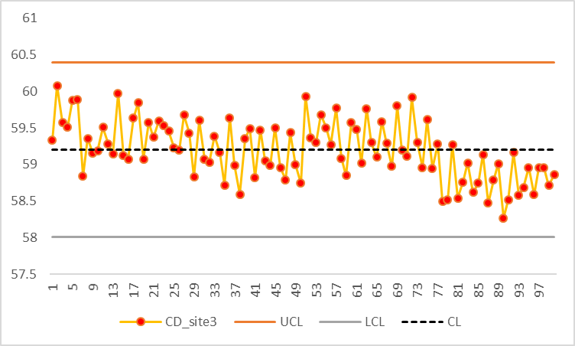

* 1. 對Range=2的individual X chart而言，將前後兩項的CD_site 3相減後平方再除以二，從資料中可以得到 $S_{p2}=\sqrt{\frac{\sum_{i=1}^{n-1}{ms_{i}^{2}}}{n-1}}=0.347708$，其中n=99。令CL= $\overline{X}=59.1975$，UCL= $\overline{X}+3×S_{p2}=60.2407$，LCL= $\overline{X}-3×S_{p2}=58.1544$。根據上下邊界可畫出individual control chart 如下：

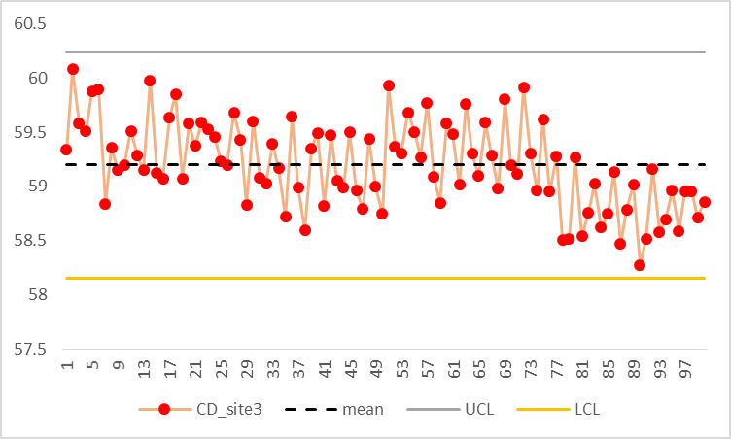

對Range=5的individual X chart而言，將前後兩項的CD_site 3相減後平方再除以二，從資料中可以得到 $S_{p2}=\sqrt{\frac{\sum_{i=1}^{n-1}{ms_{i}^{2}}}{n-1}}=0.492743$，其中n=5。令CL= $\overline{X}=59.1975$，UCL= $\overline{X}+3×S_{p2}=60.67582$，LCL= $\overline{X}-3×S_{p2}=57.71936$。根據上下邊界可畫出individual control chart 如下：

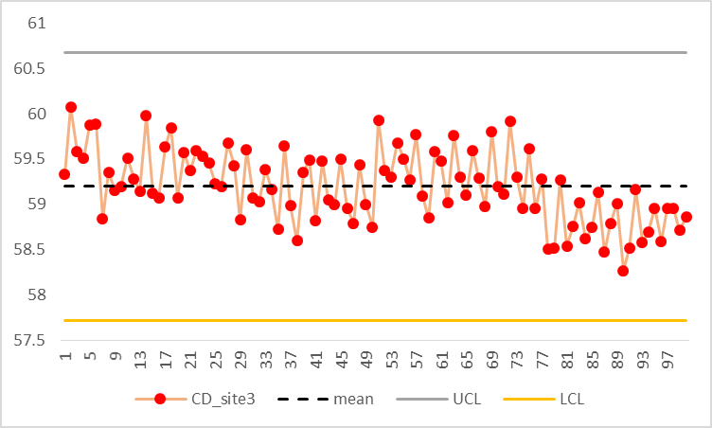

與(iii)圖比較，(iii)的上下界範圍較range=2的來的大，但又比range=5的來的小，比較三者的上下界大小為range=5>(iii)>range=2。因此可以解釋range=2的敏感度較range=5及(iii)都來的高。

* 1. 當range=2時，取得每一組MR $=\left|x_{i}-x_{i+1}\right|$，將MR取得平均後做為CL；將MR的sample variance做為 $S_{MR}$，可訂出上下界 $UCL=\overline{MR}+3S_{MR}=1.213414$， $LCL=MAX(0,\overline{MR}-3S_{MR})$ =0，可繪出MR chart如下：

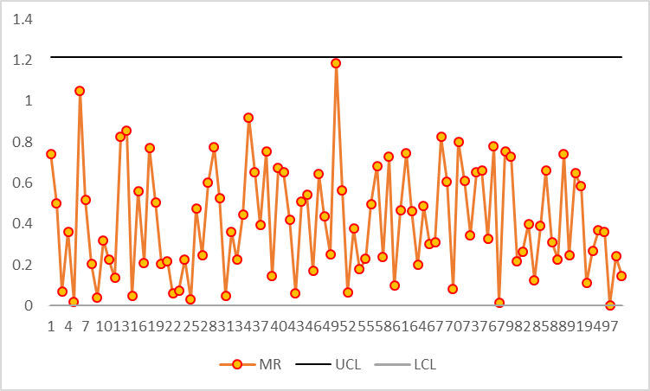

當range=5時，取得每一組MR $=\left|x_{i}-x_{i+4}\right|$，將MR取得平均後做為CL=0.492743；將MR的sample variance做為 $S_{MR}$，可訂出上下界 $UCL=\overline{MR}+3S_{MR}=1.18034$， $LCL=MAX(0,\overline{MR}-3S_{MR})$ =0，可繪出MR chart如下：

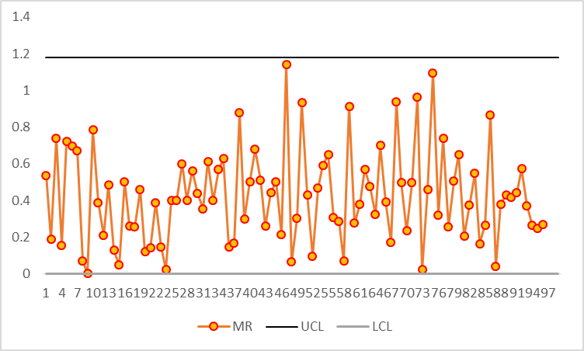

* 1. 使用sequential likelihood ratio來檢定是否為 $μ_{0}$ 或 $μ_{1}$，檢定標準為： $C_{t}≤\frac{σ^{2}}{δ}\ln\left(\frac{1-β}{α}\right),$ 
      接受 $H_{1}C_{t}≥\frac{σ^{2}}{δ}\ln\left(\frac{β}{1-α}\right),$ 接受 $H_{0}$

其中 $δ=μ_{1}-μ_{0}$， $σ$ 為CD_site 3的樣本標準差，令 $μ_{1}=59, μ_{0}=60$。一旦C value累積到了有足夠證據接受 $H_{1}$ 或 $H_{0}$ 時，即將C value重新累積。檢定結果如下：

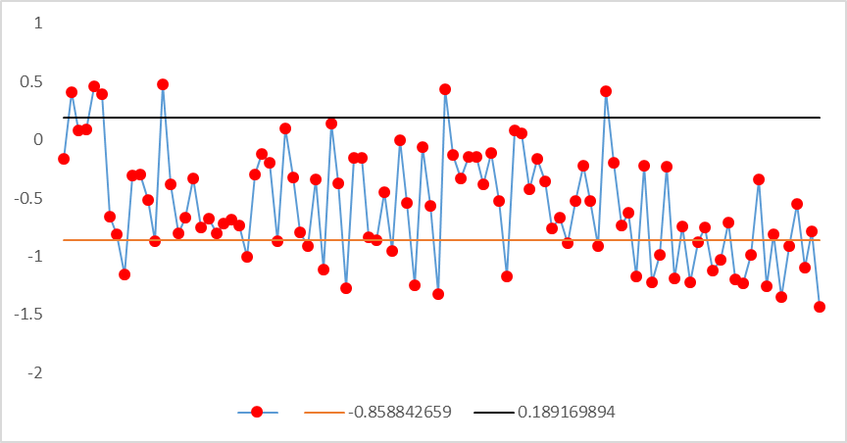

|  |  |  |  |
| --- | --- | --- | --- |
| sample | cumulated value | accept H1 | accept H0 |
| 1 | -0.1647 | 0 | 0 |
| 2 | 0.413 | 0 | accept H0 |
| 3 | 0.0779 | 0 | 0 |
| 4 | 0.0889 | 0 | 0 |
| 5 | 0.4613 | 0 | accept H0 |
| 6 | 0.3892 | 0 | accept H0 |
| 7 | -0.6621 | 0 | 0 |
| 8 | -0.8077 | 0 | 0 |
| 9 | -1.1575 | accept H1 | 0 |
| 10 | -0.3093 | 0 | 0 |
| 11 | -0.2989 | 0 | 0 |
| 12 | -0.5157 | 0 | 0 |
| 13 | -0.8687 | accept H1 | 0 |
| 14 | 0.4744 | 0 | accept H0 |
| 15 | -0.3799 | 0 | 0 |
| 16 | -0.8062 | 0 | 0 |
| 17 | -0.672 | 0 | 0 |
| 18 | -0.3274 | 0 | 0 |
| 19 | -0.7555 | 0 | 0 |
| 20 | -0.6788 | 0 | 0 |
| 21 | -0.8067 | 0 | 0 |
| 22 | -0.7176 | 0 | 0 |
| 23 | -0.6875 | 0 | 0 |
| 24 | -0.7325 | 0 | 0 |
| 25 | -1.0029 | accept H1 | 0 |
| 26 | -0.3008 | 0 | 0 |
| 27 | -0.1248 | 0 | 0 |
| 28 | -0.1964 | 0 | 0 |
| 29 | -0.8697 | accept H1 | 0 |
| 30 | 0.1014 | 0 | 0 |
| 31 | -0.3238 | 0 | 0 |
| 32 | -0.7973 | 0 | 0 |
| 33 | -0.909 | accept H1 | 0 |
| 34 | -0.3356 | 0 | 0 |
| 35 | -1.1152 | accept H1 | 0 |
| 36 | 0.1401 | 0 | 0 |
| 37 | -0.3705 | 0 | 0 |
| 38 | -1.2748 | accept H1 | 0 |
| 39 | -0.1508 | 0 | 0 |
| 40 | -0.158 | 0 | 0 |
| 41 | -0.8368 | 0 | 0 |
| 42 | -0.8639 | accept H1 | 0 |
| 43 | -0.4482 | 0 | 0 |
| 44 | -0.956 | accept H1 | 0 |
| 45 | 0.0009 | 0 | 0 |
| 46 | -0.5388 | 0 | 0 |
| 47 | -1.2474 | accept H1 | 0 |
| 48 | -0.0661 | 0 | 0 |
| 49 | -0.5685 | 0 | 0 |
| 50 | -1.3221 | accept H1 | 0 |
| 51 | 0.4318 | 0 | accept H0 |
| 52 | -0.1317 | 0 | 0 |
| 53 | -0.3294 | 0 | 0 |
| 54 | -0.1503 | 0 | 0 |
| 55 | -0.1499 | 0 | 0 |
| 56 | -0.3789 | 0 | 0 |
| 57 | -0.11 | 0 | 0 |
| 58 | -0.5236 | 0 | 0 |
| 59 | -1.1734 | accept H1 | 0 |
| 60 | 0.0783 | 0 | 0 |
| 61 | 0.0596 | 0 | 0 |
| 62 | -0.4236 | 0 | 0 |
| 63 | -0.1608 | 0 | 0 |
| 64 | -0.3603 | 0 | 0 |
| 65 | -0.7594 | 0 | 0 |
| 66 | -0.6717 | 0 | 0 |
| 67 | -0.8839 | accept H1 | 0 |
| 68 | -0.5237 | 0 | 0 |
| 69 | -0.2221 | 0 | 0 |
| 70 | -0.5283 | 0 | 0 |
| 71 | -0.9141 | accept H1 | 0 |
| 72 | 0.4152 | 0 | accept H0 |
| 73 | -0.1966 | 0 | 0 |
| 74 | -0.737 | 0 | 0 |
| 75 | -0.6253 | 0 | 0 |
| 76 | -1.1745 | accept H1 | 0 |
| 77 | -0.2207 | 0 | 0 |
| 78 | -1.2193 | accept H1 | 0 |
| 79 | -0.9846 | accept H1 | 0 |
| 80 | -0.2291 | 0 | 0 |
| 81 | -1.188 | accept H1 | 0 |
| 82 | -0.7403 | 0 | 0 |
| 83 | -1.2192 | accept H1 | 0 |
| 84 | -0.8797 | accept H1 | 0 |
| 85 | -0.7537 | 0 | 0 |
| 86 | -1.119 | accept H1 | 0 |
| 87 | -1.0259 | accept H1 | 0 |
| 88 | -0.714 | 0 | 0 |
| 89 | -1.2015 | accept H1 | 0 |
| 90 | -1.2295 | accept H1 | 0 |
| 91 | -0.9842 | accept H1 | 0 |
| 92 | -0.3363 | 0 | 0 |
| 93 | -1.2563 | accept H1 | 0 |
| 94 | -0.8104 | 0 | 0 |
| 95 | -1.3518 | accept H1 | 0 |
| 96 | -0.9102 | accept H1 | 0 |
| 97 | -0.5475 | 0 | 0 |
| 98 | -1.0935 | accept H1 | 0 |
| 99 | -0.7883 | 0 | 0 |
| 100 | -1.4297 | accept H1 | 0 |

* 1. 設定, (K, H)=(0.5 $σ$, 5 $σ$)時，繪出Tabular CUSUM chart。其中， $C_{i}^{+}=max⁡[0, x_{i}-\left(μ_{0}+K\right)+C_{i-1}^{+}]$, $C_{i}^{-}=max⁡[0,\left(μ_{0}-K\right)+x_{i}+C_{i-1}^{-}]$。分別計算 $C^{+}$ 與 $C^{-}$ 後，紀錄 $C^{+}$ 及 $C^{-}$ 不為0時的累進次數。結果如圖表所示：

|  |  |  |  |  |  |  |
| --- | --- | --- | --- | --- | --- | --- |
|  |  | a | |  | b | |
|  | CD_site3 | x-(mu_0+K) | N+ |  | (mu_0-K)-xi | N- |
| 1 | 59.3353 | 0 | 0 |  | 0 | 0 |
| 2 | 60.0777 | 0.379259532 | 1 |  | 0 | 0 |
| 3 | 59.5779 | 0.258719063 | 2 |  | 0 | 0 |
| 4 | 59.511 | 0.071278595 | 3 |  | 0 | 0 |
| 5 | 59.8724 | 0.245238126 | 4 |  | 0 | 0 |
| 6 | 59.8892 | 0.435997658 | 5 |  | 0 | 0 |
| 7 | 58.8379 | 0 | 0 |  | 0.46365953 | 1 |
| 8 | 59.3544 | 0 | 0 |  | 0.41081906 | 2 |
| 9 | 59.1502 | 0 | 0 |  | 0.56217859 | 3 |
| 10 | 59.1907 | 0 | 0 |  | 0.67303813 | 4 |
| 11 | 59.5104 | 0 | 0 |  | 0.46419766 | 5 |
| 12 | 59.2832 | 0 | 0 |  | 0.48255719 | 6 |
| 13 | 59.147 | 0 | 0 |  | 0.63711672 | 7 |
| 14 | 59.9744 | 0.275959532 | 1 |  | 0 | 0 |
| 15 | 59.1201 | 0 | 0 |  | 0.18145953 | 1 |
| 16 | 59.0737 | 0 | 0 |  | 0.40931906 | 2 |
| 17 | 59.6342 | 0 | 0 |  | 0.07667859 | 3 |
| 18 | 59.8446 | 0.146159532 | 1 |  | 0 | 0 |
| 19 | 59.0719 | 0 | 0 |  | 0.22965953 | 1 |
| 20 | 59.5767 | 0 | 0 |  | 0 | 0 |
| 21 | 59.3721 | 0 | 0 |  | 0 | 0 |
| 22 | 59.5891 | 0 | 0 |  | 0 | 0 |
| 23 | 59.5301 | 0 | 0 |  | 0 | 0 |
| 24 | 59.455 | 0 | 0 |  | 0 | 0 |
| 25 | 59.2296 | 0 | 0 |  | 0.07195953 | 1 |
| 26 | 59.1992 | 0 | 0 |  | 0.17431906 | 2 |
| 27 | 59.676 | 0 | 0 |  | 0 | 0 |
| 28 | 59.4284 | 0 | 0 |  | 0 | 0 |
| 29 | 58.8267 | 0 | 0 |  | 0.47485953 | 1 |
| 30 | 59.6014 | 0 | 0 |  | 0.17501906 | 2 |
| 31 | 59.0748 | 0 | 0 |  | 0.40177859 | 3 |
| 32 | 59.0265 | 0 | 0 |  | 0.67683813 | 4 |
| 33 | 59.3883 | 0 | 0 |  | 0.59009766 | 5 |
| 34 | 59.1644 | 0 | 0 |  | 0.72725719 | 6 |
| 35 | 58.7204 | 0 | 0 |  | 1.30841672 | 7 |
| 36 | 59.6401 | 0 | 0 |  | 0.96987625 | 8 |
| 37 | 58.9894 | 0 | 0 |  | 1.28203578 | 9 |
| 38 | 58.5957 | 0 | 0 |  | 1.98789532 | 10 |
| 39 | 59.3492 | 0 | 0 |  | 1.94025485 | 11 |
| 40 | 59.4928 | 0 | 0 |  | 1.74901438 | 12 |
| 41 | 58.8212 | 0 | 0 |  | 2.22937391 | 13 |
| 42 | 59.4729 | 0 | 0 |  | 2.05803344 | 14 |
| 43 | 59.0518 | 0 | 0 |  | 2.30779297 | 15 |
| 44 | 58.9922 | 0 | 0 |  | 2.6171525 | 16 |
| 45 | 59.5009 | 0 | 0 |  | 2.41781204 | 17 |
| 46 | 58.9603 | 0 | 0 |  | 2.75907157 | 18 |
| 47 | 58.7914 | 0 | 0 |  | 3.2692311 | 19 |
| 48 | 59.4339 | 0 | 0 |  | 3.13689063 | 20 |
| 49 | 58.9976 | 0 | 0 |  | 3.44085016 | 21 |
| 50 | 58.7464 | 0 | 0 |  | 3.99600969 | 22 |
| 51 | 59.9318 | 0.233359532 | 1 |  | 3.36576922 | 23 |
| 52 | 59.3683 | 0 | 0 |  | 3.29902876 | 24 |
| 53 | 59.3023 | 0 | 0 |  | 3.29828829 | 25 |
| 54 | 59.6791 | 0 | 0 |  | 2.92074782 | 26 |
| 55 | 59.5004 | 0 | 0 |  | 2.72190735 | 27 |
| 56 | 59.271 | 0 | 0 |  | 2.75246688 | 28 |
| 57 | 59.7689 | 0.070459532 | 1 |  | 2.28512641 | 29 |
| 58 | 59.0864 | 0 | 0 |  | 2.50028595 | 30 |
| 59 | 58.8502 | 0 | 0 |  | 2.95164548 | 31 |
| 60 | 59.5783 | 0 | 0 |  | 2.67490501 | 32 |
| 61 | 59.4813 | 0 | 0 |  | 2.49516454 | 33 |
| 62 | 59.0168 | 0 | 0 |  | 2.77992407 | 34 |
| 63 | 59.7628 | 0.064359532 | 1 |  | 2.3186836 | 35 |
| 64 | 59.3005 | 0 | 0 |  | 2.31974313 | 36 |
| 65 | 59.1009 | 0 | 0 |  | 2.52040267 | 37 |
| 66 | 59.5877 | 0 | 0 |  | 2.2342622 | 38 |
| 67 | 59.2878 | 0 | 0 |  | 2.24802173 | 39 |
| 68 | 58.9763 | 0 | 0 |  | 2.57328126 | 40 |
| 69 | 59.8016 | 0.103159532 | 1 |  | 2.07324079 | 41 |
| 70 | 59.1938 | 0 | 0 |  | 2.18100032 | 42 |
| 71 | 59.1142 | 0 | 0 |  | 2.36835985 | 43 |
| 72 | 59.9152 | 0.216759532 | 1 |  | 1.75471939 | 44 |
| 73 | 59.3034 | 0 | 0 |  | 1.75287892 | 45 |
| 74 | 58.9596 | 0 | 0 |  | 2.09483845 | 46 |
| 75 | 59.6117 | 0 | 0 |  | 1.78469798 | 47 |
| 76 | 58.9508 | 0 | 0 |  | 2.13545751 | 48 |
| 77 | 59.2793 | 0 | 0 |  | 2.15771704 | 49 |
| 78 | 58.5014 | 0 | 0 |  | 2.95787658 | 50 |
| 79 | 58.5154 | 0 | 0 |  | 3.74403611 | 51 |
| 80 | 59.2709 | 0 | 0 |  | 3.77469564 | 52 |
| 81 | 58.5411 | 0 | 0 |  | 4.53515517 | 53 |
| 82 | 58.7597 | 0 | 0 |  | 5.0770147 | 54 |
| 83 | 59.0211 | 0 | 0 |  | 5.35747423 | 55 |
| 84 | 58.6203 | 0 | 0 |  | 6.03873376 | 56 |
| 85 | 58.7463 | 0 | 0 |  | 6.5939933 | 57 |
| 86 | 59.1347 | 0 | 0 |  | 6.76085283 | 58 |
| 87 | 58.4741 | 0 | 0 |  | 7.58831236 | 59 |
| 88 | 58.786 | 0 | 0 |  | 8.10387189 | 60 |
| 89 | 59.0125 | 0 | 0 |  | 8.39293142 | 61 |
| 90 | 58.2705 | 0 | 0 |  | 9.42399095 | 62 |
| 91 | 58.5158 | 0 | 0 |  | 10.2097505 | 63 |
| 92 | 59.1637 | 0 | 0 |  | 10.34761 | 64 |
| 93 | 58.58 | 0 | 0 |  | 11.0691695 | 65 |
| 94 | 58.6896 | 0 | 0 |  | 11.6811291 | 66 |
| 95 | 58.9586 | 0 | 0 |  | 12.0240886 | 67 |
| 96 | 58.5898 | 0 | 0 |  | 12.7358481 | 68 |
| 97 | 58.9525 | 0 | 0 |  | 13.0849077 | 69 |
| 98 | 58.954 | 0 | 0 |  | 13.4324672 | 70 |
| 99 | 58.7117 | 0 | 0 |  | 14.0223267 | 71 |
| 100 | 58.8586 | 0 | 0 |  | 14.4652863 | 72 |

計算後得H=1.984405，可繪出control chart:

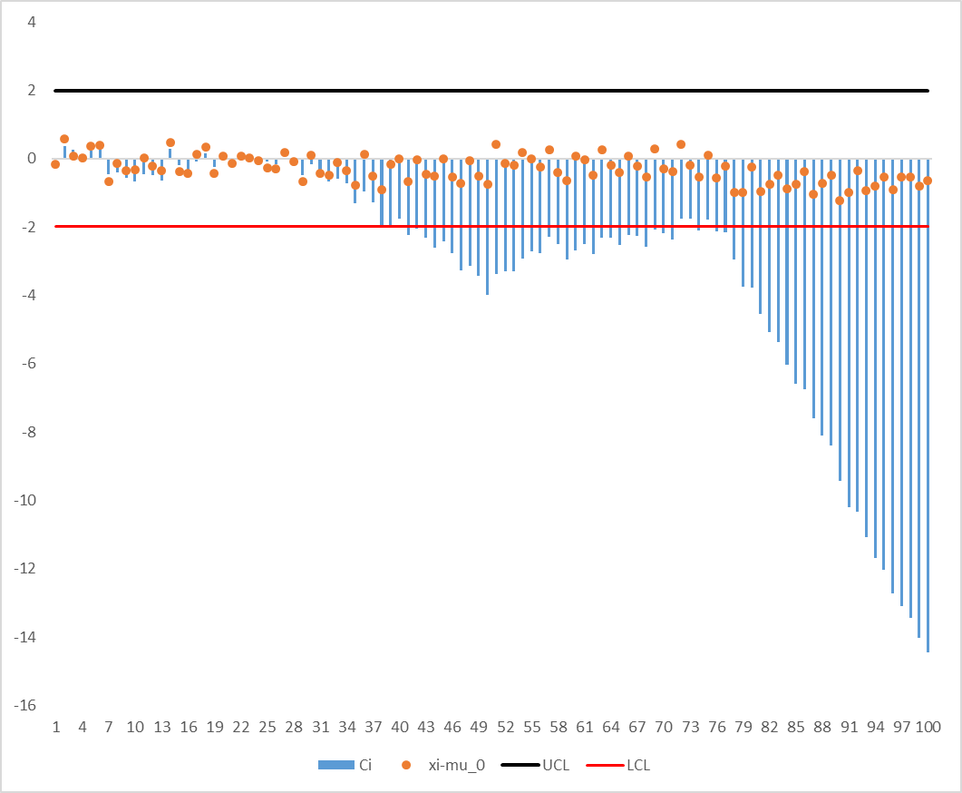

從圖中可以看到五個區段的平均數是在檢定範圍之外的，計算每組的平均後可整理於下表：

|  |  |  |
| --- | --- | --- |
| start sample | end sample | new process mean |
| 29 | 38 | 59.10277 |
| 29 | 41 | 59.13007 |
| 29 | 42 | 59.15456 |
| 29 | 43 | 59.14771 |
| 29 | 44 | 59.13799 |
| 29 | 45 | 59.15934 |
| 29 | 46 | 59.14828 |
| 29 | 47 | 59.12949 |
| 29 | 48 | 59.14472 |
| 29 | 49 | 59.13771 |
| 29 | 50 | 59.11992 |
| 29 | 51 | 59.15522 |
| 29 | 52 | 59.1641 |
| 29 | 53 | 59.16963 |
| 29 | 54 | 59.18922 |
| 29 | 55 | 59.20075 |
| 29 | 56 | 59.20326 |
| 29 | 57 | 59.22276 |
| 29 | 58 | 59.21822 |
| 29 | 59 | 59.20635 |
| 29 | 60 | 59.21797 |
| 29 | 61 | 59.22595 |
| 29 | 62 | 59.2198 |
| 29 | 63 | 59.23531 |
| 29 | 64 | 59.23712 |
| 29 | 65 | 59.23344 |
| 29 | 66 | 59.24276 |
| 29 | 67 | 59.24392 |
| 29 | 68 | 59.23723 |
| 29 | 69 | 59.25099 |
| 29 | 70 | 59.24963 |
| 29 | 71 | 59.24648 |
| 29 | 74 | 59.25602 |
| 29 | 76 | 59.25707 |
| 29 | 77 | 59.25752 |
| 29 | 78 | 59.2424 |
| 29 | 79 | 59.22815 |
| 29 | 80 | 59.22897 |
| 29 | 81 | 59.21599 |
| 29 | 82 | 59.20754 |
| 29 | 83 | 59.20415 |
| 29 | 84 | 59.19373 |
| 29 | 85 | 59.18588 |
| 29 | 86 | 59.18499 |
| 29 | 87 | 59.17294 |
| 29 | 88 | 59.1665 |
| 29 | 89 | 59.16397 |
| 29 | 90 | 59.14956 |
| 29 | 91 | 59.1395 |
| 29 | 92 | 59.13988 |
| 29 | 93 | 59.13126 |
| 29 | 94 | 59.12457 |
| 29 | 95 | 59.1221 |
| 29 | 96 | 59.11427 |
| 29 | 97 | 59.11192 |
| 29 | 98 | 59.10967 |
| 29 | 99 | 59.10406 |
| 29 | 100 | 59.10065 |

設定 $μ_{0}=59.5$, (K, H)=(0.25 $σ$, 8 $σ$)時，繪出Tabular CUSUM chart。其中， $C_{i}^{+}=max⁡[0, x_{i}-\left(μ_{0}+K\right)+C_{i-1}^{+}]$, $C_{i}^{-}=max⁡[0,\left(μ_{0}-K\right)+x_{i}+C_{i-1}^{-}]$。分別計算 $C^{+}$ 與 $C^{-}$ 後，紀錄 $C^{+}$ 及 $C^{-}$ 不為0時的累進次數。結果如圖表所示：

|  |  |  |  |  |  |  |
| --- | --- | --- | --- | --- | --- | --- |
|  |  | a | |  | b | |
|  | CD_site3 | x-(mu_0+K) | N+ |  | (mu_0-K)-xi | N- |
| 1 | 59.3353 | 0 | 0 |  | 0.06547977 | 1 |
| 2 | 60.0777 | 0.478479766 | 1 |  | 0 | 0 |
| 3 | 59.5779 | 0.457159532 | 2 |  | 0 | 0 |
| 4 | 59.511 | 0.368939297 | 3 |  | 0 | 0 |
| 5 | 59.8724 | 0.642119063 | 4 |  | 0 | 0 |
| 6 | 59.8892 | 0.932098829 | 5 |  | 0 | 0 |
| 7 | 58.8379 | 0.170778595 | 6 |  | 0.56287977 | 1 |
| 8 | 59.3544 | 0 | 0 |  | 0.60925953 | 2 |
| 9 | 59.1502 | 0 | 0 |  | 0.8598393 | 3 |
| 10 | 59.1907 | 0 | 0 |  | 1.06991906 | 4 |
| 11 | 59.5104 | 0 | 0 |  | 0.96029883 | 5 |
| 12 | 59.2832 | 0 | 0 |  | 1.07787859 | 6 |
| 13 | 59.147 | 0 | 0 |  | 1.33165836 | 7 |
| 14 | 59.9744 | 0.375179766 | 1 |  | 0.75803813 | 8 |
| 15 | 59.1201 | 0 | 0 |  | 1.03871789 | 9 |
| 16 | 59.0737 | 0 | 0 |  | 1.36579766 | 10 |
| 17 | 59.6342 | 0.034979766 | 1 |  | 1.13237742 | 11 |
| 18 | 59.8446 | 0.280359532 | 2 |  | 0.68855719 | 12 |
| 19 | 59.0719 | 0 | 0 |  | 1.01743695 | 13 |
| 20 | 59.5767 | 0 | 0 |  | 0.84151672 | 14 |
| 21 | 59.3721 | 0 | 0 |  | 0.87019649 | 15 |
| 22 | 59.5891 | 0 | 0 |  | 0.68187625 | 16 |
| 23 | 59.5301 | 0 | 0 |  | 0.55255602 | 17 |
| 24 | 59.455 | 0 | 0 |  | 0.49833578 | 18 |
| 25 | 59.2296 | 0 | 0 |  | 0.66951555 | 19 |
| 26 | 59.1992 | 0 | 0 |  | 0.87109532 | 20 |
| 27 | 59.676 | 0.076779766 | 1 |  | 0.59587508 | 21 |
| 28 | 59.4284 | 0 | 0 |  | 0.56825485 | 22 |
| 29 | 58.8267 | 0 | 0 |  | 1.14233461 | 23 |
| 30 | 59.6014 | 0.002179766 | 1 |  | 0.94171438 | 24 |
| 31 | 59.0748 | 0 | 0 |  | 1.26769414 | 25 |
| 32 | 59.0265 | 0 | 0 |  | 1.64197391 | 26 |
| 33 | 59.3883 | 0 | 0 |  | 1.65445368 | 27 |
| 34 | 59.1644 | 0 | 0 |  | 1.89083344 | 28 |
| 35 | 58.7204 | 0 | 0 |  | 2.57121321 | 29 |
| 36 | 59.6401 | 0.040879766 | 1 |  | 2.33189297 | 30 |
| 37 | 58.9894 | 0 | 0 |  | 2.74327274 | 31 |
| 38 | 58.5957 | 0 | 0 |  | 3.5483525 | 32 |
| 39 | 59.3492 | 0 | 0 |  | 3.59993227 | 33 |
| 40 | 59.4928 | 0 | 0 |  | 3.50791204 | 34 |
| 41 | 58.8212 | 0 | 0 |  | 4.0874918 | 35 |
| 42 | 59.4729 | 0 | 0 |  | 4.01537157 | 36 |
| 43 | 59.0518 | 0 | 0 |  | 4.36435133 | 37 |
| 44 | 58.9922 | 0 | 0 |  | 4.7729311 | 38 |
| 45 | 59.5009 | 0 | 0 |  | 4.67281086 | 39 |
| 46 | 58.9603 | 0 | 0 |  | 5.11329063 | 40 |
| 47 | 58.7914 | 0 | 0 |  | 5.7226704 | 41 |
| 48 | 59.4339 | 0 | 0 |  | 5.68955016 | 42 |
| 49 | 58.9976 | 0 | 0 |  | 6.09272993 | 43 |
| 50 | 58.7464 | 0 | 0 |  | 6.74710969 | 44 |
| 51 | 59.9318 | 0.332579766 | 1 |  | 6.21608946 | 45 |
| 52 | 59.3683 | 0.101659532 | 2 |  | 6.24856922 | 46 |
| 53 | 59.3023 | 0 | 0 |  | 6.34704899 | 47 |
| 54 | 59.6791 | 0.079879766 | 1 |  | 6.06872876 | 48 |
| 55 | 59.5004 | 0 | 0 |  | 5.96910852 | 49 |
| 56 | 59.271 | 0 | 0 |  | 6.09888829 | 50 |
| 57 | 59.7689 | 0.169679766 | 1 |  | 5.73076805 | 51 |
| 58 | 59.0864 | 0 | 0 |  | 6.04514782 | 52 |
| 59 | 58.8502 | 0 | 0 |  | 6.59572758 | 53 |
| 60 | 59.5783 | 0 | 0 |  | 6.41820735 | 54 |
| 61 | 59.4813 | 0 | 0 |  | 6.33768712 | 55 |
| 62 | 59.0168 | 0 | 0 |  | 6.72166688 | 56 |
| 63 | 59.7628 | 0.163579766 | 1 |  | 6.35964665 | 57 |
| 64 | 59.3005 | 0 | 0 |  | 6.45992641 | 58 |
| 65 | 59.1009 | 0 | 0 |  | 6.75980618 | 59 |
| 66 | 59.5877 | 0 | 0 |  | 6.57288595 | 60 |
| 67 | 59.2878 | 0 | 0 |  | 6.68586571 | 61 |
| 68 | 58.9763 | 0 | 0 |  | 7.11034548 | 62 |
| 69 | 59.8016 | 0.202379766 | 1 |  | 6.70952524 | 63 |
| 70 | 59.1938 | 0 | 0 |  | 6.91650501 | 64 |
| 71 | 59.1142 | 0 | 0 |  | 7.20308477 | 65 |
| 72 | 59.9152 | 0.315979766 | 1 |  | 6.68866454 | 66 |
| 73 | 59.3034 | 0.020159532 | 2 |  | 6.78604431 | 67 |
| 74 | 58.9596 | 0 | 0 |  | 7.22722407 | 68 |
| 75 | 59.6117 | 0.012479766 | 1 |  | 7.01630384 | 69 |
| 76 | 58.9508 | 0 | 0 |  | 7.4662836 | 70 |
| 77 | 59.2793 | 0 | 0 |  | 7.58776337 | 71 |
| 78 | 58.5014 | 0 | 0 |  | 8.48714313 | 72 |
| 79 | 58.5154 | 0 | 0 |  | 9.3725229 | 73 |
| 80 | 59.2709 | 0 | 0 |  | 9.50240267 | 74 |
| 81 | 58.5411 | 0 | 0 |  | 10.3620824 | 75 |
| 82 | 58.7597 | 0 | 0 |  | 11.0031622 | 76 |
| 83 | 59.0211 | 0 | 0 |  | 11.382842 | 77 |
| 84 | 58.6203 | 0 | 0 |  | 12.1633217 | 78 |
| 85 | 58.7463 | 0 | 0 |  | 12.8178015 | 79 |
| 86 | 59.1347 | 0 | 0 |  | 13.0838813 | 80 |
| 87 | 58.4741 | 0 | 0 |  | 14.010561 | 81 |
| 88 | 58.786 | 0 | 0 |  | 14.6253408 | 82 |
| 89 | 59.0125 | 0 | 0 |  | 15.0136206 | 83 |
| 90 | 58.2705 | 0 | 0 |  | 16.1439003 | 84 |
| 91 | 58.5158 | 0 | 0 |  | 17.0288801 | 85 |
| 92 | 59.1637 | 0 | 0 |  | 17.2659599 | 86 |
| 93 | 58.58 | 0 | 0 |  | 18.0867396 | 87 |
| 94 | 58.6896 | 0 | 0 |  | 18.7979194 | 88 |
| 95 | 58.9586 | 0 | 0 |  | 19.2400992 | 89 |
| 96 | 58.5898 | 0 | 0 |  | 20.0510789 | 90 |
| 97 | 58.9525 | 0 | 0 |  | 20.4993587 | 91 |
| 98 | 58.954 | 0 | 0 |  | 20.9461384 | 92 |
| 99 | 58.7117 | 0 | 0 |  | 21.6352182 | 93 |
| 100 | 58.8586 | 0 | 0 |  | 22.177398 | 94 |

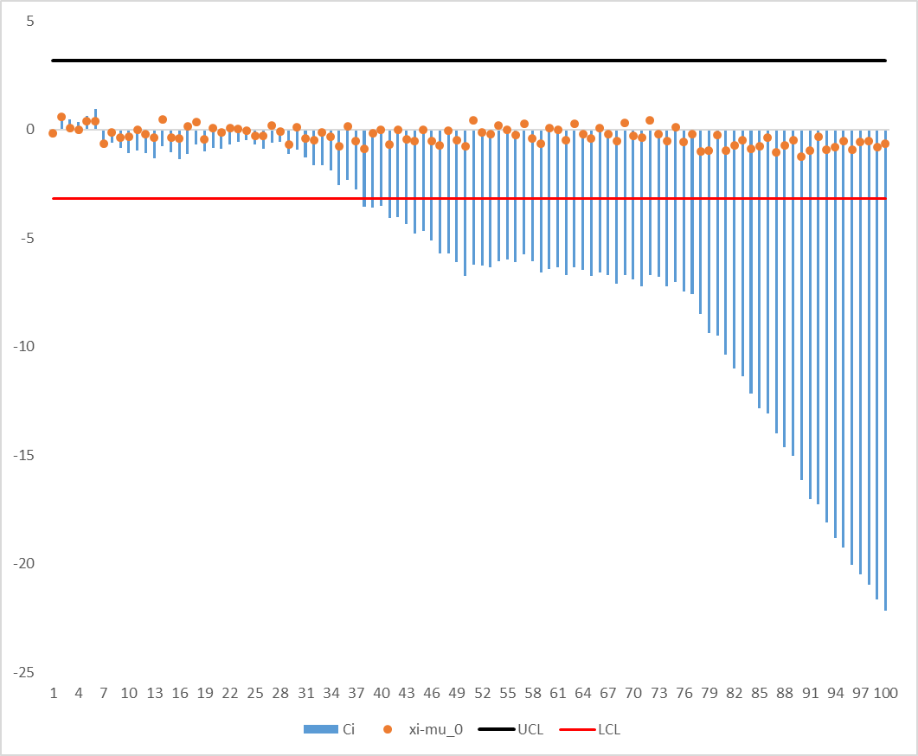

|  |  |  |
| --- | --- | --- |
| start sample | end sample | new process mean |
| 7 | 41 | 59.28989 |
| 7 | 41 | 59.29169 |
| 7 | 41 | 59.29761 |
| 7 | 41 | 59.28399 |
| 7 | 42 | 59.28924 |
| 7 | 43 | 59.28282 |
| 7 | 44 | 59.27518 |
| 7 | 45 | 59.28096 |
| 7 | 46 | 59.27295 |
| 7 | 47 | 59.2612 |
| 7 | 48 | 59.26531 |
| 7 | 49 | 59.25909 |
| 7 | 50 | 59.24744 |
| 7 | 51 | 59.26264 |
| 7 | 52 | 59.26494 |
| 7 | 53 | 59.26574 |
| 7 | 54 | 59.27435 |
| 7 | 55 | 59.27896 |
| 7 | 56 | 59.2788 |
| 7 | 57 | 59.28841 |
| 7 | 58 | 59.28453 |
| 7 | 59 | 59.27633 |
| 7 | 60 | 59.28192 |
| 7 | 61 | 59.28555 |
| 7 | 62 | 59.28075 |
| 7 | 63 | 59.28921 |
| 7 | 64 | 59.2894 |
| 7 | 65 | 59.28621 |
| 7 | 66 | 59.29123 |
| 7 | 67 | 59.29118 |
| 7 | 68 | 59.2861 |
| 7 | 69 | 59.29428 |
| 7 | 70 | 59.29271 |
| 7 | 71 | 59.28996 |
| 7 | 72 | 59.29944 |
| 7 | 73 | 59.2995 |
| 7 | 74 | 59.2945 |
| 7 | 75 | 59.29909 |
| 7 | 76 | 59.29412 |
| 7 | 77 | 59.29391 |
| 7 | 78 | 59.2829 |
| 7 | 79 | 59.27239 |
| 7 | 80 | 59.27237 |
| 7 | 81 | 59.26262 |
| 7 | 82 | 59.256 |
| 7 | 83 | 59.25295 |
| 7 | 84 | 59.24484 |
| 7 | 85 | 59.23853 |
| 7 | 86 | 59.23723 |
| 7 | 87 | 59.22781 |
| 7 | 88 | 59.22242 |
| 7 | 89 | 59.21989 |
| 7 | 90 | 59.20859 |
| 7 | 91 | 59.20044 |
| 7 | 92 | 59.20001 |
| 7 | 93 | 59.19289 |
| 7 | 94 | 59.18717 |
| 7 | 95 | 59.1846 |
| 7 | 96 | 59.17799 |
| 7 | 97 | 59.17551 |
| 7 | 98 | 59.1731 |
| 7 | 99 | 59.16814 |
| 7 | 100 | 59.16485 |