2. 由於在(ii)中需要比較CD_site3的分布狀況，且設定 $μ_{0}=59.5$，因此在這個題目中也以同樣的設定進行後續的數據處理。已知 $μ_{0}=59.5$， $σ_{CD site3}=0.39688$ 的設定下，在最佳化的optimal Tabular CUSUM的參數設計中，當 ${ARL}_{0}=400$，偏移量 $δ=1σ$，可得到 $k^{*}=0.5$、 $h^{*}=4.8428$、K=0.19844、H=1.92203。討論不同偏移量對ARL的影響整理於下表：

|  |  |
| --- | --- |
| shift | ARL |
| 0*sigma | 400 |
| 0.5*sigma | 16.3949 |
| 1*sigma | 10.0225 |
| 1.5*sigma | 7.123 |
| 2*sigma | 5.5088 |
| 2.5*sigma | 4.4871 |
| 3*sigma | 3.7836 |

1. 承(i)，根據(i)中的參數設計上下界，可得UCL=1.92203、LCL=-1.922，所繪出的optimal graphical Tabular CUSUM chart of CD_site3如下圖所示：

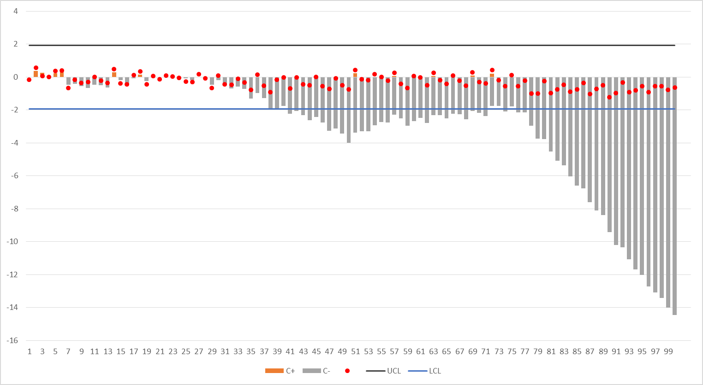

與HW7-2-vii相比，該圖的參數K= $0.5σ=0.198$ 44，H=1.984405，與optmal的CUSUM相近，因此圖形差距並不大，敏感度相似。

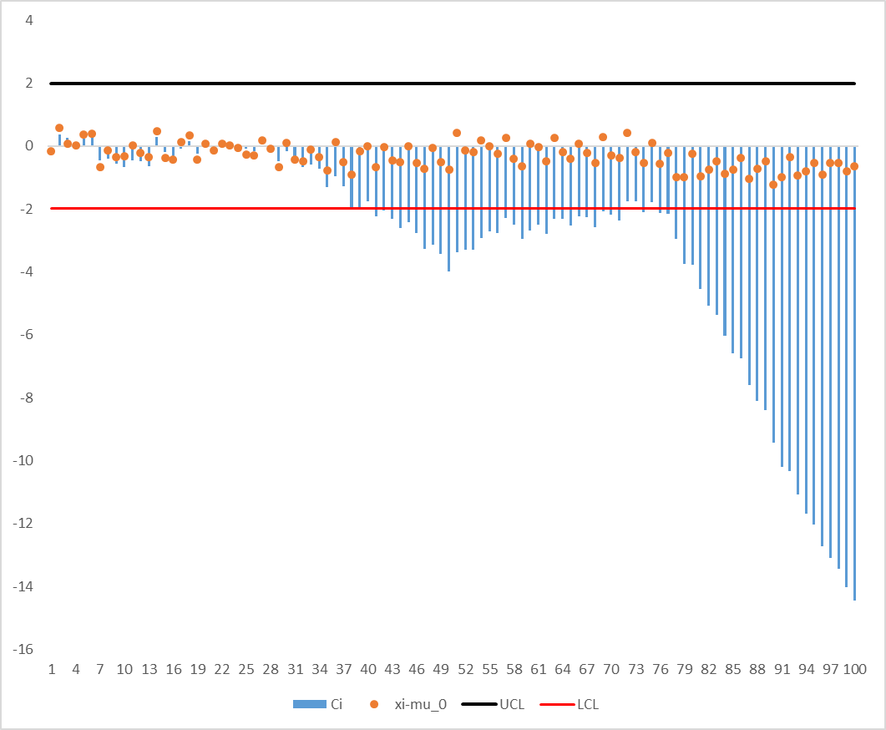

1. 當 $μ_{0}=59.5$，當($L, λ$)=(2.856, 0.133)時，可求出UCL=59.6508，LCL=59.3492，及 $\left(L, λ\right)=(2.866, 0.139)$，可求出UCL=59.65810、LCL=59.3419。將CD_site3以 $Z_{i}=λZ_{i}+\left(1-λ\right)Z_{i-1}$ 處理後，匯出EWMA如下圖：

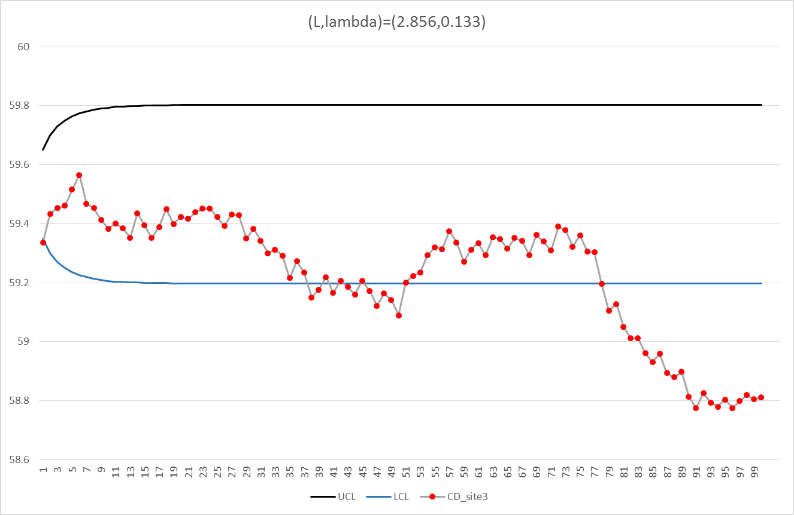

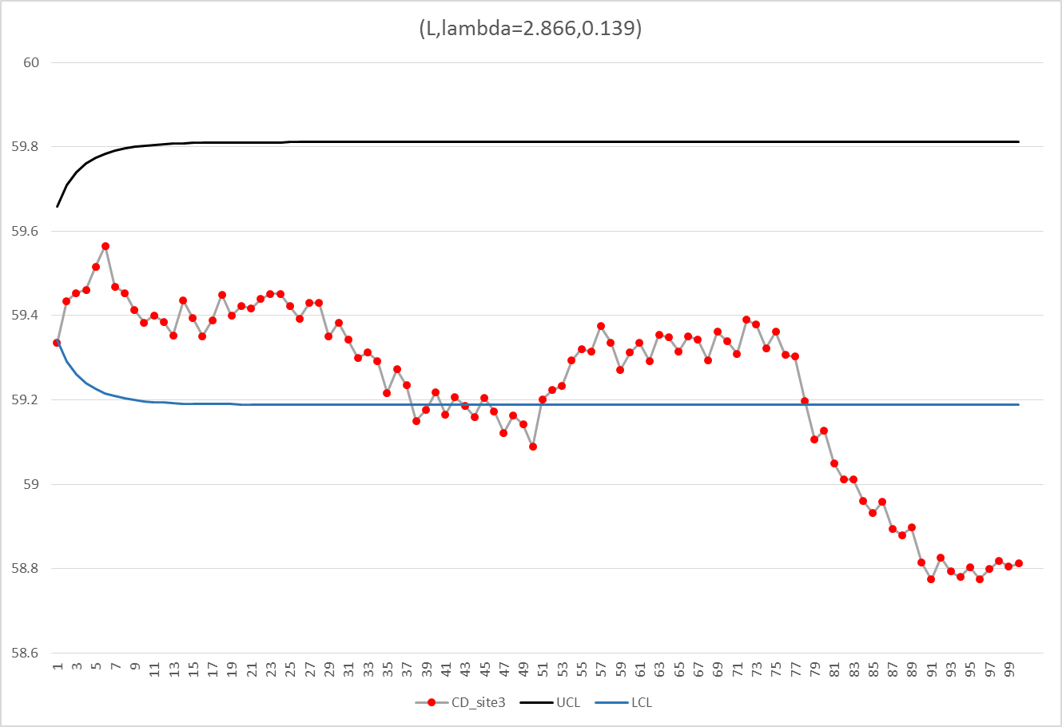

比較兩組EWMA與HW_7-2-(vii)，會發現EWMA的敏感度較CUSM來的低，且由於對於記憶的長度較短，叫先的數據會被權重所調整到較小，因此會超出上下界的sample數較少。



1. 將偏移量同為 $δ=1σ$、ARL_0=400的optimal CUSUM與EWMA在不同偏移量的ARL進行比較，可得到結果如下：

|  |  |  |  |
| --- | --- | --- | --- |
| shift | ARL(CUSUM) | ARL(EWMA) | CUSUM/EWMA |
| 0*sigma | 400 | 400 | 1 |
| 0.5*sigma | 16.3949 | 19.30564 | 0.84922852 |
| 1*sigma | 10.0225 | 9.87661 | 1.01477126 |
| 1.5*sigma | 7.123 | 6.7336 | 1.05782939 |
| 2*sigma | 5.5088 | 5.1621 | 1.06716259 |
| 2.5*sigma | 4.4871 | 4.2192 | 1.06349545 |
| 3*sigma | 3.7836 | 3.59059 | 1.0537544 |

如表所示，可以看到EWMA除了在偏移量為 $0.5σ$ 時ARL_1較長，其餘的偏移量中ARL_1皆較短。

1. 比較optimal EWMA與(ii)中所得到的結果，如下圖所示:

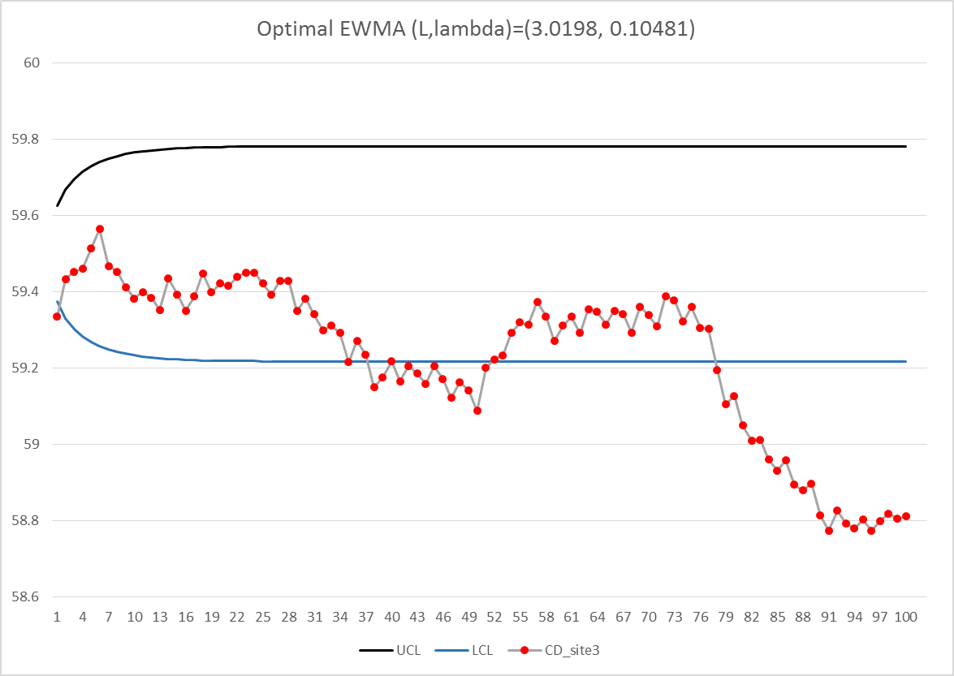

如圖所示，EWMA對於同一筆資料的判定，出界的機會較小，可見敏感度較CUSUM來的低。

2. 考量target value=60，specific window=(58,61)，針對所有晶元的CD_site 的統計結果，可得mean=59.77544、 $σ=0.537814$，求出對應的所求如下：

|  |  |
| --- | --- |
| Cp | 0.92969 |
| Cpk | 0.75897 |
| Cpm | 0.85791 |
| Cpm* | 0.57194 |

若要使 $C_{p}=2.0$，及表示在工程規格不變情況下，樣本的標準差需要變小。考量製程的流程，可以考慮加速晶圓在爐中的旋轉，使每個方向的加熱爐子在溫度控制上的偏差對每個CD site厚度的偏差影響最小。

1. 考量每個CD site的分布狀態，可將所需參數整理於下表：

|  |  |  |  |  |  |
| --- | --- | --- | --- | --- | --- |
|  | CD site 1 | CD site 2 | CD site 3 | CD site 4 | CD site 5 |
| mean | 60.270114 | 59.8406 | 59.1976 | 60.0325 | 59.5364 |
| std.s | 0.36578622 | 0.29582 | 0.39688 | 0.52637 | 0.29799 |
| Cp | 1.36691864 | 1.69023 | 1.25982 | 0.94991 | 1.6779 |
| Cpk | 0.66512985 | 1.30648 | 1.51381 | 0.61266 | 1.63718 |
| Cpm | 1.09960209 | 1.48788 | 0.55854 | 0.9481 | 0.90726 |
| Cpm* | 0.73306806 | 0.99192 | 0.37236 | 0.63207 | 0.60484 |
| P>UXL | 0.0230002 | 4.4E-05 | 2.8E-06 | 0.03303 | 4.5E-07 |
| P<LSL | 2.7154E-10 | 2.5E-10 | 0.00127 | 5.6E-05 | 1.3E-07 |
| out of spec(%) | 2.30002046 | 0.00444 | 0.12771 | 3.30886 | 5.8E-05 |

若要使 $C_{p}=2.0$，及表示在工程規格不變情況下，樣本的標準差需要變小。考量製程的流程，可以調整三個方向的爐子的垂直溫度分部，使每個方向的加熱爐子在溫度上的偏差對同一個CD site厚度的偏差影響最小。

1. 考量每個wafer內的CD site分布狀態，可將所需參數整理於下表：

|  |  |  |  |  |  |  |  |  |  |  |  |  |
| --- | --- | --- | --- | --- | --- | --- | --- | --- | --- | --- | --- | --- |
|  | CD_site1 | CD_site2 | CD_site3 | CD_site4 | CD_site5 | mean | sigma | **Cp** | **Cpk** | **Cpm** | **Cpm\*** | sigma tilda |
| 1 | 60.5162 | 59.837 | 59.3353 | 60.6154 | 59.5903 | 59.97884 | 0.565506 | **0.884163** | **0.601915** | **0.883545** | **1.76709** | 0.565902163 |
| 2 | 61.1069 | 60.2251 | 60.0777 | 61.0384 | 60.07 | 60.50362 | 0.523675 | **0.95479** | **0.315959** | **0.688188** | **1.376375** | 0.726546001 |
| 3 | 60.4273 | 60.0916 | 59.5779 | 59.667 | 59.6652 | 59.8858 | 0.362945 | **1.377619** | **1.023296** | **1.314104** | **2.628208** | 0.380487405 |
| 4 | 60.4573 | 60.1561 | 59.511 | 60.5301 | 59.5017 | 60.03124 | 0.49926 | **1.001483** | **0.646798** | **0.999528** | **1.999056** | 0.50023606 |
| 5 | 61.0794 | 60.097 | 59.8724 | 61.0229 | 60.1698 | 60.4483 | 0.561491 | **0.890487** | **0.327521** | **0.695893** | **1.391785** | 0.718501684 |
| 6 | 60.7286 | 60.6621 | 59.8892 | 60.1159 | 60.0329 | 60.28574 | 0.383337 | **1.304335** | **0.621089** | **1.045772** | **2.091544** | 0.478115802 |
| 7 | 60.1703 | 59.4637 | 58.8379 | 60.2597 | 59.6426 | 59.67484 | 0.577414 | **0.865929** | **0.764996** | **0.754519** | **1.509038** | 0.662673754 |
| 8 | 60.5165 | 59.7269 | 59.3544 | 60.4725 | 59.7791 | 59.96988 | 0.506377 | **0.987406** | **0.678098** | **0.985664** | **1.971328** | 0.507272379 |
| 9 | 60.2833 | 60.0219 | 59.1502 | 59.5856 | 59.3892 | 59.68604 | 0.46229 | **1.081572** | **0.947428** | **0.894738** | **1.789476** | 0.558822794 |
| 10 | 60.2231 | 59.8091 | 59.1907 | 60.5211 | 59.821 | 59.913 | 0.501728 | **0.996556** | **0.722171** | **0.981903** | **1.963807** | 0.509215112 |
| 11 | 60.6078 | 59.689 | 59.5104 | 60.4594 | 59.6853 | 59.99038 | 0.503853 | **0.992353** | **0.667933** | **0.992172** | **1.984344** | 0.503944914 |
| 12 | 60.0584 | 60.0024 | 59.2832 | 59.548 | 59.4336 | 59.66512 | 0.34699 | **1.440963** | **1.282342** | **1.036848** | **2.073695** | 0.482230989 |
| 13 | 60.3702 | 59.9263 | 59.147 | 60.4912 | 59.7085 | 59.92864 | 0.541035 | **0.924154** | **0.660068** | **0.916219** | **1.832438** | 0.545721122 |
| 14 | 60.7709 | 60.0212 | 59.9744 | 60.8368 | 59.7676 | 60.27418 | 0.493397 | **1.013383** | **0.490356** | **0.885802** | **1.771604** | 0.564460126 |
| 15 | 60.2213 | 59.9153 | 59.1201 | 59.5834 | 59.6324 | 59.6945 | 0.410002 | **1.219507** | **1.061377** | **0.977892** | **1.955784** | 0.511303936 |
| 16 | 60.1331 | 59.7331 | 59.0737 | 60.5905 | 60.0352 | 59.91312 | 0.561064 | **0.891164** | **0.645725** | **0.880668** | **1.761336** | 0.56775084 |
| 17 | 60.8244 | 60.132 | 59.6342 | 60.7432 | 59.7215 | 60.21106 | 0.556338 | **0.898735** | **0.472699** | **0.840297** | **1.680594** | 0.595027555 |
| 18 | 60.595 | 60.5702 | 59.8446 | 60.2178 | 60.0275 | 60.25102 | 0.330318 | **1.513693** | **0.755817** | **1.205183** | **2.410366** | 0.414874755 |
| 19 | 60.1519 | 59.4849 | 59.0719 | 60.2875 | 59.4354 | 59.68632 | 0.514593 | **0.971641** | **0.85095** | **0.829653** | **1.659305** | 0.602661907 |
| 20 | 60.7326 | 59.9997 | 59.5767 | 60.8255 | 60.1118 | 60.24926 | 0.52421 | **0.953817** | **0.477379** | **0.861396** | **1.722791** | 0.580453418 |
| 21 | 60.4442 | 60.2798 | 59.3721 | 59.8496 | 59.6713 | 59.9234 | 0.439086 | **1.138729** | **0.817304** | **1.121787** | **2.243574** | 0.445717506 |
| 22 | 60.558 | 60.2308 | 59.5891 | 60.6294 | 59.5795 | 60.11736 | 0.509306 | **0.981729** | **0.577675** | **0.956659** | **1.913317** | 0.522652535 |
| 23 | 60.5452 | 59.663 | 59.5301 | 60.4405 | 59.7173 | 59.97922 | 0.475242 | **1.052096** | **0.715973** | **1.051092** | **2.102184** | 0.475695749 |
| 24 | 60.1812 | 60.1585 | 59.455 | 59.8311 | 59.5849 | 59.84214 | 0.328336 | **1.522832** | **1.175484** | **1.372446** | **2.744892** | 0.364313097 |
| 25 | 60.4656 | 59.7521 | 59.2296 | 60.3784 | 59.5816 | 59.88146 | 0.529089 | **0.945021** | **0.704696** | **0.92216** | **1.844319** | 0.542205523 |
| 26 | 60.2171 | 59.7928 | 59.1992 | 60.1462 | 59.4706 | 59.76518 | 0.43511 | **1.149136** | **0.945984** | **1.011266** | **2.022532** | 0.494429787 |
| 27 | 60.679 | 60.0312 | 59.676 | 60.6946 | 59.7498 | 60.16612 | 0.493478 | **1.013217** | **0.563268** | **0.960268** | **1.920536** | 0.520687955 |
| 28 | 60.2856 | 60.5364 | 59.4284 | 59.7468 | 59.9994 | 59.99932 | 0.435926 | **1.146983** | **0.765175** | **1.146981** | **2.293963** | 0.435926891 |
| 29 | 60.1287 | 59.5274 | 58.8267 | 60.1089 | 59.3138 | 59.5811 | 0.552696 | **0.904657** | **0.855745** | **0.720975** | **1.44195** | 0.693505548 |
| 30 | 60.3301 | 59.6917 | 59.6014 | 60.3998 | 59.7271 | 59.95002 | 0.382335 | **1.307752** | **0.915409** | **1.29672** | **2.59344** | 0.385588287 |
| 31 | 60.0879 | 60.0963 | 59.0748 | 59.5287 | 59.5093 | 59.6594 | 0.434702 | **1.150213** | **1.027984** | **0.905396** | **1.810791** | 0.552244728 |
| 32 | 60.0727 | 59.9255 | 59.0265 | 60.2185 | 59.3554 | 59.71972 | 0.507199 | **0.985806** | **0.841405** | **0.862828** | **1.725657** | 0.5794895 |
| 33 | 60.498 | 59.7675 | 59.3883 | 60.5243 | 59.7895 | 59.99352 | 0.498806 | **1.002395** | **0.672593** | **1.00231** | **2.00462** | 0.498847644 |
| 34 | 59.4544 | 60.016 | 59.1644 | 59.3925 | 59.5823 | 59.52192 | 0.314996 | **1.587322** | **1.564126** | **0.873327** | **1.746654** | 0.572523313 |
| 35 | 60.1139 | 59.6413 | 58.7204 | 60.1391 | 59.1041 | 59.54376 | 0.624545 | **0.800583** | **0.777227** | **0.646461** | **1.292923** | 0.773441294 |
| 36 | 60.522 | 60.1795 | 59.6401 | 60.5544 | 59.8519 | 60.14958 | 0.403626 | **1.238772** | **0.702318** | **1.161573** | **2.323147** | 0.430450652 |
| 37 | 59.7652 | 59.8195 | 58.9894 | 59.1156 | 59.3309 | 59.40412 | 0.375339 | **1.33213** | **1.24698** | **0.709986** | **1.419973** | 0.704238746 |
| 38 | 59.9665 | 59.4009 | 58.5957 | 59.9417 | 59.2954 | 59.44004 | 0.56218 | **0.889395** | **0.853843** | **0.63014** | **1.26028** | 0.793474385 |
| 39 | 60.315 | 59.7813 | 59.3492 | 60.4984 | 59.5098 | 59.89074 | 0.499901 | **1.000197** | **0.739653** | **0.977131** | **1.954262** | 0.511702106 |
| 40 | 60.2152 | 60.5287 | 59.4928 | 59.5033 | 59.5491 | 59.85782 | 0.482709 | **1.03582** | **0.788729** | **0.993615** | **1.98723** | 0.503212956 |
| 41 | 59.9982 | 59.458 | 58.8212 | 60.1166 | 59.4356 | 59.56592 | 0.518014 | **0.965226** | **0.922807** | **0.739817** | **1.479634** | 0.675842836 |
| 42 | 60.5297 | 59.932 | 59.4729 | 60.5895 | 59.8498 | 60.07478 | 0.475697 | **1.051089** | **0.648326** | **1.038338** | **2.076676** | 0.481538872 |
| 43 | 60.144 | 59.9978 | 59.0518 | 59.4021 | 59.5434 | 59.62782 | 0.44531 | **1.122815** | **1.027136** | **0.861533** | **1.723066** | 0.580360685 |
| 44 | 60.122 | 59.8533 | 58.9922 | 60.1449 | 59.6087 | 59.74422 | 0.474094 | **1.054643** | **0.882933** | **0.928175** | **1.85635** | 0.538691475 |
| 45 | 60.4647 | 59.7804 | 59.5009 | 60.3826 | 59.597 | 59.94512 | 0.449167 | **1.113172** | **0.782842** | **1.104955** | **2.20991** | 0.452507184 |
| 46 | 59.9181 | 60.1042 | 58.9603 | 59.3132 | 59.7741 | 59.61398 | 0.46803 | **1.068307** | **0.98713** | **0.824154** | **1.648308** | 0.606682567 |
| 47 | 60.1301 | 59.6912 | 58.7914 | 60.1733 | 59.1663 | 59.59046 | 0.604043 | **0.827756** | **0.777837** | **0.68513** | **1.370261** | 0.72978815 |
| 48 | 60.5612 | 60.0876 | 59.4339 | 60.4631 | 59.6897 | 60.0471 | 0.485475 | **1.029919** | **0.654273** | **1.025106** | **2.050212** | 0.487754472 |
| 49 | 59.909 | 59.9883 | 58.9976 | 59.3183 | 59.5051 | 59.54366 | 0.412806 | **1.211224** | **1.175969** | **0.812547** | **1.625094** | 0.61534916 |
| 50 | 59.9923 | 59.6489 | 58.7464 | 59.9598 | 59.1805 | 59.50558 | 0.535207 | **0.934219** | **0.930744** | **0.686222** | **1.372445** | 0.728626896 |
| 51 | 61.1043 | 60.2049 | 59.9318 | 60.8897 | 60.1532 | 60.45678 | 0.509389 | **0.981567** | **0.355471** | **0.730784** | **1.461567** | 0.684196993 |
| 52 | 60.2295 | 60.1278 | 59.3683 | 59.8139 | 59.856 | 59.8791 | 0.335534 | **1.49016** | **1.113547** | **1.40193** | **2.80386** | 0.356651223 |
| 53 | 60.7804 | 59.8067 | 59.3023 | 60.5773 | 59.8628 | 60.0659 | 0.604888 | **0.826599** | **0.514751** | **0.821737** | **1.643473** | 0.608467472 |
| 54 | 60.75 | 59.8935 | 59.6791 | 60.8414 | 59.7007 | 60.17294 | 0.575502 | **0.868806** | **0.479036** | **0.83205** | **1.6641** | 0.600925384 |
| 55 | 60.4551 | 60.2238 | 59.5004 | 59.8055 | 59.6599 | 59.92894 | 0.398451 | **1.254859** | **0.89602** | **1.235367** | **2.470734** | 0.404737985 |
| 56 | 60.3195 | 59.6306 | 59.271 | 60.451 | 59.2571 | 59.78584 | 0.5692 | **0.878425** | **0.711032** | **0.822158** | **1.644315** | 0.608155925 |
| 57 | 60.9673 | 59.9522 | 59.7689 | 60.7041 | 60.0878 | 60.29606 | 0.513948 | **0.972861** | **0.456557** | **0.842997** | **1.685993** | 0.593122135 |
| 58 | 59.9257 | 59.8448 | 59.0864 | 59.4422 | 59.4461 | 59.54904 | 0.341099 | **1.46585** | **1.417927** | **0.88428** | **1.768559** | 0.565432051 |
| 59 | 60.1783 | 59.433 | 58.8502 | 60.1406 | 59.2821 | 59.57684 | 0.573399 | **0.871993** | **0.827323** | **0.70162** | **1.40324** | 0.712636709 |
| 60 | 60.2875 | 59.8001 | 59.5783 | 60.5469 | 59.4142 | 59.9254 | 0.478247 | **1.045484** | **0.748985** | **1.032992** | **2.065984** | 0.484030794 |
| 61 | 60.4904 | 60.0207 | 59.4813 | 59.6934 | 59.8112 | 59.8994 | 0.383737 | **1.302974** | **0.956036** | **1.260383** | **2.520766** | 0.396704859 |
| 62 | 60.0325 | 59.7698 | 59.0168 | 59.8108 | 59.2889 | 59.58376 | 0.417107 | **1.198734** | **1.131797** | **0.848514** | **1.697028** | 0.589265357 |
| 63 | 60.8831 | 60.1294 | 59.7628 | 60.6326 | 59.7229 | 60.22616 | 0.518194 | **0.96489** | **0.49778** | **0.884335** | **1.76867** | 0.565396461 |
| 64 | 60.0526 | 59.936 | 59.3005 | 59.5552 | 59.4016 | 59.64918 | 0.330424 | **1.513209** | **1.362715** | **1.0375** | **2.074999** | 0.481927883 |
| 65 | 60.4184 | 59.5606 | 59.1009 | 60.2908 | 59.467 | 59.76754 | 0.564574 | **0.885623** | **0.727663** | **0.818922** | **1.637844** | 0.610558703 |
| 66 | 60.5155 | 59.5419 | 59.5877 | 60.4365 | 59.4063 | 59.89758 | 0.532952 | **0.938171** | **0.689506** | **0.921313** | **1.842626** | 0.542703702 |
| 67 | 60.3555 | 60.0847 | 59.2878 | 59.5964 | 59.5282 | 59.77052 | 0.43674 | **1.144847** | **0.938378** | **1.013462** | **2.026924** | 0.493358467 |
| 68 | 60.0512 | 59.545 | 58.9763 | 60.0855 | 59.2136 | 59.57432 | 0.494299 | **1.011533** | **0.961415** | **0.766483** | **1.532965** | 0.652330414 |
| 69 | 60.9248 | 59.976 | 59.8016 | 60.6645 | 60.0629 | 60.28596 | 0.482661 | **1.035925** | **0.493128** | **0.891247** | **1.782494** | 0.56101184 |
| 70 | 60.239 | 59.9498 | 59.1938 | 59.7456 | 59.7487 | 59.77538 | 0.382492 | **1.307218** | **1.06723** | **1.127219** | **2.254437** | 0.44356972 |
| 71 | 60.4456 | 59.7708 | 59.1142 | 60.2215 | 59.2748 | 59.76538 | 0.577814 | **0.86533** | **0.712236** | **0.801756** | **1.603511** | 0.623631379 |
| 72 | 60.6727 | 60.0168 | 59.9152 | 60.6345 | 59.4723 | 60.1423 | 0.509855 | **0.98067** | **0.560747** | **0.944571** | **1.889142** | 0.529340821 |
| 73 | 60.5072 | 60.1296 | 59.3034 | 59.618 | 59.9506 | 59.90176 | 0.463521 | **1.078699** | **0.78978** | **1.055258** | **2.110516** | 0.473817692 |
| 74 | 60.2762 | 59.4334 | 58.9596 | 60.2533 | 59.3352 | 59.65154 | 0.587101 | **0.851642** | **0.765603** | **0.73236** | **1.46472** | 0.682724271 |
| 75 | 60.9508 | 60.3853 | 59.6117 | 60.3875 | 60.0287 | 60.2728 | 0.495513 | **1.009054** | **0.48919** | **0.883948** | **1.767896** | 0.565644261 |
| 76 | 59.8491 | 59.6467 | 58.9508 | 59.123 | 59.1721 | 59.34834 | 0.380676 | **1.313454** | **1.180655** | **0.662513** | **1.325027** | 0.754701761 |
| 77 | 60.2239 | 59.6311 | 59.2793 | 60.1797 | 59.4519 | 59.75318 | 0.428291 | **1.167431** | **0.970384** | **1.011489** | **2.022977** | 0.494320872 |
| 78 | 59.994 | 59.3402 | 58.5014 | 59.7491 | 59.2316 | 59.36326 | 0.571702 | **0.874581** | **0.794854** | **0.584293** | **1.168587** | 0.855734413 |
| 79 | 59.5612 | 59.709 | 58.5154 | 58.8833 | 59.323 | 59.19838 | 0.493366 | **1.013447** | **0.809663** | **0.531193** | **1.062385** | 0.94127797 |
| 80 | 60.3696 | 59.7175 | 59.2709 | 60.0944 | 59.5912 | 59.80872 | 0.430432 | **1.161624** | **0.922547** | **1.061527** | **2.123054** | 0.471019634 |
| 81 | 59.7699 | 59.4244 | 58.5411 | 59.8016 | 58.9836 | 59.30412 | 0.539406 | **0.926945** | **0.805898** | **0.567886** | **1.135771** | 0.880459131 |
| 82 | 59.7536 | 59.806 | 58.7597 | 58.9801 | 59.2243 | 59.30474 | 0.46413 | **1.077284** | **0.93705** | **0.598126** | **1.196252** | 0.835944538 |
| 83 | 60.0592 | 59.6332 | 59.0211 | 59.9445 | 59.4503 | 59.62166 | 0.414076 | **1.207507** | **1.10957** | **0.891437** | **1.782873** | 0.560892431 |
| 84 | 60.0366 | 59.518 | 58.6203 | 59.765 | 59.2901 | 59.446 | 0.538943 | **0.927742** | **0.894343** | **0.646914** | **1.293827** | 0.772900812 |
| 85 | 59.5807 | 59.7527 | 58.7463 | 59.1109 | 59.1525 | 59.26862 | 0.400907 | **1.247173** | **1.054792** | **0.599483** | **1.198966** | 0.834052131 |
| 86 | 60.5753 | 59.6743 | 59.1347 | 60.0801 | 59.4845 | 59.78978 | 0.5561 | **0.899119** | **0.725421** | **0.841032** | **1.682063** | 0.594507881 |
| 87 | 59.8815 | 59.428 | 58.4741 | 59.7458 | 59.032 | 59.31228 | 0.571499 | **0.874892** | **0.765402** | **0.559167** | **1.118335** | 0.894186768 |
| 88 | 60.0775 | 59.9759 | 58.786 | 59.2211 | 59.6387 | 59.53984 | 0.538254 | **0.928929** | **0.904257** | **0.706073** | **1.412147** | 0.708141712 |
| 89 | 60.0875 | 59.4436 | 59.0125 | 59.9681 | 59.2138 | 59.5451 | 0.468202 | **1.067916** | **1.035807** | **0.765932** | **1.531864** | 0.652799261 |
| 90 | 59.7463 | 59.347 | 58.2705 | 59.5506 | 58.9196 | 59.1668 | 0.587379 | **0.851239** | **0.662151** | **0.49047** | **0.980941** | 1.019429402 |
| 91 | 59.5332 | 59.732 | 58.5158 | 58.9822 | 59.3506 | 59.22276 | 0.482106 | **1.037117** | **0.84543** | **0.546676** | **1.093352** | 0.914618918 |
| 92 | 60.3067 | 59.4645 | 59.1637 | 60.1212 | 59.2823 | 59.66768 | 0.514253 | **0.972285** | **0.863596** | **0.816614** | **1.633228** | 0.612284447 |
| 93 | 59.7129 | 59.1805 | 58.58 | 59.6866 | 59.0019 | 59.23238 | 0.479225 | **1.043351** | **0.857203** | **0.552529** | **1.105058** | 0.904929468 |
| 94 | 59.7244 | 59.7689 | 58.6896 | 59.0174 | 59.0607 | 59.2522 | 0.473887 | **1.055105** | **0.880802** | **0.564774** | **1.129548** | 0.885309711 |
| 95 | 59.9654 | 59.4688 | 58.9586 | 59.9129 | 59.1808 | 59.4973 | 0.442443 | **1.130089** | **1.128055** | **0.746632** | **1.493264** | 0.669673861 |
| 96 | 59.8161 | 59.5173 | 58.5898 | 59.5514 | 59.0994 | 59.3148 | 0.479664 | **1.042397** | **0.913695** | **0.597795** | **1.19559** | 0.836406872 |
| 97 | 59.8729 | 59.8817 | 58.9525 | 59.1254 | 59.1892 | 59.40434 | 0.440362 | **1.135431** | **1.06302** | **0.67498** | **1.34996** | 0.740762532 |
| 98 | 60.4039 | 59.6124 | 58.954 | 60.0036 | 59.5727 | 59.70932 | 0.54028 | **0.925446** | **0.796303** | **0.81498** | **1.62996** | 0.613512094 |
| 99 | 59.7383 | 59.3571 | 58.7117 | 59.7572 | 58.9452 | 59.3019 | 0.468071 | **1.068215** | **0.927139** | **0.594887** | **1.189773** | 0.840496202 |
| 100 | 59.9693 | 59.9316 | 58.8586 | 59.1436 | 59.5216 | 59.48494 | 0.485867 | **1.029087** | **1.018755** | **0.706151** | **1.412303** | 0.708063508 |

若要使 $C_{p}=2.0$，及表示在工程規格不變情況下，樣本的標準差需要變小。考量製程的流程，可以考慮加速晶圓在爐中的旋轉，使每個方向的加熱爐子在溫度控制上的偏差對每個CD site厚度的偏差影響最小。