4-a

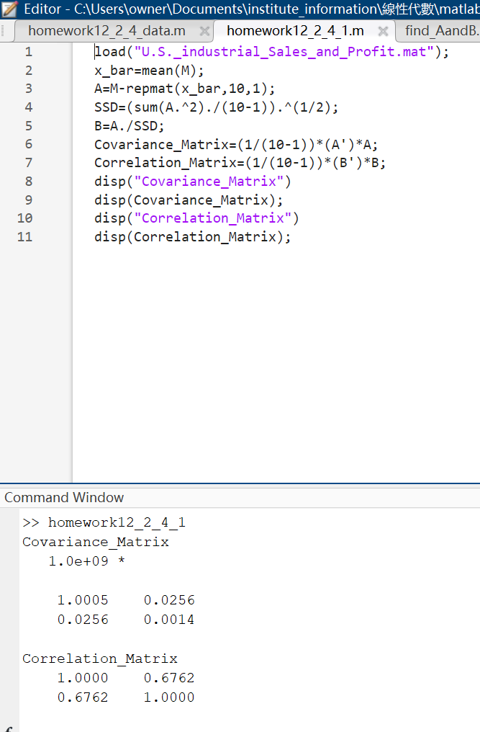

4-b

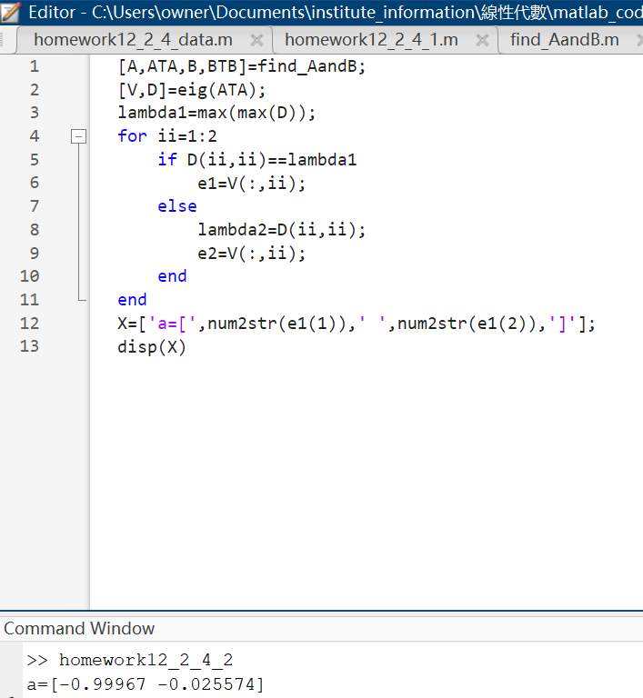

4-c

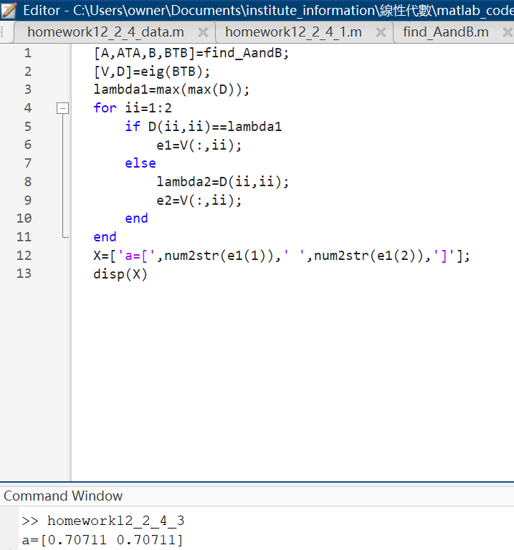

4-d

The index found in (b) is the eigenvector of ATA. The matrix A has not been normalized yet. The index found in (c) is the eigenvector of BTB. The matrix B has been normalized.

4-e

