5. (10%) Fig. 4 shows two kinematic chains. Find the characteristic polynomials of the two graphs. Use Matlab. By visual inspection, are they isomorphic?

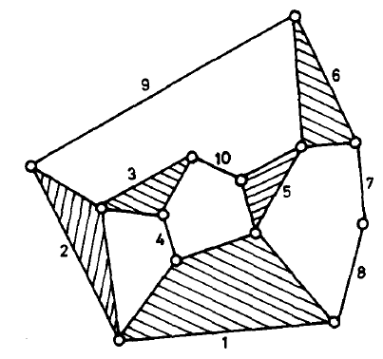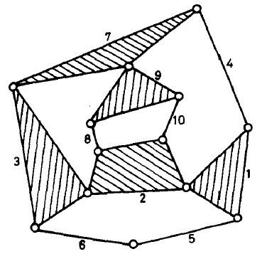

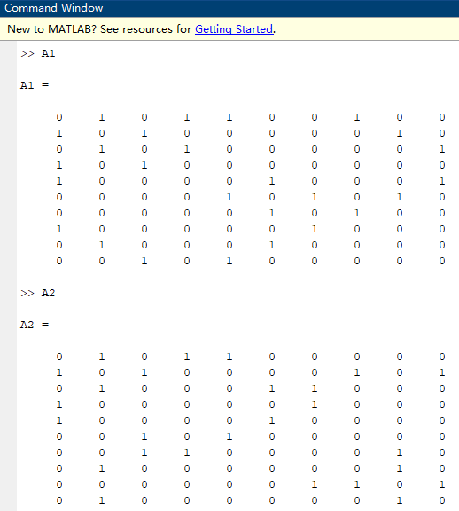

No, they are not isomorphic.

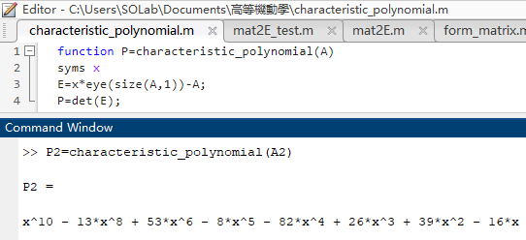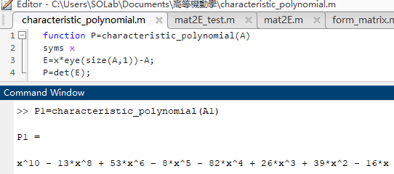

6. (20%) Fig. 5a & 5b are two graphs.

(a) (5%) Find the characteristic polynomials of the two graphs. Use Matlab.

(b) (10%) Find the degree code for each of the two graphs.

(c) (5%) Are they isomorphic?

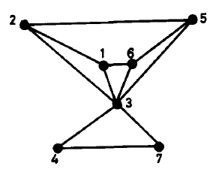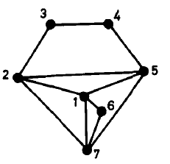

6-a.

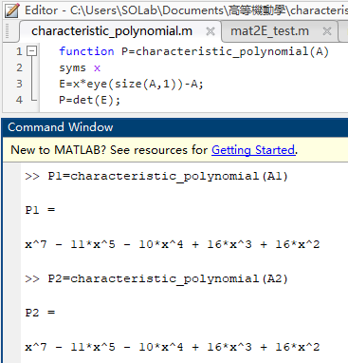

6-b.

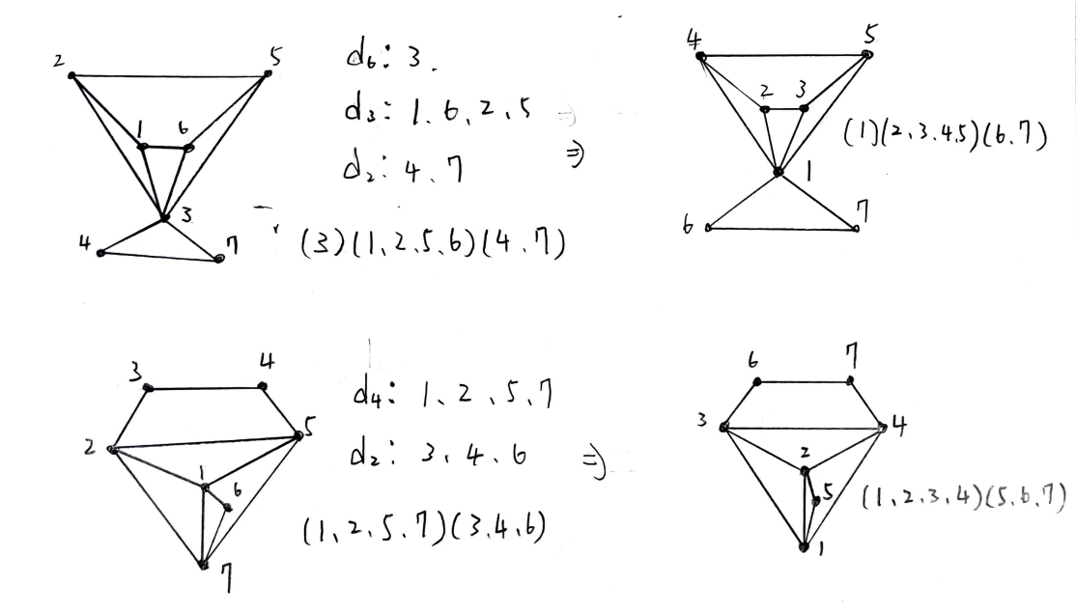

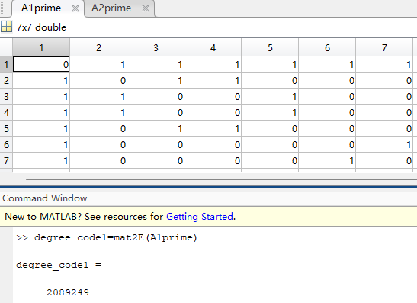

$$A_{1}^{'}= \left[\begin{matrix}\begin{matrix}0 & 1 & 1 \\ 1 & 0 & 1 \\ 1 & 1 & 0\end{matrix} & \begin{matrix}1 & 1 & \begin{matrix}1 & 1\end{matrix} \\ 1 & 0 & \begin{matrix}0 & 0\end{matrix} \\ 0 & 1 & \begin{matrix}0 & 0\end{matrix}\end{matrix} \\ \begin{matrix}1 & 1 & 0 \\ 1 & 0 & 1 \\ \begin{matrix}1 \\ 1\end{matrix} & \begin{matrix}0 \\ 0\end{matrix} & \begin{matrix}0 \\ 0\end{matrix}\end{matrix} & \begin{matrix}0 & 1 & \begin{matrix}0 & 0\end{matrix} \\ 1 & 0 & \begin{matrix}0 & 0\end{matrix} \\ \begin{matrix}0 \\ 0\end{matrix} & \begin{matrix}0 \\ 0\end{matrix} & \begin{matrix}\begin{matrix}0 \\ 1\end{matrix} & \begin{matrix}1 \\ 0\end{matrix}\end{matrix}\end{matrix}\end{matrix}\right] , A_{2}^{'}= \left[\begin{matrix}\begin{matrix}0 & 1 & 1 \\ 1 & 0 & 1 \\ 1 & 1 & 0\end{matrix} & \begin{matrix}1 & 1 & \begin{matrix}0 & 0\end{matrix} \\ 1 & 1 & \begin{matrix}0 & 0\end{matrix} \\ 1 & 0 & \begin{matrix}1 & 0\end{matrix}\end{matrix} \\ \begin{matrix}1 & 1 & 1 \\ 1 & 1 & 0 \\ \begin{matrix}0 \\ 0\end{matrix} & \begin{matrix}0 \\ 0\end{matrix} & \begin{matrix}1 \\ 0\end{matrix}\end{matrix} & \begin{matrix}0 & 0 & \begin{matrix}0 & 1\end{matrix} \\ 0 & 0 & \begin{matrix}0 & 0\end{matrix} \\ \begin{matrix}0 \\ 1\end{matrix} & \begin{matrix}0 \\ 0\end{matrix} & \begin{matrix}\begin{matrix}0 \\ 1\end{matrix} & \begin{matrix}1 \\ 0\end{matrix}\end{matrix}\end{matrix}\end{matrix}\right]$$

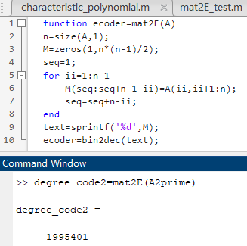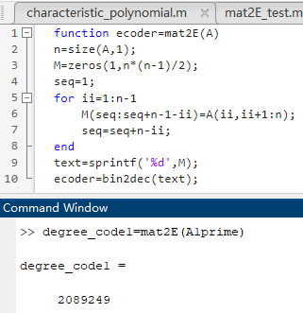

6-c.

No, they are not isomorphic.