1. (20%) Fig. 1 is an RPRP four-bar linkage where parameters are defined as shown in the figure. Axes **z**1 and **z**3 are pointing out of paper. A* is the origin of the coordinate system. (1) Find the D-H parameters for the D-H transformation matrices 2T1, 3T2, 4T3, and 1T4. (2) Analyze the linkage to find equations of all other joint variables when angle θ12 (included angle of x1 and x2) is given as an input. (3) Use vector loop method to verify you answer found by DH method. Let φ be the input for the vector loop method. Plot the linear displacement of AA* and A*B versus input φ.

1. (20%) Consider an RPR arm in Fig. 2, (1) Find the inverse kinematics needed to bring the end effector of the manipulator shown in Fig. 3 to a given position **p=**[px, py, pz]T by the D-H method. (2) How many number of possible arm configurations exist? (3) If d1=0.5, a2=1, and a3=0.2, and **p**=[1.28, 0.253, 0.442]T, find all possible configurations of the arm.
2. (20%) Continue with Problem 2, (a) Obtain an expression for the Jacobin matrix and its determinant in terms of joint variables of the arm as in Fig. 2 in two ways: (i) direct differentiation from the position equation and (ii) the recursive vector method in the classnote (Sec. 9.7.5) (b) Find the singular conditions of the robot, if any?
3. (20%) As shown in Fig. 3, a robot is set up 1 m from a table. The table top is 1 m high and 1×1 m2. A frame *o*1*x*1*y*1*z*1 is fixed to the edge of the table as shown. A cube measuring 0.2 m on a side is place in the center of the table with frame *o*2*x*2*y*2*z*2 established at the center of the cube bottom surface. A camera is situated directly above the center of the block 2 m from the table top with frame *o*3*x*3*y*3*z*3.
   1. (12%) Find the homogeneous transformation matrix 0T1, 0T2, and 0T3.
   2. (8%) If the cube on the table is rotated 90° about *z*2 and moved so that the cube center (方塊中心, not the origin of the coordinate system) has coordinate [0, 0.8, 0.1]T (unit: m) relative to the frame *o*1*x*1*y*1*z*1, find the new transformation matrix relating the cube frame to camera frame 3, 3T2,new , and cube frame to the base frame 0, 0T2, new.
4. (20%) In Fig.5, a rotation matrix about an arbitrary axis **k=**[*kx*, *ky*, *kz*]T with θ angle is to be derived by the following sequence: first rotating k about the *z*0 axis with -α angle, followed by a rotation of -β angle about *y*0 axis, then a rotation of θ about the *z*0 axis, and then reverse the above sequence of rotations. (a) Find the resultant rotation matrix if **k**=(1/, 1/, 1/)T and θ=30 degree. (b) Compare the resultant rotation matrix with the one derived by Rodrigue’s formula, are they different? or the same? Hint: express α and β in terms of (*kx*, *ky*, *kz*)

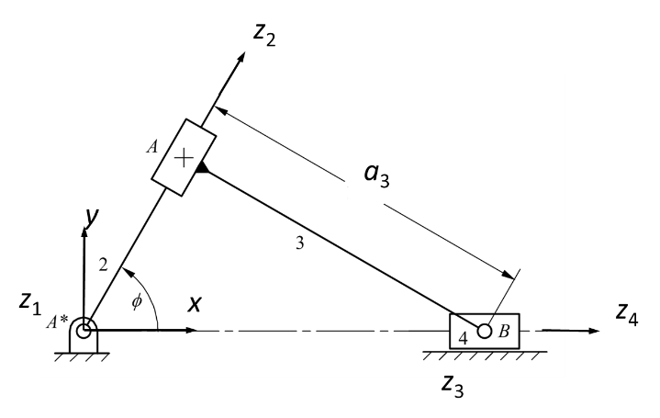

Fig. 1

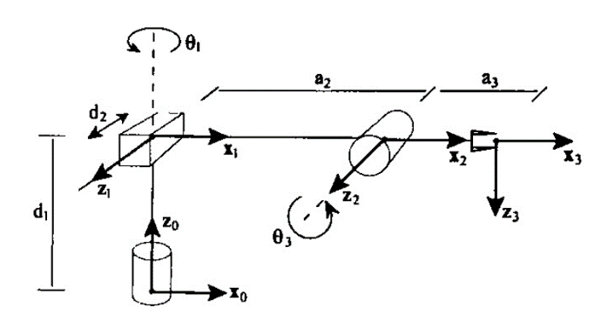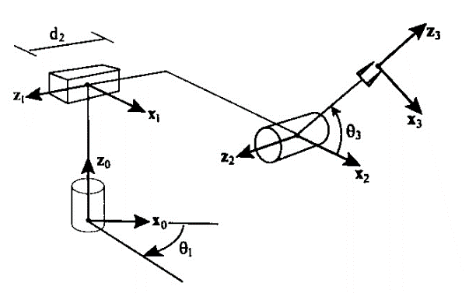

Fig. 2 RPR arm (a) in home position (b) in arbitrary position

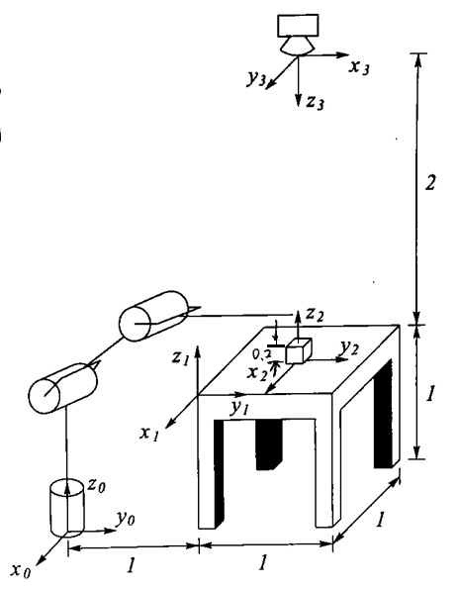 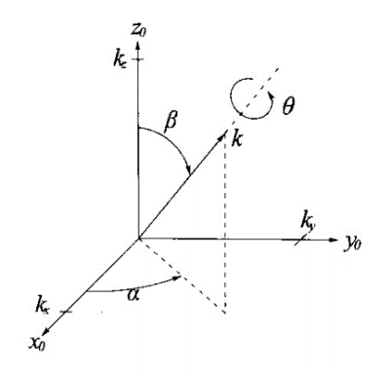

Fig. 3 Fig. 4