1. (15%)For the linkage shown in Fig. 1, construct fixed and moving polodes for coupler link 3.
2. (15%) Consider the circular polodes of diameter ratio 1:2 in Fig. 1, find the inflection circle.

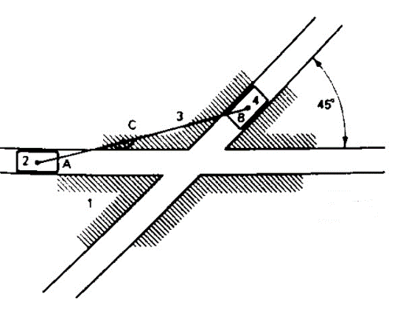 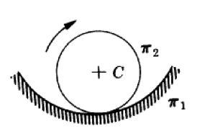

Fig. 1 Fig.2

3. (20%) Determine the pole tangent and inflection circle for link 3 and frame of the mechanisms of Fig. 3. (a) OAA=1.25, AB=2.5, OAB=3.2, AC=1.0, AD=3.5, unit: inch. (b) Dimension is shown in the picture. (Use CAD)

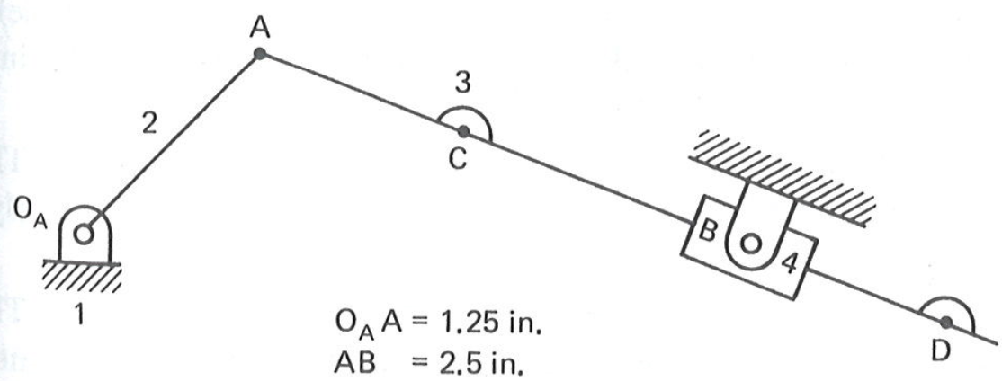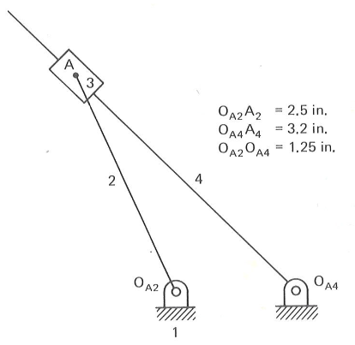

1. (b)

Fig. 3

4.(20%) For the geared five-bar linkage of Fig. 3, (a) construct the inflection circles for the motion of link 4 with respect to ground (link 1). (b) Then find the centers of path curvature for coupler points D using Euler-Savary equation. (Use CAD to draw). Note: OAA=1, AB=0.75, BD=1.75, DC=1.5, BC=2.5, OcC=1.3, OAOc=1.8, T2=40 teeth, T3=20 teeth

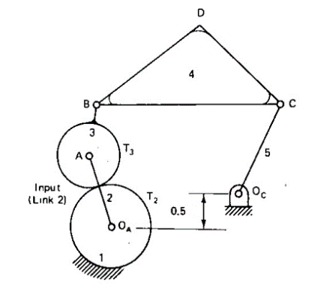 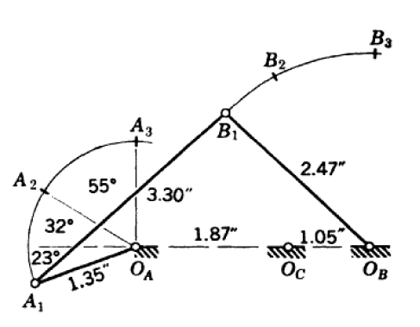

Fig. 3 Fig. 4

1. (20%) The four-bar linkage OAABOB assumes three positions as shown in Fig. 4. Find a point C of the coupler AB that will assume three positions C1, C2, C3 equidistant from OC when the linkage takes its three positions. Locate the positions C1, C2, C3 of C, and check you answer. (Adapted from book problem 8-11 in “Kinematic Synthesis of Linkage, by Hartenberg & Denavit)
2. (15%) The pole triangle is given for motion of a rigid body through three positions as shown in Fig. 5. (a) Find B1 and B3 corresponding to the given B2. (b) Find the locations (in position 1) of all points (i.e. locus) having three positions on straight lines. (Hint: see Section 6-6)

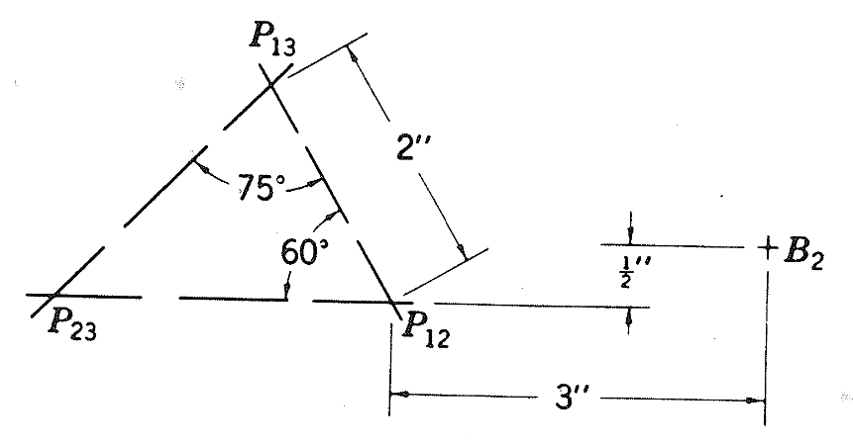 Fig. 5