1. (25%) A function generator (Fig. 1) is to be synthesized such that the rotation φj of the input crank and the displacement Sj of the output slider are prescribed. Note that **Z**4 is fixed to the slider at an known constant angle *α*. The initial position of the slider **Z**1 is given as (1, 0); (a) Write the loop-closure equation, (b) Determine the maximum number of positions that this linkage can be synthesized for, (c) What is the maximum number of positions for which a linear solution is obtainable?



Fig. 1

2. (25%) A four-bar linkage must be designed to accomplish one task in an automatic sewing machine. As input link (*A*0*A*) rotates through φ2 = 25°ccw, φ3 = 135°ccw, the coupler point *C* must travel *C*1, *C*2, and *C*3 to catch the thread loop.

(a) If the positions of *A*0, *B*0, and *A* are prescribed (see the figure, assume your proper *A*), find the location of *B* by the graphical method and draw the linkage in its three design positions using CAD.

Note: you must write down your procedure for graphic construction.

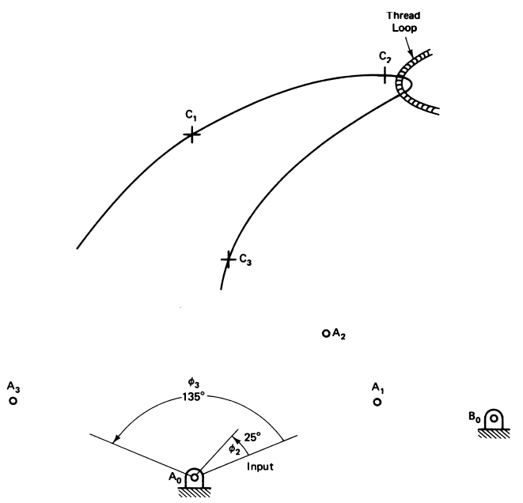 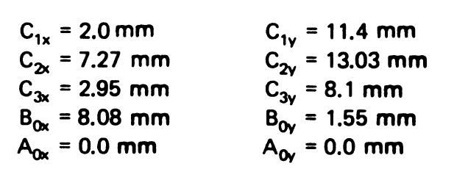

Fig. 2

1. (25%)(a) Design a four-bar linkage whose coupler moves through the three positions indicated by the line segment shown in Fig. 3. Point A is to be one moving pivot, and C* is to be one fixed pivot (See Fig. 3). Draw the four-bar linkage in position 1 using CAD. (b) Does the linkage you found have any defect? *A*2*B*2 and *A*3*B*3 are horizontal, and position *A*1*B*1 is vertical. *AB* = 3.5

Fig. 3 Figure is not in scale

1. (25%) A rigid body in plane motion is to pass through four specified positions. The positions are such that a part of the pole configuration is shown in Fig. 4. Draw the center curve using CAD.

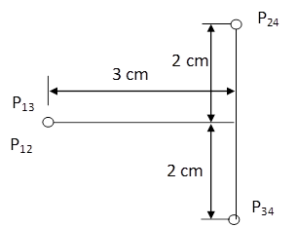

Fig. 4