PHP_OOP代码阅读练习题01

- 阅读下面PHP程序代码，写出执行结果：
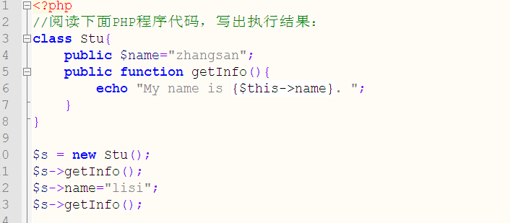
Zhangsan lisi
- 阅读下面PHP程序代码，写出执行结果：
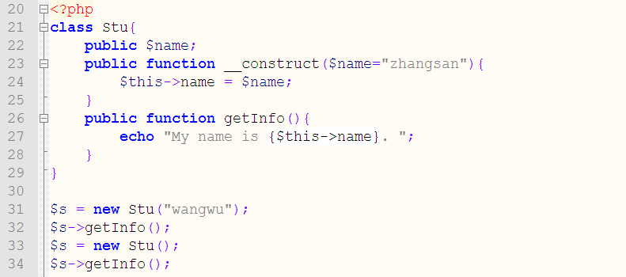
- 阅读下面PHP程序代码，写出执行结果：
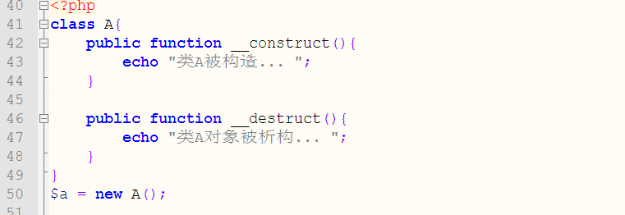
- 阅读下面PHP程序代码，写出执行结果：
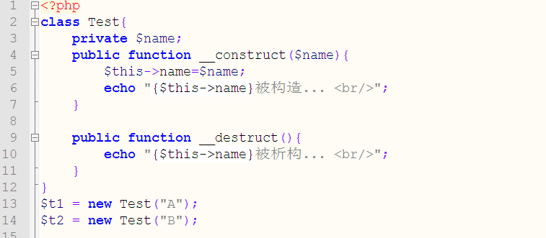
- 阅读下面PHP程序代码，写出执行结果：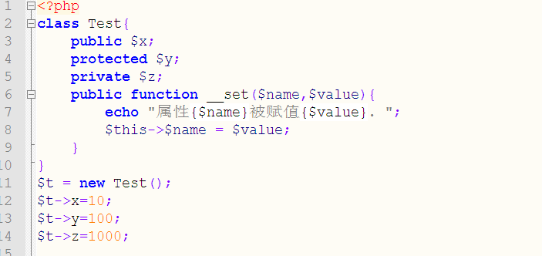

- 阅读下面PHP程序代码，写出执行结果：
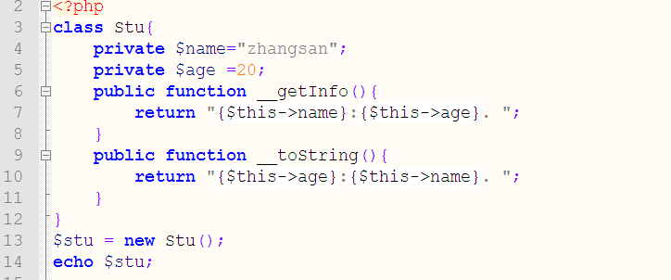
- 阅读下面PHP程序代码，写出执行结果：
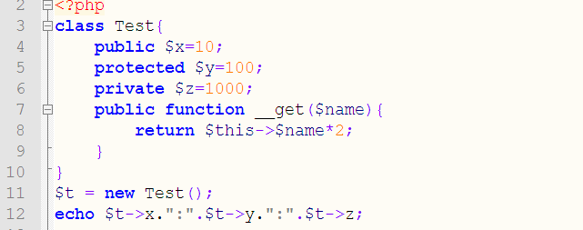
- 阅读下面PHP程序代码，写出执行结果：
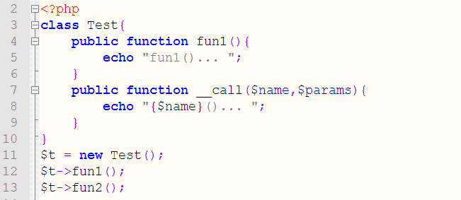
- 阅读下面PHP程序代码，写出执行结果：
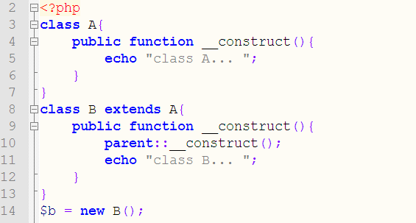
- 阅读下面PHP程序代码，写出执行结果：
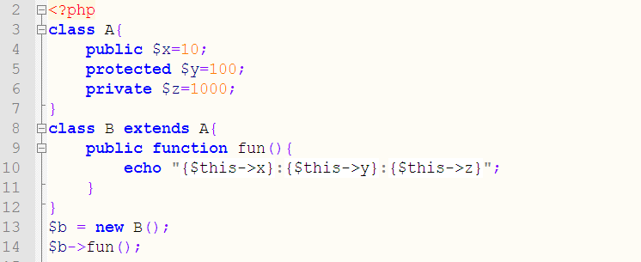
- 阅读下面PHP程序代码，写出执行结果：
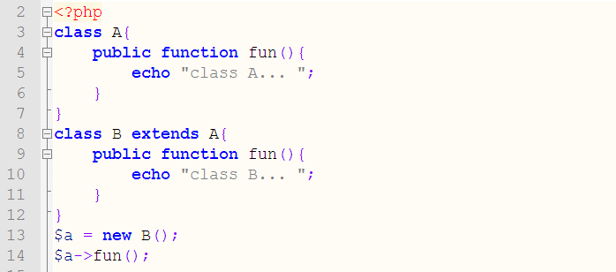
- 阅读下面PHP程序代码，写出执行结果：
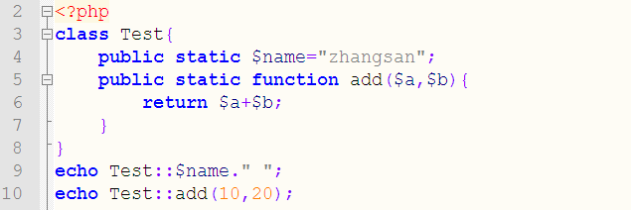

- 阅读下面PHP程序代码，写出执行结果：
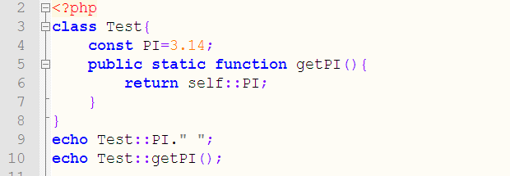
- 阅读下面PHP程序代码，写出执行结果：
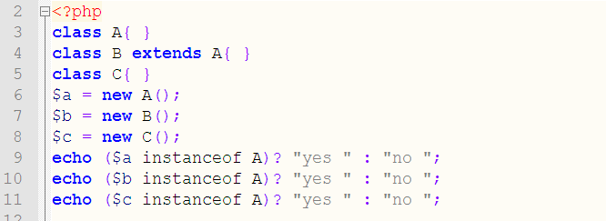
- 阅读下面PHP程序代码，写出执行结果：
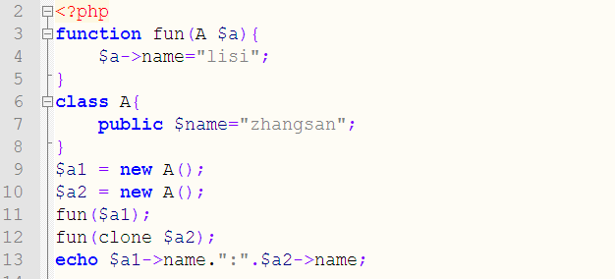
- 阅读下面PHP程序代码，写出执行结果：
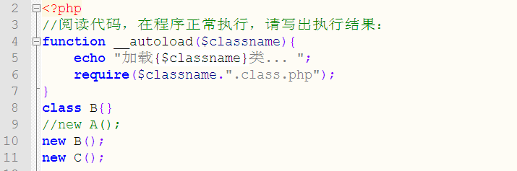
- 阅读下面PHP程序代码，请指出代码执行错误的行号，以及错误原因。
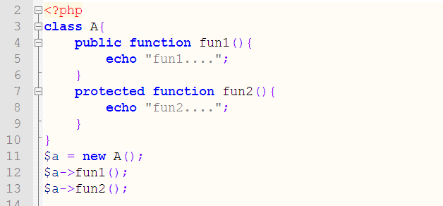
- 阅读下面PHP程序代码，请指出代码执行错误的行号，以及错误原因。
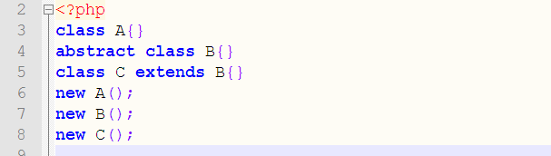

- 阅读下面PHP程序代码，请指出代码报错原因, 如何修改才可正常 。
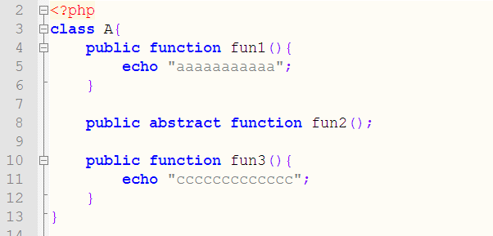
- 阅读下面PHP程序代码，请指出代码报错原因, 如何修改才可正常 。
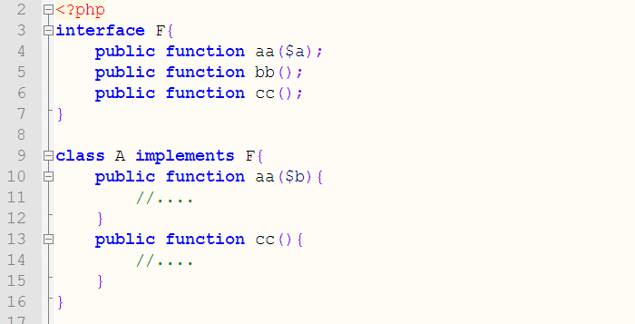
<?php
//1
/* class stu{
public $name="zhangsan";
public function getInfo(){
echo "My name is {$this -> name}.";
}
}

$s = new stu();
$s -> getInfo();
$s -> name = "lisi";
$s -> getInfo(); */
//My name is zhangsan.My name is lisi\

//2
/* class stu{
public $name;
public function __construct($name="zhangsan"){
$this -> name = $name;
}
public function getInfo(){
echo "My name is {$this -> name}.";
}
}

$s = new stu("wangwu");
$s -> getInfo();
$s = new stu();
$s -> getInfo(); */
//My name is wangwu.My name is zhangsan

//3
/* class A{
public function __construct(){
echo "类A被构造....";
}
public function __destruct(){
echo "类A对象被析构....";
}
}
$a = new A(); */
//类A被构造....类A对象被析构....

//4
/* class Test{
private $name;
public function __construct($name){
$this -> name = $name;
echo "{$this->name}被构造....</br>";
}
public function __destruct(){
echo "{$this->name}被析构....";
}
}
$t1 = new Test("A");
$t2 = new Test("B"); */

/* A被构造....
B被构造....
B被析构....A被析构.... */

//5
/* class Test{
public $x;
protected $y;
private $z;
public function __set($name,$value){
echo "属性{$name}被赋值{$value}.";
$this ->$name = $value;
}
}
$t = new Test();
$t -> x =10;
$t -> y =100;
$t -> z =1000; */

//属性y被赋值100.属性z被赋值1000.

//6
/* class Stu{
private $name="zhangsan";
private $age=20;
public function __getInfo(){
return "{$this -> name}:{$this -> age}";
}
public function __toString(){
return "{$this -> age}:{$this -> name}.";
}
}
$stu = new Stu();
echo $stu; */

//20:zhangsan.

//7
/* class Test{
public $x=10;
protected $y=100;
private $z=1000;
public function __get($name){
return $this -> $name*2;
}
}
$t = new Test();
echo $t->x.":".$t->y.":".$t->z; */
//10:200:2000

//8
/* class Test{
public function fun1(){
echo "fun1()...";
}
public function __call($name,$params){
echo "{$name}()...";
}
}
$t = new Test();
$t -> fun1();
$t -> fun2(); */
//fun1()...fun2()...

//9
/* class A {
public function __construct(){
echo "class A...";
}
}
class B extends A{
public function __construct(){
parent::__construct();
echo "class B...";
}
}
$b = new B(); */
//class A...class B...

//10
/* class A{
public $x=10;
protected $y=100;
private $z=1000;
}
class B extends A{
public function fun(){
echo "{$this -> x}:{$this -> y}:{$this -> z}";
//删除“:{$this -> z”不报错
}
}
$b = new B();
$b -> fun(); */
//Notice: Undefined property: B::$z in E:\xampp\htdocs\ssss.php on line 147
//10:100:

//11
/* class A{
public function fun(){
echo "class A...";
}
}
class B extends A{
public function fun(){
echo "class B...";
}
}
$a = new B();
$a -> fun(); */

//class B...

//12
/* class Test{
public static $name="zhangsan";
public static function add($a,$b){
return $a + $b;
}
}
echo Test::$name." ";
echo Test::add(10,20); */
//zhangsan 30

//13
/* class Test{
const PI=3.14;
public static function getPI(){
return self::PI;
}
}
echo Test::PI." ";
echo Test::getPI(); */
//3.14 3.14

//14
/* class A{ }
class B extends A{ }
class C { }
$a = new A();
$b = new B();
$c = new C();
echo ($a instanceof A)?"yes " : "no ";
echo ($b instanceof A)?"yes " : "no ";
echo ($c instanceof A)?"yes " : "no "; */
//yes yes no

//15
/* function fun (A $a){
$a -> name ="lisi";
}
class A{
public $name = "zhangsan";
}
$a1 = new A();
$a2 = new A();
fun($a1);
fun(clone $a2);
echo $a1 -> name.":".$a2->name; */
//lisi:zhangsan

//16
/* function __autoload($classname){
echo "加载{$classname}类...";
require($classname."class.php");
}
class B{}
new B();
new C(); */

//加载C类...
//

//17
/* class A{
public function fun1(){
echo "fun1...";
}
public function fun2(){
echo "fun2...";
}
}
$a = new A();
$a -> fun1();
$a -> fun2(); */
//fun1...fun2...
//protected 是受保护的不能再类的外部调用
//18
class A{}
abstract class B{}
class C extends B{}
new A();
new B();
new C(); /**/
//抽象类不能实例化，实现抽象类需要有一个子类继承
/* class A{
public function fun1(){
echo "aaaaaaaaaa";
}
public abstract function fun2();

public function fun3(){
echo "cccccccc";
}
} */
//普通类中不能有抽象方法，但抽象类中可以有普通方法
//20
/* interface F{
public function aa($a);
public function bb();
public function cc();
}
class A implements F{
public function aa($b){
//.....
}
public function cc(){
//.....
}
} */
//子类要继承父类中所有的方法

