"question": "what is langgraph?"
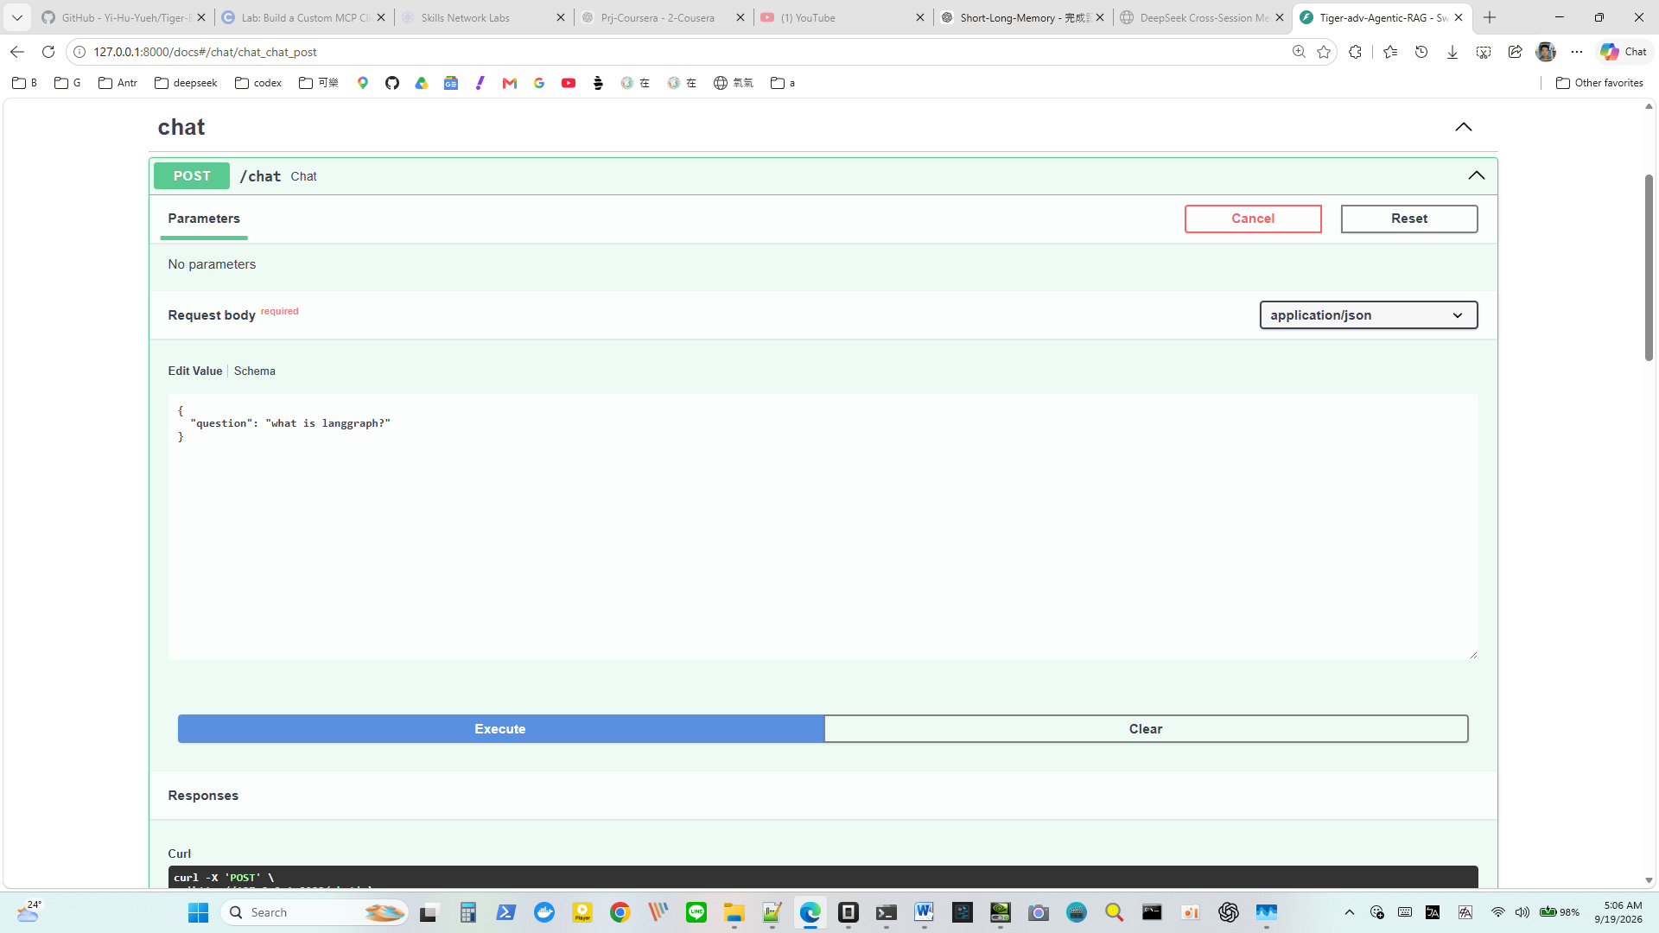

AI
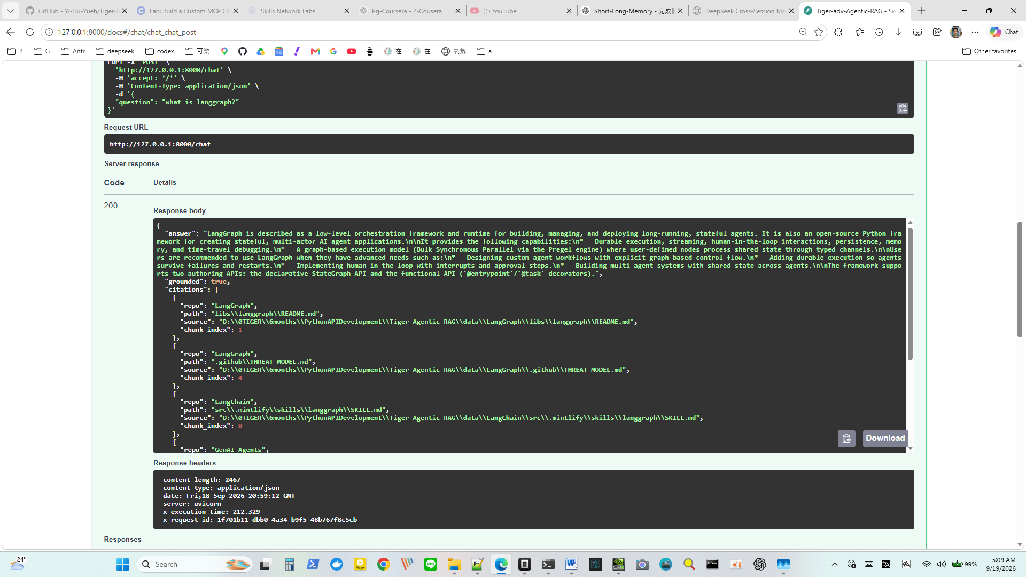

{
"answer": "LangGraph is described as a low-level orchestration framework and runtime for building, managing, and deploying long-running, stateful agents. It is also an open-source Python framework for creating stateful, multi-actor AI agent applications.\n\nIt provides the following capabilities:\n* Durable execution, streaming, human-in-the-loop interactions, persistence, memory, and time-travel debugging.\n* A graph-based execution model (Bulk Synchronous Parallel via the Pregel engine) where user-defined nodes process shared state through typed channels.\n\nUsers are recommended to use LangGraph when they have advanced needs such as:\n* Designing custom agent workflows with explicit graph-based control flow.\n* Adding durable execution so agents survive failures and restarts.\n* Implementing human-in-the-loop with interrupts and approval steps.\n* Building multi-agent systems with shared state across agents.\n\nThe framework supports two authoring APIs: the declarative StateGraph API and the functional API (`@entrypoint`/`@task` decorators).",

"grounded": true,

"citations": [
{
"repo": "LangGraph",
"path": "libs\\langgraph\\README.md",
"source": "D:\\0TIGER\\6months\\PythonAPIDevelopment\\Tiger-Agentic-RAG\\data\\LangGraph\\libs\\langgraph\\README.md",
"chunk_index": 1
},

{
"repo": "LangGraph",
"path": ".github\\THREAT_MODEL.md",
"source": "D:\\0TIGER\\6months\\PythonAPIDevelopment\\Tiger-Agentic-RAG\\data\\LangGraph\\.github\\THREAT_MODEL.md",
"chunk_index": 4
},

{
"repo": "LangChain",
"path": "src\\.mintlify\\skills\\langgraph\\SKILL.md",
"source": "D:\\0TIGER\\6months\\PythonAPIDevelopment\\Tiger-Agentic-RAG\\data\\LangChain\\src\\.mintlify\\skills\\langgraph\\SKILL.md",
"chunk_index": 0
},

{
"repo": "GenAI_Agents",
"path": "all_agents_tutorials\\chiron_learning_agent_langgraph.ipynb",
"source": "D:\\0TIGER\\6months\\PythonAPIDevelopment\\Tiger-Agentic-RAG\\data\\GenAI_Agents\\all_agents_tutorials\\chiron_learning_agent_langgraph.ipynb",
"chunk_index": 169
},

{
"repo": "LangChain",
"path": "src\\.mintlify\\skills\\langgraph\\SKILL.md",
"source": "D:\\0TIGER\\6months\\PythonAPIDevelopment\\Tiger-Agentic-RAG\\data\\LangChain\\src\\.mintlify\\skills\\langgraph\\SKILL.md",
"chunk_index": 1
},

{
"repo": "agents-towards-production",
"path": "tutorials\\LangGraph-agent\\langgraph_tutorial.ipynb",
"source": "D:\\0TIGER\\6months\\PythonAPIDevelopment\\Tiger-Agentic-RAG\\data\\agents-towards-production\\tutorials\\LangGraph-agent\\langgraph_tutorial.ipynb",
"chunk_index": 87
}
]
}

