結果分析
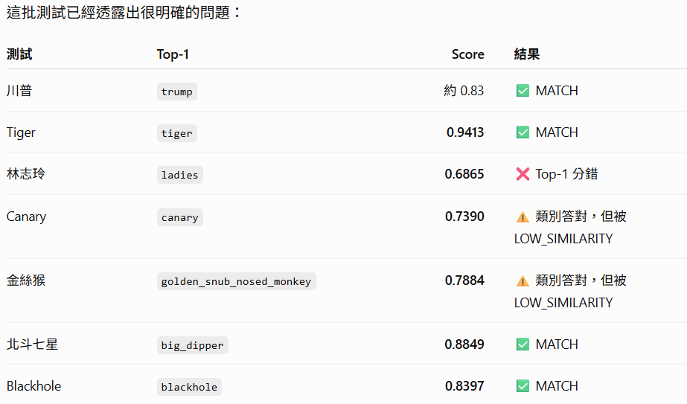

這反映 SigLIP 比較擅長：

老虎 vs 鱷魚
鯨魚 vs 老鷹
金絲猴 vs 老虎
黑洞 vs 北斗七星

這種語意/物件類別辨識。

但是：

林志玲
vs
一般女性 ladies

屬於特定人物身份辨識，單靠通用 SigLIP embedding 天生就不是最佳工具。

所以目前系統不是失敗，反而已經把架構邊界測出來了。

我目前會把狀態判定成
一般物件辨識 ✅ 成功
動物辨識 ✅ 成功
抽象/天文類別 ✅ 成功
人物大類辨識 ✅ 可做
特定人物身份辨識 ⚠️ 需要另外處理
Unknown rejection 尚未驗證

下一步最重要的不是繼續增加 reference 圖片，而是做 Unknown Test + threshold calibration。等這一步完成，我們才正式決定 MATCH_THRESHOLD 和 AMBIGUITY_MARGIN。

川普

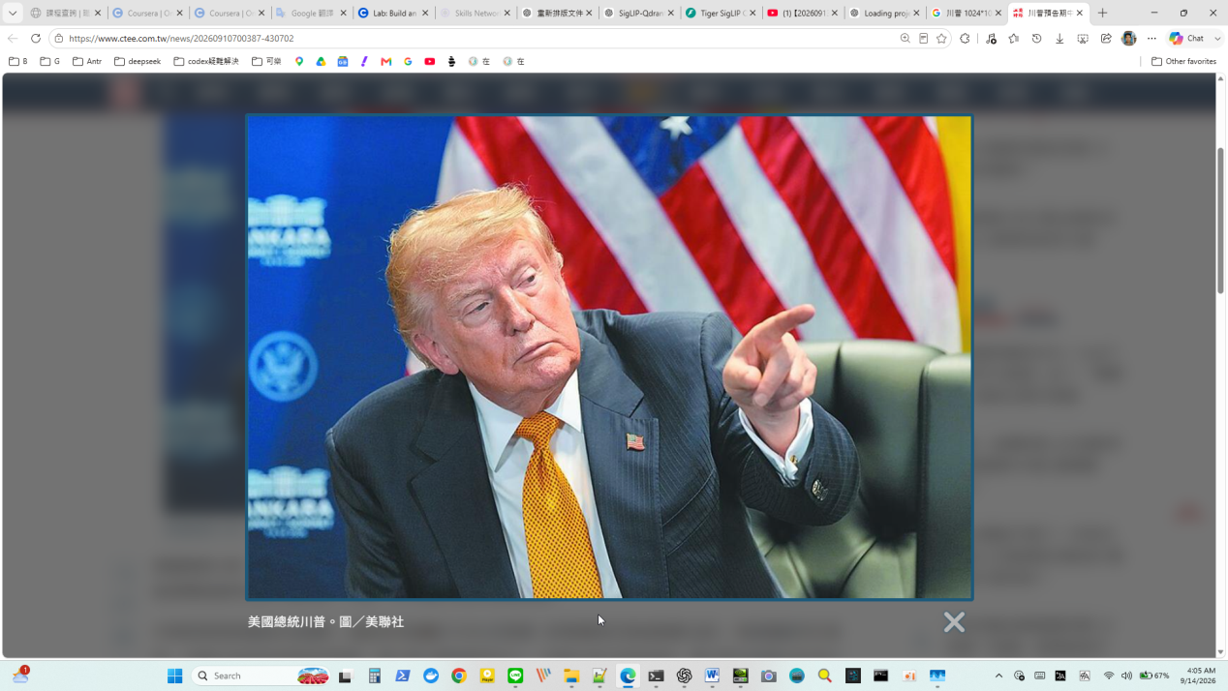

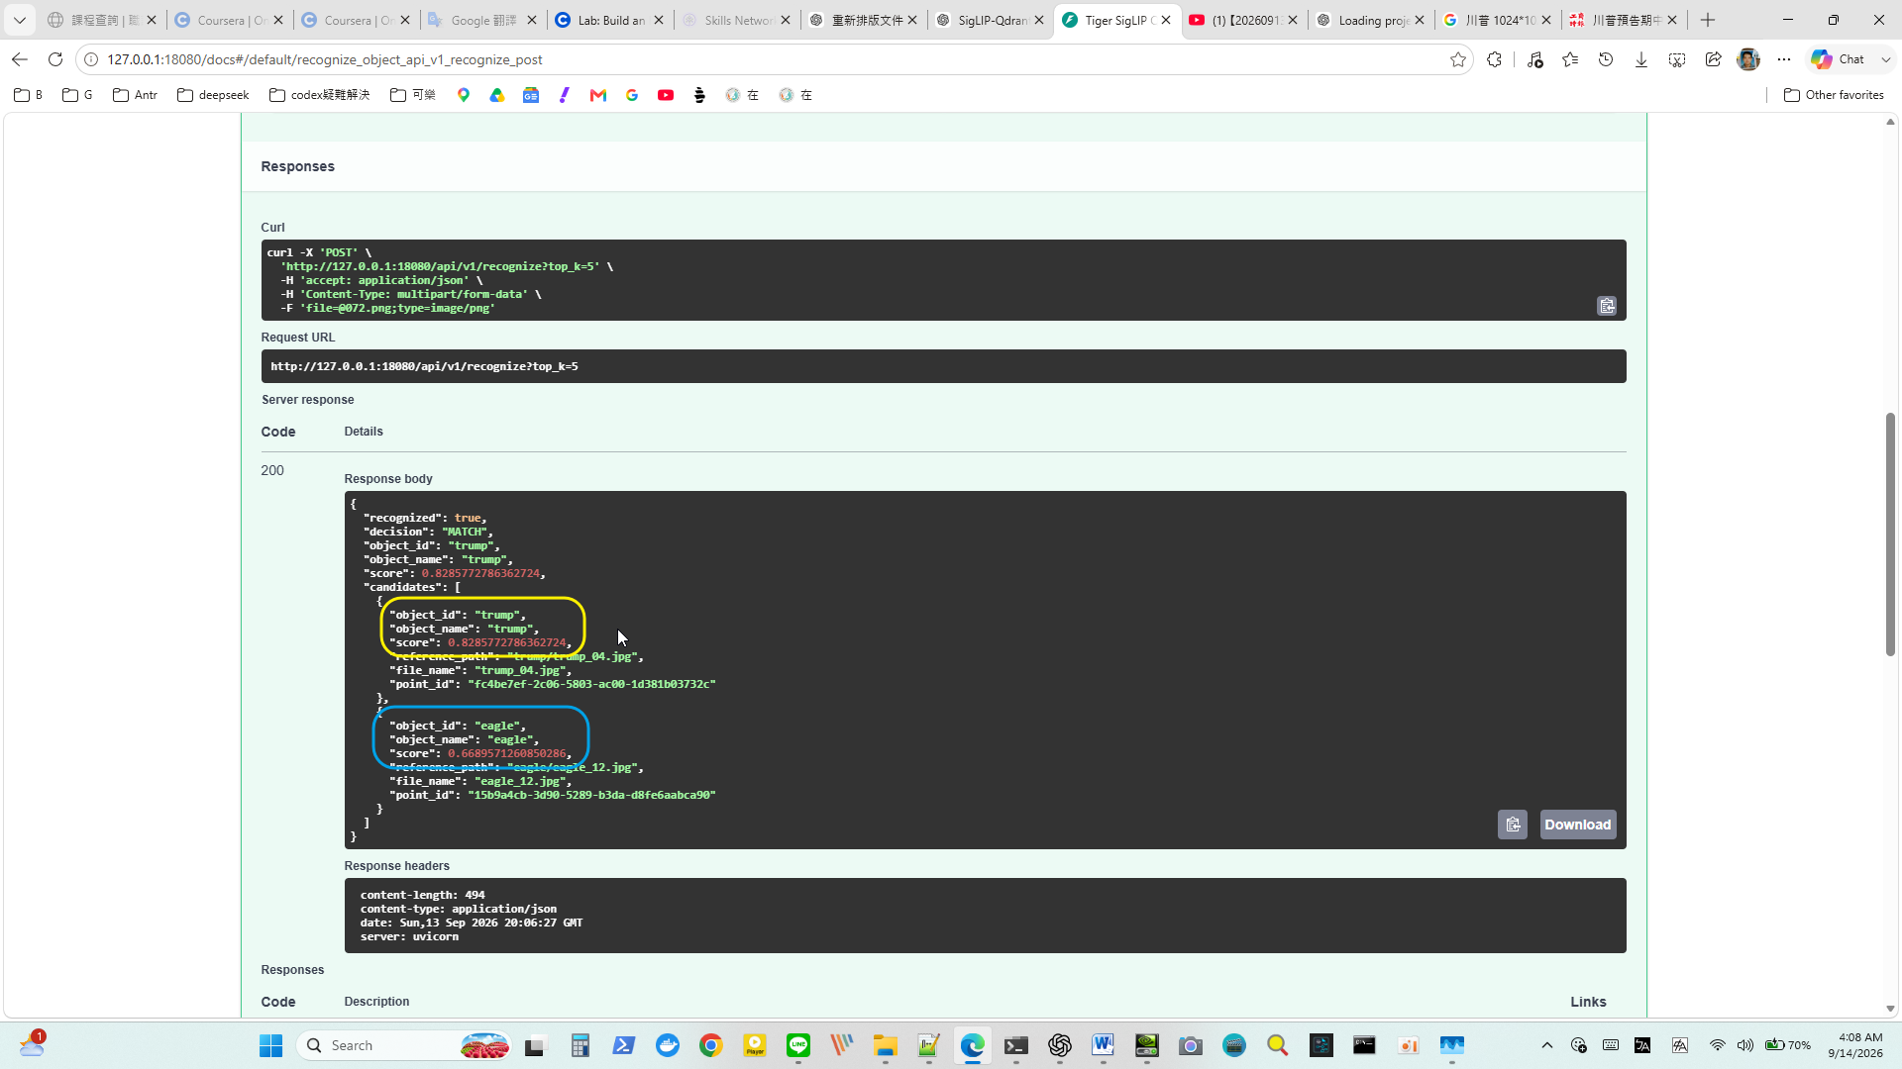

Tiger

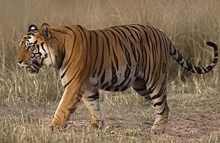

Response body
Download
{
"recognized": true,
"decision": "MATCH",
"object_id": "tiger",
"object_name": "tiger",
"score": 0.9413445074183167,
"candidates": [
{
"object_id": "tiger",
"object_name": "tiger",
"score": 0.9413445074183167,
"reference_path": "tiger/tiger_03.png",
"file_name": "tiger_03.png",
"point_id": "b3cbde04-4a13-5a94-ac89-be8a5875c911"
},
{
"object_id": "crocodile",
"object_name": "crocodile",
"score": 0.754542188164832,
"reference_path": "crocodile/crocodile_14.png",
"file_name": "crocodile_14.png",
"point_id": "db7286b6-1994-5e36-9a4e-5e81bd79e1d9"
}
]
}

林志玲



"recognized": false,
"decision": "LOW_SIMILARITY",
"object_id": "ladies",
"object_name": "ladies",
"score": 0.6865464975559474,
"candidates": [
{
"object_id": "ladies",
"object_name": "ladies",
"score": 0.6865464975559474,
"reference_path": "ladies/lady_04.jpg",
"file_name": "lady_04.jpg",
"point_id": "f446c4c0-dc58-5e7f-abf6-7ef6d5858807"
},
{
"object_id": "lin_chiling",
"object_name": "lin_chiling",
"score": 0.6405883976840419,
"reference_path": "lin_chiling/lin_chiling_19.jpg",
"file_name": "lin_chiling_19.jpg",
"point_id": "05c62169-0c1a-5d80-b06c-b35a8eaac91b"
}
]
}

Canary
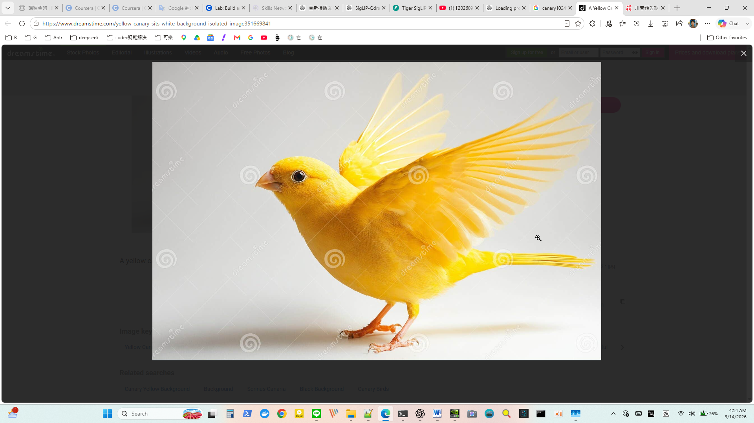

"recognized": false,
"decision": "LOW_SIMILARITY",
"object_id": "canary",
"object_name": "canary",
"score": 0.7390174330100612,
"candidates": [
{
"object_id": "canary",
"object_name": "canary",
"score": 0.7390174330100612,
"reference_path": "canary/canary_02.png",
"file_name": "canary_02.png",
"point_id": "82656b00-c106-58a3-a60a-0bf4ac05f370"
},
{
"object_id": "eagle",
"object_name": "eagle",
"score": 0.6849334342029192,
"reference_path": "eagle/eagle_12.jpg",
"file_name": "eagle_12.jpg",
"point_id": "15b9a4cb-3d90-5289-b3da-d8fe6aabca90"
}
]

金絲猴
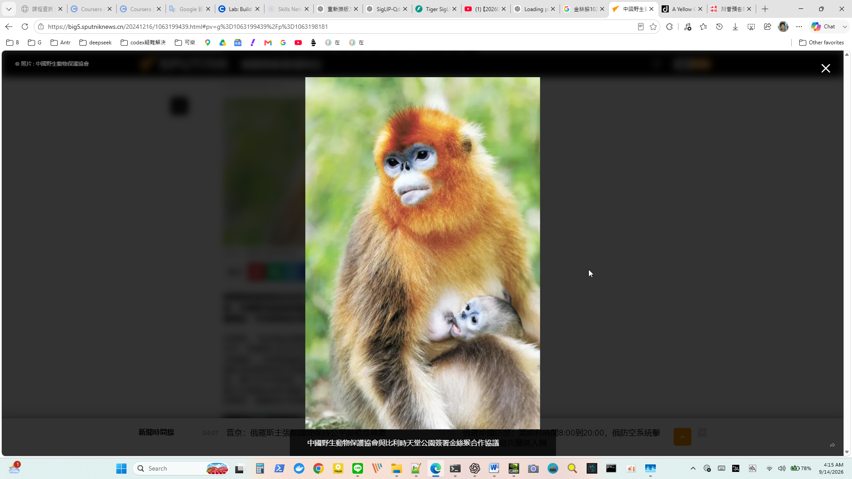

{
"recognized": false,
"decision": "LOW_SIMILARITY",
"object_id": "golden_snub_nosed_monkey",
"object_name": "golden_snub_nosed_monkey",
"score": 0.7884124534332808,
"candidates": [
{
"object_id": "golden_snub_nosed_monkey",
"object_name": "golden_snub_nosed_monkey",
"score": 0.7884124534332808,
"reference_path": "golden_snub_nosed_monkey/golden_snub_nosed_monkey_04.png",
"file_name": "golden_snub_nosed_monkey_04.png",
"point_id": "881ebc66-ee0b-53dc-9e1f-e9653535eaa9"
},
{
"object_id": "tiger",
"object_name": "tiger",
"score": 0.6435977049757491,
"reference_path": "tiger/tiger_13.png",
"file_name": "tiger_13.png",
"point_id": "d868ae8a-626b-5757-a4b9-05f1776c6d7b"
}
]
}

北斗七星
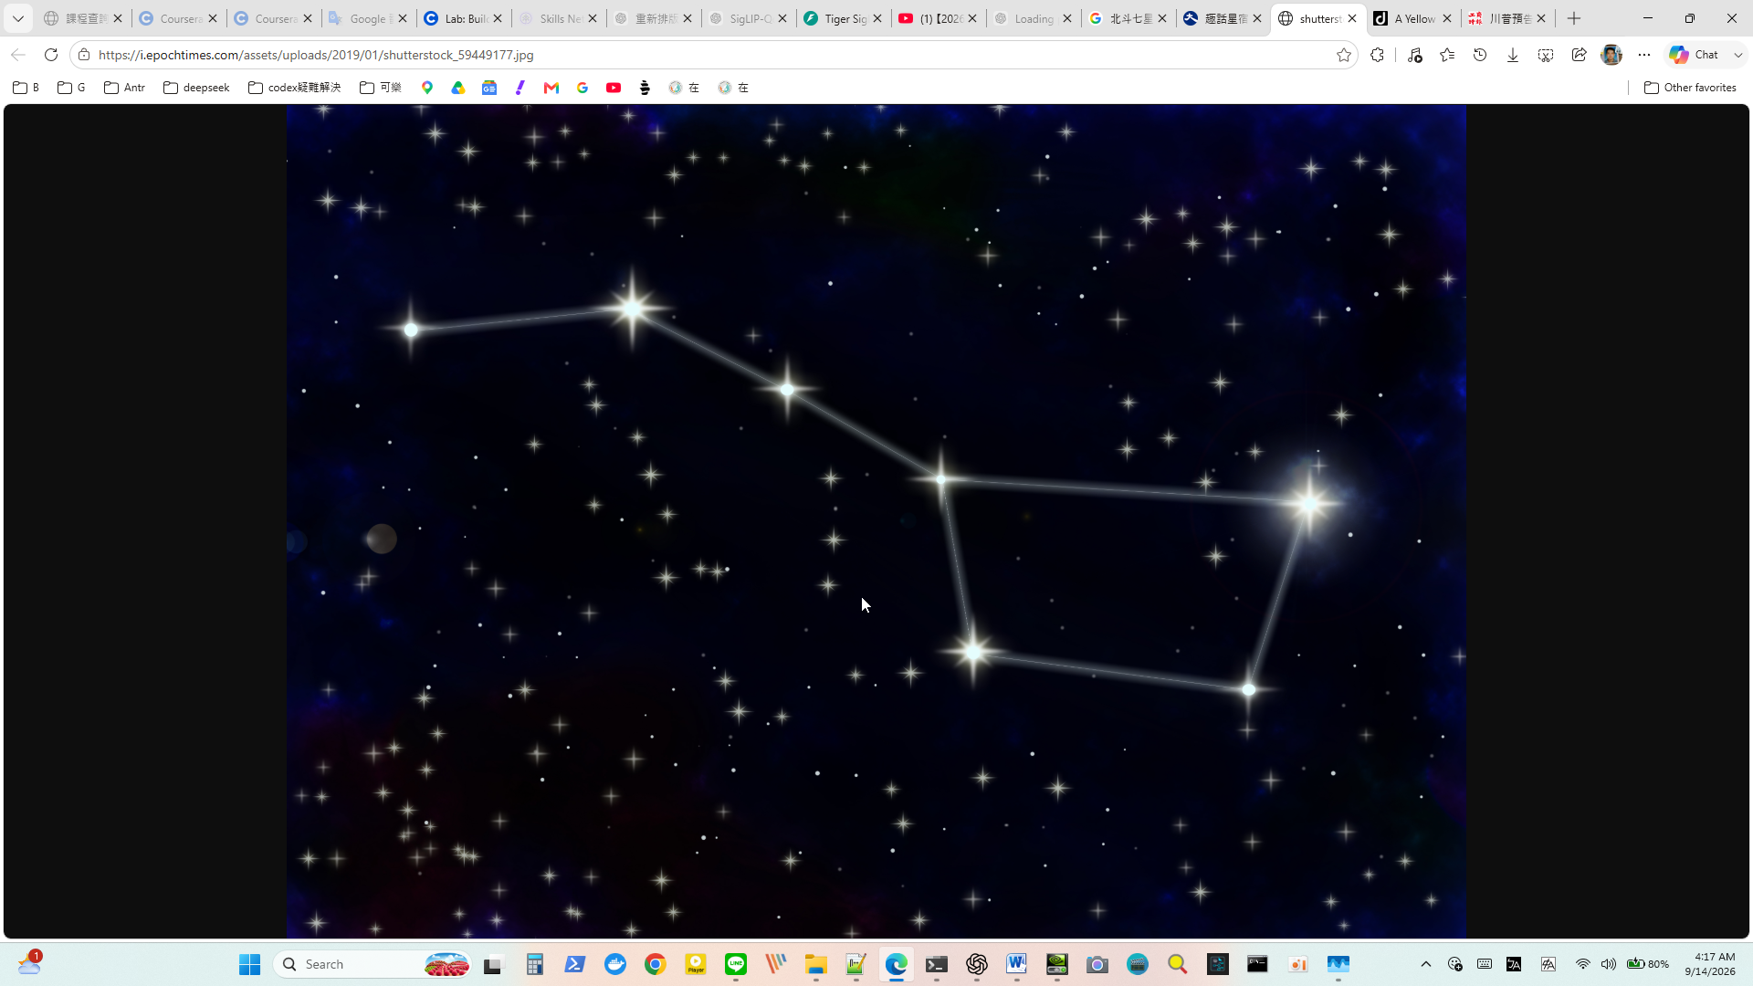

"recognized": true,
"decision": "MATCH",
"object_id": "big_dipper",
"object_name": "big_dipper",
"score": 0.8849315873527425,
"candidates": [
{
"object_id": "big_dipper",
"object_name": "big_dipper",
"score": 0.8849315873527425,
"reference_path": "big_dipper/bigdipper_07.jpg",
"file_name": "bigdipper_07.jpg",
"point_id": "811f1cab-46a1-58c7-8274-ef41f7cbfccc"
},
{
"object_id": "blackhole",
"object_name": "blackhole",
"score": 0.6558685378425727,
"reference_path": "blackhole/blackhole_10.jpg",
"file_name": "blackhole_10.jpg",
"point_id": "4d327116-9072-53a7-bb2a-346e8b01e009"
}
]
}

blackhole
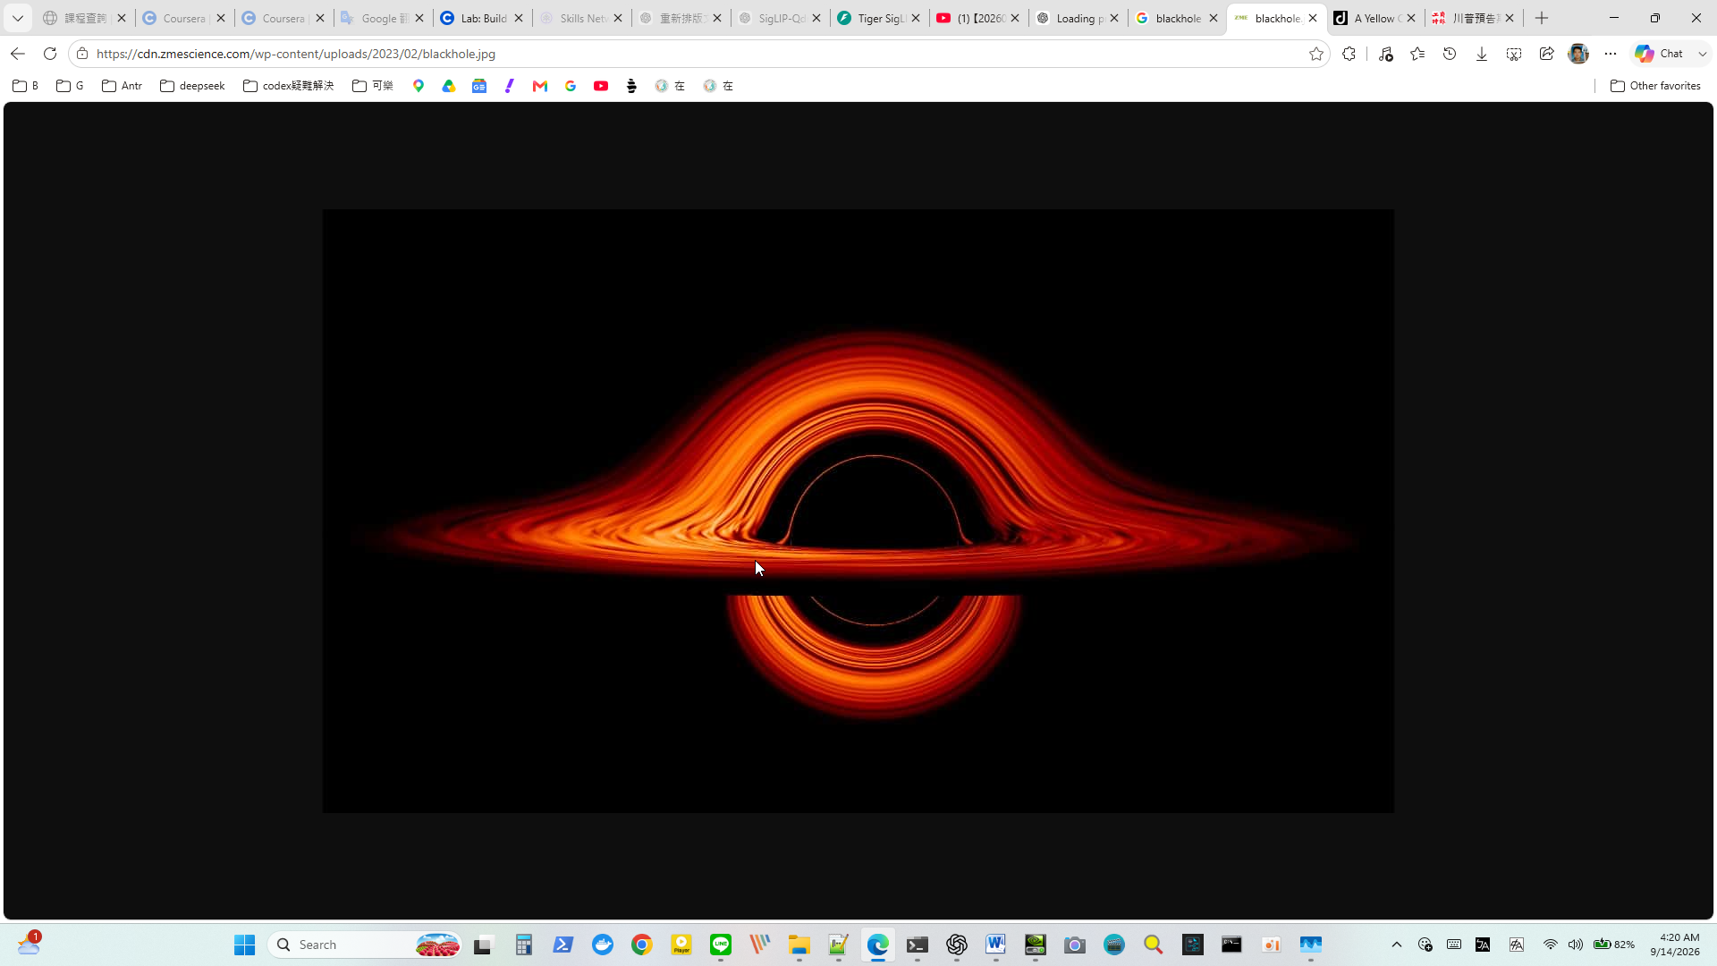

"recognized": true,
"decision": "MATCH",
"object_id": "blackhole",
"object_name": "blackhole",
"score": 0.8397359563481481,
"candidates": [
{
"object_id": "blackhole",
"object_name": "blackhole",
"score": 0.8397359563481481,
"reference_path": "blackhole/blackhole_07.jpg",
"file_name": "blackhole_07.jpg",
"point_id": "0cc025d5-2ee3-5978-b050-afba9214608a"
},
{
"object_id": "big_dipper",
"object_name": "big_dipper",
"score": 0.6088137331588941,
"reference_path": "big_dipper/bigdipper_18.jpg",
"file_name": "bigdipper_18.jpg",
"point_id": "1df2073d-4aa5-5e0a-a90d-4b46a9c1ebb9"
},
{
"object_id": "trump",
"object_name": "trump",
"score": 0.5990235628938243,
"reference_path": "trump/trump_02.jpg",

INFO: 127.0.0.1:3047 - "POST /api/v1/recognize?top_k=5 HTTP/1.1" 200 OK
INFO: 127.0.0.1:7732 - "GET /docs HTTP/1.1" 200 OK
INFO: 127.0.0.1:7732 - "GET /openapi.json HTTP/1.1" 200 OK
INFO: 127.0.0.1:4496 - "POST /api/v1/recognize?top_k=5 HTTP/1.1" 200 OK
INFO: 127.0.0.1:5705 - "GET /docs HTTP/1.1" 200 OK
INFO: 127.0.0.1:5705 - "GET /openapi.json HTTP/1.1" 200 OK
INFO: 127.0.0.1:9772 - "POST /api/v1/recognize?top_k=5 HTTP/1.1" 200 OK
INFO: 127.0.0.1:11101 - "GET /docs HTTP/1.1" 200 OK
INFO: 127.0.0.1:11101 - "GET /openapi.json HTTP/1.1" 200 OK
INFO: 127.0.0.1:2869 - "POST /api/v1/recognize?top_k=5 HTTP/1.1" 200 OK
INFO: 127.0.0.1:13359 - "GET /docs HTTP/1.1" 200 OK
INFO: 127.0.0.1:13359 - "GET /openapi.json HTTP/1.1" 200 OK
INFO: 127.0.0.1:12590 - "POST /api/v1/recognize?top_k=5 HTTP/1.1" 200 OK
INFO: 127.0.0.1:4342 - "GET /docs HTTP/1.1" 200 OK
INFO: 127.0.0.1:4342 - "GET /openapi.json HTTP/1.1" 200 OK
INFO: 127.0.0.1:12549 - "POST /api/v1/recognize?top_k=5 HTTP/1.1" 200 OK
INFO: 127.0.0.1:7342 - "GET /docs HTTP/1.1" 200 OK
INFO: 127.0.0.1:7342 - "GET /openapi.json HTTP/1.1" 200 OK
INFO: 127.0.0.1:13388 - "POST /api/v1/recognize?top_k=5 HTTP/1.1" 200 OK
INFO: 127.0.0.1:7523 - "GET /docs HTTP/1.1" 200 OK
INFO: 127.0.0.1:7523 - "GET /openapi.json HTTP/1.1" 200 OK
INFO: 127.0.0.1:6574 - "POST /api/v1/recognize?top_k=5 HTTP/1.1" 200 OK
INFO: 127.0.0.1:1300 - "GET /docs HTTP/1.1" 200 OK
INFO: 127.0.0.1:1300 - "GET /openapi.json HTTP/1.1" 200 OK
INFO: 127.0.0.1:1552 - "POST /api/v1/recognize?top_k=5 HTTP/1.1" 200 OK

