1. 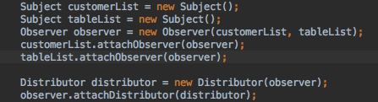CRC cards:

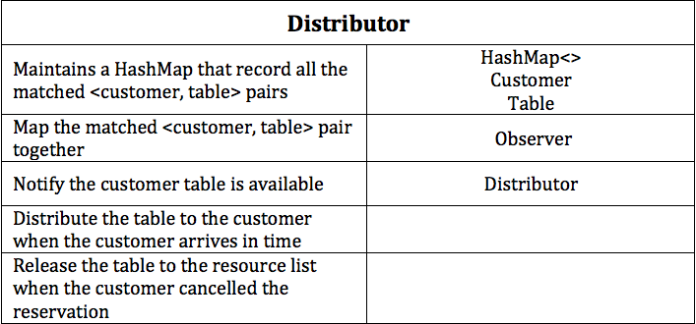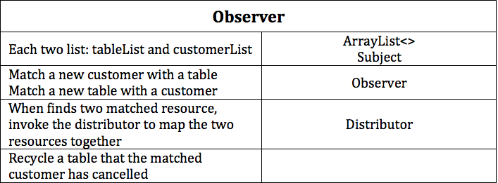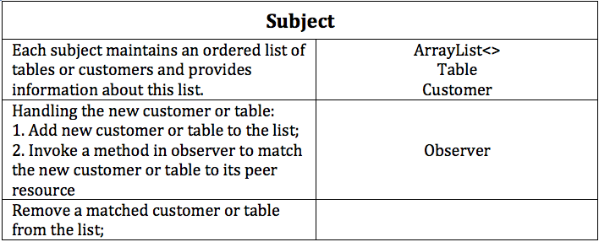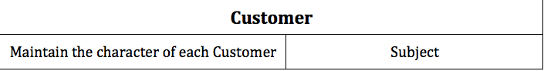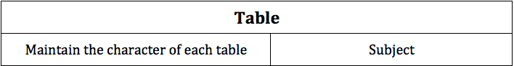

1. Design Pattern: Observer

There are two Subject-Observer relation:

1. Subject is the subject

Observer is the Observer

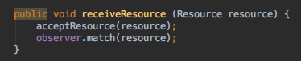So each time when a new resource (customer or table) coming, the subject will notify the Observer to match a peer resource to this new resource:

2. Subject is Observer

Observer is the Distributor

So each time when there is a matched customer and table pair, the Observer will notify the Distributor to map the resources pair together and handle the following action: