1. 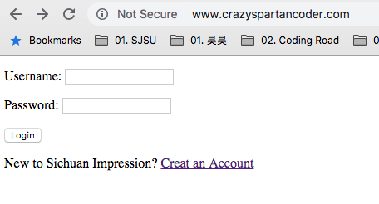Go to the index page – Login in page. For a registered user, input the username and Password. For a new comer, click “Create an Account” and navigate to the signup.html.
2. 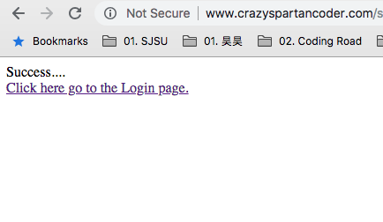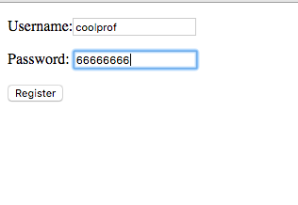 In the signup.html, input the Username and Password:
3. When the registration succeeded, navigate back to the login.html: input the name and password to login into the main page.
4. 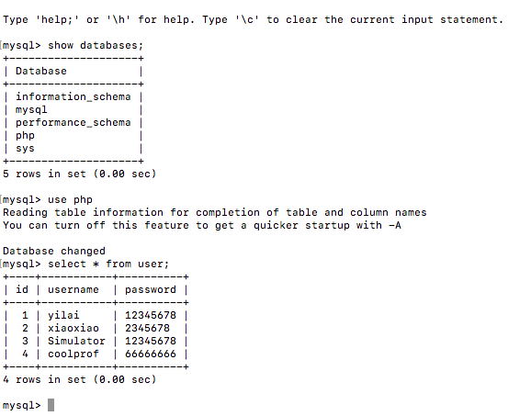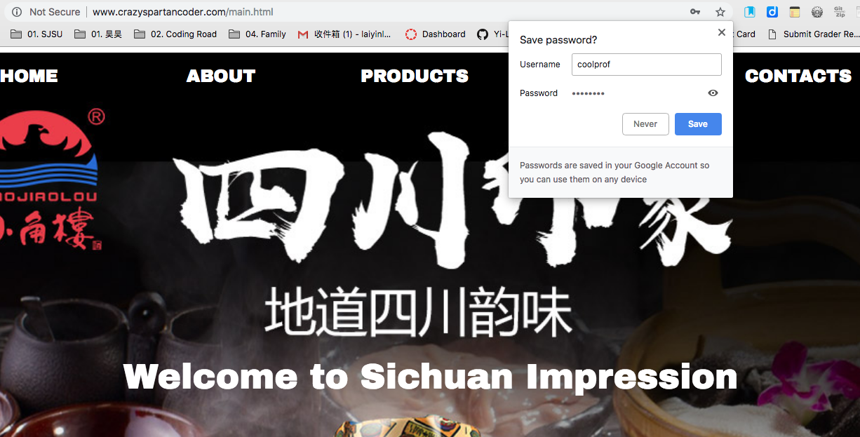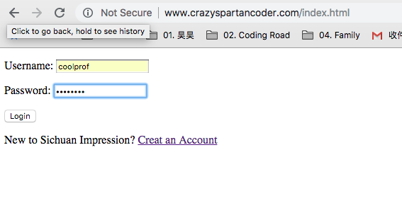A new record will added to the DB: