## Y(Monica) Hung u22561154

**Problem 4.1**

a)

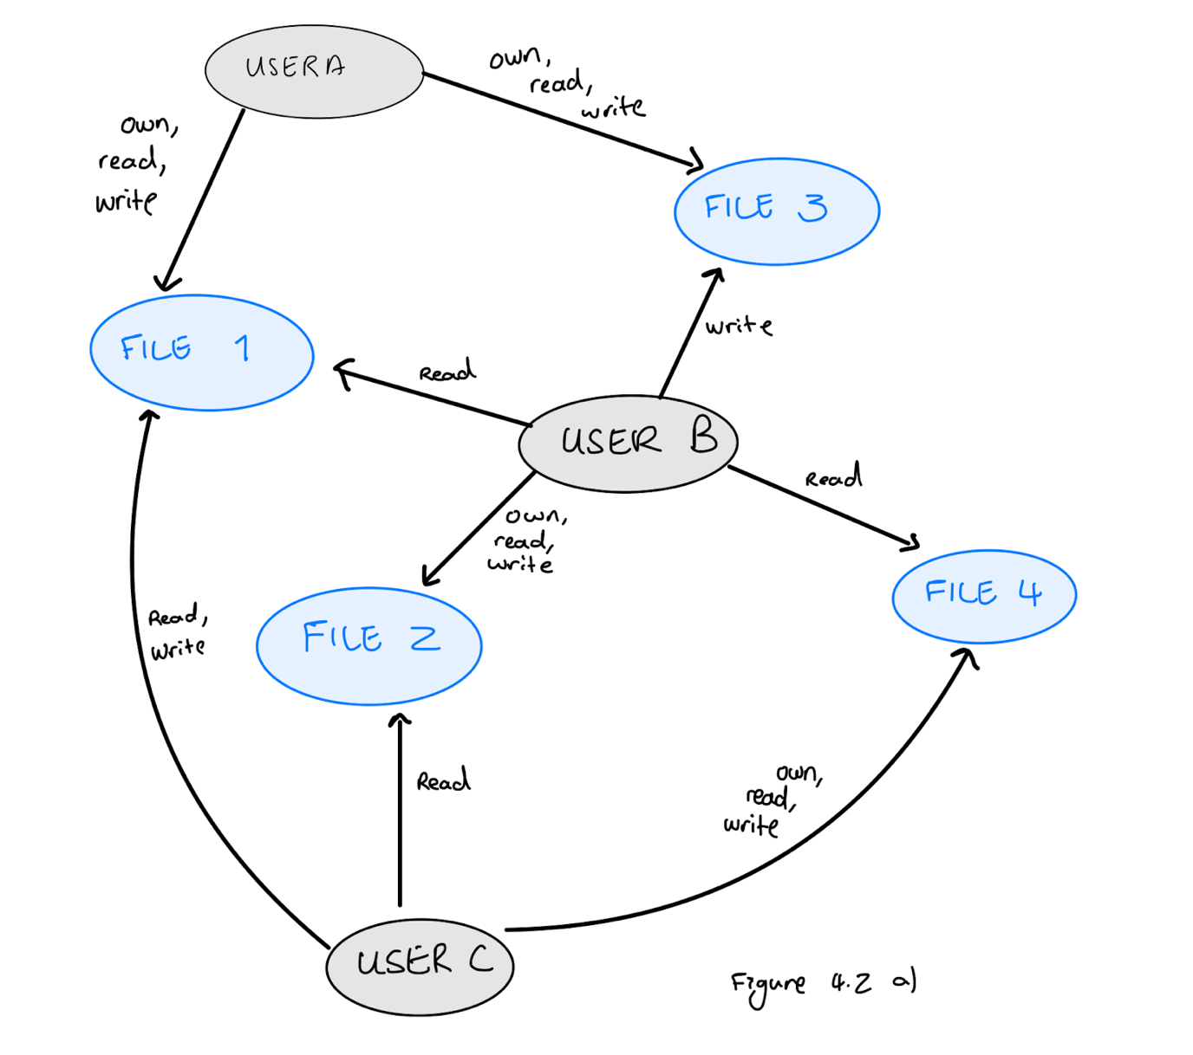

b)

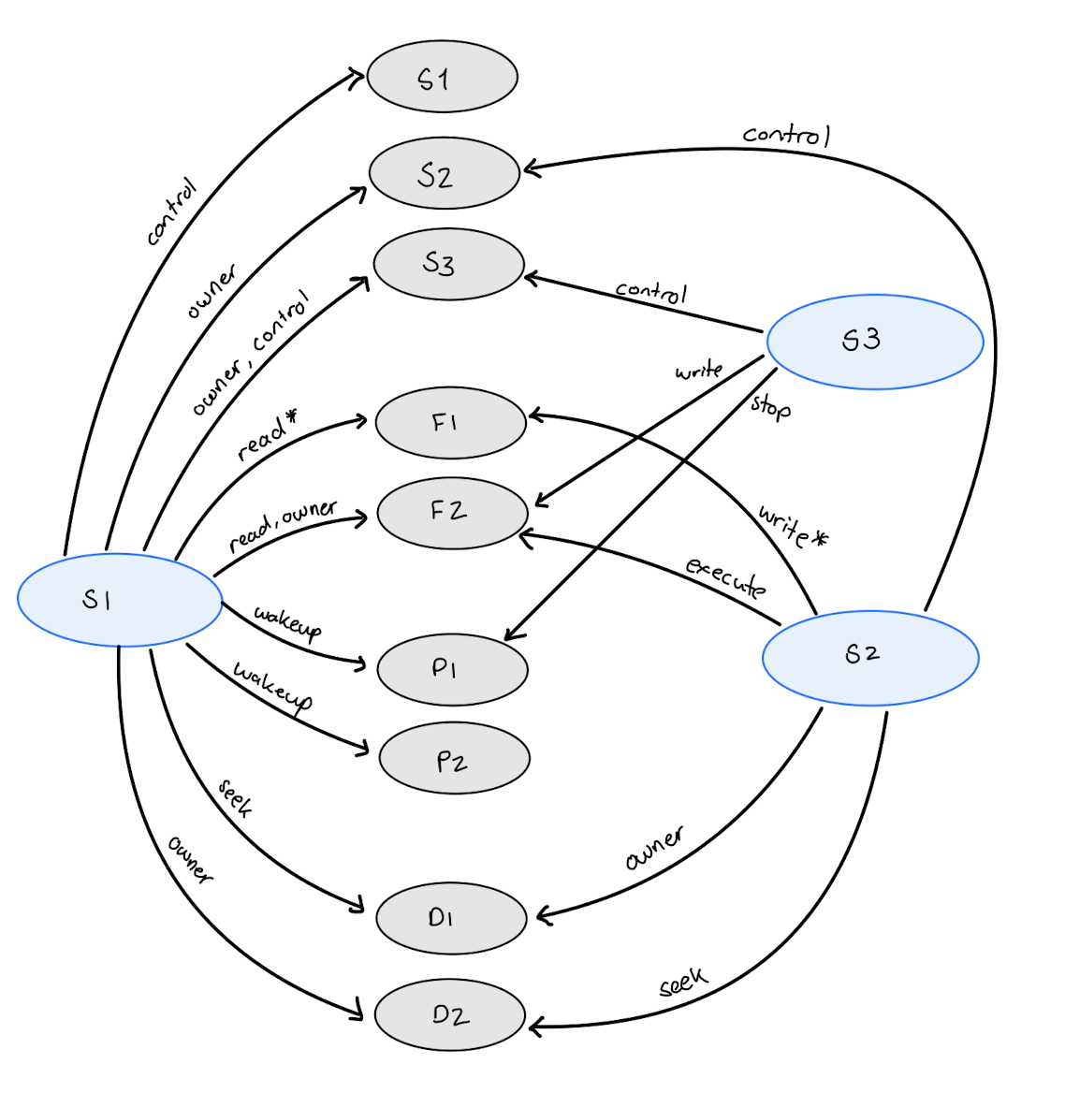

c) In the Access Matrix 4.2a, the Subject and Object are depicted as labelled blue and grey circles on the directed graph with the permission or relationship in between them. Both the illustration conveys the same information. Every row-column in the access matrix is depicted as an edge in the directed graph, and the access rights are the labels on the edges of the directed graph, therefore there is a one-to-one correspondence between the directed graph and the access matrix.

**Problem 4.3**

1. Advantages of providing four modes:

* Control and Security: When the system divides the privileges across four modes, the system can enforce precise access control. It reduces the risk of a less critical process performing dangerous operations.
* Flexibility: Because we have four different modes so it means that the operating system can efficiently distribute system calls and tailor privileges according to the tasks.
* Since we have the Executive and Supervisor in the four modes, it can potentially help prioritize resources where they are most needed.

Disadvantages of providing four modes:

* Performance overhead: frequent mode switching can cause performance degradation especially when a system has multiple layers.
* Difficult maintenance and debugging: With more complex system, it makes fixing and finding issues harder compared to systems that has two modes.

1. When we have more than four modes, we would have a highly secure environment when we add additional modes it could help segregate specific tasks into distinct privilege levels, which helps with operational efficiency. For example, a military has 5 modes: top secret mode, secret mode, confidential mode, restricted mode and user mode, the different level minimizes the risk of cross-contamination of sensitive data. The lower modes allow less critical tasks to be managed without compromising the more secure modes. Hence, it enhances security and helps with operational efficiency.