**WAD PROJECT REPORT**

x14335451 – Amanda Anicete

x14111187 – Sarah Yun Tiong

**Links to Website**

**GitHub:** [LINK](https://github.com/Yi3nz/WAD_GroupProject) **|| Deployed App**: [LINK](https://preview.c9users.io/yi3nz/project_dueweek13/index.html?_c9_id=livepreview0&_c9_host=https://ide.c9.io)

**Project Proposal**

**Introduction**

For this project deliverable, we have been asked to create an application using advanced server side functionality and develop it further by using client side scripting language. We must also be able to define and change it up as we wish, constructing a Rich Internet Application, also known as RIA, for this web application. The application must also be deployed online where it is responsive in all browsers and platforms.

**Project Goals**

Our goal for this project is to have a Rich Internet Application website as the Web is always changing and updating. We can clearly tell that all web browsers have come a long way. From simple and uncomplicated traditional web browsers to a website that acts more like a desktop in both client and server side, the Web definitely improved by several of changes.

Nowadays, websites have plenty of technologies they have implemented in their site to make it richer in functionality. Examples of these are: XHTML, CSS, JavaScript/JQuery, XML/JSON, AJAX and Node.js.

Our aim is to build a website that has these components and processes. We must also choose something that is of interest therefore we can add our own flare to it when designing and creating the application.

**Plan for the Website**

Our plan was to set up a food website, showcasing some popular dishes around the world and recipes on how to make that certain meal. However, as the weeks passed by, our idea changed. It’s still similar from the previous one but we added some extra bits to it.Our final plan for our site is an Asian cuisine website for people who have an interest in making Asian dishes. This website will consist of some starter, main course and dessert recipes that can be easily done at home.

We decided that splitting it to three categories will be easier for users as they can easily choose a dish to their preference. For example, if they want to be serving four to five people, picking a main course dish would be suitable than a starter dish as portions would be bigger.

We also chose to include a form where users can add their own dishes that can be shared with our viewers. This way, the site would be more interactive and it’s also a great way of showcasing people’s creativity. It would also help people who are looking for a particular Asian dish and wanting an easy step by step on how to make it.

**Key Characteristics**

Our website has a number of interactive functionalities. These characteristics make our website easier to use and navigate through.

* Scroll spy: This is a plugin that is used in the navigation links. Once that link is clicked, the page scrolls down to the position of that link. Navigating through the website will be more effortless since users don’t have to keep scrolling to find what they are looking for. In our website, one click will bring them right to it!
* Image Hover: When you hover over the images in the Starter, Main and Desserts heading, the image will zoom in and transform into the details of that dish. There is also a “Read Me” button where you can view the full recipe in a step by step tutorial, but that page isn’t fully ready yet therefore we have put up a JavaScript alert, informing users that they aren’t available for viewing yet.
* Catalogue: We have added a catalogue section where users can view the duration and difficulty of each dish without clicking the full recipe. It has two buttons where you can click to go forward or backwards. This is helpful for viewers who want to quickly skim through all the recipes in the website without having to actually visit each recipe.
* Recipe Submission: This is a form where users can enter in their own recipes to be included in the site. We thought that adding the viewer’s recipes is a good touch to the website since the website is for everyone who has an interest in Asian cuisine, therefore they should be allowed to contribute some Asian dishes of their own! It will also remind you if you didn’t input the right text or if you missed filling in a box when you click “Send”. This ensures that everyone fills in all the necessary fields before sending it off.
* Image Upload: The image upload is included in the submission form where users can add a photo to be included in their submitted recipe.
* RSS: There is an RSS button in the catalogue area and once clicked, extra recipes are shown. These recipes are not necessary an Asian dish as they are available nearly everywhere, but still widely served in plenty of Asian countries. You can also click the title of the dish and it will lead you to a website where you can see the recipe on how to make it.
* Social Media Links: At the bottom of the page, links to some social media are presented. The four buttons are the only social media we currently have and are using. Hovering over the buttons, you will notice that the colours will alternate with each other. When clicked, it should bring you to the home page of the website.

**List of Project Deliverables**

The deliverables that must be handed up are as follows:

* All the name of each member of the team as well as their student numbers
* GitHub repository link
* Deployed application link
* The Project Proposal which should have the following headings:
  + Short introduction
  + Goals of the project
  + Plans and ideas for our website
  + Key characteristics of our website
  + List of project deliverables
* All of the technologies used
* An architecture of our website
* A manual of our website

**Technologies Used**

We used a number of technologies to make our application highly responsive and very interactive. By using a wide variety of technologies, it makes the website look more attractive and user friendly. Using the website will be more effortless and navigating through the site will be easily done. The technologies we used are:

* **XHTML**: Our basic content is made up in the html section. All of the necessary links and body of text is put in here. All containers and divs for specific images are also contained in here. JavaScript, jQuery and style sheet links are also included in this document and they are linked to other documents in the folder in order for the whole website to run efficiently.
* **CSS**: This is where all our styling and designing is stored. We have multiple style sheets for different areas of the website. Some have some very advanced effects when hovered over while others have simple designs. The CSS is where all containers and divs are placed and how they are displayed on the website. Working with CSS is a very tedious job as one small change may affect the rest of the site.
* **JavaScript & jQuery**: JavaScript are used in order to improve our web page’s visual displays. Scrolling the page through clicking the header, effects while a picture hovered, alerting further information after clicking a button and so on are all runs with JavaScript. While jQuery helps to extend JavaScript’s work.
* **XML**: Data of all our recipes are stored in a well-formed XML file, which helps to make our html file nice and clean. Also, information coded in XML is easier to read and understand as there are no fixed set of tags that we can easily create any tags we like. Data is then retrieved and display in the html file using XMLHttpRequest by looping through every specified data. XML also helps to store our RSS file.
* **AJAX**: Ajax is used to prevent the page reloading for the content to be displayed, allowing several multi-purpose applications and features can be handled within a single web page, which create much easier and quicker interaction between the users and website. In this case we embedded Ajax for our form submission.

**Architecture of our Website**

Our first wireframe was based off of another site we saw when viewing food related websites. It had everything we were planning in terms of content and style. We just tweaked and added some other elements we thought were missing.

We decided that this site would be our guide when creating the actual application itself and it did help us a lot when we were unsure where to put certain divs or links. It also benefited us since we can have a general idea on what our website would look like towards its completed stages.

The only downside to this wireframe was that there were plenty of things happening at the top while the rest of the site is quite bare and plain. It also looked like the header is way too crowded; making the appearance of the overall website way too small, messy and unorganised.

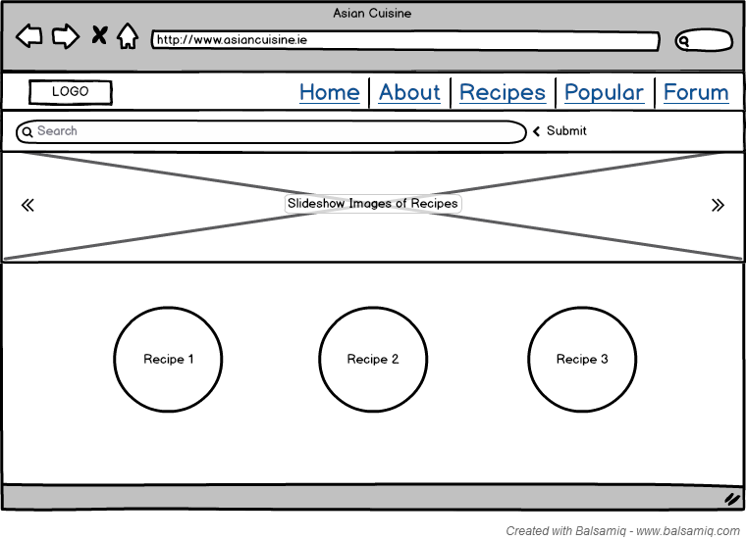

Due to that, we decided to change the header and lessen the elements on it. We cleared and took away the search bar and the slideshow, as that was the main features that made the application look jam-packed.

However, we did keep some original elements in there since we liked how they looked in the first place. Since the website is a bootstrap form, having a more simple and minimal design is better than fitting all random elements in. Towards the end, we were very happy with our new wireframe. It definitely looked better than our first draft and you can see the changes very clearly by looking at the two pictures above and below.

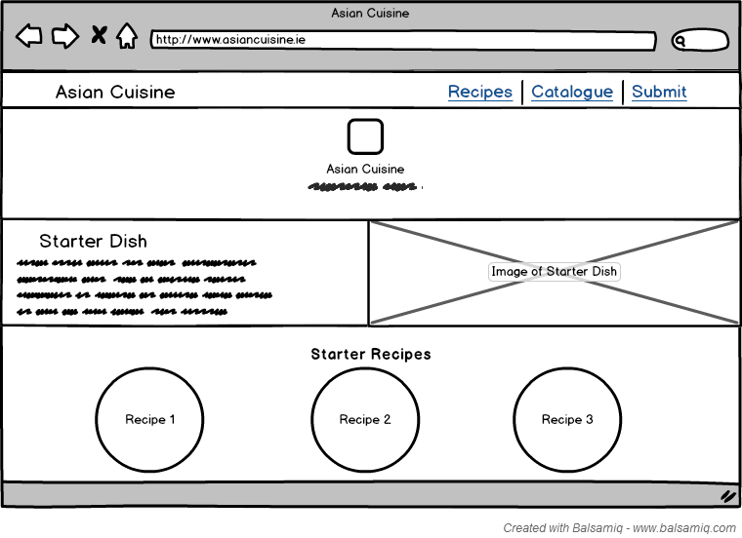

**User Manual**

1. Download our most recent file from GitHub by clicking the link provided.
2. Open up a new Cloud9 workspace, go to File > Upload Local Files. This window should appear.

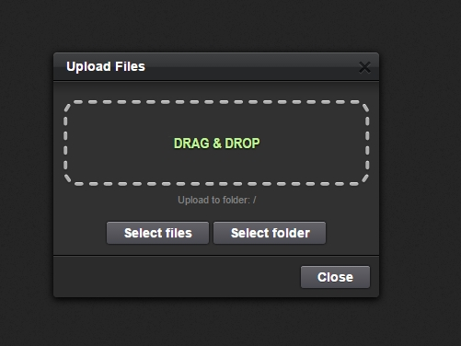

1. Click Select Folder and choose our folder that should be labelled “workspace” when extracted from the zip file.
2. The files should load as follows:

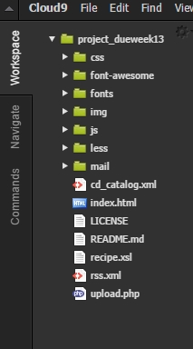

1. Double click on “index.html” and it should open up at the workspace
2. You then want to click Preview > Live Preview File

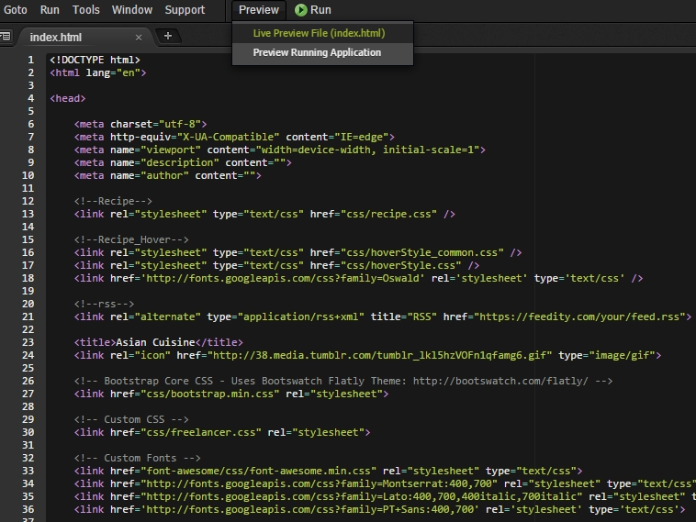

1. It will open up another window beside the index.html. Click the icon that is circled in red.

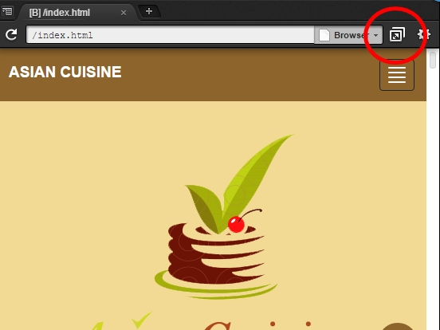

1. This will open our website in full screen where you can look at all the features properly!

