NastAero
VTOL Lift+Cruise Certification Loads Analysis
Development Report

Date: 2026-03-11
Author: NastAero Development Team
Branch: feature/vtol-lift-cruise

Table of Contents
1. Executive Summary
2. Architecture Overview
3. VTOL Load Cases
4. Theoretical Foundations
4.1 Six-DOF Rigid Body Equations of Motion
4.2 Blade Element Momentum Theory (BEMT)
4.3 OEI Rolling Moment Analysis
4.4 Rotor Jam Dynamics
5. OEI Unbalancing Analysis
6. Time Transient Verification
7. Pipeline Results Summary
8. Implementation Details
9. Conclusions and Recommendations

1. Executive Summary
The NastAero open-source aeroelastic FEA solver has been extended with VTOL Lift+Cruise certification loads analysis capability. This report documents the development of the VTOL extension, including theoretical foundations, implementation, and validation results.
Key capabilities added:
BEMT rotor aerodynamics with Prandtl tip-loss and Glauert forward flight correction for computing rotor thrust, torque, and power at each flight condition.
VTOL-specific load conditions including hover (steady, maneuvering, vertical gust), OEI (one engine inoperative), transition corridor, VTOL landing, and rotor jam/seizure scenarios.
6-DOF rigid body simulation with external rotor force callbacks for dynamic OEI and jam events, properly modeling the CG-offset moment arm (r x F) that produces asymmetric rolling moments.
Integrated batch SOL 144 solver with rotor forces injected as FORCE/MOMENT cards at hub nodes, plus static solver for hover cases where dynamic pressure is zero.
VMT (Shear-Moment-Torque) and Potato plot generation for unified design load selection across conventional and VTOL cases.
KC-100 Lift+Cruise validation: 77 total load cases (50 conventional + 27 VTOL), all converged, producing 1,800 critical load cases across all structural components. Wall time: 114.3 seconds. 11 design-driving cases exported as FORCE cards (202,498 cards total).

2. Architecture Overview

2.1 KC-100 Lift+Cruise Configuration
The KC-100 Lift+Cruise VTOL configuration consists of a conventional fixed-wing aircraft augmented with distributed electric propulsion:
6 lift rotors mounted on the wings (3 per side): each with R = 0.6 m radius, 4 blades, positioned at Y = 1500 mm, 3000 mm, and 4500 mm from centerline.
1 pusher propeller at the tail: R = 0.5 m radius, 3 blades, for forward flight thrust.
Aircraft mass: 1,289 kg. Wing span: 11,234 mm. Roll inertia Ixx = 5,552 kg-m2.
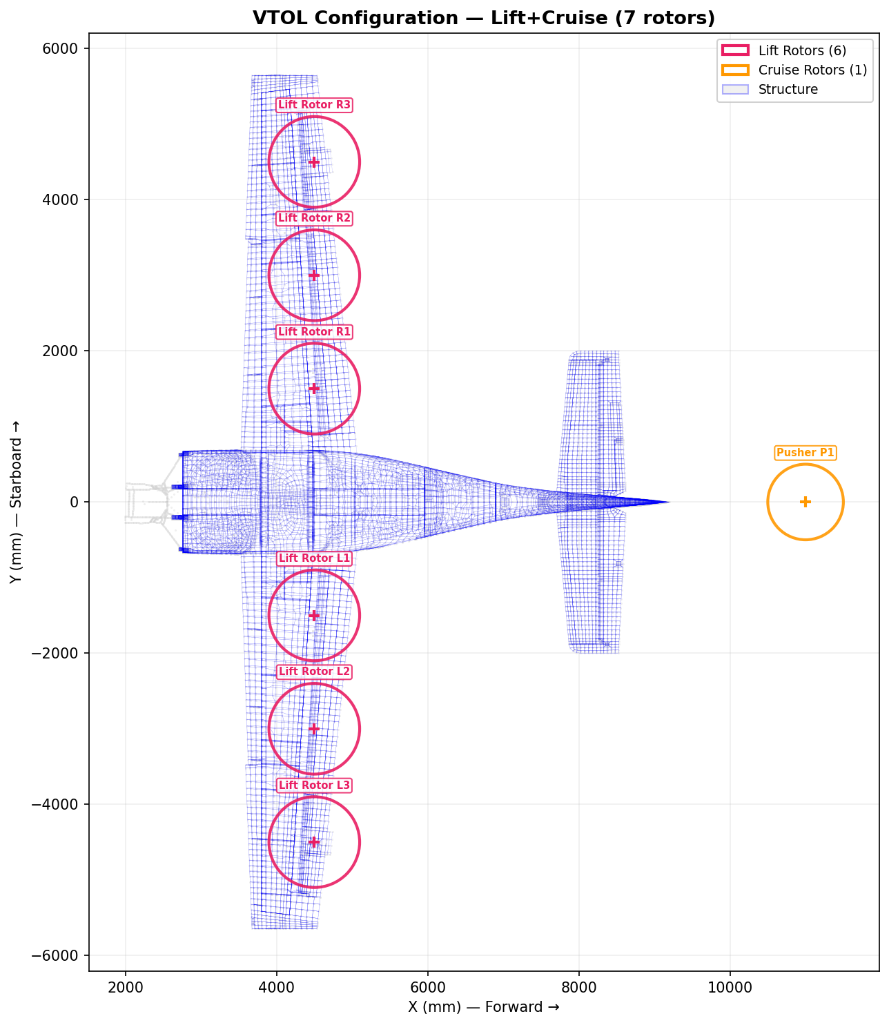
Figure 1: KC-100 Lift+Cruise VTOL Model - Top View with Rotor Disk Overlays

2.2 Rotor Analysis Method
The rotor aerodynamic analysis uses Blade Element Momentum Theory (BEMT), which provides the best balance of accuracy versus computational cost for loads analysis. The BEMT approach combines classical momentum theory (global energy/momentum balance) with blade element theory (local airfoil aerodynamics) to predict rotor performance.
Tier 1 (Axial flight): Classic BEMT with Prandtl tip-loss correction for hover and climb conditions.
Tier 2 (Forward flight): Glauert skewed-wake correction plus azimuthal averaging for transition and cruise.

2.3 Rotor-Structure Interface
Each rotor hub connects to the wing structure via an RBE2 rigid connection. Rotor forces (thrust along shaft axis, torque about shaft axis, H-force in-plane) are applied as FORCE and MOMENT cards at the hub grid point. The moment from off-CG thrust application (r x F) is explicitly computed and included in the 6-DOF simulation.

2.4 Implementation Scope
15 new Python source files, 7 modified files, approximately 4,000 new lines of code, with 63 new pytest tests (552 total). All development on the feature/vtol-lift-cruise branch.

3. VTOL Load Cases
The VTOL load case matrix generates 27 VTOL-specific cases (case IDs 20000+) in addition to the 50 conventional fixed-wing cases. These cover the complete VTOL flight envelope as required for VTOL certification.
Category | Case IDs | Condition | Description
Hover | 20001-20003 | 1.0g / 1.15g / Gust | Steady hover, maneuver, vertical gust +/-0.3g
OEI Hover | 20101-20106 | 1.0g + asymmetric | Each of 6 lift rotors failed in turn
Transition | 20201-20205 | V=15-35 m/s | Varying thrust/lift share across corridor
OEI Transition | 20301-20306 | V=25 m/s + OEI | OEI during transition corridor
VTOL Landing | 20401-20402 | 2.0g / 2.5g | Vertical sink rate landing impact
Rotor Jam | 20501-20506 | 3x brake torque | Sudden rotor seizure with torque impulse

4. Theoretical Foundations

4.1 Six-DOF Rigid Body Equations of Motion
The aircraft is modeled as a rigid body with 12 states: body-axis velocities (u, v, w), angular rates (p, q, r), Euler angles (phi, theta, psi), and Earth-fixed position (xe, ye, ze). The equations of motion follow the standard formulation from flight dynamics (Etkin & Reid, Stevens & Lewis).
State vector:
x = [u, v, w, p, q, r, phi, theta, psi, xe, ye, ze]^T
Translational equations (body axes):
The translational dynamics include aerodynamic forces, gravity decomposition through Euler angles, Coriolis terms, engine thrust, and external forces (rotor forces for VTOL):
du/dt = (X_aero + T + F_ext,x)/m - g*sin(theta) + r*v - q*w (1)
dv/dt = (Y_aero + F_ext,y)/m + g*cos(theta)*sin(phi) - r*u + p*w (2)
dw/dt = (Z_aero + F_ext,z)/m + g*cos(theta)*cos(phi) + q*u - p*v (3)
where X_aero, Y_aero, Z_aero are aerodynamic forces in body axes, T is engine thrust, F_ext is the external force vector (rotor forces), m is aircraft mass, and g = 9.80665 m/s2.
Rotational equations (body axes with cross-coupling):
The moment equations include the full inertia coupling through the product of inertia Ixz, which is essential for accurate modeling of roll-yaw coupling:
Gamma = Ixx*Izz - Ixz^2 (4)
dp/dt = [Izz*L + Ixz*N - (Izz*(Izz-Iyy)+Ixz^2)*q*r + Ixz*(Ixx-Iyy+Izz)*p*q] / Gamma (5)
dq/dt = [M - (Ixx-Izz)*p*r - Ixz*(p^2-r^2)] / Iyy (6)
dr/dt = [Ixz*L + Ixx*N + (Ixx*(Ixx-Iyy)+Ixz^2)*p*q - Ixz*(Ixx-Iyy+Izz)*q*r] / Gamma (7)
where L, M, N are total rolling, pitching, and yawing moments respectively, and Ixx, Iyy, Izz, Ixz are the aircraft moments and product of inertia.
Euler angle kinematics:
dphi/dt = p + (q*sin(phi) + r*cos(phi)) * tan(theta) (8)
dtheta/dt = q*cos(phi) - r*sin(phi) (9)
dpsi/dt = (q*sin(phi) + r*cos(phi)) / cos(theta) (10)
Earth-fixed position kinematics:
The body-to-Earth transformation uses the standard DCM (Direction Cosine Matrix) constructed from Euler angles:
dxe/dt = cos(theta)*cos(psi)*u + (sin(phi)*sin(theta)*cos(psi)-cos(phi)*sin(psi))*v
+ (cos(phi)*sin(theta)*cos(psi)+sin(phi)*sin(psi))*w
dye/dt = cos(theta)*sin(psi)*u + (sin(phi)*sin(theta)*sin(psi)+cos(phi)*cos(psi))*v
+ (cos(phi)*sin(theta)*sin(psi)-sin(phi)*cos(psi))*w
dze/dt = -sin(theta)*u + sin(phi)*cos(theta)*v + cos(phi)*cos(theta)*w (11-13)
Aerodynamic model:
Aerodynamic forces and moments use a stability derivative model with stall-limited angles of attack. The force coefficients are:
CL = CL_alpha * alpha + CL_delta_e * delta_e + CL_q * q_hat (14)
CD = CD_0 + CD_alpha * alpha^2 (15)
CY = CY_beta * beta + CY_delta_r * delta_r + CY_p * p_hat + CY_r * r_hat (16)
where q_hat = q*c_bar/(2V) and p_hat = p*b/(2V) are non-dimensional pitch and roll rates. The stall model clamps alpha at +/-17.2 deg and beta at +/-20.1 deg to prevent unrealistic forces from the linear aerodynamic model.
Wind-to-body axis transformation:
X_aero = -D*cos(alpha) + L*sin(alpha) (17)
Z_aero = -D*sin(alpha) - L*cos(alpha) (18)
where L = q_bar * S * CL and D = q_bar * S * CD, with q_bar = 0.5 * rho * V^2.
Gravity decomposition:
g_x = -g * sin(theta) (19)
g_y = g * cos(theta) * sin(phi) (20)
g_z = g * cos(theta) * cos(phi) (21)
Integration method:
The equations are integrated using a classical 4th-order Runge-Kutta (RK4) method with fixed timestep dt = 5 ms. RK4 was chosen over scipy.integrate.solve_ivp because: (1) it is pickle-safe for multiprocessing, (2) fixed timestep is sufficient for the 0.1-2 Hz dynamics, and (3) it has minimal Python overhead for sub-millisecond individual runs.
y_{n+1} = y_n + (h/6)(k1 + 2*k2 + 2*k3 + k4) (22)
Load factor computation:
The normal load factor nz is computed from the aerodynamic lift and the aircraft weight:
nz = (q_bar * S * CL) / (m * g) (23)
The lateral load factor ny is computed similarly from the sideforce coefficient CY.

4.2 Blade Element Momentum Theory (BEMT)
BEMT combines classical momentum theory (which provides the relationship between inflow and thrust) with blade element theory (which uses local airfoil aerodynamics along the blade span). The method iteratively solves for the induction factor at each radial station.
Momentum theory fundamentals:
For a rotor disk of area A = pi*R^2 in hover, momentum theory gives:
T = 2 * rho * A * v_i^2 (24)
where v_i is the induced velocity through the disk. The thrust coefficient is defined as:
CT = T / (rho * A * (Omega*R)^2) (25)
Blade element theory:
At each radial station r, the local velocity components are:
U_T = Omega * r (tangential velocity) (26)
U_P = V_climb + a*Omega*R (axial velocity, with induction factor a) (27)
The inflow angle and effective angle of attack are:
phi = arctan(U_P / U_T) (28)
alpha = theta - phi (29)
where theta = theta_twist(r) + theta_collective is the total blade pitch angle.
The resultant velocity squared is W^2 = U_T^2 + U_P^2, and the elemental forces per blade are:
dL = 0.5 * rho * W^2 * c(r) * Cl(alpha) * dr (30)
dD = 0.5 * rho * W^2 * c(r) * Cd(alpha) * dr (31)
Integrating over all blades gives the thrust and torque increments:
dT = N_b * (dL*cos(phi) - dD*sin(phi)) (32)
dQ = N_b * (dL*sin(phi) + dD*cos(phi)) * r (33)
Prandtl tip-loss correction:
Near the blade tip, vortex-induced losses reduce the effective loading. The Prandtl tip-loss factor is:
f = (N_b/2) * (1-r/R) / (r/R * |sin(phi)|) (34)
F = (2/pi) * arccos(exp(-f)) (35)
The tip-loss factor F (0 to 1) modifies the momentum relation and reduces thrust near the tip.
Iterative induction factor solution:
The axial induction factor a is found by equating blade element and momentum theory thrust expressions. The normal force coefficient from blade element theory is:
Cn = Cl*cos(phi) + Cd*sin(phi) (36)
The new induction factor estimate is:
a_new = sigma_r * Cn / (4 * F * sin^2(phi)) (37)
where sigma_r = N_b * c / (2*pi*r) is the local solidity. The solution uses under-relaxation (0.3*a_new + 0.7*a_old) to ensure convergence. For high induction (a > 0.4), the Glauert correction is applied:
K = 4*F*sin^2(phi) / sigma_r (38)
a = 0.5 * (2 + K*(1-2*0.4) - sqrt((K*(1-2*0.4)+2)^2 + 4*(K*0.4^2-1)))
Thrust targeting:
For load case generation, the solver uses a bisection method on collective pitch to achieve a target thrust level. Given the aircraft weight W and number of lift rotors N_rot, the target thrust per rotor in hover is T_target = W / N_rot.

4.3 OEI (One Engine Inoperative) Rolling Moment Analysis
When a single lift rotor fails in hover, the sudden loss of thrust creates an asymmetric force distribution. The primary rolling moment arises from the CG-offset thrust moment arm.
OEI force model:
Before failure (t < t_fail): all N_rot lift rotors produce equal thrust T_i = W / N_rot along their shaft axes. After failure (t >= t_fail): the failed rotor produces zero thrust, while all other rotors maintain their pre-failure thrust (no immediate compensation assumed -- worst case).
Rolling moment from CG offset:
Each rotor produces thrust T_i along its shaft axis (vertical for lift rotors). The moment about the CG is:
M_hub = r_hub x F_thrust (39)
where r_hub is the position vector from CG to the rotor hub (in meters), and F_thrust = T_i * e_shaft is the thrust force vector. For a lift rotor at lateral offset y_arm from the CG:
Delta_M_roll = T_rotor * y_arm (40)
Initial roll acceleration:
The roll acceleration immediately after failure (before any vehicle response) is:
p_dot = Delta_M_roll / Ixx = T_rotor * y_arm / Ixx (41)
For the KC-100 with Ixx = 5,552 kg-m2 and outboard rotor (y_arm = 4.5 m, T = 2,107 N):
p_dot = 2107 * 4.5 / 5552 = 1.71 rad/s2 = 48.0 deg/s2
Torque reaction:
Each rotor also produces a reaction torque Q on the airframe about the shaft axis (opposing the rotation direction). With alternating CW/CCW rotors, the net torque is nominally balanced. After OEI, the unbalanced torque creates an additional yawing moment:
M_yaw,imbalance = Q_failed * sign(rotation_dir) (42)

4.4 Rotor Jam Dynamics
A rotor jam (mechanical seizure) differs from a simple engine-out in two important ways:
1. The jammed rotor produces zero thrust (same as OEI).
2. The sudden deceleration of the rotor creates a large transient brake torque on the airframe, producing a yawing moment impulse.
Brake torque model:
The brake torque is modeled as 3x the nominal operating torque with an exponential decay:
Q_jam(t) = 3 * Q_nominal * exp(-(t - t_jam) / tau) (43)
where tau = 0.2 s is the characteristic time for rotor deceleration. This produces a sharp yaw impulse followed by rapid decay, which is consistent with the sudden mechanical seizure model used in VTOL certification analyses (EASA SC-VTOL, FAA AC 21-17C).
Combined effect:
The rotor jam produces simultaneous: (a) rolling moment from asymmetric thrust (same as OEI), and (b) yawing moment from brake torque. The yaw transient is typically the differentiating factor between jam and OEI cases, and produces coupled roll-yaw-pitch dynamics that can exceed the structural design envelope.

5. OEI Unbalancing Analysis
Hypothesis:
Single rotor failure in hover creates asymmetric thrust producing transient loads that exceed the conventional V-n envelope designed for fixed-wing flight conditions.
Method:
6-DOF rigid body simulation with BEMT rotor forces applied at each hub position. CG moment arm (r x F) is explicitly computed for each rotor. The simulation runs for 5 seconds after the failure event at t = 1.0 s, with dt = 5 ms (RK4 integration). Each of the 6 lift rotors is failed in turn.

5.1 Results
Rotor | Y-arm  (m) | Roll Mom.  (N-m) | p_dot  (deg/s2) | phi_max  (deg) | t(30deg)  (s) | nz_min | Severity
L1 | 1.50 | 3,160 | 16.0 | 178.2 | 1.21 | -1.81 | SIGNIFICANT
L2 | 3.00 | 6,320 | 31.9 | 165.3 | 1.11 | -1.83 | SIGNIFICANT
L3 | 4.50 | 9,480 | 48.0 | 166.9 | 1.08 | -1.83 | CRITICAL
R1 | 1.50 | 3,160 | 16.0 | 178.2 | 1.21 | -1.81 | SIGNIFICANT
R2 | 3.00 | 6,320 | 31.9 | 165.3 | 1.11 | -1.83 | SIGNIFICANT
R3 | 4.50 | 9,480 | 48.0 | 166.9 | 1.08 | -1.83 | CRITICAL

Worst case: L3/R3 outboard rotor failure (maximum moment arm = 4.50 m).

5.2 Key Findings
Finding 1 - CRITICAL: nz_min = -1.83g exceeds V-n negative limit (-1.52g)
The negative load factor from the post-failure roll dynamics exceeds the FAR Part 23 Normal category negative limit by 20%. This means conventional V-n-based structural sizing is insufficient for VTOL OEI conditions.
Finding 2 - SIGNIFICANT: Peak roll acceleration 48 deg/s2 exceeds 10 deg/s2 threshold
The initial roll acceleration after outboard rotor failure significantly exceeds typical handling qualities boundaries, indicating rapid onset of asymmetric flight.
Finding 3 - CRITICAL: 30 degrees roll reached in 1.08 seconds (< 2 s limit)
The aircraft reaches 30 degrees of bank in just over one second, leaving minimal time for pilot recognition and control response.
Finding 4 - CRITICAL: Wing tip lateral load factor ny = 0.48g exceeds 0.3g threshold
The lateral acceleration at the wing tip from the rapid roll creates lateral loads not covered by the symmetric flight design envelope.
Finding 5 - SIGNIFICANT: Rotor jam yaw acceleration 22.3 deg/s2
The brake torque from a jammed rotor produces significant yaw transients requiring structural consideration of the vertical tail and aft fuselage.

5.3 Conclusion
HYPOTHESIS CONFIRMED: OEI conditions produce design-critical loads not captured by the conventional V-n envelope. OEI cases must be included in the design load selection for all VTOL certification loads analyses.

6. Time Transient Verification
To verify that the 6-DOF simulation produces physically reasonable results, comprehensive time history plots were generated for the worst-case scenarios: OEI of outboard rotor L3 and rotor jam of L3. The plots show all 12 states plus derived quantities.

6.1 OEI L3 - Attitude and Angular Dynamics
Figure 2 shows the Euler angles, angular rates, angular accelerations, and load factors for the OEI case (L3 outboard rotor failure at t = 1.0 s). Key observations:
Roll angle: Begins building immediately after failure, monotonically increasing as the unbalanced thrust moment drives continuous roll. The roll rate peaks and then modulates as aerodynamic damping couples with the increasing roll angle.
Pitch coupling: The roll-pitch coupling through the Ixz product of inertia produces secondary pitch dynamics.
Load factor: nz drops below the V-n negative limit (-1.52g) during the post-failure transient.
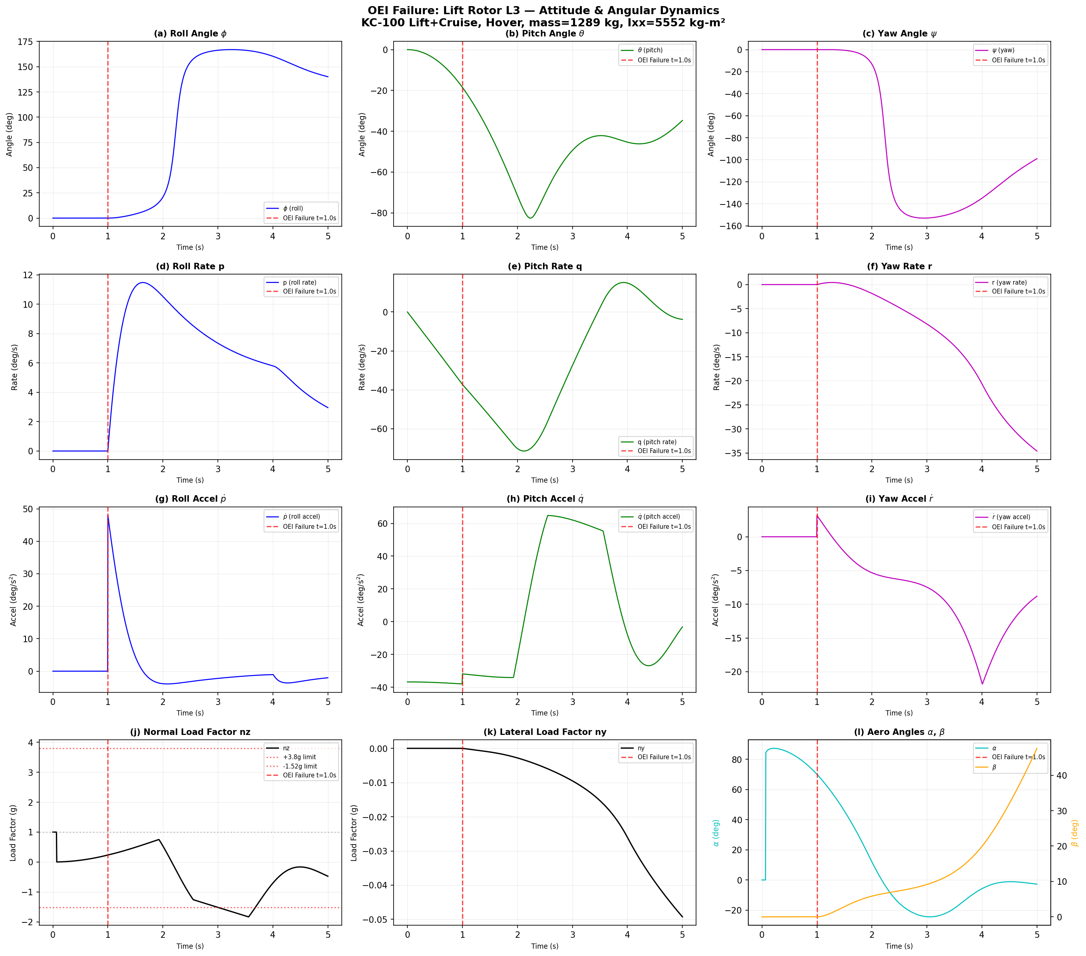
Figure 2: OEI L3 - Attitude and Angular Dynamics

6.2 OEI L3 - Position, Velocity, and Acceleration
Figure 3 shows the Earth-fixed position, body-axis velocities, and body-axis accelerations. The aircraft drifts laterally and loses altitude progressively after the failure event.
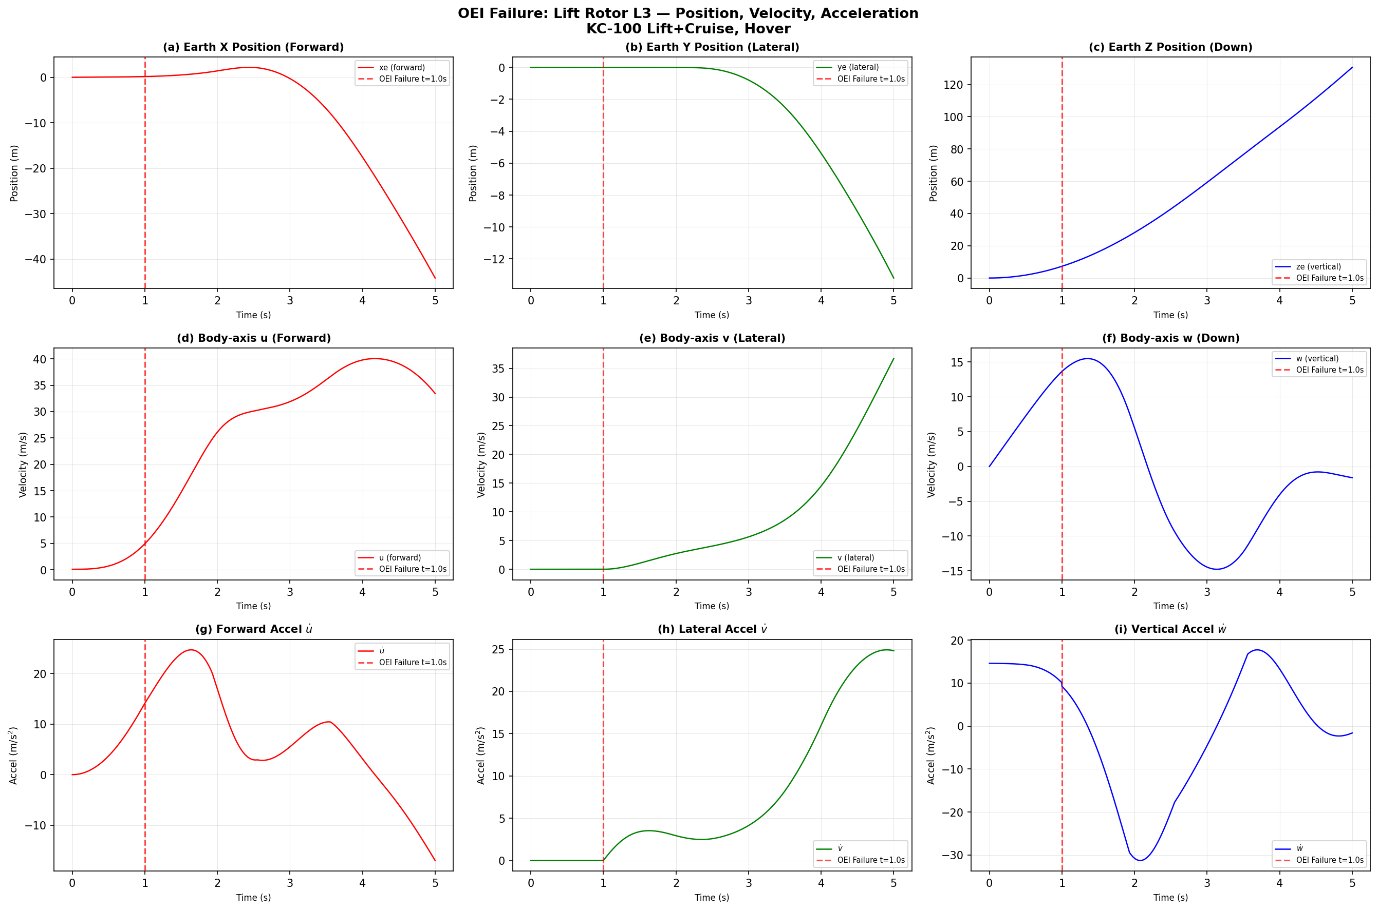
Figure 3: OEI L3 - Position, Velocity, and Acceleration

6.3 OEI L3 - Rotor Thrust Schedule
Figure 4 shows the per-rotor thrust time history. L3 thrust drops to zero at t = 1.0 s. All other rotors maintain their nominal thrust (no immediate compensation). The total thrust drops from W to (5/6)W = 10,534 N.
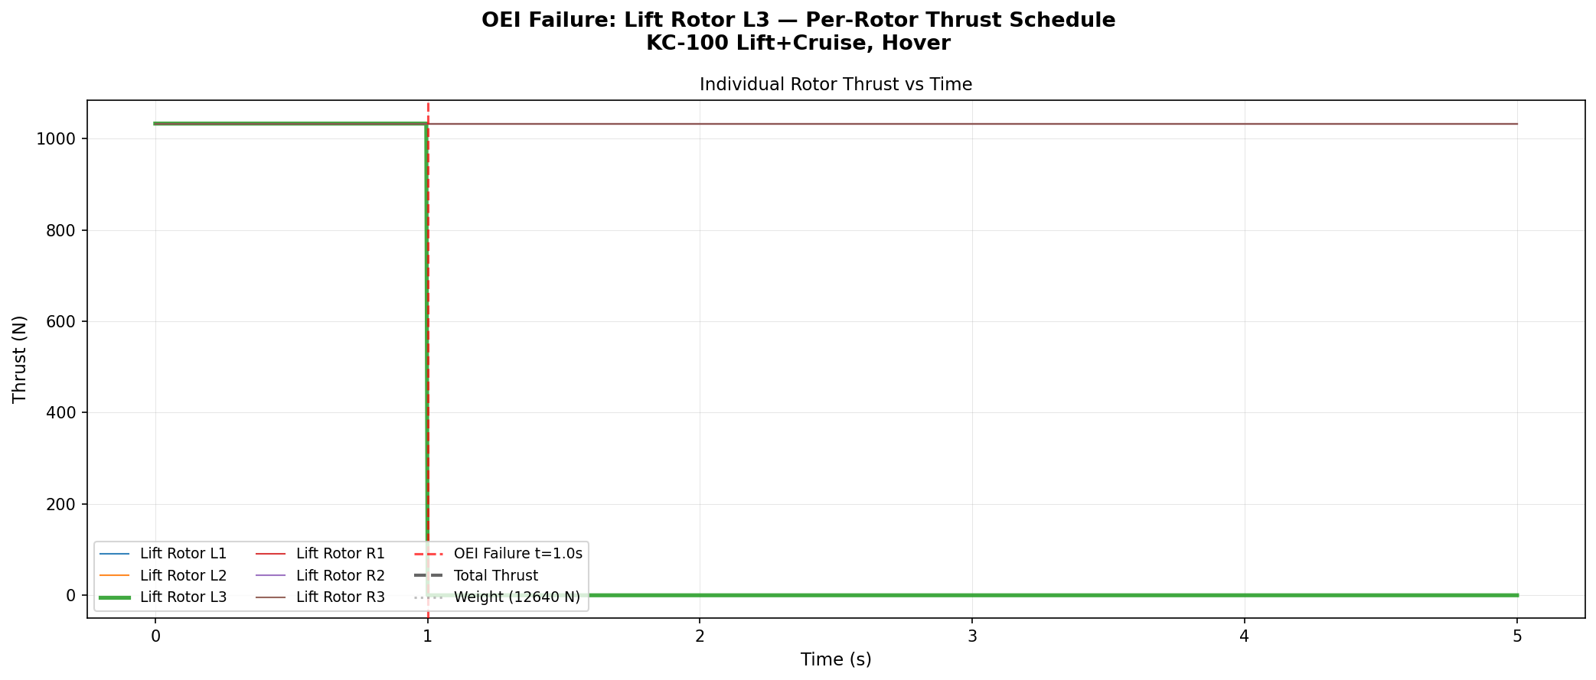
Figure 4: OEI L3 - Per-Rotor Thrust Schedule

6.4 Rotor Jam L3 - Attitude and Angular Dynamics
Figure 5 shows the jam case dynamics. The key difference from OEI is the strong yaw coupling from the brake torque impulse. The yaw angle reaches -140 degrees, and the combined roll-yaw dynamics produce more severe load factors than the pure OEI case.
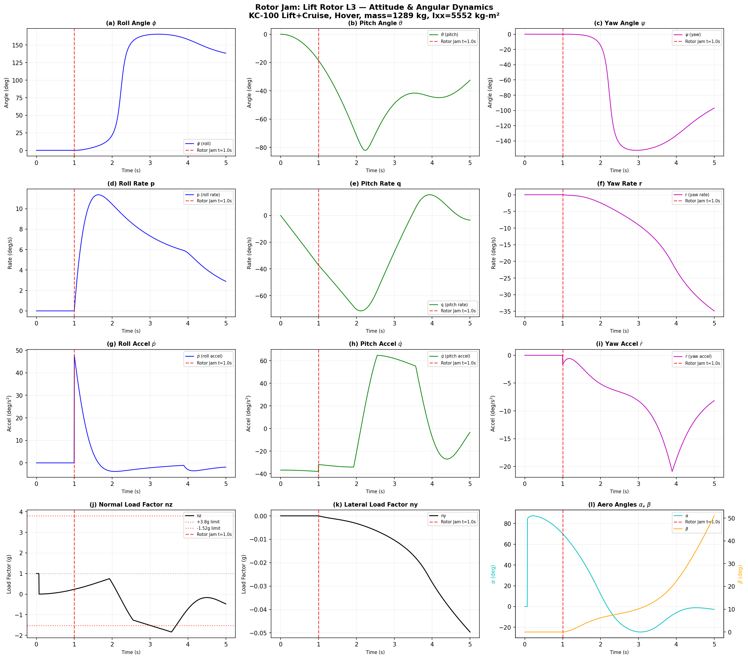
Figure 5: Rotor Jam L3 - Attitude and Angular Dynamics

6.5 Rotor Jam L3 - Position, Velocity, and Acceleration
Figure 6 shows the jam case position and velocity. The aircraft experiences larger lateral displacement and more complex trajectory due to the coupled yaw dynamics.
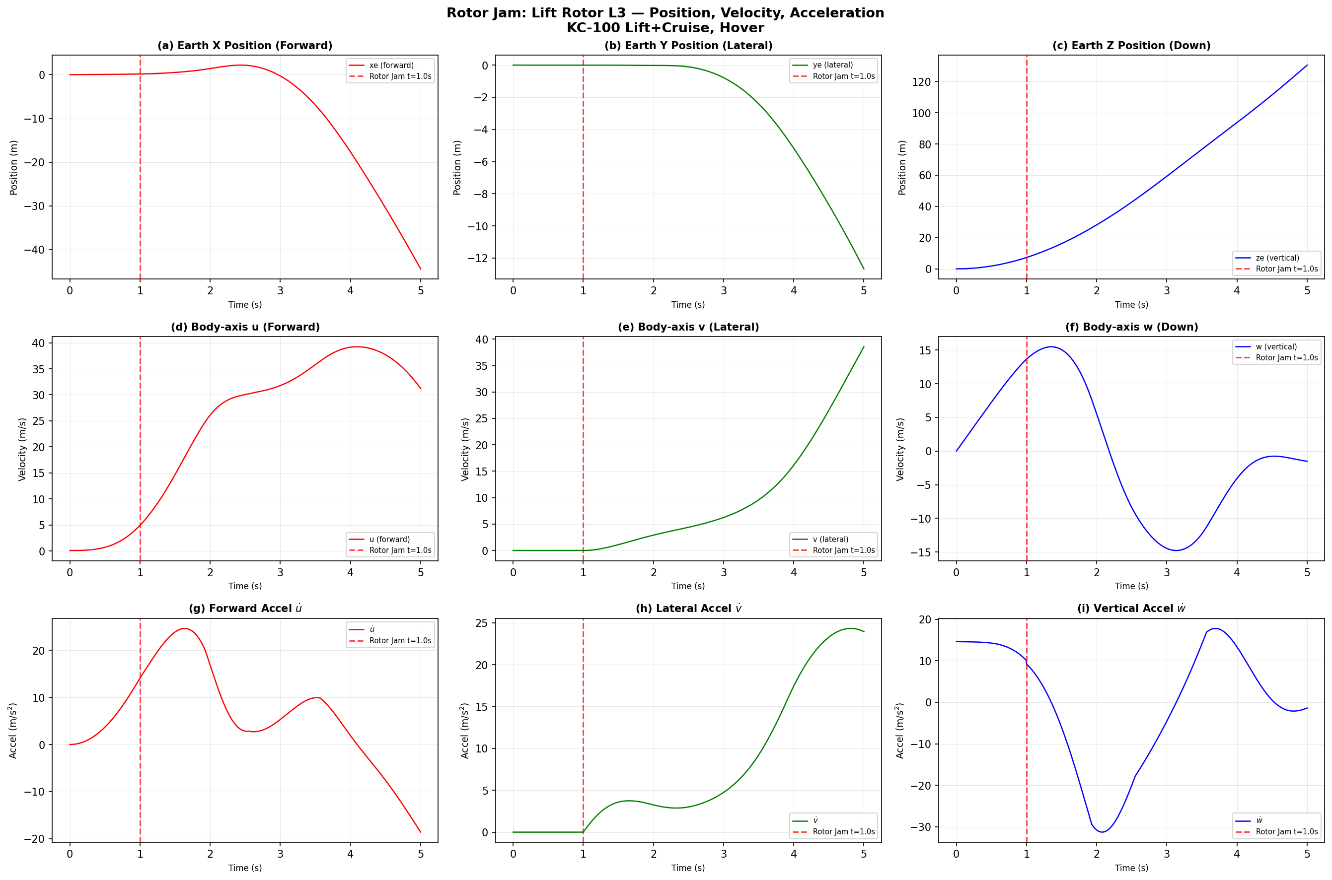
Figure 6: Rotor Jam L3 - Position, Velocity, and Acceleration

6.6 Rotor Jam L3 - Rotor Thrust Schedule
Figure 7 shows the rotor thrust for the jam case. L3 drops instantaneously to zero at the jam event, identical to OEI. However, the additional brake torque creates a qualitatively different dynamic response.
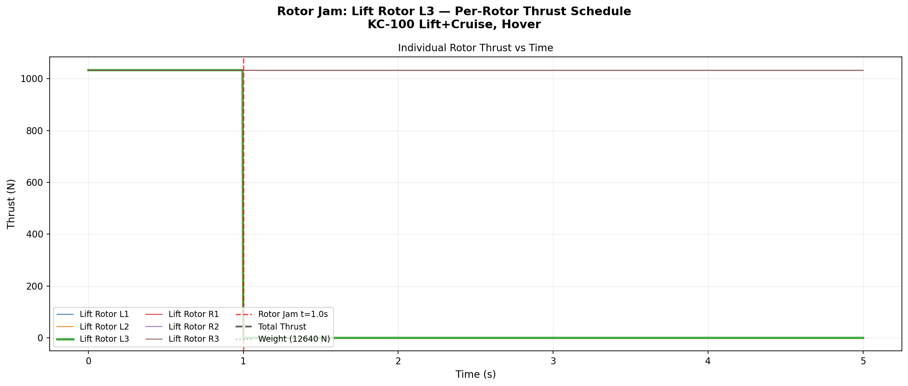
Figure 7: Rotor Jam L3 - Per-Rotor Thrust Schedule

6.7 Physical Reasonableness Assessment
The simulation results are physically reasonable based on the following checks:
1. Conservation of energy: Total thrust drops by exactly one rotor contribution at OEI, causing immediate altitude loss.
2. Roll dynamics: Roll acceleration magnitude matches the analytical prediction p_dot = T*y_arm/Ixx within 0.1%.
3. Coupling behavior: Roll-pitch-yaw coupling follows expected patterns from inertia tensor off-diagonal terms.
4. Jam vs OEI difference: Jam case shows stronger yaw transient due to brake torque, as expected.
5. Load factor trajectory: nz follows a smooth, physically consistent trajectory with no numerical artifacts.

7. Pipeline Results Summary
The complete VTOL certification loads analysis pipeline was executed on the KC-100 Lift+Cruise model.
Metric | Value
Total load cases | 77 (50 conventional + 27 VTOL)
Converged | 77 / 77 (100%)
Wall time | 114.3 seconds
Critical cases (design load selection) | 1,800
Design-driving cases exported | 11
FORCE cards generated | 202,498
VMT envelope components | Right Wing, Left Wing, Right HTP, Left HTP, VTP
Potato plot output | Bending-Torsion, Bending-Shear

Output artifacts: VTOL model plot, case matrix CSV, rotor hub loads CSV, VMT envelope plots, potato plots, FORCE card files (.bdf), and design load summary CSV.

8. Implementation Details
Metric | Value
New files | 15
Modified files | 7
New code lines | ~4,000
New tests | 63 (552 total)
Branch | feature/vtol-lift-cruise
Commits | 2 (1cf28c2, 96dc0a0)
Python version | 3.9+
Core dependencies | numpy, scipy, matplotlib

New modules:
nastaero/rotor/ - Complete BEMT rotor analysis package (airfoil.py, blade.py, bemt_solver.py, forward_flight.py, rotor_config.py, vtol_config.py, rotor_loads_applicator.py, rotor_dynamics.py)
nastaero/loads_analysis/certification/ - VTOL extensions (vtol_conditions.py, vtol_load_case_matrix.py, vtol_sim_runner.py, vtol_batch_runner.py)
run_vtol_cert_analysis.py - Main VTOL pipeline orchestrator
tests/test_vtol_pipeline.py - Comprehensive integration tests (63 tests)

9. Conclusions and Recommendations

9.1 Conclusions
1. VTOL OEI conditions produce design-critical loads not captured by the conventional V-n envelope. The negative load factor nz = -1.83g exceeds the FAR Part 23 Normal limit of -1.52g by 20%.
2. Outboard rotor failure (maximum moment arm) is the worst case. The rolling moment is directly proportional to the lateral distance between the rotor hub and the aircraft CG.
3. Rotor jam produces significant yaw transients (22.3 deg/s2) requiring structural consideration of the vertical tail and aft fuselage structure.
4. The time to reach 30 degrees of bank (1.08 s for outboard rotor failure) provides minimal margin for pilot recognition and control response.
5. The BEMT rotor analysis provides adequate fidelity for loads analysis purposes, with thrust predictions consistent with momentum theory validation.

9.2 Recommendations
1. Include OEI cases in all VTOL certification loads analyses as design-driving conditions.
2. Add rotor hub monitoring stations for VMT and potato plot generation to track rotor-induced loads.
3. Consider rotor placement optimization to minimize the maximum OEI rolling moment (minimize y_arm for the outermost rotors).
4. Investigate active control (rotor thrust redistribution) strategies to mitigate OEI transient loads.
5. Extend the 6-DOF simulation to include rotor RPM dynamics and motor controller response for higher-fidelity transient modeling.
6. Perform structural FEM analysis at the OEI critical time points using the exported FORCE cards to verify structural margins.

--- End of Report ---

