*Environ Health Perspect*

doi: 10.1289/ehp.1409055

**Note to Readers: *EHP* strives to ensure that all journal content is accessible to all readers. However, some figures and Supplemental Material published in *EHP* articles may not conform to 508 standards due to the complexity of the information being presented. If you need assistance accessing journal content, please contact** [**ehp508@niehs.nih.gov.**](mailto:ehp508@niehs.nih.gov) **Our staff will work with you to assess and meet your accessibility needs within 3 working days.**

**Supplemental Material**

**Persistent Organic Pollutants Modify Gut Microbiota–Host Metabolic Homeostasis in Mice Through Aryl Hydrocarbon Receptor Activation**

Limin Zhang, Robert G. Nichols, Jared Correll, Iain A. Murray, Naoki Tanaka, Philip Smith, Troy D. Hubbard, Aswathy Sebastian, Istvan Albert, Emmanuel Hatzakis, Frank J. Gonzalez, Gary H. Perdew, and Andrew D. Patterson

**Table of Contents**

**Materials and Methods**

**NMR-based metabolomics experiment**

***Sample preparation***

***1H NMR Spectroscopy***

***Spectral data processing and multivariate data analysis***

**Figure S1.** AHR-null liver extract reporter assay. AHR-responsiveness of extracts was examined using hepatoma reporter line, Hepa 1.1. Reporter cells were treated with 0.1 µL of control or TCDF liver extracts for 4 h. Data represent mean±S.E.M (n=5), T-test parameters: Unpaired, Two tailed, p-value < 0.001 (***).

**Figure S2.** (A) qPCR analysis of mRNA levels of bacterial *Firmicutes* and *Bacteroidetes* in the cecal content of vehicle and TCDF-treated *Ahr*+/+ mice. (B-D) 16S rRNA gene sequencing

analysis at the phylum and genus level of the cecal content. Data are presented as mean ± s. d, n

= 6 and 5 per group for *Ahr*+/+ and *Ahr*-/- mice, respectively; *p < 0.05, **p < 0.01, NS means no significance, two-tailed Student’s t-test.

**Figure S3.** (A-D) Quantification of specific bile acids levels in liver and cecum of vehicle and TCDF-treated *Ahr*+/+ mice (24 µg kg-1) by UPLC-TQMS. (E) qPCR analysis of mRNA levels of *Cyp7a1*, *Fxr* and *Shp* in the liver of vehicle and TCDF-treated *Ahr*-/- mice. Data are presented as mean ± s. d, n = 6 and 5 per group for *Ahr*+/+ and *Ahr*-/- mice, respectively; *p < 0.05, **p < 0.01, NS, no significance, two-tailed Student’s t-test. See also Table S1 and 2.

**Figure S4.** Western blot of Cyp7a1 and Actin levels in the liver.

**Figure S5.** Representative 600 MHz 1H NMR spectra of liver (A and B), fecal (C and D) and cecal content (E and F) aqueous extracts from vehicle (B, D and F) and TCDF treated group (A, C and E). The regions of δ 6.1-9.20 and δ 0.6-3.1 in the liver spectra was vertically expanded 16 times and 4 times compared with the region of δ 3.1-4.7, respectively. The regions of δ 6.1-9.4 in the fecal aqueous extracts spectra were vertically expanded 16 times compared with the region of δ 0.5-4.5. The regions of δ 6.1-9.0 in the cecal content aqueous extracts spectra were vertically expanded 16 times compared with the region of δ 0.6-4.4. Keys: 1, lipid; 2, isoleucine; 3, leucine; 4, valine; 5, D-3-hydroxybutyrate; 6, lactate; 7, alanine; 8, acetate; 9, n-butyrate; 10, propionate;

11, threonine; 12, glutamate; 13, glutamine; 14, glutathione; 15, arginine; 16, proline; 17,

creatine; 18, choline; 19, phosphorylcholine; 20, glycerophosphocholine; 21, β-glucose; 22, α-

glucose; 23, unsaturated fatty acid; 24, TMAO; 25, tyrosine; 26, histidine; 27, phenylalanine; 28,

formate; 29, betaine; 30, glycogen; 31, bile acid; 32, lysine; 33, N-acetyl aspartate; 34,

oligosaccharides; 35, succinate; 36, taurine; 37, glycine; 38, inosine; 39, uridine; 40, fumarate;

41, nicotinurate; 42, adenosine; 43, uracil; 44, α-galactose; 45, α-arabinose; 46, α-xylose; 47,

hypoxanthine; 48, glucose & amino acids; 49, ethanol; 50, pyruvate; 51,TMA; 52, raffinose; 53,

stachyose; 54, methanol; 56, urocanate; 57, adenine; 58, α-ketoglutarate. See also Table S4.

**Figure S6.** O-PLS-DA scores (left) and coefficient-coded loadings plots for the models (right) from NMR spectra of aqueous duodenum (A), jejunum (B), ileum (C), and cecum (D) extracts from the vehicle and TCDF-treated *Ahr*+/+ mice and fecal (E), cecal content (F) and liver (G) extracts from vehicle and TCDF-treated *Ahr*-/- mice.

**Figure S7.** Cross-validation with permutations test plots (200 permutations) for the PLS-DA models constructed from 1H NMR data of liver (A, *Ahr*+/+; B, *Ahr*-/-), cecal content (C, *Ahr*+/+; D, *Ahr*-/-), fecal (E, *Ahr*+/+; F, *Ahr*-/-), duodenum (G), jejunum (H), ileum (I), and cecum (J) aqueous extracts from vehicle and TCDF-treated mice.

**Figure S8.** Two dimensional (2D) 1H-1H total correlation spectroscopy (TOCSY) for the identification of n-butyrate and propionate related to Figure 5A and B. The cross peaks of n- butyrate and propionate are highlighted with dotted and solid lines, respectively.

**Figure S9.** Measurements of n-butyrate and propionate concentration from NMR peaks integration relative to internal standard TSP in the cecal content (A) and fecal extracts (B) obtained from *Ahr*+/+ and *Ahr*-/- vehicle and TCDF-treated mice. Data are presented as mean ± s. d, n = 6 and 5 per group for *Ahr*+/+ and *Ahr*-/- mice, respectively; ; *p < 0.05, **p < 0.01, NS, no significance, two-tailed Student’s t-test.

**Figure S10.** qPCR analysis of mRNA levels of *Gpr41* and *Gpr43* expression in the colon (A) and *Gck*, *G6pase*, *Glut2* and *Pepck* expression in the liver of *Ahr*+/+ vehicle and TCDF-treated *Ahr*+/+ mice. Data are presented as mean ± s. d, n = 6 per group; \**p* < 0.05, two-tailed Student’s *t*- test.

**Table S1.** Primer sequences for qRT-PCR, Related to the Experimental Procedures.

**Table S2.** Retention times and M/Z of bile acids in UPLC-TQD-MS measurements, Related to Figure 4.

**Table S3.** Significantly changed metabolites in the feces, cecal content, liver, and intestine of mice exposed to TCDF.

**Table S4.** 1H NMR chemical shifts for metabolites assigned in liver, fecal and cecal content extracts.

**Table S5.** Cross-validation with permutation test and CV-ANOVA for PLS-DA and OPLS-DA models from NMR spectra of fecal, cecal content, liver and intestinal extracts.

**Materials and Methods**

**NMR-based metabolomics experiment**

***Sample preparation***

Methanol, K2HPO4, NaH2PO4 (all in analytical grade), Sodium 3-trimethylsilyl [2,2,3,3-d4] propionate (TSP-d4) and D2O (99.9% in D) were purchased from Sigma-Aldrich (St. Louis, MO). Phosphate buffer (0.1 M K2HPO4/NaH2PO4 and PH 7.4) was prepared with K2HPO4 and NaH2PO4 for their good solubility and low-temperature stability. Liver and intestinal tissues (∼50 mg) were extracted three times with 600 µL of precooled methanol-water mixture (2/1, v/v) using the PreCellys Tissue Homogenizer (Bertin Technologies, Rockville, MD). After centrifugation at 11180 x g for 10 min at 4 °C, the combined supernatants were dried. Each of the aqueous extracts was separately reconstituted into 600 µL phosphate buffer containing 50% D2O and 0.005% TSP-d4 (chemical shift reference). Following centrifugation, 550 µL of each extract was transferred into 5 mm NMR tube. Fecal and cecal content samples were directly extracted. Briefly, samples (~50 mg) were mixed with 600 µL precooled phosphate buffer, vortexed for 30s and subjected to three consecutive freeze-thaws followed by homogenization using the Precellys Tissue Homogenizer. After centrifugation (11,180 x g, 4 °C) for 10 min, the supernatants (550 µL) were transferred into 5 mm NMR tubes for NMR analysis.

***1H NMR Spectroscopy***

1H NMR spectra of aqueous liver and fecal extracts were recorded at 298 K on a Bruker Avance III 600 MHz spectrometer (operating at 600.08 MHz for 1H) equipped with a Bruker inverse cryogenic probe (Bruker Biospin, Germany). Typical one-dimensional NMR spectrum was acquired for each of all samples employing the first increment of NOESY pulse sequence (NOESYPR1D). To suppress the water signal, a weak continuous wave irradiation was applied

to the water peak during recycle delay (2 s) and mixing time (100 ms). The 90° pulse length was adjusted to approximately 10 µs for each sample and 64 transients were collected into 32 k data points for each spectrum with spectral width of 20 ppm. To facilitate NMR signal assignments, a range of 2D NMR spectra were acquired and processed for selected samples including 1H-1H correlation spectroscopy (COSY), 1H-1H total correlation spectroscopy (TOCSY), 1H-13C heteronuclear single quantum correlation (HSQC), and 1H-13C heteronuclear multiple bond correlation spectra (HMBC).

***Spectral data processing and multivariate data analysis***

All free induction decays (FID) were multiplied by an exponential function with a 1 Hz line broadening factor prior to Fourier transformation. 1H NMR spectra were corrected manually for phase and baseline distortions and spectral region δ 0.5-9.5 was integrated into regions with equal width of 0.004 ppm (2.4 Hz) using AMIX software package (V3.8, Bruker-Biospin, Germany). Region δ 4.45-5.20 was discarded by imperfect water saturation. Regions δ 1.15-1.23 and δ 3.62-3.69 were also removed for ethanol contaminations in the cecal contents during mice dissection process. Each bucketed region was then normalized to the total sum of the spectral integrals to compensate for the overall concentration differences prior to statistical data analysis.

Multivariate data analysis was carried out with SIMCAP+ software (version 13.0, Umetrics, Sweden). Principal Component Analysis (PCA) was initially carried out on the NMR data to generate an overview and to assess data quality. Orthogonal Projection to Latent Structures with Discriminant Analysis (OPLS-DA) was subsequently conducted on the NMR data. The OPLS-DA models were validated using a 7-fold cross validation method and the quality of the model was described by the parameters R2X and Q2 values (Figure 5 and Supplemental Material Table S3). To facilitate interpretation of the results, back-transformation

of the loadings generated from the OPLS-DA was performed prior to generating the loadings plots, which were color-coded with the Pearson linear correlation coefficients of variables (or metabolites) using an in-house developed script for MATLAB (The Mathworks Inc.; Natwick, MA). The color-coded correlation coefficient indicates the significance of the metabolite contribution to the class separation, with a “hot” color (e.g., red) being more significant than a “cold” color (e.g., blue). In this study, a cutoff value of |r| > 0.707 (r > 0.707 and r < -0.707) was chosen for correlation coefficient as significant based on the discrimination significance (p ≤ 0.05).

**L iv e r E x t ra c t R e p o r te r ( A h R N u ll) in H e p a 1 . 1 ( M o u s e )**

**6 0 0**

***

**R e la t iv e L u c ife ra s e U n its**

**4 0 0**

**2 0 0**

**0**

**Figure S1.** AHR-null liver extract reporter assay. AHR-responsiveness of extracts was examined using hepatoma reporter line, Hepa 1.1. Reporter cells were treated with 0.1 µL of control or TCDF liver extracts for 4 h. Data represent mean±S.E.M (n=5), T-test parameters: Unpaired, Two tailed, p-value < 0.001 (***).

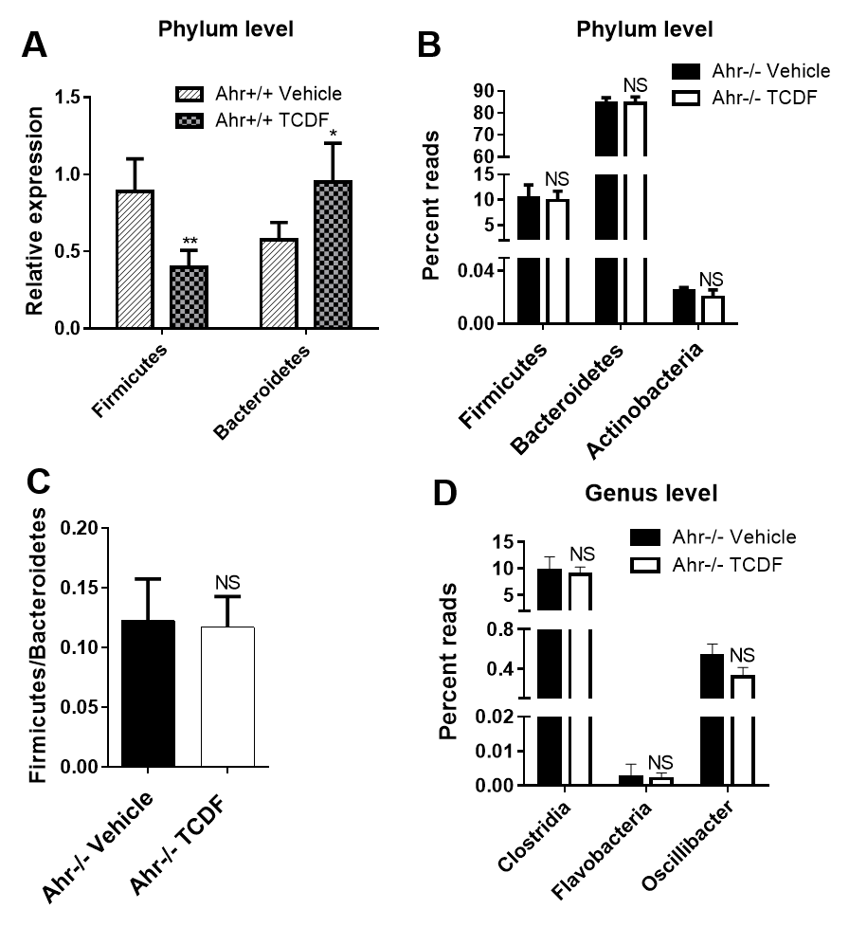

**Figure S2.** (A) qPCR analysis of mRNA levels of bacterial *Firmicutes* and *Bacteroidetes* in the cecal content of vehicle and TCDF-treated *Ahr*+/+ mice. (B-D) 16S rRNA gene sequencing analysis at the phylum and genus level of the cecal content. Data are presented as mean ± s. d, n

= 6 and 5 per group for *Ahr*+/+ and *Ahr*-/- mice, respectively; *p < 0.05, **p < 0.01, NS means no significance, two-tailed Student’s t-test.

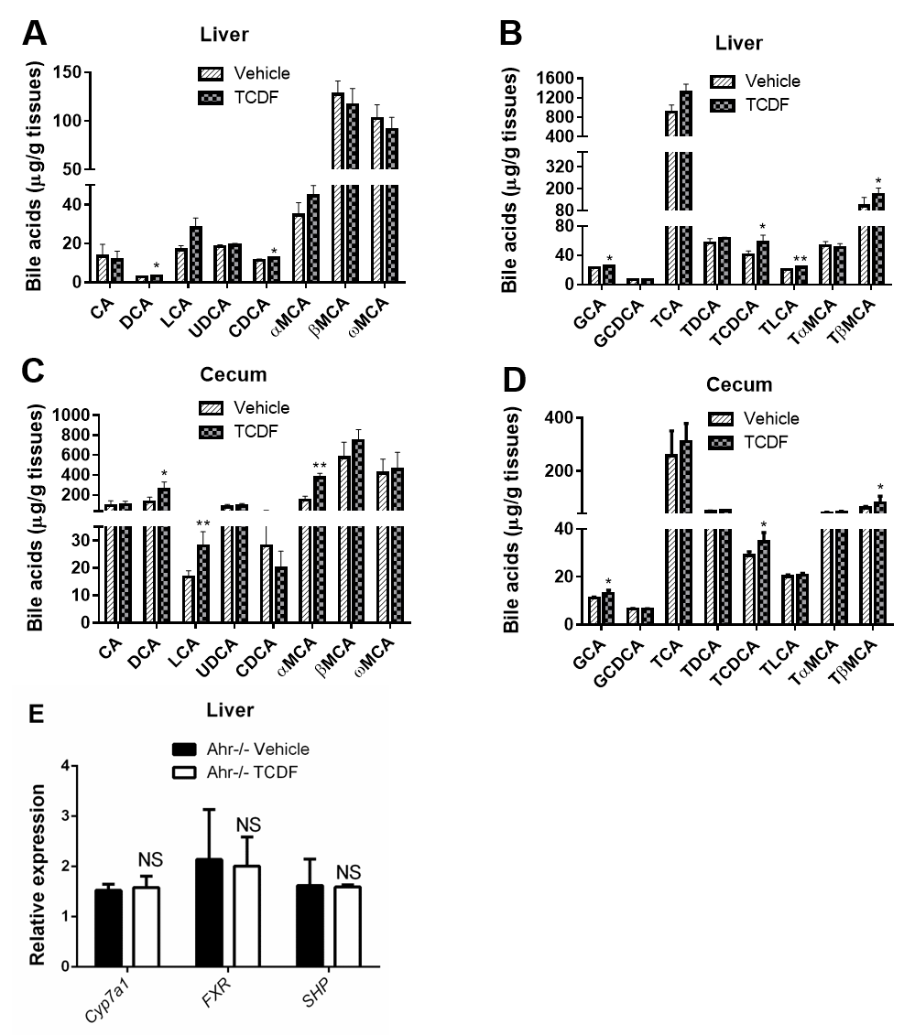

**Figure S3.** (A-D) Quantification of specific bile acids levels in liver and cecum of vehicle and TCDF-treated *Ahr*+/+ mice (24 µg kg-1) by UPLC-TQMS. (E) qPCR analysis of mRNA levels of *Cyp7a1*, *Fxr* and *Shp* in the liver of vehicle and TCDF-treated *Ahr*-/- mice. Data are presented as mean ± s. d, n = 6 and 5 per group for *Ahr*+/+ and *Ahr*-/- mice, respectively; *p < 0.05, **p < 0.01, NS, no significance, two-tailed Student’s t-test. See also Table S1 and 2.

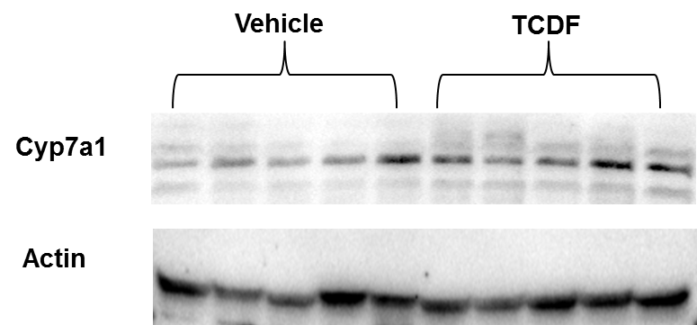

**Figure S4.** Western blot of Cyp7a1 and Actin levels in the liver.

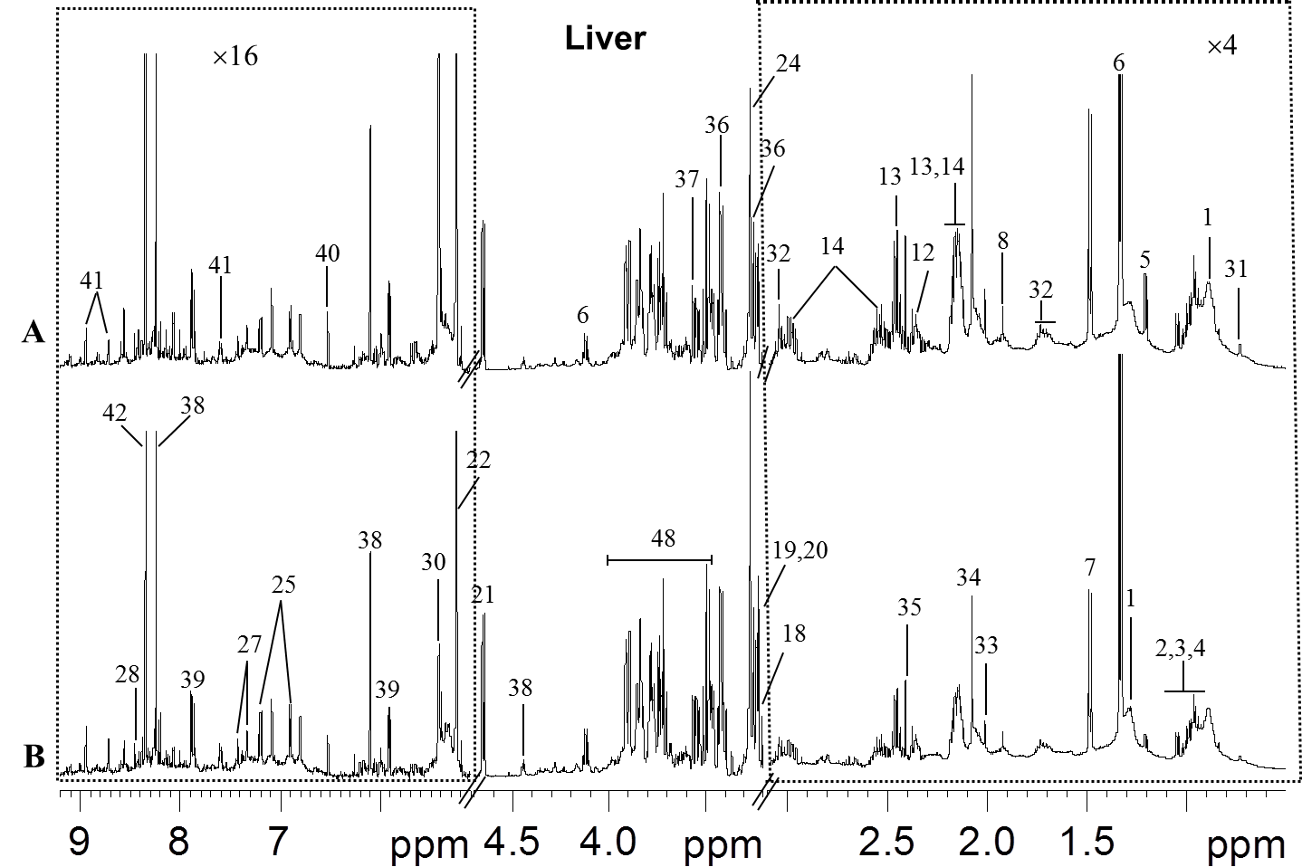

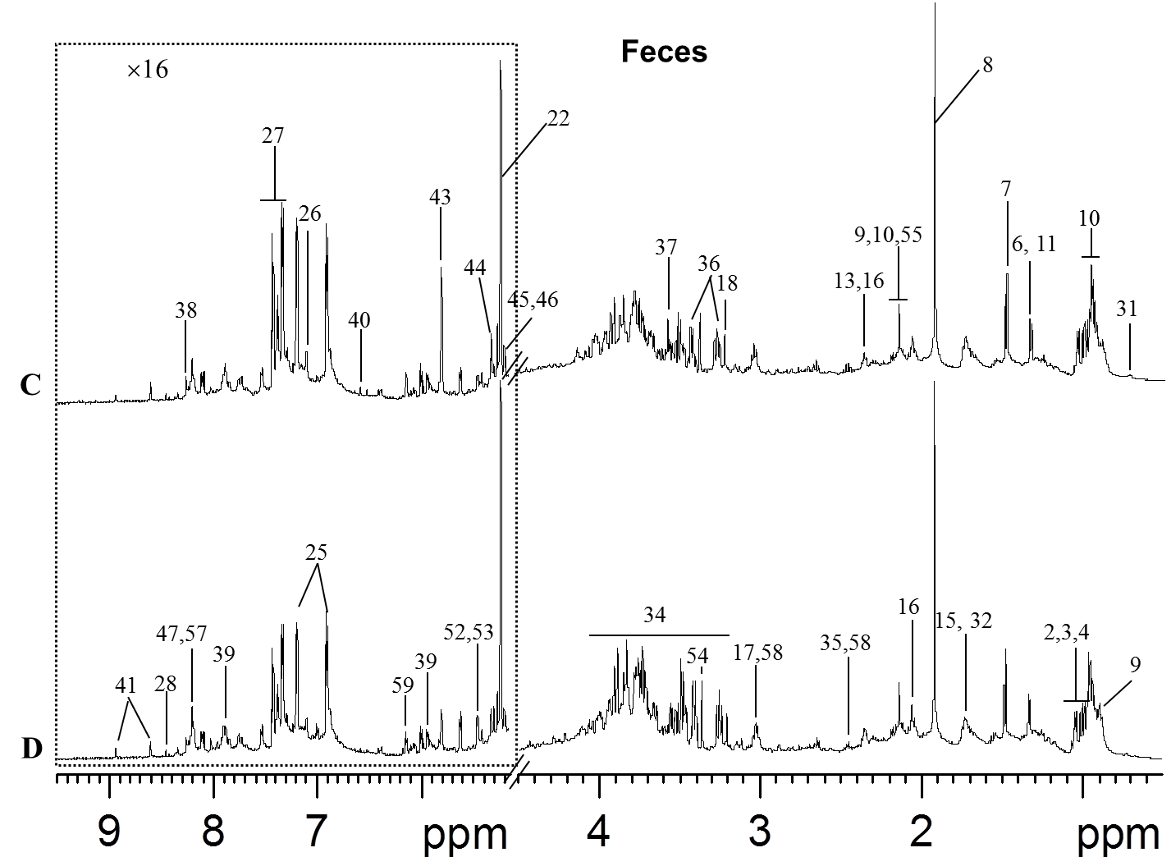

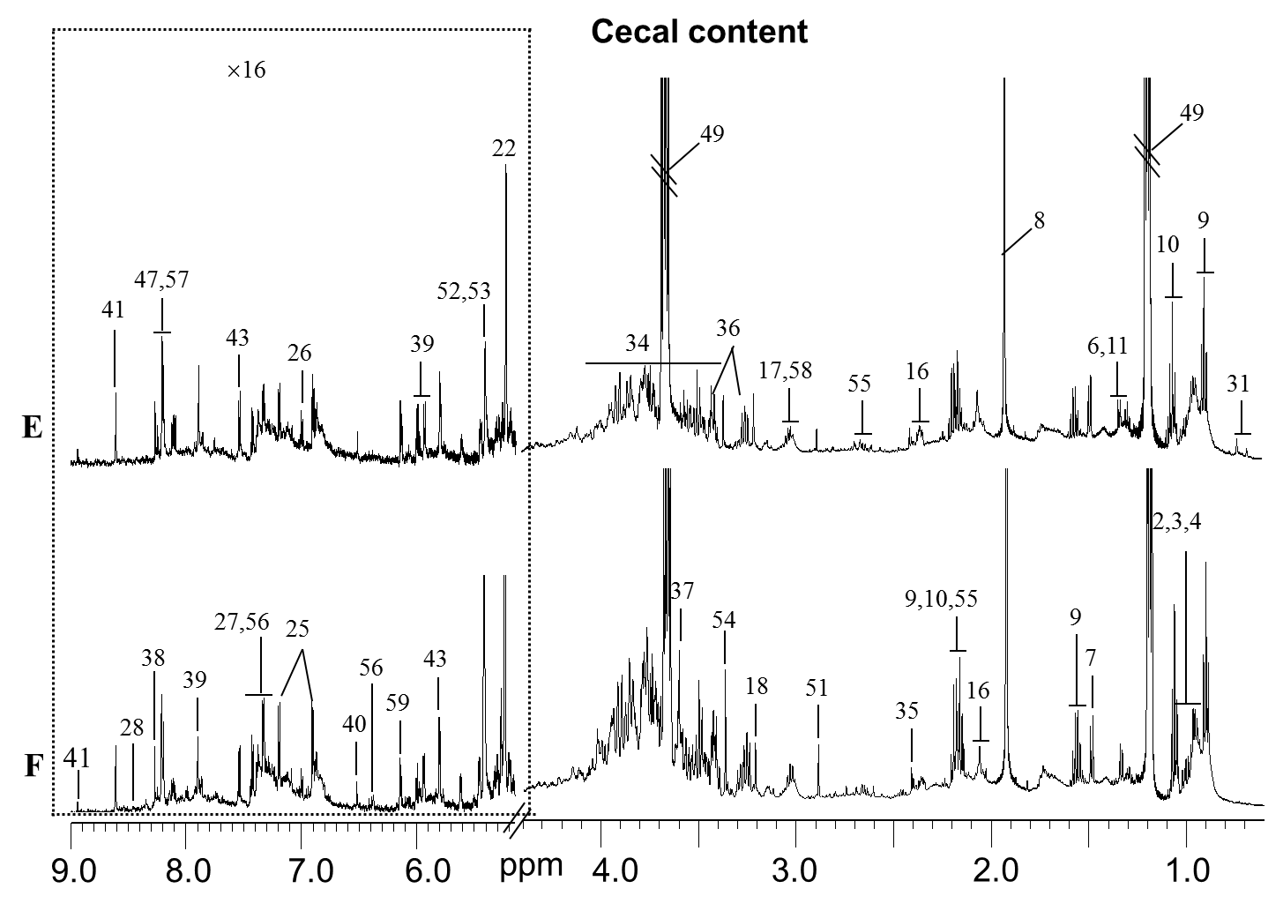

**Figure S5.** Representative 600 MHz 1H NMR spectra of liver (A and B), fecal (C and D) and cecal content (E and F) aqueous extracts from vehicle (B, D and F) and TCDF treated group (A, C and E). The regions of δ 6.1-9.20 and δ 0.6-3.1 in the liver spectra was vertically expanded 16 times and 4 times compared with the region of δ 3.1-4.7, respectively. The regions of δ 6.1-9.4 in the fecal aqueous extracts spectra were vertically expanded 16 times compared with the region of δ 0.5-4.5. The regions of δ 6.1-9.0 in the cecal content aqueous extracts spectra were vertically expanded 16 times compared with the region of δ 0.6-4.4. Keys: 1, lipid; 2, isoleucine; 3, leucine; 4, valine; 5, D-3-hydroxybutyrate; 6, lactate; 7, alanine; 8, acetate; 9, n-butyrate; 10, propionate;

11, threonine; 12, glutamate; 13, glutamine; 14, glutathione; 15, arginine; 16, proline; 17,

creatine; 18, choline; 19, phosphorylcholine; 20, glycerophosphocholine; 21, β-glucose; 22, α-

glucose; 23, unsaturated fatty acid; 24, TMAO; 25, tyrosine; 26, histidine; 27, phenylalanine; 28,

formate; 29, betaine; 30, glycogen; 31, bile acid; 32, lysine; 33, N-acetyl aspartate; 34,

oligosaccharides; 35, succinate; 36, taurine; 37, glycine; 38, inosine; 39, uridine; 40, fumarate;

41, nicotinurate; 42, adenosine; 43, uracil; 44, α-galactose; 45, α-arabinose; 46, α-xylose; 47,

hypoxanthine; 48, glucose & amino acids; 49, ethanol; 50, pyruvate; 51,TMA; 52, raffinose; 53,

stachyose; 54, methanol; 56, urocanate; 57, adenine; 58, α-ketoglutarate. See also Table S4.

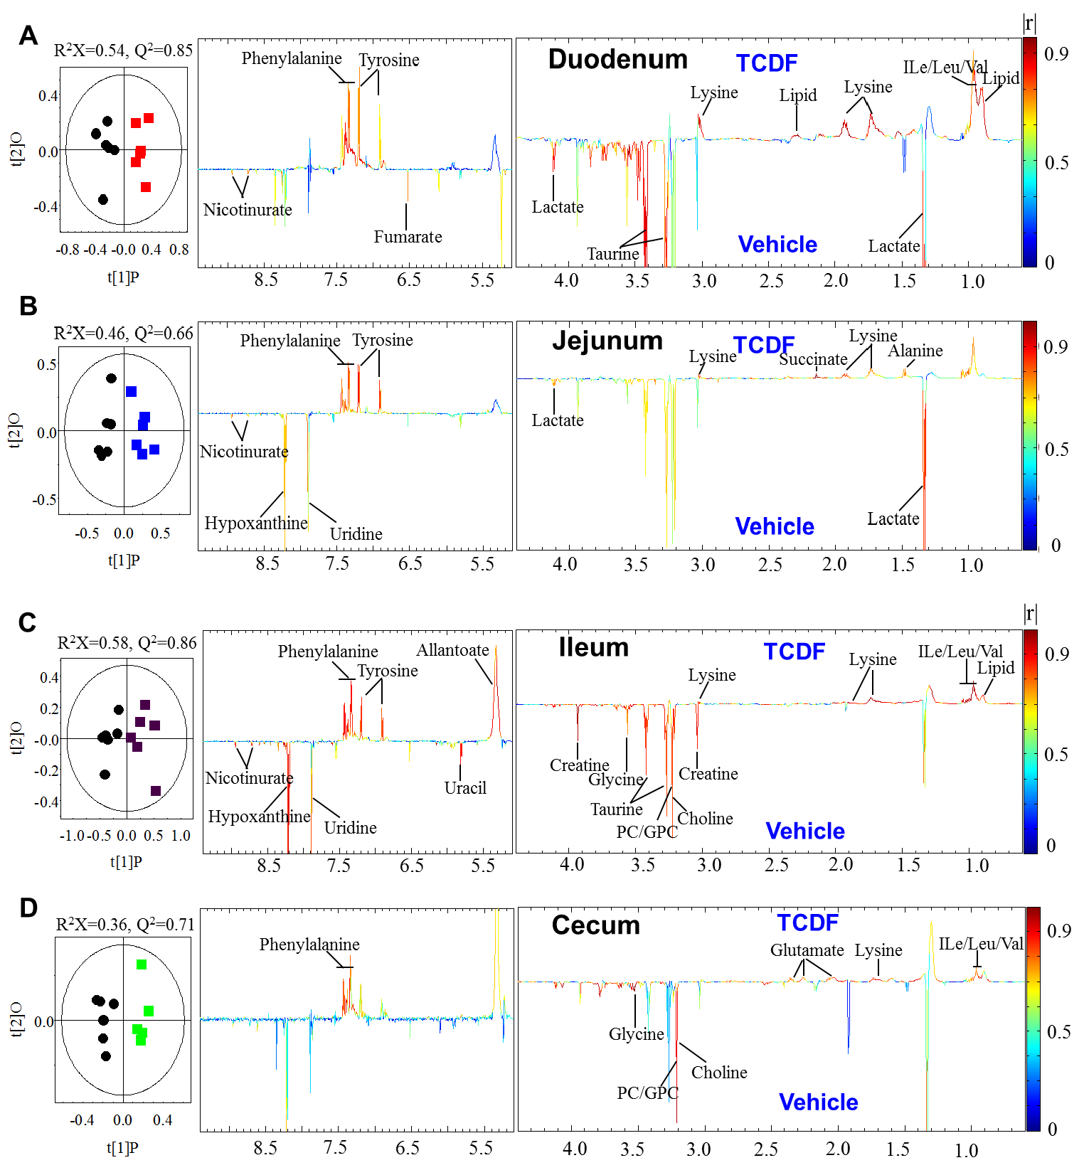

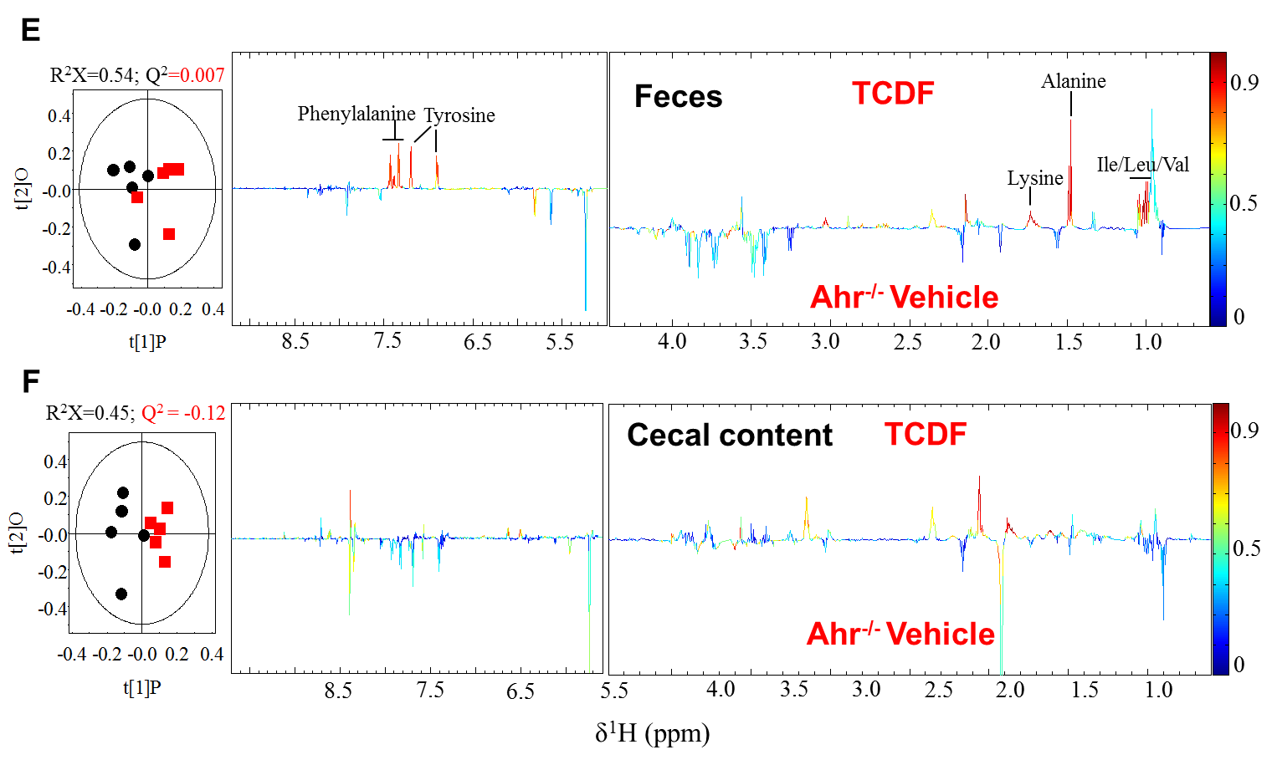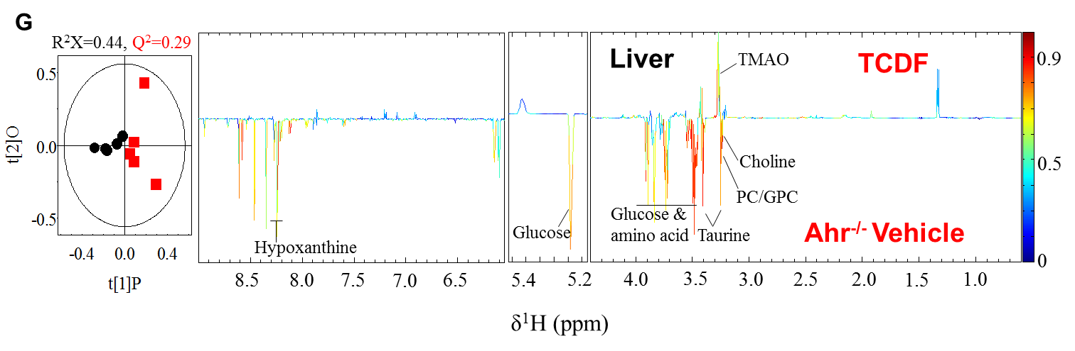

**Figure S6.** O-PLS-DA scores (left) and coefficient-coded loadings plots for the models (right) from NMR spectra of aqueous duodenum (A), jejunum (B), ileum (C), and cecum (D) extracts from the vehicle and TCDF-treated *Ahr*+/+ mice and fecal (E), cecal content (F) and liver (G) extracts from vehicle and TCDF-treated *Ahr*-/- mice.

A Liver (*Ahr*+/+) B Liver (*Ahr*-/-)

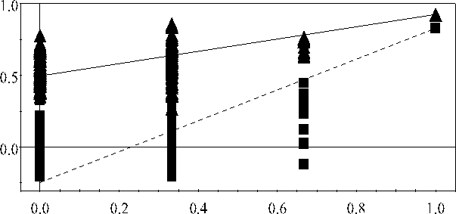 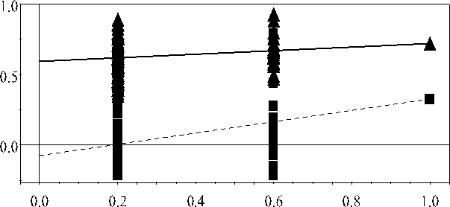

C Cecal content (*Ahr*+/+)

D Cecal content (*Ahr*-/-)

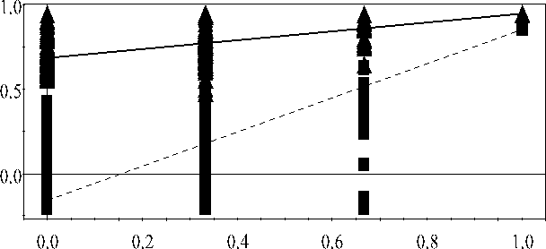 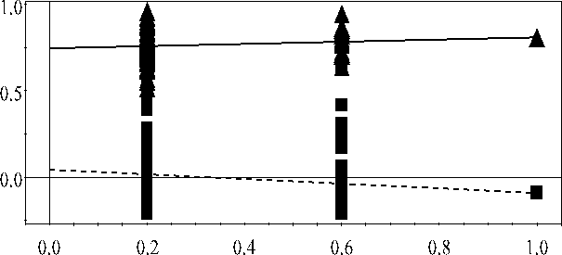

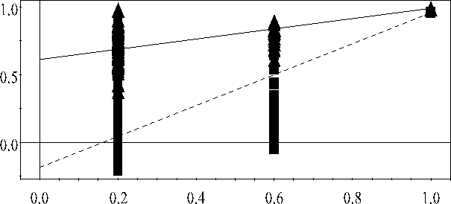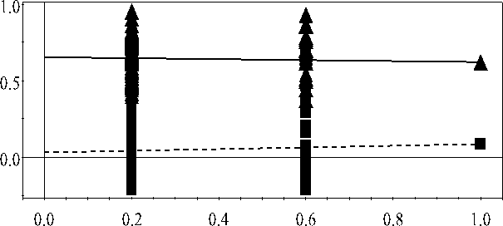E Feces (*Ahr*+/+) F Feces (*Ahr*-/-)

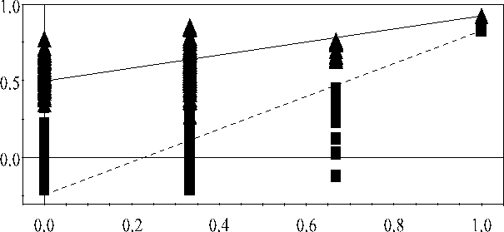G Duodenum (*Ahr*+/+)

H Jejunum (*Ahr*+/+)

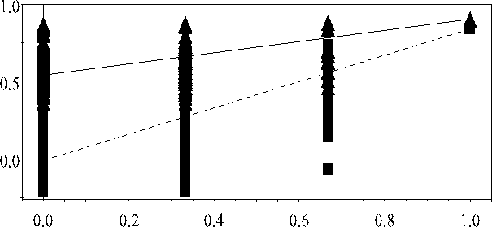

I Ileum (*Ahr*+/+)

J Cecum (*Ahr*+/+)

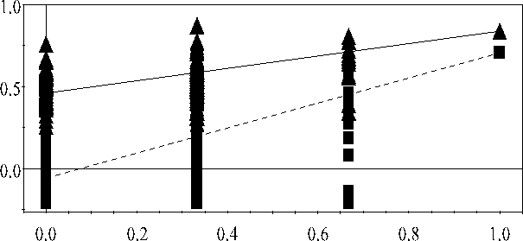 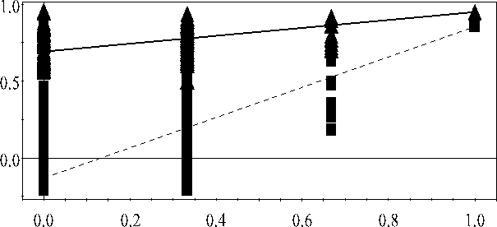

**Figure S7.** Cross-validation with permutations test plots (200 permutations) for the PLS-DA models constructed from 1H NMR data of liver (A, *Ahr*+/+; B, *Ahr*-/-), cecal content (C, *Ahr*+/+; D, *Ahr*-/-), fecal (E, *Ahr*+/+; F, *Ahr*-/-), duodenum (G), jejunum (H), ileum (I), and cecum (J) aqueous extracts from vehicle and TCDF-treated mice.

**2D 1H-1H TOCSY NMR**

n-butyrate

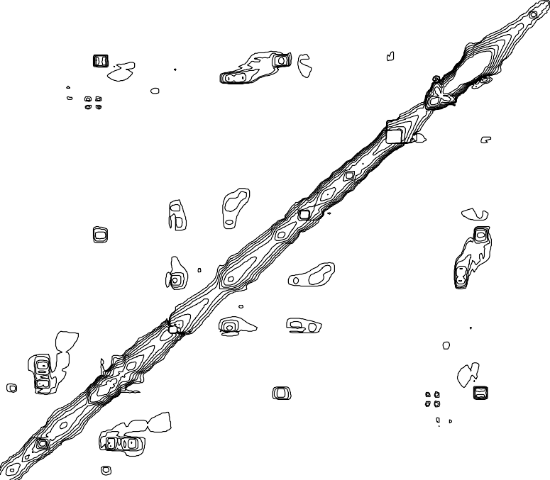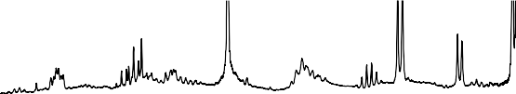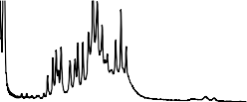

# ppm

n-butyrate

Propionate

n-butyrate

Propionate

# 1.0

**(2.16, 0.91)**

**(2.18, 1.06)**

**(1.56, 0.91)**

# 1.5

**(2.16, 1.56)**

**(0.91, 1.56)**

**(1.56, 2.16 )**

# 2.0

2.5

**(0.91, 2.16)**

**(1.06, 2.18)**

# 2.5

2.0

1.5

1.0

ppm

**Figure S8.** Two dimensional (2D) 1H-1H total correlation spectroscopy (TOCSY) for the identification of n-butyrate and propionate related to Figure 5A and B. The cross peaks of n- butyrate and propionate are highlighted with dotted and solid lines, respectively.

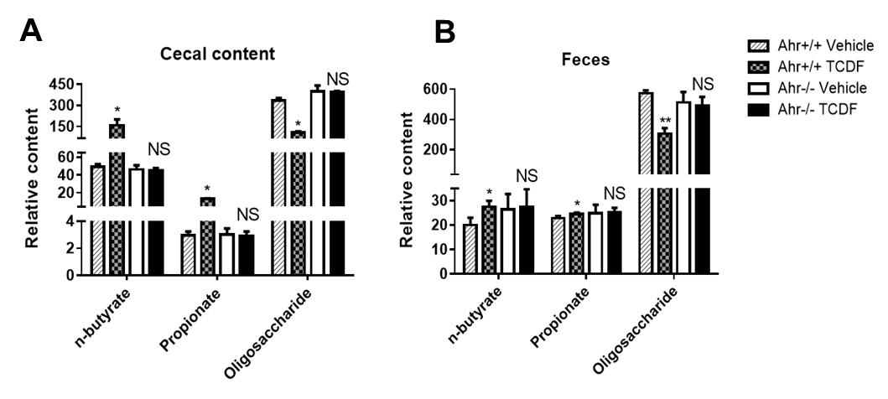

**Figure S9.** Measurements of n-butyrate and propionate concentration from NMR peaks integration relative to internal standard TSP in the cecal content (A) and fecal extracts (B) obtained from *Ahr*+/+ and *Ahr*-/- vehicle and TCDF-treated mice. Data are presented as mean ± s. d, n = 6 and 5 per group for *Ahr*+/+ and *Ahr*-/- mice, respectively; ; *p < 0.05, **p < 0.01, NS, no significance, two-tailed Student’s t-test.

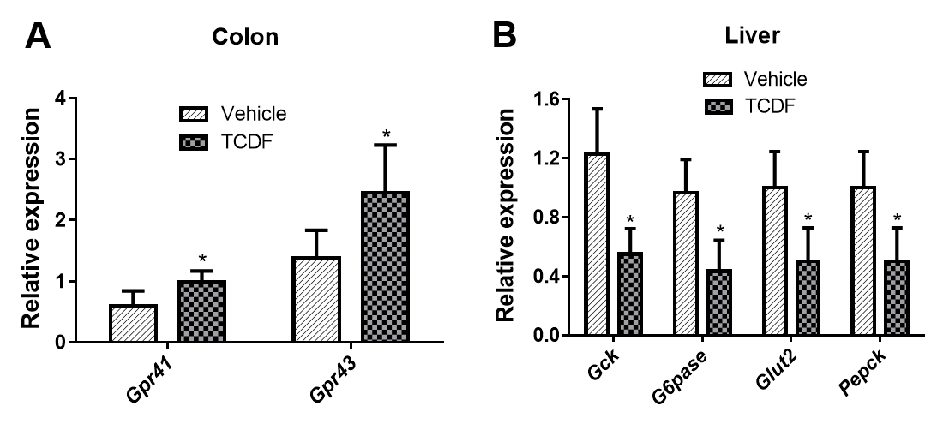

**Figure S10.** qPCR analysis of mRNA levels of *Gpr41* and *Gpr43* expression in the colon (A) and *Gck*, *G6pase*, *Glut2* and *Pepck* expression in the liver of *Ahr*+/+ vehicle and TCDF-treated *Ahr*+/+ mice. Data are presented as mean ± s. d, n = 6 per group; \**p* < 0.05, two-tailed Student’s *t*- test.

**Table S1.** Primer sequences for qRT-PCR, Related to the Experimental Procedures.

|  |  |  |
| --- | --- | --- |
| **Gene** | **Abbreviation** | **Sequence** |
| Cytochrome P450, family 1, subfamily A, polypeptide 1 | *Cyp1a1* | AGAATACGGTGACAGCCAGG  TTTGGGAGGAAGTGGAAGG |
| Cytochrome P450, family 1, subfamily A, polypeptide 2 | *Cyp1a2* | AAAGGGGTCTTTCCACTGCT AGGGACACCTCACTGAATGG |
| Cytochrome P450, family 2, subfamily E, polypeptide 1 | *Cyp2e1* | CTTAGGGAAAACCTCCGCAC GGGACATTCCTGTGTTCCAG |
| Cytochrome P450, family 2, subfamily A, polypeptide 1 | *Cyp2a1* | CCCAGCAAAGAAGAGGTTCA CCTTTCTCATCCACATGCAA |
| Aldo-keto reductase family 1 member D1 | *Akr1d1* | TGCACACCACCAAATATCCCT  CTTCACTGCCACATAGGTCTTC |
| Bile acid-CoA synthetase | *Bacs* | ACCCTGGATCAGCTCCTGGAT  GTTCTCAGCTAGCAGCTTGG |
| Bile acid-CoA: amino acid *N*-acyltransferase | *Bat* | GGAAACCTGTTAGTTCTCAGGC GTGGACCCCCATATAGTCTCC |
| Bile salt export pump (Abcb11) | *Bsep* | CTGCCAAGGATGCTAATGCA  CGATGGCTACCCTTTGCTTCT |
| Cysteine dioxygenase | *Cdo* | GGGGACGAAGTCAACGTGG  ACCCCAGCACAGAATCATCAG |
| Cysteine sulfinate decarboxylase | *Csd* | CCAGGACGTGTTTGGGATTGT ACCAGTCTTGACACTGTAGTGA |
| Cytochrome P450, family 7, subfamily A, polypeptide 1  (Cholesterol 7α-hydroxylase) | *Cyp7a1* | AGCAACTAAACAACCTGCCAGT  ACTAGTCCGGATATTCAAGGATGCA |
| Cytochrome P450, family 7, subfamily B, polypeptide 1  (Oxysterol 7α-hydroxylase) | *Cyp7b1* | TAGCCCTCTTTCCTCCACTCATA  GAACCGATCGAACCTAAATTCCT |
| Cytochrome P450, family 8, subfamily B, polypeptide 1 (Sterol 12α-hydroxylase) | *Cyp8b1* | GGCTGGCTTCCTGAGCTTATT ACTTCCTGAACAGCTCATCGG |
| Cytochrome P450, family 27, subfamily A, polypeptide 1  (Sterol 27-hydroxylase) | *Cyp27a1* | GCCTCACCTATGGGATCTTCA  TCAAAGCCTGACGCAGATG |
| Fibroblast growth factor 15 | *Fgf15* | ACGTCCTTGATGGCAATCG GAGGACCAAAACGAACGAAAT T |
| Short heterodimer partner | *Shp* | CGATCCTCTTCAACCCAGATG  AGGGCTCCAAGACTTCACACA |
| Farnesoid X receptor | *Fxr* | TCCAGGGTTTCAGACACTGG GCCGAACGAAGAAACATGG |
| Myosin Vb | *Myosin Vb* | CCCCTTCTTTGTAGTCCTTGG  CGTACAGCGAGCTCTACACC |
| Protein Tyrosine Phosphatase, Receptor Type, H | *PTPRH* | GGTAAAAGTGGGTAGGAAATGGC  GTGGCTGTGTAGGACTGAGC |
| Lipocalin-2 | *Lcn-2* | ATTTCCCAGAGTGAACTGGC  AATGTCACCTCCATCCTGGT |
| Segmented filamentous bacteria | *SFB* | GACGCTGAGGCATGAGAGCAT GACGGCACGGATTGTTATTCA |
| Hepatic nuclear factor 4α1 | *Hnf4a1* | AAATGTGCAGGTGTTGACCA  CACGCTCCTCCTGAAGAATC |
| Ileal bile acid-binding protein | *Ibabp* | CAGGAGACGTGATTGAAAGGG  GCCCCCAGAGTAAGACTGGG |
| Ileal bile acid transporter | *Ibat* | ACCACTTGCTCCACACTGCTT CGTTCCTGAGTCAACCCACAT |

|  |  |  |
| --- | --- | --- |
| **Gene** | **Abbreviation** | **Sequence** |
| Multidrug resistance-associated protein (Abcc2) | *Mrp2* | GGATGGTGACTGTGGGCTGAT GGCTGTTCTCCCTTCTCATGG |
| Multidrug resistance-associated protein (Abcc3) | *Mrp3* | TCCCACTTTTCGGAGACAGTAAC  ACTGAGGACCTTGAAGTCTTGGA |
| Na+/taurocholate cotransporter | *Ntcp* | ATGACCACCTGCTCCAGCTT  GCCTTTGTAGGGCACCTTGT |
| Organic anion transporting protein 1 | *Oatp1* | CAGTCTTACGAGTGTGCTCCAGAT ATGAGGAATACTGCCTCTGAAGTG |
| Organic solute transporter α | *Osta* | TGTTCCAGGTGCTTGTCATCC CCACTGTTAGCCAAGATGGAGAA |
| Organic solute transporter β | *Ostb* | GATGCGGCTCCTTGGAATTA  GGAGGAACATGCTTGTCATGAC |
| Taurine transporter | *Taut* | GCACACGGCCTGAAGATGA ATTTTTGTAGCAGAGGTACGGG |
| Phosphoenolpyruvate carboxykinase | *Pepck* | GGCCACAGCTGCTGCAG  GGTCGCATGGCAAAGGG |
| Glucokinase | *Gck* | TAT GAA GAC CGC CAA TGT GA TTT CCG CCA ATG ATC TTT TC |
| Glucose-6-phosphatase | *G6pase* | CTGTGAGACCGGACCAGGA  GACCATAACATAGTATACACCTGCTGC |
| Glucose transporter 2 | *Glut2* | GTCCAGAAAGCCCCAGATACC  GTGACATCCTCAGTTCCTCTTAG |
| Interleukin-1 beta | *IL-1β* | GGTCAAAGGTTTGGAAGCAG TGTGAAATGCCACCTTTTGA |
| Tumor necrosis factor alpha | *TNF-α* | AGGCTGCCCCGACTACGT  GACTTTCTCCTGGTATGAGATAGCAAA |
| Interleukin-10 | *IL-10* | GGTTGCCAAGCCTTATCGGA ACCTGCTCCACTGCCTTGCT |
| Serum amyloid A 1 | *Saa1* | TCATGTCAGTGTAGGCTCGC  GTCTTCTGCTCCCTGCTCC |
| Serum amyloid A 3 | *Saa3* | AGTAGGCTCGCCACATGTCT  TCCATTGCCATCATTCTTTG |
| G protein-coupled receptors | *Gpr41* | TTCTTGCAGCCACACTGCTC GCCCACCACATGGGACATAT |
| G protein-coupled receptors | *Gpr43* | TGGTTGGACCGTGAAGACATG TGGAACCTGTAATCCCAGCAC |

**Table S2.** Retention times and M/Z of bile acids in UPLC-TQD-MS measurements, Related to Figure 4.

|  |  |  |
| --- | --- | --- |
| **Bile acid** | **Retention time (min)** | **Multiple reaction mode** |
| CA | 7.98 | 407.2→343.2 |
| DCA | 8.95 | 391.3→391.3 |
| CDCA | 8.83 | 391.3→391.3 |
| UDCA | 8.06 | 391.3→391.3 |
| αMCA | 7.46 | 407.2→387.2 |
| βMCA | 7.57 | 407.2→371.2 |
| ωMCA | 7.38 | 407.2→387.2 |
| GCA | 7.38 | 464.3→464.3 |
| GCDCA | 8.03 | 448.3→448.3 |
| TCA | 6.68 | 514.3→124.0 |
| LCA | 9.98 | 375.3→375.3 |
| TCDCA | 7.11 | 498.5→124.3 |
| TLCA | 7.69 | 482.2→124.0 |
| TDCA | 6.63 | 498.5→124.3 |
| TαMCA | 6.22 | 514.2→107.0 |
| T βMCA | 6.28 | 514.2→107.0 |

**Table S3.** Significantly changed metabolites in the feces, cecal content, liver, and intestine of mice exposed to TCDF.

|  |  |  |  |  |  |  |  |
| --- | --- | --- | --- | --- | --- | --- | --- |
| **Metabolite** | **Feces R2X=0.64 Q2=0.88** | **Cecal content R2X=0.48 Q2=0.64** | **Liver R2X=0.74 Q2=0.75** | **Duodenum R2X=0.59 Q2=0.85** | **Jejunum R2X=0.48 Q2=0.65** | **Ileum R2X=0.66 Q2=0.87** | **Cecum R2X=0.56 Q2=0.73** |
| Lipid | － | － | +0.78a | +0.84 | － | +0.78 | － |
| UFA | － | － | +0.81 | － | － | － | － |
| PUFA | － | － | +0.74 | － | － | － | － |
| Alanine | +0.82 | － | -0.83 | － | +0.72 | － | － |
| Isoleucine | +0.93 | － | － | +0.81 | +0.69 | +0.86 | +0.71 |
| Leucine | +0.88 | － | － | +0.78 | +0.64 | +0.83 | +0.68 |
| Valine | +0.79 | － | － | +0.76 | +0.64 | +0.85 | +0.67 |
| Tyrosine | +0.94 | +0.74 | -0.73 | +0.74 | +0.77 | +0.81 | － |
| Phenylalanine | +0.92 | +0.78 | -0.72 | +0.83 | +0.79 | +0.82 | +0.84 |
| Lysine | +0.85 | － | － | +0.84 | +0.71 | +0.79 | － |
| Glutamine | +0.71 | － | － | － | － | － | +0.73 |
| Glycine | － | － | -0.63 | － | － | -0.72 | -0.86 |
| Glucose | -0.76 | -0.79 | -0.75 | － | － | － | -0.63 |
| Glycogen | － | － | +0.77 | － | － | － | － |
| Lactate | － | － | -0.75 | -0.77 | -0.81 | － | － |
| Succinate | +0.79 | － | － | － | +0.84 | － | － |
| Fumarate | － | － | － | -0.68 | － | － | － |
| Creatine | － | － | － | － | － | -0.82 | － |
| n-butyrate | +0.82 | +0.92 | － | － | － | － | － |
| Propionate | +0.68 | +0.88 | － | － | － | － | － |
| Taurine | － | － | － | -0.85 | － | -0.84 | － |
| Choline | -0.75 | － | -0.80 | － | － | -0.81 | -0.82 |
| PC/GPC | － | -0.76 | -0.68 | － | － | -0.85 | -0.83 |
| Inosine | － | － | -0.84 | － | － | － | － |
| Hypoxanthine | － | － | -0.67 | － | -0.65 | -0.85 | － |
| Uracil | － | － | － | － | － | -0.73 | － |
| Uridine | － | － | － | － | -0.63 | -0.66 | － |
| Nicotinurate | － | － | -0.69 | － | -0.67 | -0.68 | － |
| Allantoate | － | － | － | － | － | +0.78 | － |
| Oligosaccharides | -0.81 | -0.71 | － | － | － | － | － |

aCorrelation coefficient values obtained from OPLS-DA of treatment groups.

+ and – indicate a significant increase and decrease of metabolite levels in the treatment groups compared to the control mice; － no change.

**Table S4.** 1H NMR chemical shifts for metabolites assigned in liver, fecal and cecal content extracts.

|  |  |  |  |  |
| --- | --- | --- | --- | --- |
| **Key** | **Metabolites** | **Moieties** | **δ 1H (ppm) and multiplicitya** | **Samplesb** |
| 1 | Lipid | CH3, (CH2)n, CH2-C=C, CH2- C=O,C-CH2-C=,-CH=CH- | 0.89(m), 1.27(m), 2.0(m),  2.3(m), 2.78(m), 5.3(m) | L |
| 2 | Isoleucine | αCH, βCH, γCH3, δCH3 | 3.65(d), 1.95(m), 0.99(t), 1.02(d) | L, F, C |
| 3 | Leucine | αCH, βCH2, γCH3, δCH3 | 0.94(d), 3.72(t), 1.96(m), 0.91(d) | L, F, C |
| 4 | Valine | αCH, βCH, γCH3 | 3.6(d), 2.26(m), 0.98(d), 1.04(d) | L, F, C |
| 5 | D-3-hydroxybutyrate | CH, CH2, γCH3, CH2 | 4.16(dt),2.41(dd),1.20(d),2.31(dd) | L |
| 6 | Lactate | αCH, βCH3 | 4.11(q), 1.32(d) | L, F, C |
| 7 | Alanine | αCH, βCH3 | 3.77(q), 1.48(d) | L, F, C |
| 8  9  10  11 | Acetate  n-butyrate Propionate Threonine | CH3  CH3, CH2, CH2 CH3, CH2  γCH3, αCH, βCH | 1.91(s)  0.91(t), 1.56(m), 2.16(t)  1.06(t), 2.18(q)  1.33(d), 3.59(d), 4.26(m) | L, F, C F, C  F, C  F, C |
| 12 | Glutamate | αCH, βCH2, γCH2 | 2.08(m), 2.34(m), 3.75(m) | L |
| 13 | Glutamine | αCH, βCH2, γCH2 | 2.15(m), 2.44(m), 3.77(m) | L, F |
| 14 | Glutathione | CH2, CH2, S-CH2, N-CH, CH | 2.16(m), 2.55(m), 2.95(dd),  3.78(m), 4.56(q) | L |
| 15  16  17 | L-arginine L-proline Creatine | γCH2, βCH2, αCH CH2, CH2, CH CH3, CH2 | 1.72(m), 1.93(m), 3.77(m)  2.05(m), 2.34(m), 3.4(m)  3.03(s), 3.93(s) | F  F, C  F, C |
| 18 | Choline | N(CH3)3, OCH2, NCH2 | 3.2(s), 4.05(t), 3.51(t) | L, F, C |
| 19 | Phosphocholine (PC) | N(CH3)3, OCH2, NCH2 | 3.22(s), 4.21(t), 3.61(t) | L |
| 20 | Glycerophosphocholine | N(CH3)3, OCH2, NCH2 | 3.22(s), 4.32(t), 3.68(t) | L |
| 21 | β-Glucose | 1-CH | 4.66(d) | L |
| 22 | α-Glucose | 1-CH | 5.23(d) | L, F, C |
| 23 | Unsaturated fatty acid | CH=CH | 2.73, 5.3 | L |
| 24 | TMAO | CH3 | 3.27(s) | L |
| 25 | Tyrosine | CH, CH | 6.89(dd), 7.18(dd) | L, F, C |
| 26 | Histidine | 2-CH, 4-CH, CH2 | 7.75(t), 7.08(d), 6.05(d) | L, F, C |
| 27 | Phenylalanine | Ring-CH | 7.40(m), 7.33(m), 7.35(m) | L, F, C |
| 28 | Formate | CH | 8.45(s) | L, F, C |
| 29 | Betaine | CH2, CH3 | 3.27(s), 3.93(s) | L |
| 30 | Glycogen | 1-CH | 5.38-5.45(m) | L |
| 31 | Bile acid | CH3 | 0.73(m) | L, F, C |
| 32 | Lysine | αCH, βCH2, γCH2, δCH2 | 3.76(t), 1.89(m), 1.72(m), 3.01(t) | L, F, C |
| 33 | N-acetyl aspartate | CH3 | 2.01(s) | L |
| 34 | Oligosaccharides | αCH resonances | 3.3-3.9 | F, C |
| 35 | Succinate | CH3 | 2.41(s) | L, F, C |
| 36 | Taurine | S-CH2, N-CH2 | 3.26(t), 3.40(t) | L, F, C |
| 37 | Glycine | CH2 | 3.57(s) | L, F, C |
| 38 | Inosine | 14-CH, 1-CH, 8-CH, 4’-CH,  5’-CH, CH2(1/2), CH2(1/2) | 8.34(s), 6.09(d), 8.22(s), 4.76(t),  4.47(m) | L |
| 39 | Uridine | 11-CH, 7-CH, 12-CH, 6-CH,  5-CH, 4-CH, CH2, CH2 | 7.88(d), 5.92(d), 5.9(d), 4.36(m),  4.24(t) | L, F, C |
| 40 | Fumarate | CH | 6.53(s) | L, F, C |
| 41 | Nicotinurate | 2-CH, 6-CH, 4-CH, 5-CH | 8.93(s),8.62(d), 8.25(d),7.60(dd), | L, F, C |

|  |  |  |  |  |
| --- | --- | --- | --- | --- |
| **Key** | **Metabolites** | **Moieties** | **δ 1H (ppm) and multiplicitya** | **Samplesb** |
| 42 | Adenosine | 14-CH | 8.32(s) | L, C |
| 43  44  45  46 | Uracil  α-galactose α-arabinose α-xylose | 1-CH, 2-CH  1-CH, 2-CH, 3-CH  1-CH, 2-CH  1-CH, 2-CH, 3-CH | 5.81(d), 7.54(d)  5.28(d), 3.81(dd); 3.97(m)  5.21(d), 3.87(dd)  5.20(d), 3.53(dd), 3.68(m) | L, F, C F  F  F |
| 47 | Hypoxanthine | 1-CH, 2-CH | 8.20(s), 8.21(s) | F, C |
| 48 | Glucose & amino acids | αCH resonances | 3.3-3.9 | L |
| 49 | Ethanol | CH3, CH2 | 1.18(t), 3.65(q) | C |
| 50 | Pyruvate | CH3 | 2.38(s) | F, C |
| 51 | TMA | CH3 | 2.88(s) | F, C |
| 52 | Raffinose | 1-CH | 5.41(d) | F, C |
| 53 | Stachyose | 1-CH | 5.41(d) | F, C |
| 54 | Methanol | CH3 | 3.36 (s) | F, C |
| 55 | Methionine | δCH3, βCH2, γCH2 | 2.14(s), 2.16(m), 2.65(t) | F, C |
| 56 | Urocanate | CHCOOH, CH(ring), 5CH | 6.40(d), 7.31(d), 7.43(s) | F, C |
| 57 | Adenine | 2CH, 6CH | 8.19(s), 8.21(s) | F, C |
| 58 | α-ketoglutarate | γCH2, βCH2 | 2.45(t), 3.01(t) | F, C |

aKey: s, singlet; d, doublet; t, triplet; q, quartet; m, multiplet; dd, doublet of doublet. bLiver (L), fecal (F) and cecal content (C) aqueous extracts.

**Table S5.** Cross-validation with permutation test and CV-ANOVA for PLS-DA and OPLS-DA models from NMR spectra of fecal, cecal content, liver and intestinal extract.s

|  |  |  |  |  |
| --- | --- | --- | --- | --- |
|  | ***Ahr*+/+ TCDF Vs *Ahr*+/+ Vehicle** | | ***Ahr*-/- TCDF Vs *Ahr*-/- Vehicle** | |
| **Samples** | **OLPS-DA CV-ANOVA** | **PLS-DA**  **Permutation test** | **OLPS-DA CV-ANOVA** | **PLS-DA**  **Permutation test** |
| Feces | *** | √ | NS | × |
| Cecal content | * | √ | NS | × |
| Liver | ** | √ | NS | × |
| Duodenum | *** | √ | － | － |
| Jejunum | * | √ | － | － |
| Ileum | *** | √ | － | － |
| Cecum | ** | √ | － | － |

*p < 0.05, **p < 0.01, ***p < 0.001, NS, no significance, √ pass, × fail, － not determined.