**Supporting Information:**

**High-fat Diet Induces Dynamic Metabolic Alterations in Multiple Biological Matrices of Rats**

Yanpeng An,†,‡ Wenxin Xu,†,‡ Huihui Li,†,‡ Hehua Lei,† Limin Zhang,† Fuhua Hao,† Yixuan Duan,†,# Xing Yan,†,‡ Ying Zhao, †,# Junfang Wu,† Yulan Wang,† and Huiru Tang*,†

*† CAS Key Laboratory of Magnetic Resonance in Biological Systems, State Key Laboratory of Magnetic Resonance and Atomic and Molecular Physics, Wuhan Centre for Magnetic Resonance, Wuhan Institute of Physics and Mathematics, Chinese Academy of Sciences, Wuhan, 430071, P. R. China; ‡Graduate University of the Chinese Academy of Sciences, Beijing, 100049, P. R. China*

*#School of Life Science and Technology, Huazhong University of Science and Technology, Wuhan, 430074, P. R. China.*

# *To whom all correspondence should be addressed. Huiru Tang:

e-mail, Huiru.tang@wipm.ac.cn; tele,+86-27-87198430; fax, +86-27-87199291.

Control diet High-fat diet

|  |  |  |  |  |
| --- | --- | --- | --- | --- |
| Ingredients | (g) | (*k*cal) | (g) | (*k*cal) |
| Casein, 80 mesh | 200.0.00 | 800.0 | 200.0.00 | 800.0 |
| L-Cystine | 3.0.00 | 12.0 | 3.0.00 | 12.0 |
| Corn starch | 315.0.00 | 1260.0 | 72.80 | 291.0 |
| Maltodextrin10 | 35.0.00 | 140.0 | 100.0.00 | 400.0 |
| Sucrose | 350.0.00 | 1400.0 | 172.80 | 691.0 |
| Cellulose, BW200 | 50.0.00 | 0.0 | 50.0.00 | 0.0 |
| Soybean oil | 25.0.00 | 225.0 | 25.0.00 | 225.0 |
| Lard | 20.0.00 | 180.0 | 177.50 | 1598.0 |
| Mineral mix S10026 | 10.0.00 | 0.0 | 10.0.00 | 0.0 |
| Dicalcium phosphate | 13.0.00 | 0.0 | 13.0.00 | 0.0 |
| Calcium carbonate | 5.50 | 0.0 | 5.50 | 0.0 |
| Potassium citrate | 16.50 | 0.0 | 16.50 | 0.0 |
| Vitamin mix V10001 | 10.0.00 | 40.0 | 10.0.00 | 40.0 |
| Choline bitartrate | 2.0.00 | 0.0 | 2.0.00 | 0.0 |
| Total | 1055.0 | 4057.0 | 858.1 | 4057.0 |
| Nutrients and energy Protein | 19.0%a | 20.0%b | 24.0%a | 20.0%b |
| Carbohydrate | 67.0%a | 70.0%b | 41.0%a | 35.0%b |
| Fat | 4.0%a | 10.0%b | 24.0%a | 45.0%b |

a wt/wt; b percentage again total calories.

and liver tissues from rats fed with control and high-fat diets.

|  |  |  |
| --- | --- | --- |
|  | Control group | HFD group |
| Animal phenotypes |  |  |
| Initial body weight (g) | 273.8±19.7 | 275.5±27.7 |
| Final body weight (g) | 542.3±27.7 | 581.2±57.1* |
| Perirenal fat (g) | 15.54±3.49 | 23.71±6.69* |
| Epididymal fat (g) | 12.67±2.79 | 18.00±5.53* |
| Daily food and energy intakes per rat | | |
| Average food intakes (g) | 24.4±0.7 | 21.1±1.0** |
| Average energy intakes (kcal) | 92.6±2.7 | 99.3±4.6** |
| Clinical chemistry data |  |  |
| ALT (IU/L) | 43±14 | 98±86** |
| AST (IU/L) | 126±22 | 156±48* |
| AST/ALT | 3.15±0.83 | 1.97±0.69** |
| ALP (U/L) | 115±30 | 175±51** |
| TG (mmol/L) | 2.4±1.2 | 5.6±4.4** |
| Glc (mmol/L) | 6.76±0.66 | 7.58±0.46** |
| Crea (mol/L) | 49.9±3.4 | 53.8±2.5** |
| ALB (g/L) | 38±2 | 36±2* |
| GGT (IU/L) | 3±1 | 2±1* |
| TBA (mol/L) | 2.9±1.2 | 3.9±1.4 |
| BUN (mmol/L) | 4.42±0.89 | 4.00±0.46 |
| TP (g/L) | 65±2 | 63±3 |
| LDL-C (mmol/L) | 0.12±0.05 | 0.21±0.21 |
| HDL-C (mmol/L) | 0.50±0.07 | 0.46±0.08 |
| 3-HB (mmol/L) | 0.90±0.26 | 0.80±0.23 |
| tChol (mmol/L) | 1.70±0.29 | 2.00±0.97 |
| UA (mol/L) | 55.4±8.5 | 62.4±32.5 |

Data are expressed as mean ± SD. * *p*<0.05, (**)*p*<0.01.

Table S3. 1H and 13C NMR data for metabolites assigned in plasma, urine and liver extracts.

|  |  |  |  |  |  |
| --- | --- | --- | --- | --- | --- |
| key | Metabolites | Moieties | δ 1H δ 13C Sample b | | |
| 1 bile acids | | CH3 | 0.73(brs) | 12.5 | L, P |
| 2 cholesterol | | CH3 | 0.84(s) | 21.2 | L, P |
|  | | C |  | 73.9 |  |
| 3 ω-6 fatty acids | | C***H***3 | 0.89(t) a | 14.8 | L, P |
|  | | C***H***3 | 0.90(t) | 14.8 |  |
|  | | C***H***2 | 1.29(m) | 23.7 |  |
|  | | C***H***2 | 1.30(m) | 30.3 |  |
|  | | C***H***2 | 1.27(m) | 30.8 |  |
|  | | C***H***2C=C | 2.01(m) | 28.0 |  |
|  | | C***H***=C***H*** | 5.30(m) | 130.1 |  |
|  | | C=CC***H***2C=C | 2.75(m) | 26.4 |  |
|  | | C***H***2CH2COO | 1.59(m) | 25.7 |  |
|  | | C***H***2COO | 2.24(m) | 34.5 |  |
| 4 ω-3 fatty acids | | C***H***3 | 0.96(t) | 15.1 | P |
|  | | C***H***2C=C | 2.04(m) | 28.2 |  |
|  | | C***H***=C***H*** | 5.30(m) | 130.2 |  |
|  | | C=CC***H***2C=C | 2.79(m) | 26.2 |  |
|  | | C***H***2 | 1.34(m) | 30.6 |  |
|  | | C***H***2CH2COO | 1.65(m) | 25.8 |  |
|  | | C***H***2COO | 2.24(m) | 34.5 |  |
| 5 triglycerides | | CHO | 5.21(m) | 69.9 | P |
|  | | CH2O | 4.07(m) | 62.8 |  |
|  | | CH2'O | 4.28(m) | 62.8 |  |
| 6 valine | | αCH | 3.62(d) | 63.2 | L, P, U |
|  | | βCH | 2.28(m) | 32.0 |  |
|  | | γCH3 | 1.05(d) | 21.2 |  |
|  | | γ′CH3 | 0.99 (d) | 19.5 |  |
|  | | COOH |  | 177.9 |  |
| 7 isoleucine | | αCH | 3.67(d) | 62.3 | L, P |
|  | | βCH | 1.99(m) | 38.6 |  |
|  | | γCH2 | 1.47(m) | 27.5 |  |
|  | | γCH2' | 1.27(m) | 27.5 |  |
|  | | γ′CH3 | 1.01(d) | 17.9 |  |
|  | | δCH3 | 0.94 (t) | 20.9 |  |
|  | | COOH |  | 178.1 |  |
| 8 leucine | | αCH | 3.75(d) | 60.3 | L, P |
|  | | βCH2 | 1.71(m) | 42.8 |  |
|  | | γCH | 1.69(m) | 27.5 |  |
|  | | δCH3 | 0.97(d) | 24.6 |  |
|  | | δ′CH3 | 0.96(d) | 24.6 |  |
|  | | COOH |  | 178.3 |  |
| 9 -ketoisovalerate | | γCH3 | 1.11(d) | ND | P |

|  |  |  |  |  |  |
| --- | --- | --- | --- | --- | --- |
|  |  | βCH | 3.02(m) | 40.1 |  |
| 10 | 3-hydroxybutytrate | αCH | 2.31(dd) | 49.7 | L, P |
|  |  | αCH' | 2.41(dd) | 49.7 |  |
|  |  | βCH2 | 4.17(m) | 69.1 |  |
|  |  | γCH3 | 1.20(d) | 24.6 |  |
| 11 | lactate | αCH | 4.11(q) | 71.4 | L, P, U |
|  |  | βCH3 | 1.33(d) | 23.1 |  |
|  |  | COOH |  | 185.5 |  |
| 12 | threonine | αCH | 3.60(d) | 66.1 | L, P, U |
|  |  | βCH2 | 4.26(m) | 68.7 |  |
|  |  | γCH3 | 1.33(d) | 25.6 |  |
|  |  | COOH |  | 185.4 |  |
| 13 | lysine | αCH | 3.76(t) | 64.1 | L, P |
|  |  | εCH2 | 3.03(t) | 42.2 |  |
|  |  | βCH | 1.92(m) | 33.4 |  |
|  |  | γCH2 | 1.72(m) | 29.9 |  |
|  |  | δCH2 | 1.45(m) | 23.5 |  |
|  |  | COOH |  | 177.0 |  |
| 14 | alanine | αCH | 3.78(q) | 53.1 | L, P, U |
|  |  | βCH3 | 1.48(d) | 19.2 |  |
|  |  | COOH |  | 179.0 |  |
| 15 | arginine | αCH | 3.77(m) | 57.5 | P |
|  |  | βCH2 | 1.93(m) | 30.5 |  |
|  |  | γCH2 | 1.73(m) | 30.5 |  |
|  |  | δCH2 | 3.25(t) | 44.6 |  |
|  |  | COOH |  | 177.4 |  |
|  |  | C=N |  | 159.6 |  |
| 16 | acetate | CH3 | 1.92(s) | 26.5 | L, P, U |
|  |  | COOH |  | 184.2 |  |
| 17 | NAG c | CH3 | 2.04(s) | 23.2 | P,U |
|  |  | C=O |  | 175.6 |  |
| 18 | OAG | CH3 | 2.14(s) | 21.0 | P |
|  |  | C=O |  | 175.6 |  |
| 19 | glutamine | αCH | 3.77(t) | 57.2 | L, P |
|  |  | βCH2 | 2.14(m) | 29.0 |  |
|  |  | γCH2 | 2.46(m) | 34.0 |  |
|  |  | COOH |  | 175.4 |  |
|  |  | CO |  | 180.5 |  |
| 20 | glutamate | αCH | 3.78(t) | 57.7 | L, P |
|  |  | βCH2 | 2.06(m) | 29.9 |  |
|  |  | γCH2 | 2.35(m) | 36.8 |  |
|  |  | COOH |  | 178.0 |  |
|  |  | COOH |  | 184.2 |  |
| 21 | acetoacetate | CH3 | 2.27(s) | 31.5 | P |

|  |  |  |  |  |  |
| --- | --- | --- | --- | --- | --- |
|  |  | CH2 | 3.44(s) | 54.4 |  |
| 22 | pyruvate | CH3 | 2.37(s) | 36.2 | L, P, U |
|  |  | C=O |  | 172.9 |  |
|  |  | COOH |  | 207.9 |  |
| 23 | methionine | αCH | 3.87(m) | 57.2 | P |
|  |  | βCH2 | 2.16(t) | 31.3 |  |
|  |  | γCH2 | 2.65(t) | 29.4 |  |
|  |  | δCH2  COOH | 2.14 (s) | 16.6  ND |  |
| 24 | 2-ketoglutarate | αCH2 | 2.44(t) | 32.5 | P, U |
|  |  | βCH2 | 3.01(t) | 40.4 |  |
|  |  | COOH |  | 184.4 |  |
|  |  | C=O |  | 208.1 |  |
| 25 | succinate | CH2 | 2.41(s) | 37.6 | L, P, U |
|  |  | COOH |  | 185.4 |  |
| 26 | citrate | CH2 | 2.54(d) | 46.5 | P, U |
|  |  | CH2' | 2.66(d) | 46.5 |  |
|  |  | C-OH |  | 76.4 |  |
|  |  | COOH |  | 181.5 |  |
|  |  | COOH |  | 183.9 |  |
| 27 | asparagine | βCH2 | 2.87(dd) | 40.1 | P |
|  |  | βCH2' | 2.95(dd) | 40.1 |  |
|  |  | αCH | 4.00(dd) | 55.3 |  |
|  |  | COOH |  | 176.9 |  |
|  |  | CO |  | 180.5 |  |
| 28 | dimethylglycine | N-CH3 | 2.92(s) | 40.4 | L, P, U |
|  |  | CH2 | 3.72(s) | 62.6 |  |
|  |  | COOH |  | 173.1 |  |
| 29 | creatine | CH3 | 3.04(s) | 40.0 | L, P |
|  |  | CH2 | 3.93(s) | 56.9 |  |
|  |  | C=NH |  | 160.0 |  |
|  |  | COOH |  | 177.6 |  |
| 30 | choline | N(CH3)3 | 3.21(s) | 57.2 | L, P, U |
|  |  | NCH2 | 3.53(m) | 70.3 |  |
|  |  | OCH2 | 4.07(m) | 57.2 |  |
| 31 | PC | N(CH3)3 | 3.22(s) | 56.9 | L, P, U |
|  |  | NCH2 | 3.60(m) | 77.6 |  |
|  |  | OCH2 | 4.17(m) | 61.0 |  |
| 32 | GPC | N(CH3)3 | 3.24(s) | 56.9 | L, P, U |
|  |  | NCH2 | 3.69(m) | 69.1 |  |
|  |  | OCH2 | 4.33(m) | 62.5 |  |
| 33 | betaine | N(CH3)3 | 3.27(s) | 56.4 | P |
|  |  | OCH2 | 3.90(s) | 69.1 |  |
| 34 | taurine | CH2SO3 | 3.27(t) | 50.6 | P, U |

|  |  |  |  |  |  |
| --- | --- | --- | --- | --- | --- |
|  |  | CH2NH2 | 3.42(t) | 38.1 |  |
| 35 | *scyllo*-inositol | CHOH | 3.35(s) | 74.3 | P |
| 36 | α-glucose | 1-CH | 5.24(d) | 95.4 | L, P, U |
|  |  | 2-CH | 3.54(dd) | 74.9 |  |
|  |  | 3-CH | 3.73(dd) | 76.2 |  |
|  |  | 4-CH | 3.42(dd) | 72.7 |  |
|  |  | 5-CH | 3.83(dd) | 74.4 |  |
|  |  | 6-CH2 | 3.83(dd) | 63.7 |  |
| 36 | β-glucose | 1-CH | 4.45(d) | 99.3 | L, P, U |
|  |  | 2-CH | 3.26(dd) | 77.5 |  |
|  |  | 3-CH | 3.50(dd) | 79.0 |  |
|  |  | 4-CH | 3.40(dd) | 72.9 |  |
|  |  | 5-CH | 3.47(dd) | 79.0 |  |
|  |  | 6-CH | 3.74(dd) | 63.7 |  |
|  |  | 6′-CH | 3.90(dd) | 63.9 |  |
| 37 | thiamine | 6-CH | 9.42(s) | ND | U |
|  |  | 1-CH | 8.04(s) | 160.0 |  |
|  |  | 5-CH | 5.45(s) | 54.2 |  |
|  |  | CH2OH | 3.89(t) | 63.9 |  |
|  |  | CH2 | 3.18(t) | 31.9 |  |
|  |  | CH3 | 2.56(s) | 13.9 |  |
|  |  | CH3 | 2.49(s) | 27.1 |  |
| 38 | glycine | CH2 | 3.56(s) | 44.4 | L, P, U |
|  |  | COOH |  | 175.6 |  |
| 39 | urea | NH2-CO | 5.79(brs) | ND | P, U |
| 40 | cytidine | 5-CH(ring) | 6.07(d) | 99.6 | L, P |
|  |  | 6-CH(ring) | 7.85(d) | 145.1 |  |
|  |  | 1-C′H(ribose) | 5.92(d) | 90.9 |  |
| 41 | fumarate | CH | 6.52(s) | 138.6 | L, P, U |
|  |  | COOH |  | 177.7 |  |
| 42 | tyrosine | 3 or 5-CH | 6.91(d) | 118.7 | L, P |
|  |  | 2 or 6-CH | 7.20(d) | 133.7 |  |
|  |  | αCH | 3.94(dd) | 58.7 |  |
|  |  | β′CH2 | 3.20(dd) | 38.2 |  |
|  |  | βCH2 | 3.07(dd) | 38.2 |  |
|  |  | C(ring) |  | 129.6 |  |
|  |  | C-OH(ring) |  | 157.7 |  |
|  |  | COOH |  | 177.5 |  |
| 43 | histidine | 4-CH | 7.10(s) | 120.9 | L, P |
|  |  | 2-CH | 7.89(s) | 139.8 |  |
| 44 | tryptophan | 4-CH | 7.74(d) | 119.5 | L, P |
|  |  | 5-CH | 7.21(t) | 122.5 |  |
|  |  | 6-CH | 7.28(t) | 125.0 |  |
|  |  | 7-CH | 7.55(d) | 112.9 |  |

|  |  |  |  |  |
| --- | --- | --- | --- | --- |
| 45 phenylalanine | 2 or 6-CH | 7.32(dd) | 130.6 | L, P |
|  | 3 or 5-CH | 7.42(dd) | 130.0 |  |
|  | 4-CH | 7.36(m) | 129.1 |  |
|  | βCH2 | 3.12(dd) | 40.8 |  |
|  | β′CH2 | 3.25(dd) | 40.8 |  |
|  | αCH | 3.98(dd) | 61.7 |  |
|  | COOH |  | 177.4 |  |
| 46 formate | CH | 8.46(s) | 172.0 | L, P, U |
|  | COOH |  | ND |  |
| 47 deoxycytidine | 1-C′H(ribose) | 6.27(t) | ND | P |
|  | CH2(ribose) | 2.36(dd) | ND |  |
|  | 6-CH(ring) | 7.82(d) | ND |  |
|  | 5-CH(ring) | 6.05(d) | 145.7 |  |
|  | 5-C(ring) |  | 160.7 |  |
| 48 3-hydroxyisobutyrate | β′CH3  αCH | 1.06(d)  2.48(m) | 19.5  ND | P |
|  | βCH2 | 3.52(m) | ND |  |
| 49 sarcosine | βCH2'  CH3 | 3.71(m)  2.76(s) | ND  39.4 | U |
|  | CH2 | 3.65(s) | 50.9 |  |
|  | COOH |  | 185.8 |  |
| 50 asparatate | βCH2 | 2.81(dd) | 39.6 | L |
|  | β′CH2 | 2.70(dd) | 39.6 |  |
|  | αCH | 3.90(dd) | 55.2 |  |
|  | αCOOH |  | 177.2 |  |
|  | βCOOH |  | 180.5 |  |
| 51 ethanolamine | CH2NH2 | 3.14(t) | 44.4 | U |
|  | CH2OH | 3.85(t) | 60.2 |  |
| 52 methyl phosphate | OCH3 | 3.47(d) | 54.2 | L |
| 53 uracil | 5-CH | 5.81(d) | 103.9 | L |
|  | 6-CH | 7.55(d) | 146.4 |  |
| 54 cyclic AMP | 1-C'H(ribose) | 6.28(d) | 98.8 | L |
|  | 2-C'H(ribose) | 4.54(dd) | ND |  |
| 55 inosine | 2-H | 8.35(s) | 143.6 | L |
|  | 8-H | 8.27(s) | 149.8 |  |
|  | 2-H′(ribose) | 6.10(d) | 91.4 |  |
|  | half CH2 | 3.82(dd) | 63.8 |  |
|  | 5-H′(ribose) | 4.28(q) | 88.9 |  |
|  | 3-H′(ribose) | 4.44(dd) | 73.7 |  |
|  | 4-H′(ribose) | 4.78(t) | 76.9 |  |
|  | C=N |  | 151.4 |  |
|  | N-C=O |  | 161.9 |  |
| 56 xanthine | 8-CH | 7.89(s) | 144.0 | L |
| 57 hypoxanthine | 8-CH | 8.20(s) | 145.6 | L |

|  |  |  |  |  |  |
| --- | --- | --- | --- | --- | --- |
|  | | 2-CH | 8.22(s) | 149.2 |  |
| C-N |  | 160.0 |
| 58 | uridine | 6-CH(ring) | 7.89(d) | 145.4 | L |
|  |  | 5-CH(ring) | 5.91(d) | 105.5 |  |
|  |  | 2-C'H(ribose) | 4.36(dd) | 77.3 |  |
|  |  | 1-C'H(ribose) | 5.93(d) | 92.8 |  |
|  |  | 3-C'H(ribose) | 4.24(dd) | 69.0 |  |
|  |  | CH2(ribose) | 3.90(d) | 64.0 |  |
|  |  | C=O(ring) |  | 154.3 |  |
|  |  | C=O(ring) |  | 168.4 |  |
| 59 | NMN | 2-CH | 9.64(s) | ND | L |
|  |  | 6-CH | 9.30(d) | ND |  |
|  |  | 4-CH | 9.01(d) | ND |  |
|  |  | 5-CH | 8.33(t) | ND |  |
| 60 | NAD | 2-CH | 9.35(s) | ND | L |
|  |  | 4-CH | 9.15(d) | ND |  |
|  |  | 5-CH | 8.18(dd) | ND |  |
|  |  | 2''-CH | 8.41(s) | ND |  |
| 61 | PE | CH2NH2 | 3.23(s) | 43.8 | L |
| 62 | AMP | CH2OH  2-CH | 3.99(t)  8.54(s) | 66.4  ND | L |
|  |  | 7-CH | 8.17(s) | ND |  |
|  |  | 1-CH' | 6.16(s) | ND |  |
|  |  | 5-CH' | 4.50(m) | ND |  |
|  |  | 7-CH' | 4.05(m) | ND |  |
| 63 | malate | CH2 | 2.67(dd) | 45.8 | L |
|  |  | CH2' | 2.37(dd) | 45.8 |  |
|  |  | αCH | 4.35(dd) | 73.5 |  |
|  |  | αCOOH |  | 183.6 |  |
|  |  | βCOOH |  | 182.4 |  |
| 64 | trimethylamine | CH3 | 2.88(s) | 47.6 | L |
| 65 | GSSG | Glu-αCH | 3.78(m) | 56.4 | L |
|  |  | Glu-γCH2 | 2.55(m) | 34.2 |  |
|  |  | Glu-βCH2 | 2.17(m) | 29.7 |  |
|  |  | Glu-αCOOH |  | 177.2 |  |
|  |  | Cys-CH | 2.98(dd) | 41.9 |  |
|  |  | Cys-CH' | 3.32(dd) | 41.9 |  |
|  |  | Cys-αCH | 4.76(t) | 55.6 |  |
| 66 | cysteine | βCH2 | 3.05(dd) | 27.8 | L |
|  |  | αCH | 3.98(dd) | 63.1 |  |
| 67 | methanol | CH3 | 3.36(s) | 52.1 | L |
| 68 | glycogen | 1-CH | 5.41(d) | 102.6 | L |
|  |  | 2-CH | 3.60(dd) | 74.7 |  |
|  |  | CH2 | 3.89(dd) | 63.8 |  |

|  |  |  |  |  |
| --- | --- | --- | --- | --- |
|  | 3 or 5-CH | 3.70(dd) | 65.4 |  |
| CH2' | 3.86(d) | 63.6 |
| 4-CH | 3.42(dd) | 72.5 |
| 69 UDPG | Glc-1CH | 5.62(d) | 100.8 | L |
|  | Glc-2CH | 4.05(d) | 65.7 |  |
|  | 6-CH(ring) | 7.96(d) | ND |  |
|  | 5-CH(ring) | 5.98(d) | ND |  |
| 70 creatinine | CH3 | 3.05(s) | 33.2 | U |
|  | CH2 | 4.06(s) | 59.2 |  |
|  | C=NH |  | 172.1 |  |
|  | C=O |  | 191.9 |  |
| 71 methylamine | CH3 | 2.60(s) | 28.1 | U |
| 72 adipate | αCH2 | 2.19(t) | 40.5 | U |
|  | βCH2 | 1.54(m) | 28.8 |  |
| 73 sebacate | αCH2 | 2.18(t) | 48.4 | U |
|  | βCH2 | 1.56(m) | 28.4 |  |
|  | γCH2 | 1.31(m) | 31.9 |  |
| 74 2-hydroxyisobutyrate | CH3 | 1.36(s) | 30.0 | U |
|  | C |  | 77.1 |  |
|  | COOH |  | 186.7 |  |
| 75 3-hydroxyisovalerate | CH3 | 1.27(s) | 25.5 | U |
|  | CH2 | 2.38(s) | 52.0 |  |
|  | C |  | 75.5 |  |
| 76 glycerate 3-phosphate | CHOH | 4.22(m) | 80.0 | U |
|  | CH2PO4 | 4.06(d) | ND |  |
|  | CH2OH | 3.84(d) | 64.5 |  |
| 77 butyrate | CH3 | 0.94(t) | 16.3 | U |
|  | αCH2 | 2.18(t) | 48.5 |  |
|  | βCH2 | 1.58(m) | 21.5 |  |
| 78 methylmalonate | CH3 | 1.24(d) | 17.9 | U |
|  | CH | 3.17(q) | 54.7 |  |
| 79 succinimide | CH2 | 2.78(s) | 41.9 | U |
| 80 N-acetylglutamate | αCH | 4.13(t) | 68.6 | U |
|  | βCH2 | 1.83(m) | 35.9 |  |
|  | γCH2 | 2.27(t) | 38.9 |  |
|  | CH3 | 2.04(s) | 25.7 |  |
|  | C=O |  | 176.4 |  |
| 81 nicotinamide | 2-CH | 8.94(dd) | 150.1 | L,U |
|  | 4-CH | 8.27(dd) | 139.0 |  |
|  | 5-CH | 7.60(dd) | 127.0 |  |
|  | 6-CH | 8.72(dd) | 154.2 |  |
| 82 nicotinamide N-oxide | 5-CH | 7.74(dd) | 130.2 | U |
|  | 2-CH | 8.75(m) | 141.4 |  |
|  | 6-CH | 8.12(m) | 133.4 |  |

|  |  |  |  |  |  |
| --- | --- | --- | --- | --- | --- |
|  | | 4-CH | 8.49(m) | 144.2 |  |
| C |  | 135.9 |
| 83 | allantoate | CH | 5.29(s) | ND | U |
| 84 | sucrose | Glc-1-CH | 5.42(d) | 95.3 | U |
|  |  | Glc-2-CH | 3.56(dd) | 75.5 |  |
|  |  | Glc-3-CH | 3.74(dd) | ND |  |
|  |  | Glc-4-CH | 3.48(dd) | 72.2 |  |
|  |  | Glc-5-CH | 3.85(m) | 75.3 |  |
|  |  | Frc-1-CH | 4.22(dd) | 79.3 |  |
|  |  | Frc-2-CH | 4.06(d) | 76.9 |  |
| 85 | guanine | CH | 7.69(s) | 145.5 | U |
|  |  | C=C |  | 168.5 |  |
|  |  | C=C |  | 156.4 |  |
|  |  | C-NH2 |  | 81.8 |  |
| 86 | TMAO | N-CH3 | 3.27(s) | 62.5 | U |
| 87 | malonate | CH2 | 3.13(s) | 51.5 | U |
| 88 | guanidoacetate | CH2 | 3.80(s) | 47.7 | U |
|  |  | C=NH |  | 160.3 |  |
|  |  | COOH |  | 178.3 |  |
| 89 | *allo*threonine | γCH3 | 1.19(d) | 22.0 | U |
|  |  | βCH | 4.26(m) | 70.2 |  |
|  |  | αCH | 3.84(d) | 63.7 |  |
| 90 | fucose | CH3 | 1.25(d) | 18.6 | U |
|  |  | 5-CH | 3.81(m) | 73.0 |  |
|  |  | 1-CH | 5.21(d) | 94.8 |  |
|  |  | 2-CH | 3.77(m) | ND |  |
| 91 | thymidine | 1-C'H(ribose) | 6.28(t) | 89.1 | U |
|  |  | 2-C'H(ribose) | 4.44(dd) | 74.0 |  |
|  |  | 3-C'H(ribose) | 2.44(m) | 40.3 |  |
|  |  | CH(ring) | 7.68(s) | 145.2 |  |
| 92 | trigonelline | 1-CH | 9.13(s) | 148.0 | U |
|  |  | 2 or 4-CH | 8.84(dd) | 148.0 |  |
|  |  | 3-CH | 8.08(d) | 130.7 |  |
| 93 | pantothenate | CH3 | 0.94(s) | 23.7 | U |
|  |  | CH3 | 0.90(s) | 22.2 |  |
|  |  | CH2OH | 3.52(s) | 71.5 |  |
|  |  | CH2'OH | 3.40(s) | 71.5 |  |
|  |  | CHOH | 4.00(s) | 78.7 |  |
|  |  | C |  | 41.4 |  |
|  |  | C=O |  | 177.8 |  |
|  |  | CH2 | 3.45(t) | 39.5 |  |
|  |  | CH2 | 2.43(t) | 39.5 |  |
|  |  | COOH |  | 183.0 |  |
| 94 | dimethylamine | CH3 | 2.72(s) | 37.8 | U |

|  |  |  |  |  |
| --- | --- | --- | --- | --- |
| 95 β-alanine | αCH2 | 2.56(t) | 36.7 | U |
|  | βCH2 | 3.19(t) | 39.1 |  |
|  | COOH |  | 182.1 |  |
| 96 allantoin | 4-CH | 5.39(s) | 66.5 | U |
|  | C=O |  | 162.8 |  |
|  | C=O |  | 178.9 |  |
| 97 *cis*-aconitate | CH | 5.70(s) | 127.3 | U |
|  | CH2 | 3.12(s) | 46.7 |  |
|  | C |  | 147.0 |  |
|  | COOH |  | 181.5 |  |
| 98 1-methylnicotinamide | 2-CH | 9.29(s) | 148.4 | U |
|  | 4-CH | 8.97(d) | 150.6 |  |
|  | 6-CH | 8.91(dt) | 147.1 |  |
|  | 5-CH | 8.19(dd) | 131.3 |  |
|  | CH3 | 4.48(s) | 52.2 |  |
|  | C=O |  | 169.0 |  |
| 99 hippurate | 3 or 5-CH | 7.56(dd) | 132.1 | U |
|  | 4-CH | 7.64(t) | 135.5 |  |
|  | 2 or 6-CH | 7.83(dd) | 130.2 |  |
|  | αCH2  NH | 3.97(s)  8.56(brs) | 47.2 |  |
|  | C=O |  | 173.3 |  |
|  | COOH |  | 180.0 |  |
| 100 phenylacetylglycine | 3 or 5-CH | 7.42(m) | 132.0 | U |
|  | 2 or 6-CH | 7.36(m) | 132.0 |  |
|  | 4-CH | 7.36(m) | 119.3 |  |
|  | CH2 | 3.65(s) | 45.2 |  |
|  | C |  | 145.1 |  |
|  | C=O |  | 167.8 |  |
| 101 4-cresol glucuronide | 3 or 5-CH | 7.23(d) | 133.3 | U |
|  | 2 or 6-CH | 7.06(d) | 124.4 |  |
|  | CH3 | 2.30(s) | 22.7 |  |
|  | C |  | 136.2 |  |
| 102 methylguanidine | CH3 | 2.83(s) | 30.2 | U |
|  | C=O |  | 158.7 |  |
| 103 acetamide | CH3 | 1.99(s) | 25.0 | U |
|  | C=O |  | 176.5 |  |
| 104 tryptamine | 4-CH | 7.70(dd) | 120.7 | U |
|  | 5-CH | 7.20(td) | 123.3 |  |
|  | 7-CH | 7.51(d) | 115.3 |  |
|  | 6-CH | 7.28(td) | 126.1 |  |
|  | C |  | 122.7 |  |
|  | C |  | 136.3 |  |
| 105 hypotaurine | βCH2 | 3.36(t) | 37.0 | U |

|  |  |  |  |  |  |
| --- | --- | --- | --- | --- | --- |
|  | | αCH2 | 2.66(t) | 58.5 |  |
| 106 | urocanate | 2-CH | 7.86(s) | 136.9 | U |
|  |  | 4-CH | 7.36(s) | 132.1 |  |
|  |  | 5-C |  | 123.3 |  |
|  |  | CH=CH | 6.40(d) | 133.4 |  |
|  |  | CH=CH | 7.31(d) | 124.6 |  |
| 107 | 4-hydroxyphenylacetate | 2 or 6-CH | 6.87(d) | 118.2 | U |
|  |  | 3 or 5-CH | 7.16(d) | 133.4 |  |
|  |  | CH2 | 3.45(s) | 46.9 |  |
|  |  | C-OH |  | 156.9 |  |
|  |  | COOH |  | 182.7 |  |
|  |  | C |  | 132.6 |  |
| 108 | 4PY | 3-CH | 6.70(d) | 123.4 | U |
|  |  | 2-CH | 7.83(dd) | 146.8 |  |
|  |  | 6-CH | 8.56(d) | 149.2 |  |
|  |  | C |  | 120.2 |  |
|  |  | C=O |  | 180.9 |  |
|  |  | C=O |  | 170.9 |  |
|  |  | N-CH3 | 3.90(s) | 47.6 |  |
| 109 | 2PY | 3-CH | 6.67(d) | 121.9 | U |
|  |  | 4-CH | 7.97(dd) | 142.3 |  |
|  |  | 6-CH | 8.34(d) | 145.5 |  |
|  |  | C |  | 116.6 |  |
|  |  | C=O |  | 167.8 |  |
|  |  | C=O |  | 172.2 |  |
|  |  | N-CH3 | 3.65(s) | 41.4 |  |
| 110 | pseudouridine | CH(ring) | 7.68(s) | 144.5 | U |
|  |  | 1-C'H(ribose) | 4.68(d) | 81.9 |  |
|  |  | 2-C'H(ribose) | 4.29(dd) | 76.4 |  |
|  |  | 3-C'H(ribose) | 4.16(dd) | 73.5 |  |
|  |  | 4-C'H(ribose) | 4.05(dd) | 74.1 |  |
|  |  | CH2OH | 4.03(dd) | 64.4 |  |
|  |  | CH2'OH | 4.01(dd) | 64.4 |  |
|  |  | C=O |  | 156.3 |  |
|  |  | C=O |  | 168.5 |  |
|  |  | C |  | 113.6 |  |

a keys for multiplicity in parenthesis: s, singlet; d, doublet; t, triplet; q, quartet; m, multiplet; dd, doublet of doublet. b P: plasma; U: urine; L: liver extracts. ND：signals were not determined. cNAG: N-acetylated glycoproteins; OAG: O-acetylated glycoproteins; PC: phosphorylcholine; GPC: glycerophosphocholine; NMN: nicotinamide mononucleotide; NAD: nicotinamide adenine dinucleotide; PE: phosphoethanolamine; AMP: adenosine monophosphate; UDPG: uridine diphosphate glucuronate; 2PY: N-methyl-2-pyridone-5-carboxamide; 4PY: N-methyl-4-pyridone-5-carboxamide; TMAO: trimethylamine N-oxide.

Table S4. Data for fatty acids in blood plasma and liver tissues from rats fed with control and high-fat

|  |  |  |  |  |
| --- | --- | --- | --- | --- |
| diets. |  | | | |
| Fatty acid | Control(mol/L)a | HFD(mol/L) a | Control(mol/g) b | HFD(mol/g) b |
| C14:0 | - | - | 1.53±0.73 | 2.29±0.72* |
| C15:0 | - | - | 0.30±0.07 | 0.73±0.19** |
| C16:0 | 998.06±201.33 | 1079.01±191.56 | 61.61±12.53 | 66.85±11.50 |
| C16:1n7 | 120.04±42.91 | 69.27±26.48** | 10.70±5.44 | 4.55±2.27** |
| C18:0 | 635.78±88.67 | 763.33±128.19* | 24.79±1.22 | 28.22±2.59** |
| C18:1n9 | 586.16±177.79 | 909.78±210.96** | 30.83±12.83 | 67.50±19.01** |
| C18:2n6 | 565.19±160.64 | 690.35±147.28 | 23.6±4.92 | 35.26±7.46** |
| C18:3n6 | 8.08±3.56 | 9.02±3.24 | - | - |
| C18:3n3 | 28.56±9.94 | 33.24±6.02 | 0.81±0.36 | 1.33±0.37** |
| C20:0 | 2.78±0.60 | 2.98±0.64 | - | - |
| C20:1n9 | 9.95±2.76 | 12.60±3.46 | 0.12±0.04 | 0.36±0.12** |
| C20:2n6 | - | - | 0.12±0.04 | 0.25±0.06** |
| C20:3n6 | 36.24±17.85 | 57.51±11.85** | 1.17±0.41 | 1.99±0.72** |
| C20:4n6 | 696.85±111.70 | 731.74±147.87 | 27.19±1.44 | 26.79±2.03 |
| C20:5n3 | 11.14±5.19 | 11.51±4.29 | 0.33±0.11 | 0.31±0.11 |
| C22:6n3 | 74.90±16.75 | 74.88±16.21 | 4.32±0.48 | 3.31±1.63 |
| ToFA | 3773.73±727.04 | 4445.23±764.48 | 187.47±32.38 | 239.85±39.20** |
| SFA | 1636.62±274.38 | 1845.32±299.94 | 88.24±13.25 | 98.19±12.45 |
| UFA | 2137.11±464.12 | 2599.91±474.19* | 99.24±20.24 | 141.66±27.31** |
| MUFA | 716.15±219.37 | 991.66±234.28* | 41.65±17.50 | 72.41±19.39** |
| PUFA | 1420.96±264.67 | 1608.25±269.04 | 57.59±5.97 | 69.25±8.96** |
| n3 | 114.60±28.18 | 119.64±21.05 | 5.46±0.72 | 4.95±1.71 |
| n6 | 1306.36±241.73 | 1488.61±251.94 | 52.13±5.56 | 64.29±8.62** |
| n6/n3 | 11.66±1.87 | 12.52±1.24 | 9.63±1.16 | 16.14±11.17** |
| PUFA/MUFA | 2.06±0.32 | 1.66±0.21** | 1.74±1.02 | 1.00±0.19* |
| PUFA/UFA | 0.67±0.04 | 0.62±0.03** | 0.60±0.11 | 0.50±0.05* |
| PUFA/SFA | 0.87±0.07 | 0.87±0.04 | 0.66±0.10 | 0.71±0.05 |
| MUFA/UFA | 0.33±0.04 | 0.38±0.03** | 0.40±0.11 | 0.50±0.05* |
| SFA% | 0.44±0.02 | 0.42±0.01* | 0.47±0.03 | 0.41±0.02** |
| UFA% | 0.56±0.02 | 0.58±0.01* | 0.53±0.03 | 0.59±0.02** |
| MUFA% | 0.19±0.02 | 0.22±0.02** | 0.21±0.06 | 0.30±0.03** |
| PUFA% | 0.38±0.02 | 0.36±0.02 | 0.31±0.05 | 0.29±0.02 |

Data are expressed as mean ± SD. \**p*<0.05, ** *p*<0.01. a plasma; b liver.

ToFA: total fatty acids; UFA: unsaturated fatty acids; PUFA: polyunsaturated fatty acids; MUFA: monounsaturated fatty acids; SFA: saturated fatty acids; PUFA/MUFA: PUFA-to-MUFA ratio; PUFA/UFA: PUFA-to-UFA ratio; MUFA/UFA: MUFA-to-UFA ratio; PUFA/SFA: PUFA-to-SFA ratio; n3: n3 PUFA; n6: n6 PUFA; n6/n3: n6 PUFA-to-n3 PUFA ratio.

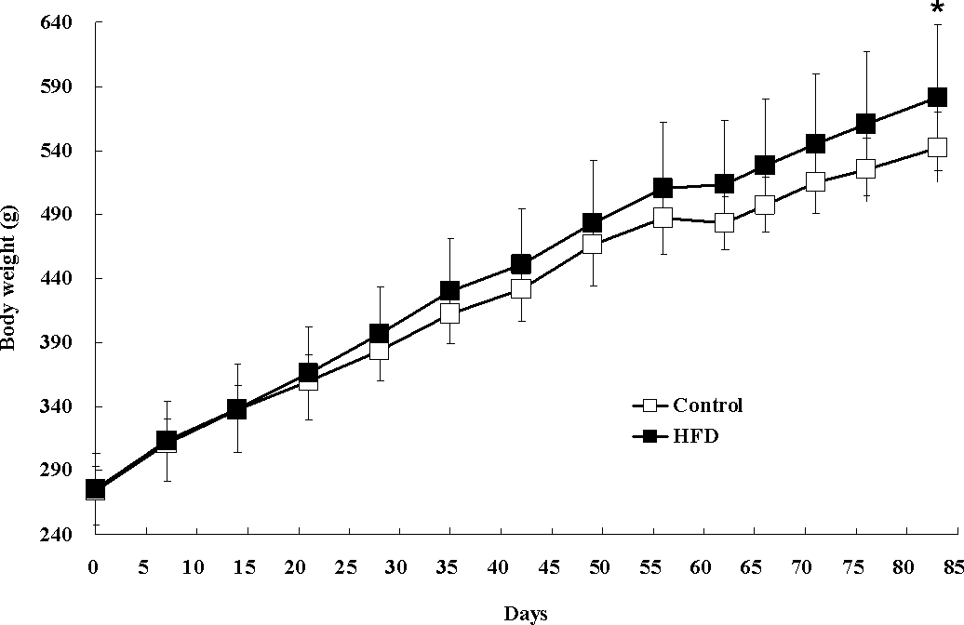

Figure S1. Changes in the body weight of rats in control group ( n=12, hollow squares) and HFD group ( n=12, solid squares) for 83 days. Values are in the form of mean ± S.D. \**p*<0.05 when comparing weight with control group.

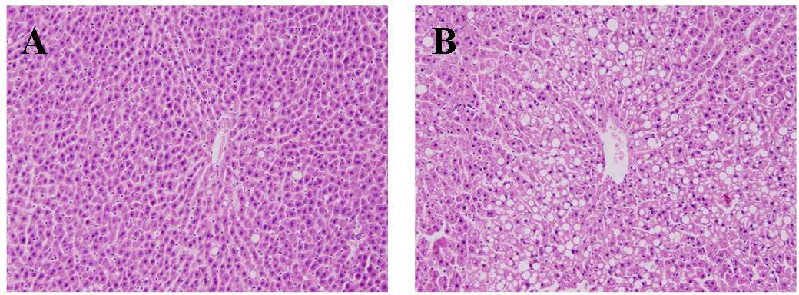

Figure S2. Micrographs (x 200) for the hematoxylin-and-eosin stained liver tissues from rats fed with

(A) control and (B) high-fat diets, respectively, for twelve weeks.

**0.00**

**-0.01**

**-0.02**

**0.00**

**0.02**

**0.000**

**-0.010**

**-0.02 0.00**

**0.02**

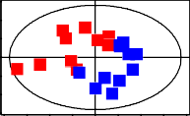Day 28 R2X=0.473, Q2=0.207

**0.01**

**0.00**

**-0.01**

**-0.01 0.00 0.01**

Day 42 R2X=0.508, Q2=0.232

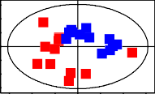**0.01**

**0.00**

**-0.01**

**-0.01 0.00 0.01**

Day 56 R2X=0.428, Q2=0.133 Day 60 R2X=0.415, Q2=0.0913

**0.01**

**0.00**

**-0.01**

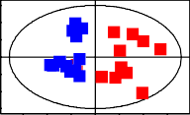**-0.01 0.00 0.01**

**0.01**

**0.00**

**-0.01**

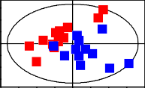**-0.01 0.00 0.01**

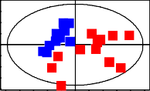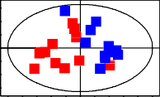Day 66 R2X=0.508, Q2=0.232 Day 71 R2X=0.428, Q2=0.133

PCA

**0.01**

**0.00**

**-0.01**

**-0.02**

**0.00**

**0.02**

**0.01**

**0.00**

**-0.01**

**-0.02**

**0.00**

**0.02**

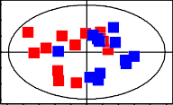Day 76 R2X=0.415, Q2=0.0913

**0.01**

**0.00**

**-0.01**

Day 83 R2X=0.475, Q2=0.176

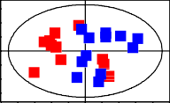**0.01**

**0.00**

**-0.01**

Plasma data

Liver extracts

**-0.02 0.00 0.02**

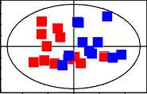CPMGpr1d R2X=0.985, Q2=0.980

**7E+07**

**0E+00**

**-7E+07**

**-5E+08 0E+00 5E+08**

Hydrophilic extracts R2X=0.922, Q2=0.889

**-0.01 0.00 0.01**

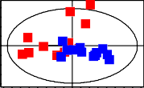Lipophilic extracts R2X=0.992, Q2=0.9

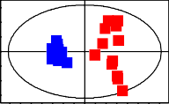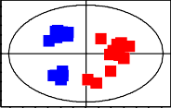

**0.01**

**0.00**

**-0.01**

**-0.10**

**0.00 0.10**

**0.07**

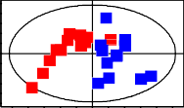**0.00**

**-0.07**

**-0.5 0.0**

**0.5**

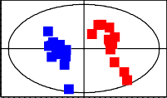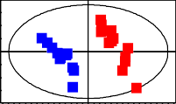**0 0**

**-30**

**-60 -30 0 30 60**

**-30**

**-40 0 40**

Day 28 R2X=0.293, Q2=0.766 Day 42 R2X=0.291, Q2=0.850

**20**

**0**

**-20**

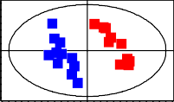**-40 0 40**

**30**

**0**

**-30**

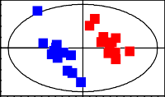**-40 0 40**

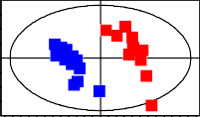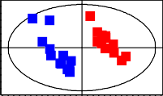Day 56 R2X=0.292, Q2=0.790 Day 60 R2X=0.324, Q2=0.765

**30**

**20**

**0 0**

**-30**

**-40 0 40**

**-20**

**-40**

**0 40**

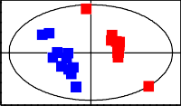Day 66 R2X=0.305, Q2=0.718 Day 71 R2X=0.263, Q2=0.722

PLS-DA

**20**

**0**

**-20**

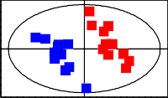**-40 0 40**

**20**

**0**

**-10**

**-40 0 40**

Day 76 R2X=0.281, Q2=0.699 Day 83 R2X=0.270, Q2=0.664

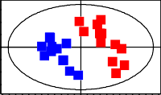**30**

**0**

**-20**

**20**

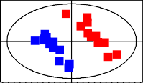**0**

**-20**

Plasma data

Liver extracts

**-40 0 40**

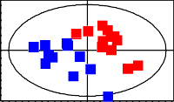CPMGpr1d R2X=0.409, Q2=0.570

**20**

**0**

**-20**

**-40 0 40**

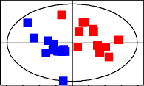Hydrophilic extracts R2X=0.834, Q2=0.795

**0.4**

**-40 0 40**

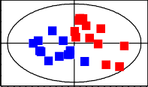Lipophilic extracts R2X=0.334, Q2=0.258

**30**

**0.0**

**-0.4**

**-2 0 2**

**0**

**-30**

**-40 0 40**

Figure S3. PCA and PLS-DA scores plots derived from 1H NMR data for urine, plamsa, liver hydrophilic extracts and lipophilic extracts from the control group (red squares) and HFD group (blue squares).

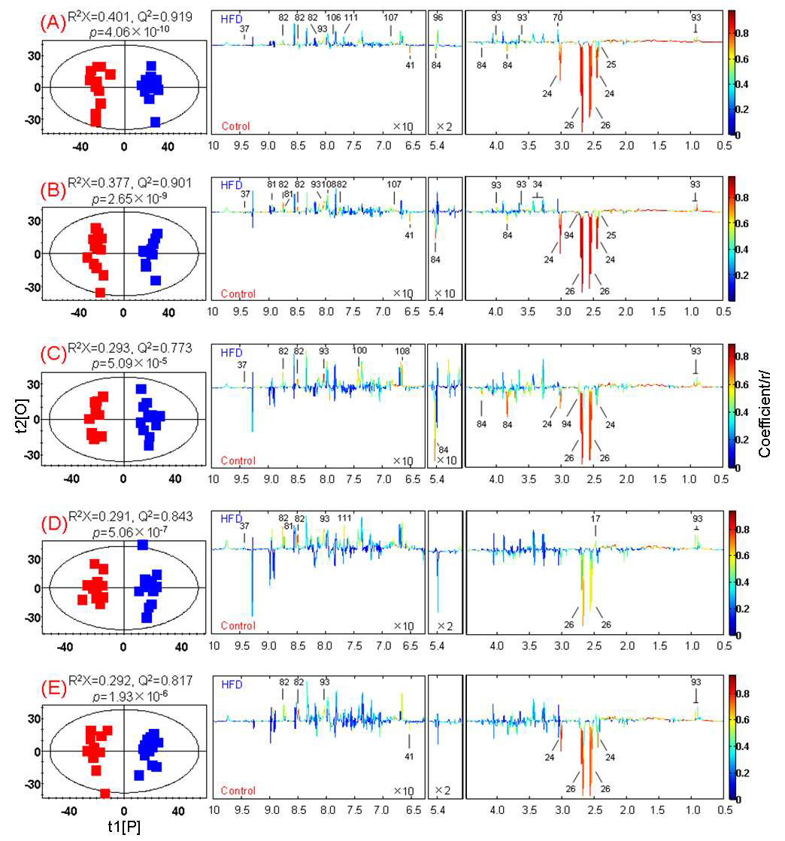

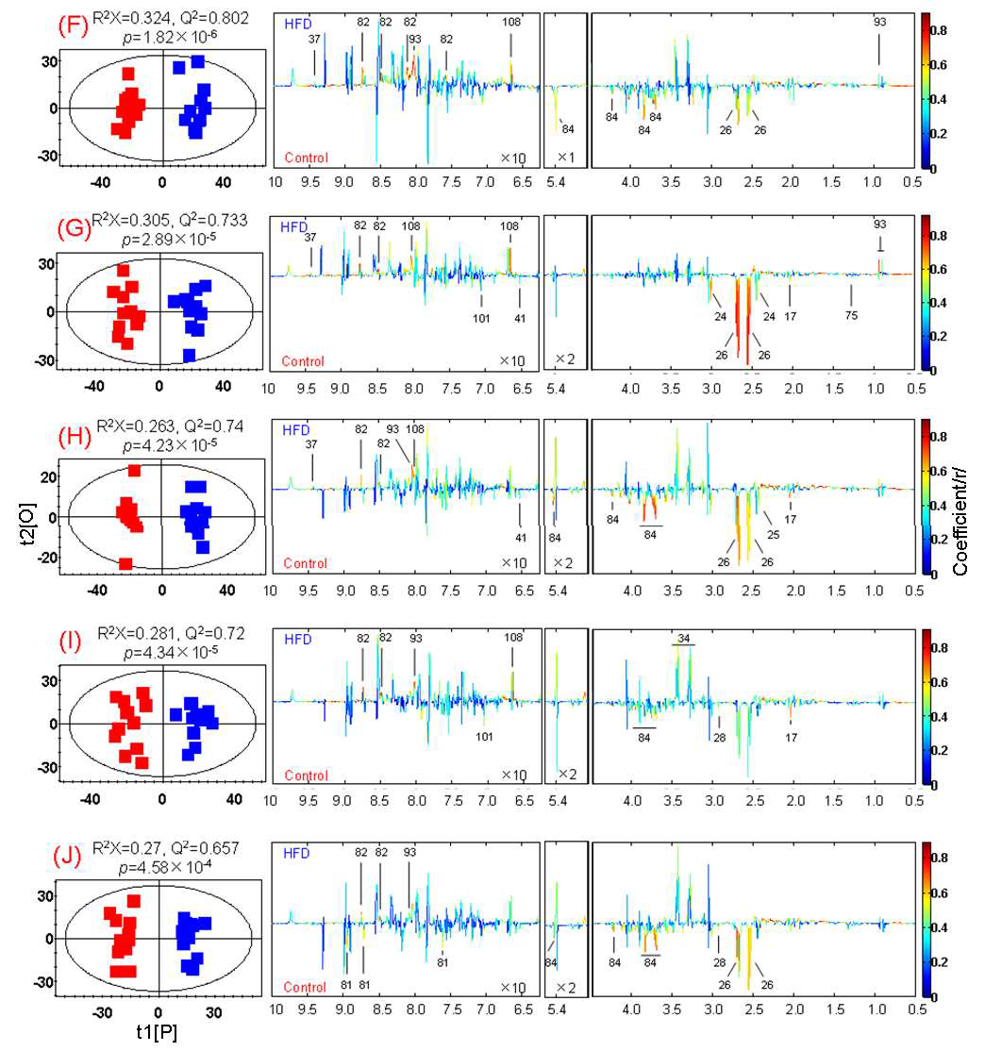

Figure S4. OPLS-DA scores plots (left) and corresponding coefficient plots (right) for 1H NMR spectra of urine obtained from the HFD (blue squares) and control (red squares) groups at time points: (A) Day 7; (B) Day 14; (C) Day 28; (D) Day 42; (E) Day 56; (F) Day 60; (G) Day 66; (H) Day 71; (I) Day 76; (J)

Day 81. Metabolite keys are shown in Table S3.

ToFA

UFA

SFA

PUFA

n6 C16:0 MUFA C18:1n9 C18:2n6 C18:0

C20:4n6

**Figure S5.** Scattered plots for the concentration of fatty acids in plasma of rats fed with HFD and control diet. Two rats (H69 and H67) of HFD groups showed obvious diversity for their plasma fatty acids. ToFA: total fatty acids; UFA: unsaturated fatty acids; PUFA: polyunsaturated fatty acids; MUFA: monounsaturated fatty acids; SFA: saturated fatty acids;

15000 5000 C16

PH69 PH69

PH69 C17

12000 4000

PH69 PH69 C18

PH69

PH67 PH69 PH67 PH67 C19

9000 3000

PH69

6000 PH69 2000 PH67 PH67 PH67 PH69 C20

PH67 PH67 PH67 PH69 C21

3000 PH67 1000 PH67 C22

C23

0 0

A 6 0 A 9 6 0 6 C24

A A A : :

F F F F n 6 F n n n 1 2 8 4

o S U 1 : : 1 : C25

T U P C MU 8 8 C 0

1 1 2 C26

C C C

C27

400 40

PH69 H61

H69 H69 H62

300 30

PH69 H63

PH69

200 PH69 20 H67 H67 H64

PH67 H69 H65

H67 H66

100 PH67 PH69 10 H69 H69

H67 H67

PH67 PH67 PH67 H67

PH69

0 PH67 0 HH6697 H68

3 6 3 3 9 7 3 6 G 0 3 A H69

n n n n n n n n T 0 n F

:

3 1 1 5 3 / H70

3 6 : : : 2 6 U

: : : :

0 2 8 0 6 0 8 C n M

2 2 1 2 1 2 1 / H71

C C C C C C C A

F H72

U P

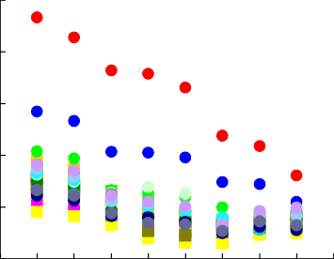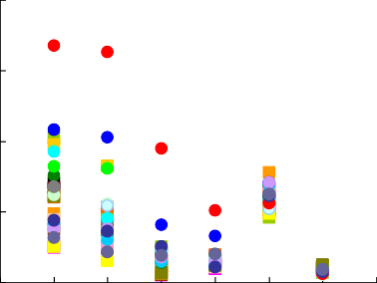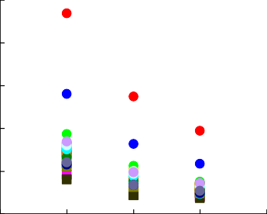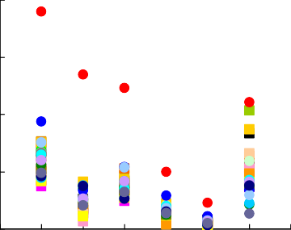

15000

5000

PH69 PH69

PH69

12000

4000

PH69 PH69

PH69

9000

PH67

3000

PH69

PH67

PH67

PH69

6000

PH69

2000

PH67 PH67 PH67

PH69

PH67

3000

PH67

1000

PH67 PH67 PH69

PH67

0

0

400

40

PH69

H69

H69

300

30

PH69

PH69

PH69

200

H67

H67

PH67

20

H69

100

PH67

PH67 PH69

PH67 PH69

PH67

10

H67

H69

PH67

H67

H69

H67

0

0

**H6**79

C16 C17 C18 C19 C20 C21 C22 C23 C24 C25 C26 C27 H61 H62 H63 H64 H65 H66 H67 H68 H69 H70 H71 H72

n3 C20:3n6 C22:6n3 C18:3n3 C20:1n9

C16:1n7

C20:5n3 C18:3n6

TG C20:0

n6/n3

PUFA/MUFA

PUFA/MUFA: PUFA-to-MUFA ratio; n3: n3 PUFA; n6: n6 PUFA.