Supporting Information

**Metabolomics Reveals that Aryl Hydrocarbon Receptor Activation by Environmental Chemicals Induces Systemic Metabolic Dysfunction in Mice** Limin Zhang,†,‡ Emmanuel Hatzakis,§ Robert G. Nichols,† Ruixin Hao,† Jared Correll,† Philip B. Smith,& Christopher R. Chiaro,† Gary H. Perdew,† Andrew D. Patterson*,†

†Center for Molecular Toxicology and Carcinogenesis, Department of Veterinary and Biomedical Sciences, The Pennsylvania State University, University Park, Pennsylvania, 16802, USA

‡CAS Key Laboratory of Magnetic Resonance in Biological Systems, State Key Laboratory of Magnetic Resonance and Atomic and Molecular Physics, Wuhan Centre for Magnetic Resonance, Wuhan Institute of Physics and Mathematics, Chinese Academy of Sciences (CAS), Wuhan 430071, China

§Department of Chemistry, The Pennsylvania State University, University Park, Pennsylvania, 16802, USA

&Metabolomics Facility, The Huck Institutes of the Life Sciences, The Pennsylvania State University, University Park, Pennsylvania, 16802, USA.

*To whom correspondence should be addressed. Address: 322 Life Sciences Building, Center for Molecular Toxicology and Carcinogenesis, Department of Veterinary and Biomedical Sciences, The Pennsylvania State University, University Park, PA 16802; USA

Phone: 8148674565; Fax: E-mail: [adp117@psu.edu](mailto:adp117@psu.edu)

There are two figures and three tables in the supplemental information.

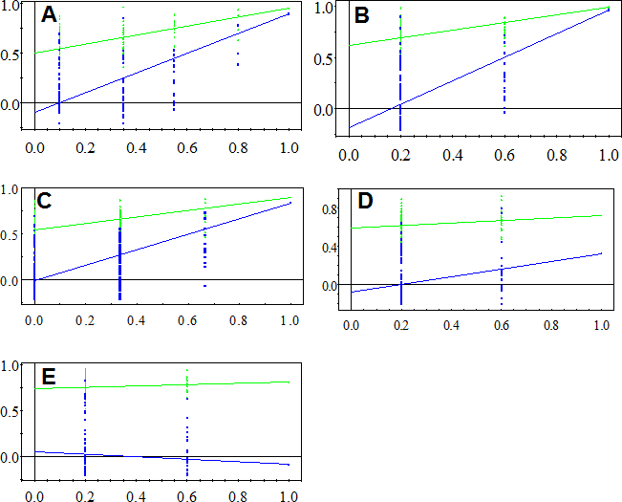

Figure S1. Permutation tests (200 tests) for the PLS-DA models of liver (A), serum CPMG (B) and serum diffusion (C) NMR data obtained from *Ahr+/+* mice and liver (D), serum CPMG (E) NMR data from *Ahr-/-* mice.

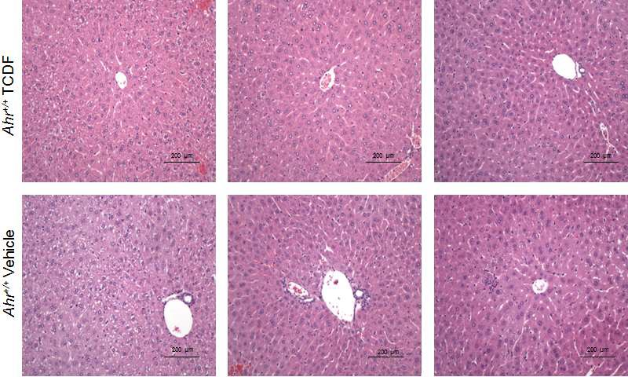

Figure S2. Hepatic histopathology. Light micrographs (×200) of liver from wild type vehicle and TCDF-treated mice (5 µg kg-1).

Table S1. 1H NMR chemical shifts for metabolites assigned in liver extracts and serum.

|  |  |  |  |  |
| --- | --- | --- | --- | --- |
| key | metabolites | moieties | δ 1H (ppm) and multiplicitya | Samplesb |
| 1  2 | Lipid  Isoleucine | CH3, (CH2)n, CH2-C=C, CH2- C=O,C-CH2-C=,-CH=CH-  αCH, βCH, γCH3, δCH3 | 0.89(m), 1.27(m), 2.0(m),  2.3(m), 2.78(m), 5.3(m)  3.65(d), 1.95(m), 0.99(t), 1.02(d) | L, S  L, S |
| 3 | Leucine | αCH, βCH2, γCH3, δCH3 | 0.94(d), 3.72(t), 1.96(m), 0.91(d) | L, S |
| 4 | Valine | αCH, βCH, γCH3 | 3.6(d), 2.26(m), 0.98(d), 1.04(d) | L, S |
| 5 | D-3-hydroxybutyrate | CH, CH2, γCH3, CH2 | 4.16(dt),2.41(dd),1.20(d),2.31(dd) | L, S |
| 6 | Lactate | αCH, βCH3 | 4.11(q), 1.32(d) | L, S |
| 7 | Alanine | αCH, βCH3 | 3.77(q), 1.48(d) | L, S |
| 8 | Acetate | CH3 | 1.91(s) | L, S |
| 9 | HDL | CH3 | 0.82(m) | S |
| 10 | LDL | CH3 | 0.85(m) | S |
| 11 | VLDL | CH3 | 0.88(m) | S |
| 12 | Glutamate | αCH, βCH2, γCH2 | 2.08(m), 2.34(m), 3.75(m) | L, S |
| 13 | Glutamine | αCH, βCH2, γCH2 | 2.15(m), 2.44(m), 3.77(m) | L, S |
| 14 | Glutathione | CH2, CH2, S-CH2, N-CH, CH | 2.16(m), 2.55(m), 2.95(dd),  3.78(m), 4.56(q) | L |
| 15 | *N*-acetyl-glycoproteins | CH3 | 2.04(S) | S |
| 16 | *O*-acetyl-glycoproteins | CH3 | 2.14(S) | S |
| 17 | Acetoacetate | CH3 | 2.26(S) | S |
| 18 | Choline | N(CH3)3, OCH2, NCH2 | 3.2(s), 4.05(t), 3.51(t) | L, S |
| 19 | Phosphocholine(PC) | N(CH3)3, OCH2, NCH2 | 3.22(s), 4.21(t), 3.61(t) | L, S |
| 20 | Glycerophosphocholine | N(CH3)3, OCH2, NCH2 | 3.22(s), 4.32(t), 3.68(t) | L, S |
| 21 | β-Glucose | 1-CH | 4.66(d) | L, S |
| 22 | α-Glucose | 1-CH | 5.23(d) | L, S |
| 23 | Unsaturated fatty acid | CH=CH | 5.3(m) | L, S |
| 24 | TMAO | CH3 | 3.27(s) | L |
| 25 | Tyrosine | CH, CH | 6.89(dd), 7.18(dd) | L, S |
| 26 | Histidine | 2-CH, 4-CH, CH2 | 7.75(t), 7.08(d), 6.05(d) | L, S |
| 27 | Phenylalanine | Ring-CH | 7.40(m), 7.33(m), 7.35(m) | L, S |
| 28 | Formate | CH | 8.45(s) | L, S |
| 29 | Betaine | CH2, CH3 | 3.27(s), 3.93(s) | L |
| 30 | Glycogen | 1-CH | 5.38-5.45(m) | L |
| 31 | Bile acid | CH3 | 0.73(m) | L |

|  |  |  |  |  |
| --- | --- | --- | --- | --- |
| 32 | Lysine | αCH, βCH2, γCH2, δCH2 | 3.76(t), 1.89(m), 1.72(m), 3.01(t) | L, S |
| 33 | N-acetyl aspartate | CH3 | 2.01(s) | L |
| 34 | PUFA | CH3 | 2.73(m) | S |
| 35 | Succinate | CH3 | 2.41(s) | L, S |
| 36 | Taurine | S-CH2, N-CH2 | 3.26(t), 3.40(t) | L |
| 37 | Glycine | CH2 | 3.57(s) | L, S |
| 38 | Inosine | 14-CH, 1-CH, 8-CH, 4’-CH, | 8.34(s), 6.09(d), 8.22(s), 4.76(t), | L |
| 39 | Uridine | 5’-CH, CH2(1/2), CH2(1/2)  11-CH, 7-CH, 12-CH, 6-CH, | 4.47(m)  7.88(d), 5.92(d), 5.9(d), 4.36(m), | L |
| 40 | Fumarate | 5-CH, 4-CH, CH2, CH2  CH | 4.24(t)  6.53(s) | L, S |
| 41 | Nicotinurate | 2-CH, 6-CH, 4-CH, 5-CH | 8.93(s),8.62(d), 8.25(d),7.60(dd), | L |
| 42 | Adenosine | 14-CH | 8.32(s) | L, C |
| 43 | Uracil | 1-CH, 2-CH | 5.81(d), 7.54(d) | L |
| 44 | Citrate | CH2(1/2), CH2(1/2) | 2.55(d), 2.65(d) | S |
| 45 | Creatine | CH2, CH3 | 3.03(s), 3.92(s) | S |
| 46 | Glucose & amino acids | αCH resonances | 3.3-3.9 | L, S |
| 47 | Pyruvate | CH3 | 2.38(s) | S |
| 48 | Triglycerides | CH | 4.08(m), 4.21(m), 5.18(m) | S |

a Key: s, singlet; d, doublet; t, triplet; q, quartet; m, multiplet; dd, doublet of doublet.

b Liver aqueous extracts (L) and serum (S).

Table S2. Cross-validation with permutation test and CV-ANOVA for PLS-DA and OPLS-DA models from NMR spectra of serum and liver extracts.

TCDF-*Ahr+/+* Vs Vehicle-*Ahr+/+* TCDF-*Ahr-/-* Vs Vehicle-*Ahr-/-*

|  |  |  |  |  |
| --- | --- | --- | --- | --- |
| Samples  Liver | OLPS-DA CV-ANOVAa  2.33×10-3 | PLS-DA  Permutation testsb  √ | OLPS-DA CV-ANOVA  0.219 | PLS-DA  Permutation tests  × |
| Serum from CPMG NMR | 0.035 | √ | 0.571 | × |
| Serum from diffusion NMR | 2.06 ×10-3 | √ | 1.392 | × |

a *P* values of CV-ANOVA for OPLS-DA models;

b √ Pass and × fail for PLS-DA models.

Table S3. Primer sequences for qRT-PCR, related to the experimental procedures.

|  |  |  |
| --- | --- | --- |
| **Gene** | **Abbreviation** | **Sequence** |
| Cytochrome P450, family 1,  subfamily A, polypeptide 1 | *Cyp1a1* | AGAATACGGTGACAGCCAGG  TTTGGGAGGAAGTGGAAGG |
| Phosphoenolpyruvate  carboxykinase | *Pepck* | GGCCACAGCTGCTGCAG  GGTCGCATGGCAAAGGG |
| Glucokinase | *Gck* | TAT GAA GAC CGC CAA TGT GA  TTT CCG CCA ATG ATC TTT TC |
| Glucose-6-phosphatase | *G6pase* | CTGTGAGACCGGACCAGGA  GACCATAACATAGTATACACCTGCTGC |
| Glucose transporter 2 | *Glut2* | GTCCAGAAAGCCCCAGATACC  GTGACATCCTCAGTTCCTCTTAG |
| Lipocalin-2 | *Lcn-2* | ATTTCCCAGAGTGAACTGGC  AATGTCACCTCCATCCTGGT |
| Interleukin-1 beta | *IL-1β* | GGTCAAAGGTTTGGAAGCAG  TGTGAAATGCCACCTTTTGA |
| Tumor necrosis factor alpha | *TNF-α* | AGGCTGCCCCGACTACGT  GACTTTCTCCTGGTATGAGATAGCAAA |
| Serum amyloid A 1 | *Saa1* | TCATGTCAGTGTAGGCTCGC  GTCTTCTGCTCCCTGCTCC |
| Stearoyl-CoA desaturase-1 | *Scd1* | TTCTTGCGATACACTCTGGTGC  CGGGATTGAATGTTCTTGTCGT |
| Fatty acid synthase | *Fasn* | GGTGTGGTGGGTTTGGTGAATTGT  TCACGAGGTCATGCTTTAGCACCT |
| Acetyl-CoA  carboxylase alpha | *Acaca* | TAACAGAATCGACACTGGCTGGCT  ATGCTGTTCCTCAGGCTCACATCT |