MultiFrame MFG Tool - User Guide

Version: develop_R1 version

Author: YiJie Wang (jasonwang@hc.hitrontech.com)

Date: 2016. 12.19

**Root folder structure**

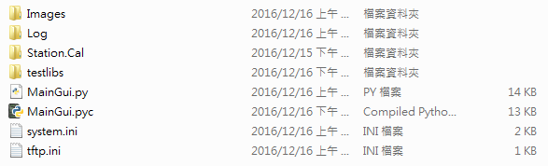

**Definition**

*Images

The figuration ex: ico, bmp, called by GUI

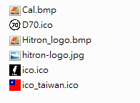

*Log

All of test results would be saved here by the model name, date, mac.



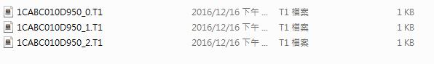

*Station.Cal

The noise source power table of each path would be saved here

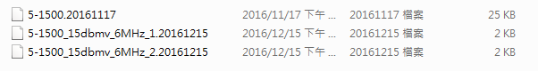

*testlibs

Library of modules

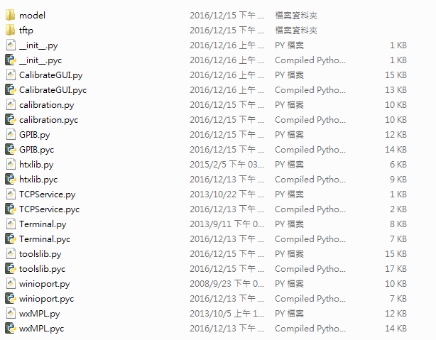

*MainGui.py / MainGui.pyc

Main code to open the GUI, it’s complied by python.exe

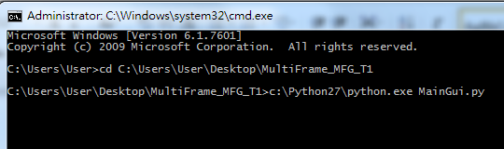

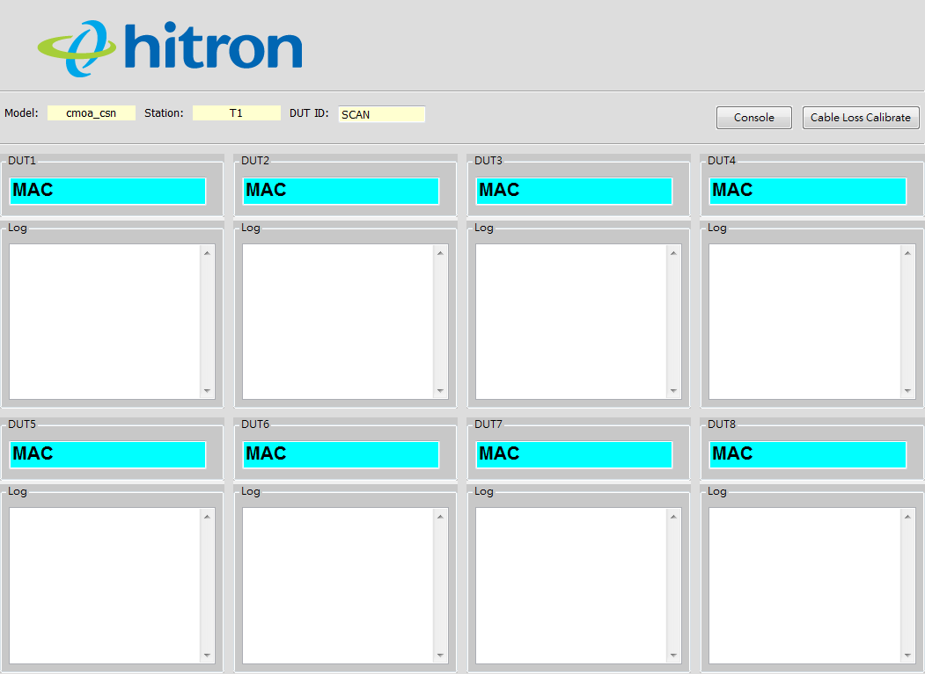

Running:

The background of DUT id would be “YELLOW”

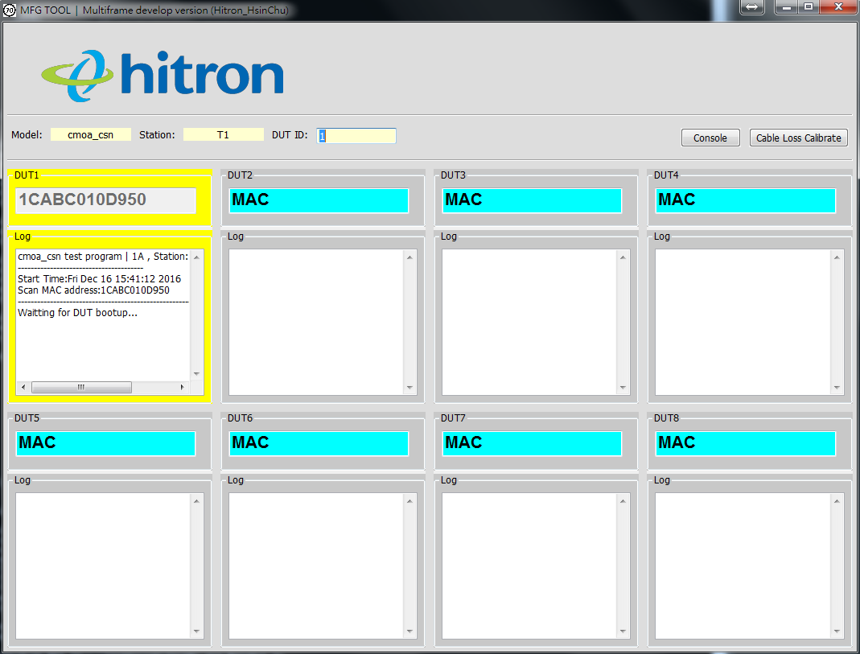

Result:

PASS – The background of DUT id would be “GREEN”

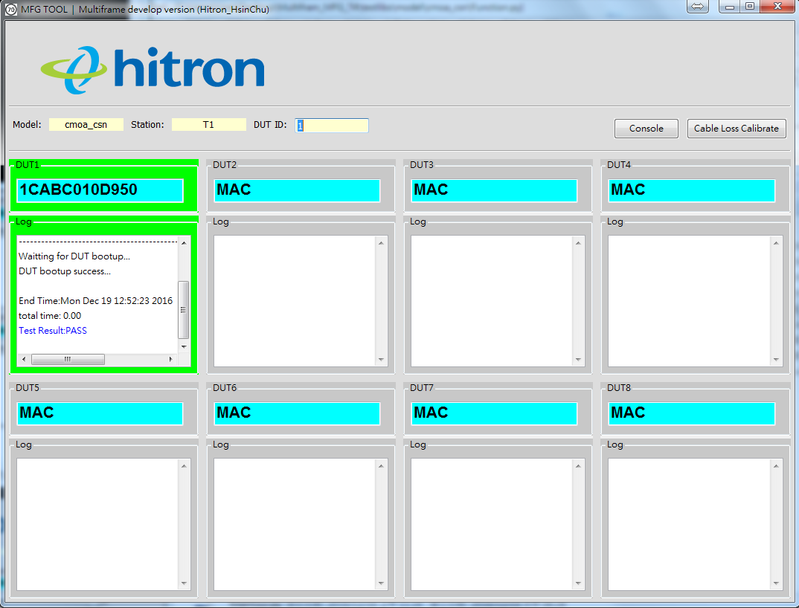

FAIL – The background of DUT id would be “RED”

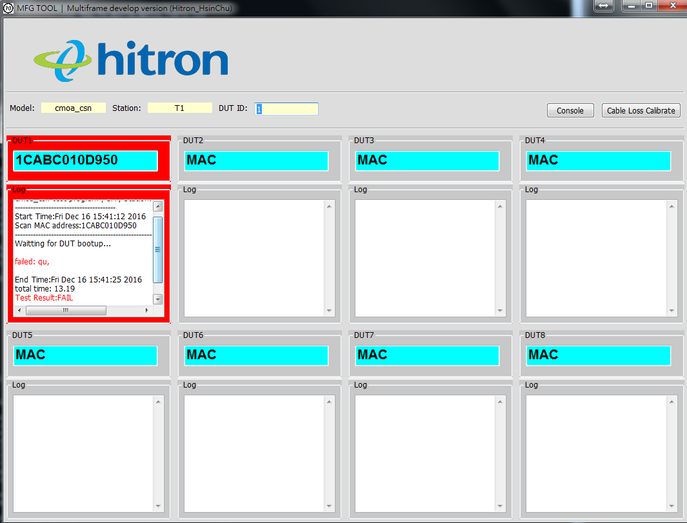

*system.ini

The configuration of GUI interface.

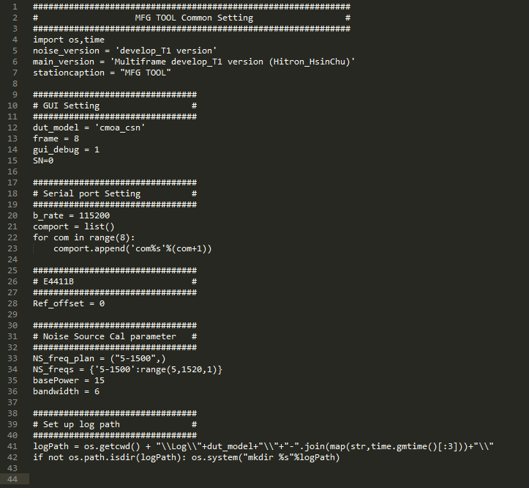

*tftp.ini

The configuration of tftp daemon

**Setup GUI**

User can configure the GUI interface via system.ini, it can be edited by your editor apps.





line 12. dut_model – functions called where referenced from /testlibs/model/<project name>

line 13. frame – defines the numbers of testing frame. (default settings is “8”)

Example: frame = 1

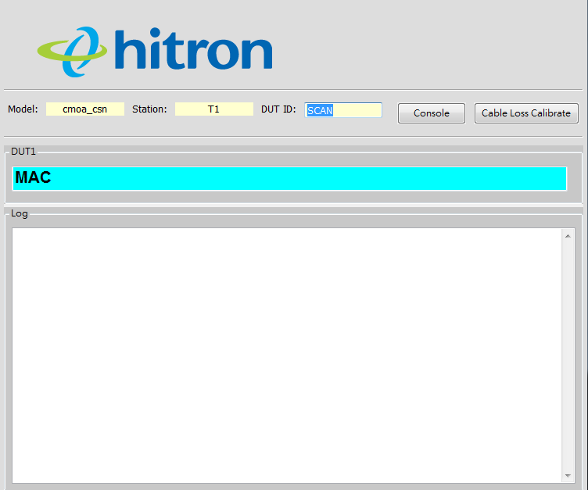

Frame = 4

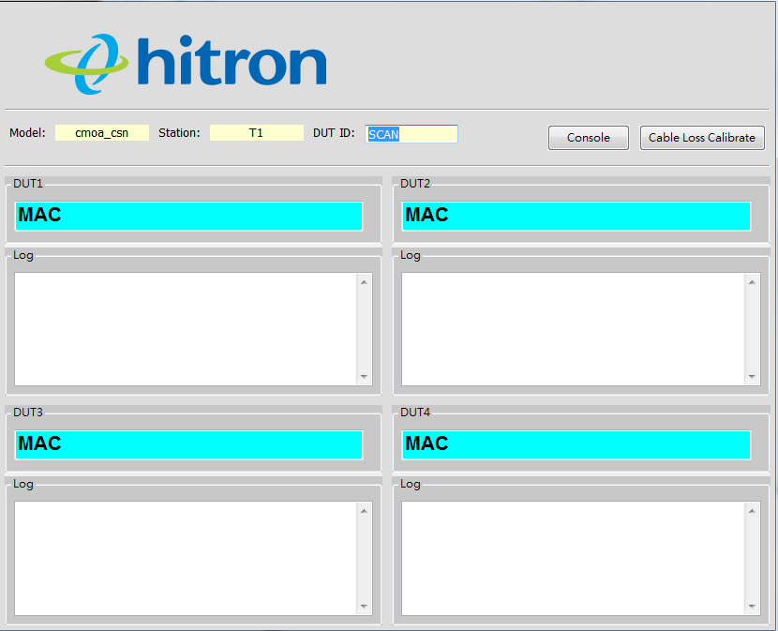

line 14 gui_debug – show(1)/hide(0) the terminal tool and Calibration tool.

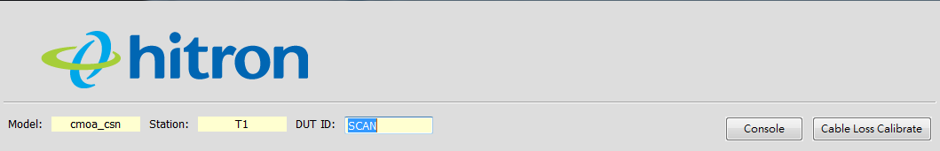

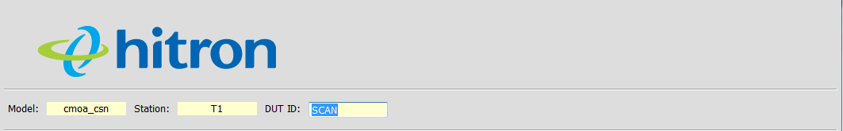

line 15 SN – show(1)/hide(0) the SN label.

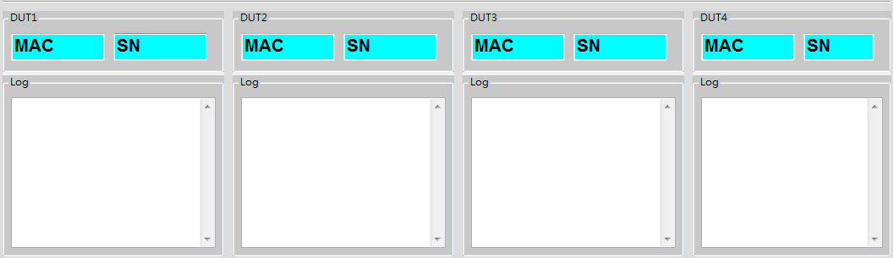

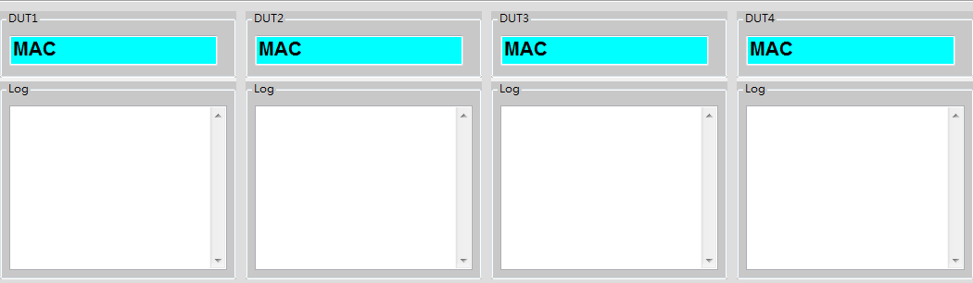

line 20-23 serial port – set up baud rate and com port. The element of com port should be organized as list type.

**Main function script**

The test scripts placed at /testlibs/model/<Project Name>



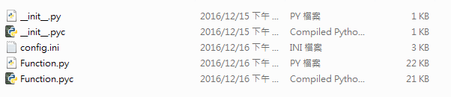

*Function.py

Scripts referenced by Main GUI.

*config.ini

Global val. referenced by Function.py

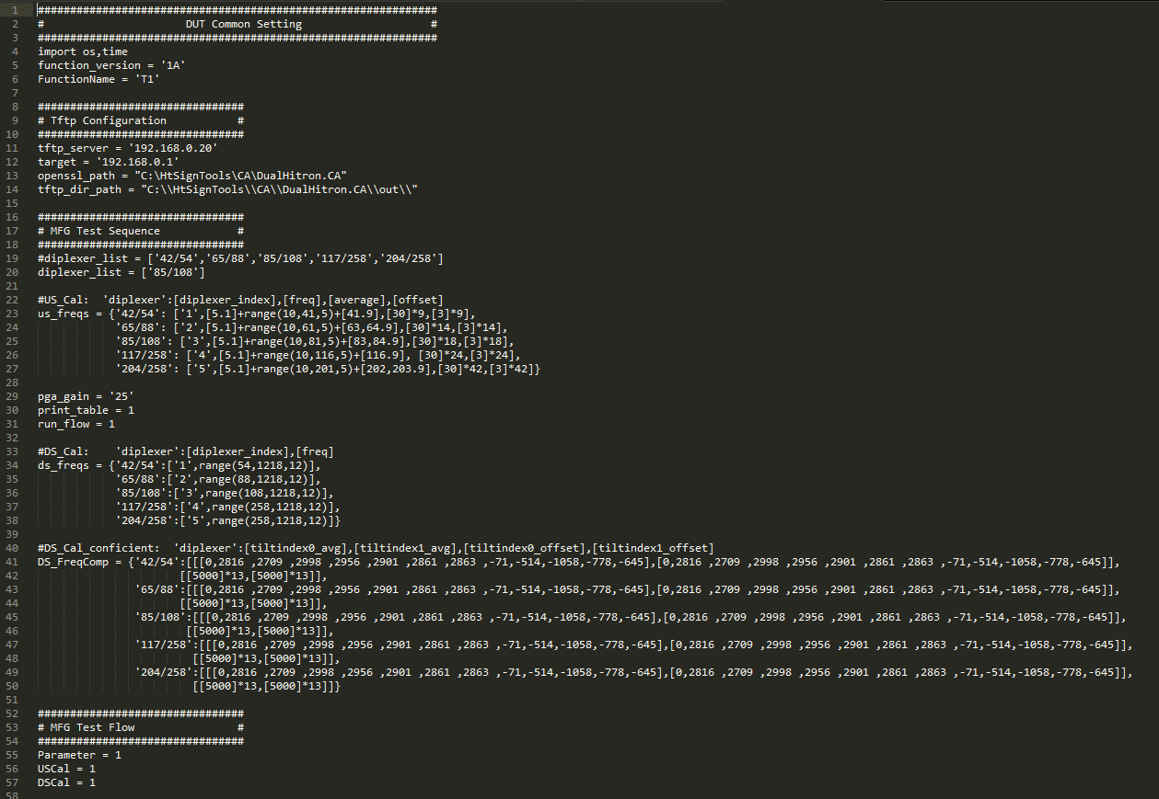

**Noise Measure Tool**

Before calibrating tuner, it must to calibrate a noise power table per each path for DS calibration algorithm referenced. The noise power table would be saved at /station.cal

The naming rule of file is <frequency_NoisePower_BandWidth_Path.date>

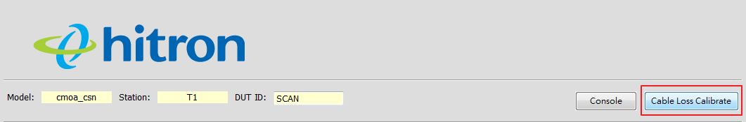

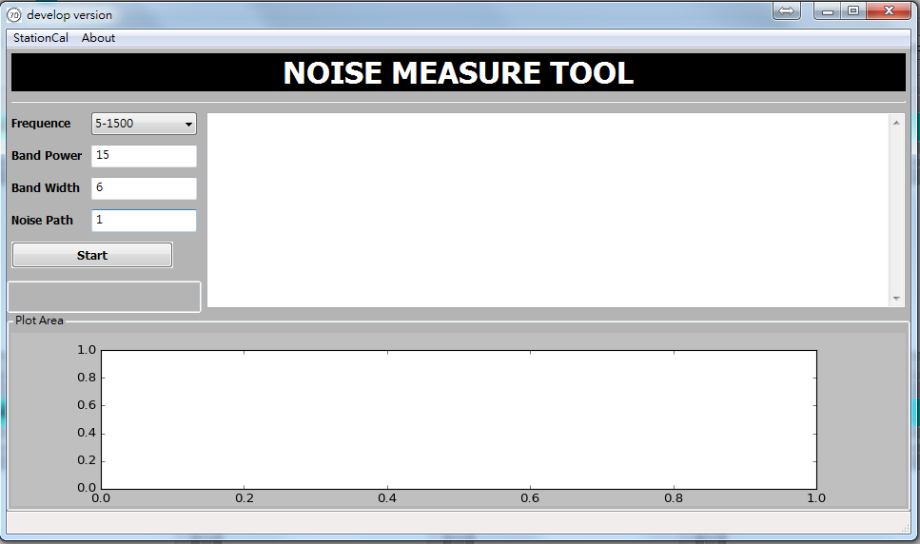

Running:

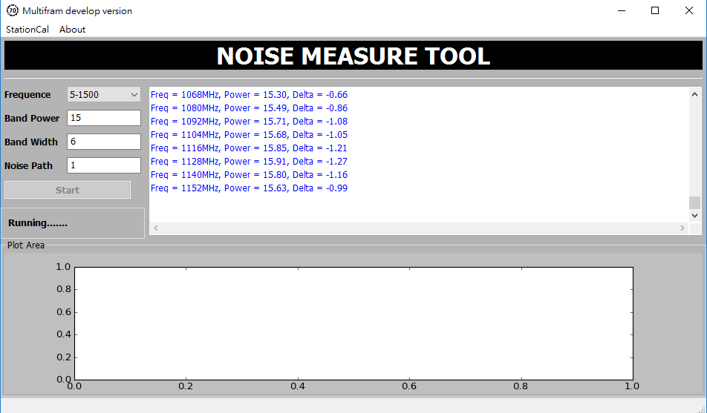

Finish:

The NS calibration log would be saved at /Log/NSCal

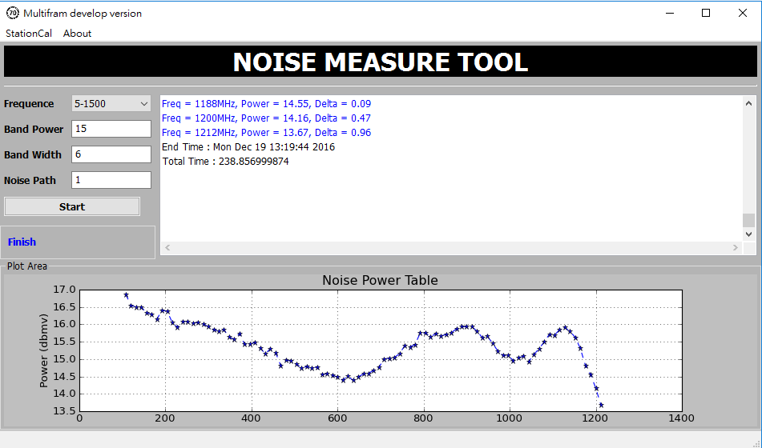

More of the calibration info please refers to the “About” on the toolbar of this tool.

