input.inpainted.png input.fillFront.png input.confidence.png input.filled.png

Kanizsa.inpainted.png Kanizsa.fillFront.png

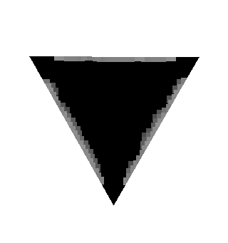

Kanizsa.confidence.png Kanizsa.filled.png

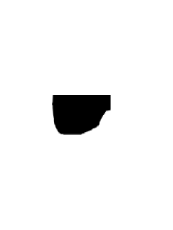

Source1.png Source1.inpainted.png Mask1.png

Source2.png Source2.inpainted.png

Mask2.png

2)

For the first pair of the images, it is called “good”, because the shape of the object we want to fill is in easy line, and the color of the object and the background are in large different. In image the algorithm can have more choice of patch and easy to choose for filling the hole. Also, the edge of the object is also clear.

For the second pair, the color is complicated, and the shape of the edges are random. Compare to the first pair, this source image is lack of patch to choose from background since less of them are similar with the edge patches of the hole.

3)

For the first pair, you can see that at the right of the filled part is not smooth and flat, on the body of the pencil some of the color is darker. That is because on the left side of the pencil the light is darker and the algorithm tend to use the darker part of the pencil as the similar patch, the right part has more light so it choose brighter part (top) of the edge and it has less shadow.

For the second pair, it is obvious that the filled part is not ideal and easy to tell a visible artifact.

As I explained in 2), the edge goes to the hole are random, and the background is really complicate, our algorithm is hard to choose similar patch from background, even the color of the round part of the hole is somewhat close, however, the pattern, the shape of the edges are random.