1.a)

b)

c)

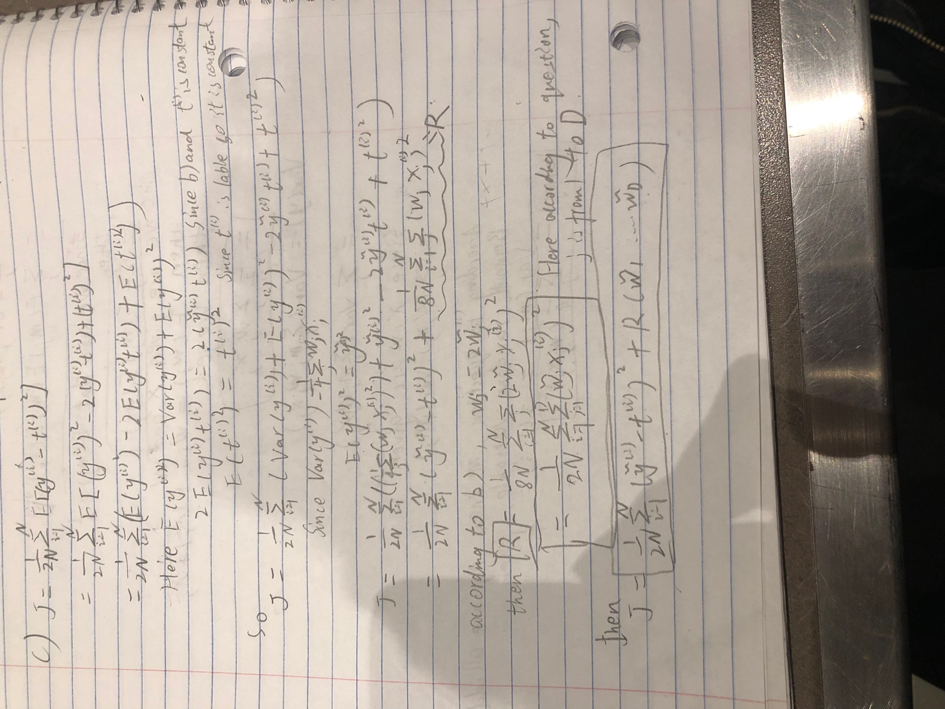

2)

