# Appendix III (informative): ITU-T G.8052 Information Model

This informative annex contains the result of the generation of the NFV Information model using gendoc.

## Class Diagrams

**Qualified Name:** G.8052_v2.05-model::Class Diagrams

**Description:** ETH_CrossConnection
deprecated by
ForwardingConstruct

**Description:** M.3160 ProtectionGroup and
ETH_SubNetworkConnectionProtectionGroup
deprecated by
FcSwitch

**Description:** M.3160 ProtectionGroup
deprecated by
FcSwitch

**Description:** ETH_CrossConnection
deprecated by
ForwardingConstruct

### Diagrams

Figure 1 Diagram Client and Server Layers of Ethernet Technology Class Diagram

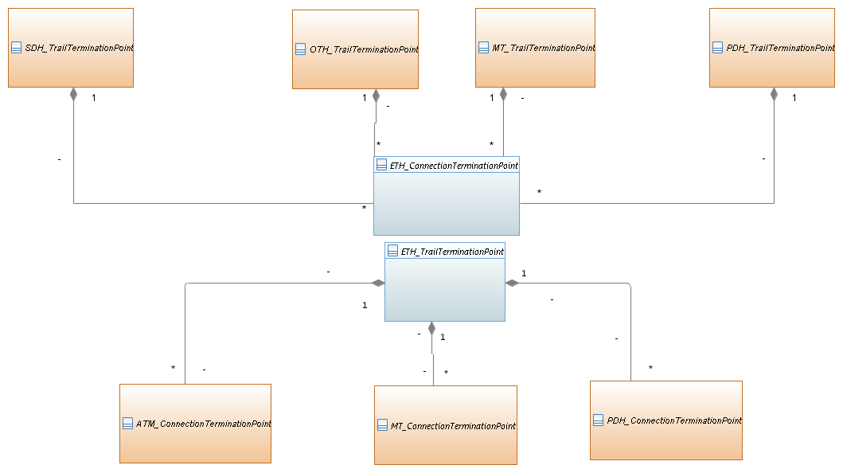

Figure 1 Diagram ETH CTP Pool Class Diagram

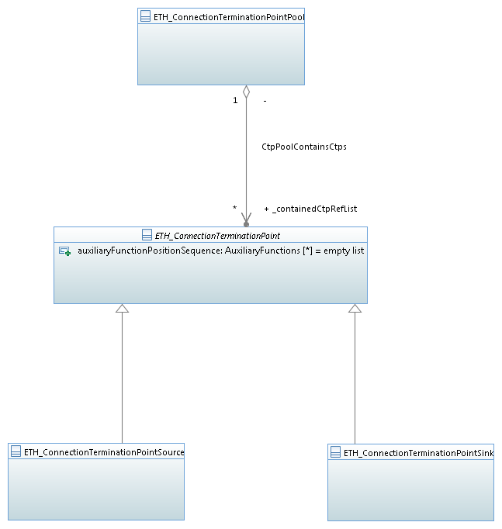

Figure 1 Diagram TTP Inheritance Class Diagram

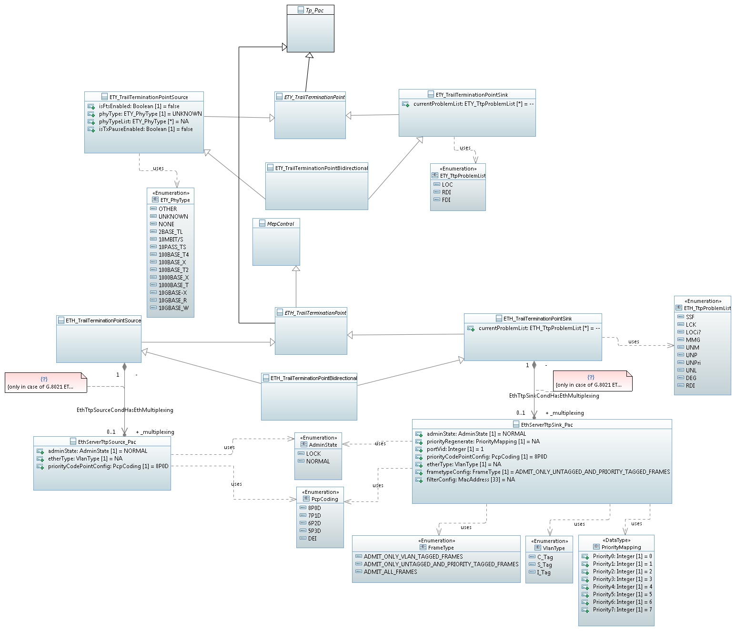

Figure 1 Diagram CTP Inheritance Class Diagram

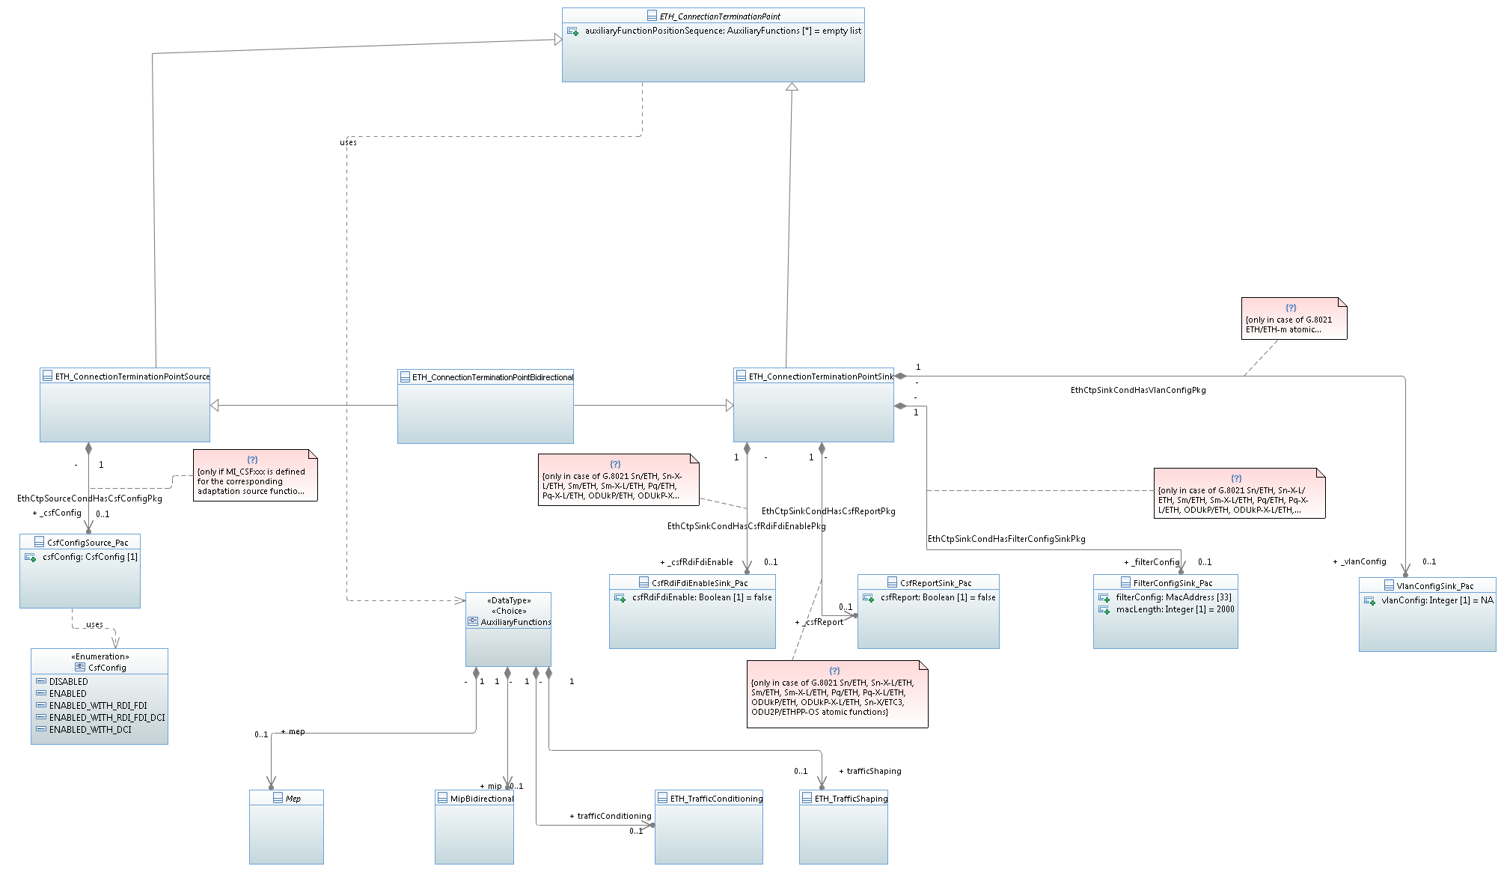

Figure 1 Diagram Threshold Profile Control

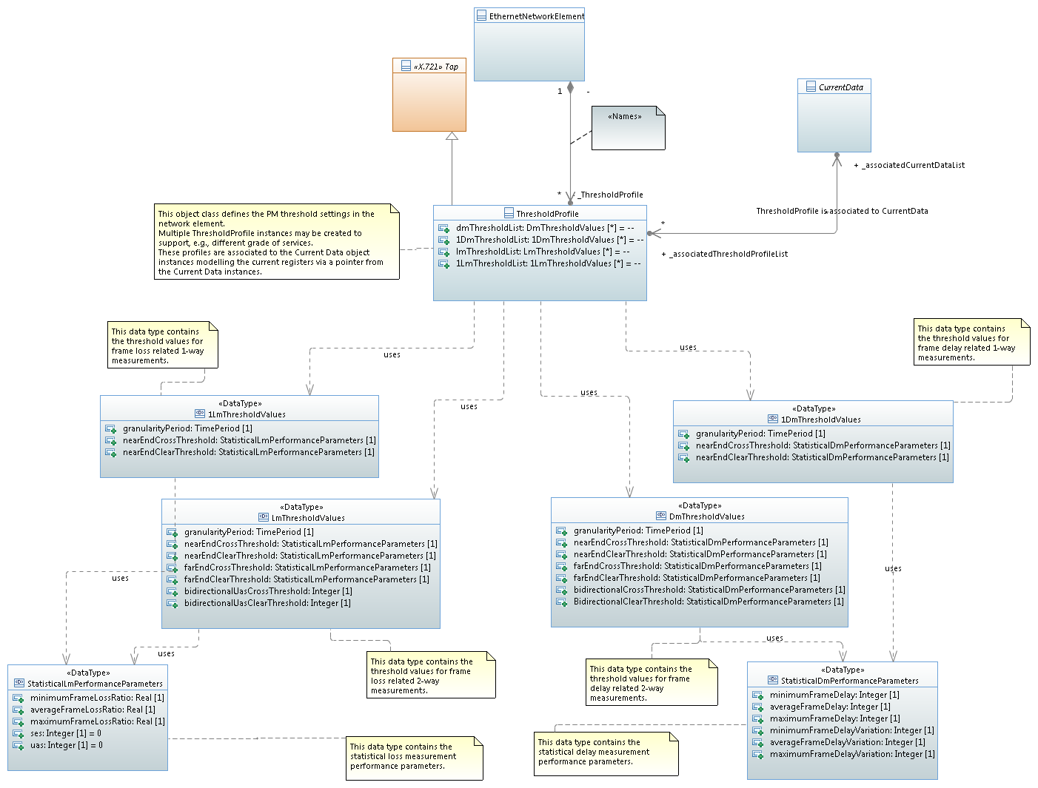

Figure 1 Diagram MIP Class Diagram

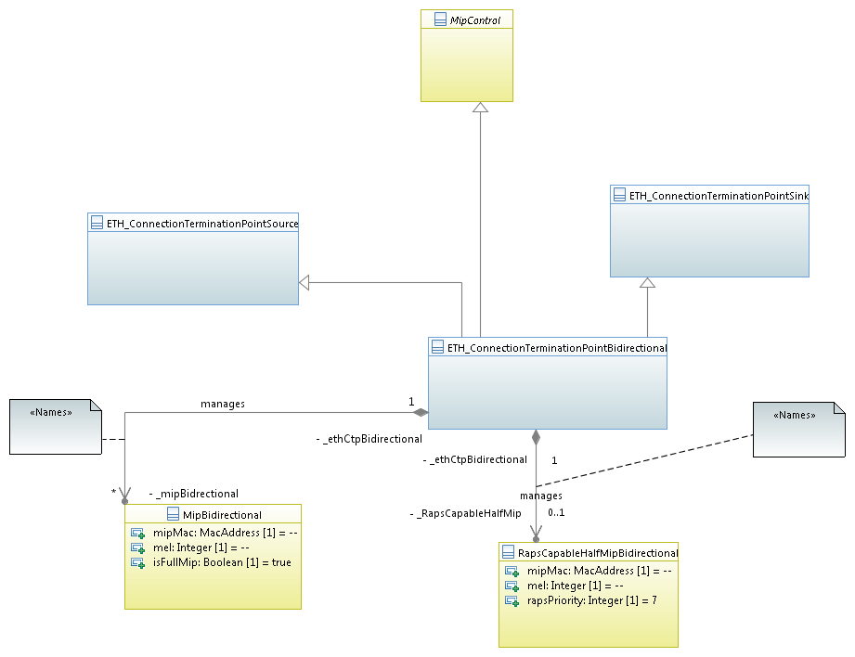

Figure 1 Diagram Operation Exceptions Class Diagram

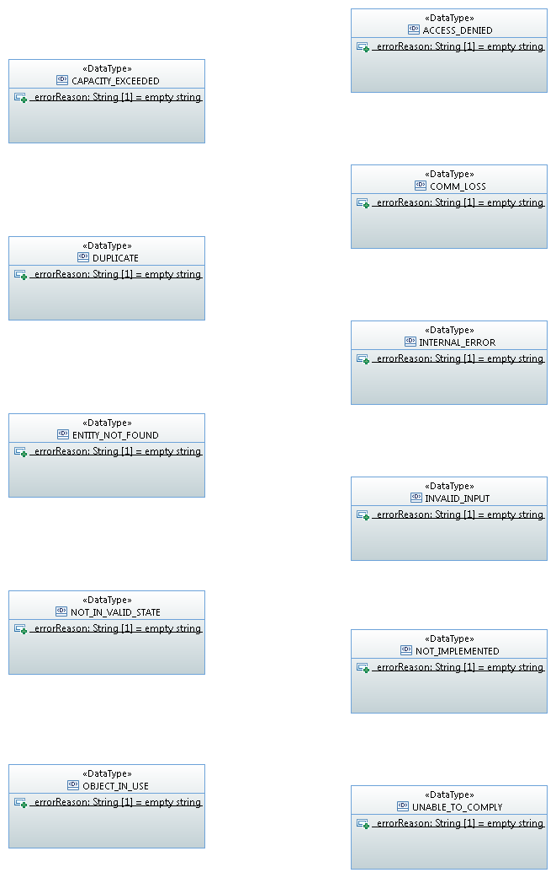

Figure 1 Diagram Connection Fragment Class Diagram

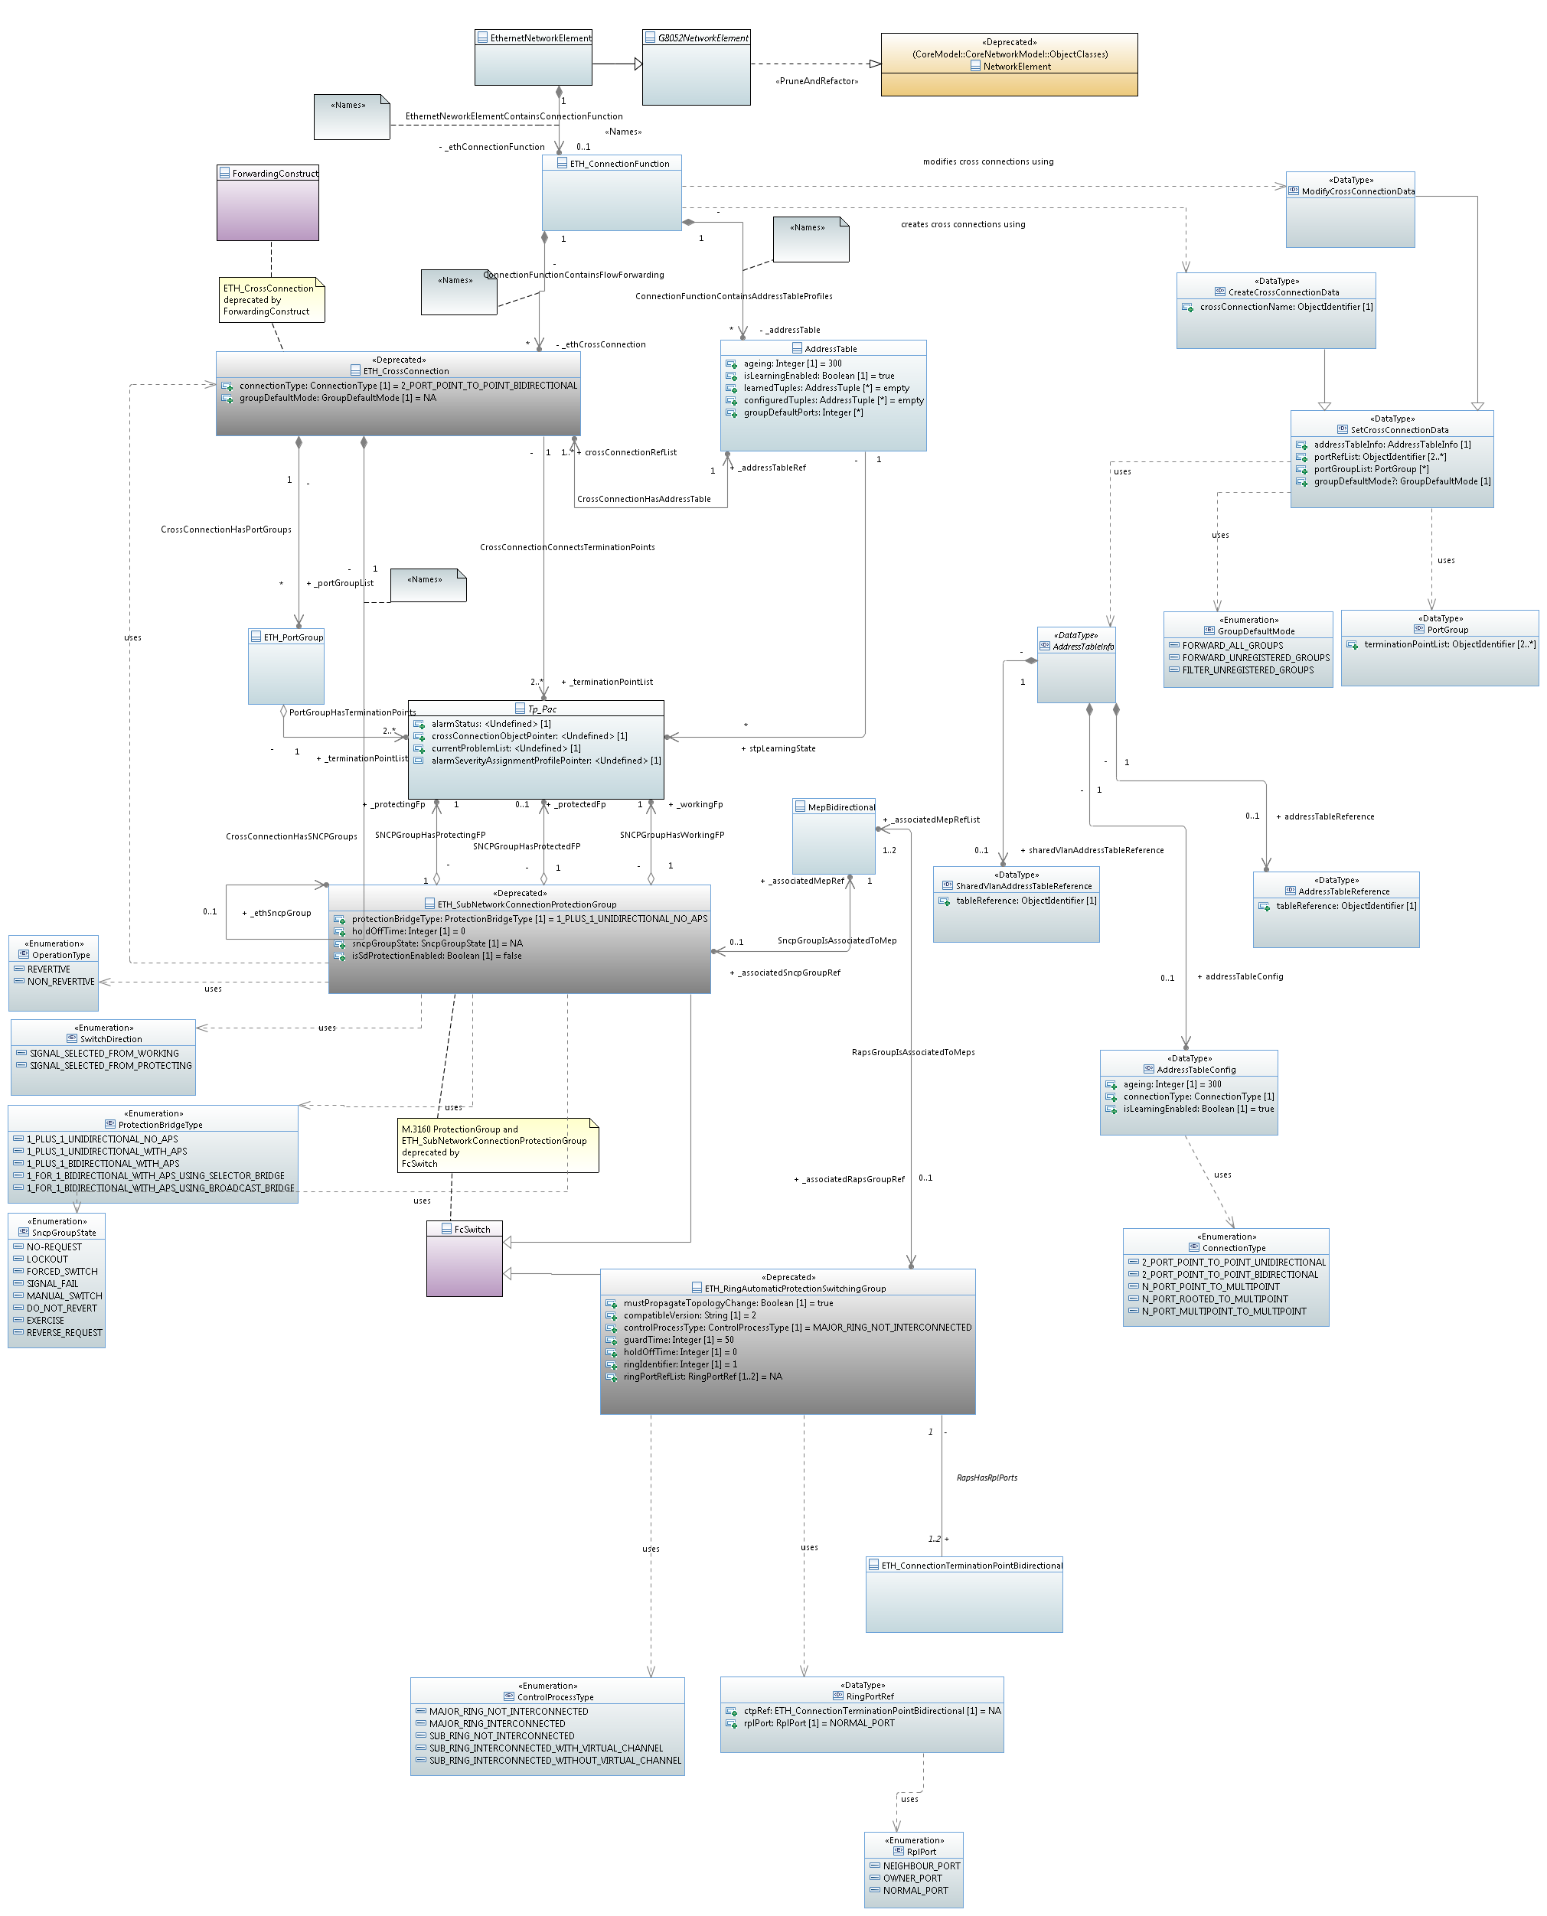

Figure 1 Diagram PhysicalSubsytem Class Diagram

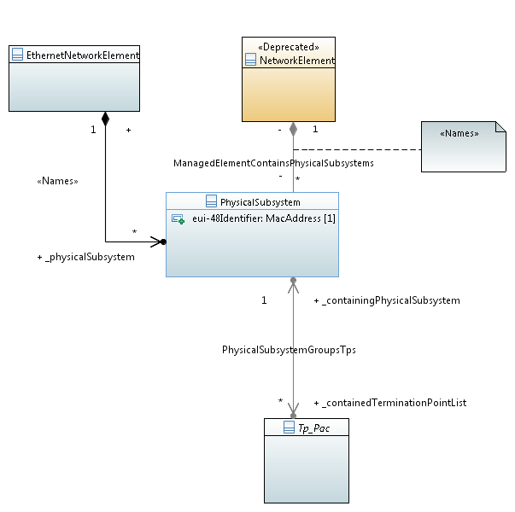

Figure 1 Diagram LAG Management Class Diagram

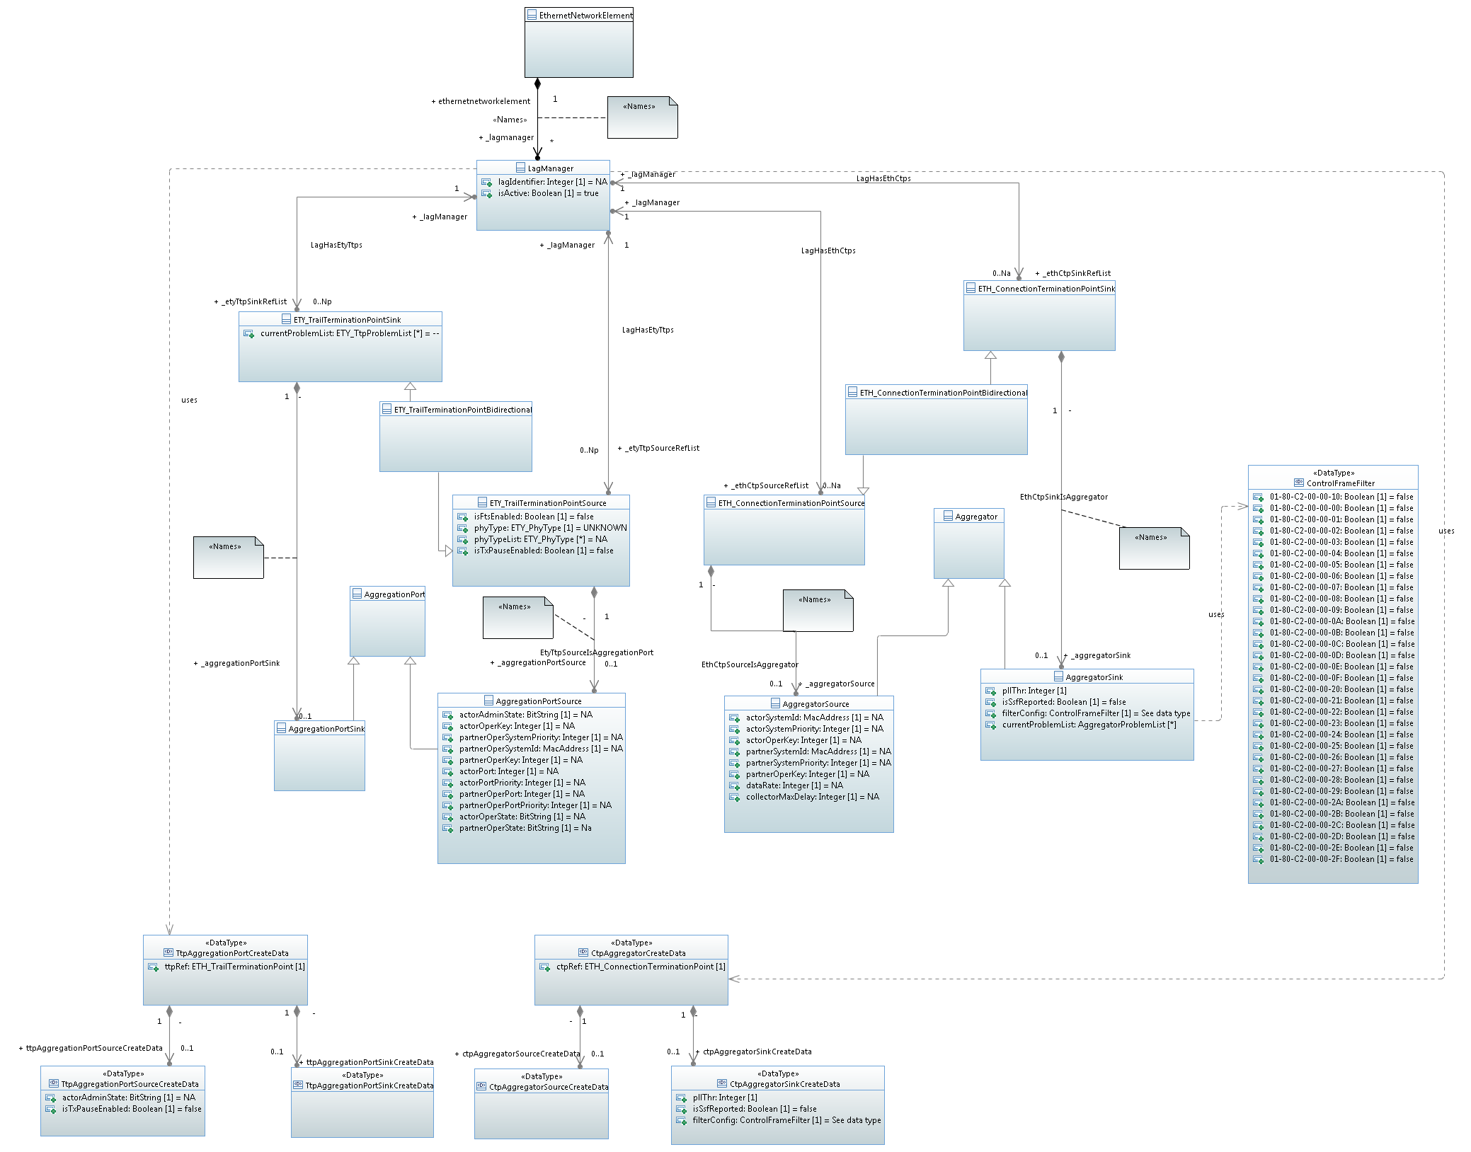

Figure 1 Diagram Ethernet Multiplexing Configuration Class Diagram

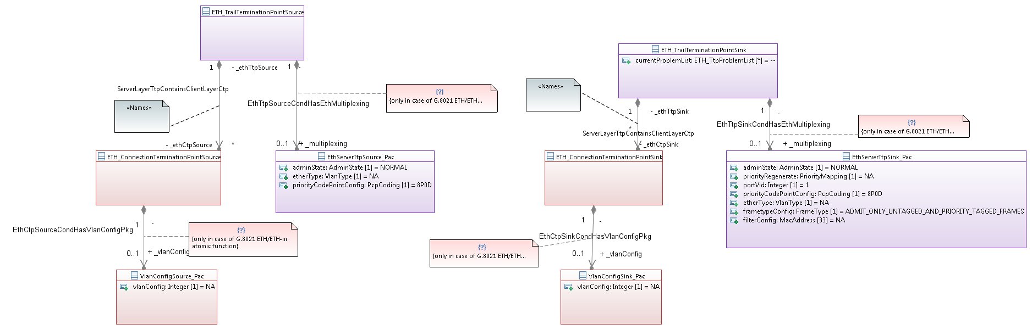

Figure 1 Diagram Ethernet Adaptation Modelling Class Diagram

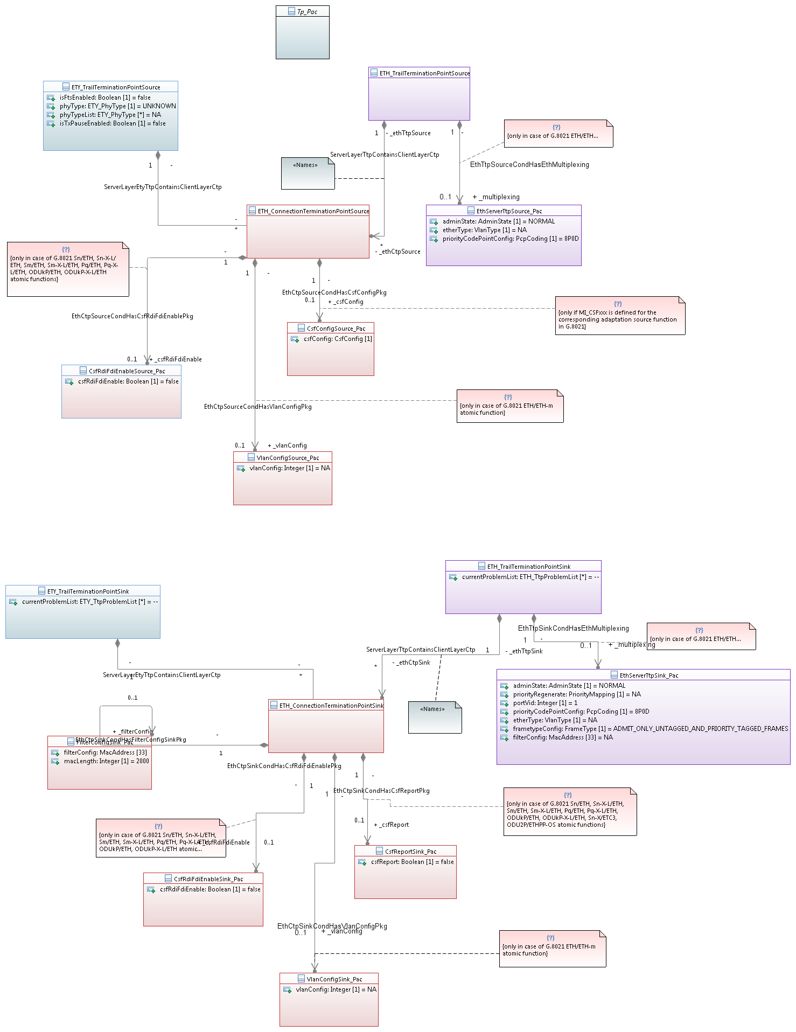

Figure 1 Diagram On Demand Measurement Class Diagram

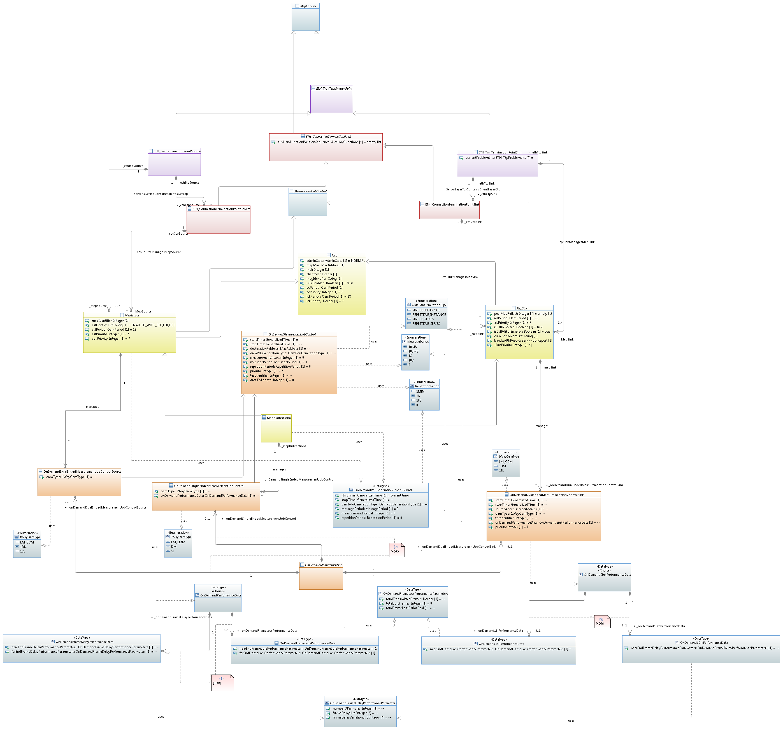

Figure 1 Diagram TCS Class Diagram

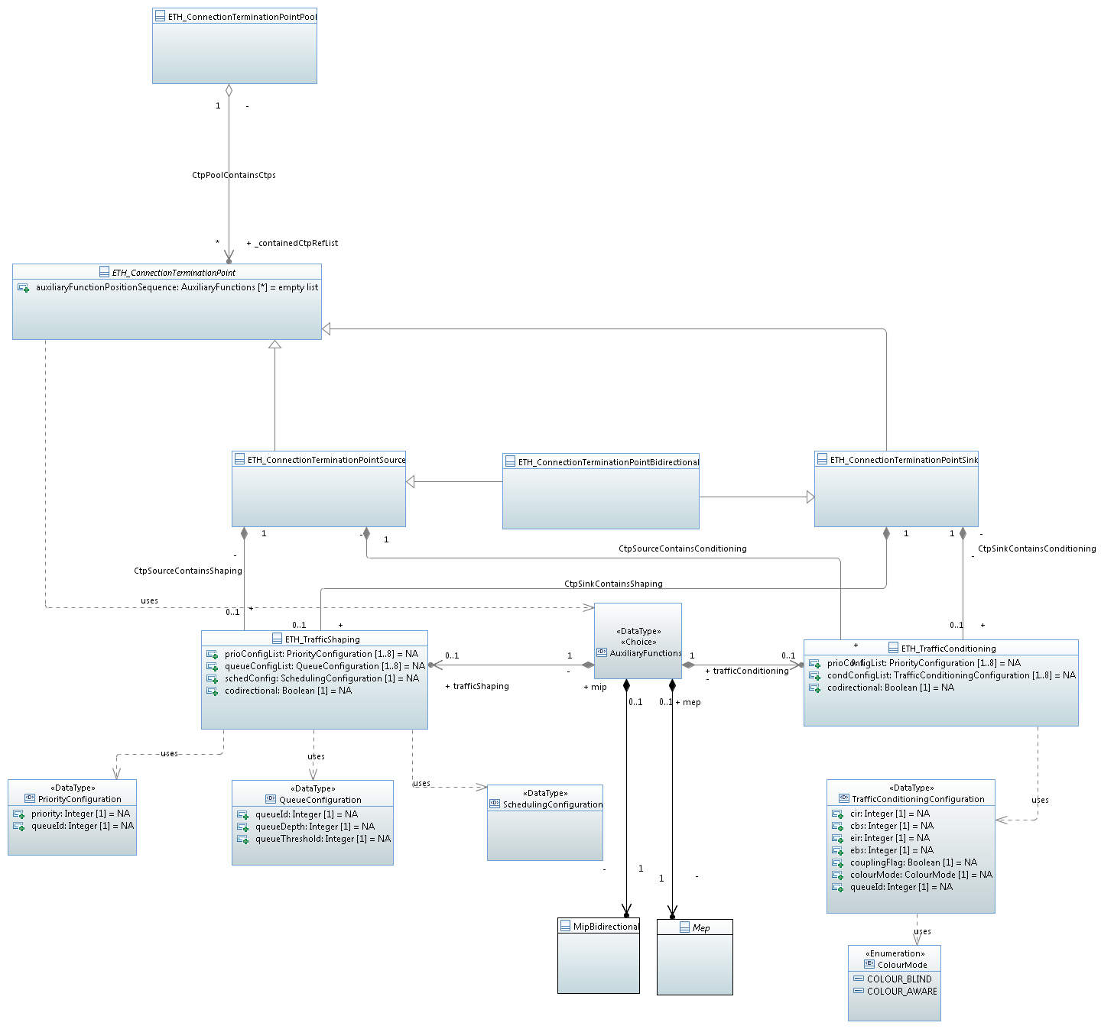

Figure 1 Diagram Pro Active Measurement Class Diagram

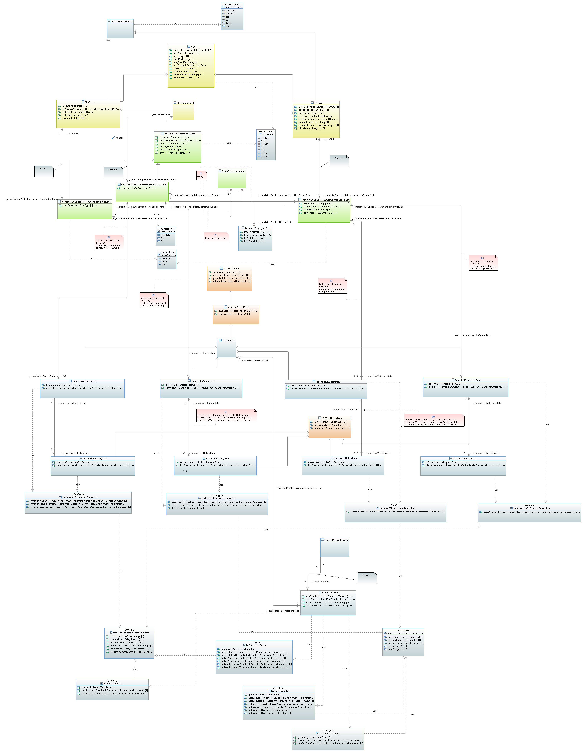

Figure 1 Diagram MEP Class Diagram

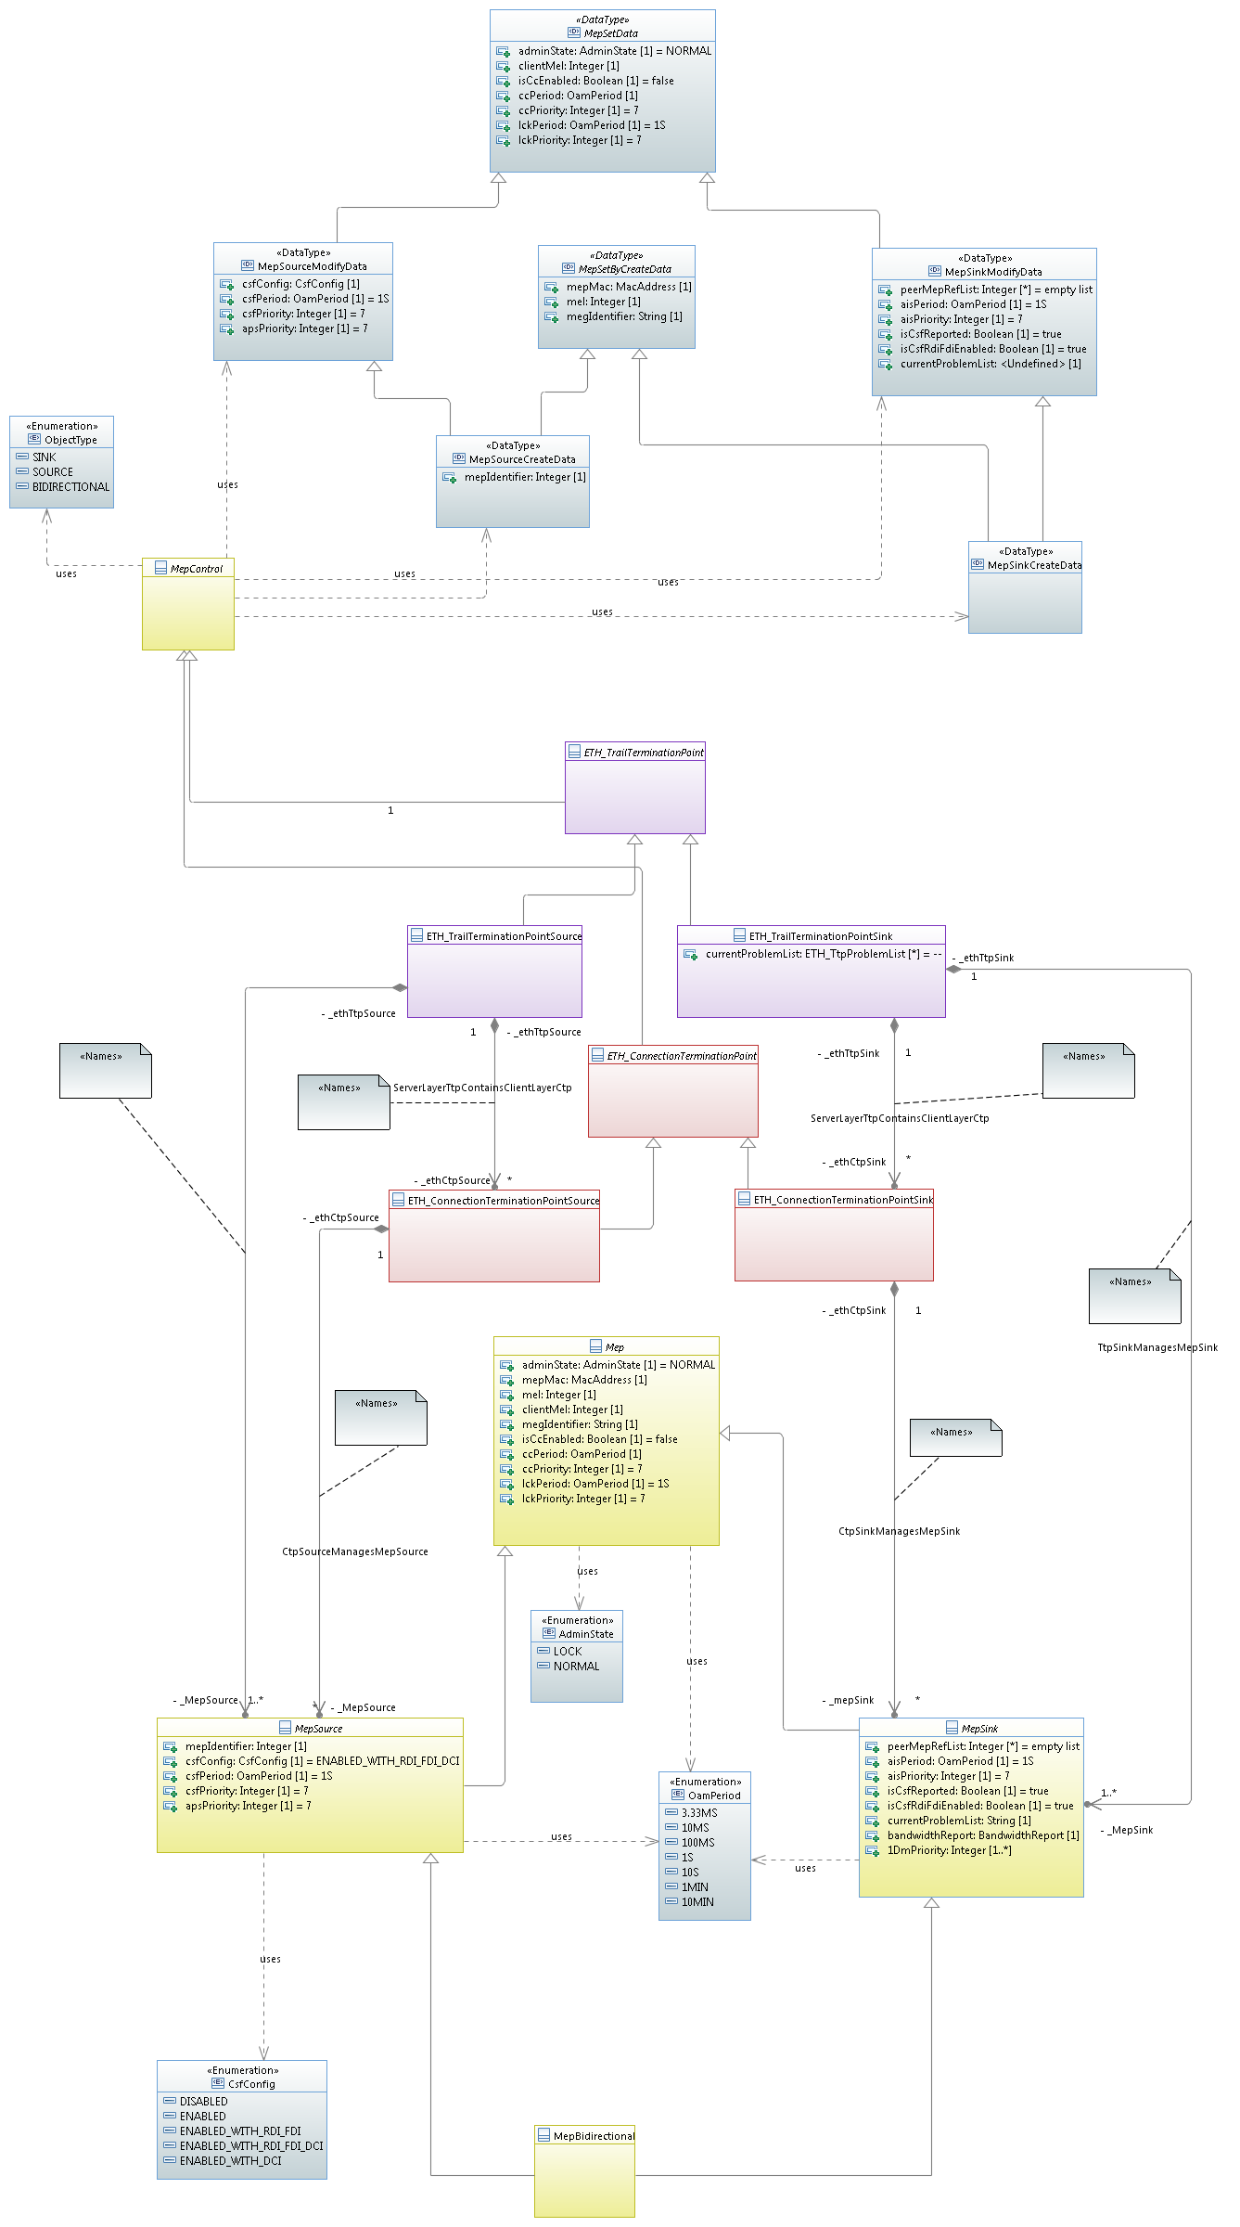

Figure 1 Diagram Ring Protection Class Diagram

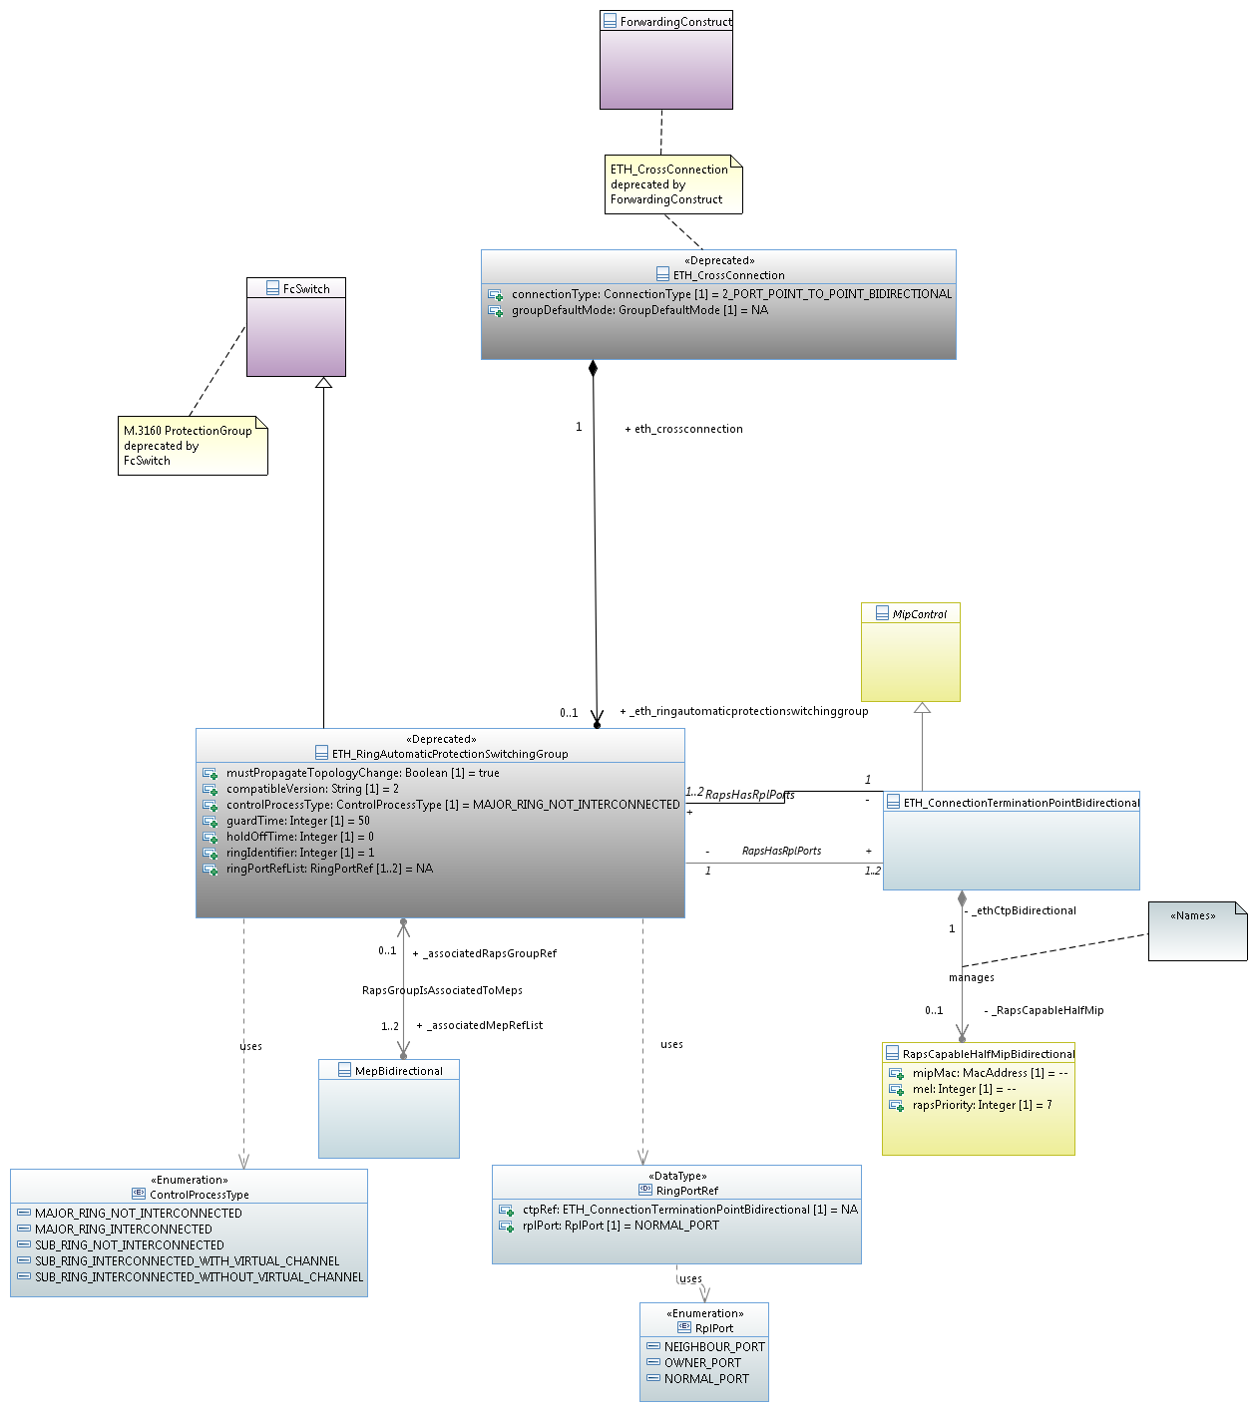

Figure 1 Diagram MCC Class Diagram

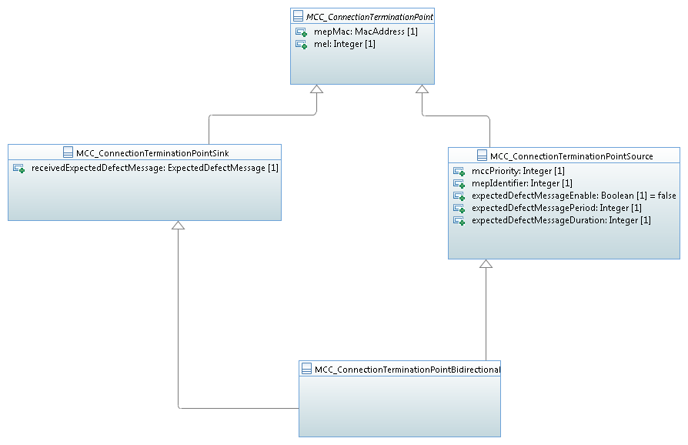

Figure 1 Diagram MEP Class Diagram Lower Part

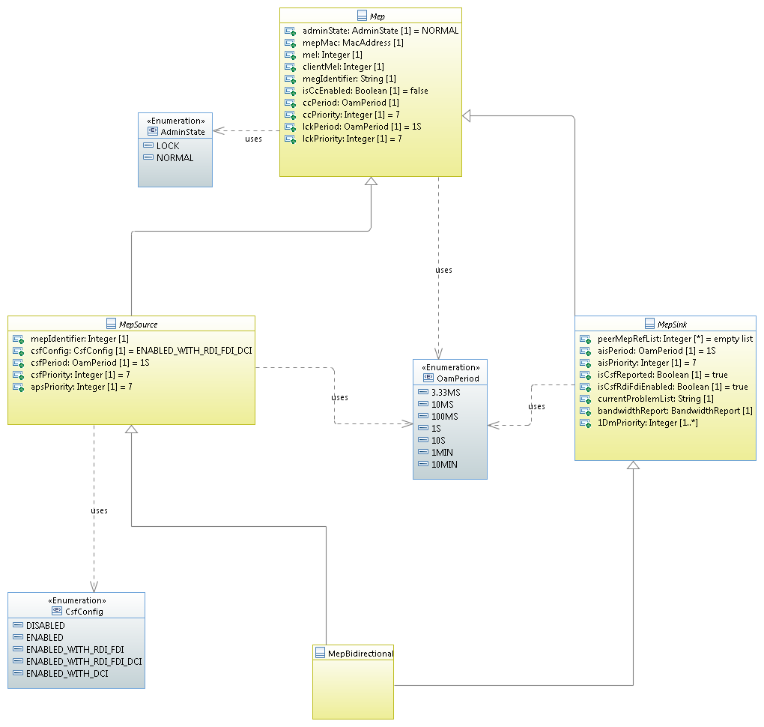

Figure 1 Diagram Connection Fragment Linear Protection Part Class Diagram

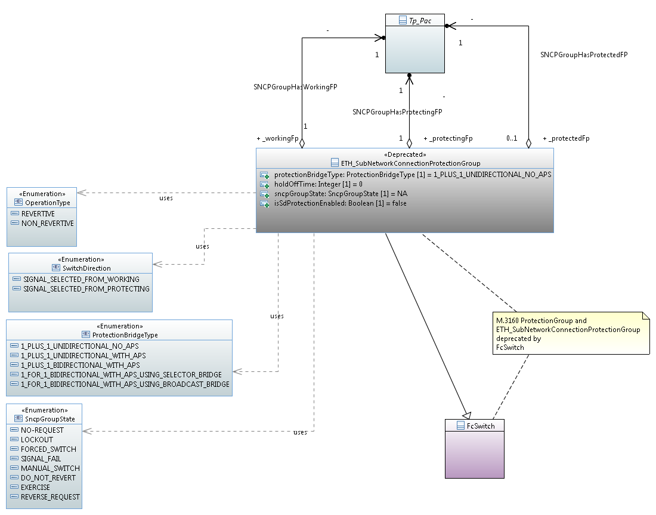

Figure 1 Diagram Identifers

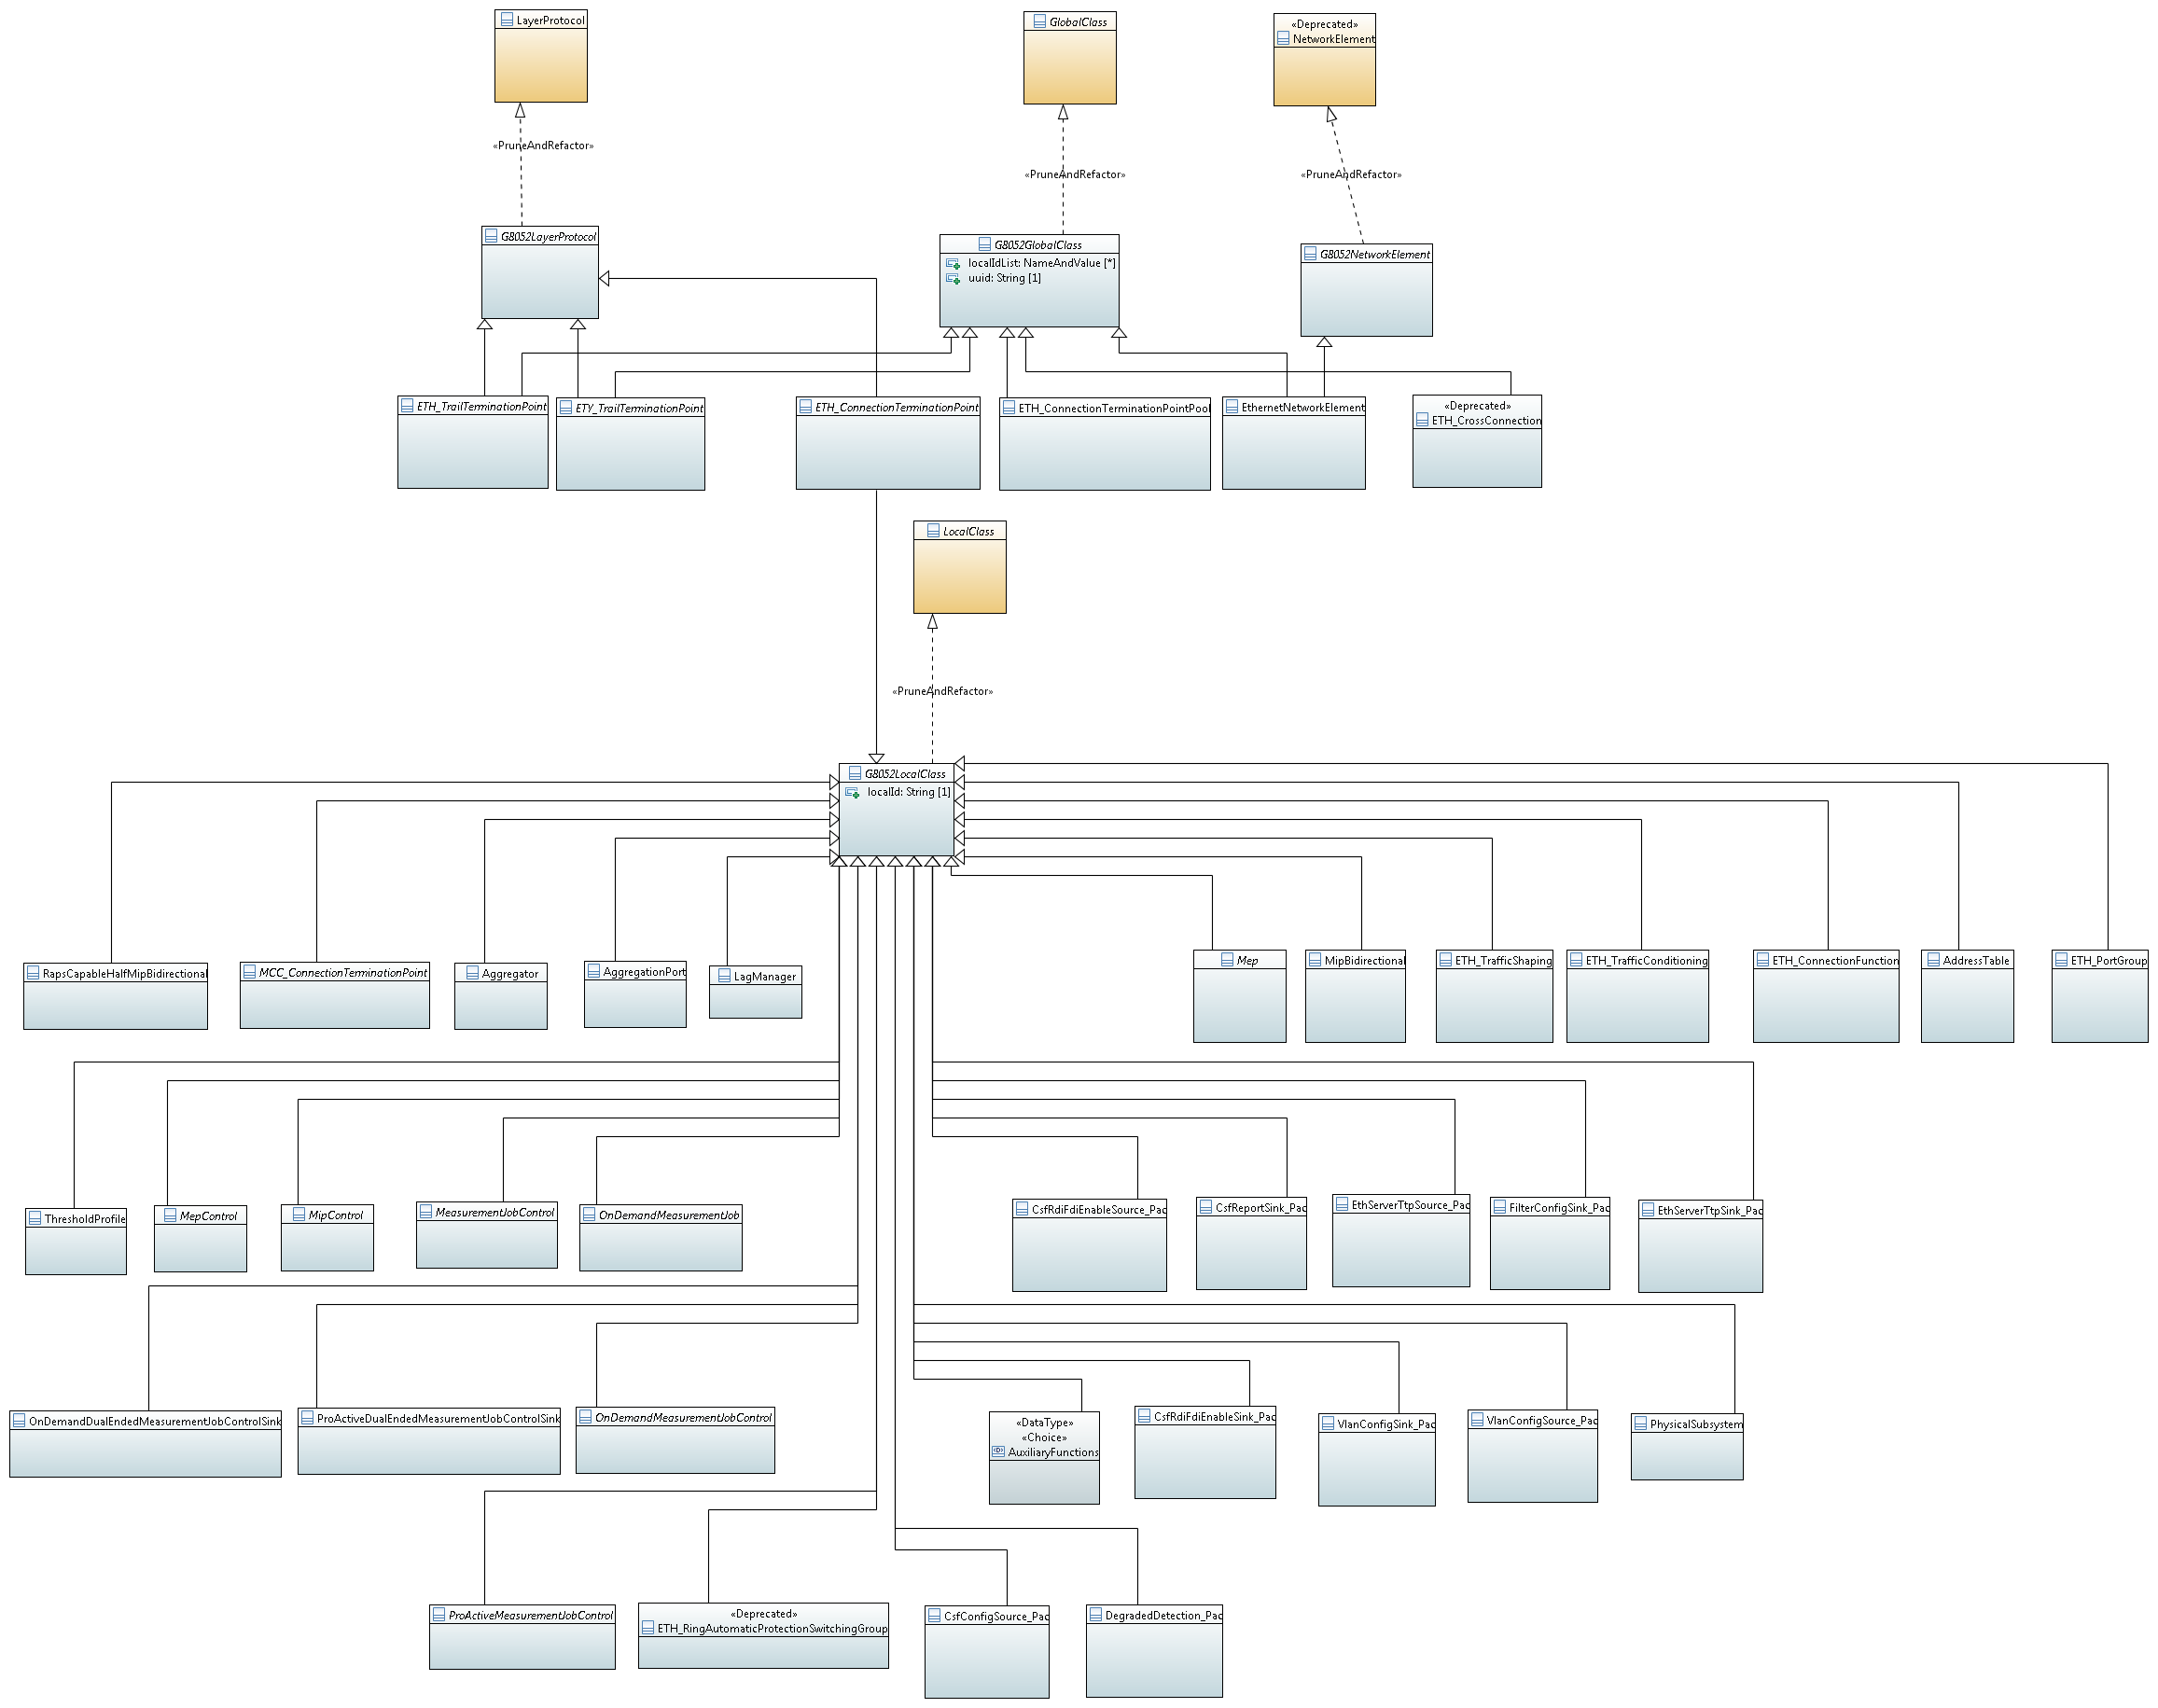

Figure 1 Diagram Containment Tree

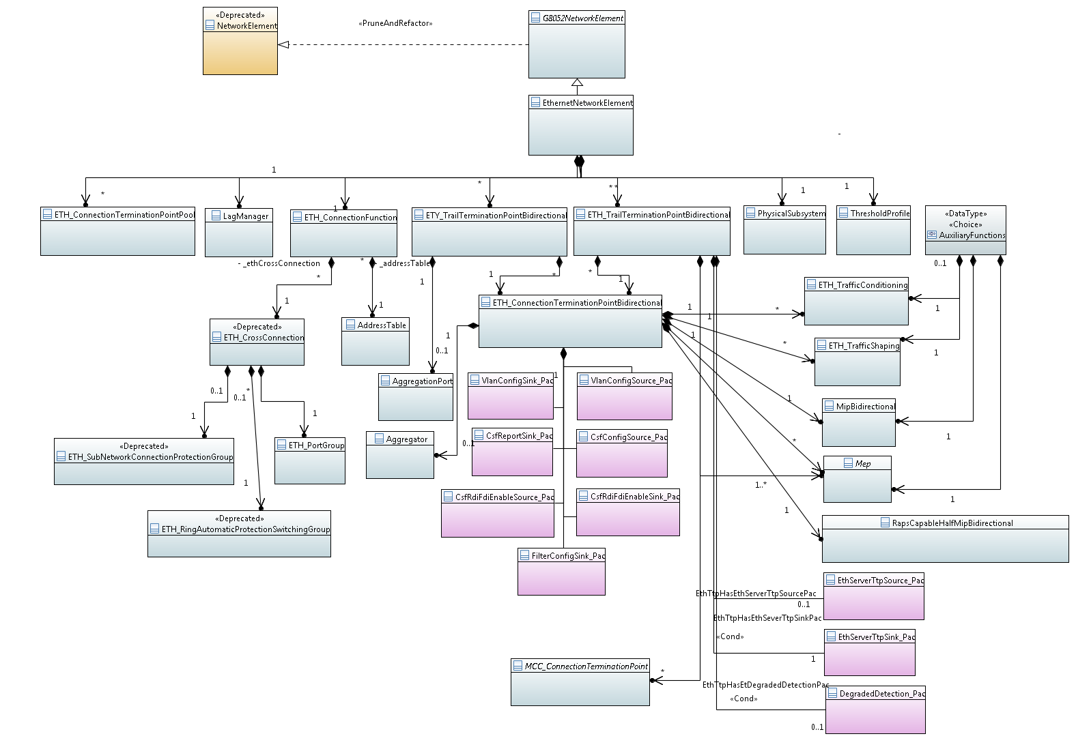

Figure 1 Diagram Containment Tree - Measurement Job

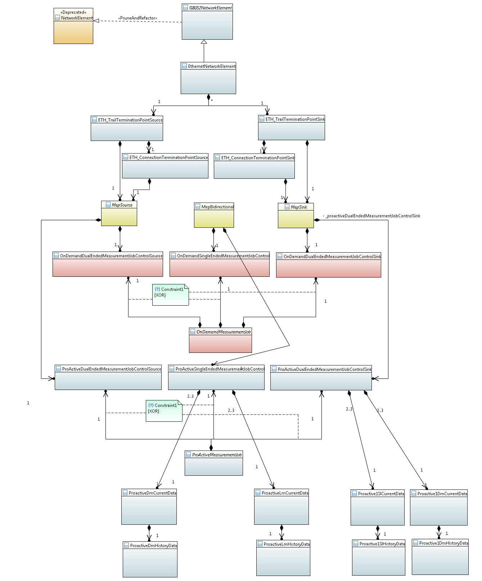

## Imported Data Types

**Qualified Name:** G.8052_v2.05-model::Imported Data Types

### Datatypes

#### GeneralizedTime primitive type

**Qualified Name:** G.8052_v2.05-model::Imported Data Types::GeneralizedTime

#### Name primitive type

**Qualified Name:** G.8052_v2.05-model::Imported Data Types::Name

#### NameAndValue datatype

**Qualified Name:** G.8052_v2.05-model::Imported Data Types::NameAndValue

**Description:** A scoped name-value pair

Table 1 Attributes for Data Type NameAndValue

|  |  |  |  |  |
| --- | --- | --- | --- | --- |
| Attribute Name | Type | Mult. | Description | Applied Stereotypes |
| valueName | String | 0..1 | The name of the value. The value need not have a name. | OpenModelAttribute   * valueRange: no range constraint * support: MANDATORY |
| value | String | 1 | The value | OpenModelAttribute   * valueRange: no range constraint * support: MANDATORY |
| _nameAndValueAuthorityRef | NameAndValueAuthority | 0..1 | The authority that defines the named value. | OpenModelAttribute   * valueRange: no range constraint * support: MANDATORY |
| _globalClassRef | GlobalClass | 0..1 | The scope of the name uniqueness | OpenModelAttribute   * valueRange: no range constraint * support: MANDATORY |
| _localClassRef | LocalClass | 0..1 | The scope of the name uniqueness | OpenModelAttribute   * valueRange: no range constraint * support: MANDATORY |

#### ObjectIdentifier primitive type

**Qualified Name:** G.8052_v2.05-model::Imported Data Types::ObjectIdentifier

#### ObjectInstance primitive type

**Qualified Name:** G.8052_v2.05-model::Imported Data Types::ObjectInstance

#### TimePeriod primitive type

**Qualified Name:** G.8052_v2.05-model::Imported Data Types::TimePeriod

**Description:** This primitive Type is imported from X.739.

## Imported Information Object Classes

**Qualified Name:** G.8052_v2.05-model::Imported Information Object Classes

### Q.822

**Qualified Name:** G.8052_v2.05-model::Imported Information Object Classes::Q.822

#### Classes

##### «Q.822» CurrentData class

**Qualified Name:** G.8052_v2.05-model::Imported Information Object Classes::Q.822::«Q.822» CurrentData

**Parent class:** «X.739» Scanner

**Applied Stereotypes:**

* OpenModelClass
  + condition: none
  + support: MANDATORY

Table 1 Attributes for Class «Q.822» CurrentData

|  |  |  |  |  |
| --- | --- | --- | --- | --- |
| Attribute Name | Type | Mult. | Description | Applied Stereotypes |
| suspectIntervalFlag | Boolean | 1 | This attribute is used to indicate that the performance data for the current period may not be reliable. Some reasons for this to occur are: – Suspect data were detected by the actual resource doing data collection. – Transition of the administrativeState attribute to/from the 'lock' state. – Transition of the operationalState to/from the 'disabled' state. – Scheduler setting that inhibits the collection function. – The performance counters were reset during the interval. – The currentData (or subclass) object instance was created during the monitoring period. | OpenModelAttribute   * valueRange: NA * support: MANDATORY * condition: none |
| elapsedTime |  | 1 |  | OpenModelAttribute   * valueRange: NA * support: MANDATORY * condition: none |
| «q.822» filtersuppressionpkg | «Q.822» filterSuppressionPkg | 0..1 |  | OpenModelAttribute   * valueRange: NA * support: MANDATORY * condition: none |
| «q.822» historyretentionpkg | «Q.822» historyRetentionPkg | 0..1 |  | OpenModelAttribute   * valueRange: NA * support: MANDATORY * condition: none |
| «q.822» maxsuppressedintervalspkg | «Q.822» maxSuppressedIntervalsPkg | 0..1 |  | OpenModelAttribute   * valueRange: NA * support: MANDATORY * condition: none |
| «q.822» measurementlistpkg | «Q.822» measurementListPkg | 0..1 |  | OpenModelAttribute   * valueRange: NA * support: MANDATORY * condition: none |
| «q.822» numsuppressedintervalspkg | «Q.822» numSuppressedIntervalsPkg | 0..1 |  | OpenModelAttribute   * valueRange: NA * support: MANDATORY * condition: none |
| «q.822» observedmanagedobjectpkg | «Q.822» observedManagedObjectPkg | 0..1 |  | OpenModelAttribute   * valueRange: NA * support: MANDATORY * condition: none |
| «q.822» scheduledpmreportpkg | «Q.822» scheduledPMReportPkg | 0..1 |  | OpenModelAttribute   * valueRange: NA * support: MANDATORY * condition: none |
| «q.822» thresholdpkg | «Q.822» thresholdPkg | 0..1 |  | OpenModelAttribute   * valueRange: NA * support: MANDATORY * condition: none |
| «q.822» zerosuppressionpkg | «Q.822» zeroSuppressionPkg | 0..1 |  | OpenModelAttribute   * valueRange: NA * support: MANDATORY * condition: none |
| scannerId |  | 1 |  | Inherited from Class «X.739» Scanner  OpenModelAttribute   * valueRange: NA * support: MANDATORY * condition: none |
| operationalState |  | 1 |  | Inherited from Class «X.739» Scanner  OpenModelAttribute   * valueRange: NA * support: MANDATORY * condition: none |
| granularityPeriod |  | 1..3 |  | Inherited from Class «X.739» Scanner  OpenModelAttribute   * valueRange: NA * support: MANDATORY * condition: none |
| administrativeState |  | 1 |  | Inherited from Class «X.739» Scanner  OpenModelAttribute   * valueRange: NA * support: MANDATORY * condition: none |
| objectClass | ObjectIdentifier | 1 | ObjectClass ::= CHOICE{ globalForm [0] OBJECT IDENTIFIER, localForm [1] INTEGER} | Inherited from Class «X.721» Top  OpenModelAttribute   * valueRange: NA * support: MANDATORY * condition: none |
| nameBinding | ObjectIdentifier | 1 |  | Inherited from Class «X.721» Top  OpenModelAttribute   * valueRange: NA * support: MANDATORY * condition: none |
| packages | ObjectIdentifier | 0..* |  | Inherited from Class «X.721» Top  OpenModelAttribute   * valueRange: NA * support: MANDATORY * condition: none |
| allomorphs | ObjectIdentifier | 0..* |  | Inherited from Class «X.721» Top  OpenModelAttribute   * valueRange: NA * support: MANDATORY * condition: none |

##### «Q.822» HistoryData class

**Qualified Name:** G.8052_v2.05-model::Imported Information Object Classes::Q.822::«Q.822» HistoryData

**Parent class:** «X.721» Top

**Applied Stereotypes:**

* OpenModelClass
  + condition: none
  + support: MANDATORY

Table 1 Attributes for Class «Q.822» HistoryData

|  |  |  |  |  |
| --- | --- | --- | --- | --- |
| Attribute Name | Type | Mult. | Description | Applied Stereotypes |
| historyDataId |  | 1 |  | OpenModelAttribute   * valueRange: NA * support: MANDATORY * condition: none |
| periodEndTime |  | 1 |  | OpenModelAttribute   * valueRange: NA * support: MANDATORY * condition: none |
| granularityPeriod |  | 1 |  | OpenModelAttribute   * valueRange: NA * support: MANDATORY * condition: none |
| «q.822» numsuppressedintervalspkg | «Q.822» numSuppressedIntervalsPkg | 0..1 |  | OpenModelAttribute   * valueRange: NA * support: MANDATORY * condition: none |
| «q.822» historydatameasurementlistpkg | «Q.822» historyDataMeasurementListPkg | 0..1 |  | OpenModelAttribute   * valueRange: NA * support: MANDATORY * condition: none |
| «q.822» historydatasuspectintervalflagpkg | «Q.822» historyDataSuspectIntervalFlagPkg | 0..1 |  | OpenModelAttribute   * valueRange: NA * support: MANDATORY * condition: none |
| «q.822» observedmanagedobjectpkg | «Q.822» observedManagedObjectPkg | 0..1 |  | OpenModelAttribute   * valueRange: NA * support: MANDATORY * condition: none |
| «q.822» objectdeletenotificationpkg | «Q.822» objectDeleteNotificationPkg | 0..1 |  | OpenModelAttribute   * valueRange: NA * support: MANDATORY * condition: none |
| objectClass | ObjectIdentifier | 1 | ObjectClass ::= CHOICE{ globalForm [0] OBJECT IDENTIFIER, localForm [1] INTEGER} | Inherited from Class «X.721» Top  OpenModelAttribute   * valueRange: NA * support: MANDATORY * condition: none |
| nameBinding | ObjectIdentifier | 1 |  | Inherited from Class «X.721» Top  OpenModelAttribute   * valueRange: NA * support: MANDATORY * condition: none |
| packages | ObjectIdentifier | 0..* |  | Inherited from Class «X.721» Top  OpenModelAttribute   * valueRange: NA * support: MANDATORY * condition: none |
| allomorphs | ObjectIdentifier | 0..* |  | Inherited from Class «X.721» Top  OpenModelAttribute   * valueRange: NA * support: MANDATORY * condition: none |

##### «Q.822» ThresholdData class

**Qualified Name:** G.8052_v2.05-model::Imported Information Object Classes::Q.822::«Q.822» ThresholdData

**Parent class:** «X.721» Top

**Applied Stereotypes:**

* OpenModelClass
  + condition: none
  + support: MANDATORY

Table 1 Attributes for Class «Q.822» ThresholdData

|  |  |  |  |  |
| --- | --- | --- | --- | --- |
| Attribute Name | Type | Mult. | Description | Applied Stereotypes |
| thresholdDataId |  | 1 | The thresholdData object class is a class of managed support objects that contains the values of the threshold settings for the PM parameters. At least one of the counterThresholdListPkg or the gaugeThresholdListPkg must be instantiated. | OpenModelAttribute   * valueRange: NA * support: MANDATORY * condition: none |
| objectClass | ObjectIdentifier | 1 | ObjectClass ::= CHOICE{ globalForm [0] OBJECT IDENTIFIER, localForm [1] INTEGER} | Inherited from Class «X.721» Top  OpenModelAttribute   * valueRange: NA * support: MANDATORY * condition: none |
| nameBinding | ObjectIdentifier | 1 |  | Inherited from Class «X.721» Top  OpenModelAttribute   * valueRange: NA * support: MANDATORY * condition: none |
| packages | ObjectIdentifier | 0..* |  | Inherited from Class «X.721» Top  OpenModelAttribute   * valueRange: NA * support: MANDATORY * condition: none |
| allomorphs | ObjectIdentifier | 0..* |  | Inherited from Class «X.721» Top  OpenModelAttribute   * valueRange: NA * support: MANDATORY * condition: none |

#### Associations

#### Imported Arche Types

**Qualified Name:** G.8052_v2.05-model::Imported Information Object Classes::Q.822::Imported Arche Types

##### Classes

###### «Q.822» filterSuppressionPkg class

**Qualified Name:** G.8052_v2.05-model::Imported Information Object Classes::Q.822::Imported Arche Types::«Q.822» filterSuppressionPkg

**Applied Stereotypes:**

* OpenModelClass
  + condition: none
  + support: MANDATORY

Table 1 Attributes for Class «Q.822» filterSuppressionPkg

|  |  |  |  |  |
| --- | --- | --- | --- | --- |
| Attribute Name | Type | Mult. | Description | Applied Stereotypes |
| discriminatorConstruct |  | 1 |  | OpenModelAttribute   * valueRange: NA * support: MANDATORY * condition: none |

###### «Q.822» historyDataMeasurementListPkg class

**Qualified Name:** G.8052_v2.05-model::Imported Information Object Classes::Q.822::Imported Arche Types::«Q.822» historyDataMeasurementListPkg

**Applied Stereotypes:**

* OpenModelClass
  + condition: none
  + support: MANDATORY

Table 1 Attributes for Class «Q.822» historyDataMeasurementListPkg

|  |  |  |  |  |
| --- | --- | --- | --- | --- |
| Attribute Name | Type | Mult. | Description | Applied Stereotypes |
| cTPId |  | 1 |  | OpenModelAttribute   * valueRange: NA * support: MANDATORY * condition: none |

###### «Q.822» historyDataSuspectIntervalFlagPkg class

**Qualified Name:** G.8052_v2.05-model::Imported Information Object Classes::Q.822::Imported Arche Types::«Q.822» historyDataSuspectIntervalFlagPkg

**Applied Stereotypes:**

* OpenModelClass
  + condition: none
  + support: MANDATORY

Table 1 Attributes for Class «Q.822» historyDataSuspectIntervalFlagPkg

|  |  |  |  |  |
| --- | --- | --- | --- | --- |
| Attribute Name | Type | Mult. | Description | Applied Stereotypes |
| cTPId |  | 1 |  | OpenModelAttribute   * valueRange: NA * support: MANDATORY * condition: none |

###### «Q.822» historyRetentionPkg class

**Qualified Name:** G.8052_v2.05-model::Imported Information Object Classes::Q.822::Imported Arche Types::«Q.822» historyRetentionPkg

**Applied Stereotypes:**

* OpenModelClass
  + condition: none
  + support: MANDATORY

Table 1 Attributes for Class «Q.822» historyRetentionPkg

|  |  |  |  |  |
| --- | --- | --- | --- | --- |
| Attribute Name | Type | Mult. | Description | Applied Stereotypes |
| historyRetention |  | 1 |  | OpenModelAttribute   * valueRange: NA * support: MANDATORY * condition: none |

###### «Q.822» maxSuppressedIntervalsPkg class

**Qualified Name:** G.8052_v2.05-model::Imported Information Object Classes::Q.822::Imported Arche Types::«Q.822» maxSuppressedIntervalsPkg

**Applied Stereotypes:**

* OpenModelClass
  + condition: none
  + support: MANDATORY

Table 1 Attributes for Class «Q.822» maxSuppressedIntervalsPkg

|  |  |  |  |  |
| --- | --- | --- | --- | --- |
| Attribute Name | Type | Mult. | Description | Applied Stereotypes |
| maxSuppressedIntervals |  | 1 |  | OpenModelAttribute   * valueRange: NA * support: MANDATORY * condition: none |

###### «Q.822» measurementListPkg class

**Qualified Name:** G.8052_v2.05-model::Imported Information Object Classes::Q.822::Imported Arche Types::«Q.822» measurementListPkg

**Applied Stereotypes:**

* OpenModelClass
  + condition: none
  + support: MANDATORY

Table 1 Attributes for Class «Q.822» measurementListPkg

|  |  |  |  |  |
| --- | --- | --- | --- | --- |
| Attribute Name | Type | Mult. | Description | Applied Stereotypes |
| measurementList |  | 0..* |  | OpenModelAttribute   * valueRange: NA * support: MANDATORY * condition: none |

###### «Q.822» numSuppressedIntervalsPkg class

**Qualified Name:** G.8052_v2.05-model::Imported Information Object Classes::Q.822::Imported Arche Types::«Q.822» numSuppressedIntervalsPkg

**Applied Stereotypes:**

* OpenModelClass
  + condition: none
  + support: MANDATORY

Table 1 Attributes for Class «Q.822» numSuppressedIntervalsPkg

|  |  |  |  |  |
| --- | --- | --- | --- | --- |
| Attribute Name | Type | Mult. | Description | Applied Stereotypes |
| numSuppressedIntervals |  | 1 |  | OpenModelAttribute   * valueRange: NA * support: MANDATORY * condition: none |

###### «Q.822» objectDeleteNotificationPkg class

**Qualified Name:** G.8052_v2.05-model::Imported Information Object Classes::Q.822::Imported Arche Types::«Q.822» objectDeleteNotificationPkg

**Applied Stereotypes:**

* OpenModelClass
  + condition: none
  + support: MANDATORY

Table 1 Attributes for Class «Q.822» objectDeleteNotificationPkg

|  |  |  |  |  |
| --- | --- | --- | --- | --- |
| Attribute Name | Type | Mult. | Description | Applied Stereotypes |
| cTPId |  | 1 |  | OpenModelAttribute   * valueRange: NA * support: MANDATORY * condition: none |

###### «Q.822» observedManagedObjectPkg class

**Qualified Name:** G.8052_v2.05-model::Imported Information Object Classes::Q.822::Imported Arche Types::«Q.822» observedManagedObjectPkg

**Applied Stereotypes:**

* OpenModelClass
  + condition: none
  + support: MANDATORY

Table 1 Attributes for Class «Q.822» observedManagedObjectPkg

|  |  |  |  |  |
| --- | --- | --- | --- | --- |
| Attribute Name | Type | Mult. | Description | Applied Stereotypes |
| observedObjectClass |  | 1 |  | OpenModelAttribute   * valueRange: NA * support: MANDATORY * condition: none |
| observedObjectInstance |  | 1 |  | OpenModelAttribute   * valueRange: NA * support: MANDATORY * condition: none |

###### «Q.822» scheduledPMReportPkg class

**Qualified Name:** G.8052_v2.05-model::Imported Information Object Classes::Q.822::Imported Arche Types::«Q.822» scheduledPMReportPkg

**Applied Stereotypes:**

* OpenModelClass
  + condition: none
  + support: MANDATORY

Table 1 Attributes for Class «Q.822» scheduledPMReportPkg

|  |  |  |  |  |
| --- | --- | --- | --- | --- |
| Attribute Name | Type | Mult. | Description | Applied Stereotypes |
| scanAttributeIdList |  | 0..* |  | OpenModelAttribute   * valueRange: NA * support: MANDATORY * condition: none |
| numericAttributeIdArray |  | 1 |  | OpenModelAttribute   * valueRange: NA * support: MANDATORY * condition: none |
| onceReportAttributeIdList |  | 0..* |  | OpenModelAttribute   * valueRange: NA * support: MANDATORY * condition: none |

###### «Q.822» thresholdPkg class

**Qualified Name:** G.8052_v2.05-model::Imported Information Object Classes::Q.822::Imported Arche Types::«Q.822» thresholdPkg

**Applied Stereotypes:**

* OpenModelClass
  + condition: none
  + support: MANDATORY

Table 1 Attributes for Class «Q.822» thresholdPkg

|  |  |  |  |  |
| --- | --- | --- | --- | --- |
| Attribute Name | Type | Mult. | Description | Applied Stereotypes |
| reportAllAttributes |  | 1 |  | OpenModelAttribute   * valueRange: NA * support: MANDATORY * condition: none |
| suppressAdditionalThresholds |  | 1 |  | OpenModelAttribute   * valueRange: NA * support: MANDATORY * condition: none |
| thresholdDataInstance |  | 1 |  | OpenModelAttribute   * valueRange: NA * support: MANDATORY * condition: none |

###### «Q.822» zeroSuppressionPkg class

**Qualified Name:** G.8052_v2.05-model::Imported Information Object Classes::Q.822::Imported Arche Types::«Q.822» zeroSuppressionPkg

**Applied Stereotypes:**

* OpenModelClass
  + condition: none
  + support: MANDATORY

### X.721

**Qualified Name:** G.8052_v2.05-model::Imported Information Object Classes::X.721

#### Classes

##### «X.721» Top class

**Qualified Name:** G.8052_v2.05-model::Imported Information Object Classes::X.721::«X.721» Top

**Description:** This is the top level of managed object class hierarchy and every other managed object class is a specialization of either this generic class (top) or a specialization of subclass of top. The parameter miscellaneousError is to be used when a processing failure has occurred and the error condition encountered does not match any of object's defined specific error types.

**Abstract class**

**Applied Stereotypes:**

* OpenModelClass
  + condition: none
  + support: MANDATORY

Table 1 Attributes for Class «X.721» Top

|  |  |  |  |  |
| --- | --- | --- | --- | --- |
| Attribute Name | Type | Mult. | Description | Applied Stereotypes |
| objectClass | ObjectIdentifier | 1 | ObjectClass ::= CHOICE{ globalForm [0] OBJECT IDENTIFIER, localForm [1] INTEGER} | OpenModelAttribute   * valueRange: NA * support: MANDATORY * condition: none |
| nameBinding | ObjectIdentifier | 1 |  | OpenModelAttribute   * valueRange: NA * support: MANDATORY * condition: none |
| packages | ObjectIdentifier | 0..* |  | OpenModelAttribute   * valueRange: NA * support: MANDATORY * condition: none |
| allomorphs | ObjectIdentifier | 0..* |  | OpenModelAttribute   * valueRange: NA * support: MANDATORY * condition: none |

#### Imported Arche Types

**Qualified Name:** G.8052_v2.05-model::Imported Information Object Classes::X.721::Imported Arche Types

##### Classes

###### «X.721» administrativeStatePackage class

**Qualified Name:** G.8052_v2.05-model::Imported Information Object Classes::X.721::Imported Arche Types::«X.721» administrativeStatePackage

**Applied Stereotypes:**

* OpenModelClass
  + condition: none
  + support: MANDATORY

Table 1 Attributes for Class «X.721» administrativeStatePackage

|  |  |  |  |  |
| --- | --- | --- | --- | --- |
| Attribute Name | Type | Mult. | Description | Applied Stereotypes |
| administrativeState |  | 1 |  | OpenModelAttribute   * valueRange: NA * support: MANDATORY * condition: none |

### X.739

**Qualified Name:** G.8052_v2.05-model::Imported Information Object Classes::X.739

#### Classes

##### «X.739» Scanner class

**Qualified Name:** G.8052_v2.05-model::Imported Information Object Classes::X.739::«X.739» Scanner

**Parent class:** «X.721» Top

**Applied Stereotypes:**

* OpenModelClass
  + condition: none
  + support: MANDATORY

Table 1 Attributes for Class «X.739» Scanner

|  |  |  |  |  |
| --- | --- | --- | --- | --- |
| Attribute Name | Type | Mult. | Description | Applied Stereotypes |
| scannerId |  | 1 |  | OpenModelAttribute   * valueRange: NA * support: MANDATORY * condition: none |
| operationalState |  | 1 |  | OpenModelAttribute   * valueRange: NA * support: MANDATORY * condition: none |
| granularityPeriod |  | 1..3 |  | OpenModelAttribute   * valueRange: NA * support: MANDATORY * condition: none |
| administrativeState |  | 1 |  | OpenModelAttribute   * valueRange: NA * support: MANDATORY * condition: none |
| objectClass | ObjectIdentifier | 1 | ObjectClass ::= CHOICE{ globalForm [0] OBJECT IDENTIFIER, localForm [1] INTEGER} | Inherited from Class «X.721» Top  OpenModelAttribute   * valueRange: NA * support: MANDATORY * condition: none |
| nameBinding | ObjectIdentifier | 1 |  | Inherited from Class «X.721» Top  OpenModelAttribute   * valueRange: NA * support: MANDATORY * condition: none |
| packages | ObjectIdentifier | 0..* |  | Inherited from Class «X.721» Top  OpenModelAttribute   * valueRange: NA * support: MANDATORY * condition: none |
| allomorphs | ObjectIdentifier | 0..* |  | Inherited from Class «X.721» Top  OpenModelAttribute   * valueRange: NA * support: MANDATORY * condition: none |

## Object Classes

**Qualified Name:** G.8052_v2.05-model::Object Classes

### Classes

#### AddressTable class

**Qualified Name:** G.8052_v2.05-model::Object Classes::AddressTable

**Description:** Basic operations: flushConfig, flushLearned, modifyAddressTable

**Description:** Basic attributes: crossConnectionRefList, stpLearningState, ageing, configuredTuples, groupDefaultPorts, isLearningEnabled, learnedTuples

**Description:** An instance of this object class manages an address table of the Ethernet connection function of an NE.

**Parent class:** G8052LocalClass

**Applied Stereotypes:**

* OpenModelClass
  + condition: none
  + support: MANDATORY

Table 1 Attributes for Class AddressTable

|  |  |  |  |  |
| --- | --- | --- | --- | --- |
| Attribute Name | Type | Mult. | Description | Applied Stereotypes |
| crossConnectionRefList | ETH_CrossConnection | 1..* | This attribute identifies the list of ETH_CrossConnection instances (i.e. flow forwarding processes) that use this address table. | OpenModelAttribute   * valueRange: NA * support: MANDATORY * condition: none |
| ageing | Integer | 1 | This attribute contains the Ageing time period for entries configured from the Learning Process. The value defines units of seconds. The value of zero implies "Never" aged. | OpenModelAttribute   * valueRange: 0, 10 – 1 000 000 * support: MANDATORY * condition: none |
| isLearningEnabled | Boolean | 1 | This attribute specifies whether the learned address information will be used to update the address table (true) or not (false). | OpenModelAttribute   * valueRange: NA * support: MANDATORY * condition: none |
| learnedTuples | AddressTuple | 0..* | This attribute contains the tuples (Address, {ports}) learned via the learning process of the Ethernet connection function. See also section 9.1.1/G.8021. | OpenModelAttribute   * valueRange: See data type * support: MANDATORY * condition: none |
| configuredTuples | AddressTuple | 0..* | This attribute contains the tuples (Address, {port}) configured via the modifyAddressTable operation (G.8021:MI_FF_ETH_FF). | OpenModelAttribute   * valueRange: NA * support: MANDATORY * condition: none |
| groupDefaultPorts | Integer | 0..* | This attribute identifies the ports for forwarding frames with destination Multicast MAC address which doesn't have a tuple (Address, {port}) in the Address table. It models the G.8021:MI_FF_Group_Default input to the Address Table. | OpenModelAttribute   * valueRange: NA * support: MANDATORY * condition: none |
| stpLearningState | Tp_Pac | 0..* | This association identifies the ports which are in the learning state. That means all frames received on that port will be discarded by the learning process, and therefore not forwarded to the forwarding process; however the (Address, {ports}) tuple may be submitted to the Address Table process before the frame is dropped (depending on the value of MI_FF_Learning). This attribute models the G.8021:MI_FF_STP_Learning_State[i]. | OpenModelAttribute   * valueRange: See data type * support: MANDATORY * condition: none |
| localId | String | 1 | An identifier that is unique in the context of some scope that is less than the global scope. (consider in the context of Identifier: A property of an entity/role with a value that is unique within an identifier space, where the identifier space is itself unique, and immutable. The identifier therefore represents the identity of the entity/role. An identifier carries no semantics with respect to the purpose of the entity.) | Inherited from Class G8052LocalClass  OpenModelAttribute   * valueRange: no range constraint * support: MANDATORY |
| name | NameAndValue | 1..* | List of names. | Inherited from Class Name  OpenModelAttribute   * valueRange: no range constraint * support: MANDATORY |
| extension | NameAndValue | 0..* | List of simple name-value extensions. | Inherited from Class Extension  OpenModelAttribute   * valueRange: no range constraint * support: MANDATORY |
| operationalState | OperationalState | 0..1 | The operational state is used to indicate whether or not the resource is installed and working. | Inherited from Class State_Pac  OpenModelAttribute   * valueRange: no range constraint * support: MANDATORY   Preliminary |
| administrativeControl | AdministrativeControl | 0..1 | The administrativeControl state provides control of the availability of specific resources without modification to the provisioning of those resources. The value is the current control target. The actual administrativeState may or may not be at target. | Inherited from Class State_Pac  Experimental  OpenModelAttribute   * valueRange: no range constraint * support: MANDATORY |
| administrativeState | AdministrativeState | 0..1 | Shows whether or not the client has permission to use or has a prohibition against using the resource. The administrative state expresses usage permissions for specific resources without modification to the provisioning of those resources. | Inherited from Class State_Pac  OpenModelAttribute   * valueRange: no range constraint * support: MANDATORY   Preliminary |
| lifecycleState | LifecycleState | 0..1 | Used to track the planned deployment, allocation to clients and withdrawal of resources. | Inherited from Class State_Pac  OpenModelAttribute   * valueRange: no range constraint * support: MANDATORY   Preliminary |
| label | NameAndValue | 0..* | List of labels. | Inherited from Class Label  OpenModelAttribute   * valueRange: no range constraint * support: MANDATORY |

#### AggregationPort class

**Qualified Name:** G.8052_v2.05-model::Object Classes::AggregationPort

**Description:** This object class the common properties of the Aggregator Source and Aggregator Sink object classes.

**Parent class:** G8052LocalClass

**Applied Stereotypes:**

* OpenModelClass
  + condition: none
  + support: MANDATORY

Table 1 Attributes for Class AggregationPort

|  |  |  |  |  |
| --- | --- | --- | --- | --- |
| Attribute Name | Type | Mult. | Description | Applied Stereotypes |
| localId | String | 1 | An identifier that is unique in the context of some scope that is less than the global scope. (consider in the context of Identifier: A property of an entity/role with a value that is unique within an identifier space, where the identifier space is itself unique, and immutable. The identifier therefore represents the identity of the entity/role. An identifier carries no semantics with respect to the purpose of the entity.) | Inherited from Class G8052LocalClass  OpenModelAttribute   * valueRange: no range constraint * support: MANDATORY |
| name | NameAndValue | 1..* | List of names. | Inherited from Class Name  OpenModelAttribute   * valueRange: no range constraint * support: MANDATORY |
| extension | NameAndValue | 0..* | List of simple name-value extensions. | Inherited from Class Extension  OpenModelAttribute   * valueRange: no range constraint * support: MANDATORY |
| operationalState | OperationalState | 0..1 | The operational state is used to indicate whether or not the resource is installed and working. | Inherited from Class State_Pac  OpenModelAttribute   * valueRange: no range constraint * support: MANDATORY   Preliminary |
| administrativeControl | AdministrativeControl | 0..1 | The administrativeControl state provides control of the availability of specific resources without modification to the provisioning of those resources. The value is the current control target. The actual administrativeState may or may not be at target. | Inherited from Class State_Pac  Experimental  OpenModelAttribute   * valueRange: no range constraint * support: MANDATORY |
| administrativeState | AdministrativeState | 0..1 | Shows whether or not the client has permission to use or has a prohibition against using the resource. The administrative state expresses usage permissions for specific resources without modification to the provisioning of those resources. | Inherited from Class State_Pac  OpenModelAttribute   * valueRange: no range constraint * support: MANDATORY   Preliminary |
| lifecycleState | LifecycleState | 0..1 | Used to track the planned deployment, allocation to clients and withdrawal of resources. | Inherited from Class State_Pac  OpenModelAttribute   * valueRange: no range constraint * support: MANDATORY   Preliminary |
| label | NameAndValue | 0..* | List of labels. | Inherited from Class Label  OpenModelAttribute   * valueRange: no range constraint * support: MANDATORY |

#### AggregationPortSink class

**Qualified Name:** G.8052_v2.05-model::Object Classes::AggregationPortSink

**Description:** An instance of this object class manages the aggregation port of the ETH Link Aggregation Sink function.
This object class models the ETYn-Np/ETH-LAG-Na_A_Sk_MI_AggPort[1..Np]_ information.

**Parent class:** AggregationPort

**Applied Stereotypes:**

* OpenModelClass
  + condition: none
  + support: MANDATORY

Table 1 Attributes for Class AggregationPortSink

|  |  |  |  |  |
| --- | --- | --- | --- | --- |
| Attribute Name | Type | Mult. | Description | Applied Stereotypes |
| localId | String | 1 | An identifier that is unique in the context of some scope that is less than the global scope. (consider in the context of Identifier: A property of an entity/role with a value that is unique within an identifier space, where the identifier space is itself unique, and immutable. The identifier therefore represents the identity of the entity/role. An identifier carries no semantics with respect to the purpose of the entity.) | Inherited from Class G8052LocalClass  OpenModelAttribute   * valueRange: no range constraint * support: MANDATORY |

#### AggregationPortSource class

**Qualified Name:** G.8052_v2.05-model::Object Classes::AggregationPortSource

**Description:** Partner Process related attributes: partnerOperKey, partnerOperPort, partnerOperPortPriority, partnerOperState, partnerOperSystemId, partnerOperSystemPriority

**Description:** Actor Process related attributes: actorAdminState, actorOperKey, actorOperState,actorPort, actorPortPriority

**Description:** An instance of this object class manages the aggregation port of the ETH Link Aggregation Source function.
This object class models the ETYn-Np/ETH-LAG-Na_A_So_MI_AggPort[1..Np]_ information.
Note: 802.1AX clause 6.3.2.1 has the following additional attributes: Port ID, ActorSystemPriority, ActorSystemID, ActorAdminKey, PartnerAdminSystemPriority, PartnerAdminSystemID, PartnerAdminKey, SelectedAggID, AttachedAggID, PartnerAdminPort, PartnerAdminPortPriority, PartnerAdminState, and AggregateOrIndividual. These attributes have been omitted because they are specific to the IEEE management philosophy or for simplification in transport equipment.

**Parent class:** AggregationPort

**Applied Stereotypes:**

* OpenModelClass
  + condition: none
  + support: MANDATORY

Table 1 Attributes for Class AggregationPortSource

|  |  |  |  |  |
| --- | --- | --- | --- | --- |
| Attribute Name | Type | Mult. | Description | Applied Stereotypes |
| actorAdminState | BitString | 1 | See IEEE 802.1AX: A string of 8 bits, corresponding to the administrative values of Actor_State (5.4.2) as transmitted by the Actor in LACPDUs. The first bit corresponds to bit 0 of Actor_State (LACP_Activity), the second bit corresponds to bit 1 (LACP_Timeout), the third bit corresponds to bit 2 (Aggregation), the fourth bit corresponds to bit 3 (Synchronization), the fifth bit corresponds to bit 4 (Collecting), the sixth bit corresponds to bit 5 (Distributing), the seventh bit corresponds to bit 6 (Defaulted), and the eighth bit corresponds to bit 7 (Expired). These values allow administrative control over the values of LACP_Activity, LACP_Timeout, and Aggregation. This attribute value is read-write. | OpenModelAttribute   * valueRange: SIZE(1..8) * support: MANDATORY * condition: none |
| actorOperKey | Integer | 1 | See IEEE 802.1AX: The current operational value of the Key for the Aggregation Port. This is a 16-bit read-only value. The meaning of particular Key values is of local significance. | OpenModelAttribute   * valueRange: See data type * support: MANDATORY * condition: none |
| partnerOperSystemPriority | Integer | 1 | See IEEE 802.1AX: A 2-octet read-only value indicating the operational value of priority associated with the Partner's System ID. The value of this attribute may contain the manually configured value carried in aAggPortPartnerAdminSystemPriority if there is no protocol Partner. | OpenModelAttribute   * valueRange: Size(1..16) * support: MANDATORY * condition: none |
| partnerOperSystemId | MacAddress | 1 | See IEEE 802.1AX: A 6-octet read-only MACAddress value representing the current value of the Aggregation Port's protocol Partner's System ID. A value of zero indicates that there is no known protocol Partner. The value of this attribute may contain the manually configured value carried in aAggPortPartnerAdminSystemID if there is no protocol Partner. | OpenModelAttribute   * valueRange: See data type * support: MANDATORY * condition: none |
| partnerOperKey | Integer | 1 | See IEEE 802.1AX: The current operational value of the Key for the protocol Partner. The value of this attribute may contain the manually configured value carried in aAggPortPartnerAdminKey if there is no protocol Partner. | OpenModelAttribute   * valueRange: 16 bit * support: MANDATORY * condition: none |
| actorPort | Integer | 1 | See IEEE 802.1AX: The port number locally assigned to the Aggregation Port. The port number is communicated in LACPDUs as the Actor_Port. | OpenModelAttribute   * valueRange: See data type * support: MANDATORY * condition: none |
| actorPortPriority | Integer | 1 | See IEEE 802.1AX: The priority value assigned to this Aggregation Port. | OpenModelAttribute   * valueRange: 16 bit * support: MANDATORY * condition: none |
| partnerOperPort | Integer | 1 | See IEEE 802.1AX: The operational port number assigned to this Aggregation Port by the Aggregation Port's protocol Partner. The value of this attribute may contain the manually configured value carried in aAggPortPartnerAdminPort if there is no protocol Partner. | OpenModelAttribute   * valueRange: 16 bit * support: MANDATORY * condition: none |
| partnerOperPortPriority | Integer | 1 | See IEEE 802.1AX: The priority value assigned to this Aggregation Port by the Partner. The value of this attribute may contain the manually configured value carried in aAggPortPartnerAdminPortPriority if there is no protocol Partner. | OpenModelAttribute   * valueRange: 16 bit * support: MANDATORY * condition: none |
| actorOperState | BitString | 1 | See IEEE 802.1AX: A string of 8 bits, corresponding to the current operational values of Actor_State (5.4.2) as transmitted by the Actor in LACPDUs. The bit allocations are as defined in 802.1AX clause 6.3.2.1.20. This attribute value is read-only. | OpenModelAttribute   * valueRange: Size(1..8) * support: MANDATORY * condition: none |
| partnerOperState | BitString | 1 | See IEEE 802.1AX: A string of 8 bits, corresponding to the current values of Actor_State in the most recently received LACPDU transmitted by the protocol Partner. The bit allocations are as defined in 802.1AX clause 6.3.2.1.20. In the absence of an active protocol Partner, this value may reflect the manually configured value aAggPortPartnerAdminState. | OpenModelAttribute   * valueRange: Size(1..8) * support: MANDATORY * condition: none |
| localId | String | 1 | An identifier that is unique in the context of some scope that is less than the global scope. (consider in the context of Identifier: A property of an entity/role with a value that is unique within an identifier space, where the identifier space is itself unique, and immutable. The identifier therefore represents the identity of the entity/role. An identifier carries no semantics with respect to the purpose of the entity.) | Inherited from Class G8052LocalClass  OpenModelAttribute   * valueRange: no range constraint * support: MANDATORY |

#### Aggregator class

**Qualified Name:** G.8052_v2.05-model::Object Classes::Aggregator

**Description:** This object class the common properties of the Aggregator Source and Aggregator Sink object classes.

**Parent class:** G8052LocalClass

**Applied Stereotypes:**

* OpenModelClass
  + condition: none
  + support: MANDATORY

Table 1 Attributes for Class Aggregator

|  |  |  |  |  |
| --- | --- | --- | --- | --- |
| Attribute Name | Type | Mult. | Description | Applied Stereotypes |
| localId | String | 1 | An identifier that is unique in the context of some scope that is less than the global scope. (consider in the context of Identifier: A property of an entity/role with a value that is unique within an identifier space, where the identifier space is itself unique, and immutable. The identifier therefore represents the identity of the entity/role. An identifier carries no semantics with respect to the purpose of the entity.) | Inherited from Class G8052LocalClass  OpenModelAttribute   * valueRange: no range constraint * support: MANDATORY |
| name | NameAndValue | 1..* | List of names. | Inherited from Class Name  OpenModelAttribute   * valueRange: no range constraint * support: MANDATORY |
| extension | NameAndValue | 0..* | List of simple name-value extensions. | Inherited from Class Extension  OpenModelAttribute   * valueRange: no range constraint * support: MANDATORY |
| operationalState | OperationalState | 0..1 | The operational state is used to indicate whether or not the resource is installed and working. | Inherited from Class State_Pac  OpenModelAttribute   * valueRange: no range constraint * support: MANDATORY   Preliminary |
| administrativeControl | AdministrativeControl | 0..1 | The administrativeControl state provides control of the availability of specific resources without modification to the provisioning of those resources. The value is the current control target. The actual administrativeState may or may not be at target. | Inherited from Class State_Pac  Experimental  OpenModelAttribute   * valueRange: no range constraint * support: MANDATORY |
| administrativeState | AdministrativeState | 0..1 | Shows whether or not the client has permission to use or has a prohibition against using the resource. The administrative state expresses usage permissions for specific resources without modification to the provisioning of those resources. | Inherited from Class State_Pac  OpenModelAttribute   * valueRange: no range constraint * support: MANDATORY   Preliminary |
| lifecycleState | LifecycleState | 0..1 | Used to track the planned deployment, allocation to clients and withdrawal of resources. | Inherited from Class State_Pac  OpenModelAttribute   * valueRange: no range constraint * support: MANDATORY   Preliminary |
| label | NameAndValue | 0..* | List of labels. | Inherited from Class Label  OpenModelAttribute   * valueRange: no range constraint * support: MANDATORY |

#### AggregatorSink class

**Qualified Name:** G.8052_v2.05-model::Object Classes::AggregatorSink

**Description:** An instance of this object class manages the aggregator of the ETH Link Aggregation Sink function.
This object class models the ETYn-Np/ETH-LAG-Na_A_Sk_MI_Agg[1..Na]_ information.

**Description:** Basic attributes: filterConfig, isSsfReported, pllThr

**Description:** Defect correlation Process related attribute: currentProblemList

**Parent class:** Aggregator

**Applied Stereotypes:**

* OpenModelClass
  + condition: none
  + support: MANDATORY

Table 1 Attributes for Class AggregatorSink

|  |  |  |  |  |
| --- | --- | --- | --- | --- |
| Attribute Name | Type | Mult. | Description | Applied Stereotypes |
| pllThr | Integer | 1 | This attribute provisions the threshold for the number of active ports. If the number of active ports is more than zero but less than the provisioned threshold, a cPLL (Partial Link Loss) is raised. See section 9.7.1.2 of G.8021. | OpenModelAttribute   * valueRange: 0..number of ports * support: MANDATORY * condition: none |
| isSsfReported | Boolean | 1 | This attribute provisions whether the SSF defect should be reported as fault cause or not. It models the ETH-LAG_FT_Sk_MI_SSF_Reported defined in G.8021. | OpenModelAttribute   * valueRange: See data type * support: MANDATORY * condition: none |
| filterConfig | ControlFrameFilter | 1 | This attribute models the FilterConfig MI defined in section 8.3/G.8021. It indicates the configured filter action for each of the 33 group MAC addresses for control frames. The 33 MAC addresses are: - All bridges address: 01-80-C2-00-00-10, - Reserved addresses: 01-80-C2-00-00-00 to 01-80-C2-00-00-0F, - GARP Application addresses: 01-80-C2-00-00-20 to 01-80-C2-00-00-2F. The filter action is Pass or Block. If the destination address of the incoming ETH_CI_D matches one of the above addresses, the filter process shall perform the corresponding configured filter action. If none of the above addresses match, the ETH_CI_D is passed. | OpenModelAttribute   * valueRange: See data type * support: MANDATORY * condition: none |
| currentProblemList | AggregatorProblemList | 0..* | This attribute identifies the active probable causes (failure) of the object. | OpenModelAttribute   * valueRange: SSF, PLL, TLL * support: MANDATORY * condition: none |
| localId | String | 1 | An identifier that is unique in the context of some scope that is less than the global scope. (consider in the context of Identifier: A property of an entity/role with a value that is unique within an identifier space, where the identifier space is itself unique, and immutable. The identifier therefore represents the identity of the entity/role. An identifier carries no semantics with respect to the purpose of the entity.) | Inherited from Class G8052LocalClass  OpenModelAttribute   * valueRange: no range constraint * support: MANDATORY |

#### AggregatorSource class

**Qualified Name:** G.8052_v2.05-model::Object Classes::AggregatorSource

**Description:** An instance of this object class manages the aggregator of the ETH Link Aggregation Source function.
This object class models the ETYn-Np/ETH-LAG-Na_A_So_MI_Agg[1..Na]_ information.
Note: 802.1AX clause 6.3.1.1 has the following additional attributes: AdminKey, MACAddress, AdminState (up/down), OperState (up/down), TimeOfLastOperChange. These attributes have been omitted because they are specific to the IEEE management philosophy or for simplification in transport equipment.

**Description:** Actor related attributes: actorOperKey, actorSystemId, actorSystemPriority

**Description:** Partner related attributes: partnerOperKey, partnerSystemId, partnerSystemPriority

**Description:** Basic attributes: collectorMaxDelay, dataRate

**Parent class:** Aggregator

**Applied Stereotypes:**

* OpenModelClass
  + condition: none
  + support: MANDATORY

Table 1 Attributes for Class AggregatorSource

|  |  |  |  |  |
| --- | --- | --- | --- | --- |
| Attribute Name | Type | Mult. | Description | Applied Stereotypes |
| actorSystemId | MacAddress | 1 | See 802.1AX: A MAC address used as a unique identifier for the System that contains this Aggregator. | OpenModelAttribute   * valueRange: See data type * support: MANDATORY * condition: none |
| actorSystemPriority | Integer | 1 | See 802.1AX: Indicating the priority associated with the Actor's System ID. | OpenModelAttribute   * valueRange: 2-octet * support: MANDATORY * condition: none |
| actorOperKey | Integer | 1 | See 802.1AX: The current operational value of the Key for the Aggregator. The administrative Key value may differ from the operational Key value for the reasons discussed in 5.6.2. The meaning of particular Key values is of local significance. | OpenModelAttribute   * valueRange: 16 bit * support: MANDATORY * condition: none |
| partnerSystemId | MacAddress | 1 | See 802.1AX: A MAC address consisting of the unique identifier for the current protocol Partner of this Aggregator. A value of zero indicates that there is no known Partner. If the aggregation is manually configured, this System ID value will be a value assigned by the local System. | OpenModelAttribute   * valueRange: See data type * support: MANDATORY * condition: none |
| partnerSystemPriority | Integer | 1 | See 802.1AX: Indicates the priority associated with the Partner's System ID. If the aggregation is manually configured, this System Priority value will be a value assigned by the local System. | OpenModelAttribute   * valueRange: 2-octet * support: MANDATORY * condition: none |
| partnerOperKey | Integer | 1 | See 802.1AX: The current operational value of the Key for the Aggregator's current protocol Partner. If the aggregation is manually configured, this Key value will be a value assigned by the local System. | OpenModelAttribute   * valueRange: 16-bit * support: MANDATORY * condition: none |
| dataRate | Integer | 1 | See 802.1AX: The current data rate, in bits per second, of the aggregate link. The value is calculated as N times the data rate of a single link in the aggregation, where N is the number of active links. | OpenModelAttribute   * valueRange: See data type * support: MANDATORY * condition: none |
| collectorMaxDelay | Integer | 1 | See 802.1AX: The value of this attribute defines the maximum delay, in tens of microseconds, that may be imposed by the Frame Collector between receiving a frame from an Aggregator Parser, and either delivering the frame to its MAC Client or discarding the frame (see IEEE 802.1AX clause 5.2.3.1.1). | OpenModelAttribute   * valueRange: 16-bit * support: MANDATORY * condition: none |
| localId | String | 1 | An identifier that is unique in the context of some scope that is less than the global scope. (consider in the context of Identifier: A property of an entity/role with a value that is unique within an identifier space, where the identifier space is itself unique, and immutable. The identifier therefore represents the identity of the entity/role. An identifier carries no semantics with respect to the purpose of the entity.) | Inherited from Class G8052LocalClass  OpenModelAttribute   * valueRange: no range constraint * support: MANDATORY |

#### CurrentData class

**Qualified Name:** G.8052_v2.05-model::Object Classes::CurrentData

**Description:** This object class is used to model the Ethernet specific Current Data.

**Description:** Basic attribute: _associatedThresholdProfileList

**Description:** Basic operation: resetAllPmCounters

**Abstract class**

**Parent class:** «Q.822» CurrentData

**Applied Stereotypes:**

* OpenModelClass
  + condition: none
  + support: MANDATORY

Table 1 Attributes for Class CurrentData

|  |  |  |  |  |
| --- | --- | --- | --- | --- |
| Attribute Name | Type | Mult. | Description | Applied Stereotypes |
| _associatedThresholdProfileList | ThresholdProfile | 0..* |  | OpenModelAttribute   * valueRange: See data type * support: MANDATORY * condition: none |
| suspectIntervalFlag | Boolean | 1 | This attribute is used to indicate that the performance data for the current period may not be reliable. Some reasons for this to occur are: – Suspect data were detected by the actual resource doing data collection. – Transition of the administrativeState attribute to/from the 'lock' state. – Transition of the operationalState to/from the 'disabled' state. – Scheduler setting that inhibits the collection function. – The performance counters were reset during the interval. – The currentData (or subclass) object instance was created during the monitoring period. | Inherited from Class «Q.822» CurrentData  OpenModelAttribute   * valueRange: NA * support: MANDATORY * condition: none |
| elapsedTime |  | 1 |  | Inherited from Class «Q.822» CurrentData  OpenModelAttribute   * valueRange: NA * support: MANDATORY * condition: none |
| «q.822» filtersuppressionpkg | «Q.822» filterSuppressionPkg | 0..1 |  | Inherited from Class «Q.822» CurrentData  OpenModelAttribute   * valueRange: NA * support: MANDATORY * condition: none |
| «q.822» historyretentionpkg | «Q.822» historyRetentionPkg | 0..1 |  | Inherited from Class «Q.822» CurrentData  OpenModelAttribute   * valueRange: NA * support: MANDATORY * condition: none |
| «q.822» maxsuppressedintervalspkg | «Q.822» maxSuppressedIntervalsPkg | 0..1 |  | Inherited from Class «Q.822» CurrentData  OpenModelAttribute   * valueRange: NA * support: MANDATORY * condition: none |
| «q.822» measurementlistpkg | «Q.822» measurementListPkg | 0..1 |  | Inherited from Class «Q.822» CurrentData  OpenModelAttribute   * valueRange: NA * support: MANDATORY * condition: none |
| «q.822» numsuppressedintervalspkg | «Q.822» numSuppressedIntervalsPkg | 0..1 |  | Inherited from Class «Q.822» CurrentData  OpenModelAttribute   * valueRange: NA * support: MANDATORY * condition: none |
| «q.822» observedmanagedobjectpkg | «Q.822» observedManagedObjectPkg | 0..1 |  | Inherited from Class «Q.822» CurrentData  OpenModelAttribute   * valueRange: NA * support: MANDATORY * condition: none |
| «q.822» scheduledpmreportpkg | «Q.822» scheduledPMReportPkg | 0..1 |  | Inherited from Class «Q.822» CurrentData  OpenModelAttribute   * valueRange: NA * support: MANDATORY * condition: none |
| «q.822» thresholdpkg | «Q.822» thresholdPkg | 0..1 |  | Inherited from Class «Q.822» CurrentData  OpenModelAttribute   * valueRange: NA * support: MANDATORY * condition: none |
| «q.822» zerosuppressionpkg | «Q.822» zeroSuppressionPkg | 0..1 |  | Inherited from Class «Q.822» CurrentData  OpenModelAttribute   * valueRange: NA * support: MANDATORY * condition: none |
| scannerId |  | 1 |  | Inherited from Class «X.739» Scanner  OpenModelAttribute   * valueRange: NA * support: MANDATORY * condition: none |
| operationalState |  | 1 |  | Inherited from Class «X.739» Scanner  OpenModelAttribute   * valueRange: NA * support: MANDATORY * condition: none |
| granularityPeriod |  | 1..3 |  | Inherited from Class «X.739» Scanner  OpenModelAttribute   * valueRange: NA * support: MANDATORY * condition: none |
| administrativeState |  | 1 |  | Inherited from Class «X.739» Scanner  OpenModelAttribute   * valueRange: NA * support: MANDATORY * condition: none |

#### ETH_ConnectionFunction class

**Qualified Name:** G.8052_v2.05-model::Object Classes::ETH_ConnectionFunction

**Description:** This object class models the Ethernet connection function of the NE defined in 9.1/G.8021. One and only one instance of this object class will be automatically instantiated.

**Description:** Basic operations: createCrossConnection, deleteCrossConnection, modifyCrossConnection

**Parent class:** G8052LocalClass

**Applied Stereotypes:**

* OpenModelClass
  + condition: none
  + support: MANDATORY

Table 1 Attributes for Class ETH_ConnectionFunction

|  |  |  |  |  |
| --- | --- | --- | --- | --- |
| Attribute Name | Type | Mult. | Description | Applied Stereotypes |
| _ethCrossConnection | ETH_CrossConnection | 0..* |  | OpenModelAttribute   * valueRange: NA * support: MANDATORY * condition: none |
| _addressTable | AddressTable | 0..* |  | OpenModelAttribute   * valueRange: NA * support: MANDATORY * condition: none |
| localId | String | 1 | An identifier that is unique in the context of some scope that is less than the global scope. (consider in the context of Identifier: A property of an entity/role with a value that is unique within an identifier space, where the identifier space is itself unique, and immutable. The identifier therefore represents the identity of the entity/role. An identifier carries no semantics with respect to the purpose of the entity.) | Inherited from Class G8052LocalClass  OpenModelAttribute   * valueRange: no range constraint * support: MANDATORY |
| name | NameAndValue | 1..* | List of names. | Inherited from Class Name  OpenModelAttribute   * valueRange: no range constraint * support: MANDATORY |
| extension | NameAndValue | 0..* | List of simple name-value extensions. | Inherited from Class Extension  OpenModelAttribute   * valueRange: no range constraint * support: MANDATORY |
| operationalState | OperationalState | 0..1 | The operational state is used to indicate whether or not the resource is installed and working. | Inherited from Class State_Pac  OpenModelAttribute   * valueRange: no range constraint * support: MANDATORY   Preliminary |
| administrativeControl | AdministrativeControl | 0..1 | The administrativeControl state provides control of the availability of specific resources without modification to the provisioning of those resources. The value is the current control target. The actual administrativeState may or may not be at target. | Inherited from Class State_Pac  Experimental  OpenModelAttribute   * valueRange: no range constraint * support: MANDATORY |
| administrativeState | AdministrativeState | 0..1 | Shows whether or not the client has permission to use or has a prohibition against using the resource. The administrative state expresses usage permissions for specific resources without modification to the provisioning of those resources. | Inherited from Class State_Pac  OpenModelAttribute   * valueRange: no range constraint * support: MANDATORY   Preliminary |
| lifecycleState | LifecycleState | 0..1 | Used to track the planned deployment, allocation to clients and withdrawal of resources. | Inherited from Class State_Pac  OpenModelAttribute   * valueRange: no range constraint * support: MANDATORY   Preliminary |
| label | NameAndValue | 0..* | List of labels. | Inherited from Class Label  OpenModelAttribute   * valueRange: no range constraint * support: MANDATORY |

#### ETH_ConnectionTerminationPoint class

**Qualified Name:** G.8052_v2.05-model::Object Classes::ETH_ConnectionTerminationPoint

**Description:** Traffic conditioning Process related operations: createTrafficConditioning, modifyTrafficConditioning, deleteTrafficConditioning

**Description:** Traffic shaping Process related operations: createTrafficShaping, modifyTrafficShaping, deleteTrafficShaping

**Description:** Auxiliary function related attribute: auxiliaryFunctionPositionSequence

**Description:** This object class models the common properties of the ETH_ConnectionTerminationPointSink and ETH_ConnectionTerminationPointSource object classes.
It is a subclass of the MEP Control and MIP Control object classes to inherit the control operations for MEP and MIP (e.g. create/modify/delete/get MEP and MIP.

**Abstract class**

**Parent class:** MepControl

**Applied Stereotypes:**

* OpenModelClass
  + condition: none
  + support: MANDATORY

Table 1 Attributes for Class ETH_ConnectionTerminationPoint

|  |  |  |  |  |
| --- | --- | --- | --- | --- |
| Attribute Name | Type | Mult. | Description | Applied Stereotypes |
| auxiliaryFunctionPositionSequence | AuxiliaryFunctions | 0..* | This attribute indicates the positions (i.e., the relative order) of all the MEP, MIP, and TCS objects which are associated with the CTP. | OpenModelAttribute   * valueRange: See data type * support: MANDATORY * condition: none |
| localId | String | 1 | An identifier that is unique in the context of some scope that is less than the global scope. (consider in the context of Identifier: A property of an entity/role with a value that is unique within an identifier space, where the identifier space is itself unique, and immutable. The identifier therefore represents the identity of the entity/role. An identifier carries no semantics with respect to the purpose of the entity.) | Inherited from Class G8052LocalClass  OpenModelAttribute   * valueRange: no range constraint * support: MANDATORY |
| layerProtocolName | LayerProtocolName | 1 | Indicate the specific layer-protocol described by the LayerProtocol entity. | Inherited from Class G8052LayerProtocol  OpenModelAttribute   * valueRange: no range constraint * support: MANDATORY |
| _lpSpec | LpSpec | 1 | The LpSpec identifies the interna structure of the LP explaining internal flexibilities, degree of termination and degree of adaptation on both client and server side. | Inherited from Class G8052LayerProtocol  OpenModelAttribute   * valueRange: no range constraint * support: MANDATORY |
| configuredClientCapacity |  | 0..1 | Provides a summarized view of the client capacity that is configurable for use. Note the cleint LTP association should provide all necessary detail hence this attribute is questionable. | Inherited from Class G8052LayerProtocol  OpenModelAttribute   * valueRange: no range constraint * support: MANDATORY |
| lpDirection | TerminationDirection | 1 | The overall directionality of the LP. - A BIDIRECTIONAL LP will have some SINK and/or SOURCE flowss. - A SINK LP can only contain elements with SINK flows or CONTRA_DIRECTION_SOURCE flows - A SOURCE LP can only contain SOURCE flows or CONTRA_DIRECTION_SINK flows | Inherited from Class G8052LayerProtocol  OpenModelAttribute   * valueRange: no range constraint * support: MANDATORY |
| terminationState |  | 1 | Indicates whether the layer is terminated and if so how. | Inherited from Class G8052LayerProtocol  OpenModelAttribute   * valueRange: no range constraint * support: MANDATORY |
| localId | NameAndValue | 1..* | An identifier that is unique in the context of some scope that is less than the global scope. (This should be considered in the context of Identifier: A property of an entity/role with a value that is unique within an identifier space, where the identifier space is itself unique, and immutable. The identifier therefore represents the identity of the entity/role. An identifier carries no semantics with respect to the purpose of the entity.) | Inherited from Class LocalClass  OpenModelAttribute   * valueRange: no range constraint * support: MANDATORY |
| localId | String | 1 | An identifier that is unique in the context of some scope that is less than the global scope. (consider in the context of Identifier: A property of an entity/role with a value that is unique within an identifier space, where the identifier space is itself unique, and immutable. The identifier therefore represents the identity of the entity/role. An identifier carries no semantics with respect to the purpose of the entity.) | Inherited from Class G8052LocalClass  OpenModelAttribute   * valueRange: no range constraint * support: MANDATORY |
| name | NameAndValue | 1..* | List of names. | Inherited from Class Name  OpenModelAttribute   * valueRange: no range constraint * support: MANDATORY |
| extension | NameAndValue | 0..* | List of simple name-value extensions. | Inherited from Class Extension  OpenModelAttribute   * valueRange: no range constraint * support: MANDATORY |
| operationalState | OperationalState | 0..1 | The operational state is used to indicate whether or not the resource is installed and working. | Inherited from Class State_Pac  OpenModelAttribute   * valueRange: no range constraint * support: MANDATORY   Preliminary |
| administrativeControl | AdministrativeControl | 0..1 | The administrativeControl state provides control of the availability of specific resources without modification to the provisioning of those resources. The value is the current control target. The actual administrativeState may or may not be at target. | Inherited from Class State_Pac  Experimental  OpenModelAttribute   * valueRange: no range constraint * support: MANDATORY |
| administrativeState | AdministrativeState | 0..1 | Shows whether or not the client has permission to use or has a prohibition against using the resource. The administrative state expresses usage permissions for specific resources without modification to the provisioning of those resources. | Inherited from Class State_Pac  OpenModelAttribute   * valueRange: no range constraint * support: MANDATORY   Preliminary |
| lifecycleState | LifecycleState | 0..1 | Used to track the planned deployment, allocation to clients and withdrawal of resources. | Inherited from Class State_Pac  OpenModelAttribute   * valueRange: no range constraint * support: MANDATORY   Preliminary |
| label | NameAndValue | 0..* | List of labels. | Inherited from Class Label  OpenModelAttribute   * valueRange: no range constraint * support: MANDATORY |

#### ETH_ConnectionTerminationPointBidirectional class

**Qualified Name:** G.8052_v2.05-model::Object Classes::ETH_ConnectionTerminationPointBidirectional

**Description:** This object class inherits the properties of the ETH_ConnectionTerminationPointSink and ETH_ConnectionTerminationPointSource object classes.

**Parent class:** MipControl

**Applied Stereotypes:**

* OpenModelClass
  + condition: none
  + support: MANDATORY

Table 1 Attributes for Class ETH_ConnectionTerminationPointBidirectional

|  |  |  |  |  |
| --- | --- | --- | --- | --- |
| Attribute Name | Type | Mult. | Description | Applied Stereotypes |
| _aggregator | Aggregator | 0..1 |  | OpenModelAttribute   * valueRange: no range constraint * support: MANDATORY |
| _ethTrafficConditioning | ETH_TrafficConditioning | 0..* |  | OpenModelAttribute   * valueRange: no range constraint * support: MANDATORY |
| _ethTrafficShaping | ETH_TrafficShaping | 0..* |  | OpenModelAttribute   * valueRange: no range constraint * support: MANDATORY |
| _mep | Mep | 0..* |  | OpenModelAttribute   * valueRange: no range constraint * support: MANDATORY |
| _mipBidrectional | MipBidirectional | 0..* |  | OpenModelAttribute   * valueRange: NA * support: MANDATORY * condition: none |
| _RapsCapableHalfMip | RapsCapableHalfMipBidirectional | 0..1 |  | OpenModelAttribute   * valueRange: no range constraint * support: MANDATORY * condition: none |
| localId | String | 1 | An identifier that is unique in the context of some scope that is less than the global scope. (consider in the context of Identifier: A property of an entity/role with a value that is unique within an identifier space, where the identifier space is itself unique, and immutable. The identifier therefore represents the identity of the entity/role. An identifier carries no semantics with respect to the purpose of the entity.) | Inherited from Class G8052LocalClass  OpenModelAttribute   * valueRange: no range constraint * support: MANDATORY |
| _lagManager | LagManager | 1 | This association identifies the LAG Manager object instance to which the ETH CTP is associated for Ethernet Link Aggregation. | Inherited from Class ETH_ConnectionTerminationPointSink  OpenModelAttribute   * valueRange: See data type * support: MANDATORY * condition: none |
| _aggregatorSink | AggregatorSink | 0..1 | This association identifies the aggregatorSink object instance to which the ETH CTP is associated for Ethernet Link Aggregation. | Inherited from Class ETH_ConnectionTerminationPointSink  OpenModelAttribute   * valueRange: See data type * support: MANDATORY * condition: none |
| _csfReport | CsfReportSink_Pac | 0..1 | This association identifies the CsfReportSink _Pac object which is only applicable under certain conditions defined in the constraint property of the association. | Inherited from Class ETH_ConnectionTerminationPointSink  OpenModelAttribute   * valueRange: See data type * support: MANDATORY * condition: none |
| _csfRdiFdiEnable | CsfRdiFdiEnableSink_Pac | 0..1 | This association identifies the CsfRdiFdiEnableSink _Pac object which is only applicable under certain conditions defined in the constraint property of the association. | Inherited from Class ETH_ConnectionTerminationPointSink  OpenModelAttribute   * valueRange: See data type * support: MANDATORY * condition: none |
| _vlanConfig | VlanConfigSink_Pac | 0..1 | This association identifies the VlanConfigSink_Pac objectt which is only applicable under certain conditions defined in the constraint property of the association. | Inherited from Class ETH_ConnectionTerminationPointSink  OpenModelAttribute   * valueRange: See data type * support: MANDATORY * condition: none |
| _filterConfig | FilterConfigSink_Pac | 0..1 | This association identifies the FilterConfigSink_Pac objectt which is only applicable under certain conditions defined in the constraint property of the association. | Inherited from Class ETH_ConnectionTerminationPointSink  OpenModelAttribute   * valueRange: See data type * support: MANDATORY * condition: none |
| _mepSink | MepSink | 0..* |  | Inherited from Class ETH_ConnectionTerminationPointSink  OpenModelAttribute   * valueRange: NA * support: MANDATORY * condition: none |
| auxiliaryFunctionPositionSequence | AuxiliaryFunctions | 0..* | This attribute indicates the positions (i.e., the relative order) of all the MEP, MIP, and TCS objects which are associated with the CTP. | Inherited from Class ETH_ConnectionTerminationPoint  OpenModelAttribute   * valueRange: See data type * support: MANDATORY * condition: none |
| _lagManager | LagManager | 1 | This attribute identifies the LAG Manager object instance to which the ETH CTP is associated for Ethernet Link Aggregation. | Inherited from Class ETH_ConnectionTerminationPointSource  OpenModelAttribute   * valueRange: NA * support: MANDATORY * condition: none |
| _aggregatorSource | AggregatorSource | 0..1 | This attribute identifies the aggregatorSource object instance to which the ETH CTP is associated for Ethernet Link Aggregation. | Inherited from Class ETH_ConnectionTerminationPointSource  OpenModelAttribute   * valueRange: See data type * support: MANDATORY * condition: none |
| _csfConfig | CsfConfigSource_Pac | 0..1 | This association identifies the CsfConfigSource_Pac object which is only applicable under certain conditions defined in the constraint property of the association. | Inherited from Class ETH_ConnectionTerminationPointSource  OpenModelAttribute   * valueRange: NA * support: MANDATORY * condition: none |
| _vlanConfig | VlanConfigSource_Pac | 0..1 | This association identifies the VlanConfigSource_Pac object that specifies the vlanConfig attribute. | Inherited from Class ETH_ConnectionTerminationPointSource  OpenModelAttribute   * valueRange: NA * support: MANDATORY * condition: none |
| _csfRdiFdiEnable | CsfRdiFdiEnableSource_Pac | 0..1 |  | Inherited from Class ETH_ConnectionTerminationPointSource  OpenModelAttribute   * valueRange: no range constraint * support: MANDATORY * condition: none |
| _MepSource | MepSource | 0..* | This field contains the mepsource associationEnd documentation | Inherited from Class ETH_ConnectionTerminationPointSource  OpenModelAttribute   * valueRange: mepsource valueRange * support: MANDATORY * condition: none |
| auxiliaryFunctionPositionSequence | AuxiliaryFunctions | 0..* | This attribute indicates the positions (i.e., the relative order) of all the MEP, MIP, and TCS objects which are associated with the CTP. | Inherited from Class ETH_ConnectionTerminationPoint  OpenModelAttribute   * valueRange: See data type * support: MANDATORY * condition: none |

#### ETH_ConnectionTerminationPointPool class

**Qualified Name:** G.8052_v2.05-model::Object Classes::ETH_ConnectionTerminationPointPool

**Description:** Basic attributes: _containedCtpRefList

**Description:** Basic operations: addCtps, removeCtps

**Description:** This object class models the grouping of a set of ETH_ConnectionTerminationPoint object instances (sink, source or bidirectional).

**Parent class:** G8052GlobalClass

**Applied Stereotypes:**

* OpenModelClass
  + condition: none
  + support: MANDATORY

Table 1 Attributes for Class ETH_ConnectionTerminationPointPool

|  |  |  |  |  |
| --- | --- | --- | --- | --- |
| Attribute Name | Type | Mult. | Description | Applied Stereotypes |
| _containedCtpRefList | ETH_ConnectionTerminationPoint | 0..* | This attribute identifies the set of ETH_ConnectionTerminationPoinkSource instances, which are being multiplexed at the ETH/ETHG adaptation function. | OpenModelAttribute   * valueRange: NA * support: MANDATORY * condition: none |
| localIdList | NameAndValue | 0..* | An identifier that is unique in the context of some scope that is less than the global scope. (consider in the context of Identifier: A property of an entity/role with a value that is unique within an identifier space, where the identifier space is itself unique, and immutable. The identifier therefore represents the identity of the entity/role. An identifier carries no semantics with respect to the purpose of the entity.) | Inherited from Class G8052GlobalClass  OpenModelAttribute   * valueRange: no range constraint * support: MANDATORY |
| uuid | String | 1 | UUID: An identifier that is universally unique (consider in the context of Identifier: A property of an entity/role with a value that is unique within an identifier space, where the identifier space is itself globally unique, and immutable. An identifier carries no semantics with respect to the purpose or state of the entity) | Inherited from Class G8052GlobalClass  OpenModelAttribute   * valueRange: no range constraint * support: MANDATORY |
| name | NameAndValue | 1..* | List of names. | Inherited from Class Name  OpenModelAttribute   * valueRange: no range constraint * support: MANDATORY |
| extension | NameAndValue | 0..* | List of simple name-value extensions. | Inherited from Class Extension  OpenModelAttribute   * valueRange: no range constraint * support: MANDATORY |
| operationalState | OperationalState | 0..1 | The operational state is used to indicate whether or not the resource is installed and working. | Inherited from Class State_Pac  OpenModelAttribute   * valueRange: no range constraint * support: MANDATORY   Preliminary |
| administrativeControl | AdministrativeControl | 0..1 | The administrativeControl state provides control of the availability of specific resources without modification to the provisioning of those resources. The value is the current control target. The actual administrativeState may or may not be at target. | Inherited from Class State_Pac  Experimental  OpenModelAttribute   * valueRange: no range constraint * support: MANDATORY |
| administrativeState | AdministrativeState | 0..1 | Shows whether or not the client has permission to use or has a prohibition against using the resource. The administrative state expresses usage permissions for specific resources without modification to the provisioning of those resources. | Inherited from Class State_Pac  OpenModelAttribute   * valueRange: no range constraint * support: MANDATORY   Preliminary |
| lifecycleState | LifecycleState | 0..1 | Used to track the planned deployment, allocation to clients and withdrawal of resources. | Inherited from Class State_Pac  OpenModelAttribute   * valueRange: no range constraint * support: MANDATORY   Preliminary |
| label | NameAndValue | 0..* | List of labels. | Inherited from Class Label  OpenModelAttribute   * valueRange: no range constraint * support: MANDATORY |

#### ETH_ConnectionTerminationPointSink class

**Qualified Name:** G.8052_v2.05-model::Object Classes::ETH_ConnectionTerminationPointSink

**Description:** Filter Process related attribute: _filterConfig

**Description:** Consequent Actions Process related attribute: _csfRdiFdiEnable

**Description:** Defect correlations Process related attribute: _csfReport

**Description:** This object class models the client layer related sink function of all adaptation functions defined in G.8021 who has Ethernet as their client.

**Description:** VID DEMUX Process related attribute: _vlanConfig

**Description:** LAG Process related attributes: _lagManager, _aggregatorSink

**Parent class:** ETH_ConnectionTerminationPoint

**Applied Stereotypes:**

* OpenModelClass
  + condition: none
  + support: MANDATORY

Table 1 Attributes for Class ETH_ConnectionTerminationPointSink

|  |  |  |  |  |
| --- | --- | --- | --- | --- |
| Attribute Name | Type | Mult. | Description | Applied Stereotypes |
| _lagManager | LagManager | 1 | This association identifies the LAG Manager object instance to which the ETH CTP is associated for Ethernet Link Aggregation. | OpenModelAttribute   * valueRange: See data type * support: MANDATORY * condition: none |
| _aggregatorSink | AggregatorSink | 0..1 | This association identifies the aggregatorSink object instance to which the ETH CTP is associated for Ethernet Link Aggregation. | OpenModelAttribute   * valueRange: See data type * support: MANDATORY * condition: none |
| _csfReport | CsfReportSink_Pac | 0..1 | This association identifies the CsfReportSink _Pac object which is only applicable under certain conditions defined in the constraint property of the association. | OpenModelAttribute   * valueRange: See data type * support: MANDATORY * condition: none |
| _csfRdiFdiEnable | CsfRdiFdiEnableSink_Pac | 0..1 | This association identifies the CsfRdiFdiEnableSink _Pac object which is only applicable under certain conditions defined in the constraint property of the association. | OpenModelAttribute   * valueRange: See data type * support: MANDATORY * condition: none |
| _vlanConfig | VlanConfigSink_Pac | 0..1 | This association identifies the VlanConfigSink_Pac objectt which is only applicable under certain conditions defined in the constraint property of the association. | OpenModelAttribute   * valueRange: See data type * support: MANDATORY * condition: none |
| _filterConfig | FilterConfigSink_Pac | 0..1 | This association identifies the FilterConfigSink_Pac objectt which is only applicable under certain conditions defined in the constraint property of the association. | OpenModelAttribute   * valueRange: See data type * support: MANDATORY * condition: none |
| _mepSink | MepSink | 0..* |  | OpenModelAttribute   * valueRange: NA * support: MANDATORY * condition: none |
| auxiliaryFunctionPositionSequence | AuxiliaryFunctions | 0..* | This attribute indicates the positions (i.e., the relative order) of all the MEP, MIP, and TCS objects which are associated with the CTP. | Inherited from Class ETH_ConnectionTerminationPoint  OpenModelAttribute   * valueRange: See data type * support: MANDATORY * condition: none |
| layerProtocolName | LayerProtocolName | 1 | Indicate the specific layer-protocol described by the LayerProtocol entity. | Inherited from Class G8052LayerProtocol  OpenModelAttribute   * valueRange: no range constraint * support: MANDATORY |
| _lpSpec | LpSpec | 1 | The LpSpec identifies the interna structure of the LP explaining internal flexibilities, degree of termination and degree of adaptation on both client and server side. | Inherited from Class G8052LayerProtocol  OpenModelAttribute   * valueRange: no range constraint * support: MANDATORY |
| configuredClientCapacity |  | 0..1 | Provides a summarized view of the client capacity that is configurable for use. Note the cleint LTP association should provide all necessary detail hence this attribute is questionable. | Inherited from Class G8052LayerProtocol  OpenModelAttribute   * valueRange: no range constraint * support: MANDATORY |
| lpDirection | TerminationDirection | 1 | The overall directionality of the LP. - A BIDIRECTIONAL LP will have some SINK and/or SOURCE flowss. - A SINK LP can only contain elements with SINK flows or CONTRA_DIRECTION_SOURCE flows - A SOURCE LP can only contain SOURCE flows or CONTRA_DIRECTION_SINK flows | Inherited from Class G8052LayerProtocol  OpenModelAttribute   * valueRange: no range constraint * support: MANDATORY |
| terminationState |  | 1 | Indicates whether the layer is terminated and if so how. | Inherited from Class G8052LayerProtocol  OpenModelAttribute   * valueRange: no range constraint * support: MANDATORY |
| localId | String | 1 | An identifier that is unique in the context of some scope that is less than the global scope. (consider in the context of Identifier: A property of an entity/role with a value that is unique within an identifier space, where the identifier space is itself unique, and immutable. The identifier therefore represents the identity of the entity/role. An identifier carries no semantics with respect to the purpose of the entity.) | Inherited from Class G8052LocalClass  OpenModelAttribute   * valueRange: no range constraint * support: MANDATORY |

#### ETH_ConnectionTerminationPointSource class

**Qualified Name:** G.8052_v2.05-model::Object Classes::ETH_ConnectionTerminationPointSource

**Description:** This object class models the client layer related source function of all adaptation functions defined in G.8021 who has Ethernet as their client.

**Description:** VID MUX Process related attrbute: _vlanConfig

**Description:** Consequent actions Process related attributes: _csfConfig, _csfRdiFdiEnable

**Description:** LAG Process related attributes: _lagManager, _aggregatorSource

**Parent class:** ETH_ConnectionTerminationPoint

**Applied Stereotypes:**

* OpenModelClass
  + condition: none
  + support: MANDATORY

Table 1 Attributes for Class ETH_ConnectionTerminationPointSource

|  |  |  |  |  |
| --- | --- | --- | --- | --- |
| Attribute Name | Type | Mult. | Description | Applied Stereotypes |
| _lagManager | LagManager | 1 | This attribute identifies the LAG Manager object instance to which the ETH CTP is associated for Ethernet Link Aggregation. | OpenModelAttribute   * valueRange: NA * support: MANDATORY * condition: none |
| _aggregatorSource | AggregatorSource | 0..1 | This attribute identifies the aggregatorSource object instance to which the ETH CTP is associated for Ethernet Link Aggregation. | OpenModelAttribute   * valueRange: See data type * support: MANDATORY * condition: none |
| _csfConfig | CsfConfigSource_Pac | 0..1 | This association identifies the CsfConfigSource_Pac object which is only applicable under certain conditions defined in the constraint property of the association. | OpenModelAttribute   * valueRange: NA * support: MANDATORY * condition: none |
| _vlanConfig | VlanConfigSource_Pac | 0..1 | This association identifies the VlanConfigSource_Pac object that specifies the vlanConfig attribute. | OpenModelAttribute   * valueRange: NA * support: MANDATORY * condition: none |
| _csfRdiFdiEnable | CsfRdiFdiEnableSource_Pac | 0..1 |  | OpenModelAttribute   * valueRange: no range constraint * support: MANDATORY * condition: none |
| _MepSource | MepSource | 0..* | This field contains the mepsource associationEnd documentation | OpenModelAttribute   * valueRange: mepsource valueRange * support: MANDATORY * condition: none |
| auxiliaryFunctionPositionSequence | AuxiliaryFunctions | 0..* | This attribute indicates the positions (i.e., the relative order) of all the MEP, MIP, and TCS objects which are associated with the CTP. | Inherited from Class ETH_ConnectionTerminationPoint  OpenModelAttribute   * valueRange: See data type * support: MANDATORY * condition: none |
| layerProtocolName | LayerProtocolName | 1 | Indicate the specific layer-protocol described by the LayerProtocol entity. | Inherited from Class G8052LayerProtocol  OpenModelAttribute   * valueRange: no range constraint * support: MANDATORY |
| _lpSpec | LpSpec | 1 | The LpSpec identifies the interna structure of the LP explaining internal flexibilities, degree of termination and degree of adaptation on both client and server side. | Inherited from Class G8052LayerProtocol  OpenModelAttribute   * valueRange: no range constraint * support: MANDATORY |
| configuredClientCapacity |  | 0..1 | Provides a summarized view of the client capacity that is configurable for use. Note the cleint LTP association should provide all necessary detail hence this attribute is questionable. | Inherited from Class G8052LayerProtocol  OpenModelAttribute   * valueRange: no range constraint * support: MANDATORY |
| lpDirection | TerminationDirection | 1 | The overall directionality of the LP. - A BIDIRECTIONAL LP will have some SINK and/or SOURCE flowss. - A SINK LP can only contain elements with SINK flows or CONTRA_DIRECTION_SOURCE flows - A SOURCE LP can only contain SOURCE flows or CONTRA_DIRECTION_SINK flows | Inherited from Class G8052LayerProtocol  OpenModelAttribute   * valueRange: no range constraint * support: MANDATORY |
| terminationState |  | 1 | Indicates whether the layer is terminated and if so how. | Inherited from Class G8052LayerProtocol  OpenModelAttribute   * valueRange: no range constraint * support: MANDATORY |
| localId | String | 1 | An identifier that is unique in the context of some scope that is less than the global scope. (consider in the context of Identifier: A property of an entity/role with a value that is unique within an identifier space, where the identifier space is itself unique, and immutable. The identifier therefore represents the identity of the entity/role. An identifier carries no semantics with respect to the purpose of the entity.) | Inherited from Class G8052LocalClass  OpenModelAttribute   * valueRange: no range constraint * support: MANDATORY |

#### ETH_CrossConnection class

**Qualified Name:** G.8052_v2.05-model::Object Classes::ETH_CrossConnection

**Description:** Port group related operations: createPortGroups, deletePortGroups, modifyPortGrops

**Description:** Basic attributes: _addressTableRef, _terminationPointList, connectionType, groupDefaultMode

**Description:** Basic operaton: MI_FF_Set_PortIds

**Description:** Ring automatic Protection Switching related attribute: _ethRapsGroup

**Description:** This object class models the Ethernet flow forwarding function, as defined in 9.1/G.8021. Each ETH_C flow forwarding process is represented by an instance of this object class.

**Description:** SNC Protection related attribute: _ethSncpGroup

**Description:** Port group Process related attribute: _portGroupList

**Parent class:** G8052GlobalClass

**Applied Stereotypes:**

* Deprecated
* OpenModelClass
  + condition: none
  + support: MANDATORY

Table 1 Attributes for Class ETH_CrossConnection

|  |  |  |  |  |
| --- | --- | --- | --- | --- |
| Attribute Name | Type | Mult. | Description | Applied Stereotypes |
| _addressTableRef | AddressTable | 1 | This attribute identifies the Address Table instance that is used by the cross connection for forwarding. | OpenModelAttribute   * valueRange: NA * support: MANDATORY * condition: none |
| connectionType | ConnectionType | 1 | This attribute contains the type of the cross connection. TBD in G.8021. Allowed values: - twoPort-point-to-point (unidirectional, no learning) - twoPort-point-to-point (bidirectional, no learning) - nPort(n>2)-point-to-multipoint (unidirectional, no learning) - nPort(n>2)-rooted-multipoint (bidirectional, learning) - nPort(n>2)-multipoint -to-multipoint (bidirectional, learning) | OpenModelAttribute   * valueRange: NA * support: MANDATORY * condition: none |
| _portGroupList | ETH_PortGroup | 0..* | This attribute models the port group feature of the flow forwarding function. Ports belong to the same port group have restriction regarding forwarding. Frames from a port are not forwarded to the ports in the same port group. Note that the Port Group feature is current described in Appendix VII as asymmetric VLAN of G.8021. | OpenModelAttribute   * valueRange: NA * support: MANDATORY * condition: none |
| groupDefaultMode | GroupDefaultMode | 1 | This attribute defines the default group filtering behavior as specified in IEEE 802.1 section 8.8.6. | OpenModelAttribute   * valueRange: NA * support: MANDATORY * condition: none |
| _terminationPointList | Tp_Pac | 2..* | This attribute identifies the terminnation points (i.e. ports) that have connectivity among them, except for the restriction as configured in the portGroupList attribute. Connectivity among termination points is configured via the create/modify/delete Cross Connection operations defined in the ETH_ConnectionFunction object. | OpenModelAttribute   * valueRange: NA * support: MANDATORY * condition: none |
| _ethSncpGroup | ETH_SubNetworkConnectionProtectionGroup | 0..1 | This attribute models the SNC Protection feature of the cross connection. | OpenModelAttribute   * valueRange: NA * support: MANDATORY * condition: none |
| _eth_ringautomaticprotectionswitchinggroup | ETH_RingAutomaticProtectionSwitchingGroup | 0..1 |  | OpenModelAttribute   * valueRange: no range constraint * support: MANDATORY |
| localIdList | NameAndValue | 0..* | An identifier that is unique in the context of some scope that is less than the global scope. (consider in the context of Identifier: A property of an entity/role with a value that is unique within an identifier space, where the identifier space is itself unique, and immutable. The identifier therefore represents the identity of the entity/role. An identifier carries no semantics with respect to the purpose of the entity.) | Inherited from Class G8052GlobalClass  OpenModelAttribute   * valueRange: no range constraint * support: MANDATORY |
| uuid | String | 1 | UUID: An identifier that is universally unique (consider in the context of Identifier: A property of an entity/role with a value that is unique within an identifier space, where the identifier space is itself globally unique, and immutable. An identifier carries no semantics with respect to the purpose or state of the entity) | Inherited from Class G8052GlobalClass  OpenModelAttribute   * valueRange: no range constraint * support: MANDATORY |
| name | NameAndValue | 1..* | List of names. | Inherited from Class Name  OpenModelAttribute   * valueRange: no range constraint * support: MANDATORY |
| extension | NameAndValue | 0..* | List of simple name-value extensions. | Inherited from Class Extension  OpenModelAttribute   * valueRange: no range constraint * support: MANDATORY |
| operationalState | OperationalState | 0..1 | The operational state is used to indicate whether or not the resource is installed and working. | Inherited from Class State_Pac  OpenModelAttribute   * valueRange: no range constraint * support: MANDATORY   Preliminary |
| administrativeControl | AdministrativeControl | 0..1 | The administrativeControl state provides control of the availability of specific resources without modification to the provisioning of those resources. The value is the current control target. The actual administrativeState may or may not be at target. | Inherited from Class State_Pac  Experimental  OpenModelAttribute   * valueRange: no range constraint * support: MANDATORY |
| administrativeState | AdministrativeState | 0..1 | Shows whether or not the client has permission to use or has a prohibition against using the resource. The administrative state expresses usage permissions for specific resources without modification to the provisioning of those resources. | Inherited from Class State_Pac  OpenModelAttribute   * valueRange: no range constraint * support: MANDATORY   Preliminary |
| lifecycleState | LifecycleState | 0..1 | Used to track the planned deployment, allocation to clients and withdrawal of resources. | Inherited from Class State_Pac  OpenModelAttribute   * valueRange: no range constraint * support: MANDATORY   Preliminary |
| label | NameAndValue | 0..* | List of labels. | Inherited from Class Label  OpenModelAttribute   * valueRange: no range constraint * support: MANDATORY |

#### ETH_PortGroup class

**Qualified Name:** G.8052_v2.05-model::Object Classes::ETH_PortGroup

**Description:** See G.8021 section 9.1.1
This object class models the port group function of G.8021 (Appendix VII). An instance of this object class consists of a group of ports such that direct traffic communication among members of the port group is disabled.

**Description:** Basic attribute: _terminationPointList

**Parent class:** G8052LocalClass

**Applied Stereotypes:**

* OpenModelClass
  + condition: none
  + support: MANDATORY

Table 1 Attributes for Class ETH_PortGroup

|  |  |  |  |  |
| --- | --- | --- | --- | --- |
| Attribute Name | Type | Mult. | Description | Applied Stereotypes |
| _terminationPointList | Tp_Pac | 2..* | This association identifies a set of termination points (ports) so that direct traffic communication among members of the list is disabled. | OpenModelAttribute   * valueRange: NA * support: MANDATORY * condition: none |
| localId | String | 1 | An identifier that is unique in the context of some scope that is less than the global scope. (consider in the context of Identifier: A property of an entity/role with a value that is unique within an identifier space, where the identifier space is itself unique, and immutable. The identifier therefore represents the identity of the entity/role. An identifier carries no semantics with respect to the purpose of the entity.) | Inherited from Class G8052LocalClass  OpenModelAttribute   * valueRange: no range constraint * support: MANDATORY |
| name | NameAndValue | 1..* | List of names. | Inherited from Class Name  OpenModelAttribute   * valueRange: no range constraint * support: MANDATORY |
| extension | NameAndValue | 0..* | List of simple name-value extensions. | Inherited from Class Extension  OpenModelAttribute   * valueRange: no range constraint * support: MANDATORY |
| operationalState | OperationalState | 0..1 | The operational state is used to indicate whether or not the resource is installed and working. | Inherited from Class State_Pac  OpenModelAttribute   * valueRange: no range constraint * support: MANDATORY   Preliminary |
| administrativeControl | AdministrativeControl | 0..1 | The administrativeControl state provides control of the availability of specific resources without modification to the provisioning of those resources. The value is the current control target. The actual administrativeState may or may not be at target. | Inherited from Class State_Pac  Experimental  OpenModelAttribute   * valueRange: no range constraint * support: MANDATORY |
| administrativeState | AdministrativeState | 0..1 | Shows whether or not the client has permission to use or has a prohibition against using the resource. The administrative state expresses usage permissions for specific resources without modification to the provisioning of those resources. | Inherited from Class State_Pac  OpenModelAttribute   * valueRange: no range constraint * support: MANDATORY   Preliminary |
| lifecycleState | LifecycleState | 0..1 | Used to track the planned deployment, allocation to clients and withdrawal of resources. | Inherited from Class State_Pac  OpenModelAttribute   * valueRange: no range constraint * support: MANDATORY   Preliminary |
| label | NameAndValue | 0..* | List of labels. | Inherited from Class Label  OpenModelAttribute   * valueRange: no range constraint * support: MANDATORY |

#### ETH_RingAutomaticProtectionSwitchingGroup class

**Qualified Name:** G.8052_v2.05-model::Object Classes::ETH_RingAutomaticProtectionSwitchingGroup

**Description:** Basic operations: clearSwitch, forceSwitch, manualSwitch

**Description:** This object class represents the participation of the Network Element in Ring Protections. If the NE is involved in many Ring Protection schemes, there is one ETH_RAPS_Group object instance per Ring Protection scheme.
See G.8021 and G.8032.
Note: The object class inherits the protectionSwitchNotification from M.3160:ProtectionGroup.
Additional information on inherited attributes:
- revertive: default value = true; readOnly = false; AVC = YES.
- waitToRestoreTime: defaultValue = 300 seconds; readOnly = false; AVC = YES; nullable = true; valueRange = 60..720 seconds in steps of 60 seconds; only applicable if rplOwnerNode is not empty.

**Description:** Basic attributes: _associatedMepRefList, compatibleVersion, controlProcessType, guardTime, holdOffTime, mustProgagateTopologyChange, ringIdentifier, ringPortRefList

**Parent class:** FcSwitch

**Applied Stereotypes:**

* Deprecated
* OpenModelClass
  + condition: none
  + support: MANDATORY

Table 1 Attributes for Class ETH_RingAutomaticProtectionSwitchingGroup

|  |  |  |  |  |
| --- | --- | --- | --- | --- |
| Attribute Name | Type | Mult. | Description | Applied Stereotypes |
| mustPropagateTopologyChange | Boolean | 1 | See clause 10.1.12 of G.8032. | OpenModelAttribute   * valueRange: See data type * support: MANDATORY * condition: none |
| compatibleVersion | String | 1 | This attribute represents the backward compatibility logic. See clause 10.1.13 of G.8032. | OpenModelAttribute   * valueRange: See data type * support: MANDATORY * condition: none |
| controlProcessType | ControlProcessType | 1 | This attribute models the type of the R-APS Group (node) in the NE defined in section 10.1.14 and section 9.7 Figure 9-8 of G.8032 (02/2012). An example showing the usage of the allowed values is provided in the ControlProcessType enumeration definition. Note: Not all values of the attribute can be changed directly by the general set operation. | OpenModelAttribute   * valueRange: See data type * support: MANDATORY * condition: none |
| guardTime | Integer | 1 | This attribute defines the guard time. It can be configured in steps of 10 ms. Note that this attribute is related to the "wait to block time" which is equal to the guard time + 5 seconds. See G.8032. | OpenModelAttribute   * valueRange: 10..2000 ms * support: MANDATORY * condition: none |
| holdOffTime | Integer | 1 | This attribute defines the hold off time. It can be configured in steps of 100 ms. See clause 10.1.8 of G.8032. | OpenModelAttribute   * valueRange: 0..10.000 ms * support: MANDATORY * condition: none |
| ringIdentifier | Integer | 1 | This attribute indicates the ring ID of an ethernet ring protection instance. See section 10.1.1 in G.8032. | OpenModelAttribute   * valueRange: 1..239 * support: MANDATORY * condition: none |
| _associatedMepRefList | MepBidirectional | 1..2 | This association identifies the MEPs which will provide the APS signal. In case of an edge node participating in a sub-ring without a virtual channel, only one MEP is associated. | OpenModelAttribute   * valueRange: See data type * support: MANDATORY * condition: none |
| ringPortRefList | RingPortRef | 1..2 | This attribute identifies the ETH CTPs that contain the RAPS-capable half MIPs which carries the RAPS signal. The syntax of this attribute identifies one or two ETH CTPs and their role in the RPL (i.e. either owner port, neighbour port, or normal port) with the constraint that in case of two CTP instances in the attribute, at least one of them has to be a normal port. See G.8032 for further details. | OpenModelAttribute   * valueRange: no range constraint * support: MANDATORY * condition: none |
| holdOffTime | Integer | 1 | Moved to ControlParameter_Pac... This attribute indicates the time, in seconds, between declaration of unacceptable quality of signal on the currently selected FcPort, and the initialization of the protection switching algorithm. | Inherited from Class FcSwitch  Obsolete  OpenModelAttribute   * valueRange: no range constraint * support: MANDATORY |
| protType | ProtectionType | 1 | Indicates the protection scheme that is used for the ProtectionGroup. | Inherited from Class FcSwitch  Obsolete  OpenModelAttribute   * valueRange: no range constraint * support: MANDATORY |
| reversionMode | ReversionMode | 1 | Moved to ControlParameter_Pac... This attribute whether or not the protection scheme is revertive or non-revertive. | Inherited from Class FcSwitch  Obsolete  OpenModelAttribute   * valueRange: no range constraint * support: MANDATORY |
| _selectedFcPort | FcPort | 0..* | Indicates which points are selected by the switch. Depending on the switch spec (via FcSpec) - more than one FcPort can be selected at any one time (e.g. egress switch, ingress packet switch) - zero FcPorts can be selected. For an ingress switch this indicates that the switch common (egress) is "high impedance" . | Inherited from Class FcSwitch  OpenModelAttribute   * valueRange: no range constraint * support: MANDATORY |
| _profileProxy | ProfileProxy | 0..* | Provides a set of predefined values for switch control in place of the direct values available via the FcSwitch or via _configurationAndSwitchControl. | Inherited from Class FcSwitch  Experimental  OpenModelAttribute   * valueRange: no range constraint * support: MANDATORY |
| _configurationAndSwitchControl | ConfigurationAndSwitchControl | 0..1 | A ConfigurationAndSwitchController that is external to the switch (it is coordinating many switches and hence cannot be encapsulated in the FcSwitch. | Inherited from Class FcSwitch  Experimental  OpenModelAttribute   * valueRange: no range constraint * support: MANDATORY |
| _internalConfigurationAndSwitchControl | ConfigurationAndSwitchControl | 0..1 | A ConfigurationAndSwitchController encapsulated in the FcSwitch that controls the FcSwitch alone. | Inherited from Class FcSwitch  Experimental  OpenModelAttribute   * valueRange: no range constraint * support: MANDATORY |
| switchControl | SwitchControl | 1 | Degree of administrative control applied to the switch selection. | Inherited from Class FcSwitch  OpenModelAttribute   * valueRange: no range constraint * support: MANDATORY   Preliminary |
| switchSelectsPorts | PortDirection | 1 | Indicates whether the switch selects from ingress to the FC or to egress of the FC, or both. | Inherited from Class FcSwitch  OpenModelAttribute   * valueRange: no range constraint * support: MANDATORY   Preliminary |
| switchSelectionReason | SwitchStateReason | 1 | The reason for the current switch selection. | Inherited from Class FcSwitch  OpenModelAttribute   * valueRange: no range constraint * support: MANDATORY   Preliminary |
| _controlParameters | ControlParameters_Pac | 0..1 |  | Inherited from Class FcSwitch  OpenModelAttribute   * valueRange: no range constraint * support: MANDATORY |
| waitToRestoreTime | Integer | 1 | Moved to ControlParameter_Pac and changed to waitToRevert... If the protection system is revertive, this attribute specifies the amount of time, in seconds, to wait after the preferred FcPort returns to an acceptable state of operation (e.g. a fault has cleared) before restoring traffic to that preferred FcPort. | Inherited from Class FcSwitch  Obsolete  OpenModelAttribute   * valueRange: no range constraint * support: MANDATORY |
| localId | NameAndValue | 1..* | An identifier that is unique in the context of some scope that is less than the global scope. (This should be considered in the context of Identifier: A property of an entity/role with a value that is unique within an identifier space, where the identifier space is itself unique, and immutable. The identifier therefore represents the identity of the entity/role. An identifier carries no semantics with respect to the purpose of the entity.) | Inherited from Class LocalClass  OpenModelAttribute   * valueRange: no range constraint * support: MANDATORY |
| localId | String | 1 | An identifier that is unique in the context of some scope that is less than the global scope. (consider in the context of Identifier: A property of an entity/role with a value that is unique within an identifier space, where the identifier space is itself unique, and immutable. The identifier therefore represents the identity of the entity/role. An identifier carries no semantics with respect to the purpose of the entity.) | Inherited from Class G8052LocalClass  OpenModelAttribute   * valueRange: no range constraint * support: MANDATORY |
| name | NameAndValue | 1..* | List of names. | Inherited from Class Name  OpenModelAttribute   * valueRange: no range constraint * support: MANDATORY |
| extension | NameAndValue | 0..* | List of simple name-value extensions. | Inherited from Class Extension  OpenModelAttribute   * valueRange: no range constraint * support: MANDATORY |
| operationalState | OperationalState | 0..1 | The operational state is used to indicate whether or not the resource is installed and working. | Inherited from Class State_Pac  OpenModelAttribute   * valueRange: no range constraint * support: MANDATORY   Preliminary |
| administrativeControl | AdministrativeControl | 0..1 | The administrativeControl state provides control of the availability of specific resources without modification to the provisioning of those resources. The value is the current control target. The actual administrativeState may or may not be at target. | Inherited from Class State_Pac  Experimental  OpenModelAttribute   * valueRange: no range constraint * support: MANDATORY |
| administrativeState | AdministrativeState | 0..1 | Shows whether or not the client has permission to use or has a prohibition against using the resource. The administrative state expresses usage permissions for specific resources without modification to the provisioning of those resources. | Inherited from Class State_Pac  OpenModelAttribute   * valueRange: no range constraint * support: MANDATORY   Preliminary |
| lifecycleState | LifecycleState | 0..1 | Used to track the planned deployment, allocation to clients and withdrawal of resources. | Inherited from Class State_Pac  OpenModelAttribute   * valueRange: no range constraint * support: MANDATORY   Preliminary |
| label | NameAndValue | 0..* | List of labels. | Inherited from Class Label  OpenModelAttribute   * valueRange: no range constraint * support: MANDATORY |

#### ETH_SubNetworkConnectionProtectionGroup class

**Qualified Name:** G.8052_v2.05-model::Object Classes::ETH_SubNetworkConnectionProtectionGroup

**Description:** Basic attributes: _associatedMepRef, _protectedFp, _protectingFp, _workingFp, holdOffTime, isSdProtectionEnabled, protectionBridgeType, sncpGroupState

**Description:** This object class represents the "Subnetwork Connection Protection Process" defined in G.8021. It supports only 1+1 and 1:1 protection schemes as defined in G.8031.
Note: The object class inherits the protectionSwitchNotification from M.3160:ProtectionGroup.
Additional information on inherited attributes:
- revertive: default value = true; readOnly = false; AVC = YES.
- protectionGroupType: not used
- waitToRestoreTime: defaultValue = 300 seconds; readOnly = false; AVC = YES; nullable = false; valueRange = 300..720 seconds in steps of 60 seconds

**Description:** Basic operations: clearExternalCommandAndWaitToRestoreState, clearLocalFreeze, exercise, forceSwitch, localFreeze, lockoutProtection, manualSwitch

**Parent class:** FcSwitch

**Applied Stereotypes:**

* Deprecated
* OpenModelClass
  + condition: none
  + support: MANDATORY

Table 1 Attributes for Class ETH_SubNetworkConnectionProtectionGroup

|  |  |  |  |  |
| --- | --- | --- | --- | --- |
| Attribute Name | Type | Mult. | Description | Applied Stereotypes |
| _workingFp | Tp_Pac | 1 | This association identifies the working port (ETH_FP). | OpenModelAttribute   * valueRange: See data type * support: MANDATORY * condition: none |
| _protectingFp | Tp_Pac | 1 | This association identifies the protecting port (ETH_FP). | OpenModelAttribute   * valueRange: See data type * support: MANDATORY * condition: none |
| protectionBridgeType | ProtectionBridgeType | 1 | This attribute models the ETH_C_MI_PS_ProtType and the ETH_C_MI_PS_BridgeType management information defined in G.8021. See section 11.4 of G.8031. | OpenModelAttribute   * valueRange: See data type * support: MANDATORY * condition: none |
| holdOffTime | Integer | 1 | This attribute models the hold off timer of the protection scheme. The value can be defined in steps of 100 ms. See section 11.12 in G.8031. | OpenModelAttribute   * valueRange: 0 .. 10.000 ms * support: MANDATORY * condition: none |
| sncpGroupState | SncpGroupState | 1 | This attribute indicates the state of the protection group. See G.8031 Appendix IV. | OpenModelAttribute   * valueRange: NA * support: MANDATORY * condition: none |
| _protectedFp | Tp_Pac | 0..1 | This association identifies the port (EH_FP) that is protected by the protection group. | OpenModelAttribute   * valueRange: See data type * support: MANDATORY * condition: none |
| isSdProtectionEnabled | Boolean | 1 | This attribute indicates whether signal degrade (SD) protection is enabled or not. | OpenModelAttribute   * valueRange: See data type * support: MANDATORY * condition: none |
| _associatedMepRef | MepBidirectional | 1 | This association identifies the MEPs which will provide the APS signal. | OpenModelAttribute   * valueRange: See data type * support: MANDATORY * condition: none |
| holdOffTime | Integer | 1 | Moved to ControlParameter_Pac... This attribute indicates the time, in seconds, between declaration of unacceptable quality of signal on the currently selected FcPort, and the initialization of the protection switching algorithm. | Inherited from Class FcSwitch  Obsolete  OpenModelAttribute   * valueRange: no range constraint * support: MANDATORY |
| protType | ProtectionType | 1 | Indicates the protection scheme that is used for the ProtectionGroup. | Inherited from Class FcSwitch  Obsolete  OpenModelAttribute   * valueRange: no range constraint * support: MANDATORY |
| reversionMode | ReversionMode | 1 | Moved to ControlParameter_Pac... This attribute whether or not the protection scheme is revertive or non-revertive. | Inherited from Class FcSwitch  Obsolete  OpenModelAttribute   * valueRange: no range constraint * support: MANDATORY |
| _selectedFcPort | FcPort | 0..* | Indicates which points are selected by the switch. Depending on the switch spec (via FcSpec) - more than one FcPort can be selected at any one time (e.g. egress switch, ingress packet switch) - zero FcPorts can be selected. For an ingress switch this indicates that the switch common (egress) is "high impedance" . | Inherited from Class FcSwitch  OpenModelAttribute   * valueRange: no range constraint * support: MANDATORY |
| _profileProxy | ProfileProxy | 0..* | Provides a set of predefined values for switch control in place of the direct values available via the FcSwitch or via _configurationAndSwitchControl. | Inherited from Class FcSwitch  Experimental  OpenModelAttribute   * valueRange: no range constraint * support: MANDATORY |
| _configurationAndSwitchControl | ConfigurationAndSwitchControl | 0..1 | A ConfigurationAndSwitchController that is external to the switch (it is coordinating many switches and hence cannot be encapsulated in the FcSwitch. | Inherited from Class FcSwitch  Experimental  OpenModelAttribute   * valueRange: no range constraint * support: MANDATORY |
| _internalConfigurationAndSwitchControl | ConfigurationAndSwitchControl | 0..1 | A ConfigurationAndSwitchController encapsulated in the FcSwitch that controls the FcSwitch alone. | Inherited from Class FcSwitch  Experimental  OpenModelAttribute   * valueRange: no range constraint * support: MANDATORY |
| switchControl | SwitchControl | 1 | Degree of administrative control applied to the switch selection. | Inherited from Class FcSwitch  OpenModelAttribute   * valueRange: no range constraint * support: MANDATORY   Preliminary |
| switchSelectsPorts | PortDirection | 1 | Indicates whether the switch selects from ingress to the FC or to egress of the FC, or both. | Inherited from Class FcSwitch  OpenModelAttribute   * valueRange: no range constraint * support: MANDATORY   Preliminary |
| switchSelectionReason | SwitchStateReason | 1 | The reason for the current switch selection. | Inherited from Class FcSwitch  OpenModelAttribute   * valueRange: no range constraint * support: MANDATORY   Preliminary |
| _controlParameters | ControlParameters_Pac | 0..1 |  | Inherited from Class FcSwitch  OpenModelAttribute   * valueRange: no range constraint * support: MANDATORY |
| waitToRestoreTime | Integer | 1 | Moved to ControlParameter_Pac and changed to waitToRevert... If the protection system is revertive, this attribute specifies the amount of time, in seconds, to wait after the preferred FcPort returns to an acceptable state of operation (e.g. a fault has cleared) before restoring traffic to that preferred FcPort. | Inherited from Class FcSwitch  Obsolete  OpenModelAttribute   * valueRange: no range constraint * support: MANDATORY |
| localId | NameAndValue | 1..* | An identifier that is unique in the context of some scope that is less than the global scope. (This should be considered in the context of Identifier: A property of an entity/role with a value that is unique within an identifier space, where the identifier space is itself unique, and immutable. The identifier therefore represents the identity of the entity/role. An identifier carries no semantics with respect to the purpose of the entity.) | Inherited from Class LocalClass  OpenModelAttribute   * valueRange: no range constraint * support: MANDATORY |

#### ETH_TrafficConditioning class

**Qualified Name:** G.8052_v2.05-model::Object Classes::ETH_TrafficConditioning

**Description:** Basic attributes: codirectional, condConfigList, prioConfigList

**Description:** This object class models the ETH traffic conditioning function as defined in G.8021.

**Parent class:** G8052LocalClass

**Applied Stereotypes:**

* OpenModelClass
  + condition: none
  + support: MANDATORY

Table 1 Attributes for Class ETH_TrafficConditioning

|  |  |  |  |  |
| --- | --- | --- | --- | --- |
| Attribute Name | Type | Mult. | Description | Applied Stereotypes |
| prioConfigList | PriorityConfiguration | 1..8 | This attribute indicates the Priority Splitter function for the mapping of the Ethernet frame priority (ETH_CI_P) values to the output queue. | OpenModelAttribute   * valueRange: See data type * support: MANDATORY * condition: none |
| condConfigList | TrafficConditioningConfiguration | 1..8 | This attribute indicates for the conditioner process the conditioning parameters: - Queue ID: Indicates the Queue ID - Committed Information Rate (CIR): number of bits per second - Committed Burst Size (CBS): number of bytes - Excess Information Rate (EIR): number of bits per second - Excess Burst Size (EBS): number of bytes - Coupling flag (CF): 0 or 1 - Color mode (CM): color-blind and color-aware. | OpenModelAttribute   * valueRange: See data type * support: MANDATORY * condition: none |
| codirectional | Boolean | 1 | This attribute indicates the direction of the conditioner. The value of true means that the conditioner (modeled as a TCS Sink according to G.8021) is associated with the sink part of the containing CTP. The value of false means that the conditioner (modeled as a TCS Sink according to G.8021) is associated with the source part of the containing CTP. | OpenModelAttribute   * valueRange: See data type * support: MANDATORY * condition: none |
| localId | String | 1 | An identifier that is unique in the context of some scope that is less than the global scope. (consider in the context of Identifier: A property of an entity/role with a value that is unique within an identifier space, where the identifier space is itself unique, and immutable. The identifier therefore represents the identity of the entity/role. An identifier carries no semantics with respect to the purpose of the entity.) | Inherited from Class G8052LocalClass  OpenModelAttribute   * valueRange: no range constraint * support: MANDATORY |
| name | NameAndValue | 1..* | List of names. | Inherited from Class Name  OpenModelAttribute   * valueRange: no range constraint * support: MANDATORY |
| extension | NameAndValue | 0..* | List of simple name-value extensions. | Inherited from Class Extension  OpenModelAttribute   * valueRange: no range constraint * support: MANDATORY |
| operationalState | OperationalState | 0..1 | The operational state is used to indicate whether or not the resource is installed and working. | Inherited from Class State_Pac  OpenModelAttribute   * valueRange: no range constraint * support: MANDATORY   Preliminary |
| administrativeControl | AdministrativeControl | 0..1 | The administrativeControl state provides control of the availability of specific resources without modification to the provisioning of those resources. The value is the current control target. The actual administrativeState may or may not be at target. | Inherited from Class State_Pac  Experimental  OpenModelAttribute   * valueRange: no range constraint * support: MANDATORY |
| administrativeState | AdministrativeState | 0..1 | Shows whether or not the client has permission to use or has a prohibition against using the resource. The administrative state expresses usage permissions for specific resources without modification to the provisioning of those resources. | Inherited from Class State_Pac  OpenModelAttribute   * valueRange: no range constraint * support: MANDATORY   Preliminary |
| lifecycleState | LifecycleState | 0..1 | Used to track the planned deployment, allocation to clients and withdrawal of resources. | Inherited from Class State_Pac  OpenModelAttribute   * valueRange: no range constraint * support: MANDATORY   Preliminary |
| label | NameAndValue | 0..* | List of labels. | Inherited from Class Label  OpenModelAttribute   * valueRange: no range constraint * support: MANDATORY |

#### ETH_TrafficShaping class

**Qualified Name:** G.8052_v2.05-model::Object Classes::ETH_TrafficShaping

**Description:** This object class models the ETH traffic shaping function as defined in G.8021.

**Description:** Basic attribute: codirectional, prioConfigList, queueConfigList, schedConfig

**Parent class:** G8052LocalClass

**Applied Stereotypes:**

* OpenModelClass
  + condition: none
  + support: MANDATORY

Table 1 Attributes for Class ETH_TrafficShaping

|  |  |  |  |  |
| --- | --- | --- | --- | --- |
| Attribute Name | Type | Mult. | Description | Applied Stereotypes |
| prioConfigList | PriorityConfiguration | 1..8 | This attribute configures the Priority Splitter function for the mapping of the Ethernet frame priority (ETH_CI_P) values to the output queue. | OpenModelAttribute   * valueRange: See data type * support: MANDATORY * condition: none |
| queueConfigList | QueueConfiguration | 1..8 | This attribute configures the Queue depth and Dropping threshold parameters of the Queue process. The Queue depth sets the maximum size of the queue in bytes. An incoming ETH_CI traffic unit is dropped if there is insufficient space in the queue to hold the whole unit. The Dropping threshold sets the threshold of the queue. If the queue is filled beyond this threshold, incoming ETH_CI traffic units accompanied by the ETH_CI_DE signal set are dropped. | OpenModelAttribute   * valueRange: See data type * support: MANDATORY * condition: none |
| schedConfig | SchedulingConfiguration | 1 | This attribute configures the scheduler process. The value of this attribute is for further study because it is for further study in G.8021. Scheduler is a pointer to a Scheduler object, which is to be defined in the future (because in G.8021, this is FFS). Note that the only significance of the GTCS function defined in G.8021 is the use of a common scheduler for shaping. Given that, G.8052 models the common scheduler feature by having a common value for this attribute. | OpenModelAttribute   * valueRange: See data type * support: MANDATORY * condition: none |
| codirectional | Boolean | 1 | This attribute indicates the direction of the shaping function. The value of true means that the shaping (modeled as a TCS Source according to G.8021) is associated with the source part of the containing CTP. The value of false means that the shaping (modeled as a TCS Source according to G.8021) is associated with the sink part of the containing CTP. | OpenModelAttribute   * valueRange: See data type * support: MANDATORY * condition: none |
| localId | String | 1 | An identifier that is unique in the context of some scope that is less than the global scope. (consider in the context of Identifier: A property of an entity/role with a value that is unique within an identifier space, where the identifier space is itself unique, and immutable. The identifier therefore represents the identity of the entity/role. An identifier carries no semantics with respect to the purpose of the entity.) | Inherited from Class G8052LocalClass  OpenModelAttribute   * valueRange: no range constraint * support: MANDATORY |
| name | NameAndValue | 1..* | List of names. | Inherited from Class Name  OpenModelAttribute   * valueRange: no range constraint * support: MANDATORY |
| extension | NameAndValue | 0..* | List of simple name-value extensions. | Inherited from Class Extension  OpenModelAttribute   * valueRange: no range constraint * support: MANDATORY |
| operationalState | OperationalState | 0..1 | The operational state is used to indicate whether or not the resource is installed and working. | Inherited from Class State_Pac  OpenModelAttribute   * valueRange: no range constraint * support: MANDATORY   Preliminary |
| administrativeControl | AdministrativeControl | 0..1 | The administrativeControl state provides control of the availability of specific resources without modification to the provisioning of those resources. The value is the current control target. The actual administrativeState may or may not be at target. | Inherited from Class State_Pac  Experimental  OpenModelAttribute   * valueRange: no range constraint * support: MANDATORY |
| administrativeState | AdministrativeState | 0..1 | Shows whether or not the client has permission to use or has a prohibition against using the resource. The administrative state expresses usage permissions for specific resources without modification to the provisioning of those resources. | Inherited from Class State_Pac  OpenModelAttribute   * valueRange: no range constraint * support: MANDATORY   Preliminary |
| lifecycleState | LifecycleState | 0..1 | Used to track the planned deployment, allocation to clients and withdrawal of resources. | Inherited from Class State_Pac  OpenModelAttribute   * valueRange: no range constraint * support: MANDATORY   Preliminary |
| label | NameAndValue | 0..* | List of labels. | Inherited from Class Label  OpenModelAttribute   * valueRange: no range constraint * support: MANDATORY |

#### ETH_TrailTerminationPoint class

**Qualified Name:** G.8052_v2.05-model::Object Classes::ETH_TrailTerminationPoint

**Description:** This object class models the Ethernet Flow Termination function located at a layer boundary.

**Abstract class**

**Parent class:** G8052GlobalClass

**Applied Stereotypes:**

* OpenModelClass
  + condition: none
  + support: MANDATORY

Table 1 Attributes for Class ETH_TrailTerminationPoint

|  |  |  |  |  |
| --- | --- | --- | --- | --- |
| Attribute Name | Type | Mult. | Description | Applied Stereotypes |
| localIdList | NameAndValue | 0..* | An identifier that is unique in the context of some scope that is less than the global scope. (consider in the context of Identifier: A property of an entity/role with a value that is unique within an identifier space, where the identifier space is itself unique, and immutable. The identifier therefore represents the identity of the entity/role. An identifier carries no semantics with respect to the purpose of the entity.) | Inherited from Class G8052GlobalClass  OpenModelAttribute   * valueRange: no range constraint * support: MANDATORY |
| uuid | String | 1 | UUID: An identifier that is universally unique (consider in the context of Identifier: A property of an entity/role with a value that is unique within an identifier space, where the identifier space is itself globally unique, and immutable. An identifier carries no semantics with respect to the purpose or state of the entity) | Inherited from Class G8052GlobalClass  OpenModelAttribute   * valueRange: no range constraint * support: MANDATORY |
| name | NameAndValue | 1..* | List of names. | Inherited from Class Name  OpenModelAttribute   * valueRange: no range constraint * support: MANDATORY |
| extension | NameAndValue | 0..* | List of simple name-value extensions. | Inherited from Class Extension  OpenModelAttribute   * valueRange: no range constraint * support: MANDATORY |
| operationalState | OperationalState | 0..1 | The operational state is used to indicate whether or not the resource is installed and working. | Inherited from Class State_Pac  OpenModelAttribute   * valueRange: no range constraint * support: MANDATORY   Preliminary |
| administrativeControl | AdministrativeControl | 0..1 | The administrativeControl state provides control of the availability of specific resources without modification to the provisioning of those resources. The value is the current control target. The actual administrativeState may or may not be at target. | Inherited from Class State_Pac  Experimental  OpenModelAttribute   * valueRange: no range constraint * support: MANDATORY |
| administrativeState | AdministrativeState | 0..1 | Shows whether or not the client has permission to use or has a prohibition against using the resource. The administrative state expresses usage permissions for specific resources without modification to the provisioning of those resources. | Inherited from Class State_Pac  OpenModelAttribute   * valueRange: no range constraint * support: MANDATORY   Preliminary |
| lifecycleState | LifecycleState | 0..1 | Used to track the planned deployment, allocation to clients and withdrawal of resources. | Inherited from Class State_Pac  OpenModelAttribute   * valueRange: no range constraint * support: MANDATORY   Preliminary |
| label | NameAndValue | 0..* | List of labels. | Inherited from Class Label  OpenModelAttribute   * valueRange: no range constraint * support: MANDATORY |
| alarmStatus |  | 1 |  | Inherited from Class Tp_Pac  OpenModelAttribute   * valueRange: NA * support: MANDATORY * condition: none |
| crossConnectionObjectPointer |  | 1 |  | Inherited from Class Tp_Pac  OpenModelAttribute   * valueRange: NA * support: MANDATORY * condition: none |
| currentProblemList |  | 1 |  | Inherited from Class Tp_Pac  OpenModelAttribute   * valueRange: NA * support: MANDATORY * condition: none |
| alarmSeverityAssignmentProfilePointer |  | 1 | This role (when present) represents the Termination Point (include its child classes Trail/Connection Termination Point Source/Sink/Bidirectional, Network CTP/TTP Source/Sink/Bidirectional) capability to identify the Alarm Severity Assignment Profile that is associated with this Termination Point. When this role is present, the TerminationPoint.alarmSeverityAssignmentProfilePointe shall carry the DN of Alarm Severity Assignment Profile. | Inherited from Class Tp_Pac  OpenModelAttribute   * valueRange: no range constraint * support: MANDATORY |
| _containingPhysicalSubsystem | PhysicalSubsystem | 1 |  | Inherited from Class Tp_Pac  OpenModelAttribute   * valueRange: NA * support: MANDATORY * condition: none |
| localId | String | 1 | An identifier that is unique in the context of some scope that is less than the global scope. (consider in the context of Identifier: A property of an entity/role with a value that is unique within an identifier space, where the identifier space is itself unique, and immutable. The identifier therefore represents the identity of the entity/role. An identifier carries no semantics with respect to the purpose of the entity.) | Inherited from Class G8052LocalClass  OpenModelAttribute   * valueRange: no range constraint * support: MANDATORY |
| layerProtocolName | LayerProtocolName | 1 | Indicate the specific layer-protocol described by the LayerProtocol entity. | Inherited from Class G8052LayerProtocol  OpenModelAttribute   * valueRange: no range constraint * support: MANDATORY |
| _lpSpec | LpSpec | 1 | The LpSpec identifies the interna structure of the LP explaining internal flexibilities, degree of termination and degree of adaptation on both client and server side. | Inherited from Class G8052LayerProtocol  OpenModelAttribute   * valueRange: no range constraint * support: MANDATORY |
| configuredClientCapacity |  | 0..1 | Provides a summarized view of the client capacity that is configurable for use. Note the cleint LTP association should provide all necessary detail hence this attribute is questionable. | Inherited from Class G8052LayerProtocol  OpenModelAttribute   * valueRange: no range constraint * support: MANDATORY |
| lpDirection | TerminationDirection | 1 | The overall directionality of the LP. - A BIDIRECTIONAL LP will have some SINK and/or SOURCE flowss. - A SINK LP can only contain elements with SINK flows or CONTRA_DIRECTION_SOURCE flows - A SOURCE LP can only contain SOURCE flows or CONTRA_DIRECTION_SINK flows | Inherited from Class G8052LayerProtocol  OpenModelAttribute   * valueRange: no range constraint * support: MANDATORY |
| terminationState |  | 1 | Indicates whether the layer is terminated and if so how. | Inherited from Class G8052LayerProtocol  OpenModelAttribute   * valueRange: no range constraint * support: MANDATORY |
| localId | NameAndValue | 1..* | An identifier that is unique in the context of some scope that is less than the global scope. (This should be considered in the context of Identifier: A property of an entity/role with a value that is unique within an identifier space, where the identifier space is itself unique, and immutable. The identifier therefore represents the identity of the entity/role. An identifier carries no semantics with respect to the purpose of the entity.) | Inherited from Class LocalClass  OpenModelAttribute   * valueRange: no range constraint * support: MANDATORY |

#### ETH_TrailTerminationPointBidirectional class

**Qualified Name:** G.8052_v2.05-model::Object Classes::ETH_TrailTerminationPointBidirectional

**Description:** This object class models the Ethernet Flow Termination bidirectional function located at a layer boundary.

**Parent class:** ETH_TrailTerminationPointSink

**Applied Stereotypes:**

* OpenModelClass
  + condition: none
  + support: MANDATORY

Table 1 Attributes for Class ETH_TrailTerminationPointBidirectional

|  |  |  |  |  |
| --- | --- | --- | --- | --- |
| Attribute Name | Type | Mult. | Description | Applied Stereotypes |
| _ethCtpBidirectional | ETH_ConnectionTerminationPointBidirectional | 0..* |  | OpenModelAttribute   * valueRange: NA * support: MANDATORY * condition: none |
| _mccCtp | MCC_ConnectionTerminationPoint | 0..* |  | OpenModelAttribute   * valueRange: no range constraint * support: MANDATORY |
| _mep | Mep | 1..* |  | OpenModelAttribute   * valueRange: no range constraint * support: MANDATORY |
| _multiplexing | EthServerTtpSink_Pac | 0..1 | This navigable attribute models the sever layer (Ethernet) related information of the ETH/ETH-m source function. This information is modeled as a conditional set (Pac) of attributes specified in EthServerTtpSink_Pac. | Inherited from Class ETH_TrailTerminationPointSink  OpenModelAttribute   * valueRange: See data type * support: MANDATORY * condition: none |
| currentProblemList | ETH_TtpProblemList | 0..* | This attribute indicates the currently active failure(s) of the entity. | Inherited from Class ETH_TrailTerminationPointSink  OpenModelAttribute   * valueRange: SSF, LCK, LOC[i], MMG, UNM, UNP, UNPri, UNL, DEG, RDI * support: MANDATORY * condition: none |
| _ethCtpSink | ETH_ConnectionTerminationPointSink | 0..* |  | Inherited from Class ETH_TrailTerminationPointSink  OpenModelAttribute   * valueRange: NA * support: MANDATORY * condition: none |
| _MepSink | MepSink | 1..* |  | Inherited from Class ETH_TrailTerminationPointSink  OpenModelAttribute   * valueRange: NA * support: MANDATORY * condition: none |
| _multiplexing | EthServerTtpSource_Pac | 0..1 | This navigable attribute models the sever layer (Ethernet) related information of the ETH/ETH-m source function. This information is modeled as a conditional set (Pac) of attributes specified in EthServerTtpSource_Pac. | Inherited from Class ETH_TrailTerminationPointSource  OpenModelAttribute   * valueRange: See data type * support: MANDATORY * condition: none |
| _ethCtpSource | ETH_ConnectionTerminationPointSource | 0..* |  | Inherited from Class ETH_TrailTerminationPointSource  OpenModelAttribute   * valueRange: NA * support: MANDATORY * condition: none |
| _MepSource | MepSource | 1..* |  | Inherited from Class ETH_TrailTerminationPointSource  OpenModelAttribute   * valueRange: NA * support: MANDATORY * condition: none |

#### ETH_TrailTerminationPointSink class

**Qualified Name:** G.8052_v2.05-model::Object Classes::ETH_TrailTerminationPointSink

**Description:** Defect correlation Process related attribute: currentProblemList

**Description:** ETH multiplexing server sink related attribute: _multiplexing, which is conditional package consisting of attributes: adminState, etherType, priorityCodePointConfig, priorityRegenerate, portVid, frametypeConfig, filterConfig

**Description:** This object class models the Ethernet Flow Termination Sink function (ETH_FT_Sk) located at a layer boundary.

**Parent class:** ETH_TrailTerminationPoint

**Applied Stereotypes:**

* OpenModelClass
  + condition: none
  + support: MANDATORY

Table 1 Attributes for Class ETH_TrailTerminationPointSink

|  |  |  |  |  |
| --- | --- | --- | --- | --- |
| Attribute Name | Type | Mult. | Description | Applied Stereotypes |
| _multiplexing | EthServerTtpSink_Pac | 0..1 | This navigable attribute models the sever layer (Ethernet) related information of the ETH/ETH-m source function. This information is modeled as a conditional set (Pac) of attributes specified in EthServerTtpSink_Pac. | OpenModelAttribute   * valueRange: See data type * support: MANDATORY * condition: none |
| currentProblemList | ETH_TtpProblemList | 0..* | This attribute indicates the currently active failure(s) of the entity. | OpenModelAttribute   * valueRange: SSF, LCK, LOC[i], MMG, UNM, UNP, UNPri, UNL, DEG, RDI * support: MANDATORY * condition: none |
| _ethCtpSink | ETH_ConnectionTerminationPointSink | 0..* |  | OpenModelAttribute   * valueRange: NA * support: MANDATORY * condition: none |
| _MepSink | MepSink | 1..* |  | OpenModelAttribute   * valueRange: NA * support: MANDATORY * condition: none |
| localIdList | NameAndValue | 0..* | An identifier that is unique in the context of some scope that is less than the global scope. (consider in the context of Identifier: A property of an entity/role with a value that is unique within an identifier space, where the identifier space is itself unique, and immutable. The identifier therefore represents the identity of the entity/role. An identifier carries no semantics with respect to the purpose of the entity.) | Inherited from Class G8052GlobalClass  OpenModelAttribute   * valueRange: no range constraint * support: MANDATORY |
| uuid | String | 1 | UUID: An identifier that is universally unique (consider in the context of Identifier: A property of an entity/role with a value that is unique within an identifier space, where the identifier space is itself globally unique, and immutable. An identifier carries no semantics with respect to the purpose or state of the entity) | Inherited from Class G8052GlobalClass  OpenModelAttribute   * valueRange: no range constraint * support: MANDATORY |
| alarmStatus |  | 1 |  | Inherited from Class Tp_Pac  OpenModelAttribute   * valueRange: NA * support: MANDATORY * condition: none |
| crossConnectionObjectPointer |  | 1 |  | Inherited from Class Tp_Pac  OpenModelAttribute   * valueRange: NA * support: MANDATORY * condition: none |
| currentProblemList |  | 1 |  | Inherited from Class Tp_Pac  OpenModelAttribute   * valueRange: NA * support: MANDATORY * condition: none |
| alarmSeverityAssignmentProfilePointer |  | 1 | This role (when present) represents the Termination Point (include its child classes Trail/Connection Termination Point Source/Sink/Bidirectional, Network CTP/TTP Source/Sink/Bidirectional) capability to identify the Alarm Severity Assignment Profile that is associated with this Termination Point. When this role is present, the TerminationPoint.alarmSeverityAssignmentProfilePointe shall carry the DN of Alarm Severity Assignment Profile. | Inherited from Class Tp_Pac  OpenModelAttribute   * valueRange: no range constraint * support: MANDATORY |
| _containingPhysicalSubsystem | PhysicalSubsystem | 1 |  | Inherited from Class Tp_Pac  OpenModelAttribute   * valueRange: NA * support: MANDATORY * condition: none |
| layerProtocolName | LayerProtocolName | 1 | Indicate the specific layer-protocol described by the LayerProtocol entity. | Inherited from Class G8052LayerProtocol  OpenModelAttribute   * valueRange: no range constraint * support: MANDATORY |
| _lpSpec | LpSpec | 1 | The LpSpec identifies the interna structure of the LP explaining internal flexibilities, degree of termination and degree of adaptation on both client and server side. | Inherited from Class G8052LayerProtocol  OpenModelAttribute   * valueRange: no range constraint * support: MANDATORY |
| configuredClientCapacity |  | 0..1 | Provides a summarized view of the client capacity that is configurable for use. Note the cleint LTP association should provide all necessary detail hence this attribute is questionable. | Inherited from Class G8052LayerProtocol  OpenModelAttribute   * valueRange: no range constraint * support: MANDATORY |
| lpDirection | TerminationDirection | 1 | The overall directionality of the LP. - A BIDIRECTIONAL LP will have some SINK and/or SOURCE flowss. - A SINK LP can only contain elements with SINK flows or CONTRA_DIRECTION_SOURCE flows - A SOURCE LP can only contain SOURCE flows or CONTRA_DIRECTION_SINK flows | Inherited from Class G8052LayerProtocol  OpenModelAttribute   * valueRange: no range constraint * support: MANDATORY |
| terminationState |  | 1 | Indicates whether the layer is terminated and if so how. | Inherited from Class G8052LayerProtocol  OpenModelAttribute   * valueRange: no range constraint * support: MANDATORY |

#### ETH_TrailTerminationPointSource class

**Qualified Name:** G.8052_v2.05-model::Object Classes::ETH_TrailTerminationPointSource

**Description:** This object class models the Ethernet Flow Termination Source function (ETH_FT_So) located at a layer boundary.

**Description:** ETH multiplexing server source related attribute: _multiplexing, which is a conditional package consisting of attributes: adminState, etherType, priorityCodePointConfig

**Parent class:** ETH_TrailTerminationPoint

**Applied Stereotypes:**

* OpenModelClass
  + condition: none
  + support: MANDATORY

Table 1 Attributes for Class ETH_TrailTerminationPointSource

|  |  |  |  |  |
| --- | --- | --- | --- | --- |
| Attribute Name | Type | Mult. | Description | Applied Stereotypes |
| _multiplexing | EthServerTtpSource_Pac | 0..1 | This navigable attribute models the sever layer (Ethernet) related information of the ETH/ETH-m source function. This information is modeled as a conditional set (Pac) of attributes specified in EthServerTtpSource_Pac. | OpenModelAttribute   * valueRange: See data type * support: MANDATORY * condition: none |
| _ethCtpSource | ETH_ConnectionTerminationPointSource | 0..* |  | OpenModelAttribute   * valueRange: NA * support: MANDATORY * condition: none |
| _MepSource | MepSource | 1..* |  | OpenModelAttribute   * valueRange: NA * support: MANDATORY * condition: none |
| localIdList | NameAndValue | 0..* | An identifier that is unique in the context of some scope that is less than the global scope. (consider in the context of Identifier: A property of an entity/role with a value that is unique within an identifier space, where the identifier space is itself unique, and immutable. The identifier therefore represents the identity of the entity/role. An identifier carries no semantics with respect to the purpose of the entity.) | Inherited from Class G8052GlobalClass  OpenModelAttribute   * valueRange: no range constraint * support: MANDATORY |
| uuid | String | 1 | UUID: An identifier that is universally unique (consider in the context of Identifier: A property of an entity/role with a value that is unique within an identifier space, where the identifier space is itself globally unique, and immutable. An identifier carries no semantics with respect to the purpose or state of the entity) | Inherited from Class G8052GlobalClass  OpenModelAttribute   * valueRange: no range constraint * support: MANDATORY |
| alarmStatus |  | 1 |  | Inherited from Class Tp_Pac  OpenModelAttribute   * valueRange: NA * support: MANDATORY * condition: none |
| crossConnectionObjectPointer |  | 1 |  | Inherited from Class Tp_Pac  OpenModelAttribute   * valueRange: NA * support: MANDATORY * condition: none |
| currentProblemList |  | 1 |  | Inherited from Class Tp_Pac  OpenModelAttribute   * valueRange: NA * support: MANDATORY * condition: none |
| alarmSeverityAssignmentProfilePointer |  | 1 | This role (when present) represents the Termination Point (include its child classes Trail/Connection Termination Point Source/Sink/Bidirectional, Network CTP/TTP Source/Sink/Bidirectional) capability to identify the Alarm Severity Assignment Profile that is associated with this Termination Point. When this role is present, the TerminationPoint.alarmSeverityAssignmentProfilePointe shall carry the DN of Alarm Severity Assignment Profile. | Inherited from Class Tp_Pac  OpenModelAttribute   * valueRange: no range constraint * support: MANDATORY |
| _containingPhysicalSubsystem | PhysicalSubsystem | 1 |  | Inherited from Class Tp_Pac  OpenModelAttribute   * valueRange: NA * support: MANDATORY * condition: none |
| layerProtocolName | LayerProtocolName | 1 | Indicate the specific layer-protocol described by the LayerProtocol entity. | Inherited from Class G8052LayerProtocol  OpenModelAttribute   * valueRange: no range constraint * support: MANDATORY |
| _lpSpec | LpSpec | 1 | The LpSpec identifies the interna structure of the LP explaining internal flexibilities, degree of termination and degree of adaptation on both client and server side. | Inherited from Class G8052LayerProtocol  OpenModelAttribute   * valueRange: no range constraint * support: MANDATORY |
| configuredClientCapacity |  | 0..1 | Provides a summarized view of the client capacity that is configurable for use. Note the cleint LTP association should provide all necessary detail hence this attribute is questionable. | Inherited from Class G8052LayerProtocol  OpenModelAttribute   * valueRange: no range constraint * support: MANDATORY |
| lpDirection | TerminationDirection | 1 | The overall directionality of the LP. - A BIDIRECTIONAL LP will have some SINK and/or SOURCE flowss. - A SINK LP can only contain elements with SINK flows or CONTRA_DIRECTION_SOURCE flows - A SOURCE LP can only contain SOURCE flows or CONTRA_DIRECTION_SINK flows | Inherited from Class G8052LayerProtocol  OpenModelAttribute   * valueRange: no range constraint * support: MANDATORY |
| terminationState |  | 1 | Indicates whether the layer is terminated and if so how. | Inherited from Class G8052LayerProtocol  OpenModelAttribute   * valueRange: no range constraint * support: MANDATORY |

#### ETY_TrailTerminationPoint class

**Qualified Name:** G.8052_v2.05-model::Object Classes::ETY_TrailTerminationPoint

**Description:** This object class models the common parts of the ETYn_TT function, which are defined in G.8021.

**Abstract class**

**Parent class:** G8052GlobalClass

**Applied Stereotypes:**

* OpenModelClass
  + condition: none
  + support: MANDATORY

Table 1 Attributes for Class ETY_TrailTerminationPoint

|  |  |  |  |  |
| --- | --- | --- | --- | --- |
| Attribute Name | Type | Mult. | Description | Applied Stereotypes |
| localIdList | NameAndValue | 0..* | An identifier that is unique in the context of some scope that is less than the global scope. (consider in the context of Identifier: A property of an entity/role with a value that is unique within an identifier space, where the identifier space is itself unique, and immutable. The identifier therefore represents the identity of the entity/role. An identifier carries no semantics with respect to the purpose of the entity.) | Inherited from Class G8052GlobalClass  OpenModelAttribute   * valueRange: no range constraint * support: MANDATORY |
| uuid | String | 1 | UUID: An identifier that is universally unique (consider in the context of Identifier: A property of an entity/role with a value that is unique within an identifier space, where the identifier space is itself globally unique, and immutable. An identifier carries no semantics with respect to the purpose or state of the entity) | Inherited from Class G8052GlobalClass  OpenModelAttribute   * valueRange: no range constraint * support: MANDATORY |
| name | NameAndValue | 1..* | List of names. | Inherited from Class Name  OpenModelAttribute   * valueRange: no range constraint * support: MANDATORY |
| extension | NameAndValue | 0..* | List of simple name-value extensions. | Inherited from Class Extension  OpenModelAttribute   * valueRange: no range constraint * support: MANDATORY |
| operationalState | OperationalState | 0..1 | The operational state is used to indicate whether or not the resource is installed and working. | Inherited from Class State_Pac  OpenModelAttribute   * valueRange: no range constraint * support: MANDATORY   Preliminary |
| administrativeControl | AdministrativeControl | 0..1 | The administrativeControl state provides control of the availability of specific resources without modification to the provisioning of those resources. The value is the current control target. The actual administrativeState may or may not be at target. | Inherited from Class State_Pac  Experimental  OpenModelAttribute   * valueRange: no range constraint * support: MANDATORY |
| administrativeState | AdministrativeState | 0..1 | Shows whether or not the client has permission to use or has a prohibition against using the resource. The administrative state expresses usage permissions for specific resources without modification to the provisioning of those resources. | Inherited from Class State_Pac  OpenModelAttribute   * valueRange: no range constraint * support: MANDATORY   Preliminary |
| lifecycleState | LifecycleState | 0..1 | Used to track the planned deployment, allocation to clients and withdrawal of resources. | Inherited from Class State_Pac  OpenModelAttribute   * valueRange: no range constraint * support: MANDATORY   Preliminary |
| label | NameAndValue | 0..* | List of labels. | Inherited from Class Label  OpenModelAttribute   * valueRange: no range constraint * support: MANDATORY |
| alarmStatus |  | 1 |  | Inherited from Class Tp_Pac  OpenModelAttribute   * valueRange: NA * support: MANDATORY * condition: none |
| crossConnectionObjectPointer |  | 1 |  | Inherited from Class Tp_Pac  OpenModelAttribute   * valueRange: NA * support: MANDATORY * condition: none |
| currentProblemList |  | 1 |  | Inherited from Class Tp_Pac  OpenModelAttribute   * valueRange: NA * support: MANDATORY * condition: none |
| alarmSeverityAssignmentProfilePointer |  | 1 | This role (when present) represents the Termination Point (include its child classes Trail/Connection Termination Point Source/Sink/Bidirectional, Network CTP/TTP Source/Sink/Bidirectional) capability to identify the Alarm Severity Assignment Profile that is associated with this Termination Point. When this role is present, the TerminationPoint.alarmSeverityAssignmentProfilePointe shall carry the DN of Alarm Severity Assignment Profile. | Inherited from Class Tp_Pac  OpenModelAttribute   * valueRange: no range constraint * support: MANDATORY |
| _containingPhysicalSubsystem | PhysicalSubsystem | 1 |  | Inherited from Class Tp_Pac  OpenModelAttribute   * valueRange: NA * support: MANDATORY * condition: none |
| layerProtocolName | LayerProtocolName | 1 | Indicate the specific layer-protocol described by the LayerProtocol entity. | Inherited from Class G8052LayerProtocol  OpenModelAttribute   * valueRange: no range constraint * support: MANDATORY |
| _lpSpec | LpSpec | 1 | The LpSpec identifies the interna structure of the LP explaining internal flexibilities, degree of termination and degree of adaptation on both client and server side. | Inherited from Class G8052LayerProtocol  OpenModelAttribute   * valueRange: no range constraint * support: MANDATORY |
| configuredClientCapacity |  | 0..1 | Provides a summarized view of the client capacity that is configurable for use. Note the cleint LTP association should provide all necessary detail hence this attribute is questionable. | Inherited from Class G8052LayerProtocol  OpenModelAttribute   * valueRange: no range constraint * support: MANDATORY |
| lpDirection | TerminationDirection | 1 | The overall directionality of the LP. - A BIDIRECTIONAL LP will have some SINK and/or SOURCE flowss. - A SINK LP can only contain elements with SINK flows or CONTRA_DIRECTION_SOURCE flows - A SOURCE LP can only contain SOURCE flows or CONTRA_DIRECTION_SINK flows | Inherited from Class G8052LayerProtocol  OpenModelAttribute   * valueRange: no range constraint * support: MANDATORY |
| terminationState |  | 1 | Indicates whether the layer is terminated and if so how. | Inherited from Class G8052LayerProtocol  OpenModelAttribute   * valueRange: no range constraint * support: MANDATORY |
| localId | NameAndValue | 1..* | An identifier that is unique in the context of some scope that is less than the global scope. (This should be considered in the context of Identifier: A property of an entity/role with a value that is unique within an identifier space, where the identifier space is itself unique, and immutable. The identifier therefore represents the identity of the entity/role. An identifier carries no semantics with respect to the purpose of the entity.) | Inherited from Class LocalClass  OpenModelAttribute   * valueRange: no range constraint * support: MANDATORY |

#### ETY_TrailTerminationPointBidirectional class

**Qualified Name:** G.8052_v2.05-model::Object Classes::ETY_TrailTerminationPointBidirectional

**Description:** This object class models the Ethernet PHY Layer (ETY) trail termination functions (ETYn_TT) defined in G.8021.

**Parent class:** ETY_TrailTerminationPointSource

**Applied Stereotypes:**

* OpenModelClass
  + condition: none
  + support: MANDATORY

Table 1 Attributes for Class ETY_TrailTerminationPointBidirectional

|  |  |  |  |  |
| --- | --- | --- | --- | --- |
| Attribute Name | Type | Mult. | Description | Applied Stereotypes |
| _aggregationPort | AggregationPort | 0..1 |  | OpenModelAttribute   * valueRange: no range constraint * support: MANDATORY |
| _ethCtpBidirectional | ETH_ConnectionTerminationPointBidirectional | 0..* |  | OpenModelAttribute   * valueRange: NA * support: MANDATORY * condition: none |
| isFtsEnabled | Boolean | 1 | This attribute indicates whether Forced Transmitter Shutdown (FTS) is enabled or not. It models the ETYn_TT_So_MI_FTSEnable information. | Inherited from Class ETY_TrailTerminationPointSource  OpenModelAttribute   * valueRange: See data type * support: MANDATORY * condition: none |
| phyType | ETY_PhyType | 1 | This attribute identifies the PHY type of the ETY trail termination. See IEEE 802.3 clause 30.3.2.1.2. | Inherited from Class ETY_TrailTerminationPointSource  OpenModelAttribute   * valueRange: See data type * support: MANDATORY * condition: none |
| phyTypeList | ETY_PhyType | 0..* | This attribute identifies the possible PHY types that could be supported at the ETY trail termination. See IEEE 802.3 clause 30.3.2.1.3. | Inherited from Class ETY_TrailTerminationPointSource  OpenModelAttribute   * valueRange: See data type * support: MANDATORY * condition: none |
| _lagManager | LagManager | 1 | This navigable attribute identifies the LAG Manager object instance to which the ETY TTP is associated for Ethernet Link Aggregation. | Inherited from Class ETY_TrailTerminationPointSource  OpenModelAttribute   * valueRange: See data type * support: MANDATORY * condition: none |
| isTxPauseEnabled | Boolean | 1 | This attribute identifies whether the Transmit Pause process is enabled or not. It models the MI_TxPauseEnable defined in G.8021. | Inherited from Class ETY_TrailTerminationPointSource  OpenModelAttribute   * valueRange: See data type * support: MANDATORY * condition: none |
| _aggregationPortSource | AggregationPortSource | 0..1 | This navigable attribute identifies the aggregationPortSource object instance to which the ETY TTP is associated for Ethernet Link Aggregation. | Inherited from Class ETY_TrailTerminationPointSource  OpenModelAttribute   * valueRange: See data type * support: MANDATORY * condition: none |
| _lagManager | LagManager | 1 | This navigable attribute identifies the LAG Manager object instance to which the ETY TTP is associated for Ethernet Link Aggregation. | Inherited from Class ETY_TrailTerminationPointSink  OpenModelAttribute   * valueRange: See data type * support: MANDATORY * condition: none |
| _aggregationPortSink | AggregationPortSink | 0..1 | This navigable attribute identifies the aggregationPortSink object instance to which the ETY TTP is associated for Ethernet Link Aggregation. | Inherited from Class ETY_TrailTerminationPointSink  OpenModelAttribute   * valueRange: See data type * support: MANDATORY * condition: none |
| currentProblemList | ETY_TtpProblemList | 0..* | This attribute indicates the currently active failure(s) of the entity. | Inherited from Class ETY_TrailTerminationPointSink  OpenModelAttribute   * valueRange: See data type * support: MANDATORY * condition: none |

#### ETY_TrailTerminationPointSink class

**Qualified Name:** G.8052_v2.05-model::Object Classes::ETY_TrailTerminationPointSink

**Description:** LAG Process related attributes: _lagManager, _aggregationPortSink

**Description:** This object class models the ETYn_TT_Sk function and also the sever layer (i.e. ETY) related ETY/ETH adaptation function, which are defined in G.8021.

**Description:** Defect correlation Process related attribute: currentProblemList

**Parent class:** ETY_TrailTerminationPoint

**Applied Stereotypes:**

* OpenModelClass
  + condition: none
  + support: MANDATORY

Table 1 Attributes for Class ETY_TrailTerminationPointSink

|  |  |  |  |  |
| --- | --- | --- | --- | --- |
| Attribute Name | Type | Mult. | Description | Applied Stereotypes |
| _lagManager | LagManager | 1 | This navigable attribute identifies the LAG Manager object instance to which the ETY TTP is associated for Ethernet Link Aggregation. | OpenModelAttribute   * valueRange: See data type * support: MANDATORY * condition: none |
| _aggregationPortSink | AggregationPortSink | 0..1 | This navigable attribute identifies the aggregationPortSink object instance to which the ETY TTP is associated for Ethernet Link Aggregation. | OpenModelAttribute   * valueRange: See data type * support: MANDATORY * condition: none |
| currentProblemList | ETY_TtpProblemList | 0..* | This attribute indicates the currently active failure(s) of the entity. | OpenModelAttribute   * valueRange: See data type * support: MANDATORY * condition: none |
| localIdList | NameAndValue | 0..* | An identifier that is unique in the context of some scope that is less than the global scope. (consider in the context of Identifier: A property of an entity/role with a value that is unique within an identifier space, where the identifier space is itself unique, and immutable. The identifier therefore represents the identity of the entity/role. An identifier carries no semantics with respect to the purpose of the entity.) | Inherited from Class G8052GlobalClass  OpenModelAttribute   * valueRange: no range constraint * support: MANDATORY |
| uuid | String | 1 | UUID: An identifier that is universally unique (consider in the context of Identifier: A property of an entity/role with a value that is unique within an identifier space, where the identifier space is itself globally unique, and immutable. An identifier carries no semantics with respect to the purpose or state of the entity) | Inherited from Class G8052GlobalClass  OpenModelAttribute   * valueRange: no range constraint * support: MANDATORY |
| alarmStatus |  | 1 |  | Inherited from Class Tp_Pac  OpenModelAttribute   * valueRange: NA * support: MANDATORY * condition: none |
| crossConnectionObjectPointer |  | 1 |  | Inherited from Class Tp_Pac  OpenModelAttribute   * valueRange: NA * support: MANDATORY * condition: none |
| currentProblemList |  | 1 |  | Inherited from Class Tp_Pac  OpenModelAttribute   * valueRange: NA * support: MANDATORY * condition: none |
| alarmSeverityAssignmentProfilePointer |  | 1 | This role (when present) represents the Termination Point (include its child classes Trail/Connection Termination Point Source/Sink/Bidirectional, Network CTP/TTP Source/Sink/Bidirectional) capability to identify the Alarm Severity Assignment Profile that is associated with this Termination Point. When this role is present, the TerminationPoint.alarmSeverityAssignmentProfilePointe shall carry the DN of Alarm Severity Assignment Profile. | Inherited from Class Tp_Pac  OpenModelAttribute   * valueRange: no range constraint * support: MANDATORY |
| _containingPhysicalSubsystem | PhysicalSubsystem | 1 |  | Inherited from Class Tp_Pac  OpenModelAttribute   * valueRange: NA * support: MANDATORY * condition: none |
| layerProtocolName | LayerProtocolName | 1 | Indicate the specific layer-protocol described by the LayerProtocol entity. | Inherited from Class G8052LayerProtocol  OpenModelAttribute   * valueRange: no range constraint * support: MANDATORY |
| _lpSpec | LpSpec | 1 | The LpSpec identifies the interna structure of the LP explaining internal flexibilities, degree of termination and degree of adaptation on both client and server side. | Inherited from Class G8052LayerProtocol  OpenModelAttribute   * valueRange: no range constraint * support: MANDATORY |
| configuredClientCapacity |  | 0..1 | Provides a summarized view of the client capacity that is configurable for use. Note the cleint LTP association should provide all necessary detail hence this attribute is questionable. | Inherited from Class G8052LayerProtocol  OpenModelAttribute   * valueRange: no range constraint * support: MANDATORY |
| lpDirection | TerminationDirection | 1 | The overall directionality of the LP. - A BIDIRECTIONAL LP will have some SINK and/or SOURCE flowss. - A SINK LP can only contain elements with SINK flows or CONTRA_DIRECTION_SOURCE flows - A SOURCE LP can only contain SOURCE flows or CONTRA_DIRECTION_SINK flows | Inherited from Class G8052LayerProtocol  OpenModelAttribute   * valueRange: no range constraint * support: MANDATORY |
| terminationState |  | 1 | Indicates whether the layer is terminated and if so how. | Inherited from Class G8052LayerProtocol  OpenModelAttribute   * valueRange: no range constraint * support: MANDATORY |

#### ETY_TrailTerminationPointSource class

**Qualified Name:** G.8052_v2.05-model::Object Classes::ETY_TrailTerminationPointSource

**Description:** This object class models the ETYn_TT_So function and also the sever layer (i.e. ETY) related ETY/ETH adaptation function, which are defined in G.8021.

**Description:** Fault propagation Process related attribute: isFtsEnabled

**Description:** Transmit pause Process related attribute: isTxPauseEnabled

**Description:** LAG Process related attributes: _lagManager, _aggregationPortSource

**Description:** Basic attributes: phyType, phyTypeList

**Parent class:** ETY_TrailTerminationPoint

**Applied Stereotypes:**

* OpenModelClass
  + condition: none
  + support: MANDATORY

Table 1 Attributes for Class ETY_TrailTerminationPointSource

|  |  |  |  |  |
| --- | --- | --- | --- | --- |
| Attribute Name | Type | Mult. | Description | Applied Stereotypes |
| isFtsEnabled | Boolean | 1 | This attribute indicates whether Forced Transmitter Shutdown (FTS) is enabled or not. It models the ETYn_TT_So_MI_FTSEnable information. | OpenModelAttribute   * valueRange: See data type * support: MANDATORY * condition: none |
| phyType | ETY_PhyType | 1 | This attribute identifies the PHY type of the ETY trail termination. See IEEE 802.3 clause 30.3.2.1.2. | OpenModelAttribute   * valueRange: See data type * support: MANDATORY * condition: none |
| phyTypeList | ETY_PhyType | 0..* | This attribute identifies the possible PHY types that could be supported at the ETY trail termination. See IEEE 802.3 clause 30.3.2.1.3. | OpenModelAttribute   * valueRange: See data type * support: MANDATORY * condition: none |
| _lagManager | LagManager | 1 | This navigable attribute identifies the LAG Manager object instance to which the ETY TTP is associated for Ethernet Link Aggregation. | OpenModelAttribute   * valueRange: See data type * support: MANDATORY * condition: none |
| isTxPauseEnabled | Boolean | 1 | This attribute identifies whether the Transmit Pause process is enabled or not. It models the MI_TxPauseEnable defined in G.8021. | OpenModelAttribute   * valueRange: See data type * support: MANDATORY * condition: none |
| _aggregationPortSource | AggregationPortSource | 0..1 | This navigable attribute identifies the aggregationPortSource object instance to which the ETY TTP is associated for Ethernet Link Aggregation. | OpenModelAttribute   * valueRange: See data type * support: MANDATORY * condition: none |
| localIdList | NameAndValue | 0..* | An identifier that is unique in the context of some scope that is less than the global scope. (consider in the context of Identifier: A property of an entity/role with a value that is unique within an identifier space, where the identifier space is itself unique, and immutable. The identifier therefore represents the identity of the entity/role. An identifier carries no semantics with respect to the purpose of the entity.) | Inherited from Class G8052GlobalClass  OpenModelAttribute   * valueRange: no range constraint * support: MANDATORY |
| uuid | String | 1 | UUID: An identifier that is universally unique (consider in the context of Identifier: A property of an entity/role with a value that is unique within an identifier space, where the identifier space is itself globally unique, and immutable. An identifier carries no semantics with respect to the purpose or state of the entity) | Inherited from Class G8052GlobalClass  OpenModelAttribute   * valueRange: no range constraint * support: MANDATORY |
| alarmStatus |  | 1 |  | Inherited from Class Tp_Pac  OpenModelAttribute   * valueRange: NA * support: MANDATORY * condition: none |
| crossConnectionObjectPointer |  | 1 |  | Inherited from Class Tp_Pac  OpenModelAttribute   * valueRange: NA * support: MANDATORY * condition: none |
| currentProblemList |  | 1 |  | Inherited from Class Tp_Pac  OpenModelAttribute   * valueRange: NA * support: MANDATORY * condition: none |
| alarmSeverityAssignmentProfilePointer |  | 1 | This role (when present) represents the Termination Point (include its child classes Trail/Connection Termination Point Source/Sink/Bidirectional, Network CTP/TTP Source/Sink/Bidirectional) capability to identify the Alarm Severity Assignment Profile that is associated with this Termination Point. When this role is present, the TerminationPoint.alarmSeverityAssignmentProfilePointe shall carry the DN of Alarm Severity Assignment Profile. | Inherited from Class Tp_Pac  OpenModelAttribute   * valueRange: no range constraint * support: MANDATORY |
| _containingPhysicalSubsystem | PhysicalSubsystem | 1 |  | Inherited from Class Tp_Pac  OpenModelAttribute   * valueRange: NA * support: MANDATORY * condition: none |
| layerProtocolName | LayerProtocolName | 1 | Indicate the specific layer-protocol described by the LayerProtocol entity. | Inherited from Class G8052LayerProtocol  OpenModelAttribute   * valueRange: no range constraint * support: MANDATORY |
| _lpSpec | LpSpec | 1 | The LpSpec identifies the interna structure of the LP explaining internal flexibilities, degree of termination and degree of adaptation on both client and server side. | Inherited from Class G8052LayerProtocol  OpenModelAttribute   * valueRange: no range constraint * support: MANDATORY |
| configuredClientCapacity |  | 0..1 | Provides a summarized view of the client capacity that is configurable for use. Note the cleint LTP association should provide all necessary detail hence this attribute is questionable. | Inherited from Class G8052LayerProtocol  OpenModelAttribute   * valueRange: no range constraint * support: MANDATORY |
| lpDirection | TerminationDirection | 1 | The overall directionality of the LP. - A BIDIRECTIONAL LP will have some SINK and/or SOURCE flowss. - A SINK LP can only contain elements with SINK flows or CONTRA_DIRECTION_SOURCE flows - A SOURCE LP can only contain SOURCE flows or CONTRA_DIRECTION_SINK flows | Inherited from Class G8052LayerProtocol  OpenModelAttribute   * valueRange: no range constraint * support: MANDATORY |
| terminationState |  | 1 | Indicates whether the layer is terminated and if so how. | Inherited from Class G8052LayerProtocol  OpenModelAttribute   * valueRange: no range constraint * support: MANDATORY |

#### EthernetNetworkElement class

**Qualified Name:** G.8052_v2.05-model::Object Classes::EthernetNetworkElement

**Description:** Threshol profile related operations: createThresholdProfile, deleteThresholdProfile, gettAllContainedThresholdProfileNames, getThresholdProfile, modifyThresholdProfile

**Description:** The object class models the network element that supports the transport Ethernet functions. An instance of this object class or sub-class may be a hybrid network element that contains additional functions of other transport technologies.

**Parent class:** G8052GlobalClass

**Applied Stereotypes:**

* OpenModelClass
  + condition: none
  + support: MANDATORY

Table 1 Attributes for Class EthernetNetworkElement

|  |  |  |  |  |
| --- | --- | --- | --- | --- |
| Attribute Name | Type | Mult. | Description | Applied Stereotypes |
| _lagmanager | LagManager | 0..* |  | OpenModelAttribute   * valueRange: no range constraint * support: MANDATORY |
| _ethCtpPool | ETH_ConnectionTerminationPointPool | 0..* |  | OpenModelAttribute   * valueRange: no range constraint * support: MANDATORY |
| _ethConnectionFunction | ETH_ConnectionFunction | 0..1 |  | OpenModelAttribute   * valueRange: no range constraint * support: MANDATORY |
| _etyTtpBidirectional | ETY_TrailTerminationPointBidirectional | 0..* |  | OpenModelAttribute   * valueRange: no range constraint * support: MANDATORY |
| _ethTtpBidirectional | ETH_TrailTerminationPointBidirectional | 0..* |  | OpenModelAttribute   * valueRange: no range constraint * support: MANDATORY |
| _physicalSubsystem | PhysicalSubsystem | 0..* |  | OpenModelAttribute   * valueRange: no range constraint * support: MANDATORY |
| _ThresholdProfile | ThresholdProfile | 0..* |  | OpenModelAttribute   * valueRange: NA * support: MANDATORY * condition: none |
| _ethTtpSource | ETH_TrailTerminationPointSource | 0..* |  | OpenModelAttribute   * valueRange: NA * support: MANDATORY * condition: none |
| _ethTtpSink | ETH_TrailTerminationPointSink | 0..* |  | OpenModelAttribute   * valueRange: NA * support: MANDATORY * condition: none |
| localIdList | NameAndValue | 0..* | An identifier that is unique in the context of some scope that is less than the global scope. (consider in the context of Identifier: A property of an entity/role with a value that is unique within an identifier space, where the identifier space is itself unique, and immutable. The identifier therefore represents the identity of the entity/role. An identifier carries no semantics with respect to the purpose of the entity.) | Inherited from Class G8052GlobalClass  OpenModelAttribute   * valueRange: no range constraint * support: MANDATORY |
| uuid | String | 1 | UUID: An identifier that is universally unique (consider in the context of Identifier: A property of an entity/role with a value that is unique within an identifier space, where the identifier space is itself globally unique, and immutable. An identifier carries no semantics with respect to the purpose or state of the entity) | Inherited from Class G8052GlobalClass  OpenModelAttribute   * valueRange: no range constraint * support: MANDATORY |
| name | NameAndValue | 1..* | List of names. | Inherited from Class Name  OpenModelAttribute   * valueRange: no range constraint * support: MANDATORY |
| extension | NameAndValue | 0..* | List of simple name-value extensions. | Inherited from Class Extension  OpenModelAttribute   * valueRange: no range constraint * support: MANDATORY |
| operationalState | OperationalState | 0..1 | The operational state is used to indicate whether or not the resource is installed and working. | Inherited from Class State_Pac  OpenModelAttribute   * valueRange: no range constraint * support: MANDATORY   Preliminary |
| administrativeControl | AdministrativeControl | 0..1 | The administrativeControl state provides control of the availability of specific resources without modification to the provisioning of those resources. The value is the current control target. The actual administrativeState may or may not be at target. | Inherited from Class State_Pac  Experimental  OpenModelAttribute   * valueRange: no range constraint * support: MANDATORY |
| administrativeState | AdministrativeState | 0..1 | Shows whether or not the client has permission to use or has a prohibition against using the resource. The administrative state expresses usage permissions for specific resources without modification to the provisioning of those resources. | Inherited from Class State_Pac  OpenModelAttribute   * valueRange: no range constraint * support: MANDATORY   Preliminary |
| lifecycleState | LifecycleState | 0..1 | Used to track the planned deployment, allocation to clients and withdrawal of resources. | Inherited from Class State_Pac  OpenModelAttribute   * valueRange: no range constraint * support: MANDATORY   Preliminary |
| label | NameAndValue | 0..* | List of labels. | Inherited from Class Label  OpenModelAttribute   * valueRange: no range constraint * support: MANDATORY |
| _fdRefList | ForwardingDomain | 0..* | Represents the FD that is completely within the boundary of the NE. At a low level of recursion, an FD (within a network element (NE)) represents a switch matrix (i.e., a fabric). Note that an NE can encompass multiple switch matrices (FDs) and the FD representing the switch matrix can be further partitioned. Where an FD is referenced by the NeEncompassesFd association, any FDs that it encompasses (i.e., that are associated with it by HigherLevelFdEncompassesLowerLevelFds), must also be encompassed by the NE and hence must have the NeEncompassesFd association. | Inherited from Class G8052NetworkElement  OpenModelAttribute   * valueRange: no range constraint * support: MANDATORY |
| _ltppList |  | 0..* | OBSOLETE. Was reference to LtpPool. The pool has now been subsumed into the LTP. This will be deleted in the next release. | Inherited from Class G8052NetworkElement  OpenModelAttribute   * valueRange: no range constraint * support: MANDATORY |
| _ltpRefList | LogicalTerminationPoint | 0..* | An NE has associated LTPs that are at its boundary. The NeEncompassesFd association occurs for FDs that are within the bounds of the NetworkElement definition such that the FD is bounded by LTPs, all of which are on the boundary of the NetworkElement or are within the NetworkElement. An LTP can be independent of an NE. | Inherited from Class G8052NetworkElement  OpenModelAttribute   * valueRange: no range constraint * support: MANDATORY |
| localId | NameAndValue | 0..* | An identifier that is unique in the context of some scope that is less than the global scope. (This should be considered in the context of Identifier: A property of an entity/role with a value that is unique within an identifier space, where the identifier space is itself unique, and immutable. The identifier therefore represents the identity of the entity/role. An identifier carries no semantics with respect to the purpose of the entity.) | Inherited from Class GlobalClass  OpenModelAttribute   * valueRange: no range constraint * support: MANDATORY |
| uuid | UniversalId | 1 | UUID: An identifier that is universally unique (This should be considered in the context of Identifier: A property of an entity/role with a value that is unique within an identifier space, where the identifier space is itself globally unique, and immutable. An identifier carries no semantics with respect to the purpose or state of the entity) The uuid should be treated as opaque by the user. | Inherited from Class GlobalClass  OpenModelAttribute   * valueRange: no range constraint * support: MANDATORY |

#### G8052GlobalClass class

**Qualified Name:** G.8052_v2.05-model::Object Classes::G8052GlobalClass

**Description:** Represents a type of thing (an Entity) that has instances which can exist in their own right (independently of any others).
Entity: Has identity, defined boundary, properties, functionality and lifecycle in a global context.
(consider in the context of an Object Class: (usage) The representation of a thing that may be an entity or an inseparable Entity Feature)

**Abstract class**

**Parent class:** Name

**Applied Stereotypes:**

* OpenModelClass
  + support: MANDATORY

Table 1 Attributes for Class G8052GlobalClass

|  |  |  |  |  |
| --- | --- | --- | --- | --- |
| Attribute Name | Type | Mult. | Description | Applied Stereotypes |
| localIdList | NameAndValue | 0..* | An identifier that is unique in the context of some scope that is less than the global scope. (consider in the context of Identifier: A property of an entity/role with a value that is unique within an identifier space, where the identifier space is itself unique, and immutable. The identifier therefore represents the identity of the entity/role. An identifier carries no semantics with respect to the purpose of the entity.) | OpenModelAttribute   * valueRange: no range constraint * support: MANDATORY |
| uuid | String | 1 | UUID: An identifier that is universally unique (consider in the context of Identifier: A property of an entity/role with a value that is unique within an identifier space, where the identifier space is itself globally unique, and immutable. An identifier carries no semantics with respect to the purpose or state of the entity) | OpenModelAttribute   * valueRange: no range constraint * support: MANDATORY |
| name | NameAndValue | 1..* | List of names. | Inherited from Class Name  OpenModelAttribute   * valueRange: no range constraint * support: MANDATORY |
| extension | NameAndValue | 0..* | List of simple name-value extensions. | Inherited from Class Extension  OpenModelAttribute   * valueRange: no range constraint * support: MANDATORY |
| operationalState | OperationalState | 0..1 | The operational state is used to indicate whether or not the resource is installed and working. | Inherited from Class State_Pac  OpenModelAttribute   * valueRange: no range constraint * support: MANDATORY   Preliminary |
| administrativeControl | AdministrativeControl | 0..1 | The administrativeControl state provides control of the availability of specific resources without modification to the provisioning of those resources. The value is the current control target. The actual administrativeState may or may not be at target. | Inherited from Class State_Pac  Experimental  OpenModelAttribute   * valueRange: no range constraint * support: MANDATORY |
| administrativeState | AdministrativeState | 0..1 | Shows whether or not the client has permission to use or has a prohibition against using the resource. The administrative state expresses usage permissions for specific resources without modification to the provisioning of those resources. | Inherited from Class State_Pac  OpenModelAttribute   * valueRange: no range constraint * support: MANDATORY   Preliminary |
| lifecycleState | LifecycleState | 0..1 | Used to track the planned deployment, allocation to clients and withdrawal of resources. | Inherited from Class State_Pac  OpenModelAttribute   * valueRange: no range constraint * support: MANDATORY   Preliminary |
| label | NameAndValue | 0..* | List of labels. | Inherited from Class Label  OpenModelAttribute   * valueRange: no range constraint * support: MANDATORY |

#### G8052LayerProtocol class

**Qualified Name:** G.8052_v2.05-model::Object Classes::G8052LayerProtocol

**Description:** Each transport layer is represented by a LayerProtocol (LP) instance. The LayerProtocol instances it can be used for controlling termination and monitoring functionality.
It can also be used for controlling the adaptation (i.e. encapsulation and/or multiplexing of client signal), tandem connection monitoring, traffic conditioning and/or shaping functionality at an intermediate point along a connection.
Where the client – server relationship is fixed 1:1 and immutable, the layers can be encapsulated in a single LTP instance. Where the is a n:1 relationship between client and server, the layers must be split over two separate instances of LTP.

**Abstract class**

**Parent class:** LocalClass

**Applied Stereotypes:**

* OpenModelClass
  + support: MANDATORY

Table 1 Attributes for Class G8052LayerProtocol

|  |  |  |  |  |
| --- | --- | --- | --- | --- |
| Attribute Name | Type | Mult. | Description | Applied Stereotypes |
| layerProtocolName | LayerProtocolName | 1 | Indicate the specific layer-protocol described by the LayerProtocol entity. | OpenModelAttribute   * valueRange: no range constraint * support: MANDATORY |
| _lpSpec | LpSpec | 1 | The LpSpec identifies the interna structure of the LP explaining internal flexibilities, degree of termination and degree of adaptation on both client and server side. | OpenModelAttribute   * valueRange: no range constraint * support: MANDATORY |
| configuredClientCapacity |  | 0..1 | Provides a summarized view of the client capacity that is configurable for use. Note the cleint LTP association should provide all necessary detail hence this attribute is questionable. | OpenModelAttribute   * valueRange: no range constraint * support: MANDATORY |
| lpDirection | TerminationDirection | 1 | The overall directionality of the LP. - A BIDIRECTIONAL LP will have some SINK and/or SOURCE flowss. - A SINK LP can only contain elements with SINK flows or CONTRA_DIRECTION_SOURCE flows - A SOURCE LP can only contain SOURCE flows or CONTRA_DIRECTION_SINK flows | OpenModelAttribute   * valueRange: no range constraint * support: MANDATORY |
| terminationState |  | 1 | Indicates whether the layer is terminated and if so how. | OpenModelAttribute   * valueRange: no range constraint * support: MANDATORY |
| localId | NameAndValue | 1..* | An identifier that is unique in the context of some scope that is less than the global scope. (This should be considered in the context of Identifier: A property of an entity/role with a value that is unique within an identifier space, where the identifier space is itself unique, and immutable. The identifier therefore represents the identity of the entity/role. An identifier carries no semantics with respect to the purpose of the entity.) | Inherited from Class LocalClass  OpenModelAttribute   * valueRange: no range constraint * support: MANDATORY |
| name | NameAndValue | 1..* | List of names. | Inherited from Class Name  OpenModelAttribute   * valueRange: no range constraint * support: MANDATORY |
| extension | NameAndValue | 0..* | List of simple name-value extensions. | Inherited from Class Extension  OpenModelAttribute   * valueRange: no range constraint * support: MANDATORY |
| address | Address | 0..* | One or more descriptions of the location. | Inherited from Class Address  Experimental  OpenModelAttribute   * valueRange: no range constraint * support: MANDATORY |
| operationalState | OperationalState | 0..1 | The operational state is used to indicate whether or not the resource is installed and working. | Inherited from Class State_Pac  OpenModelAttribute   * valueRange: no range constraint * support: MANDATORY   Preliminary |
| administrativeControl | AdministrativeControl | 0..1 | The administrativeControl state provides control of the availability of specific resources without modification to the provisioning of those resources. The value is the current control target. The actual administrativeState may or may not be at target. | Inherited from Class State_Pac  Experimental  OpenModelAttribute   * valueRange: no range constraint * support: MANDATORY |
| administrativeState | AdministrativeState | 0..1 | Shows whether or not the client has permission to use or has a prohibition against using the resource. The administrative state expresses usage permissions for specific resources without modification to the provisioning of those resources. | Inherited from Class State_Pac  OpenModelAttribute   * valueRange: no range constraint * support: MANDATORY   Preliminary |
| lifecycleState | LifecycleState | 0..1 | Used to track the planned deployment, allocation to clients and withdrawal of resources. | Inherited from Class State_Pac  OpenModelAttribute   * valueRange: no range constraint * support: MANDATORY   Preliminary |
| label | NameAndValue | 0..* | List of labels. | Inherited from Class Label  OpenModelAttribute   * valueRange: no range constraint * support: MANDATORY |

#### G8052LocalClass class

**Qualified Name:** G.8052_v2.05-model::Object Classes::G8052LocalClass

**Description:** A LocalClass represents a Feature of an Entity. It is inseparable from a GlobalClass but is a distinct feature of that GlobalClass such that the instances of LocalClass are able to have associations to other instances..
Feature of an Entity: An inseparable, externally distinguishable part of an entity.
The mandatory LocalId of the LocalClass instance is unique in the context of the GlobalClass from which it is inseparable.
(consider in the context of an Object Class: (usage) The representation of a thing that may be an entity or an inseparable feature of an entity)

**Abstract class**

**Parent class:** Name

**Applied Stereotypes:**

* OpenModelClass
  + support: MANDATORY

Table 1 Attributes for Class G8052LocalClass

|  |  |  |  |  |
| --- | --- | --- | --- | --- |
| Attribute Name | Type | Mult. | Description | Applied Stereotypes |
| localId | String | 1 | An identifier that is unique in the context of some scope that is less than the global scope. (consider in the context of Identifier: A property of an entity/role with a value that is unique within an identifier space, where the identifier space is itself unique, and immutable. The identifier therefore represents the identity of the entity/role. An identifier carries no semantics with respect to the purpose of the entity.) | OpenModelAttribute   * valueRange: no range constraint * support: MANDATORY |
| name | NameAndValue | 1..* | List of names. | Inherited from Class Name  OpenModelAttribute   * valueRange: no range constraint * support: MANDATORY |
| extension | NameAndValue | 0..* | List of simple name-value extensions. | Inherited from Class Extension  OpenModelAttribute   * valueRange: no range constraint * support: MANDATORY |
| operationalState | OperationalState | 0..1 | The operational state is used to indicate whether or not the resource is installed and working. | Inherited from Class State_Pac  OpenModelAttribute   * valueRange: no range constraint * support: MANDATORY   Preliminary |
| administrativeControl | AdministrativeControl | 0..1 | The administrativeControl state provides control of the availability of specific resources without modification to the provisioning of those resources. The value is the current control target. The actual administrativeState may or may not be at target. | Inherited from Class State_Pac  Experimental  OpenModelAttribute   * valueRange: no range constraint * support: MANDATORY |
| administrativeState | AdministrativeState | 0..1 | Shows whether or not the client has permission to use or has a prohibition against using the resource. The administrative state expresses usage permissions for specific resources without modification to the provisioning of those resources. | Inherited from Class State_Pac  OpenModelAttribute   * valueRange: no range constraint * support: MANDATORY   Preliminary |
| lifecycleState | LifecycleState | 0..1 | Used to track the planned deployment, allocation to clients and withdrawal of resources. | Inherited from Class State_Pac  OpenModelAttribute   * valueRange: no range constraint * support: MANDATORY   Preliminary |
| label | NameAndValue | 0..* | List of labels. | Inherited from Class Label  OpenModelAttribute   * valueRange: no range constraint * support: MANDATORY |

#### G8052NetworkElement class

**Qualified Name:** G.8052_v2.05-model::Object Classes::G8052NetworkElement

**Description:** The Network Element (NE) object class represents a network element (traditional NE) in the data plane.
A data plane network element is essentially a consolidation of capabilities that can be viewed and controlled through a "single" management-control port.
In the direct interface from an SDN controller to a network element in the data plane, the NetworkElement object defines the scope of control for the resources within the network element
For example internal transfer of user information between the external terminations (ports of the NE), encapsulation, multiplexing/demultiplexing, and OAM functions, etc.
The NetworkElement provides the scope of the naming space for identifying objects representing the resources within the data plane network element.
NE is really a product bundling or some view of management scope, management access, session.
The NE is not directly part of topology but brings meaning to the FD context and the LTP context (and hence the links).

**Abstract class**

**Parent class:** GlobalClass

**Applied Stereotypes:**

* OpenModelClass
  + support: MANDATORY

Table 1 Attributes for Class G8052NetworkElement

|  |  |  |  |  |
| --- | --- | --- | --- | --- |
| Attribute Name | Type | Mult. | Description | Applied Stereotypes |
| _fdRefList | ForwardingDomain | 0..* | Represents the FD that is completely within the boundary of the NE. At a low level of recursion, an FD (within a network element (NE)) represents a switch matrix (i.e., a fabric). Note that an NE can encompass multiple switch matrices (FDs) and the FD representing the switch matrix can be further partitioned. Where an FD is referenced by the NeEncompassesFd association, any FDs that it encompasses (i.e., that are associated with it by HigherLevelFdEncompassesLowerLevelFds), must also be encompassed by the NE and hence must have the NeEncompassesFd association. | OpenModelAttribute   * valueRange: no range constraint * support: MANDATORY |
| _ltppList |  | 0..* | OBSOLETE. Was reference to LtpPool. The pool has now been subsumed into the LTP. This will be deleted in the next release. | OpenModelAttribute   * valueRange: no range constraint * support: MANDATORY |
| _ltpRefList | LogicalTerminationPoint | 0..* | An NE has associated LTPs that are at its boundary. The NeEncompassesFd association occurs for FDs that are within the bounds of the NetworkElement definition such that the FD is bounded by LTPs, all of which are on the boundary of the NetworkElement or are within the NetworkElement. An LTP can be independent of an NE. | OpenModelAttribute   * valueRange: no range constraint * support: MANDATORY |
| localId | NameAndValue | 0..* | An identifier that is unique in the context of some scope that is less than the global scope. (This should be considered in the context of Identifier: A property of an entity/role with a value that is unique within an identifier space, where the identifier space is itself unique, and immutable. The identifier therefore represents the identity of the entity/role. An identifier carries no semantics with respect to the purpose of the entity.) | Inherited from Class GlobalClass  OpenModelAttribute   * valueRange: no range constraint * support: MANDATORY |
| uuid | UniversalId | 1 | UUID: An identifier that is universally unique (This should be considered in the context of Identifier: A property of an entity/role with a value that is unique within an identifier space, where the identifier space is itself globally unique, and immutable. An identifier carries no semantics with respect to the purpose or state of the entity) The uuid should be treated as opaque by the user. | Inherited from Class GlobalClass  OpenModelAttribute   * valueRange: no range constraint * support: MANDATORY |
| name | NameAndValue | 1..* | List of names. | Inherited from Class Name  OpenModelAttribute   * valueRange: no range constraint * support: MANDATORY |
| extension | NameAndValue | 0..* | List of simple name-value extensions. | Inherited from Class Extension  OpenModelAttribute   * valueRange: no range constraint * support: MANDATORY |
| address | Address | 0..* | One or more descriptions of the location. | Inherited from Class Address  Experimental  OpenModelAttribute   * valueRange: no range constraint * support: MANDATORY |
| operationalState | OperationalState | 0..1 | The operational state is used to indicate whether or not the resource is installed and working. | Inherited from Class State_Pac  OpenModelAttribute   * valueRange: no range constraint * support: MANDATORY   Preliminary |
| administrativeControl | AdministrativeControl | 0..1 | The administrativeControl state provides control of the availability of specific resources without modification to the provisioning of those resources. The value is the current control target. The actual administrativeState may or may not be at target. | Inherited from Class State_Pac  Experimental  OpenModelAttribute   * valueRange: no range constraint * support: MANDATORY |
| administrativeState | AdministrativeState | 0..1 | Shows whether or not the client has permission to use or has a prohibition against using the resource. The administrative state expresses usage permissions for specific resources without modification to the provisioning of those resources. | Inherited from Class State_Pac  OpenModelAttribute   * valueRange: no range constraint * support: MANDATORY   Preliminary |
| lifecycleState | LifecycleState | 0..1 | Used to track the planned deployment, allocation to clients and withdrawal of resources. | Inherited from Class State_Pac  OpenModelAttribute   * valueRange: no range constraint * support: MANDATORY   Preliminary |
| label | NameAndValue | 0..* | List of labels. | Inherited from Class Label  OpenModelAttribute   * valueRange: no range constraint * support: MANDATORY |

#### LagManager class

**Qualified Name:** G.8052_v2.05-model::Object Classes::LagManager

**Description:** Aggregator related operations: addEthCtps, removeEthCtps

**Description:** This object class models the Ethernet link aggregation functions for adding and removing aggregators and/or aggregation ports to or from the aggregation.

**Description:** LAG function control related attribute: isActive

**Description:** Aggregation Port related operations: addEtyTtps, removeEtyTtps

**Description:** Basic attributes: _ethCtpSinkRefList, _ethCtpSourceRefList, _etyTtpSinkRefList, _etyTtpSourceRefList, lagIdentifier

**Parent class:** G8052LocalClass

**Applied Stereotypes:**

* OpenModelClass
  + condition: none
  + support: MANDATORY

Table 1 Attributes for Class LagManager

|  |  |  |  |  |
| --- | --- | --- | --- | --- |
| Attribute Name | Type | Mult. | Description | Applied Stereotypes |
| lagIdentifier | Integer | 1 | This attribute identifies the instance of the LagManager object. | OpenModelAttribute   * valueRange: positive integer * support: MANDATORY * condition: none |
| _etyTtpSinkRefList | ETY_TrailTerminationPointSink | 0..1 | This navigable attribute identifies the ETY_TrailTerminationPointSink object instances to which the LagManager is associated for Ethernet Link Aggregation. | OpenModelAttribute   * valueRange: See data type * support: MANDATORY * condition: none |
| _etyTtpSourceRefList | ETY_TrailTerminationPointSource | 0..1 | This navigable attribute identifies the ETY_TrailTerminationPointSource object instances to which the LagManager is associated for Ethernet Link Aggregation. | OpenModelAttribute   * valueRange: See data type * support: MANDATORY * condition: none |
| _ethCtpSourceRefList | ETH_ConnectionTerminationPointSource | 0..1 | This navigable attribute identifies the ETH_ConnectionTerminationPointSource object instances to which the LagManager is associated for Ethernet Link Aggregation. | OpenModelAttribute   * valueRange: See data type * support: MANDATORY * condition: none |
| _ethCtpSinkRefList | ETH_ConnectionTerminationPointSink | 0..1 | This navigable attribute identifies the ETH_ConnectionTerminationPointSink object instances to which the LagManager is associated for Ethernet Link Aggregation. | OpenModelAttribute   * valueRange: See data type * support: MANDATORY * condition: none |
| isActive | Boolean | 1 | This attribute indicates whether the LagManager instance is active. | OpenModelAttribute   * valueRange: See data type * support: MANDATORY * condition: none |
| localId | String | 1 | An identifier that is unique in the context of some scope that is less than the global scope. (consider in the context of Identifier: A property of an entity/role with a value that is unique within an identifier space, where the identifier space is itself unique, and immutable. The identifier therefore represents the identity of the entity/role. An identifier carries no semantics with respect to the purpose of the entity.) | Inherited from Class G8052LocalClass  OpenModelAttribute   * valueRange: no range constraint * support: MANDATORY |
| name | NameAndValue | 1..* | List of names. | Inherited from Class Name  OpenModelAttribute   * valueRange: no range constraint * support: MANDATORY |
| extension | NameAndValue | 0..* | List of simple name-value extensions. | Inherited from Class Extension  OpenModelAttribute   * valueRange: no range constraint * support: MANDATORY |
| operationalState | OperationalState | 0..1 | The operational state is used to indicate whether or not the resource is installed and working. | Inherited from Class State_Pac  OpenModelAttribute   * valueRange: no range constraint * support: MANDATORY   Preliminary |
| administrativeControl | AdministrativeControl | 0..1 | The administrativeControl state provides control of the availability of specific resources without modification to the provisioning of those resources. The value is the current control target. The actual administrativeState may or may not be at target. | Inherited from Class State_Pac  Experimental  OpenModelAttribute   * valueRange: no range constraint * support: MANDATORY |
| administrativeState | AdministrativeState | 0..1 | Shows whether or not the client has permission to use or has a prohibition against using the resource. The administrative state expresses usage permissions for specific resources without modification to the provisioning of those resources. | Inherited from Class State_Pac  OpenModelAttribute   * valueRange: no range constraint * support: MANDATORY   Preliminary |
| lifecycleState | LifecycleState | 0..1 | Used to track the planned deployment, allocation to clients and withdrawal of resources. | Inherited from Class State_Pac  OpenModelAttribute   * valueRange: no range constraint * support: MANDATORY   Preliminary |
| label | NameAndValue | 0..* | List of labels. | Inherited from Class Label  OpenModelAttribute   * valueRange: no range constraint * support: MANDATORY |

#### MCC_ConnectionTerminationPoint class

**Qualified Name:** G.8052_v2.05-model::Object Classes::MCC_ConnectionTerminationPoint

**Description:** Basic attributes: mel, mepMac

**Description:** This object class models the client specific (MCC) of the ETH/MCC adaptation function.

**Abstract class**

**Parent class:** G8052LocalClass

**Applied Stereotypes:**

* OpenModelClass
  + condition: none
  + support: MANDATORY

Table 1 Attributes for Class MCC_ConnectionTerminationPoint

|  |  |  |  |  |
| --- | --- | --- | --- | --- |
| Attribute Name | Type | Mult. | Description | Applied Stereotypes |
| mepMac | MacAddress | 1 | This attribute contains the MAC Address of the MEP. | OpenModelAttribute   * valueRange: See data type * support: MANDATORY * condition: none |
| mel | Integer | 1 | This attribute identifies the MEG Level associated to the MEP. | OpenModelAttribute   * valueRange: 0..7 * support: MANDATORY * condition: none |
| localId | String | 1 | An identifier that is unique in the context of some scope that is less than the global scope. (consider in the context of Identifier: A property of an entity/role with a value that is unique within an identifier space, where the identifier space is itself unique, and immutable. The identifier therefore represents the identity of the entity/role. An identifier carries no semantics with respect to the purpose of the entity.) | Inherited from Class G8052LocalClass  OpenModelAttribute   * valueRange: no range constraint * support: MANDATORY |
| name | NameAndValue | 1..* | List of names. | Inherited from Class Name  OpenModelAttribute   * valueRange: no range constraint * support: MANDATORY |
| extension | NameAndValue | 0..* | List of simple name-value extensions. | Inherited from Class Extension  OpenModelAttribute   * valueRange: no range constraint * support: MANDATORY |
| operationalState | OperationalState | 0..1 | The operational state is used to indicate whether or not the resource is installed and working. | Inherited from Class State_Pac  OpenModelAttribute   * valueRange: no range constraint * support: MANDATORY   Preliminary |
| administrativeControl | AdministrativeControl | 0..1 | The administrativeControl state provides control of the availability of specific resources without modification to the provisioning of those resources. The value is the current control target. The actual administrativeState may or may not be at target. | Inherited from Class State_Pac  Experimental  OpenModelAttribute   * valueRange: no range constraint * support: MANDATORY |
| administrativeState | AdministrativeState | 0..1 | Shows whether or not the client has permission to use or has a prohibition against using the resource. The administrative state expresses usage permissions for specific resources without modification to the provisioning of those resources. | Inherited from Class State_Pac  OpenModelAttribute   * valueRange: no range constraint * support: MANDATORY   Preliminary |
| lifecycleState | LifecycleState | 0..1 | Used to track the planned deployment, allocation to clients and withdrawal of resources. | Inherited from Class State_Pac  OpenModelAttribute   * valueRange: no range constraint * support: MANDATORY   Preliminary |
| label | NameAndValue | 0..* | List of labels. | Inherited from Class Label  OpenModelAttribute   * valueRange: no range constraint * support: MANDATORY |

#### MCC_ConnectionTerminationPointBidirectional class

**Qualified Name:** G.8052_v2.05-model::Object Classes::MCC_ConnectionTerminationPointBidirectional

**Description:** This object class models the bidirectional client specific (MCC) of the ETH/MCC adaptation function.

**Parent class:** MCC_ConnectionTerminationPointSource

**Applied Stereotypes:**

* OpenModelClass
  + condition: none
  + support: MANDATORY

Table 1 Attributes for Class MCC_ConnectionTerminationPointBidirectional

|  |  |  |  |  |
| --- | --- | --- | --- | --- |
| Attribute Name | Type | Mult. | Description | Applied Stereotypes |
| mccPriority | Integer | 1 | This attribute is the priority of the expected defect message. | Inherited from Class MCC_ConnectionTerminationPointSource  OpenModelAttribute   * valueRange: 0..7 * support: MANDATORY * condition: none |
| mepIdentifier | Integer | 1 | This attribute identifies the peer MEP. | Inherited from Class MCC_ConnectionTerminationPointSource  OpenModelAttribute   * valueRange: 0..8191 * support: MANDATORY * condition: none |
| expectedDefectMessageEnable | Boolean | 1 | This attribute enables the sending of expected defect messages. | Inherited from Class MCC_ConnectionTerminationPointSource  OpenModelAttribute   * valueRange: no range constraint * support: MANDATORY * condition: none |
| expectedDefectMessagePeriod | Integer | 1 | This attribute configures how often to send expected defect messages. | Inherited from Class MCC_ConnectionTerminationPointSource  OpenModelAttribute   * valueRange: no range constraint * support: MANDATORY * condition: none |
| expectedDefectMessageDuration | Integer | 1 | This attribute configures the duration for sending expected defect messages. | Inherited from Class MCC_ConnectionTerminationPointSource  OpenModelAttribute   * valueRange: Non negative (in seconds) * support: MANDATORY * condition: none |
| mepMac | MacAddress | 1 | This attribute contains the MAC Address of the MEP. | Inherited from Class MCC_ConnectionTerminationPoint  OpenModelAttribute   * valueRange: See data type * support: MANDATORY * condition: none |
| mel | Integer | 1 | This attribute identifies the MEG Level associated to the MEP. | Inherited from Class MCC_ConnectionTerminationPoint  OpenModelAttribute   * valueRange: 0..7 * support: MANDATORY * condition: none |
| receivedExpectedDefectMessage | ExpectedDefectMessage | 1 | This attribute models the received expected defect message. | Inherited from Class MCC_ConnectionTerminationPointSink  OpenModelAttribute   * valueRange: no range constraint * support: MANDATORY * condition: none |
| mepMac | MacAddress | 1 | This attribute contains the MAC Address of the MEP. | Inherited from Class MCC_ConnectionTerminationPoint  OpenModelAttribute   * valueRange: See data type * support: MANDATORY * condition: none |
| mel | Integer | 1 | This attribute identifies the MEG Level associated to the MEP. | Inherited from Class MCC_ConnectionTerminationPoint  OpenModelAttribute   * valueRange: 0..7 * support: MANDATORY * condition: none |

#### MCC_ConnectionTerminationPointSink class

**Qualified Name:** G.8052_v2.05-model::Object Classes::MCC_ConnectionTerminationPointSink

**Description:** This object class models the sink side of the client specific (MCC) of the ETH/MCC adaptation function.

**Description:** Expected defect Process related attribute: receivedExpectedDefectMessage

**Parent class:** MCC_ConnectionTerminationPoint

**Applied Stereotypes:**

* OpenModelClass
  + condition: none
  + support: MANDATORY

Table 1 Attributes for Class MCC_ConnectionTerminationPointSink

|  |  |  |  |  |
| --- | --- | --- | --- | --- |
| Attribute Name | Type | Mult. | Description | Applied Stereotypes |
| receivedExpectedDefectMessage | ExpectedDefectMessage | 1 | This attribute models the received expected defect message. | OpenModelAttribute   * valueRange: no range constraint * support: MANDATORY * condition: none |
| mepMac | MacAddress | 1 | This attribute contains the MAC Address of the MEP. | Inherited from Class MCC_ConnectionTerminationPoint  OpenModelAttribute   * valueRange: See data type * support: MANDATORY * condition: none |
| mel | Integer | 1 | This attribute identifies the MEG Level associated to the MEP. | Inherited from Class MCC_ConnectionTerminationPoint  OpenModelAttribute   * valueRange: 0..7 * support: MANDATORY * condition: none |
| localId | String | 1 | An identifier that is unique in the context of some scope that is less than the global scope. (consider in the context of Identifier: A property of an entity/role with a value that is unique within an identifier space, where the identifier space is itself unique, and immutable. The identifier therefore represents the identity of the entity/role. An identifier carries no semantics with respect to the purpose of the entity.) | Inherited from Class G8052LocalClass  OpenModelAttribute   * valueRange: no range constraint * support: MANDATORY |

#### MCC_ConnectionTerminationPointSource class

**Qualified Name:** G.8052_v2.05-model::Object Classes::MCC_ConnectionTerminationPointSource

**Description:** Expected defect Process related attributes: expectedDefectMessageDuration, expectedDefectMessageEnable, expectedDefectMessagePeriod

**Description:** This object class models the source side of the client specific (MCC) of the ETH/MCC adaptation function.

**Description:** Basic attributes: mccPriority, mepIdentifier

**Parent class:** MCC_ConnectionTerminationPoint

**Applied Stereotypes:**

* OpenModelClass
  + condition: none
  + support: MANDATORY

Table 1 Attributes for Class MCC_ConnectionTerminationPointSource

|  |  |  |  |  |
| --- | --- | --- | --- | --- |
| Attribute Name | Type | Mult. | Description | Applied Stereotypes |
| mccPriority | Integer | 1 | This attribute is the priority of the expected defect message. | OpenModelAttribute   * valueRange: 0..7 * support: MANDATORY * condition: none |
| mepIdentifier | Integer | 1 | This attribute identifies the peer MEP. | OpenModelAttribute   * valueRange: 0..8191 * support: MANDATORY * condition: none |
| expectedDefectMessageEnable | Boolean | 1 | This attribute enables the sending of expected defect messages. | OpenModelAttribute   * valueRange: no range constraint * support: MANDATORY * condition: none |
| expectedDefectMessagePeriod | Integer | 1 | This attribute configures how often to send expected defect messages. | OpenModelAttribute   * valueRange: no range constraint * support: MANDATORY * condition: none |
| expectedDefectMessageDuration | Integer | 1 | This attribute configures the duration for sending expected defect messages. | OpenModelAttribute   * valueRange: Non negative (in seconds) * support: MANDATORY * condition: none |
| mepMac | MacAddress | 1 | This attribute contains the MAC Address of the MEP. | Inherited from Class MCC_ConnectionTerminationPoint  OpenModelAttribute   * valueRange: See data type * support: MANDATORY * condition: none |
| mel | Integer | 1 | This attribute identifies the MEG Level associated to the MEP. | Inherited from Class MCC_ConnectionTerminationPoint  OpenModelAttribute   * valueRange: 0..7 * support: MANDATORY * condition: none |
| localId | String | 1 | An identifier that is unique in the context of some scope that is less than the global scope. (consider in the context of Identifier: A property of an entity/role with a value that is unique within an identifier space, where the identifier space is itself unique, and immutable. The identifier therefore represents the identity of the entity/role. An identifier carries no semantics with respect to the purpose of the entity.) | Inherited from Class G8052LocalClass  OpenModelAttribute   * valueRange: no range constraint * support: MANDATORY |

#### MeasurementJobControl class

**Qualified Name:** G.8052_v2.05-model::Object Classes::MeasurementJobControl

**Description:** On demand measurement job related operation: abortOnDemandMeasurementJob

**Description:** This object class models the function of managing Measurement Jobs, such as enable/disable/terminate/get Measurement Jobs and retrieve PM data. The object class can be subclassed by MEP Source and MEP Sink for inheriting the management functions.

**Description:** Proactive meausrement job related operations: disabeProActiveMeasurementJob, enableProActiveMeasurementJob, terminateProActiveMeasurementJob, getAllContainedMeasurementJobs, getCurrentDataValues, getHistoryDataValues

**Abstract class**

**Parent class:** G8052LocalClass

**Applied Stereotypes:**

* OpenModelClass
  + condition: none
  + support: MANDATORY

Table 1 Attributes for Class MeasurementJobControl

|  |  |  |  |  |
| --- | --- | --- | --- | --- |
| Attribute Name | Type | Mult. | Description | Applied Stereotypes |
| localId | String | 1 | An identifier that is unique in the context of some scope that is less than the global scope. (consider in the context of Identifier: A property of an entity/role with a value that is unique within an identifier space, where the identifier space is itself unique, and immutable. The identifier therefore represents the identity of the entity/role. An identifier carries no semantics with respect to the purpose of the entity.) | Inherited from Class G8052LocalClass  OpenModelAttribute   * valueRange: no range constraint * support: MANDATORY |
| name | NameAndValue | 1..* | List of names. | Inherited from Class Name  OpenModelAttribute   * valueRange: no range constraint * support: MANDATORY |
| extension | NameAndValue | 0..* | List of simple name-value extensions. | Inherited from Class Extension  OpenModelAttribute   * valueRange: no range constraint * support: MANDATORY |
| operationalState | OperationalState | 0..1 | The operational state is used to indicate whether or not the resource is installed and working. | Inherited from Class State_Pac  OpenModelAttribute   * valueRange: no range constraint * support: MANDATORY   Preliminary |
| administrativeControl | AdministrativeControl | 0..1 | The administrativeControl state provides control of the availability of specific resources without modification to the provisioning of those resources. The value is the current control target. The actual administrativeState may or may not be at target. | Inherited from Class State_Pac  Experimental  OpenModelAttribute   * valueRange: no range constraint * support: MANDATORY |
| administrativeState | AdministrativeState | 0..1 | Shows whether or not the client has permission to use or has a prohibition against using the resource. The administrative state expresses usage permissions for specific resources without modification to the provisioning of those resources. | Inherited from Class State_Pac  OpenModelAttribute   * valueRange: no range constraint * support: MANDATORY   Preliminary |
| lifecycleState | LifecycleState | 0..1 | Used to track the planned deployment, allocation to clients and withdrawal of resources. | Inherited from Class State_Pac  OpenModelAttribute   * valueRange: no range constraint * support: MANDATORY   Preliminary |
| label | NameAndValue | 0..* | List of labels. | Inherited from Class Label  OpenModelAttribute   * valueRange: no range constraint * support: MANDATORY |

#### Mep class

**Qualified Name:** G.8052_v2.05-model::Object Classes::Mep

**Description:** Basic attributes: adminState, clientMel, megIdentifier, mepMac

**Description:** Continuity Check Process related attributes: ccPeriod, ccPriority, isCcEnabled

**Description:** Lock Process related attributes: lckPeriod, lckPriority

**Description:** This object class models the MEP functions that are common to MEP Sink and MEP Source.

**Abstract class**

**Parent class:** G8052LocalClass

**Applied Stereotypes:**

* OpenModelClass
  + condition: none
  + support: MANDATORY

Table 1 Attributes for Class Mep

|  |  |  |  |  |
| --- | --- | --- | --- | --- |
| Attribute Name | Type | Mult. | Description | Applied Stereotypes |
| adminState | AdminState | 1 | This attribute models the MI_Admin_State information defined in G.8021. | OpenModelAttribute   * valueRange: See data type * support: MANDATORY * condition: none |
| mepMac | MacAddress | 1 | This attribute contains the MAC Address of the MEP. | OpenModelAttribute   * valueRange: See data type * support: MANDATORY * condition: none |
| mel | Integer | 1 | This attribute identifies the MEG Level associated to the MEP. | OpenModelAttribute   * valueRange: 0..7 * support: MANDATORY * condition: none |
| clientMel | Integer | 1 | This attribute models the MI_Client_MEL signal defined in G.8021 and configured as specified in G8051. | OpenModelAttribute   * valueRange: 0..7 * support: MANDATORY * condition: none |
| megIdentifier | String | 1 | This attribute identifies the MEG associated to the MEP. | OpenModelAttribute   * valueRange: See data type * support: MANDATORY * condition: none |
| isCcEnabled | Boolean | 1 | This attribute models the MI_CC_Enable signal defined in G.8021 and configured as specified in G8051. | OpenModelAttribute   * valueRange: See data type * support: MANDATORY * condition: none |
| ccPeriod | OamPeriod | 1 | This attribute models the MI_CC_Period signal defined in G.8021 and configured as specified in G8051. It is the period at which the CCM message should be sent. Default values are: 3.33 ms for PS, 100 ms for PM, 1 s for FM. | OpenModelAttribute   * valueRange: See data type * support: MANDATORY * condition: none |
| ccPriority | Integer | 1 | This attribute models the MI_CC_Pri signal defined in G.8021 and configured as specified in G8051. It is the priority at which the CCM message should be sent. | OpenModelAttribute   * valueRange: 0..7 * support: MANDATORY * condition: none |
| lckPeriod | OamPeriod | 1 | This attribute models the MI_LCK_Period signal defined in G.8021 and configured as specified in G8051. It is the frequency at which the LCK messages should be sent. | OpenModelAttribute   * valueRange: 1s, 1min * support: MANDATORY * condition: none |
| lckPriority | Integer | 1 | This attribute models the MI_LCK_Pri signal defined in G.8021 and configured as specified in G8051. It is the priority at which the LCK messages should be sent. | OpenModelAttribute   * valueRange: 0..7 * support: MANDATORY * condition: none |
| localId | String | 1 | An identifier that is unique in the context of some scope that is less than the global scope. (consider in the context of Identifier: A property of an entity/role with a value that is unique within an identifier space, where the identifier space is itself unique, and immutable. The identifier therefore represents the identity of the entity/role. An identifier carries no semantics with respect to the purpose of the entity.) | Inherited from Class G8052LocalClass  OpenModelAttribute   * valueRange: no range constraint * support: MANDATORY |
| name | NameAndValue | 1..* | List of names. | Inherited from Class Name  OpenModelAttribute   * valueRange: no range constraint * support: MANDATORY |
| extension | NameAndValue | 0..* | List of simple name-value extensions. | Inherited from Class Extension  OpenModelAttribute   * valueRange: no range constraint * support: MANDATORY |
| operationalState | OperationalState | 0..1 | The operational state is used to indicate whether or not the resource is installed and working. | Inherited from Class State_Pac  OpenModelAttribute   * valueRange: no range constraint * support: MANDATORY   Preliminary |
| administrativeControl | AdministrativeControl | 0..1 | The administrativeControl state provides control of the availability of specific resources without modification to the provisioning of those resources. The value is the current control target. The actual administrativeState may or may not be at target. | Inherited from Class State_Pac  Experimental  OpenModelAttribute   * valueRange: no range constraint * support: MANDATORY |
| administrativeState | AdministrativeState | 0..1 | Shows whether or not the client has permission to use or has a prohibition against using the resource. The administrative state expresses usage permissions for specific resources without modification to the provisioning of those resources. | Inherited from Class State_Pac  OpenModelAttribute   * valueRange: no range constraint * support: MANDATORY   Preliminary |
| lifecycleState | LifecycleState | 0..1 | Used to track the planned deployment, allocation to clients and withdrawal of resources. | Inherited from Class State_Pac  OpenModelAttribute   * valueRange: no range constraint * support: MANDATORY   Preliminary |
| label | NameAndValue | 0..* | List of labels. | Inherited from Class Label  OpenModelAttribute   * valueRange: no range constraint * support: MANDATORY |

#### MepBidirectional class

**Qualified Name:** G.8052_v2.05-model::Object Classes::MepBidirectional

**Description:** This object class models instance of MEP which supports both the MEP Sink and MEP Source functions.

**Description:** Proactive measurement job related operation: establishProActiveSingleEndedMeasurementJob

**Description:** On demand measurement job related operaton: establishOnDemandSingleEndedMeasurementJob

**Description:** RAPS related attribute: _associatedRapsGroupRef

**Description:** SNCP related attribute: _associatedSncpGroupRef

**Parent class:** MepSink

**Applied Stereotypes:**

* OpenModelClass
  + condition: none
  + support: MANDATORY

Table 1 Attributes for Class MepBidirectional

|  |  |  |  |  |
| --- | --- | --- | --- | --- |
| Attribute Name | Type | Mult. | Description | Applied Stereotypes |
| _associatedRapsGroupRef | ETH_RingAutomaticProtectionSwitchingGroup | 0..1 | This association identifies the associated RAPS Group to which the APS signal has to be forwarded. | OpenModelAttribute   * valueRange: See data type * support: MANDATORY * condition: none |
| _associatedSncpGroupRef | ETH_SubNetworkConnectionProtectionGroup | 0..1 | This association identifies the associated SNCP Group to which the APS signal has to be forwarded. | OpenModelAttribute   * valueRange: See data type * support: MANDATORY * condition: none |
| _onDemandSingleEndedMeasurementJobControl | OnDemandSingleEndedMeasurementJobControl | 0..* |  | OpenModelAttribute   * valueRange: no range constraint * support: MANDATORY * condition: none |
| _proactiveSingleEndedMeasurementJobControl | ProActiveSingleEndedMeasurementJobControl | 0..* |  | OpenModelAttribute   * valueRange: no range constraint * support: MANDATORY * condition: none |
| peerMepRefList | Integer | 0..* | This attribute models the MI_PeerMEP_ID[i] signal defined in G.8021 and configured as specified in G.8051. It provides the identifiers of the MEPs which are peer to the subject MEP. | Inherited from Class MepSink  OpenModelAttribute   * valueRange: 0..8191 * support: MANDATORY * condition: none |
| aisPeriod | OamPeriod | 1 | This attribute models the MI_AIS_Period signal defined in G.8021 and configured as specified in G8051. It is the frequency at which the AIS messages should be sent. | Inherited from Class MepSink  OpenModelAttribute   * valueRange: 1s, 1min * support: MANDATORY * condition: none |
| aisPriority | Integer | 1 | This attribute models the MI_AIS_Pri signal defined in G.8021 and configured as specified in G8051. It is the priority at which the AIS messages should be sent. | Inherited from Class MepSink  OpenModelAttribute   * valueRange: 0..7 * support: MANDATORY * condition: none |
| isCsfReported | Boolean | 1 | This attribute models the MI_CSF_Reported signal defined in G.8021 and configured as specified in G8051. It configures whether the secondary failure CSF should be reported or not. | Inherited from Class MepSink  OpenModelAttribute   * valueRange: See data type * support: MANDATORY * condition: none |
| isCsfRdiFdiEnabled | Boolean | 1 | This attribute models the MI_CSFrdifdiEnable signal defined in G.8021 and configured as specified in G8051. | Inherited from Class MepSink  OpenModelAttribute   * valueRange: See data type * support: MANDATORY * condition: none |
| currentProblemList | String | 1 | This attribute indicates the active alarms (i.e. current problems) of the MEP. | Inherited from Class MepSink  OpenModelAttribute   * valueRange: cLOC[i], cUNL, cMMG, cUNM, cDEG, cUNP, cUNPr, cRDI, cSSF, cLCK * support: MANDATORY * condition: none |
| bandwidthReport | BandwidthReport | 1 | This attribute models the content of the bandwidth report received by the MEP Sink from the peer MEP Source. | Inherited from Class MepSink  OpenModelAttribute   * valueRange: no range constraint * support: MANDATORY * condition: none |
| 1DmPriority | Integer | 1..* | This attribute indicates the list of 1DM priorities for the MepSink. | Inherited from Class MepSink  OpenModelAttribute   * valueRange: no range constraint * support: MANDATORY |
| _onDemandDualEndedMeasurementJobControlSink | OnDemandDualEndedMeasurementJobControlSink | 0..* |  | Inherited from Class MepSink  OpenModelAttribute   * valueRange: NA * support: MANDATORY * condition: none |
| _proactiveDualEndedMeasurementJobControlSink | ProActiveDualEndedMeasurementJobControlSink | 0..* |  | Inherited from Class MepSink  OpenModelAttribute   * valueRange: no range constraint * support: MANDATORY * condition: none |
| adminState | AdminState | 1 | This attribute models the MI_Admin_State information defined in G.8021. | Inherited from Class Mep  OpenModelAttribute   * valueRange: See data type * support: MANDATORY * condition: none |
| mepMac | MacAddress | 1 | This attribute contains the MAC Address of the MEP. | Inherited from Class Mep  OpenModelAttribute   * valueRange: See data type * support: MANDATORY * condition: none |
| mel | Integer | 1 | This attribute identifies the MEG Level associated to the MEP. | Inherited from Class Mep  OpenModelAttribute   * valueRange: 0..7 * support: MANDATORY * condition: none |
| clientMel | Integer | 1 | This attribute models the MI_Client_MEL signal defined in G.8021 and configured as specified in G8051. | Inherited from Class Mep  OpenModelAttribute   * valueRange: 0..7 * support: MANDATORY * condition: none |
| megIdentifier | String | 1 | This attribute identifies the MEG associated to the MEP. | Inherited from Class Mep  OpenModelAttribute   * valueRange: See data type * support: MANDATORY * condition: none |
| isCcEnabled | Boolean | 1 | This attribute models the MI_CC_Enable signal defined in G.8021 and configured as specified in G8051. | Inherited from Class Mep  OpenModelAttribute   * valueRange: See data type * support: MANDATORY * condition: none |
| ccPeriod | OamPeriod | 1 | This attribute models the MI_CC_Period signal defined in G.8021 and configured as specified in G8051. It is the period at which the CCM message should be sent. Default values are: 3.33 ms for PS, 100 ms for PM, 1 s for FM. | Inherited from Class Mep  OpenModelAttribute   * valueRange: See data type * support: MANDATORY * condition: none |
| ccPriority | Integer | 1 | This attribute models the MI_CC_Pri signal defined in G.8021 and configured as specified in G8051. It is the priority at which the CCM message should be sent. | Inherited from Class Mep  OpenModelAttribute   * valueRange: 0..7 * support: MANDATORY * condition: none |
| lckPeriod | OamPeriod | 1 | This attribute models the MI_LCK_Period signal defined in G.8021 and configured as specified in G8051. It is the frequency at which the LCK messages should be sent. | Inherited from Class Mep  OpenModelAttribute   * valueRange: 1s, 1min * support: MANDATORY * condition: none |
| lckPriority | Integer | 1 | This attribute models the MI_LCK_Pri signal defined in G.8021 and configured as specified in G8051. It is the priority at which the LCK messages should be sent. | Inherited from Class Mep  OpenModelAttribute   * valueRange: 0..7 * support: MANDATORY * condition: none |
| mepIdentifier | Integer | 1 | This attribute contains the identifier of the MEP. | Inherited from Class MepSource  OpenModelAttribute   * valueRange: 0..8191 * support: MANDATORY * condition: none |
| csfConfig | CsfConfig | 1 | This attribute models the combination of all CSF related MI signals (MI_CSF_Enable, MI_CSFrdifdi_Enable, MI_CSFdci_Enable) as defined in G.8021. | Inherited from Class MepSource  OpenModelAttribute   * valueRange: See data type * support: MANDATORY * condition: none |
| csfPeriod | OamPeriod | 1 | This attribute models the MI_CSF_Period signal defined in G.8021 and configured as specified in G8051. It is the period at which the CSF messages should be sent. | Inherited from Class MepSource  OpenModelAttribute   * valueRange: 1s, 1min * support: MANDATORY * condition: none |
| csfPriority | Integer | 1 | This attribute models the MI_CSF_Pri signal defined in G.8021 and configured as specified in G8051. It is the priority at which the CSF messages should be sent | Inherited from Class MepSource  OpenModelAttribute   * valueRange: 0..7 * support: MANDATORY * condition: none |
| apsPriority | Integer | 1 | This attribute specifies the priority of the APS messages. See section 8.1.5 APS insert process in G.8021. | Inherited from Class MepSource  OpenModelAttribute   * valueRange: 0..7 * support: MANDATORY * condition: none |
| _proactiveDualEndedMeasurementJobControlSource | ProActiveDualEndedMeasurementJobControlSource | 0..* |  | Inherited from Class MepSource  OpenModelAttribute   * valueRange: no range constraint * support: MANDATORY * condition: none |
| _onDemandMeasurementJobControlSource | OnDemandDualEndedMeasurementJobControlSource | 0..* |  | Inherited from Class MepSource  OpenModelAttribute   * valueRange: NA * support: MANDATORY * condition: none |
| adminState | AdminState | 1 | This attribute models the MI_Admin_State information defined in G.8021. | Inherited from Class Mep  OpenModelAttribute   * valueRange: See data type * support: MANDATORY * condition: none |
| mepMac | MacAddress | 1 | This attribute contains the MAC Address of the MEP. | Inherited from Class Mep  OpenModelAttribute   * valueRange: See data type * support: MANDATORY * condition: none |
| mel | Integer | 1 | This attribute identifies the MEG Level associated to the MEP. | Inherited from Class Mep  OpenModelAttribute   * valueRange: 0..7 * support: MANDATORY * condition: none |
| clientMel | Integer | 1 | This attribute models the MI_Client_MEL signal defined in G.8021 and configured as specified in G8051. | Inherited from Class Mep  OpenModelAttribute   * valueRange: 0..7 * support: MANDATORY * condition: none |
| megIdentifier | String | 1 | This attribute identifies the MEG associated to the MEP. | Inherited from Class Mep  OpenModelAttribute   * valueRange: See data type * support: MANDATORY * condition: none |
| isCcEnabled | Boolean | 1 | This attribute models the MI_CC_Enable signal defined in G.8021 and configured as specified in G8051. | Inherited from Class Mep  OpenModelAttribute   * valueRange: See data type * support: MANDATORY * condition: none |
| ccPeriod | OamPeriod | 1 | This attribute models the MI_CC_Period signal defined in G.8021 and configured as specified in G8051. It is the period at which the CCM message should be sent. Default values are: 3.33 ms for PS, 100 ms for PM, 1 s for FM. | Inherited from Class Mep  OpenModelAttribute   * valueRange: See data type * support: MANDATORY * condition: none |
| ccPriority | Integer | 1 | This attribute models the MI_CC_Pri signal defined in G.8021 and configured as specified in G8051. It is the priority at which the CCM message should be sent. | Inherited from Class Mep  OpenModelAttribute   * valueRange: 0..7 * support: MANDATORY * condition: none |
| lckPeriod | OamPeriod | 1 | This attribute models the MI_LCK_Period signal defined in G.8021 and configured as specified in G8051. It is the frequency at which the LCK messages should be sent. | Inherited from Class Mep  OpenModelAttribute   * valueRange: 1s, 1min * support: MANDATORY * condition: none |
| lckPriority | Integer | 1 | This attribute models the MI_LCK_Pri signal defined in G.8021 and configured as specified in G8051. It is the priority at which the LCK messages should be sent. | Inherited from Class Mep  OpenModelAttribute   * valueRange: 0..7 * support: MANDATORY * condition: none |

#### MepControl class

**Qualified Name:** G.8052_v2.05-model::Object Classes::MepControl

**Description:** This object class models the function of managing MEPs, such as create/modify/delete/get MEPs and retrieve PM data. The object class can be sub classed by ETH CTP and TTP for inheriting the MEP management functions.

**Description:** Basic operations: createMep, modifyMep, deleteMep, getAllContainedMeps

**Abstract class**

**Parent class:** G8052LocalClass

**Applied Stereotypes:**

* OpenModelClass
  + condition: none
  + support: MANDATORY

Table 1 Attributes for Class MepControl

|  |  |  |  |  |
| --- | --- | --- | --- | --- |
| Attribute Name | Type | Mult. | Description | Applied Stereotypes |
| localId | String | 1 | An identifier that is unique in the context of some scope that is less than the global scope. (consider in the context of Identifier: A property of an entity/role with a value that is unique within an identifier space, where the identifier space is itself unique, and immutable. The identifier therefore represents the identity of the entity/role. An identifier carries no semantics with respect to the purpose of the entity.) | Inherited from Class G8052LocalClass  OpenModelAttribute   * valueRange: no range constraint * support: MANDATORY |
| name | NameAndValue | 1..* | List of names. | Inherited from Class Name  OpenModelAttribute   * valueRange: no range constraint * support: MANDATORY |
| extension | NameAndValue | 0..* | List of simple name-value extensions. | Inherited from Class Extension  OpenModelAttribute   * valueRange: no range constraint * support: MANDATORY |
| operationalState | OperationalState | 0..1 | The operational state is used to indicate whether or not the resource is installed and working. | Inherited from Class State_Pac  OpenModelAttribute   * valueRange: no range constraint * support: MANDATORY   Preliminary |
| administrativeControl | AdministrativeControl | 0..1 | The administrativeControl state provides control of the availability of specific resources without modification to the provisioning of those resources. The value is the current control target. The actual administrativeState may or may not be at target. | Inherited from Class State_Pac  Experimental  OpenModelAttribute   * valueRange: no range constraint * support: MANDATORY |
| administrativeState | AdministrativeState | 0..1 | Shows whether or not the client has permission to use or has a prohibition against using the resource. The administrative state expresses usage permissions for specific resources without modification to the provisioning of those resources. | Inherited from Class State_Pac  OpenModelAttribute   * valueRange: no range constraint * support: MANDATORY   Preliminary |
| lifecycleState | LifecycleState | 0..1 | Used to track the planned deployment, allocation to clients and withdrawal of resources. | Inherited from Class State_Pac  OpenModelAttribute   * valueRange: no range constraint * support: MANDATORY   Preliminary |
| label | NameAndValue | 0..* | List of labels. | Inherited from Class Label  OpenModelAttribute   * valueRange: no range constraint * support: MANDATORY |

#### MepSink class

**Qualified Name:** G.8052_v2.05-model::Object Classes::MepSink

**Description:** This object class models the MEP sink function. Instance of this object class can be created and contained by ETH CTP or TTP objects.
It also provides the management of the dual-ended maintenance job, such as test.

**Description:** 1DM related attribute: 1DmPriority

**Description:** Bandwidth notification Process related attribute: bandwidthReport

**Description:** Basic attribute: peerMepRefList

**Description:** AIS Process related attributes: aisPeriod, aisPriority

**Description:** CSF Process related attributes: isCsfRdiFdiEnabled, isCsfReported

**Description:** Defect correlation Process related attribute: currentProblemList

**Abstract class**

**Parent class:** Mep

**Applied Stereotypes:**

* OpenModelClass
  + condition: none
  + support: MANDATORY

Table 1 Attributes for Class MepSink

|  |  |  |  |  |
| --- | --- | --- | --- | --- |
| Attribute Name | Type | Mult. | Description | Applied Stereotypes |
| peerMepRefList | Integer | 0..* | This attribute models the MI_PeerMEP_ID[i] signal defined in G.8021 and configured as specified in G.8051. It provides the identifiers of the MEPs which are peer to the subject MEP. | OpenModelAttribute   * valueRange: 0..8191 * support: MANDATORY * condition: none |
| aisPeriod | OamPeriod | 1 | This attribute models the MI_AIS_Period signal defined in G.8021 and configured as specified in G8051. It is the frequency at which the AIS messages should be sent. | OpenModelAttribute   * valueRange: 1s, 1min * support: MANDATORY * condition: none |
| aisPriority | Integer | 1 | This attribute models the MI_AIS_Pri signal defined in G.8021 and configured as specified in G8051. It is the priority at which the AIS messages should be sent. | OpenModelAttribute   * valueRange: 0..7 * support: MANDATORY * condition: none |
| isCsfReported | Boolean | 1 | This attribute models the MI_CSF_Reported signal defined in G.8021 and configured as specified in G8051. It configures whether the secondary failure CSF should be reported or not. | OpenModelAttribute   * valueRange: See data type * support: MANDATORY * condition: none |
| isCsfRdiFdiEnabled | Boolean | 1 | This attribute models the MI_CSFrdifdiEnable signal defined in G.8021 and configured as specified in G8051. | OpenModelAttribute   * valueRange: See data type * support: MANDATORY * condition: none |
| currentProblemList | String | 1 | This attribute indicates the active alarms (i.e. current problems) of the MEP. | OpenModelAttribute   * valueRange: cLOC[i], cUNL, cMMG, cUNM, cDEG, cUNP, cUNPr, cRDI, cSSF, cLCK * support: MANDATORY * condition: none |
| bandwidthReport | BandwidthReport | 1 | This attribute models the content of the bandwidth report received by the MEP Sink from the peer MEP Source. | OpenModelAttribute   * valueRange: no range constraint * support: MANDATORY * condition: none |
| 1DmPriority | Integer | 1..* | This attribute indicates the list of 1DM priorities for the MepSink. | OpenModelAttribute   * valueRange: no range constraint * support: MANDATORY |
| _onDemandDualEndedMeasurementJobControlSink | OnDemandDualEndedMeasurementJobControlSink | 0..* |  | OpenModelAttribute   * valueRange: NA * support: MANDATORY * condition: none |
| _proactiveDualEndedMeasurementJobControlSink | ProActiveDualEndedMeasurementJobControlSink | 0..* |  | OpenModelAttribute   * valueRange: no range constraint * support: MANDATORY * condition: none |
| adminState | AdminState | 1 | This attribute models the MI_Admin_State information defined in G.8021. | Inherited from Class Mep  OpenModelAttribute   * valueRange: See data type * support: MANDATORY * condition: none |
| mepMac | MacAddress | 1 | This attribute contains the MAC Address of the MEP. | Inherited from Class Mep  OpenModelAttribute   * valueRange: See data type * support: MANDATORY * condition: none |
| mel | Integer | 1 | This attribute identifies the MEG Level associated to the MEP. | Inherited from Class Mep  OpenModelAttribute   * valueRange: 0..7 * support: MANDATORY * condition: none |
| clientMel | Integer | 1 | This attribute models the MI_Client_MEL signal defined in G.8021 and configured as specified in G8051. | Inherited from Class Mep  OpenModelAttribute   * valueRange: 0..7 * support: MANDATORY * condition: none |
| megIdentifier | String | 1 | This attribute identifies the MEG associated to the MEP. | Inherited from Class Mep  OpenModelAttribute   * valueRange: See data type * support: MANDATORY * condition: none |
| isCcEnabled | Boolean | 1 | This attribute models the MI_CC_Enable signal defined in G.8021 and configured as specified in G8051. | Inherited from Class Mep  OpenModelAttribute   * valueRange: See data type * support: MANDATORY * condition: none |
| ccPeriod | OamPeriod | 1 | This attribute models the MI_CC_Period signal defined in G.8021 and configured as specified in G8051. It is the period at which the CCM message should be sent. Default values are: 3.33 ms for PS, 100 ms for PM, 1 s for FM. | Inherited from Class Mep  OpenModelAttribute   * valueRange: See data type * support: MANDATORY * condition: none |
| ccPriority | Integer | 1 | This attribute models the MI_CC_Pri signal defined in G.8021 and configured as specified in G8051. It is the priority at which the CCM message should be sent. | Inherited from Class Mep  OpenModelAttribute   * valueRange: 0..7 * support: MANDATORY * condition: none |
| lckPeriod | OamPeriod | 1 | This attribute models the MI_LCK_Period signal defined in G.8021 and configured as specified in G8051. It is the frequency at which the LCK messages should be sent. | Inherited from Class Mep  OpenModelAttribute   * valueRange: 1s, 1min * support: MANDATORY * condition: none |
| lckPriority | Integer | 1 | This attribute models the MI_LCK_Pri signal defined in G.8021 and configured as specified in G8051. It is the priority at which the LCK messages should be sent. | Inherited from Class Mep  OpenModelAttribute   * valueRange: 0..7 * support: MANDATORY * condition: none |
| localId | String | 1 | An identifier that is unique in the context of some scope that is less than the global scope. (consider in the context of Identifier: A property of an entity/role with a value that is unique within an identifier space, where the identifier space is itself unique, and immutable. The identifier therefore represents the identity of the entity/role. An identifier carries no semantics with respect to the purpose of the entity.) | Inherited from Class G8052LocalClass  OpenModelAttribute   * valueRange: no range constraint * support: MANDATORY |
| localId | String | 1 | An identifier that is unique in the context of some scope that is less than the global scope. (consider in the context of Identifier: A property of an entity/role with a value that is unique within an identifier space, where the identifier space is itself unique, and immutable. The identifier therefore represents the identity of the entity/role. An identifier carries no semantics with respect to the purpose of the entity.) | Inherited from Class G8052LocalClass  OpenModelAttribute   * valueRange: no range constraint * support: MANDATORY |

#### MepSource class

**Qualified Name:** G.8052_v2.05-model::Object Classes::MepSource

**Description:** CSF Process related attributes: csfConfig, csfPeriod, csfPriority

**Description:** Loopback related operations: loopbackDiscover, loopbackSeries, loopbackTest, loopbackTestTerminate

**Description:** Test related operations: testInitiatorStart, testInitiatorTerminate

**Description:** This object class models the MEP source function. Instance of this object class can be created and contained by ETH CTP or TTP objects.
It also provides the management of single-ended maintenance jobs, such as loopback test, loopback discover, loopback series, link trace, and dual-ended maintenance job, such as test.

**Description:** APS Process related attribute: apsPriority

**Description:** Proactive measurement job control related operation: establishProActiveDualEndedMeasurementJobSource

**Description:** Link trace related operation: linkTrace

**Description:** On demand measurement job control related operation: establishOnDemandDualEndedMeasurementJobSource

**Description:** Basic attribute: mepIdentifier

**Abstract class**

**Parent class:** Mep

**Applied Stereotypes:**

* OpenModelClass
  + condition: none
  + support: MANDATORY

Table 1 Attributes for Class MepSource

|  |  |  |  |  |
| --- | --- | --- | --- | --- |
| Attribute Name | Type | Mult. | Description | Applied Stereotypes |
| mepIdentifier | Integer | 1 | This attribute contains the identifier of the MEP. | OpenModelAttribute   * valueRange: 0..8191 * support: MANDATORY * condition: none |
| csfConfig | CsfConfig | 1 | This attribute models the combination of all CSF related MI signals (MI_CSF_Enable, MI_CSFrdifdi_Enable, MI_CSFdci_Enable) as defined in G.8021. | OpenModelAttribute   * valueRange: See data type * support: MANDATORY * condition: none |
| csfPeriod | OamPeriod | 1 | This attribute models the MI_CSF_Period signal defined in G.8021 and configured as specified in G8051. It is the period at which the CSF messages should be sent. | OpenModelAttribute   * valueRange: 1s, 1min * support: MANDATORY * condition: none |
| csfPriority | Integer | 1 | This attribute models the MI_CSF_Pri signal defined in G.8021 and configured as specified in G8051. It is the priority at which the CSF messages should be sent | OpenModelAttribute   * valueRange: 0..7 * support: MANDATORY * condition: none |
| apsPriority | Integer | 1 | This attribute specifies the priority of the APS messages. See section 8.1.5 APS insert process in G.8021. | OpenModelAttribute   * valueRange: 0..7 * support: MANDATORY * condition: none |
| _proactiveDualEndedMeasurementJobControlSource | ProActiveDualEndedMeasurementJobControlSource | 0..* |  | OpenModelAttribute   * valueRange: no range constraint * support: MANDATORY * condition: none |
| _onDemandMeasurementJobControlSource | OnDemandDualEndedMeasurementJobControlSource | 0..* |  | OpenModelAttribute   * valueRange: NA * support: MANDATORY * condition: none |
| adminState | AdminState | 1 | This attribute models the MI_Admin_State information defined in G.8021. | Inherited from Class Mep  OpenModelAttribute   * valueRange: See data type * support: MANDATORY * condition: none |
| mepMac | MacAddress | 1 | This attribute contains the MAC Address of the MEP. | Inherited from Class Mep  OpenModelAttribute   * valueRange: See data type * support: MANDATORY * condition: none |
| mel | Integer | 1 | This attribute identifies the MEG Level associated to the MEP. | Inherited from Class Mep  OpenModelAttribute   * valueRange: 0..7 * support: MANDATORY * condition: none |
| clientMel | Integer | 1 | This attribute models the MI_Client_MEL signal defined in G.8021 and configured as specified in G8051. | Inherited from Class Mep  OpenModelAttribute   * valueRange: 0..7 * support: MANDATORY * condition: none |
| megIdentifier | String | 1 | This attribute identifies the MEG associated to the MEP. | Inherited from Class Mep  OpenModelAttribute   * valueRange: See data type * support: MANDATORY * condition: none |
| isCcEnabled | Boolean | 1 | This attribute models the MI_CC_Enable signal defined in G.8021 and configured as specified in G8051. | Inherited from Class Mep  OpenModelAttribute   * valueRange: See data type * support: MANDATORY * condition: none |
| ccPeriod | OamPeriod | 1 | This attribute models the MI_CC_Period signal defined in G.8021 and configured as specified in G8051. It is the period at which the CCM message should be sent. Default values are: 3.33 ms for PS, 100 ms for PM, 1 s for FM. | Inherited from Class Mep  OpenModelAttribute   * valueRange: See data type * support: MANDATORY * condition: none |
| ccPriority | Integer | 1 | This attribute models the MI_CC_Pri signal defined in G.8021 and configured as specified in G8051. It is the priority at which the CCM message should be sent. | Inherited from Class Mep  OpenModelAttribute   * valueRange: 0..7 * support: MANDATORY * condition: none |
| lckPeriod | OamPeriod | 1 | This attribute models the MI_LCK_Period signal defined in G.8021 and configured as specified in G8051. It is the frequency at which the LCK messages should be sent. | Inherited from Class Mep  OpenModelAttribute   * valueRange: 1s, 1min * support: MANDATORY * condition: none |
| lckPriority | Integer | 1 | This attribute models the MI_LCK_Pri signal defined in G.8021 and configured as specified in G8051. It is the priority at which the LCK messages should be sent. | Inherited from Class Mep  OpenModelAttribute   * valueRange: 0..7 * support: MANDATORY * condition: none |
| localId | String | 1 | An identifier that is unique in the context of some scope that is less than the global scope. (consider in the context of Identifier: A property of an entity/role with a value that is unique within an identifier space, where the identifier space is itself unique, and immutable. The identifier therefore represents the identity of the entity/role. An identifier carries no semantics with respect to the purpose of the entity.) | Inherited from Class G8052LocalClass  OpenModelAttribute   * valueRange: no range constraint * support: MANDATORY |
| localId | String | 1 | An identifier that is unique in the context of some scope that is less than the global scope. (consider in the context of Identifier: A property of an entity/role with a value that is unique within an identifier space, where the identifier space is itself unique, and immutable. The identifier therefore represents the identity of the entity/role. An identifier carries no semantics with respect to the purpose of the entity.) | Inherited from Class G8052LocalClass  OpenModelAttribute   * valueRange: no range constraint * support: MANDATORY |

#### MipBidirectional class

**Qualified Name:** G.8052_v2.05-model::Object Classes::MipBidirectional

**Description:** Basic attributes: isFullMip, mel, mipMac

**Description:** This object class models the MIP Sink and MIP Source functions. Only the bidirectional MIP is defined in the model.

**Parent class:** G8052LocalClass

**Applied Stereotypes:**

* OpenModelClass
  + condition: none
  + support: MANDATORY

Table 1 Attributes for Class MipBidirectional

|  |  |  |  |  |
| --- | --- | --- | --- | --- |
| Attribute Name | Type | Mult. | Description | Applied Stereotypes |
| mipMac | MacAddress | 1 | This attribute contains the MAC address of the MIP instance. | OpenModelAttribute   * valueRange: See data type * support: MANDATORY * condition: none |
| mel | Integer | 1 | This attribute identifies the MEG Level associated to the MIP. | OpenModelAttribute   * valueRange: 0..7 * support: MANDATORY * condition: none |
| isFullMip | Boolean | 1 | This attribute indicates whether the MIP is a full MIP (true) or a down-half MIP (false). | OpenModelAttribute   * valueRange: See data type * support: MANDATORY * condition: none |
| localId | String | 1 | An identifier that is unique in the context of some scope that is less than the global scope. (consider in the context of Identifier: A property of an entity/role with a value that is unique within an identifier space, where the identifier space is itself unique, and immutable. The identifier therefore represents the identity of the entity/role. An identifier carries no semantics with respect to the purpose of the entity.) | Inherited from Class G8052LocalClass  OpenModelAttribute   * valueRange: no range constraint * support: MANDATORY |
| name | NameAndValue | 1..* | List of names. | Inherited from Class Name  OpenModelAttribute   * valueRange: no range constraint * support: MANDATORY |
| extension | NameAndValue | 0..* | List of simple name-value extensions. | Inherited from Class Extension  OpenModelAttribute   * valueRange: no range constraint * support: MANDATORY |
| operationalState | OperationalState | 0..1 | The operational state is used to indicate whether or not the resource is installed and working. | Inherited from Class State_Pac  OpenModelAttribute   * valueRange: no range constraint * support: MANDATORY   Preliminary |
| administrativeControl | AdministrativeControl | 0..1 | The administrativeControl state provides control of the availability of specific resources without modification to the provisioning of those resources. The value is the current control target. The actual administrativeState may or may not be at target. | Inherited from Class State_Pac  Experimental  OpenModelAttribute   * valueRange: no range constraint * support: MANDATORY |
| administrativeState | AdministrativeState | 0..1 | Shows whether or not the client has permission to use or has a prohibition against using the resource. The administrative state expresses usage permissions for specific resources without modification to the provisioning of those resources. | Inherited from Class State_Pac  OpenModelAttribute   * valueRange: no range constraint * support: MANDATORY   Preliminary |
| lifecycleState | LifecycleState | 0..1 | Used to track the planned deployment, allocation to clients and withdrawal of resources. | Inherited from Class State_Pac  OpenModelAttribute   * valueRange: no range constraint * support: MANDATORY   Preliminary |
| label | NameAndValue | 0..* | List of labels. | Inherited from Class Label  OpenModelAttribute   * valueRange: no range constraint * support: MANDATORY |

#### MipControl class

**Qualified Name:** G.8052_v2.05-model::Object Classes::MipControl

**Description:** Basic operations: createMip, deleteMip, getAllContainedMips

**Description:** This object class models the function of managing MIPs, such as create/delete/get MIPs.
It can be subclassed by ETH CTP Bidirectional for inheriting the MIP management functions.

**Description:** RAPS related opertion: createRapsCapableMip

**Abstract class**

**Parent class:** G8052LocalClass

**Applied Stereotypes:**

* OpenModelClass
  + condition: none
  + support: MANDATORY

Table 1 Attributes for Class MipControl

|  |  |  |  |  |
| --- | --- | --- | --- | --- |
| Attribute Name | Type | Mult. | Description | Applied Stereotypes |
| localId | String | 1 | An identifier that is unique in the context of some scope that is less than the global scope. (consider in the context of Identifier: A property of an entity/role with a value that is unique within an identifier space, where the identifier space is itself unique, and immutable. The identifier therefore represents the identity of the entity/role. An identifier carries no semantics with respect to the purpose of the entity.) | Inherited from Class G8052LocalClass  OpenModelAttribute   * valueRange: no range constraint * support: MANDATORY |
| name | NameAndValue | 1..* | List of names. | Inherited from Class Name  OpenModelAttribute   * valueRange: no range constraint * support: MANDATORY |
| extension | NameAndValue | 0..* | List of simple name-value extensions. | Inherited from Class Extension  OpenModelAttribute   * valueRange: no range constraint * support: MANDATORY |
| operationalState | OperationalState | 0..1 | The operational state is used to indicate whether or not the resource is installed and working. | Inherited from Class State_Pac  OpenModelAttribute   * valueRange: no range constraint * support: MANDATORY   Preliminary |
| administrativeControl | AdministrativeControl | 0..1 | The administrativeControl state provides control of the availability of specific resources without modification to the provisioning of those resources. The value is the current control target. The actual administrativeState may or may not be at target. | Inherited from Class State_Pac  Experimental  OpenModelAttribute   * valueRange: no range constraint * support: MANDATORY |
| administrativeState | AdministrativeState | 0..1 | Shows whether or not the client has permission to use or has a prohibition against using the resource. The administrative state expresses usage permissions for specific resources without modification to the provisioning of those resources. | Inherited from Class State_Pac  OpenModelAttribute   * valueRange: no range constraint * support: MANDATORY   Preliminary |
| lifecycleState | LifecycleState | 0..1 | Used to track the planned deployment, allocation to clients and withdrawal of resources. | Inherited from Class State_Pac  OpenModelAttribute   * valueRange: no range constraint * support: MANDATORY   Preliminary |
| label | NameAndValue | 0..* | List of labels. | Inherited from Class Label  OpenModelAttribute   * valueRange: no range constraint * support: MANDATORY |

#### OnDemandDualEndedMeasurementJobControlSink class

**Qualified Name:** G.8052_v2.05-model::Object Classes::OnDemandDualEndedMeasurementJobControlSink

**Description:** Basic attributes: oamType, priority, sourceAddress, startTime, stopTime, testIdentifier

**Description:** This object class represents an on-demand measurement job controller sink for 1-way measurements. It is created as a result of an establishOnDemandDualEndedMeasurementJobSink() operation. It is deleted either automatically after the measurement job has completed (stop time reached) and the performance data AVC notification has been sent, or by an explicit abortOnDemandMeasurementJob() operation when the measurement job is running.

**Description:** Performance data related attribute: onDemandPerformanceData

**Description:** Performance data related operation: getIntermediateReport

**Parent class:** G8052LocalClass

**Applied Stereotypes:**

* OpenModelClass
  + condition: none
  + support: MANDATORY

Table 1 Attributes for Class OnDemandDualEndedMeasurementJobControlSink

|  |  |  |  |  |
| --- | --- | --- | --- | --- |
| Attribute Name | Type | Mult. | Description | Applied Stereotypes |
| startTime | GeneralizedTime | 1 | This attribute contains the start date and time of the on-demand session. | OpenModelAttribute   * valueRange: NA * support: MANDATORY * condition: none |
| stopTime | GeneralizedTime | 1 | This attribute contains the stop date and time of the on-demand session. | OpenModelAttribute   * valueRange: NA * support: MANDATORY * condition: none |
| sourceAddress | MacAddress | 1 | This attribute contains the MAC address of the peer MEP. See G.8013 for details. | OpenModelAttribute   * valueRange: NA * support: MANDATORY * condition: none |
| oamType | 1WayOamType | 1 | This attribute contains the type of the 1-way measurement. | OpenModelAttribute   * valueRange: See corresponding Enum. * support: MANDATORY * condition: none |
| testIdentifier | Integer | 1 | This attribute is used to distinguish each measurement session if multiple measurement sessions are simultaneously activated towards a peer MEP including concurrent on-demand and proactive tests. It must be unique at least within the context of any measurement type for the MEG and initiating MEP. | OpenModelAttribute   * valueRange: 0..(2^32) - 1 * support: OPTIONAL * condition: none |
| onDemandPerformanceData | OnDemandSinkPerformanceData | 1 | This attribute provides the final (at the end of the measurement interval) PM data report. The management system receives the final PM data report via the attributeValueChangeNotification of this attribute. | OpenModelAttribute   * valueRange: NA * support: MANDATORY * condition: none |
| priority | Integer | 1 | This attribute contains the priority of the OAM PDU frames. | OpenModelAttribute   * valueRange: 0, 1, 2, 3, 4, 5, 6, 7 * support: MANDATORY * condition: none |
| localId | String | 1 | An identifier that is unique in the context of some scope that is less than the global scope. (consider in the context of Identifier: A property of an entity/role with a value that is unique within an identifier space, where the identifier space is itself unique, and immutable. The identifier therefore represents the identity of the entity/role. An identifier carries no semantics with respect to the purpose of the entity.) | Inherited from Class G8052LocalClass  OpenModelAttribute   * valueRange: no range constraint * support: MANDATORY |
| name | NameAndValue | 1..* | List of names. | Inherited from Class Name  OpenModelAttribute   * valueRange: no range constraint * support: MANDATORY |
| extension | NameAndValue | 0..* | List of simple name-value extensions. | Inherited from Class Extension  OpenModelAttribute   * valueRange: no range constraint * support: MANDATORY |
| operationalState | OperationalState | 0..1 | The operational state is used to indicate whether or not the resource is installed and working. | Inherited from Class State_Pac  OpenModelAttribute   * valueRange: no range constraint * support: MANDATORY   Preliminary |
| administrativeControl | AdministrativeControl | 0..1 | The administrativeControl state provides control of the availability of specific resources without modification to the provisioning of those resources. The value is the current control target. The actual administrativeState may or may not be at target. | Inherited from Class State_Pac  Experimental  OpenModelAttribute   * valueRange: no range constraint * support: MANDATORY |
| administrativeState | AdministrativeState | 0..1 | Shows whether or not the client has permission to use or has a prohibition against using the resource. The administrative state expresses usage permissions for specific resources without modification to the provisioning of those resources. | Inherited from Class State_Pac  OpenModelAttribute   * valueRange: no range constraint * support: MANDATORY   Preliminary |
| lifecycleState | LifecycleState | 0..1 | Used to track the planned deployment, allocation to clients and withdrawal of resources. | Inherited from Class State_Pac  OpenModelAttribute   * valueRange: no range constraint * support: MANDATORY   Preliminary |
| label | NameAndValue | 0..* | List of labels. | Inherited from Class Label  OpenModelAttribute   * valueRange: no range constraint * support: MANDATORY |

#### OnDemandDualEndedMeasurementJobControlSource class

**Qualified Name:** G.8052_v2.05-model::Object Classes::OnDemandDualEndedMeasurementJobControlSource

**Description:** This object class represents an on-demand measurement job controller source for 1-way measurements. It is created as a result of an establishOnDemandDualEndedMeasurementJobSource() operation. It is deleted either automatically after the measurement job has completed (stop time reached), or by an explicit abortOnDemandMeasurementJob() operation while the measurement job is running.

**Description:** Basic attribute: oamType

**Parent class:** OnDemandMeasurementJobControl

**Applied Stereotypes:**

* OpenModelClass
  + condition: none
  + support: MANDATORY

Table 1 Attributes for Class OnDemandDualEndedMeasurementJobControlSource

|  |  |  |  |  |
| --- | --- | --- | --- | --- |
| Attribute Name | Type | Mult. | Description | Applied Stereotypes |
| oamType | 1WayOamType | 1 | This attribute contains the type of the 1-way measurement. | OpenModelAttribute   * valueRange: See corresponding Enum * support: MANDATORY * condition: none |
| startTime | GeneralizedTime | 1 | This attribute contains the start date and time of the on-demand session. | Inherited from Class OnDemandMeasurementJobControl  OpenModelAttribute   * valueRange: See data type * support: MANDATORY * condition: none |
| stopTime | GeneralizedTime | 1 | This attribute contains the stop date and time of the on-demand session. | Inherited from Class OnDemandMeasurementJobControl  OpenModelAttribute   * valueRange: See data type * support: MANDATORY * condition: none |
| destinationAddress | MacAddress | 1 | This attribute contains the MAC address of the peer MEP. See G.8013 for details. | Inherited from Class OnDemandMeasurementJobControl  OpenModelAttribute   * valueRange: NA * support: MANDATORY * condition: none |
| oamPduGenerationType | OamPduGenerationType | 1 | This attribute contains the pattern that is used for the generation of OAM PDUs. | Inherited from Class OnDemandMeasurementJobControl  OpenModelAttribute   * valueRange: See data type. * support: MANDATORY * condition: none |
| measurementInterval | Integer | 1 | This attribute contains the discrete non overlapping periods of time (in seconds) during which measurements are performed (i.e., OAM messages are generated) and reports are gathered at the end of the measurement intervals. Note that the value 0 means a degenerated measurement interval with a single OAM message and the report is sent as immediately as possible. | Inherited from Class OnDemandMeasurementJobControl  OpenModelAttribute   * valueRange: Non-negative * support: MANDATORY * condition: none |
| messagePeriod | MessagePeriod | 1 | This attribute contains the frequency of the OAM message (PDU) generation within a series. Note that the value 0 means that only one OAM message per measurement interval is generated. | Inherited from Class OnDemandMeasurementJobControl  OpenModelAttribute   * valueRange: See corresponding Enum. * support: MANDATORY * condition: none |
| repetitionPeriod | RepetitionPeriod | 1 | This attribute contains the time between the start of two measurement intervals. This IS applicable for the repetitive instance type and MAY be applicable for the repetitive series type. Note that a value of 0 means not applicable (NA), which is for the cases of single instance, single series, or repetitive series without extra gap in between the measurement intervals (i.e., also as known as continuous series). | Inherited from Class OnDemandMeasurementJobControl  OpenModelAttribute   * valueRange: See data type * support: MANDATORY * condition: none |
| priority | Integer | 1 | This attribute contains the priority of the OAM PDU frames. | Inherited from Class OnDemandMeasurementJobControl  OpenModelAttribute   * valueRange: 0, 1, 2, 3, 4, 5, 6, 7 * support: MANDATORY * condition: none |
| testIdentifier | Integer | 1 | This attribute is used to distinguish each measurement session if multiple measurement sessions are simultaneously activated towards a peer MEP including concurrent on-demand and proactive tests. It must be unique at least within the context of any measurement type for the MEG and initiating MEP. Note: The attribute is not used in case of LMM/LMR measurement. | Inherited from Class OnDemandMeasurementJobControl  OpenModelAttribute   * valueRange: 0..(2^32) - 1 * support: OPTIONAL * condition: none |
| dataTlvLength | Integer | 1 | This parameter provides the size of the optional data TLV. Non-negative integer represents the number of bytes for the length of the padding TLV. Notes: When configuring this parameter one should be aware of the maximum allowed total frame size limitation. The attribute is not used in case of 2-way loss measurement. | Inherited from Class OnDemandMeasurementJobControl  OpenModelAttribute   * valueRange: Depends on the allowed MTU size. * support: MANDATORY * condition: none |
| localId | String | 1 | An identifier that is unique in the context of some scope that is less than the global scope. (consider in the context of Identifier: A property of an entity/role with a value that is unique within an identifier space, where the identifier space is itself unique, and immutable. The identifier therefore represents the identity of the entity/role. An identifier carries no semantics with respect to the purpose of the entity.) | Inherited from Class G8052LocalClass  OpenModelAttribute   * valueRange: no range constraint * support: MANDATORY |

#### OnDemandMeasurementJob class

**Qualified Name:** G.8052_v2.05-model::Object Classes::OnDemandMeasurementJob

**Description:** Basic attributes: onDemandDualEndedMeasurementJobControlSink, onDemandDualEndedMeasurementJobControlSource, onDemandSingleEndedMeasurementJobControl

**Description:** This object class models the "proxy" of all OnDemand Measurement Jobs.

**Abstract class**

**Parent class:** G8052LocalClass

**Applied Stereotypes:**

* OpenModelClass
  + condition: none
  + support: MANDATORY

Table 1 Attributes for Class OnDemandMeasurementJob

|  |  |  |  |  |
| --- | --- | --- | --- | --- |
| Attribute Name | Type | Mult. | Description | Applied Stereotypes |
| _onDemandDualEndedMeasurementJobControlSink | OnDemandDualEndedMeasurementJobControlSink | 0..1 |  | OpenModelAttribute   * valueRange: no range constraint * support: MANDATORY * condition: none |
| _onDemandSingleEndedMeasurementJobControl | OnDemandSingleEndedMeasurementJobControl | 0..1 |  | OpenModelAttribute   * valueRange: no range constraint * support: MANDATORY * condition: none |
| _onDemandDualEndedMeasurementJobControlSource | OnDemandDualEndedMeasurementJobControlSource | 0..1 |  | OpenModelAttribute   * valueRange: no range constraint * support: MANDATORY * condition: none |
| localId | String | 1 | An identifier that is unique in the context of some scope that is less than the global scope. (consider in the context of Identifier: A property of an entity/role with a value that is unique within an identifier space, where the identifier space is itself unique, and immutable. The identifier therefore represents the identity of the entity/role. An identifier carries no semantics with respect to the purpose of the entity.) | Inherited from Class G8052LocalClass  OpenModelAttribute   * valueRange: no range constraint * support: MANDATORY |
| name | NameAndValue | 1..* | List of names. | Inherited from Class Name  OpenModelAttribute   * valueRange: no range constraint * support: MANDATORY |
| extension | NameAndValue | 0..* | List of simple name-value extensions. | Inherited from Class Extension  OpenModelAttribute   * valueRange: no range constraint * support: MANDATORY |
| operationalState | OperationalState | 0..1 | The operational state is used to indicate whether or not the resource is installed and working. | Inherited from Class State_Pac  OpenModelAttribute   * valueRange: no range constraint * support: MANDATORY   Preliminary |
| administrativeControl | AdministrativeControl | 0..1 | The administrativeControl state provides control of the availability of specific resources without modification to the provisioning of those resources. The value is the current control target. The actual administrativeState may or may not be at target. | Inherited from Class State_Pac  Experimental  OpenModelAttribute   * valueRange: no range constraint * support: MANDATORY |
| administrativeState | AdministrativeState | 0..1 | Shows whether or not the client has permission to use or has a prohibition against using the resource. The administrative state expresses usage permissions for specific resources without modification to the provisioning of those resources. | Inherited from Class State_Pac  OpenModelAttribute   * valueRange: no range constraint * support: MANDATORY   Preliminary |
| lifecycleState | LifecycleState | 0..1 | Used to track the planned deployment, allocation to clients and withdrawal of resources. | Inherited from Class State_Pac  OpenModelAttribute   * valueRange: no range constraint * support: MANDATORY   Preliminary |
| label | NameAndValue | 0..* | List of labels. | Inherited from Class Label  OpenModelAttribute   * valueRange: no range constraint * support: MANDATORY |

#### OnDemandMeasurementJobControl class

**Qualified Name:** G.8052_v2.05-model::Object Classes::OnDemandMeasurementJobControl

**Description:** Measurement configuration related attributes: oamPduGenerationType, startTime, stopTime, messagePeriod, repetitionPeriod, measurementInterval

**Description:** This object class contains the common attributes representing the configuration of an on-demand measurement job.

**Description:** Optional attributes: dataTlvLength, testIdentifier

**Description:** Basic attributes: destinationAddress, priority

**Abstract class**

**Parent class:** G8052LocalClass

**Applied Stereotypes:**

* OpenModelClass
  + condition: none
  + support: MANDATORY

Table 1 Attributes for Class OnDemandMeasurementJobControl

|  |  |  |  |  |
| --- | --- | --- | --- | --- |
| Attribute Name | Type | Mult. | Description | Applied Stereotypes |
| startTime | GeneralizedTime | 1 | This attribute contains the start date and time of the on-demand session. | OpenModelAttribute   * valueRange: See data type * support: MANDATORY * condition: none |
| stopTime | GeneralizedTime | 1 | This attribute contains the stop date and time of the on-demand session. | OpenModelAttribute   * valueRange: See data type * support: MANDATORY * condition: none |
| destinationAddress | MacAddress | 1 | This attribute contains the MAC address of the peer MEP. See G.8013 for details. | OpenModelAttribute   * valueRange: NA * support: MANDATORY * condition: none |
| oamPduGenerationType | OamPduGenerationType | 1 | This attribute contains the pattern that is used for the generation of OAM PDUs. | OpenModelAttribute   * valueRange: See data type. * support: MANDATORY * condition: none |
| measurementInterval | Integer | 1 | This attribute contains the discrete non overlapping periods of time (in seconds) during which measurements are performed (i.e., OAM messages are generated) and reports are gathered at the end of the measurement intervals. Note that the value 0 means a degenerated measurement interval with a single OAM message and the report is sent as immediately as possible. | OpenModelAttribute   * valueRange: Non-negative * support: MANDATORY * condition: none |
| messagePeriod | MessagePeriod | 1 | This attribute contains the frequency of the OAM message (PDU) generation within a series. Note that the value 0 means that only one OAM message per measurement interval is generated. | OpenModelAttribute   * valueRange: See corresponding Enum. * support: MANDATORY * condition: none |
| repetitionPeriod | RepetitionPeriod | 1 | This attribute contains the time between the start of two measurement intervals. This IS applicable for the repetitive instance type and MAY be applicable for the repetitive series type. Note that a value of 0 means not applicable (NA), which is for the cases of single instance, single series, or repetitive series without extra gap in between the measurement intervals (i.e., also as known as continuous series). | OpenModelAttribute   * valueRange: See data type * support: MANDATORY * condition: none |
| priority | Integer | 1 | This attribute contains the priority of the OAM PDU frames. | OpenModelAttribute   * valueRange: 0, 1, 2, 3, 4, 5, 6, 7 * support: MANDATORY * condition: none |
| testIdentifier | Integer | 1 | This attribute is used to distinguish each measurement session if multiple measurement sessions are simultaneously activated towards a peer MEP including concurrent on-demand and proactive tests. It must be unique at least within the context of any measurement type for the MEG and initiating MEP. Note: The attribute is not used in case of LMM/LMR measurement. | OpenModelAttribute   * valueRange: 0..(2^32) - 1 * support: OPTIONAL * condition: none |
| dataTlvLength | Integer | 1 | This parameter provides the size of the optional data TLV. Non-negative integer represents the number of bytes for the length of the padding TLV. Notes: When configuring this parameter one should be aware of the maximum allowed total frame size limitation. The attribute is not used in case of 2-way loss measurement. | OpenModelAttribute   * valueRange: Depends on the allowed MTU size. * support: MANDATORY * condition: none |
| localId | String | 1 | An identifier that is unique in the context of some scope that is less than the global scope. (consider in the context of Identifier: A property of an entity/role with a value that is unique within an identifier space, where the identifier space is itself unique, and immutable. The identifier therefore represents the identity of the entity/role. An identifier carries no semantics with respect to the purpose of the entity.) | Inherited from Class G8052LocalClass  OpenModelAttribute   * valueRange: no range constraint * support: MANDATORY |
| name | NameAndValue | 1..* | List of names. | Inherited from Class Name  OpenModelAttribute   * valueRange: no range constraint * support: MANDATORY |
| extension | NameAndValue | 0..* | List of simple name-value extensions. | Inherited from Class Extension  OpenModelAttribute   * valueRange: no range constraint * support: MANDATORY |
| operationalState | OperationalState | 0..1 | The operational state is used to indicate whether or not the resource is installed and working. | Inherited from Class State_Pac  OpenModelAttribute   * valueRange: no range constraint * support: MANDATORY   Preliminary |
| administrativeControl | AdministrativeControl | 0..1 | The administrativeControl state provides control of the availability of specific resources without modification to the provisioning of those resources. The value is the current control target. The actual administrativeState may or may not be at target. | Inherited from Class State_Pac  Experimental  OpenModelAttribute   * valueRange: no range constraint * support: MANDATORY |
| administrativeState | AdministrativeState | 0..1 | Shows whether or not the client has permission to use or has a prohibition against using the resource. The administrative state expresses usage permissions for specific resources without modification to the provisioning of those resources. | Inherited from Class State_Pac  OpenModelAttribute   * valueRange: no range constraint * support: MANDATORY   Preliminary |
| lifecycleState | LifecycleState | 0..1 | Used to track the planned deployment, allocation to clients and withdrawal of resources. | Inherited from Class State_Pac  OpenModelAttribute   * valueRange: no range constraint * support: MANDATORY   Preliminary |
| label | NameAndValue | 0..* | List of labels. | Inherited from Class Label  OpenModelAttribute   * valueRange: no range constraint * support: MANDATORY |

#### OnDemandSingleEndedMeasurementJobControl class

**Qualified Name:** G.8052_v2.05-model::Object Classes::OnDemandSingleEndedMeasurementJobControl

**Description:** This object class represents an on-demand measurement job controller for 2-way measurements. It is created as a result of an establishOnDemandSingleEndedMeasurementJob() operation. It is deleted either automatically after the measurement job has completed (stop time reached) and the performance data AVC notification has been sent, or by an explicit abortOnDemandMeasurementJob() operation while the measurement job is running.

**Description:** Performance data related operation: getIntermediateReport

**Description:** Basic attribute: oamType

**Description:** Performance data related attribute: onDemandPerformanceData

**Parent class:** OnDemandMeasurementJobControl

**Applied Stereotypes:**

* OpenModelClass
  + condition: none
  + support: MANDATORY

Table 1 Attributes for Class OnDemandSingleEndedMeasurementJobControl

|  |  |  |  |  |
| --- | --- | --- | --- | --- |
| Attribute Name | Type | Mult. | Description | Applied Stereotypes |
| oamType | 2WayOamType | 1 | This attribute contains the type of the 2-way measurement. | OpenModelAttribute   * valueRange: See corresponding Enum. * support: MANDATORY * condition: none |
| onDemandPerformanceData | OnDemandPerformanceData | 1 | This attribute provides the final (at the end of the measurement interval) PM data report. The OS receives the final PM data report via the attributeValueChangeNotification of this attribute. | OpenModelAttribute   * valueRange: NA * support: MANDATORY * condition: none |
| startTime | GeneralizedTime | 1 | This attribute contains the start date and time of the on-demand session. | Inherited from Class OnDemandMeasurementJobControl  OpenModelAttribute   * valueRange: See data type * support: MANDATORY * condition: none |
| stopTime | GeneralizedTime | 1 | This attribute contains the stop date and time of the on-demand session. | Inherited from Class OnDemandMeasurementJobControl  OpenModelAttribute   * valueRange: See data type * support: MANDATORY * condition: none |
| destinationAddress | MacAddress | 1 | This attribute contains the MAC address of the peer MEP. See G.8013 for details. | Inherited from Class OnDemandMeasurementJobControl  OpenModelAttribute   * valueRange: NA * support: MANDATORY * condition: none |
| oamPduGenerationType | OamPduGenerationType | 1 | This attribute contains the pattern that is used for the generation of OAM PDUs. | Inherited from Class OnDemandMeasurementJobControl  OpenModelAttribute   * valueRange: See data type. * support: MANDATORY * condition: none |
| measurementInterval | Integer | 1 | This attribute contains the discrete non overlapping periods of time (in seconds) during which measurements are performed (i.e., OAM messages are generated) and reports are gathered at the end of the measurement intervals. Note that the value 0 means a degenerated measurement interval with a single OAM message and the report is sent as immediately as possible. | Inherited from Class OnDemandMeasurementJobControl  OpenModelAttribute   * valueRange: Non-negative * support: MANDATORY * condition: none |
| messagePeriod | MessagePeriod | 1 | This attribute contains the frequency of the OAM message (PDU) generation within a series. Note that the value 0 means that only one OAM message per measurement interval is generated. | Inherited from Class OnDemandMeasurementJobControl  OpenModelAttribute   * valueRange: See corresponding Enum. * support: MANDATORY * condition: none |
| repetitionPeriod | RepetitionPeriod | 1 | This attribute contains the time between the start of two measurement intervals. This IS applicable for the repetitive instance type and MAY be applicable for the repetitive series type. Note that a value of 0 means not applicable (NA), which is for the cases of single instance, single series, or repetitive series without extra gap in between the measurement intervals (i.e., also as known as continuous series). | Inherited from Class OnDemandMeasurementJobControl  OpenModelAttribute   * valueRange: See data type * support: MANDATORY * condition: none |
| priority | Integer | 1 | This attribute contains the priority of the OAM PDU frames. | Inherited from Class OnDemandMeasurementJobControl  OpenModelAttribute   * valueRange: 0, 1, 2, 3, 4, 5, 6, 7 * support: MANDATORY * condition: none |
| testIdentifier | Integer | 1 | This attribute is used to distinguish each measurement session if multiple measurement sessions are simultaneously activated towards a peer MEP including concurrent on-demand and proactive tests. It must be unique at least within the context of any measurement type for the MEG and initiating MEP. Note: The attribute is not used in case of LMM/LMR measurement. | Inherited from Class OnDemandMeasurementJobControl  OpenModelAttribute   * valueRange: 0..(2^32) - 1 * support: OPTIONAL * condition: none |
| dataTlvLength | Integer | 1 | This parameter provides the size of the optional data TLV. Non-negative integer represents the number of bytes for the length of the padding TLV. Notes: When configuring this parameter one should be aware of the maximum allowed total frame size limitation. The attribute is not used in case of 2-way loss measurement. | Inherited from Class OnDemandMeasurementJobControl  OpenModelAttribute   * valueRange: Depends on the allowed MTU size. * support: MANDATORY * condition: none |
| localId | String | 1 | An identifier that is unique in the context of some scope that is less than the global scope. (consider in the context of Identifier: A property of an entity/role with a value that is unique within an identifier space, where the identifier space is itself unique, and immutable. The identifier therefore represents the identity of the entity/role. An identifier carries no semantics with respect to the purpose of the entity.) | Inherited from Class G8052LocalClass  OpenModelAttribute   * valueRange: no range constraint * support: MANDATORY |

#### PhysicalSubsystem class

**Qualified Name:** G.8052_v2.05-model::Object Classes::PhysicalSubsystem

**Description:** This object class groups a set of atomic functions within the network element. It is used for the configuration of all properties (e.g., the EUI-48 identifier (MAC address)) that are common to all object instances (and their containing object instances), such as termination points, grouped by the PhysicalSubsystem.
Even though these common properties are defined in the PhysicalSubsystem, these properties will still be also part of the individual object classes are read-only in the individual objects if the PhysicalSubsystem is supported; and read-write if the PhysicalSubsystem is not supported.
For the MAC Address property, there are two-way pointers between the Physical Subsystem object and the related termination points (TP). Since MEP and MIP are contained in TP, there is no need for any pointers between the Physical Subsystem MOC and the associated MEP/MIP. The MAC Address will still be an attribute of the TP, MEP, and MIP, but read-only if the Physical Subsystem MOC is supported in the Ethernet NE. Otherwise, the MAC address of the TP, MEP, and MIP will be read-write if the Physical Subsystem is not supported.

**Description:** Basic attributes: _containedTerminationPointList, eui-48Identifier

**Parent class:** G8052LocalClass

**Applied Stereotypes:**

* OpenModelClass
  + condition: none
  + support: MANDATORY

Table 1 Attributes for Class PhysicalSubsystem

|  |  |  |  |  |
| --- | --- | --- | --- | --- |
| Attribute Name | Type | Mult. | Description | Applied Stereotypes |
| _containedTerminationPointList | Tp_Pac | 0..* | This navigable attribute points to the Termination Point objects that have the same common MAC Address defined in this Physical Subsystem object. | OpenModelAttribute   * valueRange: See data type * support: MANDATORY * condition: none |
| eui-48Identifier | MacAddress | 1 | This attribute provides the configured MAC Address that is common to all the Termination Point objects identified in the _containedTerminationPointList attribute. | OpenModelAttribute   * valueRange: See data type * support: MANDATORY * condition: none |
| localId | String | 1 | An identifier that is unique in the context of some scope that is less than the global scope. (consider in the context of Identifier: A property of an entity/role with a value that is unique within an identifier space, where the identifier space is itself unique, and immutable. The identifier therefore represents the identity of the entity/role. An identifier carries no semantics with respect to the purpose of the entity.) | Inherited from Class G8052LocalClass  OpenModelAttribute   * valueRange: no range constraint * support: MANDATORY |
| name | NameAndValue | 1..* | List of names. | Inherited from Class Name  OpenModelAttribute   * valueRange: no range constraint * support: MANDATORY |
| extension | NameAndValue | 0..* | List of simple name-value extensions. | Inherited from Class Extension  OpenModelAttribute   * valueRange: no range constraint * support: MANDATORY |
| operationalState | OperationalState | 0..1 | The operational state is used to indicate whether or not the resource is installed and working. | Inherited from Class State_Pac  OpenModelAttribute   * valueRange: no range constraint * support: MANDATORY   Preliminary |
| administrativeControl | AdministrativeControl | 0..1 | The administrativeControl state provides control of the availability of specific resources without modification to the provisioning of those resources. The value is the current control target. The actual administrativeState may or may not be at target. | Inherited from Class State_Pac  Experimental  OpenModelAttribute   * valueRange: no range constraint * support: MANDATORY |
| administrativeState | AdministrativeState | 0..1 | Shows whether or not the client has permission to use or has a prohibition against using the resource. The administrative state expresses usage permissions for specific resources without modification to the provisioning of those resources. | Inherited from Class State_Pac  OpenModelAttribute   * valueRange: no range constraint * support: MANDATORY   Preliminary |
| lifecycleState | LifecycleState | 0..1 | Used to track the planned deployment, allocation to clients and withdrawal of resources. | Inherited from Class State_Pac  OpenModelAttribute   * valueRange: no range constraint * support: MANDATORY   Preliminary |
| label | NameAndValue | 0..* | List of labels. | Inherited from Class Label  OpenModelAttribute   * valueRange: no range constraint * support: MANDATORY |

#### ProActiveDualEndedMeasurementJobControlSink class

**Qualified Name:** G.8052_v2.05-model::Object Classes::ProActiveDualEndedMeasurementJobControlSink

**Description:** This object class allows the control of the proactive 1-way measurement. It is created as a result of an establishProActiveDualEndedMeasurementJobSink() operation. Lifecycle: A pre-condition of deleting the object is that the "Enable" attribute should have the value "FALSE".

**Description:** Basic attributes: oamType, isEnabled, sourceAddress

**Description:** Optional attribute: testIdentifier

**Parent class:** G8052LocalClass

**Applied Stereotypes:**

* OpenModelClass
  + condition: none
  + support: MANDATORY

Table 1 Attributes for Class ProActiveDualEndedMeasurementJobControlSink

|  |  |  |  |  |
| --- | --- | --- | --- | --- |
| Attribute Name | Type | Mult. | Description | Applied Stereotypes |
| isEnabled | Boolean | 1 | This attribute identifies the state of the measurement job. If set to TRUE, the MEP performs proactive Performance Measurement. | OpenModelAttribute   * valueRange: See data type * support: MANDATORY * condition: none |
| sourceAddress | MacAddress | 1 | This attribute contains the MAC address of the peer MEP. See G.8013 for details. | OpenModelAttribute   * valueRange: See data type * support: MANDATORY * condition: none |
| testIdentifier | Integer | 1 | This attribute is used to distinguish each measurement session if multiple measurement sessions are simultaneously activated towards a peer MEP including concurrent on-demand and proactive tests. It must be unique at least within the context of any measurement type for the MEG and initiating MEP. | OpenModelAttribute   * valueRange: 0..(2^32) - 1 * support: OPTIONAL * condition: none |
| oamType | 1WayOamType | 1 | This attribute contains the type of the 1way measurement. | OpenModelAttribute   * valueRange: See data type * support: MANDATORY * condition: none |
| _proactive1SlCurrentData | Proactive1SlCurrentData | 2..3 |  | OpenModelAttribute   * valueRange: no range constraint * support: MANDATORY * condition: none |
| _proactive1DmCurrentData | Proactive1DmCurrentData | 2..3 |  | OpenModelAttribute   * valueRange: no range constraint * support: MANDATORY * condition: none |
| localId | String | 1 | An identifier that is unique in the context of some scope that is less than the global scope. (consider in the context of Identifier: A property of an entity/role with a value that is unique within an identifier space, where the identifier space is itself unique, and immutable. The identifier therefore represents the identity of the entity/role. An identifier carries no semantics with respect to the purpose of the entity.) | Inherited from Class G8052LocalClass  OpenModelAttribute   * valueRange: no range constraint * support: MANDATORY |
| name | NameAndValue | 1..* | List of names. | Inherited from Class Name  OpenModelAttribute   * valueRange: no range constraint * support: MANDATORY |
| extension | NameAndValue | 0..* | List of simple name-value extensions. | Inherited from Class Extension  OpenModelAttribute   * valueRange: no range constraint * support: MANDATORY |
| operationalState | OperationalState | 0..1 | The operational state is used to indicate whether or not the resource is installed and working. | Inherited from Class State_Pac  OpenModelAttribute   * valueRange: no range constraint * support: MANDATORY   Preliminary |
| administrativeControl | AdministrativeControl | 0..1 | The administrativeControl state provides control of the availability of specific resources without modification to the provisioning of those resources. The value is the current control target. The actual administrativeState may or may not be at target. | Inherited from Class State_Pac  Experimental  OpenModelAttribute   * valueRange: no range constraint * support: MANDATORY |
| administrativeState | AdministrativeState | 0..1 | Shows whether or not the client has permission to use or has a prohibition against using the resource. The administrative state expresses usage permissions for specific resources without modification to the provisioning of those resources. | Inherited from Class State_Pac  OpenModelAttribute   * valueRange: no range constraint * support: MANDATORY   Preliminary |
| lifecycleState | LifecycleState | 0..1 | Used to track the planned deployment, allocation to clients and withdrawal of resources. | Inherited from Class State_Pac  OpenModelAttribute   * valueRange: no range constraint * support: MANDATORY   Preliminary |
| label | NameAndValue | 0..* | List of labels. | Inherited from Class Label  OpenModelAttribute   * valueRange: no range constraint * support: MANDATORY |

#### ProActiveDualEndedMeasurementJobControlSource class

**Qualified Name:** G.8052_v2.05-model::Object Classes::ProActiveDualEndedMeasurementJobControlSource

**Description:** This object class represents a proactive measurement job controller source for 1way measurements. It is created as a result of an establishProactiveDualEndedMeasurementJobSource() operation.

**Description:** Basic attribue: oamType

**Parent class:** ProActiveMeasurementJobControl

**Applied Stereotypes:**

* OpenModelClass
  + condition: none
  + support: MANDATORY

Table 1 Attributes for Class ProActiveDualEndedMeasurementJobControlSource

|  |  |  |  |  |
| --- | --- | --- | --- | --- |
| Attribute Name | Type | Mult. | Description | Applied Stereotypes |
| oamType | 1WayOamType | 1 | This attribute contains the type of the 1way measurement. | OpenModelAttribute   * valueRange: See data type * support: MANDATORY * condition: none |
| isEnabled | Boolean | 1 | This attribute identifies the state of the measurement job. If set to TRUE, the MEP performs proactive Performance Measurement. | Inherited from Class ProActiveMeasurementJobControl  OpenModelAttribute   * valueRange: See data type * support: MANDATORY * condition: none |
| destinationAddress | MacAddress | 1 | This attribute provides the Unicast MAC address of the intented destination. | Inherited from Class ProActiveMeasurementJobControl  OpenModelAttribute   * valueRange: See data type * support: MANDATORY * condition: none |
| period | OamPeriod | 1 | This attribute indicates the period (frequency) of the measurement frame transmission. | Inherited from Class ProActiveMeasurementJobControl  OpenModelAttribute   * valueRange: 100ms, 1s, 10s * support: MANDATORY * condition: none |
| priority | Integer | 1 | This attribute contains the priority value on which the MEP performs the measurement. When the measurement is enabled, the MEP should use this value to encode the priority of generated measurement frames. The EMF usese this value to assign the "P" parameter of the measurement operation. | Inherited from Class ProActiveMeasurementJobControl  OpenModelAttribute   * valueRange: 0..7 * support: MANDATORY * condition: none |
| testIdentifier | Integer | 1 | This attribute is used to distinguish each measurement session if multiple measurement sessions are simultaneously activated towards a peer MEP including concurrent on-demand and proactive tests. It must be unique at least within the context of any measurement type for the MEG and initiating MEP. Note: The attribute is not used in case of 2-way loss measurement. | Inherited from Class ProActiveMeasurementJobControl  OpenModelAttribute   * valueRange: 0..(2^32) - 1 * support: OPTIONAL * condition: none |
| dataTlvLength | Integer | 1 | This parameter provides the size of the optional data TLV. Non-negative integer represents the number of bytes for the length of the padding TLV. Notes: When configuring this parameter one should be aware of the maximum allowed total frame size limitation. The attribute is not used in case of 2-way loss measurement. | Inherited from Class ProActiveMeasurementJobControl  OpenModelAttribute   * valueRange: Depends on the allowed MTU size. * support: MANDATORY * condition: none |
| localId | String | 1 | An identifier that is unique in the context of some scope that is less than the global scope. (consider in the context of Identifier: A property of an entity/role with a value that is unique within an identifier space, where the identifier space is itself unique, and immutable. The identifier therefore represents the identity of the entity/role. An identifier carries no semantics with respect to the purpose of the entity.) | Inherited from Class G8052LocalClass  OpenModelAttribute   * valueRange: no range constraint * support: MANDATORY |

#### ProActiveMeasurementJob class

**Qualified Name:** G.8052_v2.05-model::Object Classes::ProActiveMeasurementJob

**Description:** This object class models the "proxy" of all ProActive Measurement Jobs.

**Abstract class**

**Applied Stereotypes:**

* OpenModelClass
  + condition: none
  + support: MANDATORY

Table 1 Attributes for Class ProActiveMeasurementJob

|  |  |  |  |  |
| --- | --- | --- | --- | --- |
| Attribute Name | Type | Mult. | Description | Applied Stereotypes |
| _proActiveDualEndedMeasurementJobControlSink | ProActiveDualEndedMeasurementJobControlSink | 0..1 |  | OpenModelAttribute   * valueRange: no range constraint * support: MANDATORY * condition: none |
| _proActiveSingleEndedMeasurementJobControl | ProActiveSingleEndedMeasurementJobControl | 0..1 |  | OpenModelAttribute   * valueRange: no range constraint * support: MANDATORY * condition: none |
| _proActiveDualEndedMeasurementJobControlSource | ProActiveDualEndedMeasurementJobControlSource | 0..1 |  | OpenModelAttribute   * valueRange: no range constraint * support: MANDATORY * condition: none |

#### ProActiveMeasurementJobControl class

**Qualified Name:** G.8052_v2.05-model::Object Classes::ProActiveMeasurementJobControl

**Description:** This object class contains the common attributes representing the configuration of an Proactive Measurement Job.

**Description:** Basic attributes: destinationAddress, isEnabled, period, priority

**Description:** Optional attributes: dataTlvLength, testIdentifier

**Abstract class**

**Parent class:** G8052LocalClass

**Applied Stereotypes:**

* OpenModelClass
  + condition: none
  + support: MANDATORY

Table 1 Attributes for Class ProActiveMeasurementJobControl

|  |  |  |  |  |
| --- | --- | --- | --- | --- |
| Attribute Name | Type | Mult. | Description | Applied Stereotypes |
| isEnabled | Boolean | 1 | This attribute identifies the state of the measurement job. If set to TRUE, the MEP performs proactive Performance Measurement. | OpenModelAttribute   * valueRange: See data type * support: MANDATORY * condition: none |
| destinationAddress | MacAddress | 1 | This attribute provides the Unicast MAC address of the intented destination. | OpenModelAttribute   * valueRange: See data type * support: MANDATORY * condition: none |
| period | OamPeriod | 1 | This attribute indicates the period (frequency) of the measurement frame transmission. | OpenModelAttribute   * valueRange: 100ms, 1s, 10s * support: MANDATORY * condition: none |
| priority | Integer | 1 | This attribute contains the priority value on which the MEP performs the measurement. When the measurement is enabled, the MEP should use this value to encode the priority of generated measurement frames. The EMF usese this value to assign the "P" parameter of the measurement operation. | OpenModelAttribute   * valueRange: 0..7 * support: MANDATORY * condition: none |
| testIdentifier | Integer | 1 | This attribute is used to distinguish each measurement session if multiple measurement sessions are simultaneously activated towards a peer MEP including concurrent on-demand and proactive tests. It must be unique at least within the context of any measurement type for the MEG and initiating MEP. Note: The attribute is not used in case of 2-way loss measurement. | OpenModelAttribute   * valueRange: 0..(2^32) - 1 * support: OPTIONAL * condition: none |
| dataTlvLength | Integer | 1 | This parameter provides the size of the optional data TLV. Non-negative integer represents the number of bytes for the length of the padding TLV. Notes: When configuring this parameter one should be aware of the maximum allowed total frame size limitation. The attribute is not used in case of 2-way loss measurement. | OpenModelAttribute   * valueRange: Depends on the allowed MTU size. * support: MANDATORY * condition: none |
| localId | String | 1 | An identifier that is unique in the context of some scope that is less than the global scope. (consider in the context of Identifier: A property of an entity/role with a value that is unique within an identifier space, where the identifier space is itself unique, and immutable. The identifier therefore represents the identity of the entity/role. An identifier carries no semantics with respect to the purpose of the entity.) | Inherited from Class G8052LocalClass  OpenModelAttribute   * valueRange: no range constraint * support: MANDATORY |
| name | NameAndValue | 1..* | List of names. | Inherited from Class Name  OpenModelAttribute   * valueRange: no range constraint * support: MANDATORY |
| extension | NameAndValue | 0..* | List of simple name-value extensions. | Inherited from Class Extension  OpenModelAttribute   * valueRange: no range constraint * support: MANDATORY |
| operationalState | OperationalState | 0..1 | The operational state is used to indicate whether or not the resource is installed and working. | Inherited from Class State_Pac  OpenModelAttribute   * valueRange: no range constraint * support: MANDATORY   Preliminary |
| administrativeControl | AdministrativeControl | 0..1 | The administrativeControl state provides control of the availability of specific resources without modification to the provisioning of those resources. The value is the current control target. The actual administrativeState may or may not be at target. | Inherited from Class State_Pac  Experimental  OpenModelAttribute   * valueRange: no range constraint * support: MANDATORY |
| administrativeState | AdministrativeState | 0..1 | Shows whether or not the client has permission to use or has a prohibition against using the resource. The administrative state expresses usage permissions for specific resources without modification to the provisioning of those resources. | Inherited from Class State_Pac  OpenModelAttribute   * valueRange: no range constraint * support: MANDATORY   Preliminary |
| lifecycleState | LifecycleState | 0..1 | Used to track the planned deployment, allocation to clients and withdrawal of resources. | Inherited from Class State_Pac  OpenModelAttribute   * valueRange: no range constraint * support: MANDATORY   Preliminary |
| label | NameAndValue | 0..* | List of labels. | Inherited from Class Label  OpenModelAttribute   * valueRange: no range constraint * support: MANDATORY |

#### ProActiveSingleEndedMeasurementJobControl class

**Qualified Name:** G.8052_v2.05-model::Object Classes::ProActiveSingleEndedMeasurementJobControl

**Description:** Basic attributes: oamType, _proActiveCcmSinkAttributeList

**Description:** This object class represents a proactive measurement job controller for 2-way measurements. It is created as a result of an establishProActiveSingleEndedMeasurementJob() operation.

**Parent class:** ProActiveMeasurementJobControl

**Applied Stereotypes:**

* OpenModelClass
  + condition: none
  + support: MANDATORY

Table 1 Attributes for Class ProActiveSingleEndedMeasurementJobControl

|  |  |  |  |  |
| --- | --- | --- | --- | --- |
| Attribute Name | Type | Mult. | Description | Applied Stereotypes |
| oamType | 2WayOamType | 1 | This attribute contains the type of the 2-way measurement. | OpenModelAttribute   * valueRange: See data type * support: MANDATORY * condition: none |
| _proActiveCcmSinkAttributeList | DegradedDetection_Pac | 0..1 | This relationship provides the configuration parameters for detecting "degraded signal" (DEG). Only applicable if the OAM Type is set to LM CCM. | OpenModelAttribute   * valueRange: See data type * support: MANDATORY * condition: none |
| _proactiveDmCurrentData | ProactiveDmCurrentData | 2..3 |  | OpenModelAttribute   * valueRange: no range constraint * support: MANDATORY * condition: none |
| _proactiveLmCurrentData | ProactiveLmCurrentData | 2..3 |  | OpenModelAttribute   * valueRange: no range constraint * support: MANDATORY * condition: none |
| isEnabled | Boolean | 1 | This attribute identifies the state of the measurement job. If set to TRUE, the MEP performs proactive Performance Measurement. | Inherited from Class ProActiveMeasurementJobControl  OpenModelAttribute   * valueRange: See data type * support: MANDATORY * condition: none |
| destinationAddress | MacAddress | 1 | This attribute provides the Unicast MAC address of the intented destination. | Inherited from Class ProActiveMeasurementJobControl  OpenModelAttribute   * valueRange: See data type * support: MANDATORY * condition: none |
| period | OamPeriod | 1 | This attribute indicates the period (frequency) of the measurement frame transmission. | Inherited from Class ProActiveMeasurementJobControl  OpenModelAttribute   * valueRange: 100ms, 1s, 10s * support: MANDATORY * condition: none |
| priority | Integer | 1 | This attribute contains the priority value on which the MEP performs the measurement. When the measurement is enabled, the MEP should use this value to encode the priority of generated measurement frames. The EMF usese this value to assign the "P" parameter of the measurement operation. | Inherited from Class ProActiveMeasurementJobControl  OpenModelAttribute   * valueRange: 0..7 * support: MANDATORY * condition: none |
| testIdentifier | Integer | 1 | This attribute is used to distinguish each measurement session if multiple measurement sessions are simultaneously activated towards a peer MEP including concurrent on-demand and proactive tests. It must be unique at least within the context of any measurement type for the MEG and initiating MEP. Note: The attribute is not used in case of 2-way loss measurement. | Inherited from Class ProActiveMeasurementJobControl  OpenModelAttribute   * valueRange: 0..(2^32) - 1 * support: OPTIONAL * condition: none |
| dataTlvLength | Integer | 1 | This parameter provides the size of the optional data TLV. Non-negative integer represents the number of bytes for the length of the padding TLV. Notes: When configuring this parameter one should be aware of the maximum allowed total frame size limitation. The attribute is not used in case of 2-way loss measurement. | Inherited from Class ProActiveMeasurementJobControl  OpenModelAttribute   * valueRange: Depends on the allowed MTU size. * support: MANDATORY * condition: none |
| localId | String | 1 | An identifier that is unique in the context of some scope that is less than the global scope. (consider in the context of Identifier: A property of an entity/role with a value that is unique within an identifier space, where the identifier space is itself unique, and immutable. The identifier therefore represents the identity of the entity/role. An identifier carries no semantics with respect to the purpose of the entity.) | Inherited from Class G8052LocalClass  OpenModelAttribute   * valueRange: no range constraint * support: MANDATORY |

#### Proactive1DmCurrentData class

**Qualified Name:** G.8052_v2.05-model::Object Classes::Proactive1DmCurrentData

**Description:** Performance data related attribute: delayMeasurementParameters

**Description:** This object class represents the PM current data collected in a pro-active delay measurement job (using 1DM).

**Description:** Basic attribute: timestamp

**Parent class:** CurrentData

**Applied Stereotypes:**

* OpenModelClass
  + condition: none
  + support: MANDATORY

Table 1 Attributes for Class Proactive1DmCurrentData

|  |  |  |  |  |
| --- | --- | --- | --- | --- |
| Attribute Name | Type | Mult. | Description | Applied Stereotypes |
| timestamp | GeneralizedTime | 1 | This attribute contains the interval start time. The value is bound to the quarter of an hour in case of a 15 minute interval and bound to the hour in case of a 24 hour interval. | OpenModelAttribute   * valueRange: See data type * support: MANDATORY * condition: none |
| delayMeasurementParameters | ProActive1DmPerformanceParameters | 1 | This attribute contains the current pro-active delay measurement PM data. | OpenModelAttribute   * valueRange: See data type * support: MANDATORY * condition: none |
| _proactive1DmHistoryData | Proactive1DmHistoryData | 1..* |  | OpenModelAttribute   * valueRange: no range constraint * support: MANDATORY * condition: none |
| _associatedThresholdProfileList | ThresholdProfile | 0..* |  | Inherited from Class CurrentData  OpenModelAttribute   * valueRange: See data type * support: MANDATORY * condition: none |
| suspectIntervalFlag | Boolean | 1 | This attribute is used to indicate that the performance data for the current period may not be reliable. Some reasons for this to occur are: – Suspect data were detected by the actual resource doing data collection. – Transition of the administrativeState attribute to/from the 'lock' state. – Transition of the operationalState to/from the 'disabled' state. – Scheduler setting that inhibits the collection function. – The performance counters were reset during the interval. – The currentData (or subclass) object instance was created during the monitoring period. | Inherited from Class «Q.822» CurrentData  OpenModelAttribute   * valueRange: NA * support: MANDATORY * condition: none |
| elapsedTime |  | 1 |  | Inherited from Class «Q.822» CurrentData  OpenModelAttribute   * valueRange: NA * support: MANDATORY * condition: none |
| «q.822» filtersuppressionpkg | «Q.822» filterSuppressionPkg | 0..1 |  | Inherited from Class «Q.822» CurrentData  OpenModelAttribute   * valueRange: NA * support: MANDATORY * condition: none |
| «q.822» historyretentionpkg | «Q.822» historyRetentionPkg | 0..1 |  | Inherited from Class «Q.822» CurrentData  OpenModelAttribute   * valueRange: NA * support: MANDATORY * condition: none |
| «q.822» maxsuppressedintervalspkg | «Q.822» maxSuppressedIntervalsPkg | 0..1 |  | Inherited from Class «Q.822» CurrentData  OpenModelAttribute   * valueRange: NA * support: MANDATORY * condition: none |
| «q.822» measurementlistpkg | «Q.822» measurementListPkg | 0..1 |  | Inherited from Class «Q.822» CurrentData  OpenModelAttribute   * valueRange: NA * support: MANDATORY * condition: none |
| «q.822» numsuppressedintervalspkg | «Q.822» numSuppressedIntervalsPkg | 0..1 |  | Inherited from Class «Q.822» CurrentData  OpenModelAttribute   * valueRange: NA * support: MANDATORY * condition: none |
| «q.822» observedmanagedobjectpkg | «Q.822» observedManagedObjectPkg | 0..1 |  | Inherited from Class «Q.822» CurrentData  OpenModelAttribute   * valueRange: NA * support: MANDATORY * condition: none |
| «q.822» scheduledpmreportpkg | «Q.822» scheduledPMReportPkg | 0..1 |  | Inherited from Class «Q.822» CurrentData  OpenModelAttribute   * valueRange: NA * support: MANDATORY * condition: none |
| «q.822» thresholdpkg | «Q.822» thresholdPkg | 0..1 |  | Inherited from Class «Q.822» CurrentData  OpenModelAttribute   * valueRange: NA * support: MANDATORY * condition: none |
| «q.822» zerosuppressionpkg | «Q.822» zeroSuppressionPkg | 0..1 |  | Inherited from Class «Q.822» CurrentData  OpenModelAttribute   * valueRange: NA * support: MANDATORY * condition: none |

#### Proactive1DmHistoryData class

**Qualified Name:** G.8052_v2.05-model::Object Classes::Proactive1DmHistoryData

**Description:** Basic attribute: isSuspectIntervalFlagSet

**Description:** This object class represents the PM history data collected in a pro-active delay measurement job (using 1DM).

**Description:** Performance data related attribute: delayMeasurementParameters

**Parent class:** «Q.822» HistoryData

**Applied Stereotypes:**

* OpenModelClass
  + condition: none
  + support: MANDATORY

Table 1 Attributes for Class Proactive1DmHistoryData

|  |  |  |  |  |
| --- | --- | --- | --- | --- |
| Attribute Name | Type | Mult. | Description | Applied Stereotypes |
| isSuspectIntervalFlagSet | Boolean | 1 | This attribute indicates that the performance data may not be reliable. | OpenModelAttribute   * valueRange: See data type * support: MANDATORY * condition: none |
| delayMeasurementParameters | ProActive1DmPerformanceParameters | 1 | This attribute contains the history pro-active delay measurement PM data. | OpenModelAttribute   * valueRange: See data type * support: MANDATORY * condition: none |
| historyDataId |  | 1 |  | Inherited from Class «Q.822» HistoryData  OpenModelAttribute   * valueRange: NA * support: MANDATORY * condition: none |
| periodEndTime |  | 1 |  | Inherited from Class «Q.822» HistoryData  OpenModelAttribute   * valueRange: NA * support: MANDATORY * condition: none |
| granularityPeriod |  | 1 |  | Inherited from Class «Q.822» HistoryData  OpenModelAttribute   * valueRange: NA * support: MANDATORY * condition: none |
| «q.822» numsuppressedintervalspkg | «Q.822» numSuppressedIntervalsPkg | 0..1 |  | Inherited from Class «Q.822» HistoryData  OpenModelAttribute   * valueRange: NA * support: MANDATORY * condition: none |
| «q.822» historydatameasurementlistpkg | «Q.822» historyDataMeasurementListPkg | 0..1 |  | Inherited from Class «Q.822» HistoryData  OpenModelAttribute   * valueRange: NA * support: MANDATORY * condition: none |
| «q.822» historydatasuspectintervalflagpkg | «Q.822» historyDataSuspectIntervalFlagPkg | 0..1 |  | Inherited from Class «Q.822» HistoryData  OpenModelAttribute   * valueRange: NA * support: MANDATORY * condition: none |
| «q.822» observedmanagedobjectpkg | «Q.822» observedManagedObjectPkg | 0..1 |  | Inherited from Class «Q.822» HistoryData  OpenModelAttribute   * valueRange: NA * support: MANDATORY * condition: none |
| «q.822» objectdeletenotificationpkg | «Q.822» objectDeleteNotificationPkg | 0..1 |  | Inherited from Class «Q.822» HistoryData  OpenModelAttribute   * valueRange: NA * support: MANDATORY * condition: none |
| objectClass | ObjectIdentifier | 1 | ObjectClass ::= CHOICE{ globalForm [0] OBJECT IDENTIFIER, localForm [1] INTEGER} | Inherited from Class «X.721» Top  OpenModelAttribute   * valueRange: NA * support: MANDATORY * condition: none |
| nameBinding | ObjectIdentifier | 1 |  | Inherited from Class «X.721» Top  OpenModelAttribute   * valueRange: NA * support: MANDATORY * condition: none |
| packages | ObjectIdentifier | 0..* |  | Inherited from Class «X.721» Top  OpenModelAttribute   * valueRange: NA * support: MANDATORY * condition: none |
| allomorphs | ObjectIdentifier | 0..* |  | Inherited from Class «X.721» Top  OpenModelAttribute   * valueRange: NA * support: MANDATORY * condition: none |

#### Proactive1SlCurrentData class

**Qualified Name:** G.8052_v2.05-model::Object Classes::Proactive1SlCurrentData

**Description:** This object class represents the PM current data collected in a pro-active loss measurement job (using 1SL).

**Description:** Basic attribute: timestamp

**Description:** Performance data related attribute: lossMeasurementParameters

**Parent class:** CurrentData

**Applied Stereotypes:**

* OpenModelClass
  + condition: none
  + support: MANDATORY

Table 1 Attributes for Class Proactive1SlCurrentData

|  |  |  |  |  |
| --- | --- | --- | --- | --- |
| Attribute Name | Type | Mult. | Description | Applied Stereotypes |
| timestamp | GeneralizedTime | 1 | This attribute indicates the start of the current monitoring interval. The value is bound to the quarter of an hour in case of a 15 minute interval and bound to the hour in case of a 24 hour interval. | OpenModelAttribute   * valueRange: See data type * support: MANDATORY * condition: none |
| lossMeasurementParameters | ProActive1SlPerformanceParameters | 1 | This attribute contains the current pro-active loss measurement PM data. | OpenModelAttribute   * valueRange: See data type * support: MANDATORY * condition: none |
| _proactive1SlHistoryData | Proactive1SlHistoryData | 1..* |  | OpenModelAttribute   * valueRange: no range constraint * support: MANDATORY * condition: none |
| _associatedThresholdProfileList | ThresholdProfile | 0..* |  | Inherited from Class CurrentData  OpenModelAttribute   * valueRange: See data type * support: MANDATORY * condition: none |
| suspectIntervalFlag | Boolean | 1 | This attribute is used to indicate that the performance data for the current period may not be reliable. Some reasons for this to occur are: – Suspect data were detected by the actual resource doing data collection. – Transition of the administrativeState attribute to/from the 'lock' state. – Transition of the operationalState to/from the 'disabled' state. – Scheduler setting that inhibits the collection function. – The performance counters were reset during the interval. – The currentData (or subclass) object instance was created during the monitoring period. | Inherited from Class «Q.822» CurrentData  OpenModelAttribute   * valueRange: NA * support: MANDATORY * condition: none |
| elapsedTime |  | 1 |  | Inherited from Class «Q.822» CurrentData  OpenModelAttribute   * valueRange: NA * support: MANDATORY * condition: none |
| «q.822» filtersuppressionpkg | «Q.822» filterSuppressionPkg | 0..1 |  | Inherited from Class «Q.822» CurrentData  OpenModelAttribute   * valueRange: NA * support: MANDATORY * condition: none |
| «q.822» historyretentionpkg | «Q.822» historyRetentionPkg | 0..1 |  | Inherited from Class «Q.822» CurrentData  OpenModelAttribute   * valueRange: NA * support: MANDATORY * condition: none |
| «q.822» maxsuppressedintervalspkg | «Q.822» maxSuppressedIntervalsPkg | 0..1 |  | Inherited from Class «Q.822» CurrentData  OpenModelAttribute   * valueRange: NA * support: MANDATORY * condition: none |
| «q.822» measurementlistpkg | «Q.822» measurementListPkg | 0..1 |  | Inherited from Class «Q.822» CurrentData  OpenModelAttribute   * valueRange: NA * support: MANDATORY * condition: none |
| «q.822» numsuppressedintervalspkg | «Q.822» numSuppressedIntervalsPkg | 0..1 |  | Inherited from Class «Q.822» CurrentData  OpenModelAttribute   * valueRange: NA * support: MANDATORY * condition: none |
| «q.822» observedmanagedobjectpkg | «Q.822» observedManagedObjectPkg | 0..1 |  | Inherited from Class «Q.822» CurrentData  OpenModelAttribute   * valueRange: NA * support: MANDATORY * condition: none |
| «q.822» scheduledpmreportpkg | «Q.822» scheduledPMReportPkg | 0..1 |  | Inherited from Class «Q.822» CurrentData  OpenModelAttribute   * valueRange: NA * support: MANDATORY * condition: none |
| «q.822» thresholdpkg | «Q.822» thresholdPkg | 0..1 |  | Inherited from Class «Q.822» CurrentData  OpenModelAttribute   * valueRange: NA * support: MANDATORY * condition: none |
| «q.822» zerosuppressionpkg | «Q.822» zeroSuppressionPkg | 0..1 |  | Inherited from Class «Q.822» CurrentData  OpenModelAttribute   * valueRange: NA * support: MANDATORY * condition: none |

#### Proactive1SlHistoryData class

**Qualified Name:** G.8052_v2.05-model::Object Classes::Proactive1SlHistoryData

**Description:** This object class represents the PM history data collected in a pro-active loss measurement job (using 1SL).

**Description:** Basic attribute: isSuspectIntervalFlagSet

**Description:** Performance data related attribute: lossMeasurementParameters

**Parent class:** «Q.822» HistoryData

**Applied Stereotypes:**

* OpenModelClass
  + condition: none
  + support: MANDATORY

Table 1 Attributes for Class Proactive1SlHistoryData

|  |  |  |  |  |
| --- | --- | --- | --- | --- |
| Attribute Name | Type | Mult. | Description | Applied Stereotypes |
| isSuspectIntervalFlagSet | Boolean | 1 | This attribute indicates that the performance data may not be reliable. | OpenModelAttribute   * valueRange: See data type * support: MANDATORY * condition: none |
| lossMeasurementParameters | ProActive1SlPerformanceParameters | 1 | This attribute contains the near end pro-active PM data. | OpenModelAttribute   * valueRange: See data type * support: MANDATORY * condition: none |
| historyDataId |  | 1 |  | Inherited from Class «Q.822» HistoryData  OpenModelAttribute   * valueRange: NA * support: MANDATORY * condition: none |
| periodEndTime |  | 1 |  | Inherited from Class «Q.822» HistoryData  OpenModelAttribute   * valueRange: NA * support: MANDATORY * condition: none |
| granularityPeriod |  | 1 |  | Inherited from Class «Q.822» HistoryData  OpenModelAttribute   * valueRange: NA * support: MANDATORY * condition: none |
| «q.822» numsuppressedintervalspkg | «Q.822» numSuppressedIntervalsPkg | 0..1 |  | Inherited from Class «Q.822» HistoryData  OpenModelAttribute   * valueRange: NA * support: MANDATORY * condition: none |
| «q.822» historydatameasurementlistpkg | «Q.822» historyDataMeasurementListPkg | 0..1 |  | Inherited from Class «Q.822» HistoryData  OpenModelAttribute   * valueRange: NA * support: MANDATORY * condition: none |
| «q.822» historydatasuspectintervalflagpkg | «Q.822» historyDataSuspectIntervalFlagPkg | 0..1 |  | Inherited from Class «Q.822» HistoryData  OpenModelAttribute   * valueRange: NA * support: MANDATORY * condition: none |
| «q.822» observedmanagedobjectpkg | «Q.822» observedManagedObjectPkg | 0..1 |  | Inherited from Class «Q.822» HistoryData  OpenModelAttribute   * valueRange: NA * support: MANDATORY * condition: none |
| «q.822» objectdeletenotificationpkg | «Q.822» objectDeleteNotificationPkg | 0..1 |  | Inherited from Class «Q.822» HistoryData  OpenModelAttribute   * valueRange: NA * support: MANDATORY * condition: none |
| objectClass | ObjectIdentifier | 1 | ObjectClass ::= CHOICE{ globalForm [0] OBJECT IDENTIFIER, localForm [1] INTEGER} | Inherited from Class «X.721» Top  OpenModelAttribute   * valueRange: NA * support: MANDATORY * condition: none |
| nameBinding | ObjectIdentifier | 1 |  | Inherited from Class «X.721» Top  OpenModelAttribute   * valueRange: NA * support: MANDATORY * condition: none |
| packages | ObjectIdentifier | 0..* |  | Inherited from Class «X.721» Top  OpenModelAttribute   * valueRange: NA * support: MANDATORY * condition: none |
| allomorphs | ObjectIdentifier | 0..* |  | Inherited from Class «X.721» Top  OpenModelAttribute   * valueRange: NA * support: MANDATORY * condition: none |

#### ProactiveDmCurrentData class

**Qualified Name:** G.8052_v2.05-model::Object Classes::ProactiveDmCurrentData

**Description:** Basic attribute: timestamp

**Description:** Performance data related attribute: delayMeasurementParameters

**Description:** This object class represents the PM current data collected in a pro-active delay measurement job (using DMM/DMR).

**Parent class:** CurrentData

**Applied Stereotypes:**

* OpenModelClass
  + condition: none
  + support: MANDATORY

Table 1 Attributes for Class ProactiveDmCurrentData

|  |  |  |  |  |
| --- | --- | --- | --- | --- |
| Attribute Name | Type | Mult. | Description | Applied Stereotypes |
| timestamp | GeneralizedTime | 1 | This attribute contains the interval start time. The value is bound to the quarter of an hour in case of a 15 minute interval and bound to the hour in case of a 24 hour interval. | OpenModelAttribute   * valueRange: NA * support: MANDATORY * condition: none |
| delayMeasurementParameters | ProActiveDmPerformanceParameters | 1 | This attribute contains the current pro-active delay measurement PM data. | OpenModelAttribute   * valueRange: See data type * support: MANDATORY * condition: none |
| _proactiveDmHistoryData | ProactiveDmHistoryData | 1..* |  | OpenModelAttribute   * valueRange: NA * support: MANDATORY * condition: none |
| _associatedThresholdProfileList | ThresholdProfile | 0..* |  | Inherited from Class CurrentData  OpenModelAttribute   * valueRange: See data type * support: MANDATORY * condition: none |
| suspectIntervalFlag | Boolean | 1 | This attribute is used to indicate that the performance data for the current period may not be reliable. Some reasons for this to occur are: – Suspect data were detected by the actual resource doing data collection. – Transition of the administrativeState attribute to/from the 'lock' state. – Transition of the operationalState to/from the 'disabled' state. – Scheduler setting that inhibits the collection function. – The performance counters were reset during the interval. – The currentData (or subclass) object instance was created during the monitoring period. | Inherited from Class «Q.822» CurrentData  OpenModelAttribute   * valueRange: NA * support: MANDATORY * condition: none |
| elapsedTime |  | 1 |  | Inherited from Class «Q.822» CurrentData  OpenModelAttribute   * valueRange: NA * support: MANDATORY * condition: none |
| «q.822» filtersuppressionpkg | «Q.822» filterSuppressionPkg | 0..1 |  | Inherited from Class «Q.822» CurrentData  OpenModelAttribute   * valueRange: NA * support: MANDATORY * condition: none |
| «q.822» historyretentionpkg | «Q.822» historyRetentionPkg | 0..1 |  | Inherited from Class «Q.822» CurrentData  OpenModelAttribute   * valueRange: NA * support: MANDATORY * condition: none |
| «q.822» maxsuppressedintervalspkg | «Q.822» maxSuppressedIntervalsPkg | 0..1 |  | Inherited from Class «Q.822» CurrentData  OpenModelAttribute   * valueRange: NA * support: MANDATORY * condition: none |
| «q.822» measurementlistpkg | «Q.822» measurementListPkg | 0..1 |  | Inherited from Class «Q.822» CurrentData  OpenModelAttribute   * valueRange: NA * support: MANDATORY * condition: none |
| «q.822» numsuppressedintervalspkg | «Q.822» numSuppressedIntervalsPkg | 0..1 |  | Inherited from Class «Q.822» CurrentData  OpenModelAttribute   * valueRange: NA * support: MANDATORY * condition: none |
| «q.822» observedmanagedobjectpkg | «Q.822» observedManagedObjectPkg | 0..1 |  | Inherited from Class «Q.822» CurrentData  OpenModelAttribute   * valueRange: NA * support: MANDATORY * condition: none |
| «q.822» scheduledpmreportpkg | «Q.822» scheduledPMReportPkg | 0..1 |  | Inherited from Class «Q.822» CurrentData  OpenModelAttribute   * valueRange: NA * support: MANDATORY * condition: none |
| «q.822» thresholdpkg | «Q.822» thresholdPkg | 0..1 |  | Inherited from Class «Q.822» CurrentData  OpenModelAttribute   * valueRange: NA * support: MANDATORY * condition: none |
| «q.822» zerosuppressionpkg | «Q.822» zeroSuppressionPkg | 0..1 |  | Inherited from Class «Q.822» CurrentData  OpenModelAttribute   * valueRange: NA * support: MANDATORY * condition: none |

#### ProactiveDmHistoryData class

**Qualified Name:** G.8052_v2.05-model::Object Classes::ProactiveDmHistoryData

**Description:** Performance data related attribute: delayMeasurementParameters

**Description:** This object class represents the PM history data collected in a pro-active delay measurement job (using DMM/DMR).

**Description:** Basic attribute: isSuspectIntervalFlagSet

**Parent class:** «Q.822» HistoryData

**Applied Stereotypes:**

* OpenModelClass
  + condition: none
  + support: MANDATORY

Table 1 Attributes for Class ProactiveDmHistoryData

|  |  |  |  |  |
| --- | --- | --- | --- | --- |
| Attribute Name | Type | Mult. | Description | Applied Stereotypes |
| isSuspectIntervalFlagSet | Boolean | 1 | This attribute indicates that the performance data may not be reliable. | OpenModelAttribute   * valueRange: See data type * support: MANDATORY * condition: none |
| delayMeasurementParameters | ProActiveDmPerformanceParameters | 1 | This attribute contains the history pro-active delay measurement PM data. | OpenModelAttribute   * valueRange: See data type * support: MANDATORY * condition: none |
| historyDataId |  | 1 |  | Inherited from Class «Q.822» HistoryData  OpenModelAttribute   * valueRange: NA * support: MANDATORY * condition: none |
| periodEndTime |  | 1 |  | Inherited from Class «Q.822» HistoryData  OpenModelAttribute   * valueRange: NA * support: MANDATORY * condition: none |
| granularityPeriod |  | 1 |  | Inherited from Class «Q.822» HistoryData  OpenModelAttribute   * valueRange: NA * support: MANDATORY * condition: none |
| «q.822» numsuppressedintervalspkg | «Q.822» numSuppressedIntervalsPkg | 0..1 |  | Inherited from Class «Q.822» HistoryData  OpenModelAttribute   * valueRange: NA * support: MANDATORY * condition: none |
| «q.822» historydatameasurementlistpkg | «Q.822» historyDataMeasurementListPkg | 0..1 |  | Inherited from Class «Q.822» HistoryData  OpenModelAttribute   * valueRange: NA * support: MANDATORY * condition: none |
| «q.822» historydatasuspectintervalflagpkg | «Q.822» historyDataSuspectIntervalFlagPkg | 0..1 |  | Inherited from Class «Q.822» HistoryData  OpenModelAttribute   * valueRange: NA * support: MANDATORY * condition: none |
| «q.822» observedmanagedobjectpkg | «Q.822» observedManagedObjectPkg | 0..1 |  | Inherited from Class «Q.822» HistoryData  OpenModelAttribute   * valueRange: NA * support: MANDATORY * condition: none |
| «q.822» objectdeletenotificationpkg | «Q.822» objectDeleteNotificationPkg | 0..1 |  | Inherited from Class «Q.822» HistoryData  OpenModelAttribute   * valueRange: NA * support: MANDATORY * condition: none |
| objectClass | ObjectIdentifier | 1 | ObjectClass ::= CHOICE{ globalForm [0] OBJECT IDENTIFIER, localForm [1] INTEGER} | Inherited from Class «X.721» Top  OpenModelAttribute   * valueRange: NA * support: MANDATORY * condition: none |
| nameBinding | ObjectIdentifier | 1 |  | Inherited from Class «X.721» Top  OpenModelAttribute   * valueRange: NA * support: MANDATORY * condition: none |
| packages | ObjectIdentifier | 0..* |  | Inherited from Class «X.721» Top  OpenModelAttribute   * valueRange: NA * support: MANDATORY * condition: none |
| allomorphs | ObjectIdentifier | 0..* |  | Inherited from Class «X.721» Top  OpenModelAttribute   * valueRange: NA * support: MANDATORY * condition: none |

#### ProactiveLmCurrentData class

**Qualified Name:** G.8052_v2.05-model::Object Classes::ProactiveLmCurrentData

**Description:** Basic attribute: timestamp

**Description:** This object class represents the PM current data collected in a pro-active loss measurement job (using LMM/LMR or SLM/SLR).

**Description:** Performance data related attribute: lossMeasurementParameters

**Parent class:** CurrentData

**Applied Stereotypes:**

* OpenModelClass
  + condition: none
  + support: MANDATORY

Table 1 Attributes for Class ProactiveLmCurrentData

|  |  |  |  |  |
| --- | --- | --- | --- | --- |
| Attribute Name | Type | Mult. | Description | Applied Stereotypes |
| timestamp | GeneralizedTime | 1 | This attribute indicates the start of the current monitoring interval. The value is bound to the quarter of an hour in case of a 15 minute interval and bound to the hour in case of a 24 hour interval. | OpenModelAttribute   * valueRange: See data type * support: MANDATORY * condition: none |
| lossMeasurementParameters | ProActiveLmPerformanceParameters | 1 | This attribute contains the pro-active loss measurement PM data. | OpenModelAttribute   * valueRange: See data type * support: MANDATORY * condition: none |
| _proactiveLmHistoryData | ProactiveLmHistoryData | 1..* |  | OpenModelAttribute   * valueRange: NA * support: MANDATORY * condition: none |
| _associatedThresholdProfileList | ThresholdProfile | 0..* |  | Inherited from Class CurrentData  OpenModelAttribute   * valueRange: See data type * support: MANDATORY * condition: none |
| suspectIntervalFlag | Boolean | 1 | This attribute is used to indicate that the performance data for the current period may not be reliable. Some reasons for this to occur are: – Suspect data were detected by the actual resource doing data collection. – Transition of the administrativeState attribute to/from the 'lock' state. – Transition of the operationalState to/from the 'disabled' state. – Scheduler setting that inhibits the collection function. – The performance counters were reset during the interval. – The currentData (or subclass) object instance was created during the monitoring period. | Inherited from Class «Q.822» CurrentData  OpenModelAttribute   * valueRange: NA * support: MANDATORY * condition: none |
| elapsedTime |  | 1 |  | Inherited from Class «Q.822» CurrentData  OpenModelAttribute   * valueRange: NA * support: MANDATORY * condition: none |
| «q.822» filtersuppressionpkg | «Q.822» filterSuppressionPkg | 0..1 |  | Inherited from Class «Q.822» CurrentData  OpenModelAttribute   * valueRange: NA * support: MANDATORY * condition: none |
| «q.822» historyretentionpkg | «Q.822» historyRetentionPkg | 0..1 |  | Inherited from Class «Q.822» CurrentData  OpenModelAttribute   * valueRange: NA * support: MANDATORY * condition: none |
| «q.822» maxsuppressedintervalspkg | «Q.822» maxSuppressedIntervalsPkg | 0..1 |  | Inherited from Class «Q.822» CurrentData  OpenModelAttribute   * valueRange: NA * support: MANDATORY * condition: none |
| «q.822» measurementlistpkg | «Q.822» measurementListPkg | 0..1 |  | Inherited from Class «Q.822» CurrentData  OpenModelAttribute   * valueRange: NA * support: MANDATORY * condition: none |
| «q.822» numsuppressedintervalspkg | «Q.822» numSuppressedIntervalsPkg | 0..1 |  | Inherited from Class «Q.822» CurrentData  OpenModelAttribute   * valueRange: NA * support: MANDATORY * condition: none |
| «q.822» observedmanagedobjectpkg | «Q.822» observedManagedObjectPkg | 0..1 |  | Inherited from Class «Q.822» CurrentData  OpenModelAttribute   * valueRange: NA * support: MANDATORY * condition: none |
| «q.822» scheduledpmreportpkg | «Q.822» scheduledPMReportPkg | 0..1 |  | Inherited from Class «Q.822» CurrentData  OpenModelAttribute   * valueRange: NA * support: MANDATORY * condition: none |
| «q.822» thresholdpkg | «Q.822» thresholdPkg | 0..1 |  | Inherited from Class «Q.822» CurrentData  OpenModelAttribute   * valueRange: NA * support: MANDATORY * condition: none |
| «q.822» zerosuppressionpkg | «Q.822» zeroSuppressionPkg | 0..1 |  | Inherited from Class «Q.822» CurrentData  OpenModelAttribute   * valueRange: NA * support: MANDATORY * condition: none |

#### ProactiveLmHistoryData class

**Qualified Name:** G.8052_v2.05-model::Object Classes::ProactiveLmHistoryData

**Description:** Basic attribute: isSuspectIntervalFlagSet

**Description:** This object class represents the PM history data collected in a pro-active loss measurement job (using LMM/LMR or SLM/SLR).

**Description:** Performance data related attribute: lossMeasurementParameters

**Parent class:** «Q.822» HistoryData

**Applied Stereotypes:**

* OpenModelClass
  + condition: none
  + support: MANDATORY

Table 1 Attributes for Class ProactiveLmHistoryData

|  |  |  |  |  |
| --- | --- | --- | --- | --- |
| Attribute Name | Type | Mult. | Description | Applied Stereotypes |
| isSuspectIntervalFlagSet | Boolean | 1 | This attribute indicates that the performance data may not be reliable. | OpenModelAttribute   * valueRange: See data type * support: MANDATORY * condition: none |
| lossMeasurementParameters | ProActiveLmPerformanceParameters | 1 | This attribute contains the near and far end pro-active PM data. | OpenModelAttribute   * valueRange: See data type * support: MANDATORY * condition: none |
| historyDataId |  | 1 |  | Inherited from Class «Q.822» HistoryData  OpenModelAttribute   * valueRange: NA * support: MANDATORY * condition: none |
| periodEndTime |  | 1 |  | Inherited from Class «Q.822» HistoryData  OpenModelAttribute   * valueRange: NA * support: MANDATORY * condition: none |
| granularityPeriod |  | 1 |  | Inherited from Class «Q.822» HistoryData  OpenModelAttribute   * valueRange: NA * support: MANDATORY * condition: none |
| «q.822» numsuppressedintervalspkg | «Q.822» numSuppressedIntervalsPkg | 0..1 |  | Inherited from Class «Q.822» HistoryData  OpenModelAttribute   * valueRange: NA * support: MANDATORY * condition: none |
| «q.822» historydatameasurementlistpkg | «Q.822» historyDataMeasurementListPkg | 0..1 |  | Inherited from Class «Q.822» HistoryData  OpenModelAttribute   * valueRange: NA * support: MANDATORY * condition: none |
| «q.822» historydatasuspectintervalflagpkg | «Q.822» historyDataSuspectIntervalFlagPkg | 0..1 |  | Inherited from Class «Q.822» HistoryData  OpenModelAttribute   * valueRange: NA * support: MANDATORY * condition: none |
| «q.822» observedmanagedobjectpkg | «Q.822» observedManagedObjectPkg | 0..1 |  | Inherited from Class «Q.822» HistoryData  OpenModelAttribute   * valueRange: NA * support: MANDATORY * condition: none |
| «q.822» objectdeletenotificationpkg | «Q.822» objectDeleteNotificationPkg | 0..1 |  | Inherited from Class «Q.822» HistoryData  OpenModelAttribute   * valueRange: NA * support: MANDATORY * condition: none |
| objectClass | ObjectIdentifier | 1 | ObjectClass ::= CHOICE{ globalForm [0] OBJECT IDENTIFIER, localForm [1] INTEGER} | Inherited from Class «X.721» Top  OpenModelAttribute   * valueRange: NA * support: MANDATORY * condition: none |
| nameBinding | ObjectIdentifier | 1 |  | Inherited from Class «X.721» Top  OpenModelAttribute   * valueRange: NA * support: MANDATORY * condition: none |
| packages | ObjectIdentifier | 0..* |  | Inherited from Class «X.721» Top  OpenModelAttribute   * valueRange: NA * support: MANDATORY * condition: none |
| allomorphs | ObjectIdentifier | 0..* |  | Inherited from Class «X.721» Top  OpenModelAttribute   * valueRange: NA * support: MANDATORY * condition: none |

#### RapsCapableHalfMipBidirectional class

**Qualified Name:** G.8052_v2.05-model::Object Classes::RapsCapableHalfMipBidirectional

**Description:** This object class models the MIP Sink and MIP Source functions. Only the bidirectional MIP is defined in the model.

**Description:** Basic attributes: mel, mipMac, rapsPriority

**Parent class:** G8052LocalClass

**Applied Stereotypes:**

* OpenModelClass
  + condition: none
  + support: MANDATORY

Table 1 Attributes for Class RapsCapableHalfMipBidirectional

|  |  |  |  |  |
| --- | --- | --- | --- | --- |
| Attribute Name | Type | Mult. | Description | Applied Stereotypes |
| mipMac | MacAddress | 1 | This attribute contains the MAC address of the MIP instance. | OpenModelAttribute   * valueRange: See data type * support: MANDATORY * condition: none |
| mel | Integer | 1 | This attribute identifies the MEG Level associated to the MIP. | OpenModelAttribute   * valueRange: 0..7 * support: MANDATORY * condition: none |
| rapsPriority | Integer | 1 | This attribute models the MI_RAPS_Pri signal defined in G.8021 and configured as specified in G8051. | OpenModelAttribute   * valueRange: See data type * support: MANDATORY * condition: none |
| localId | String | 1 | An identifier that is unique in the context of some scope that is less than the global scope. (consider in the context of Identifier: A property of an entity/role with a value that is unique within an identifier space, where the identifier space is itself unique, and immutable. The identifier therefore represents the identity of the entity/role. An identifier carries no semantics with respect to the purpose of the entity.) | Inherited from Class G8052LocalClass  OpenModelAttribute   * valueRange: no range constraint * support: MANDATORY |
| name | NameAndValue | 1..* | List of names. | Inherited from Class Name  OpenModelAttribute   * valueRange: no range constraint * support: MANDATORY |
| extension | NameAndValue | 0..* | List of simple name-value extensions. | Inherited from Class Extension  OpenModelAttribute   * valueRange: no range constraint * support: MANDATORY |
| operationalState | OperationalState | 0..1 | The operational state is used to indicate whether or not the resource is installed and working. | Inherited from Class State_Pac  OpenModelAttribute   * valueRange: no range constraint * support: MANDATORY   Preliminary |
| administrativeControl | AdministrativeControl | 0..1 | The administrativeControl state provides control of the availability of specific resources without modification to the provisioning of those resources. The value is the current control target. The actual administrativeState may or may not be at target. | Inherited from Class State_Pac  Experimental  OpenModelAttribute   * valueRange: no range constraint * support: MANDATORY |
| administrativeState | AdministrativeState | 0..1 | Shows whether or not the client has permission to use or has a prohibition against using the resource. The administrative state expresses usage permissions for specific resources without modification to the provisioning of those resources. | Inherited from Class State_Pac  OpenModelAttribute   * valueRange: no range constraint * support: MANDATORY   Preliminary |
| lifecycleState | LifecycleState | 0..1 | Used to track the planned deployment, allocation to clients and withdrawal of resources. | Inherited from Class State_Pac  OpenModelAttribute   * valueRange: no range constraint * support: MANDATORY   Preliminary |
| label | NameAndValue | 0..* | List of labels. | Inherited from Class Label  OpenModelAttribute   * valueRange: no range constraint * support: MANDATORY |

#### ThresholdProfile class

**Qualified Name:** G.8052_v2.05-model::Object Classes::ThresholdProfile

**Description:** This object class defines the PM threshold settings in the network element.
Multiple ThresholdProfile instances may be created to support, e.g., different grade of services.
These profiles are associated to the Current Data object instances modelling the current registers via a pointer from the Current Data instances.

**Description:** 1DM threshold related attribute: 1DmThresholdList

**Description:** 1LM threshold related attribute: 1LmThresholdList

**Description:** Basic attribute: _associatedCurrentDataList

**Description:** DM threshold related attribute: dmThresholdList

**Description:** LM threshold related attribute: lmThresholdList

**Parent class:** «X.721» Top

**Applied Stereotypes:**

* OpenModelClass
  + condition: none
  + support: MANDATORY

Table 1 Attributes for Class ThresholdProfile

|  |  |  |  |  |
| --- | --- | --- | --- | --- |
| Attribute Name | Type | Mult. | Description | Applied Stereotypes |
| dmThresholdList | DmThresholdValues | 0..* | This attribute contains the threshold settings for the delay measurements (2-way) in the current registers. This attribute is defined as a list because it may contain lists for different granularity periods (e.g., 24hr, 15min, ...). | OpenModelAttribute   * valueRange: See data type * support: MANDATORY * condition: none |
| 1DmThresholdList | 1DmThresholdValues | 0..* | This attribute contains the threshold settings for the delay measurements (1-way) in the current registers. This attribute is defined as a list because it may contain lists for different granularity periods (e.g., 24hr, 15min, ...). | OpenModelAttribute   * valueRange: See data type * support: MANDATORY * condition: none |
| lmThresholdList | LmThresholdValues | 0..* | This attribute contains the threshold settings for the frame loss measurements (2-way) in the current registers. This attribute is defined as a list because it may contain lists for different granularity periods (e.g., 24hr, 15min, ...). | OpenModelAttribute   * valueRange: See data type * support: MANDATORY * condition: none |
| 1LmThresholdList | 1LmThresholdValues | 0..* | This attribute contains the threshold settings for the frame loss measurements (1-way) in the current registers. This attribute is defined as a list because it may contain lists for different granularity periods (e.g., 24hr, 15min, ...). | OpenModelAttribute   * valueRange: See data type * support: MANDATORY * condition: none |
| _associatedCurrentDataList | CurrentData | 0..* | This navigable end contains the list of Current Data object instances associated to the Threshold Profile. | OpenModelAttribute   * valueRange: See data type * support: MANDATORY * condition: none |
| objectClass | ObjectIdentifier | 1 | ObjectClass ::= CHOICE{ globalForm [0] OBJECT IDENTIFIER, localForm [1] INTEGER} | Inherited from Class «X.721» Top  OpenModelAttribute   * valueRange: NA * support: MANDATORY * condition: none |
| nameBinding | ObjectIdentifier | 1 |  | Inherited from Class «X.721» Top  OpenModelAttribute   * valueRange: NA * support: MANDATORY * condition: none |
| packages | ObjectIdentifier | 0..* |  | Inherited from Class «X.721» Top  OpenModelAttribute   * valueRange: NA * support: MANDATORY * condition: none |
| allomorphs | ObjectIdentifier | 0..* |  | Inherited from Class «X.721» Top  OpenModelAttribute   * valueRange: NA * support: MANDATORY * condition: none |
| localId | String | 1 | An identifier that is unique in the context of some scope that is less than the global scope. (consider in the context of Identifier: A property of an entity/role with a value that is unique within an identifier space, where the identifier space is itself unique, and immutable. The identifier therefore represents the identity of the entity/role. An identifier carries no semantics with respect to the purpose of the entity.) | Inherited from Class G8052LocalClass  OpenModelAttribute   * valueRange: no range constraint * support: MANDATORY |
| name | NameAndValue | 1..* | List of names. | Inherited from Class Name  OpenModelAttribute   * valueRange: no range constraint * support: MANDATORY |
| extension | NameAndValue | 0..* | List of simple name-value extensions. | Inherited from Class Extension  OpenModelAttribute   * valueRange: no range constraint * support: MANDATORY |
| operationalState | OperationalState | 0..1 | The operational state is used to indicate whether or not the resource is installed and working. | Inherited from Class State_Pac  OpenModelAttribute   * valueRange: no range constraint * support: MANDATORY   Preliminary |
| administrativeControl | AdministrativeControl | 0..1 | The administrativeControl state provides control of the availability of specific resources without modification to the provisioning of those resources. The value is the current control target. The actual administrativeState may or may not be at target. | Inherited from Class State_Pac  Experimental  OpenModelAttribute   * valueRange: no range constraint * support: MANDATORY |
| administrativeState | AdministrativeState | 0..1 | Shows whether or not the client has permission to use or has a prohibition against using the resource. The administrative state expresses usage permissions for specific resources without modification to the provisioning of those resources. | Inherited from Class State_Pac  OpenModelAttribute   * valueRange: no range constraint * support: MANDATORY   Preliminary |
| lifecycleState | LifecycleState | 0..1 | Used to track the planned deployment, allocation to clients and withdrawal of resources. | Inherited from Class State_Pac  OpenModelAttribute   * valueRange: no range constraint * support: MANDATORY   Preliminary |
| label | NameAndValue | 0..* | List of labels. | Inherited from Class Label  OpenModelAttribute   * valueRange: no range constraint * support: MANDATORY |

### Associations

## OperationExceptions

**Qualified Name:** G.8052_v2.05-model::OperationExceptions

### CommonExceptions

**Qualified Name:** G.8052_v2.05-model::OperationExceptions::CommonExceptions

#### Diagrams

Figure 1 Diagram Common operations exceptions

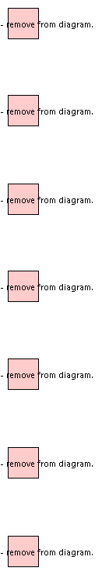

#### Datatypes

##### ALREADY_IN_POST_CONDITION datatype

**Qualified Name:** G.8052_v2.05-model::OperationExceptions::CommonExceptions::ALREADY_IN_POST_CONDITION

**Description:** Raised when the the server is already in the post-condition. It can be used by operations which are not defined as idempotent.

Table 1 Attributes for Data Type ALREADY_IN_POST_CONDITION

|  |  |  |  |  |
| --- | --- | --- | --- | --- |
| Attribute Name | Type | Mult. | Description | Applied Stereotypes |
| errorReason | String | 1 | This Parameter is a string indicating further details about the exception. It is a free format string filled by the NE (i.e., the Server of the Operation). | OpenModelAttribute   * valueRange: NA * support: MANDATORY * condition: none |

##### CAPACITY_EXCEEDED datatype

**Qualified Name:** G.8052_v2.05-model::OperationExceptions::CommonExceptions::CAPACITY_EXCEEDED

**Description:** Raised when the request will result in resources being created or activated beyond the capacity supported by the NE.

Table 1 Attributes for Data Type CAPACITY_EXCEEDED

|  |  |  |  |  |
| --- | --- | --- | --- | --- |
| Attribute Name | Type | Mult. | Description | Applied Stereotypes |
| errorReason | String | 1 | This Parameter is a string indicating further details about the exception. It is a free format string filled by the NE (i.e., the Server of the Operation). | OpenModelAttribute   * valueRange: NA * support: MANDATORY * condition: none |

##### DUPLICATE datatype

**Qualified Name:** G.8052_v2.05-model::OperationExceptions::CommonExceptions::DUPLICATE

**Description:** Raised when an entity cannot be created because an object with the same identifier/name already exists.

Table 1 Attributes for Data Type DUPLICATE

|  |  |  |  |  |
| --- | --- | --- | --- | --- |
| Attribute Name | Type | Mult. | Description | Applied Stereotypes |
| errorReason | String | 1 | This Parameter is a string indicating further details about the exception. It is a free format string filled by the NE (i.e., the Server of the Operation). | OpenModelAttribute   * valueRange: NA * support: MANDATORY * condition: none |

##### ENTITY_NOT_FOUND datatype

**Qualified Name:** G.8052_v2.05-model::OperationExceptions::CommonExceptions::ENTITY_NOT_FOUND

**Description:** Raised when at least one of the specified entities does not exist.

Table 1 Attributes for Data Type ENTITY_NOT_FOUND

|  |  |  |  |  |
| --- | --- | --- | --- | --- |
| Attribute Name | Type | Mult. | Description | Applied Stereotypes |
| errorReason | String | 1 | This Parameter is a string indicating further details about the exception. It is a free format string filled by the NE (i.e., the Server of the Operation). | OpenModelAttribute   * valueRange: NA * support: MANDATORY * condition: none |

##### LOW_PRIORITY datatype

**Qualified Name:** G.8052_v2.05-model::OperationExceptions::CommonExceptions::LOW_PRIORITY

**Description:** Raised when the operation cannot be excecuted beacuse of an other higher priority command is still in effect.

Table 1 Attributes for Data Type LOW_PRIORITY

|  |  |  |  |  |
| --- | --- | --- | --- | --- |
| Attribute Name | Type | Mult. | Description | Applied Stereotypes |
| errorReason | String | 1 | This Parameter is a string indicating further details about the exception. It is a free format string filled by the NE (i.e., the Server of the Operation). | OpenModelAttribute   * valueRange: NA * support: MANDATORY * condition: none |

##### NOT_IN_VALID_STATE datatype

**Qualified Name:** G.8052_v2.05-model::OperationExceptions::CommonExceptions::NOT_IN_VALID_STATE

**Description:** Raised when the state of the specified object is such that the NE cannot perform the request. In other words, the environment or the application is not in an appropriate state for the requested operation.

Table 1 Attributes for Data Type NOT_IN_VALID_STATE

|  |  |  |  |  |
| --- | --- | --- | --- | --- |
| Attribute Name | Type | Mult. | Description | Applied Stereotypes |
| errorReason | String | 1 | This Parameter is a string indicating further details about the exception. It is a free format string filled by the NE (i.e., the Server of the Operation). | OpenModelAttribute   * valueRange: NA * support: MANDATORY * condition: none |

##### OBJECT_IN_USE datatype

**Qualified Name:** G.8052_v2.05-model::OperationExceptions::CommonExceptions::OBJECT_IN_USE

**Description:** Raised when the object identified in the request is currently in use.

Table 1 Attributes for Data Type OBJECT_IN_USE

|  |  |  |  |  |
| --- | --- | --- | --- | --- |
| Attribute Name | Type | Mult. | Description | Applied Stereotypes |
| errorReason | String | 1 | This Parameter is a string indicating further details about the exception. It is a free format string filled by the NE (i.e., the Server of the Operation). | OpenModelAttribute   * valueRange: NA * support: MANDATORY * condition: none |

### GenericExceptions

**Qualified Name:** G.8052_v2.05-model::OperationExceptions::GenericExceptions

#### Diagrams

Figure 1 Diagram Generic exceptions

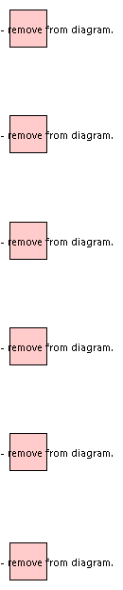

#### Datatypes

##### ACCESS_DENIED datatype

**Qualified Name:** G.8052_v2.05-model::OperationExceptions::GenericExceptions::ACCESS_DENIED

**Description:** Raised when the EMS does not have access rights to request the given operation.

Table 1 Attributes for Data Type ACCESS_DENIED

|  |  |  |  |  |
| --- | --- | --- | --- | --- |
| Attribute Name | Type | Mult. | Description | Applied Stereotypes |
| errorReason | String | 1 | This Parameter is a string indicating further details about the exception. It is a free format string filled by the NE (i.e., the Server of the Operation). | OpenModelAttribute   * valueRange: NA * support: MANDATORY * condition: none |

##### COMM_LOSS datatype

**Qualified Name:** G.8052_v2.05-model::OperationExceptions::GenericExceptions::COMM_LOSS

**Description:** Raised when the NE is unable to communicate with an underlying system or resource, and such communication is required to complete the request.

Table 1 Attributes for Data Type COMM_LOSS

|  |  |  |  |  |
| --- | --- | --- | --- | --- |
| Attribute Name | Type | Mult. | Description | Applied Stereotypes |
| errorReason | String | 1 | This Parameter is a string indicating further details about the exception. It is a free format string filled by the NE (i.e., the Server of the Operation). | OpenModelAttribute   * valueRange: NA * support: MANDATORY * condition: none |

##### INTERNAL_ERROR datatype

**Qualified Name:** G.8052_v2.05-model::OperationExceptions::GenericExceptions::INTERNAL_ERROR

**Description:** Raised when the NE has an internal error.

Table 1 Attributes for Data Type INTERNAL_ERROR

|  |  |  |  |  |
| --- | --- | --- | --- | --- |
| Attribute Name | Type | Mult. | Description | Applied Stereotypes |
| errorReason | String | 1 | This Parameter is a string indicating further details about the exception. It is a free format string filled by the NE (i.e., the Server of the Operation). | OpenModelAttribute   * valueRange: NA * support: MANDATORY * condition: none |

##### INVALID_INPUT datatype

**Qualified Name:** G.8052_v2.05-model::OperationExceptions::GenericExceptions::INVALID_INPUT

**Description:** Raised when the request contains an input parameter that is syntactically incorrect or identifies an object of the wrong type or is out of range (as defined in the model or because of NE limitation).

Table 1 Attributes for Data Type INVALID_INPUT

|  |  |  |  |  |
| --- | --- | --- | --- | --- |
| Attribute Name | Type | Mult. | Description | Applied Stereotypes |
| errorReason | String | 1 | This Parameter is a string indicating further details about the exception. It is a free format string filled by the NE (i.e., the Server of the Operation). | OpenModelAttribute   * valueRange: NA * support: MANDATORY * condition: none |

##### NOT_IMPLEMENTED datatype

**Qualified Name:** G.8052_v2.05-model::OperationExceptions::GenericExceptions::NOT_IMPLEMENTED

**Description:** Raised when the entire request is not supported by the NE or the request with the specified input parameters is not supported.

Table 1 Attributes for Data Type NOT_IMPLEMENTED

|  |  |  |  |  |
| --- | --- | --- | --- | --- |
| Attribute Name | Type | Mult. | Description | Applied Stereotypes |
| errorReason | String | 1 | This Parameter is a string indicating further details about the exception. It is a free format string filled by the NE (i.e., the Server of the Operation). | OpenModelAttribute   * valueRange: NA * support: MANDATORY * condition: none |

##### UNABLE_TO_COMPLY datatype

**Qualified Name:** G.8052_v2.05-model::OperationExceptions::GenericExceptions::UNABLE_TO_COMPLY

**Description:** Raised when the NE cannot perform the request. Use Cases may identify specific conditions that will result in this exception.

Table 1 Attributes for Data Type UNABLE_TO_COMPLY

|  |  |  |  |  |
| --- | --- | --- | --- | --- |
| Attribute Name | Type | Mult. | Description | Applied Stereotypes |
| errorReason | String | 1 | This Parameter is a string indicating further details about the exception. It is a free format string filled by the NE (i.e., the Server of the Operation). | OpenModelAttribute   * valueRange: NA * support: MANDATORY * condition: none |

## Pacs

**Qualified Name:** G.8052_v2.05-model::Pacs

**Description:** Note that in the UML modeling, a "_package" object class is used to group a set of attributes/parameters and parameters for the purpose that they can be conditionally associated to an object class.

### Classes

#### CsfConfigSource_Pac class

**Qualified Name:** G.8052_v2.05-model::Pacs::CsfConfigSource_Pac

**Description:** This package provides the CSF related MI signals defined in the adaptation source atomic functions.

**Parent class:** G8052LocalClass

**Applied Stereotypes:**

* OpenModelClass
  + condition: none
  + support: MANDATORY

Table 1 Attributes for Class CsfConfigSource_Pac

|  |  |  |  |  |
| --- | --- | --- | --- | --- |
| Attribute Name | Type | Mult. | Description | Applied Stereotypes |
| csfConfig | CsfConfig | 1 | This attribute models the combination of all CSF related MI signals (MI_CSF_Enable, MI_CSFrdifdi_Enable, MI_CSFdci_Enable) as defined in G.8021. | OpenModelAttribute   * valueRange: true, false * support: MANDATORY * condition: none |
| localId | String | 1 | An identifier that is unique in the context of some scope that is less than the global scope. (consider in the context of Identifier: A property of an entity/role with a value that is unique within an identifier space, where the identifier space is itself unique, and immutable. The identifier therefore represents the identity of the entity/role. An identifier carries no semantics with respect to the purpose of the entity.) | Inherited from Class G8052LocalClass  OpenModelAttribute   * valueRange: no range constraint * support: MANDATORY |
| name | NameAndValue | 1..* | List of names. | Inherited from Class Name  OpenModelAttribute   * valueRange: no range constraint * support: MANDATORY |
| extension | NameAndValue | 0..* | List of simple name-value extensions. | Inherited from Class Extension  OpenModelAttribute   * valueRange: no range constraint * support: MANDATORY |
| operationalState | OperationalState | 0..1 | The operational state is used to indicate whether or not the resource is installed and working. | Inherited from Class State_Pac  OpenModelAttribute   * valueRange: no range constraint * support: MANDATORY   Preliminary |
| administrativeControl | AdministrativeControl | 0..1 | The administrativeControl state provides control of the availability of specific resources without modification to the provisioning of those resources. The value is the current control target. The actual administrativeState may or may not be at target. | Inherited from Class State_Pac  Experimental  OpenModelAttribute   * valueRange: no range constraint * support: MANDATORY |
| administrativeState | AdministrativeState | 0..1 | Shows whether or not the client has permission to use or has a prohibition against using the resource. The administrative state expresses usage permissions for specific resources without modification to the provisioning of those resources. | Inherited from Class State_Pac  OpenModelAttribute   * valueRange: no range constraint * support: MANDATORY   Preliminary |
| lifecycleState | LifecycleState | 0..1 | Used to track the planned deployment, allocation to clients and withdrawal of resources. | Inherited from Class State_Pac  OpenModelAttribute   * valueRange: no range constraint * support: MANDATORY   Preliminary |
| label | NameAndValue | 0..* | List of labels. | Inherited from Class Label  OpenModelAttribute   * valueRange: no range constraint * support: MANDATORY |

#### CsfRdiFdiEnableSink_Pac class

**Qualified Name:** G.8052_v2.05-model::Pacs::CsfRdiFdiEnableSink_Pac

**Description:** This pac provides the client layer related MI attributes defined in the following adaptation functions: G.8021 Sn/ETH, Sn-X-L/ETH, Sm/ETH, Sm-X-L/ETH, Pq/ETH, Pq-X-L/ETH, ODUkP/ETH.

**Parent class:** G8052LocalClass

**Applied Stereotypes:**

* OpenModelClass
  + condition: none
  + support: MANDATORY

Table 1 Attributes for Class CsfRdiFdiEnableSink_Pac

|  |  |  |  |  |
| --- | --- | --- | --- | --- |
| Attribute Name | Type | Mult. | Description | Applied Stereotypes |
| csfRdiFdiEnable | Boolean | 1 | This attribute models the MI_CSFrdifdiEnable information defined in G.8021. | OpenModelAttribute   * valueRange: NA * support: MANDATORY * condition: none |
| localId | String | 1 | An identifier that is unique in the context of some scope that is less than the global scope. (consider in the context of Identifier: A property of an entity/role with a value that is unique within an identifier space, where the identifier space is itself unique, and immutable. The identifier therefore represents the identity of the entity/role. An identifier carries no semantics with respect to the purpose of the entity.) | Inherited from Class G8052LocalClass  OpenModelAttribute   * valueRange: no range constraint * support: MANDATORY |
| name | NameAndValue | 1..* | List of names. | Inherited from Class Name  OpenModelAttribute   * valueRange: no range constraint * support: MANDATORY |
| extension | NameAndValue | 0..* | List of simple name-value extensions. | Inherited from Class Extension  OpenModelAttribute   * valueRange: no range constraint * support: MANDATORY |
| operationalState | OperationalState | 0..1 | The operational state is used to indicate whether or not the resource is installed and working. | Inherited from Class State_Pac  OpenModelAttribute   * valueRange: no range constraint * support: MANDATORY   Preliminary |
| administrativeControl | AdministrativeControl | 0..1 | The administrativeControl state provides control of the availability of specific resources without modification to the provisioning of those resources. The value is the current control target. The actual administrativeState may or may not be at target. | Inherited from Class State_Pac  Experimental  OpenModelAttribute   * valueRange: no range constraint * support: MANDATORY |
| administrativeState | AdministrativeState | 0..1 | Shows whether or not the client has permission to use or has a prohibition against using the resource. The administrative state expresses usage permissions for specific resources without modification to the provisioning of those resources. | Inherited from Class State_Pac  OpenModelAttribute   * valueRange: no range constraint * support: MANDATORY   Preliminary |
| lifecycleState | LifecycleState | 0..1 | Used to track the planned deployment, allocation to clients and withdrawal of resources. | Inherited from Class State_Pac  OpenModelAttribute   * valueRange: no range constraint * support: MANDATORY   Preliminary |
| label | NameAndValue | 0..* | List of labels. | Inherited from Class Label  OpenModelAttribute   * valueRange: no range constraint * support: MANDATORY |

#### CsfRdiFdiEnableSource_Pac class

**Qualified Name:** G.8052_v2.05-model::Pacs::CsfRdiFdiEnableSource_Pac

**Description:** This pac provides the client layer related MI attributes defined in the following adaptation functions: G.8021 Sn/ETH, Sn-X-L/ETH, Sm/ETH, Sm-X-L/ETH, Pq/ETH, Pq-X-L/ETH, ODUkP/ETH.

**Parent class:** G8052LocalClass

**Applied Stereotypes:**

* OpenModelClass
  + condition: none
  + support: MANDATORY

Table 1 Attributes for Class CsfRdiFdiEnableSource_Pac

|  |  |  |  |  |
| --- | --- | --- | --- | --- |
| Attribute Name | Type | Mult. | Description | Applied Stereotypes |
| csfRdiFdiEnable | Boolean | 1 | This attribute models the MI_CSFrdifdiEnable information defined in G.8021. | OpenModelAttribute   * valueRange: no range constraint * support: MANDATORY * condition: none |
| localId | String | 1 | An identifier that is unique in the context of some scope that is less than the global scope. (consider in the context of Identifier: A property of an entity/role with a value that is unique within an identifier space, where the identifier space is itself unique, and immutable. The identifier therefore represents the identity of the entity/role. An identifier carries no semantics with respect to the purpose of the entity.) | Inherited from Class G8052LocalClass  OpenModelAttribute   * valueRange: no range constraint * support: MANDATORY |
| name | NameAndValue | 1..* | List of names. | Inherited from Class Name  OpenModelAttribute   * valueRange: no range constraint * support: MANDATORY |
| extension | NameAndValue | 0..* | List of simple name-value extensions. | Inherited from Class Extension  OpenModelAttribute   * valueRange: no range constraint * support: MANDATORY |
| operationalState | OperationalState | 0..1 | The operational state is used to indicate whether or not the resource is installed and working. | Inherited from Class State_Pac  OpenModelAttribute   * valueRange: no range constraint * support: MANDATORY   Preliminary |
| administrativeControl | AdministrativeControl | 0..1 | The administrativeControl state provides control of the availability of specific resources without modification to the provisioning of those resources. The value is the current control target. The actual administrativeState may or may not be at target. | Inherited from Class State_Pac  Experimental  OpenModelAttribute   * valueRange: no range constraint * support: MANDATORY |
| administrativeState | AdministrativeState | 0..1 | Shows whether or not the client has permission to use or has a prohibition against using the resource. The administrative state expresses usage permissions for specific resources without modification to the provisioning of those resources. | Inherited from Class State_Pac  OpenModelAttribute   * valueRange: no range constraint * support: MANDATORY   Preliminary |
| lifecycleState | LifecycleState | 0..1 | Used to track the planned deployment, allocation to clients and withdrawal of resources. | Inherited from Class State_Pac  OpenModelAttribute   * valueRange: no range constraint * support: MANDATORY   Preliminary |
| label | NameAndValue | 0..* | List of labels. | Inherited from Class Label  OpenModelAttribute   * valueRange: no range constraint * support: MANDATORY |

#### CsfReportSink_Pac class

**Qualified Name:** G.8052_v2.05-model::Pacs::CsfReportSink_Pac

**Description:** This package provides the client layer related MI attributes defined in the following adaptation functions: G.8021 Sn/ETH, Sn-X-L/ETH, Sm/ETH, Sm-X-L/ETH, Pq/ETH, Pq-X-L/ETH, ODUkP/ETH, Sn-X/ETC3, ODU2P/ETHPP-OS.

**Parent class:** G8052LocalClass

**Applied Stereotypes:**

* OpenModelClass
  + condition: none
  + support: MANDATORY

Table 1 Attributes for Class CsfReportSink_Pac

|  |  |  |  |  |
| --- | --- | --- | --- | --- |
| Attribute Name | Type | Mult. | Description | Applied Stereotypes |
| csfReport | Boolean | 1 | This attribute models the MI_CSF_Reported information defined in G.8021. | OpenModelAttribute   * valueRange: true, false * support: MANDATORY * condition: none |
| localId | String | 1 | An identifier that is unique in the context of some scope that is less than the global scope. (consider in the context of Identifier: A property of an entity/role with a value that is unique within an identifier space, where the identifier space is itself unique, and immutable. The identifier therefore represents the identity of the entity/role. An identifier carries no semantics with respect to the purpose of the entity.) | Inherited from Class G8052LocalClass  OpenModelAttribute   * valueRange: no range constraint * support: MANDATORY |
| name | NameAndValue | 1..* | List of names. | Inherited from Class Name  OpenModelAttribute   * valueRange: no range constraint * support: MANDATORY |
| extension | NameAndValue | 0..* | List of simple name-value extensions. | Inherited from Class Extension  OpenModelAttribute   * valueRange: no range constraint * support: MANDATORY |
| operationalState | OperationalState | 0..1 | The operational state is used to indicate whether or not the resource is installed and working. | Inherited from Class State_Pac  OpenModelAttribute   * valueRange: no range constraint * support: MANDATORY   Preliminary |
| administrativeControl | AdministrativeControl | 0..1 | The administrativeControl state provides control of the availability of specific resources without modification to the provisioning of those resources. The value is the current control target. The actual administrativeState may or may not be at target. | Inherited from Class State_Pac  Experimental  OpenModelAttribute   * valueRange: no range constraint * support: MANDATORY |
| administrativeState | AdministrativeState | 0..1 | Shows whether or not the client has permission to use or has a prohibition against using the resource. The administrative state expresses usage permissions for specific resources without modification to the provisioning of those resources. | Inherited from Class State_Pac  OpenModelAttribute   * valueRange: no range constraint * support: MANDATORY   Preliminary |
| lifecycleState | LifecycleState | 0..1 | Used to track the planned deployment, allocation to clients and withdrawal of resources. | Inherited from Class State_Pac  OpenModelAttribute   * valueRange: no range constraint * support: MANDATORY   Preliminary |
| label | NameAndValue | 0..* | List of labels. | Inherited from Class Label  OpenModelAttribute   * valueRange: no range constraint * support: MANDATORY |

#### DegradedDetection_Pac class

**Qualified Name:** G.8052_v2.05-model::Pacs::DegradedDetection_Pac

**Description:** This package contains the configuration parameters for detecting "degraded signal" (DEG).

**Parent class:** G8052LocalClass

**Applied Stereotypes:**

* OpenModelClass
  + condition: none
  + support: MANDATORY

Table 1 Attributes for Class DegradedDetection_Pac

|  |  |  |  |  |
| --- | --- | --- | --- | --- |
| Attribute Name | Type | Mult. | Description | Applied Stereotypes |
| lmDegm | Integer | 1 | This attribute defines the number of consecutive bad seconds necessary for the "degraded" detection. See also section "Degraded signal defect (dDEG)" in G.8021. | OpenModelAttribute   * valueRange: See data type * support: MANDATORY * condition: none |
| lmDegThr | Integer | 1 | This attribute defines the threshold for declaring a "bad second". See also section "Degraded signal defect (dDEG)" in G.8021. | OpenModelAttribute   * valueRange: See data type * support: MANDATORY * condition: none |
| lmM | Integer | 1 | This attribute defines the number of consecutive good seconds necessary for the clearing of "degraded". See also section "Degraded signal defect (dDEG)" in G.8021. | OpenModelAttribute   * valueRange: 2..10 * support: MANDATORY * condition: none |
| lmTfMin | Integer | 1 | This attribute defines the necessary number of transmitted frames to enable the detection of "bad seconds". See also section "Degraded signal defect (dDEG)" in G.8021. | OpenModelAttribute   * valueRange: NA * support: MANDATORY * condition: none |
| localId | String | 1 | An identifier that is unique in the context of some scope that is less than the global scope. (consider in the context of Identifier: A property of an entity/role with a value that is unique within an identifier space, where the identifier space is itself unique, and immutable. The identifier therefore represents the identity of the entity/role. An identifier carries no semantics with respect to the purpose of the entity.) | Inherited from Class G8052LocalClass  OpenModelAttribute   * valueRange: no range constraint * support: MANDATORY |
| name | NameAndValue | 1..* | List of names. | Inherited from Class Name  OpenModelAttribute   * valueRange: no range constraint * support: MANDATORY |
| extension | NameAndValue | 0..* | List of simple name-value extensions. | Inherited from Class Extension  OpenModelAttribute   * valueRange: no range constraint * support: MANDATORY |
| operationalState | OperationalState | 0..1 | The operational state is used to indicate whether or not the resource is installed and working. | Inherited from Class State_Pac  OpenModelAttribute   * valueRange: no range constraint * support: MANDATORY   Preliminary |
| administrativeControl | AdministrativeControl | 0..1 | The administrativeControl state provides control of the availability of specific resources without modification to the provisioning of those resources. The value is the current control target. The actual administrativeState may or may not be at target. | Inherited from Class State_Pac  Experimental  OpenModelAttribute   * valueRange: no range constraint * support: MANDATORY |
| administrativeState | AdministrativeState | 0..1 | Shows whether or not the client has permission to use or has a prohibition against using the resource. The administrative state expresses usage permissions for specific resources without modification to the provisioning of those resources. | Inherited from Class State_Pac  OpenModelAttribute   * valueRange: no range constraint * support: MANDATORY   Preliminary |
| lifecycleState | LifecycleState | 0..1 | Used to track the planned deployment, allocation to clients and withdrawal of resources. | Inherited from Class State_Pac  OpenModelAttribute   * valueRange: no range constraint * support: MANDATORY   Preliminary |
| label | NameAndValue | 0..* | List of labels. | Inherited from Class Label  OpenModelAttribute   * valueRange: no range constraint * support: MANDATORY |

#### EthServerTtpSink_Pac class

**Qualified Name:** G.8052_v2.05-model::Pacs::EthServerTtpSink_Pac

**Description:** This pac models the server layer (i.e. ETHx) related function of ETHx/ETH-m_A_Sk defined in 9.3.3/G.8021. This pac is contained in the ETH_TrailTerminationPointSink object.

**Parent class:** G8052LocalClass

**Applied Stereotypes:**

* OpenModelClass
  + condition: none
  + support: MANDATORY

Table 1 Attributes for Class EthServerTtpSink_Pac

|  |  |  |  |  |
| --- | --- | --- | --- | --- |
| Attribute Name | Type | Mult. | Description | Applied Stereotypes |
| adminState | AdminState | 1 | This attribute models the ETHx/ETH-m_A_Sk_MI_Admin_State information defined in G.8021. | OpenModelAttribute   * valueRange: Lock, Normal * support: MANDATORY * condition: none |
| priorityRegenerate | PriorityMapping | 1 | This attribute models the ETHx/ETH-m _A_Sk_MI_P_Regenerate information defined in G.8021. | OpenModelAttribute   * valueRange: NA * support: MANDATORY * condition: none |
| portVid | Integer | 1 | This attribute models the ETHx/ETH-m _A_Sk_MI_PVID information defined in G.8021. | OpenModelAttribute   * valueRange: 0..4095 * support: MANDATORY * condition: none |
| priorityCodePointConfig | PcpCoding | 1 | This attribute models the ETHx/ETH-m _A_Sk_MI_PCP_Config information defined in G.8021. | OpenModelAttribute   * valueRange: see Enumeration * support: MANDATORY * condition: none |
| etherType | VlanType | 1 | This attribute models the ETHx/ETH-m _A_Sk_MI_Etype information defined in G.8021. | OpenModelAttribute   * valueRange: See data type * support: MANDATORY * condition: none |
| frametypeConfig | FrameType | 1 | This attribute models the ETHx/ETH-m_A_Sk_MI_Frametype_Config information defined in G.8021. | OpenModelAttribute   * valueRange: see Enumeration * support: MANDATORY * condition: none |
| filterConfig | MacAddress | 1 | This attribute models the ETHx/ETH-m_A_Sk_MI_Filter_Config information defined in G.8021. It indicates the configured filter action for each of the 33 group MAC addresses for control frames. The 33 MAC addresses are: 01-80-C2-00-00-10, 01-80-C2-00-00-00 to 01-80-C2-00-00-0F, and 01-80-C2-00-00-20 to 01-80-C2-00-00-2F. The filter action is Pass or Block. If the destination address of the incoming ETH_CI_D matches one of the above addresses, the filter process shall perform the corresponding configured filter action. If none of the above addresses match, the ETH_CI_D is passed. | OpenModelAttribute   * valueRange: MacAddress:   01-80-C2-00-00-10,   01-80-C2-00-00-00 to   01-80-C2-00-00-0F, and   01-80-C2-00-00-20 to   01-80-C2-00-00-2F;   ActionEnum:   PASS, BLOCK * support: MANDATORY * condition: none |
| localId | String | 1 | An identifier that is unique in the context of some scope that is less than the global scope. (consider in the context of Identifier: A property of an entity/role with a value that is unique within an identifier space, where the identifier space is itself unique, and immutable. The identifier therefore represents the identity of the entity/role. An identifier carries no semantics with respect to the purpose of the entity.) | Inherited from Class G8052LocalClass  OpenModelAttribute   * valueRange: no range constraint * support: MANDATORY |
| name | NameAndValue | 1..* | List of names. | Inherited from Class Name  OpenModelAttribute   * valueRange: no range constraint * support: MANDATORY |
| extension | NameAndValue | 0..* | List of simple name-value extensions. | Inherited from Class Extension  OpenModelAttribute   * valueRange: no range constraint * support: MANDATORY |
| operationalState | OperationalState | 0..1 | The operational state is used to indicate whether or not the resource is installed and working. | Inherited from Class State_Pac  OpenModelAttribute   * valueRange: no range constraint * support: MANDATORY   Preliminary |
| administrativeControl | AdministrativeControl | 0..1 | The administrativeControl state provides control of the availability of specific resources without modification to the provisioning of those resources. The value is the current control target. The actual administrativeState may or may not be at target. | Inherited from Class State_Pac  Experimental  OpenModelAttribute   * valueRange: no range constraint * support: MANDATORY |
| administrativeState | AdministrativeState | 0..1 | Shows whether or not the client has permission to use or has a prohibition against using the resource. The administrative state expresses usage permissions for specific resources without modification to the provisioning of those resources. | Inherited from Class State_Pac  OpenModelAttribute   * valueRange: no range constraint * support: MANDATORY   Preliminary |
| lifecycleState | LifecycleState | 0..1 | Used to track the planned deployment, allocation to clients and withdrawal of resources. | Inherited from Class State_Pac  OpenModelAttribute   * valueRange: no range constraint * support: MANDATORY   Preliminary |
| label | NameAndValue | 0..* | List of labels. | Inherited from Class Label  OpenModelAttribute   * valueRange: no range constraint * support: MANDATORY |

#### EthServerTtpSource_Pac class

**Qualified Name:** G.8052_v2.05-model::Pacs::EthServerTtpSource_Pac

**Description:** This pac models the server layer (i.e. ETHx) related function of ETHx/ETH-m_A_So defined in 9.3.3/G.8021.
This pac is contained in the ETH_TrailTerminationPointSource object.

**Parent class:** G8052LocalClass

**Applied Stereotypes:**

* OpenModelClass
  + condition: none
  + support: MANDATORY

Table 1 Attributes for Class EthServerTtpSource_Pac

|  |  |  |  |  |
| --- | --- | --- | --- | --- |
| Attribute Name | Type | Mult. | Description | Applied Stereotypes |
| adminState | AdminState | 1 | This attribute models the ETHx/ETH-m_A_So_MI_Admin_State information defined in G.8021. | OpenModelAttribute   * valueRange: Lock, Normal * support: MANDATORY * condition: none |
| etherType | VlanType | 1 | This attribute models the ETHx/ETH-m_A_So_MI_Etype information defined in G.8021. | OpenModelAttribute   * valueRange: See data type * support: MANDATORY * condition: none |
| priorityCodePointConfig | PcpCoding | 1 | This attribute models the ETHx/ETH-m _A_Sk_MI_PCP_Config information defined in G.8021. | OpenModelAttribute   * valueRange: see Enumeration * support: MANDATORY * condition: none |
| localId | String | 1 | An identifier that is unique in the context of some scope that is less than the global scope. (consider in the context of Identifier: A property of an entity/role with a value that is unique within an identifier space, where the identifier space is itself unique, and immutable. The identifier therefore represents the identity of the entity/role. An identifier carries no semantics with respect to the purpose of the entity.) | Inherited from Class G8052LocalClass  OpenModelAttribute   * valueRange: no range constraint * support: MANDATORY |
| name | NameAndValue | 1..* | List of names. | Inherited from Class Name  OpenModelAttribute   * valueRange: no range constraint * support: MANDATORY |
| extension | NameAndValue | 0..* | List of simple name-value extensions. | Inherited from Class Extension  OpenModelAttribute   * valueRange: no range constraint * support: MANDATORY |
| operationalState | OperationalState | 0..1 | The operational state is used to indicate whether or not the resource is installed and working. | Inherited from Class State_Pac  OpenModelAttribute   * valueRange: no range constraint * support: MANDATORY   Preliminary |
| administrativeControl | AdministrativeControl | 0..1 | The administrativeControl state provides control of the availability of specific resources without modification to the provisioning of those resources. The value is the current control target. The actual administrativeState may or may not be at target. | Inherited from Class State_Pac  Experimental  OpenModelAttribute   * valueRange: no range constraint * support: MANDATORY |
| administrativeState | AdministrativeState | 0..1 | Shows whether or not the client has permission to use or has a prohibition against using the resource. The administrative state expresses usage permissions for specific resources without modification to the provisioning of those resources. | Inherited from Class State_Pac  OpenModelAttribute   * valueRange: no range constraint * support: MANDATORY   Preliminary |
| lifecycleState | LifecycleState | 0..1 | Used to track the planned deployment, allocation to clients and withdrawal of resources. | Inherited from Class State_Pac  OpenModelAttribute   * valueRange: no range constraint * support: MANDATORY   Preliminary |
| label | NameAndValue | 0..* | List of labels. | Inherited from Class Label  OpenModelAttribute   * valueRange: no range constraint * support: MANDATORY |

#### FilterConfigSink_Pac class

**Qualified Name:** G.8052_v2.05-model::Pacs::FilterConfigSink_Pac

**Parent class:** G8052LocalClass

**Applied Stereotypes:**

* OpenModelClass
  + condition: none
  + support: MANDATORY

Table 1 Attributes for Class FilterConfigSink_Pac

|  |  |  |  |  |
| --- | --- | --- | --- | --- |
| Attribute Name | Type | Mult. | Description | Applied Stereotypes |
| filterConfig | MacAddress | 1 | This attribute models the FilteConfig MI defined in 8.3/G.8021. It indicates the configured filter action for each of the 33 group MAC addresses for control frames. The 33 MAC addresses are: 01-80-C2-00-00-10, 01-80-C2-00-00-00 to 01-80-C2-00-00-0F, and 01-80-C2-00-00-20 to 01-80-C2-00-00-2F. The filter action is Pass or Block. If the destination address of the incoming ETH_CI_D matches one of the above addresses, the filter process shall perform the corresponding configured filter action. If none of the above addresses match, the ETH_CI_D is passed. | OpenModelAttribute   * valueRange: NA * support: MANDATORY * condition: none |
| macLength | Integer | 1 | This attribute models the MAC_Lenght MI defined in 8.6/G.8021 for the MAC Length Check process. It indicates the allowed maximum frame length in bytes. | OpenModelAttribute   * valueRange: 1518, 1522, 2000 * support: MANDATORY * condition: none |
| localId | String | 1 | An identifier that is unique in the context of some scope that is less than the global scope. (consider in the context of Identifier: A property of an entity/role with a value that is unique within an identifier space, where the identifier space is itself unique, and immutable. The identifier therefore represents the identity of the entity/role. An identifier carries no semantics with respect to the purpose of the entity.) | Inherited from Class G8052LocalClass  OpenModelAttribute   * valueRange: no range constraint * support: MANDATORY |
| name | NameAndValue | 1..* | List of names. | Inherited from Class Name  OpenModelAttribute   * valueRange: no range constraint * support: MANDATORY |
| extension | NameAndValue | 0..* | List of simple name-value extensions. | Inherited from Class Extension  OpenModelAttribute   * valueRange: no range constraint * support: MANDATORY |
| operationalState | OperationalState | 0..1 | The operational state is used to indicate whether or not the resource is installed and working. | Inherited from Class State_Pac  OpenModelAttribute   * valueRange: no range constraint * support: MANDATORY   Preliminary |
| administrativeControl | AdministrativeControl | 0..1 | The administrativeControl state provides control of the availability of specific resources without modification to the provisioning of those resources. The value is the current control target. The actual administrativeState may or may not be at target. | Inherited from Class State_Pac  Experimental  OpenModelAttribute   * valueRange: no range constraint * support: MANDATORY |
| administrativeState | AdministrativeState | 0..1 | Shows whether or not the client has permission to use or has a prohibition against using the resource. The administrative state expresses usage permissions for specific resources without modification to the provisioning of those resources. | Inherited from Class State_Pac  OpenModelAttribute   * valueRange: no range constraint * support: MANDATORY   Preliminary |
| lifecycleState | LifecycleState | 0..1 | Used to track the planned deployment, allocation to clients and withdrawal of resources. | Inherited from Class State_Pac  OpenModelAttribute   * valueRange: no range constraint * support: MANDATORY   Preliminary |
| label | NameAndValue | 0..* | List of labels. | Inherited from Class Label  OpenModelAttribute   * valueRange: no range constraint * support: MANDATORY |

#### Tp_Pac class

**Qualified Name:** G.8052_v2.05-model::Pacs::Tp_Pac

**Abstract class**

**Applied Stereotypes:**

* OpenModelClass
  + support: MANDATORY

Table 1 Attributes for Class Tp_Pac

|  |  |  |  |  |
| --- | --- | --- | --- | --- |
| Attribute Name | Type | Mult. | Description | Applied Stereotypes |
| alarmStatus |  | 1 |  | OpenModelAttribute   * valueRange: NA * support: MANDATORY * condition: none |
| crossConnectionObjectPointer |  | 1 |  | OpenModelAttribute   * valueRange: NA * support: MANDATORY * condition: none |
| currentProblemList |  | 1 |  | OpenModelAttribute   * valueRange: NA * support: MANDATORY * condition: none |
| alarmSeverityAssignmentProfilePointer |  | 1 | This role (when present) represents the Termination Point (include its child classes Trail/Connection Termination Point Source/Sink/Bidirectional, Network CTP/TTP Source/Sink/Bidirectional) capability to identify the Alarm Severity Assignment Profile that is associated with this Termination Point. When this role is present, the TerminationPoint.alarmSeverityAssignmentProfilePointe shall carry the DN of Alarm Severity Assignment Profile. | OpenModelAttribute   * valueRange: no range constraint * support: MANDATORY |
| _containingPhysicalSubsystem | PhysicalSubsystem | 1 |  | OpenModelAttribute   * valueRange: NA * support: MANDATORY * condition: none |

#### VlanConfigSink_Pac class

**Qualified Name:** G.8052_v2.05-model::Pacs::VlanConfigSink_Pac

**Parent class:** G8052LocalClass

**Applied Stereotypes:**

* OpenModelClass
  + condition: none
  + support: MANDATORY

Table 1 Attributes for Class VlanConfigSink_Pac

|  |  |  |  |  |
| --- | --- | --- | --- | --- |
| Attribute Name | Type | Mult. | Description | Applied Stereotypes |
| vlanConfig | Integer | 1 | This attribute models the ETHx/ETH-m_A_So_MI_Vlan_Config information defined in G.8021. | OpenModelAttribute   * valueRange: -1, 0, 1..4094 * support: MANDATORY * condition: none |
| localId | String | 1 | An identifier that is unique in the context of some scope that is less than the global scope. (consider in the context of Identifier: A property of an entity/role with a value that is unique within an identifier space, where the identifier space is itself unique, and immutable. The identifier therefore represents the identity of the entity/role. An identifier carries no semantics with respect to the purpose of the entity.) | Inherited from Class G8052LocalClass  OpenModelAttribute   * valueRange: no range constraint * support: MANDATORY |
| name | NameAndValue | 1..* | List of names. | Inherited from Class Name  OpenModelAttribute   * valueRange: no range constraint * support: MANDATORY |
| extension | NameAndValue | 0..* | List of simple name-value extensions. | Inherited from Class Extension  OpenModelAttribute   * valueRange: no range constraint * support: MANDATORY |
| operationalState | OperationalState | 0..1 | The operational state is used to indicate whether or not the resource is installed and working. | Inherited from Class State_Pac  OpenModelAttribute   * valueRange: no range constraint * support: MANDATORY   Preliminary |
| administrativeControl | AdministrativeControl | 0..1 | The administrativeControl state provides control of the availability of specific resources without modification to the provisioning of those resources. The value is the current control target. The actual administrativeState may or may not be at target. | Inherited from Class State_Pac  Experimental  OpenModelAttribute   * valueRange: no range constraint * support: MANDATORY |
| administrativeState | AdministrativeState | 0..1 | Shows whether or not the client has permission to use or has a prohibition against using the resource. The administrative state expresses usage permissions for specific resources without modification to the provisioning of those resources. | Inherited from Class State_Pac  OpenModelAttribute   * valueRange: no range constraint * support: MANDATORY   Preliminary |
| lifecycleState | LifecycleState | 0..1 | Used to track the planned deployment, allocation to clients and withdrawal of resources. | Inherited from Class State_Pac  OpenModelAttribute   * valueRange: no range constraint * support: MANDATORY   Preliminary |
| label | NameAndValue | 0..* | List of labels. | Inherited from Class Label  OpenModelAttribute   * valueRange: no range constraint * support: MANDATORY |

#### VlanConfigSource_Pac class

**Qualified Name:** G.8052_v2.05-model::Pacs::VlanConfigSource_Pac

**Parent class:** G8052LocalClass

**Applied Stereotypes:**

* OpenModelClass
  + condition: none
  + support: MANDATORY

Table 1 Attributes for Class VlanConfigSource_Pac

|  |  |  |  |  |
| --- | --- | --- | --- | --- |
| Attribute Name | Type | Mult. | Description | Applied Stereotypes |
| vlanConfig | Integer | 1 | This attribute models the ETHx/ETH-m_A_So_MI_Vlan_Config information defined in G.8021. | OpenModelAttribute   * valueRange: -1, 0, 1..4094 * support: MANDATORY * condition: none |
| localId | String | 1 | An identifier that is unique in the context of some scope that is less than the global scope. (consider in the context of Identifier: A property of an entity/role with a value that is unique within an identifier space, where the identifier space is itself unique, and immutable. The identifier therefore represents the identity of the entity/role. An identifier carries no semantics with respect to the purpose of the entity.) | Inherited from Class G8052LocalClass  OpenModelAttribute   * valueRange: no range constraint * support: MANDATORY |
| name | NameAndValue | 1..* | List of names. | Inherited from Class Name  OpenModelAttribute   * valueRange: no range constraint * support: MANDATORY |
| extension | NameAndValue | 0..* | List of simple name-value extensions. | Inherited from Class Extension  OpenModelAttribute   * valueRange: no range constraint * support: MANDATORY |
| operationalState | OperationalState | 0..1 | The operational state is used to indicate whether or not the resource is installed and working. | Inherited from Class State_Pac  OpenModelAttribute   * valueRange: no range constraint * support: MANDATORY   Preliminary |
| administrativeControl | AdministrativeControl | 0..1 | The administrativeControl state provides control of the availability of specific resources without modification to the provisioning of those resources. The value is the current control target. The actual administrativeState may or may not be at target. | Inherited from Class State_Pac  Experimental  OpenModelAttribute   * valueRange: no range constraint * support: MANDATORY |
| administrativeState | AdministrativeState | 0..1 | Shows whether or not the client has permission to use or has a prohibition against using the resource. The administrative state expresses usage permissions for specific resources without modification to the provisioning of those resources. | Inherited from Class State_Pac  OpenModelAttribute   * valueRange: no range constraint * support: MANDATORY   Preliminary |
| lifecycleState | LifecycleState | 0..1 | Used to track the planned deployment, allocation to clients and withdrawal of resources. | Inherited from Class State_Pac  OpenModelAttribute   * valueRange: no range constraint * support: MANDATORY   Preliminary |
| label | NameAndValue | 0..* | List of labels. | Inherited from Class Label  OpenModelAttribute   * valueRange: no range constraint * support: MANDATORY |

## Server/Client Object Classes

**Qualified Name:** G.8052_v2.05-model::Server/Client Object Classes

### Classes

#### ATM_ConnectionTerminationPoint class

**Qualified Name:** G.8052_v2.05-model::Server/Client Object Classes::ATM_ConnectionTerminationPoint

**Description:** Not in scope of G.8052.

**Abstract class**

**Applied Stereotypes:**

* OpenModelClass
  + condition: none
  + support: MANDATORY

#### MT_ConnectionTerminationPoint class

**Qualified Name:** G.8052_v2.05-model::Server/Client Object Classes::MT_ConnectionTerminationPoint

**Description:** Not in scope of G.8052.

**Abstract class**

**Applied Stereotypes:**

* OpenModelClass
  + condition: none
  + support: MANDATORY

#### MT_TrailTerminationPoint class

**Qualified Name:** G.8052_v2.05-model::Server/Client Object Classes::MT_TrailTerminationPoint

**Description:** Not in scope of G.8052.

**Abstract class**

**Applied Stereotypes:**

* OpenModelClass
  + condition: none
  + support: MANDATORY

#### OTH_TrailTerminationPoint class

**Qualified Name:** G.8052_v2.05-model::Server/Client Object Classes::OTH_TrailTerminationPoint

**Description:** Not in scope of G.8052.

**Abstract class**

**Applied Stereotypes:**

* OpenModelClass
  + condition: none
  + support: MANDATORY

#### PDH_ConnectionTerminationPoint class

**Qualified Name:** G.8052_v2.05-model::Server/Client Object Classes::PDH_ConnectionTerminationPoint

**Description:** Not in scope of G.8052.

**Abstract class**

**Applied Stereotypes:**

* OpenModelClass
  + condition: none
  + support: MANDATORY

#### PDH_TrailTerminationPoint class

**Qualified Name:** G.8052_v2.05-model::Server/Client Object Classes::PDH_TrailTerminationPoint

**Description:** Not in scope of G.8052.

**Abstract class**

**Applied Stereotypes:**

* OpenModelClass
  + condition: none
  + support: MANDATORY

#### SDH_TrailTerminationPoint class

**Qualified Name:** G.8052_v2.05-model::Server/Client Object Classes::SDH_TrailTerminationPoint

**Description:** Not in scope of G.8052.

**Abstract class**

**Applied Stereotypes:**

* OpenModelClass
  + condition: none
  + support: MANDATORY

### Associations

## Type Definitions Common

**Qualified Name:** G.8052_v2.05-model::Type Definitions Common

**Description:** This package contains all type definitions that are common to all UML interface specifications in SG 15.

### Datatypes

#### BitString primitive type

**Qualified Name:** G.8052_v2.05-model::Type Definitions Common::BitString

**Description:** This primitive type defines a bit oriented string.
The size of the BitString will be defined in the valueRange property of the attribute; according to ASN.1 (X.680).
The semantic of each bit position will be defined in the Documentation field of the attribute.

#### DateAndTime primitive type

**Qualified Name:** G.8052_v2.05-model::Type Definitions Common::DateAndTime

**Description:** This primitive type defines the date and time according to the following structure:
"yyyyMMddhhmmss.s[Z|{+|-}HHMm]" where:
yyyy "0000".."9999" year
MM "01".."12" month
dd "01".."31" day
hh "00".."23" hour
mm "00".."59" minute
ss "00".."59" second
s ".0"..".9" tenth of second (set to ".0" if EMS or NE cannot support this granularity)
Z "Z" indicates UTC (rather than local time)
{+|-} "+" or "-" delta from UTC
HH "00".."23" time zone difference in hours
Mm "00".."59" time zone difference in minutes.

#### Real primitive type

**Qualified Name:** G.8052_v2.05-model::Type Definitions Common::Real

**Description:** This primitive type maps to the "realnumber" defined in Recommendation X.680.

## Type Definitions Specific

**Qualified Name:** G.8052_v2.05-model::Type Definitions Specific

**Description:** This package contains all type definitions that are specific to this Ethernet interface specification.

### Datatypes

#### 1DmThresholdValues datatype

**Qualified Name:** G.8052_v2.05-model::Type Definitions Specific::1DmThresholdValues

**Description:** This data type contains the threshold values for frame delay related 1-way measurements.

Table 1 Attributes for Data Type 1DmThresholdValues

|  |  |  |  |  |
| --- | --- | --- | --- | --- |
| Attribute Name | Type | Mult. | Description | Applied Stereotypes |
| granularityPeriod | TimePeriod | 1 | This attribute defines the granularity period of the current registers to which the thresholds are assigned. | OpenModelAttribute   * valueRange: 24hr, 15min, 1 - 14 min * support: MANDATORY * condition: none |
| nearEndCrossThreshold | StatisticalDmPerformanceParameters | 1 | This attribute contains the near end cross threshold values of the delay measurements. | OpenModelAttribute   * valueRange: NA * support: MANDATORY * condition: none |
| nearEndClearThreshold | StatisticalDmPerformanceParameters | 1 | This attribute contains the near end clear threshold values of the delay measurements. | OpenModelAttribute   * valueRange: NA * support: MANDATORY * condition: none |

#### 1LmThresholdValues datatype

**Qualified Name:** G.8052_v2.05-model::Type Definitions Specific::1LmThresholdValues

**Description:** This data type contains the threshold values for frame loss related 1-way measurements.

Table 1 Attributes for Data Type 1LmThresholdValues

|  |  |  |  |  |
| --- | --- | --- | --- | --- |
| Attribute Name | Type | Mult. | Description | Applied Stereotypes |
| granularityPeriod | TimePeriod | 1 | This attribute defines the granularity period of the current registers to which the thresholds are assigned. | OpenModelAttribute   * valueRange: 24hr, 15min, 1 - 14 min * support: MANDATORY * condition: none |
| nearEndCrossThreshold | StatisticalLmPerformanceParameters | 1 | This attribute contains the near end cross threshold values of the loss measurements. | OpenModelAttribute   * valueRange: NA * support: MANDATORY * condition: none |
| nearEndClearThreshold | StatisticalLmPerformanceParameters | 1 | This attribute is only valid for frame loss ratio parameters and counter type parameters working in the "standing condition method" (see G.7710, section 10.1.7.2: Threshold reporting) and contains the near end clear threshold values of the loss measurements. | OpenModelAttribute   * valueRange: NA * support: MANDATORY * condition: none |

#### 1WayOamType enumeration

**Qualified Name:** G.8052_v2.05-model::Type Definitions Specific::1WayOamType

**Contains Enumeration Literals:**

* LM_CCM
* 1DM
* 1SL

#### 2WayOamType enumeration

**Qualified Name:** G.8052_v2.05-model::Type Definitions Specific::2WayOamType

**Description:** This enumeration contains OAM types that produces 2-way measurement, such as Near-end and Far-end loss measurement, Near-end and Far-end delay measurement and round-trip delay measurement.

**Contains Enumeration Literals:**

* LM_LMM
* DM
* SL

#### AddressTableConfig datatype

**Qualified Name:** G.8052_v2.05-model::Type Definitions Specific::AddressTableConfig

**Description:** This data type contains the information to be configured in the address table.

Table 1 Attributes for Data Type AddressTableConfig

|  |  |  |  |  |
| --- | --- | --- | --- | --- |
| Attribute Name | Type | Mult. | Description | Applied Stereotypes |
| ageing | Integer | 1 | This attribute is used to provision the Ageing time period for entries configured from the Learning Process. The value defines units of seconds. | OpenModelAttribute   * valueRange: 10–1 000 000 s * support: MANDATORY * condition: none |
| connectionType | ConnectionType | 1 | This attribute contains the type of the cross connection. TBD in G.8021. Allowed values: - twoPort-point-to-point (unidirectional, no learning) - twoPort-point-to-point (bidirectional, no learning) - nPort(n>2)-point-to-multipoint (unidirectional, no learning) - nPort(n>2)-rooted-multipoint (bidirectional, learning) - nPort(n>2)-multipoint -to-multipoint (bidirectional, learning) | OpenModelAttribute   * valueRange: NA * support: MANDATORY * condition: none |
| isLearningEnabled | Boolean | 1 | This attribute configures whether the learned address information will be used to update the address table (true) or not (false). | OpenModelAttribute   * valueRange: NA * support: MANDATORY * condition: none |

#### AddressTableInfo datatype

**Qualified Name:** G.8052_v2.05-model::Type Definitions Specific::AddressTableInfo

Table 1 Attributes for Data Type AddressTableInfo

|  |  |  |  |  |
| --- | --- | --- | --- | --- |
| Attribute Name | Type | Mult. | Description | Applied Stereotypes |
| addressTableConfig | AddressTableConfig | 0..1 |  | OpenModelAttribute   * valueRange: no range constraint * support: MANDATORY * condition: none |
| sharedVlanAddressTableReference | SharedVlanAddressTableReference | 0..1 |  | OpenModelAttribute   * valueRange: no range constraint * support: MANDATORY * condition: none |
| addressTableReference | AddressTableReference | 0..1 |  | OpenModelAttribute   * valueRange: no range constraint * support: MANDATORY * condition: none |

#### AddressTableReference datatype

**Qualified Name:** G.8052_v2.05-model::Type Definitions Specific::AddressTableReference

**Description:** This data type contains the identifier of the address table that will be copied into a new address table.

Table 1 Attributes for Data Type AddressTableReference

|  |  |  |  |  |
| --- | --- | --- | --- | --- |
| Attribute Name | Type | Mult. | Description | Applied Stereotypes |
| tableReference | ObjectIdentifier | 1 |  | OpenModelAttribute   * valueRange: NA * support: MANDATORY * condition: none |

#### AddressTuple datatype

**Qualified Name:** G.8052_v2.05-model::Type Definitions Specific::AddressTuple

**Description:** This data type contains an address tuple consisting of a MAC address and a corresponding port list.

Table 1 Attributes for Data Type AddressTuple

|  |  |  |  |  |
| --- | --- | --- | --- | --- |
| Attribute Name | Type | Mult. | Description | Applied Stereotypes |
| address | MacAddress | 1 | This attribute contains the MAC address of the address tuple. | OpenModelAttribute   * valueRange: * support: MANDATORY * condition: none |
| portList |  | 0..* | This attribute contains the ports associated to the MAC address in the address tuple. | OpenModelAttribute   * valueRange: * support: MANDATORY * condition: none |

#### AdminState enumeration

**Qualified Name:** G.8052_v2.05-model::Type Definitions Specific::AdminState

**Contains Enumeration Literals:**

* LOCK
* NORMAL

#### AggregatorProblemList enumeration

**Qualified Name:** G.8052_v2.05-model::Type Definitions Specific::AggregatorProblemList

**Description:** This enumeration defines the valid list of problems for the LAG aggregator.

**Contains Enumeration Literals:**

* SSF
* PLL
* TLL

#### AuxiliaryFunctions datatype

**Qualified Name:** G.8052_v2.05-model::Type Definitions Specific::AuxiliaryFunctions

**Description:** This choice data type represents a MEP, MIP, or TCS object.

**Applied Stereotypes:**

* Choice

Table 1 Attributes for Data Type AuxiliaryFunctions

|  |  |  |  |  |
| --- | --- | --- | --- | --- |
| Attribute Name | Type | Mult. | Description | Applied Stereotypes |
| mip | MipBidirectional | 0..1 |  | OpenModelAttribute   * valueRange: no range constraint * support: MANDATORY * condition: none |
| mep | Mep | 0..1 |  | OpenModelAttribute   * valueRange: no range constraint * support: MANDATORY * condition: none |
| trafficConditioning | ETH_TrafficConditioning | 0..1 |  | OpenModelAttribute   * valueRange: no range constraint * support: MANDATORY * condition: none |
| trafficShaping | ETH_TrafficShaping | 0..1 |  | OpenModelAttribute   * valueRange: no range constraint * support: MANDATORY * condition: none |
| localId | String | 1 | An identifier that is unique in the context of some scope that is less than the global scope. (consider in the context of Identifier: A property of an entity/role with a value that is unique within an identifier space, where the identifier space is itself unique, and immutable. The identifier therefore represents the identity of the entity/role. An identifier carries no semantics with respect to the purpose of the entity.) | Inherited from Class G8052LocalClass  OpenModelAttribute   * valueRange: no range constraint * support: MANDATORY |
| name | NameAndValue | 1..* | List of names. | Inherited from Class Name  OpenModelAttribute   * valueRange: no range constraint * support: MANDATORY |
| extension | NameAndValue | 0..* | List of simple name-value extensions. | Inherited from Class Extension  OpenModelAttribute   * valueRange: no range constraint * support: MANDATORY |
| operationalState | OperationalState | 0..1 | The operational state is used to indicate whether or not the resource is installed and working. | Inherited from Class State_Pac  OpenModelAttribute   * valueRange: no range constraint * support: MANDATORY   Preliminary |
| administrativeControl | AdministrativeControl | 0..1 | The administrativeControl state provides control of the availability of specific resources without modification to the provisioning of those resources. The value is the current control target. The actual administrativeState may or may not be at target. | Inherited from Class State_Pac  Experimental  OpenModelAttribute   * valueRange: no range constraint * support: MANDATORY |
| administrativeState | AdministrativeState | 0..1 | Shows whether or not the client has permission to use or has a prohibition against using the resource. The administrative state expresses usage permissions for specific resources without modification to the provisioning of those resources. | Inherited from Class State_Pac  OpenModelAttribute   * valueRange: no range constraint * support: MANDATORY   Preliminary |
| lifecycleState | LifecycleState | 0..1 | Used to track the planned deployment, allocation to clients and withdrawal of resources. | Inherited from Class State_Pac  OpenModelAttribute   * valueRange: no range constraint * support: MANDATORY   Preliminary |
| label | NameAndValue | 0..* | List of labels. | Inherited from Class Label  OpenModelAttribute   * valueRange: no range constraint * support: MANDATORY |

#### BandwidthReport datatype

**Qualified Name:** G.8052_v2.05-model::Type Definitions Specific::BandwidthReport

**Description:** Data type for the bandwidth report.

Table 1 Attributes for Data Type BandwidthReport

|  |  |  |  |  |
| --- | --- | --- | --- | --- |
| Attribute Name | Type | Mult. | Description | Applied Stereotypes |
| sourceMacAddress | MacAddress | 1 | The sourceMacAddress is the address from the far end. | OpenModelAttribute   * valueRange: no range constraint * support: MANDATORY * condition: none |
| portId | Integer | 1 | This attribute returns the far end port identifier. | OpenModelAttribute   * valueRange: no range constraint * support: MANDATORY * condition: none |
| nominalBandwidth | Integer | 1 | This attribute returns the configured bandwidth | OpenModelAttribute   * valueRange: no range constraint * support: MANDATORY * condition: none |
| currentBandwidth | Integer | 1 | This attribute returns the current bandwidth. | OpenModelAttribute   * valueRange: no range constraint * support: MANDATORY * condition: none |

#### ColourMode enumeration

**Qualified Name:** G.8052_v2.05-model::Type Definitions Specific::ColourMode

**Contains Enumeration Literals:**

* COLOUR_BLIND
* COLOUR_AWARE

#### ConnectionType enumeration

**Qualified Name:** G.8052_v2.05-model::Type Definitions Specific::ConnectionType

**Description:** This enumeration provides the type of a cross connection.

**Contains Enumeration Literals:**

* 2_PORT_POINT_TO_POINT_UNIDIRECTIONAL
* 2_PORT_POINT_TO_POINT_BIDIRECTIONAL
* N_PORT_POINT_TO_MULTIPOINT
* N_PORT_ROOTED_TO_MULTIPOINT
* N_PORT_MULTIPOINT_TO_MULTIPOINT

#### ControlFrameFilter datatype

**Qualified Name:** G.8052_v2.05-model::Type Definitions Specific::ControlFrameFilter

**Description:** This data type identifies the filter action for each of the 33 group MAC addresses (control frames).
Value "false" means block: The frame is discarded by the filter process.
Value "true" means pass: The frame is passed unchanged through the filter process.

Table 1 Attributes for Data Type ControlFrameFilter

|  |  |  |  |  |
| --- | --- | --- | --- | --- |
| Attribute Name | Type | Mult. | Description | Applied Stereotypes |
| 01-80-C2-00-00-10 | Boolean | 1 | This attribute identifies the "All LANs Bridge Management Group Address". | OpenModelAttribute   * valueRange: NA * support: MANDATORY * condition: none |
| 01-80-C2-00-00-00 | Boolean | 1 | This attribute identifies the STP/RSTP/MSTP protocol address. | OpenModelAttribute   * valueRange: NA * support: MANDATORY * condition: none |
| 01-80-C2-00-00-01 | Boolean | 1 | This attribute identifies the IEEE MAC-specific Control Protocols group address (PAUSE protocol). | OpenModelAttribute   * valueRange: NA * support: MANDATORY * condition: none |
| 01-80-C2-00-00-02 | Boolean | 1 | This attribute identifies the IEEE 802.3 Slow_Protocols_Multicast address (LACP/LAMP or Link OAM protocols). | OpenModelAttribute   * valueRange: NA * support: MANDATORY * condition: none |
| 01-80-C2-00-00-03 | Boolean | 1 | This attribute identifies the Nearest non-TPMR Bridge group address (Port Authentication protocol). | OpenModelAttribute   * valueRange: NA * support: MANDATORY * condition: none |
| 01-80-C2-00-00-04 | Boolean | 1 | This attribute identifies the IEEE MAC-specific Control Protocols group address. | OpenModelAttribute   * valueRange: NA * support: MANDATORY * condition: none |
| 01-80-C2-00-00-05 | Boolean | 1 | Reserved for future standardization. | OpenModelAttribute   * valueRange: NA * support: MANDATORY * condition: none |
| 01-80-C2-00-00-06 | Boolean | 1 | Reserved for future standardization. | OpenModelAttribute   * valueRange: NA * support: MANDATORY * condition: none |
| 01-80-C2-00-00-07 | Boolean | 1 | This attribute identifies the Metro Ethernet Forum E-LMI protocol group address. | OpenModelAttribute   * valueRange: NA * support: MANDATORY * condition: none |
| 01-80-C2-00-00-08 | Boolean | 1 | This attribute identifies the Provider Bridge Group address. | OpenModelAttribute   * valueRange: NA * support: MANDATORY * condition: none |
| 01-80-C2-00-00-09 | Boolean | 1 | Reserved for future standardization. | OpenModelAttribute   * valueRange: NA * support: MANDATORY * condition: none |
| 01-80-C2-00-00-0A | Boolean | 1 | Reserved for future standardization. | OpenModelAttribute   * valueRange: NA * support: MANDATORY * condition: none |
| 01-80-C2-00-00-0B | Boolean | 1 | Reserved for future standardization. | OpenModelAttribute   * valueRange: NA * support: MANDATORY * condition: none |
| 01-80-C2-00-00-0C | Boolean | 1 | Reserved for future standardization. | OpenModelAttribute   * valueRange: NA * support: MANDATORY * condition: none |
| 01-80-C2-00-00-0D | Boolean | 1 | This attribute identifies the Provider Bridge MVRP address. | OpenModelAttribute   * valueRange: NA * support: MANDATORY * condition: none |
| 01-80-C2-00-00-0E | Boolean | 1 | This attribute identifies the Individual LAN Scope group address, Nearest Bridge group address (LLDP protocol). | OpenModelAttribute   * valueRange: NA * support: MANDATORY * condition: none |
| 01-80-C2-00-00-0F | Boolean | 1 | Reserved for future standardization. | OpenModelAttribute   * valueRange: NA * support: MANDATORY * condition: none |
| 01-80-C2-00-00-20 | Boolean | 1 | This attribute identifies the Customer and Provider Bridge MMRP address. | OpenModelAttribute   * valueRange: NA * support: MANDATORY * condition: none |
| 01-80-C2-00-00-21 | Boolean | 1 | This attribute identifies the Customer Bridge MVRP address. | OpenModelAttribute   * valueRange: NA * support: MANDATORY * condition: none |
| 01-80-C2-00-00-22 | Boolean | 1 | Reserved for future standardization. | OpenModelAttribute   * valueRange: NA * support: MANDATORY * condition: none |
| 01-80-C2-00-00-23 | Boolean | 1 | Reserved for future standardization. | OpenModelAttribute   * valueRange: NA * support: MANDATORY * condition: none |
| 01-80-C2-00-00-24 | Boolean | 1 | Reserved for future standardization. | OpenModelAttribute   * valueRange: NA * support: MANDATORY * condition: none |
| 01-80-C2-00-00-25 | Boolean | 1 | Reserved for future standardization. | OpenModelAttribute   * valueRange: NA * support: MANDATORY * condition: none |
| 01-80-C2-00-00-26 | Boolean | 1 | Reserved for future standardization. | OpenModelAttribute   * valueRange: NA * support: MANDATORY * condition: none |
| 01-80-C2-00-00-27 | Boolean | 1 | Reserved for future standardization. | OpenModelAttribute   * valueRange: NA * support: MANDATORY * condition: none |
| 01-80-C2-00-00-28 | Boolean | 1 | Reserved for future standardization. | OpenModelAttribute   * valueRange: NA * support: MANDATORY * condition: none |
| 01-80-C2-00-00-29 | Boolean | 1 | Reserved for future standardization. | OpenModelAttribute   * valueRange: NA * support: MANDATORY * condition: none |
| 01-80-C2-00-00-2A | Boolean | 1 | Reserved for future standardization. | OpenModelAttribute   * valueRange: NA * support: MANDATORY * condition: none |
| 01-80-C2-00-00-2B | Boolean | 1 | Reserved for future standardization. | OpenModelAttribute   * valueRange: NA * support: MANDATORY * condition: none |
| 01-80-C2-00-00-2C | Boolean | 1 | Reserved for future standardization. | OpenModelAttribute   * valueRange: NA * support: MANDATORY * condition: none |
| 01-80-C2-00-00-2D | Boolean | 1 | Reserved for future standardization. | OpenModelAttribute   * valueRange: NA * support: MANDATORY * condition: none |
| 01-80-C2-00-00-2E | Boolean | 1 | Reserved for future standardization. | OpenModelAttribute   * valueRange: NA * support: MANDATORY * condition: none |
| 01-80-C2-00-00-2F | Boolean | 1 | Reserved for future standardization. | OpenModelAttribute   * valueRange: NA * support: MANDATORY * condition: none |

#### ControlProcessType enumeration

**Qualified Name:** G.8052_v2.05-model::Type Definitions Specific::ControlProcessType

**Description:** This enumeration models the the allowed values for the R-APS block logic in interconnected rings.
An example showing the usage of these values is attached.

**Description:** RAPS_ControlProcessType.jpg

**Contains Enumeration Literals:**

* MAJOR_RING_NOT_INTERCONNECTED
* MAJOR_RING_INTERCONNECTED
* SUB_RING_NOT_INTERCONNECTED
* SUB_RING_INTERCONNECTED_WITH_VIRTUAL_CHANNEL
* SUB_RING_INTERCONNECTED_WITHOUT_VIRTUAL_CHANNEL

#### CreateCrossConnectionData datatype

**Qualified Name:** G.8052_v2.05-model::Type Definitions Specific::CreateCrossConnectionData

Table 1 Attributes for Data Type CreateCrossConnectionData

|  |  |  |  |  |
| --- | --- | --- | --- | --- |
| Attribute Name | Type | Mult. | Description | Applied Stereotypes |
| crossConnectionName | ObjectIdentifier | 1 | This attribute provides the name of the CrossConnection to be created. | OpenModelAttribute   * valueRange: NA * support: MANDATORY * condition: none |
| addressTableInfo | AddressTableInfo | 1 | This parameter provides the configuration information creating an AddressTable to be used by the CrossConnection or a reference to an existing AddressTable (in the Shared VLAN case) to be used by the CrossConnection. | Inherited from Data Type SetCrossConnectionData  OpenModelAttribute   * valueRange: NA * support: MANDATORY * condition: none |
| portRefList | ObjectIdentifier | 2..* | This attribute provides the list of TPs/FPs/Ports to be connected by the new cross connection. TBD in G.8021 (Am2) | Inherited from Data Type SetCrossConnectionData  OpenModelAttribute   * valueRange: NA * support: MANDATORY * condition: none |
| portGroupList | PortGroup | 0..* | This parameter provides a list of port groups together with their contained ports. | Inherited from Data Type SetCrossConnectionData  OpenModelAttribute   * valueRange: NA * support: MANDATORY * condition: none |
| groupDefaultMode? | GroupDefaultMode | 1 | This attribute defines the default group filtering behavior as specified in IEEE 802.1Q section 8.8.6. | Inherited from Data Type SetCrossConnectionData  OpenModelAttribute   * valueRange: NA * support: MANDATORY * condition: none |

#### CsfConfig enumeration

**Qualified Name:** G.8052_v2.05-model::Type Definitions Specific::CsfConfig

**Contains Enumeration Literals:**

* DISABLED
  + This literal covers the following states of the CSF related MI informations:
    - MI_CSF_Enable is false
    - MI_CSFrdifdi_Enable is false
    - MI_CSFdci_Enable is false.
* ENABLED
  + This literal covers the following states of the CSF related MI informations:
    - MI_CSF_Enable is true
    - MI_CSFrdifdi_Enable is false
    - MI_CSFdci_Enable is false.
* ENABLED_WITH_RDI_FDI
  + This literal covers the following states of the CSF related MI informations:
    - MI_CSF_Enable is true
    - MI_CSFrdifdi_Enable is true
    - MI_CSFdci_Enable is false.
* ENABLED_WITH_RDI_FDI_DCI
  + This literal covers the following states of the CSF related MI informations:
    - MI_CSF_Enable is true
    - MI_CSFrdifdi_Enable is true
    - MI_CSFdci_Enable is true.
* ENABLED_WITH_DCI
  + This literal covers the following states of the CSF related MI informations:
    - MI_CSF_Enable is true
    - MI_CSFrdifdi_Enable is false
    - MI_CSFdci_Enable is true.

#### CtpAggregatorCreateData datatype

**Qualified Name:** G.8052_v2.05-model::Type Definitions Specific::CtpAggregatorCreateData

**Description:** This data type contains the configuration parameters for creating an Aggregator object accociated to a CTP.

Table 1 Attributes for Data Type CtpAggregatorCreateData

|  |  |  |  |  |
| --- | --- | --- | --- | --- |
| Attribute Name | Type | Mult. | Description | Applied Stereotypes |
| ctpRef | ETH_ConnectionTerminationPoint | 1 | This attribute provides the CTP identifier to be added to the LAG. | OpenModelAttribute   * valueRange: See data type * support: MANDATORY * condition: none |
| ctpAggregatorSourceCreateData | CtpAggregatorSourceCreateData | 0..1 |  | OpenModelAttribute   * valueRange: no range constraint * support: MANDATORY * condition: none |
| ctpAggregatorSinkCreateData | CtpAggregatorSinkCreateData | 0..1 |  | OpenModelAttribute   * valueRange: no range constraint * support: MANDATORY * condition: none |

#### CtpAggregatorSinkCreateData datatype

**Qualified Name:** G.8052_v2.05-model::Type Definitions Specific::CtpAggregatorSinkCreateData

**Description:** This data type contains the configuration parameters for creating an Aggregator Sink object.

Table 1 Attributes for Data Type CtpAggregatorSinkCreateData

|  |  |  |  |  |
| --- | --- | --- | --- | --- |
| Attribute Name | Type | Mult. | Description | Applied Stereotypes |
| pllThr | Integer | 1 | This attribute provisions the threshold for the number of active ports. If the number of active ports is more than zero but less than the provisioned threshold, a cPLL (Partial Link Loss) is raised. See section 9.7.1.2 of G.8021. Note: cannot find this in 802.1AX# | OpenModelAttribute   * valueRange: 0..number of ports * support: MANDATORY * condition: none |
| isSsfReported | Boolean | 1 | This attribute provisions whether the SSF defect should be reported as fault cause or not. It models the ETH-LAG_FT_Sk_MI_SSF_Reported defined in G.8021. | OpenModelAttribute   * valueRange: See data type * support: MANDATORY * condition: none |
| filterConfig | ControlFrameFilter | 1 | This attribute models the FilterConfig MI defined in section 8.3/G.8021. It indicates the configured filter action for each of the 33 group MAC addresses for control frames. The 33 MAC addresses are: - All bridges address: 01-80-C2-00-00-10, - Reserved addresses: 01-80-C2-00-00-00 to 01-80-C2-00-00-0F, - GARP Application addresses: 01-80-C2-00-00-20 to 01-80-C2-00-00-2F. The filter action is Pass or Block. If the destination address of the incoming ETH_CI_D matches one of the above addresses, the filter process shall perform the corresponding configured filter action. If none of the above addresses match, the ETH_CI_D is passed. | OpenModelAttribute   * valueRange: See data type * support: MANDATORY * condition: none |

#### CtpAggregatorSourceCreateData datatype

**Qualified Name:** G.8052_v2.05-model::Type Definitions Specific::CtpAggregatorSourceCreateData

**Description:** This data type contains the configuration parameters for creating an Aggregator Source object.

#### DmThresholdValues datatype

**Qualified Name:** G.8052_v2.05-model::Type Definitions Specific::DmThresholdValues

**Description:** This data type contains the threshold values for frame delay related 2-way measurements.

Table 1 Attributes for Data Type DmThresholdValues

|  |  |  |  |  |
| --- | --- | --- | --- | --- |
| Attribute Name | Type | Mult. | Description | Applied Stereotypes |
| granularityPeriod | TimePeriod | 1 | This attribute defines the granularity period of the current registers to which the thresholds are assigned. | OpenModelAttribute   * valueRange: 24hr, 15min, 1 - 14 min * support: MANDATORY * condition: none |
| nearEndCrossThreshold | StatisticalDmPerformanceParameters | 1 | This attribute contains the near end cross threshold values of the delay measurements. | OpenModelAttribute   * valueRange: NA * support: MANDATORY * condition: none |
| nearEndClearThreshold | StatisticalDmPerformanceParameters | 1 | This attribute contains the near end clear threshold values of the delay measurements. | OpenModelAttribute   * valueRange: NA * support: MANDATORY * condition: none |
| farEndCrossThreshold | StatisticalDmPerformanceParameters | 1 | This attribute contains the far end cross threshold values of the delay measurements. | OpenModelAttribute   * valueRange: NA * support: MANDATORY * condition: none |
| farEndClearThreshold | StatisticalDmPerformanceParameters | 1 | This attribute contains the far end clear threshold values of the delay measurements. | OpenModelAttribute   * valueRange: NA * support: MANDATORY * condition: none |
| bidirectionalCrossThreshold | StatisticalDmPerformanceParameters | 1 | This attribute contains the bidirectional cross threshold values of the delay measurements. | OpenModelAttribute   * valueRange: NA * support: MANDATORY * condition: none |
| BidirectionalClearThreshold | StatisticalDmPerformanceParameters | 1 | This attribute contains the bidirectional clear threshold values of the delay measurements. | OpenModelAttribute   * valueRange: NA * support: MANDATORY * condition: none |

#### ETH_TtpProblemList enumeration

**Qualified Name:** G.8052_v2.05-model::Type Definitions Specific::ETH_TtpProblemList

**Description:** This enumeration defines the valid list of problems for the ETH TTP Sink.

**Contains Enumeration Literals:**

* SSF
  + Server Signal Fail
* LCK
  + Locked
* LOCi?
  + Loss Of Continuity
* MMG
  + Mismerge
* UNM
  + Unexpected MEP
* UNP
  + Unexpected Periodicity
* UNPri
  + Unexpected Priority
* UNL
  + Unpextected MEG Level
* DEG
  + Degraded
* RDI
  + Remote Defect Indication

#### ETY_PhyType enumeration

**Qualified Name:** G.8052_v2.05-model::Type Definitions Specific::ETY_PhyType

**Contains Enumeration Literals:**

* OTHER
* UNKNOWN
* NONE
* 2BASE_TL
* 10MBIT/S
* 10PASS_TS
* 100BASE_T4
* 100BASE_X
* 100BASE_T2
* 1000BASE_X
* 1000BASE_T
* 10GBASE-X
* 10GBASE_R
* 10GBASE_W

#### ETY_TtpProblemList enumeration

**Qualified Name:** G.8052_v2.05-model::Type Definitions Specific::ETY_TtpProblemList

**Description:** This enumeration defines the valid list of problems for the ETH TTP Sink.

**Contains Enumeration Literals:**

* LOC
  + Loss Of Continuity
* RDI
  + Remote Defect Indication
* FDI
  + Forward Defect Indication

#### ExpectedDefectMessage datatype

**Qualified Name:** G.8052_v2.05-model::Type Definitions Specific::ExpectedDefectMessage

**Description:** This models the expected defect message.

Table 1 Attributes for Data Type ExpectedDefectMessage

|  |  |  |  |  |
| --- | --- | --- | --- | --- |
| Attribute Name | Type | Mult. | Description | Applied Stereotypes |
| mepIdentifier | Integer | 1 | This attribute provides the identifier for the peer MEP. | OpenModelAttribute   * valueRange: no range constraint * support: MANDATORY * condition: none |
| duration | Integer | 1 | This attribute reports on the duration of the expected defect message. | OpenModelAttribute   * valueRange: no range constraint * support: MANDATORY * condition: none |

#### FrameType enumeration

**Qualified Name:** G.8052_v2.05-model::Type Definitions Specific::FrameType

**Contains Enumeration Literals:**

* ADMIT_ONLY_VLAN_TAGGED_FRAMES
* ADMIT_ONLY_UNTAGGED_AND_PRIORITY_TAGGED_FRAMES
* ADMIT_ALL_FRAMES

#### GranularityPeriod enumeration

**Qualified Name:** G.8052_v2.05-model::Type Definitions Specific::GranularityPeriod

**Description:** This enumeration defines the granularity periods of the PM registers at the pro-active measurements.

**Contains Enumeration Literals:**

* 24_HOUR
* 15_MINUTE
* Less_Than_15_MINUTE

#### GroupDefaultMode enumeration

**Qualified Name:** G.8052_v2.05-model::Type Definitions Specific::GroupDefaultMode

**Description:** This enumeration provides the default group filtering behavior as specified in IEEE 802.1Q section 8.8.6. I.e., it defines how multicast MAC addresses are processed.

**Contains Enumeration Literals:**

* FORWARD_ALL_GROUPS
* FORWARD_UNREGISTERED_GROUPS
* FILTER_UNREGISTERED_GROUPS

#### LinkTraceResult datatype

**Qualified Name:** G.8052_v2.05-model::Type Definitions Specific::LinkTraceResult

**Description:** This data type contains the result from an individual LTR frame.

Table 1 Attributes for Data Type LinkTraceResult

|  |  |  |  |  |
| --- | --- | --- | --- | --- |
| Attribute Name | Type | Mult. | Description | Applied Stereotypes |
| sourceAddress | MacAddress | 1 | This attribute contains the source MAC Address of an individual LTR frame result. | OpenModelAttribute   * valueRange: See data type * support: MANDATORY * condition: none |
| timeToLiveValue | Integer | 1 | This attribute contains the Time To Live (TTL) value of an individual LTR frame result. | OpenModelAttribute   * valueRange: See data type * support: MANDATORY * condition: none |
| dataTlvLength | Integer | 1 | This attribute contains the length (in number of octets) of the Data TLV of an individual LTR frame result. | OpenModelAttribute   * valueRange: See data type * support: MANDATORY * condition: none |

#### LmThresholdValues datatype

**Qualified Name:** G.8052_v2.05-model::Type Definitions Specific::LmThresholdValues

**Description:** This data type contains the threshold values for frame loss related 2-way measurements.

Table 1 Attributes for Data Type LmThresholdValues

|  |  |  |  |  |
| --- | --- | --- | --- | --- |
| Attribute Name | Type | Mult. | Description | Applied Stereotypes |
| granularityPeriod | TimePeriod | 1 | This attribute defines the granularity period of the current registers to which the thresholds are assigned. | OpenModelAttribute   * valueRange: 24hr, 15min, 1 - 14 min * support: MANDATORY * condition: none |
| nearEndCrossThreshold | StatisticalLmPerformanceParameters | 1 | This attribute contains the near end cross threshold values of the loss measurements. | OpenModelAttribute   * valueRange: NA * support: MANDATORY * condition: none |
| nearEndClearThreshold | StatisticalLmPerformanceParameters | 1 | This attribute is only valid for frame loss ratio parameters and counter type parameters working in the "standing condition method" (see G.7710, section 10.1.7.2: Threshold reporting) and contains the near end clear threshold values of the loss measurements. | OpenModelAttribute   * valueRange: NA * support: MANDATORY * condition: none |
| farEndCrossThreshold | StatisticalLmPerformanceParameters | 1 | This attribute contains the far end cross threshold values of the loss measurements. | OpenModelAttribute   * valueRange: NA * support: MANDATORY * condition: none |
| farEndClearThreshold | StatisticalLmPerformanceParameters | 1 | This attribute is only valid for frame loss ratio parameters and counter type parameters working in the "standing condition method" (see G.7710, section 10.1.7.2: Threshold reporting) and contains the far end clear threshold values of the loss measurements. | OpenModelAttribute   * valueRange: NA * support: MANDATORY * condition: none |
| bidirectionalUasCrossThreshold | Integer | 1 | This attribute contains the bidirectional cross threshold value of the UAS loss measurement. | OpenModelAttribute   * valueRange: NA * support: MANDATORY * condition: none |
| bidirectionalUasClearThreshold | Integer | 1 | This attribute is only valid for the UAS parameter working in the "standing condition method" (see G.7710, section 10.1.7.2: Threshold reporting) and contains the bidirectional clear threshold value of the UAS loss measurement. | OpenModelAttribute   * valueRange: NA * support: MANDATORY * condition: none |

#### MacAddress primitive type

**Qualified Name:** G.8052_v2.05-model::Type Definitions Specific::MacAddress

**Description:** This primitive data type contains an Ethernet MAC address defined by IEEE 802a. The format of the address consists of 12 hexadecimal characters, grouped in pairs and separated by "-" (e.g., 03-27-AC-75-3E-1D).

#### MacOrMpId datatype

**Qualified Name:** G.8052_v2.05-model::Type Definitions Specific::MacOrMpId

**Description:** This data type models the choice between a MAC address format and a Maintenance Point identifier format.

Table 1 Attributes for Data Type MacOrMpId

|  |  |  |  |  |
| --- | --- | --- | --- | --- |
| Attribute Name | Type | Mult. | Description | Applied Stereotypes |
| mpIdentifier | MpIdentifier | 0..1 |  | OpenModelAttribute   * valueRange: no range constraint * support: MANDATORY * condition: none |
| macAddress | MacAddress | 0..1 |  | OpenModelAttribute   * valueRange: no range constraint * support: MANDATORY * condition: none |

#### MepSetByCreateData datatype

**Qualified Name:** G.8052_v2.05-model::Type Definitions Specific::MepSetByCreateData

**Description:** This data type contains the common parameters necessary for creating MEPs.

Table 1 Attributes for Data Type MepSetByCreateData

|  |  |  |  |  |
| --- | --- | --- | --- | --- |
| Attribute Name | Type | Mult. | Description | Applied Stereotypes |
| mepMac | MacAddress | 1 | This attribute contains the MAC Address of the MEP. | OpenModelAttribute   * valueRange: See data type * support: MANDATORY * condition: none |
| mel | Integer | 1 | This attribute identifies the MEG Level associated to the MEP. The default MEL is by agreement. | OpenModelAttribute   * valueRange: 0..7 * support: MANDATORY * condition: none |
| megIdentifier | String | 1 | This attribute identifies the MEG associated to the MEP. | OpenModelAttribute   * valueRange: See data type * support: MANDATORY * condition: none |

#### MepSetData datatype

**Qualified Name:** G.8052_v2.05-model::Type Definitions Specific::MepSetData

**Description:** This data type contains the common parameters necessary for creating and modifying MEPs.

Table 1 Attributes for Data Type MepSetData

|  |  |  |  |  |
| --- | --- | --- | --- | --- |
| Attribute Name | Type | Mult. | Description | Applied Stereotypes |
| adminState | AdminState | 1 | This attribute models the MI_Admin_State information defined in G.8021. | OpenModelAttribute   * valueRange: See data type * support: MANDATORY * condition: none |
| clientMel | Integer | 1 | This attribute models the MI_Client_MEL signal defined in G.8021 and configured as specified in G8051. | OpenModelAttribute   * valueRange: 0..7 * support: MANDATORY * condition: none |
| isCcEnabled | Boolean | 1 | This attribute models the MI_CC_Enable signal defined in G.8021 and configured as specified in G8051. | OpenModelAttribute   * valueRange: See data type * support: MANDATORY * condition: none |
| ccPeriod | OamPeriod | 1 | This attribute models the MI_CC_Period signal defined in G.8021 and configured as specified in G8051. It is the period at which the CCM message should be sent. Default values: 3.33 ms for PS, 100 ms for PM, 1 s for FM | OpenModelAttribute   * valueRange: See data type * support: MANDATORY * condition: none |
| ccPriority | Integer | 1 | This attribute models the MI_CC_Pri signal defined in G.8021 and configured as specified in G8051. It is the priority at which the CCM message should be sent. | OpenModelAttribute   * valueRange: 0..7 * support: MANDATORY * condition: none |
| lckPeriod | OamPeriod | 1 | This attribute models the MI_LCK_Period signal defined in G.8021 and configured as specified in G8051. It is the frequency at which the LCK messages should be sent. | OpenModelAttribute   * valueRange: 1s, 1min * support: MANDATORY * condition: none |
| lckPriority | Integer | 1 | This attribute models the MI_LCK_Pri signal defined in G.8021 and configured as specified in G8051. It is the priority at which the LCK messages should be sent. | OpenModelAttribute   * valueRange: 0..7 * support: MANDATORY * condition: none |

#### MepSinkCreateData datatype

**Qualified Name:** G.8052_v2.05-model::Type Definitions Specific::MepSinkCreateData

**Description:** This data type contains the parameters necessary for creating MEP Sinks.

Table 1 Attributes for Data Type MepSinkCreateData

|  |  |  |  |  |
| --- | --- | --- | --- | --- |
| Attribute Name | Type | Mult. | Description | Applied Stereotypes |
| peerMepRefList | Integer | 0..* | This attribute models the MI_PeerMEP_ID[i] signal defined in G.8021 and configured as specified in G.8051. It provides the identifiers of the MEPs which are peer to the subject MEP. | Inherited from Data Type MepSinkModifyData  OpenModelAttribute   * valueRange: 0..8191 * support: MANDATORY * condition: none |
| aisPeriod | OamPeriod | 1 | This attribute models the MI_AIS_Period signal defined in G.8021 and configured as specified in G8051. It is the frequency at which the AIS messages should be sent. | Inherited from Data Type MepSinkModifyData  OpenModelAttribute   * valueRange: 1s, 1min * support: MANDATORY * condition: none |
| aisPriority | Integer | 1 | This attribute models the MI_AIS_Pri signal defined in G.8021 and configured as specified in G8051. It is the priority at which the AIS messages should be sent. | Inherited from Data Type MepSinkModifyData  OpenModelAttribute   * valueRange: 0..7 * support: MANDATORY * condition: none |
| isCsfReported | Boolean | 1 | This attribute models the MI_CSF_Reported signal defined in G.8021 and configured as specified in G8051. It configures whether the secondary failure CSF should be reported or not. | Inherited from Data Type MepSinkModifyData  OpenModelAttribute   * valueRange: See data type * support: MANDATORY * condition: none |
| isCsfRdiFdiEnabled | Boolean | 1 | This attribute models the MI_CSFrdifdiEnable signal defined in G.8021 and configured as specified in G8051. | Inherited from Data Type MepSinkModifyData  OpenModelAttribute   * valueRange: See data type * support: MANDATORY * condition: none |
| currentProblemList |  | 1 | This attribute indicates the active alarms (i.e. current problems) of the MEP. | Inherited from Data Type MepSinkModifyData  OpenModelAttribute   * valueRange: cLOC[i], cUNL, cMMG, cUNM, cDEG, cUNP, cUNPr, cRDI, cSSF, cLCK * support: MANDATORY * condition: none |
| adminState | AdminState | 1 | This attribute models the MI_Admin_State information defined in G.8021. | Inherited from Data Type MepSetData  OpenModelAttribute   * valueRange: See data type * support: MANDATORY * condition: none |
| clientMel | Integer | 1 | This attribute models the MI_Client_MEL signal defined in G.8021 and configured as specified in G8051. | Inherited from Data Type MepSetData  OpenModelAttribute   * valueRange: 0..7 * support: MANDATORY * condition: none |
| isCcEnabled | Boolean | 1 | This attribute models the MI_CC_Enable signal defined in G.8021 and configured as specified in G8051. | Inherited from Data Type MepSetData  OpenModelAttribute   * valueRange: See data type * support: MANDATORY * condition: none |
| ccPeriod | OamPeriod | 1 | This attribute models the MI_CC_Period signal defined in G.8021 and configured as specified in G8051. It is the period at which the CCM message should be sent. Default values: 3.33 ms for PS, 100 ms for PM, 1 s for FM | Inherited from Data Type MepSetData  OpenModelAttribute   * valueRange: See data type * support: MANDATORY * condition: none |
| ccPriority | Integer | 1 | This attribute models the MI_CC_Pri signal defined in G.8021 and configured as specified in G8051. It is the priority at which the CCM message should be sent. | Inherited from Data Type MepSetData  OpenModelAttribute   * valueRange: 0..7 * support: MANDATORY * condition: none |
| lckPeriod | OamPeriod | 1 | This attribute models the MI_LCK_Period signal defined in G.8021 and configured as specified in G8051. It is the frequency at which the LCK messages should be sent. | Inherited from Data Type MepSetData  OpenModelAttribute   * valueRange: 1s, 1min * support: MANDATORY * condition: none |
| lckPriority | Integer | 1 | This attribute models the MI_LCK_Pri signal defined in G.8021 and configured as specified in G8051. It is the priority at which the LCK messages should be sent. | Inherited from Data Type MepSetData  OpenModelAttribute   * valueRange: 0..7 * support: MANDATORY * condition: none |
| mepMac | MacAddress | 1 | This attribute contains the MAC Address of the MEP. | Inherited from Data Type MepSetByCreateData  OpenModelAttribute   * valueRange: See data type * support: MANDATORY * condition: none |
| mel | Integer | 1 | This attribute identifies the MEG Level associated to the MEP. The default MEL is by agreement. | Inherited from Data Type MepSetByCreateData  OpenModelAttribute   * valueRange: 0..7 * support: MANDATORY * condition: none |
| megIdentifier | String | 1 | This attribute identifies the MEG associated to the MEP. | Inherited from Data Type MepSetByCreateData  OpenModelAttribute   * valueRange: See data type * support: MANDATORY * condition: none |

#### MepSinkModifyData datatype

**Qualified Name:** G.8052_v2.05-model::Type Definitions Specific::MepSinkModifyData

**Description:** This data type contains the parameters necessary for modifying MEP Sinks.

Table 1 Attributes for Data Type MepSinkModifyData

|  |  |  |  |  |
| --- | --- | --- | --- | --- |
| Attribute Name | Type | Mult. | Description | Applied Stereotypes |
| peerMepRefList | Integer | 0..* | This attribute models the MI_PeerMEP_ID[i] signal defined in G.8021 and configured as specified in G.8051. It provides the identifiers of the MEPs which are peer to the subject MEP. | OpenModelAttribute   * valueRange: 0..8191 * support: MANDATORY * condition: none |
| aisPeriod | OamPeriod | 1 | This attribute models the MI_AIS_Period signal defined in G.8021 and configured as specified in G8051. It is the frequency at which the AIS messages should be sent. | OpenModelAttribute   * valueRange: 1s, 1min * support: MANDATORY * condition: none |
| aisPriority | Integer | 1 | This attribute models the MI_AIS_Pri signal defined in G.8021 and configured as specified in G8051. It is the priority at which the AIS messages should be sent. | OpenModelAttribute   * valueRange: 0..7 * support: MANDATORY * condition: none |
| isCsfReported | Boolean | 1 | This attribute models the MI_CSF_Reported signal defined in G.8021 and configured as specified in G8051. It configures whether the secondary failure CSF should be reported or not. | OpenModelAttribute   * valueRange: See data type * support: MANDATORY * condition: none |
| isCsfRdiFdiEnabled | Boolean | 1 | This attribute models the MI_CSFrdifdiEnable signal defined in G.8021 and configured as specified in G8051. | OpenModelAttribute   * valueRange: See data type * support: MANDATORY * condition: none |
| currentProblemList |  | 1 | This attribute indicates the active alarms (i.e. current problems) of the MEP. | OpenModelAttribute   * valueRange: cLOC[i], cUNL, cMMG, cUNM, cDEG, cUNP, cUNPr, cRDI, cSSF, cLCK * support: MANDATORY * condition: none |
| adminState | AdminState | 1 | This attribute models the MI_Admin_State information defined in G.8021. | Inherited from Data Type MepSetData  OpenModelAttribute   * valueRange: See data type * support: MANDATORY * condition: none |
| clientMel | Integer | 1 | This attribute models the MI_Client_MEL signal defined in G.8021 and configured as specified in G8051. | Inherited from Data Type MepSetData  OpenModelAttribute   * valueRange: 0..7 * support: MANDATORY * condition: none |
| isCcEnabled | Boolean | 1 | This attribute models the MI_CC_Enable signal defined in G.8021 and configured as specified in G8051. | Inherited from Data Type MepSetData  OpenModelAttribute   * valueRange: See data type * support: MANDATORY * condition: none |
| ccPeriod | OamPeriod | 1 | This attribute models the MI_CC_Period signal defined in G.8021 and configured as specified in G8051. It is the period at which the CCM message should be sent. Default values: 3.33 ms for PS, 100 ms for PM, 1 s for FM | Inherited from Data Type MepSetData  OpenModelAttribute   * valueRange: See data type * support: MANDATORY * condition: none |
| ccPriority | Integer | 1 | This attribute models the MI_CC_Pri signal defined in G.8021 and configured as specified in G8051. It is the priority at which the CCM message should be sent. | Inherited from Data Type MepSetData  OpenModelAttribute   * valueRange: 0..7 * support: MANDATORY * condition: none |
| lckPeriod | OamPeriod | 1 | This attribute models the MI_LCK_Period signal defined in G.8021 and configured as specified in G8051. It is the frequency at which the LCK messages should be sent. | Inherited from Data Type MepSetData  OpenModelAttribute   * valueRange: 1s, 1min * support: MANDATORY * condition: none |
| lckPriority | Integer | 1 | This attribute models the MI_LCK_Pri signal defined in G.8021 and configured as specified in G8051. It is the priority at which the LCK messages should be sent. | Inherited from Data Type MepSetData  OpenModelAttribute   * valueRange: 0..7 * support: MANDATORY * condition: none |

#### MepSourceCreateData datatype

**Qualified Name:** G.8052_v2.05-model::Type Definitions Specific::MepSourceCreateData

**Description:** This data type contains the parameters necessary for creating MEP Sources.

Table 1 Attributes for Data Type MepSourceCreateData

|  |  |  |  |  |
| --- | --- | --- | --- | --- |
| Attribute Name | Type | Mult. | Description | Applied Stereotypes |
| mepIdentifier | Integer | 1 | This attribute contains the identifier of the MEP. | OpenModelAttribute   * valueRange: 0..8191 * support: MANDATORY * condition: none |
| csfConfig | CsfConfig | 1 | This attribute models the combination of all CSF related MI signals (MI_CSF_Enable, MI_CSFrdifdi_Enable, MI_CSFdci_Enable) as defined in G.8021. | Inherited from Data Type MepSourceModifyData  OpenModelAttribute   * valueRange: See data type * support: MANDATORY * condition: none |
| csfPeriod | OamPeriod | 1 | This attribute models the MI_CSF_Period signal defined in G.8021 and configured as specified in G8051. It is the period at which the CSF messages should be sent. | Inherited from Data Type MepSourceModifyData  OpenModelAttribute   * valueRange: 1s, 1min * support: MANDATORY * condition: none |
| csfPriority | Integer | 1 | This attribute models the MI_CSF_Pri signal defined in G.8021 and configured as specified in G8051. It is the priority at which the CSF messages should be sent | Inherited from Data Type MepSourceModifyData  OpenModelAttribute   * valueRange: 0..7 * support: MANDATORY * condition: none |
| apsPriority | Integer | 1 | This attribute specifies the priority of the APS messages. See section 8.1.5 APS insert process in G.8021. | Inherited from Data Type MepSourceModifyData  OpenModelAttribute   * valueRange: 0..7 * support: MANDATORY * condition: none |
| adminState | AdminState | 1 | This attribute models the MI_Admin_State information defined in G.8021. | Inherited from Data Type MepSetData  OpenModelAttribute   * valueRange: See data type * support: MANDATORY * condition: none |
| clientMel | Integer | 1 | This attribute models the MI_Client_MEL signal defined in G.8021 and configured as specified in G8051. | Inherited from Data Type MepSetData  OpenModelAttribute   * valueRange: 0..7 * support: MANDATORY * condition: none |
| isCcEnabled | Boolean | 1 | This attribute models the MI_CC_Enable signal defined in G.8021 and configured as specified in G8051. | Inherited from Data Type MepSetData  OpenModelAttribute   * valueRange: See data type * support: MANDATORY * condition: none |
| ccPeriod | OamPeriod | 1 | This attribute models the MI_CC_Period signal defined in G.8021 and configured as specified in G8051. It is the period at which the CCM message should be sent. Default values: 3.33 ms for PS, 100 ms for PM, 1 s for FM | Inherited from Data Type MepSetData  OpenModelAttribute   * valueRange: See data type * support: MANDATORY * condition: none |
| ccPriority | Integer | 1 | This attribute models the MI_CC_Pri signal defined in G.8021 and configured as specified in G8051. It is the priority at which the CCM message should be sent. | Inherited from Data Type MepSetData  OpenModelAttribute   * valueRange: 0..7 * support: MANDATORY * condition: none |
| lckPeriod | OamPeriod | 1 | This attribute models the MI_LCK_Period signal defined in G.8021 and configured as specified in G8051. It is the frequency at which the LCK messages should be sent. | Inherited from Data Type MepSetData  OpenModelAttribute   * valueRange: 1s, 1min * support: MANDATORY * condition: none |
| lckPriority | Integer | 1 | This attribute models the MI_LCK_Pri signal defined in G.8021 and configured as specified in G8051. It is the priority at which the LCK messages should be sent. | Inherited from Data Type MepSetData  OpenModelAttribute   * valueRange: 0..7 * support: MANDATORY * condition: none |
| mepMac | MacAddress | 1 | This attribute contains the MAC Address of the MEP. | Inherited from Data Type MepSetByCreateData  OpenModelAttribute   * valueRange: See data type * support: MANDATORY * condition: none |
| mel | Integer | 1 | This attribute identifies the MEG Level associated to the MEP. The default MEL is by agreement. | Inherited from Data Type MepSetByCreateData  OpenModelAttribute   * valueRange: 0..7 * support: MANDATORY * condition: none |
| megIdentifier | String | 1 | This attribute identifies the MEG associated to the MEP. | Inherited from Data Type MepSetByCreateData  OpenModelAttribute   * valueRange: See data type * support: MANDATORY * condition: none |

#### MepSourceModifyData datatype

**Qualified Name:** G.8052_v2.05-model::Type Definitions Specific::MepSourceModifyData

**Description:** This data type contains the parameters necessary for modifying MEP Sources.

Table 1 Attributes for Data Type MepSourceModifyData

|  |  |  |  |  |
| --- | --- | --- | --- | --- |
| Attribute Name | Type | Mult. | Description | Applied Stereotypes |
| csfConfig | CsfConfig | 1 | This attribute models the combination of all CSF related MI signals (MI_CSF_Enable, MI_CSFrdifdi_Enable, MI_CSFdci_Enable) as defined in G.8021. | OpenModelAttribute   * valueRange: See data type * support: MANDATORY * condition: none |
| csfPeriod | OamPeriod | 1 | This attribute models the MI_CSF_Period signal defined in G.8021 and configured as specified in G8051. It is the period at which the CSF messages should be sent. | OpenModelAttribute   * valueRange: 1s, 1min * support: MANDATORY * condition: none |
| csfPriority | Integer | 1 | This attribute models the MI_CSF_Pri signal defined in G.8021 and configured as specified in G8051. It is the priority at which the CSF messages should be sent | OpenModelAttribute   * valueRange: 0..7 * support: MANDATORY * condition: none |
| apsPriority | Integer | 1 | This attribute specifies the priority of the APS messages. See section 8.1.5 APS insert process in G.8021. | OpenModelAttribute   * valueRange: 0..7 * support: MANDATORY * condition: none |
| adminState | AdminState | 1 | This attribute models the MI_Admin_State information defined in G.8021. | Inherited from Data Type MepSetData  OpenModelAttribute   * valueRange: See data type * support: MANDATORY * condition: none |
| clientMel | Integer | 1 | This attribute models the MI_Client_MEL signal defined in G.8021 and configured as specified in G8051. | Inherited from Data Type MepSetData  OpenModelAttribute   * valueRange: 0..7 * support: MANDATORY * condition: none |
| isCcEnabled | Boolean | 1 | This attribute models the MI_CC_Enable signal defined in G.8021 and configured as specified in G8051. | Inherited from Data Type MepSetData  OpenModelAttribute   * valueRange: See data type * support: MANDATORY * condition: none |
| ccPeriod | OamPeriod | 1 | This attribute models the MI_CC_Period signal defined in G.8021 and configured as specified in G8051. It is the period at which the CCM message should be sent. Default values: 3.33 ms for PS, 100 ms for PM, 1 s for FM | Inherited from Data Type MepSetData  OpenModelAttribute   * valueRange: See data type * support: MANDATORY * condition: none |
| ccPriority | Integer | 1 | This attribute models the MI_CC_Pri signal defined in G.8021 and configured as specified in G8051. It is the priority at which the CCM message should be sent. | Inherited from Data Type MepSetData  OpenModelAttribute   * valueRange: 0..7 * support: MANDATORY * condition: none |
| lckPeriod | OamPeriod | 1 | This attribute models the MI_LCK_Period signal defined in G.8021 and configured as specified in G8051. It is the frequency at which the LCK messages should be sent. | Inherited from Data Type MepSetData  OpenModelAttribute   * valueRange: 1s, 1min * support: MANDATORY * condition: none |
| lckPriority | Integer | 1 | This attribute models the MI_LCK_Pri signal defined in G.8021 and configured as specified in G8051. It is the priority at which the LCK messages should be sent. | Inherited from Data Type MepSetData  OpenModelAttribute   * valueRange: 0..7 * support: MANDATORY * condition: none |

#### MessagePeriod enumeration

**Qualified Name:** G.8052_v2.05-model::Type Definitions Specific::MessagePeriod

**Description:** This enumeration defines the allowed values for the message period in on-demand measurements.
Notes:
The value 10ms is only used in synthetic loss measurements.
The value 0 means that the value is not relevant.

**Contains Enumeration Literals:**

* 10MS
* 100MS
* 1S
* 10S
* 0

#### ModifyCrossConnectionData datatype

**Qualified Name:** G.8052_v2.05-model::Type Definitions Specific::ModifyCrossConnectionData

Table 1 Attributes for Data Type ModifyCrossConnectionData

|  |  |  |  |  |
| --- | --- | --- | --- | --- |
| Attribute Name | Type | Mult. | Description | Applied Stereotypes |
| addressTableInfo | AddressTableInfo | 1 | This parameter provides the configuration information creating an AddressTable to be used by the CrossConnection or a reference to an existing AddressTable (in the Shared VLAN case) to be used by the CrossConnection. | Inherited from Data Type SetCrossConnectionData  OpenModelAttribute   * valueRange: NA * support: MANDATORY * condition: none |
| portRefList | ObjectIdentifier | 2..* | This attribute provides the list of TPs/FPs/Ports to be connected by the new cross connection. TBD in G.8021 (Am2) | Inherited from Data Type SetCrossConnectionData  OpenModelAttribute   * valueRange: NA * support: MANDATORY * condition: none |
| portGroupList | PortGroup | 0..* | This parameter provides a list of port groups together with their contained ports. | Inherited from Data Type SetCrossConnectionData  OpenModelAttribute   * valueRange: NA * support: MANDATORY * condition: none |
| groupDefaultMode? | GroupDefaultMode | 1 | This attribute defines the default group filtering behavior as specified in IEEE 802.1Q section 8.8.6. | Inherited from Data Type SetCrossConnectionData  OpenModelAttribute   * valueRange: NA * support: MANDATORY * condition: none |

#### MpIdentifier primitive type

**Qualified Name:** G.8052_v2.05-model::Type Definitions Specific::MpIdentifier

**Description:** This primitive data type contains a Maintenance Point (MEP or MIP) identifier. The format of the identifier is a 2-octet field where the 13 least significant bits are used to identify the Maintenance Point. The identifier is unique within the MEG.

#### OamPduGenerationType enumeration

**Qualified Name:** G.8052_v2.05-model::Type Definitions Specific::OamPduGenerationType

**Description:** This enumeration defines the generation pattern of the on-demand OAM PDUs (messages).

**Contains Enumeration Literals:**

* SINGLE_INSTANCE
* REPETITIVE_INSTANCE
* SINGLE_SERIES
* REPETITIVE_SERIES

#### OamPeriod enumeration

**Qualified Name:** G.8052_v2.05-model::Type Definitions Specific::OamPeriod

**Description:** Provides the frequency for the OAM PDU insertion.

**Contains Enumeration Literals:**

* 3.33MS
  + Default for protection.
* 10MS
* 100MS
* 1S
* 10S
* 1MIN
* 10MIN

#### ObjectType enumeration

**Qualified Name:** G.8052_v2.05-model::Type Definitions Specific::ObjectType

**Description:** This enumeration identifies the kind of object.

**Contains Enumeration Literals:**

* SINK
* SOURCE
* BIDIRECTIONAL

#### OnDemand1DmPerformanceData datatype

**Qualified Name:** G.8052_v2.05-model::Type Definitions Specific::OnDemand1DmPerformanceData

**Description:** This data type contains the near end on-demand frame delay PM data.

Table 1 Attributes for Data Type OnDemand1DmPerformanceData

|  |  |  |  |  |
| --- | --- | --- | --- | --- |
| Attribute Name | Type | Mult. | Description | Applied Stereotypes |
| nearEndFrameDelayPerformanceParameters | OnDemandFrameDelayPerformanceParameters | 1 | This attribute contains the results of an on-demand frame delay measurement job in the ingress direction. | OpenModelAttribute   * valueRange: no range constraint * support: MANDATORY * condition: none |

#### OnDemand1SlPerformanceData datatype

**Qualified Name:** G.8052_v2.05-model::Type Definitions Specific::OnDemand1SlPerformanceData

**Description:** This data type contains the near end on-demand synthetic frame loss PM data.

Table 1 Attributes for Data Type OnDemand1SlPerformanceData

|  |  |  |  |  |
| --- | --- | --- | --- | --- |
| Attribute Name | Type | Mult. | Description | Applied Stereotypes |
| nearEndFrameLossPerformanceParameters | OnDemandFrameLossPerformanceParameters | 1 | This attribute contains the results of an on-demand synthetic loss measurement job in the ingress direction. | OpenModelAttribute   * valueRange: no range constraint * support: MANDATORY * condition: none |

#### OnDemandFrameDelayPerformanceData datatype

**Qualified Name:** G.8052_v2.05-model::Type Definitions Specific::OnDemandFrameDelayPerformanceData

**Description:** This data type contains the near end on-demand frame delay PM data.

Table 1 Attributes for Data Type OnDemandFrameDelayPerformanceData

|  |  |  |  |  |
| --- | --- | --- | --- | --- |
| Attribute Name | Type | Mult. | Description | Applied Stereotypes |
| nearEndFrameDelayPerformanceParameters | OnDemandFrameDelayPerformanceParameters | 1 | This attribute contains the results of an on-demand frame delay measurement job in the ingress direction. | OpenModelAttribute   * valueRange: no range constraint * support: MANDATORY * condition: none |
| farEndFrameDelayPerformanceParameters | OnDemandFrameDelayPerformanceParameters | 1 | This attribute contains the results of an on-demand frame delay measurement job in the ingress direction. | OpenModelAttribute   * valueRange: no range constraint * support: MANDATORY * condition: none |

#### OnDemandFrameDelayPerformanceParameters datatype

**Qualified Name:** G.8052_v2.05-model::Type Definitions Specific::OnDemandFrameDelayPerformanceParameters

**Description:** This data type contains the results of an on-demand delay measurement job.

Table 1 Attributes for Data Type OnDemandFrameDelayPerformanceParameters

|  |  |  |  |  |
| --- | --- | --- | --- | --- |
| Attribute Name | Type | Mult. | Description | Applied Stereotypes |
| numberOfSamples | Integer | 1 | This attribute contains the number of received DM frames (successful samples) used for this frame delay measurement. | OpenModelAttribute   * valueRange: non-negative * support: MANDATORY * condition: none |
| frameDelayList | Integer | 0..* | This attribute contains the frame delays measured in ns (nano second, 1x10e-9 seconds). The multiplicity is defined by the numberOfSamples attribute. | OpenModelAttribute   * valueRange: NA * support: MANDATORY * condition: none |
| frameDelayVariationList | Integer | 0..* | This attribute contains the frame delay variations measured in ns (nano second). The multiplicity is defined by (numberOfSamples - 1, for numberOfSamples > 0). | OpenModelAttribute   * valueRange: NA * support: MANDATORY * condition: none |

#### OnDemandFrameLossPerformanceData datatype

**Qualified Name:** G.8052_v2.05-model::Type Definitions Specific::OnDemandFrameLossPerformanceData

**Description:** This data type contains the near and far end on-demand frame loss PM data.

Table 1 Attributes for Data Type OnDemandFrameLossPerformanceData

|  |  |  |  |  |
| --- | --- | --- | --- | --- |
| Attribute Name | Type | Mult. | Description | Applied Stereotypes |
| nearEndFrameLossPerformanceParameters | OnDemandFrameLossPerformanceParameters | 1 | This attribute contains the results of an on-demand synthetic loss measurement job in the ingress direction. | OpenModelAttribute   * valueRange: no range constraint * support: MANDATORY * condition: none |
| farEndFrameLossPerformanceParameters | OnDemandFrameLossPerformanceParameters | 1 | This attribute contains the results of an on-demand synthetic loss measurement job in the egress direction. | OpenModelAttribute   * valueRange: no range constraint * support: MANDATORY * condition: none |

#### OnDemandFrameLossPerformanceParameters datatype

**Qualified Name:** G.8052_v2.05-model::Type Definitions Specific::OnDemandFrameLossPerformanceParameters

**Description:** This data type contains the results of an on-demand loss measurement job.

Table 1 Attributes for Data Type OnDemandFrameLossPerformanceParameters

|  |  |  |  |  |
| --- | --- | --- | --- | --- |
| Attribute Name | Type | Mult. | Description | Applied Stereotypes |
| totalTransmittedFrames | Integer | 1 | This attribute contains the total number of frames transmitted. | OpenModelAttribute   * valueRange: NA * support: MANDATORY * condition: none |
| totalLostFrames | Integer | 1 | This attribute contains the total number of frames lost. | OpenModelAttribute   * valueRange: NA * support: MANDATORY * condition: none |
| totalFrameLossRatio | Real | 1 | This attribute contains the frame loss ratio (number of lost frames divided by the number of total frames (N_LF / N_TF)). The accuracy of the value is for further study. | OpenModelAttribute   * valueRange: NA * support: MANDATORY * condition: none |

#### OnDemandPduGenerationScheduleData datatype

**Qualified Name:** G.8052_v2.05-model::Type Definitions Specific::OnDemandPduGenerationScheduleData

**Description:** This data type contains the parameters necessary for the configuration of the PDU generation cycle.
Not all parameters are always necessary; this is dependent on the PDU generation type (single instance, repetitive instance, single series, repetitive series).
Single instance:
- Start Time = any time
- Stop Time = same as Start Time
- Message Period = 0
- Repetition Period = 0
- Measurement Interval = 0
Repetitive instance:
- Start Time = any time
- Stop Time greater than start time
- Message Period = 0
- Measurement Interval = 0
- Repetition Period = value required
Single series:
- Start Time = any time
- Stop Time = greater than Start Time
- Message Period = value required
- Measurement Interval = Stop Time - Start Time
- Repetition Period = 0
Repetitive series:
- Start Time = any time
- Stop Time = greater than Start Time
- Message Period = value required
- Measurement Interval = value required
- Repetition Period = value required {< Measurement Interval}

Table 1 Attributes for Data Type OnDemandPduGenerationScheduleData

|  |  |  |  |  |
| --- | --- | --- | --- | --- |
| Attribute Name | Type | Mult. | Description | Applied Stereotypes |
| startTime | GeneralizedTime | 1 | This attribute contains the start date and time of the on-demand session. The default value of this attribute shall be the current time of the NE's real-time clock at the moment the measurement job is being created. | OpenModelAttribute   * valueRange: NA * support: MANDATORY * condition: none |
| stopTime | GeneralizedTime | 1 | This attribute contains the stop date and time of the on-demand session. | OpenModelAttribute   * valueRange: NA * support: MANDATORY * condition: none |
| oamPduGenerationType | OamPduGenerationType | 1 | This attribute contains the pattern that is used for the generation of OAM PDUs. | OpenModelAttribute   * valueRange: See associated Enum. * support: MANDATORY * condition: none |
| messagePeriod | MessagePeriod | 1 | This attribute contains the frequency of the OAM message (PDU) generation within a series. Note that the value 0 means that only one OAM message per measurement interval is generated. Note that for on-demand LM, practical period should be 1 sec or longer.# | OpenModelAttribute   * valueRange: See corresponding Enum * support: MANDATORY * condition: none |
| measurementInterval | Integer | 1 | This attribute contains the discrete non overlapping periods of time during which measurements are performed (i.e., OAM messages are generated) and reports are gathered at the end of the measurement intervals. Note that the value 0 means a degenerated measurement interval with a single OAM message and the report is sent as immediately as possible. | OpenModelAttribute   * valueRange: NA * support: MANDATORY * condition: none |
| repetitionPeriod | RepetitionPeriod | 1 | This attribute contains the time between the start of two measurement intervals. This IS applicable for the repetitive instance type and MAY be applicable for the repetitive series type. Note that a value of 0 means not applicable (NA), which is for the cases of single instance, single series, or repetitive series without extra gap in between the measurement intervals (i.e., also as known as continuous series). | OpenModelAttribute   * valueRange: See corresponding Enum * support: MANDATORY * condition: none |

#### OnDemandPerformanceData datatype

**Qualified Name:** G.8052_v2.05-model::Type Definitions Specific::OnDemandPerformanceData

**Description:** This data type choice is used as the generic data type for all kinds of 1 way on-demand PM data.

**Applied Stereotypes:**

* Choice

Table 1 Attributes for Data Type OnDemandPerformanceData

|  |  |  |  |  |
| --- | --- | --- | --- | --- |
| Attribute Name | Type | Mult. | Description | Applied Stereotypes |
| _onDemandFrameFelayPerformanceData | OnDemandFrameDelayPerformanceData | 0..1 |  | OpenModelAttribute   * valueRange: no range constraint * support: MANDATORY * condition: none |
| _onDemandFrameLossPerformanceData | OnDemandFrameLossPerformanceData | 0..1 |  | OpenModelAttribute   * valueRange: no range constraint * support: MANDATORY * condition: none |

#### OnDemandSinkPerformanceData datatype

**Qualified Name:** G.8052_v2.05-model::Type Definitions Specific::OnDemandSinkPerformanceData

**Description:** This data type choice is used as the generic data type for all kinds of 1 way on-demand PM data.

**Applied Stereotypes:**

* Choice

Table 1 Attributes for Data Type OnDemandSinkPerformanceData

|  |  |  |  |  |
| --- | --- | --- | --- | --- |
| Attribute Name | Type | Mult. | Description | Applied Stereotypes |
| _onDemand1SlPerformanceData | OnDemand1SlPerformanceData | 0..1 |  | OpenModelAttribute   * valueRange: no range constraint * support: MANDATORY * condition: none |
| _onDemand1DmPerformanceData | OnDemand1DmPerformanceData | 0..1 |  | OpenModelAttribute   * valueRange: no range constraint * support: MANDATORY * condition: none |

#### OperationType enumeration

**Qualified Name:** G.8052_v2.05-model::Type Definitions Specific::OperationType

**Contains Enumeration Literals:**

* REVERTIVE
* NON_REVERTIVE

#### PcpCoding enumeration

**Qualified Name:** G.8052_v2.05-model::Type Definitions Specific::PcpCoding

**Description:** This enum models the coding of the Priority Code Point as defined in section "Priority Code Point encoding" of IEEE 802.1Q.

**Contains Enumeration Literals:**

* 8P0D
* 7P1D
* 6P2D
* 5P3D
* DEI
  + This enumeration value means that all priorities should be drop eligible.
    DEI = Drop Eligibility Indicator

#### PortGroup datatype

**Qualified Name:** G.8052_v2.05-model::Type Definitions Specific::PortGroup

**Description:** This data type provides the list of TPs/FPs associated to a port group.

Table 1 Attributes for Data Type PortGroup

|  |  |  |  |  |
| --- | --- | --- | --- | --- |
| Attribute Name | Type | Mult. | Description | Applied Stereotypes |
| terminationPointList | ObjectIdentifier | 2..* |  | OpenModelAttribute   * valueRange: NA * support: MANDATORY * condition: none |

#### PriorityConfiguration datatype

**Qualified Name:** G.8052_v2.05-model::Type Definitions Specific::PriorityConfiguration

Table 1 Attributes for Data Type PriorityConfiguration

|  |  |  |  |  |
| --- | --- | --- | --- | --- |
| Attribute Name | Type | Mult. | Description | Applied Stereotypes |
| priority | Integer | 1 |  | OpenModelAttribute   * valueRange: 0..7 * support: MANDATORY * condition: none |
| queueId | Integer | 1 |  | OpenModelAttribute   * valueRange: 1..8 * support: MANDATORY * condition: none |

#### PriorityMapping datatype

**Qualified Name:** G.8052_v2.05-model::Type Definitions Specific::PriorityMapping

**Description:** This data type provides the priority mapping done in the "P Regenerate" process defined in G.8021.

Table 1 Attributes for Data Type PriorityMapping

|  |  |  |  |  |
| --- | --- | --- | --- | --- |
| Attribute Name | Type | Mult. | Description | Applied Stereotypes |
| Priority0 | Integer | 1 | This attribute defines the new priority value for the old priority value 0. | OpenModelAttribute   * valueRange: 0..7 * support: MANDATORY * condition: none |
| Priority1 | Integer | 1 | This attribute defines the new priority value for the old priority value 1. | OpenModelAttribute   * valueRange: 0..7 * support: MANDATORY * condition: none |
| Priority2 | Integer | 1 | This attribute defines the new priority value for the old priority value 2. | OpenModelAttribute   * valueRange: 0..7 * support: MANDATORY * condition: none |
| Priority3 | Integer | 1 | This attribute defines the new priority value for the old priority value 3. | OpenModelAttribute   * valueRange: 0..7 * support: MANDATORY * condition: none |
| Priority4 | Integer | 1 | This attribute defines the new priority value for the old priority value 4. | OpenModelAttribute   * valueRange: 0..7 * support: MANDATORY * condition: none |
| Priority5 | Integer | 1 | This attribute defines the new priority value for the old priority value 5. | OpenModelAttribute   * valueRange: 0..7 * support: MANDATORY * condition: none |
| Priority6 | Integer | 1 | This attribute defines the new priority value for the old priority value 6. | OpenModelAttribute   * valueRange: 0..7 * support: MANDATORY * condition: none |
| Priority7 | Integer | 1 | This attribute defines the new priority value for the old priority value 7. | OpenModelAttribute   * valueRange: 0..7 * support: MANDATORY * condition: none |

#### ProActive1DmPerformanceParameters datatype

**Qualified Name:** G.8052_v2.05-model::Type Definitions Specific::ProActive1DmPerformanceParameters

**Description:** This data type contains the near end pro-active delay measurement PM data.

Table 1 Attributes for Data Type ProActive1DmPerformanceParameters

|  |  |  |  |  |
| --- | --- | --- | --- | --- |
| Attribute Name | Type | Mult. | Description | Applied Stereotypes |
| statisticalNearEndFrameDelayPerformanceParameters | StatisticalDmPerformanceParameters | 1 | This attribute contains the statistical near end performnace parameters. | OpenModelAttribute   * valueRange: NA * support: MANDATORY * condition: none |

#### ProActive1SlPerformanceParameters datatype

**Qualified Name:** G.8052_v2.05-model::Type Definitions Specific::ProActive1SlPerformanceParameters

**Description:** This data type contains the near end pro-active PM data.

Table 1 Attributes for Data Type ProActive1SlPerformanceParameters

|  |  |  |  |  |
| --- | --- | --- | --- | --- |
| Attribute Name | Type | Mult. | Description | Applied Stereotypes |
| statisticalNearEndFrameLossPerformanceParameters | StatisticalLmPerformanceParameters | 1 | This attribute contains the statistical near end performnace parameters. | OpenModelAttribute   * valueRange: NA * support: MANDATORY * condition: none |

#### ProActiveDmPerformanceParameters datatype

**Qualified Name:** G.8052_v2.05-model::Type Definitions Specific::ProActiveDmPerformanceParameters

**Description:** This data type contains the near end, far end and bidirectional pro-active delay measurement PM data.

Table 1 Attributes for Data Type ProActiveDmPerformanceParameters

|  |  |  |  |  |
| --- | --- | --- | --- | --- |
| Attribute Name | Type | Mult. | Description | Applied Stereotypes |
| statisticalNearEndFrameDelayPerformanceParameters | StatisticalDmPerformanceParameters | 1 | This attribute contains the statistical near end performnace parameters. | OpenModelAttribute   * valueRange: NA * support: MANDATORY * condition: none |
| statisticalFarEndFrameDelayPerformanceParameters | StatisticalDmPerformanceParameters | 1 | This attribute contains the statistical far end performnace parameters. | OpenModelAttribute   * valueRange: NA * support: MANDATORY * condition: none |
| statisticalBidirectionalFrameDelayPerformanceParameters | StatisticalDmPerformanceParameters | 1 | This attribute contains the statistical bidirectional performnace parameters. | OpenModelAttribute   * valueRange: NA * support: MANDATORY * condition: none |

#### ProActiveLmPerformanceParameters datatype

**Qualified Name:** G.8052_v2.05-model::Type Definitions Specific::ProActiveLmPerformanceParameters

**Description:** This data type contains the near and far end pro-active loss measurement PM data.

Table 1 Attributes for Data Type ProActiveLmPerformanceParameters

|  |  |  |  |  |
| --- | --- | --- | --- | --- |
| Attribute Name | Type | Mult. | Description | Applied Stereotypes |
| statisticalNearEndFrameLossPerformanceParameters | StatisticalLmPerformanceParameters | 1 | This attribute contains the statistical near end performnace parameters. | OpenModelAttribute   * valueRange: NA * support: MANDATORY * condition: none |
| statisticalFarEndFrameLossPerformanceParameters | StatisticalLmPerformanceParameters | 1 | This attribute contains the statistical far end performnace parameters. | OpenModelAttribute   * valueRange: NA * support: MANDATORY * condition: none |
| bidirectionalUas | Integer | 1 | This attribute contains the bidirectional UAS (unavailable seconds) detected in the monitoring interval. | OpenModelAttribute   * valueRange: 0..900 for 15min interval or 0..86400 for 24 hr interval. * support: MANDATORY * condition: none |

#### ProActiveOamType enumeration

**Qualified Name:** G.8052_v2.05-model::Type Definitions Specific::ProActiveOamType

**Contains Enumeration Literals:**

* LM_CCM
* LM_LMM
* 1SL
* SL
* 1DM
* DM

#### ProtectionBridgeType enumeration

**Qualified Name:** G.8052_v2.05-model::Type Definitions Specific::ProtectionBridgeType

**Description:** This enumeration models the valid configurations of the Protection Type and Bridge Type defined in Table 11-2 of G.8031 (06/2011).

**Contains Enumeration Literals:**

* 1_PLUS_1_UNIDIRECTIONAL_NO_APS
* 1_PLUS_1_UNIDIRECTIONAL_WITH_APS
* 1_PLUS_1_BIDIRECTIONAL_WITH_APS
* 1_FOR_1_BIDIRECTIONAL_WITH_APS_USING_SELECTOR_BRIDGE
* 1_FOR_1_BIDIRECTIONAL_WITH_APS_USING_BROADCAST_BRIDGE

#### QueueConfiguration datatype

**Qualified Name:** G.8052_v2.05-model::Type Definitions Specific::QueueConfiguration

Table 1 Attributes for Data Type QueueConfiguration

|  |  |  |  |  |
| --- | --- | --- | --- | --- |
| Attribute Name | Type | Mult. | Description | Applied Stereotypes |
| queueId | Integer | 1 | This attribute indicates the queue id. | OpenModelAttribute   * valueRange: NA * support: MANDATORY * condition: none |
| queueDepth | Integer | 1 | This attribute defines the depth of the queue in bytes. | OpenModelAttribute   * valueRange: NA * support: MANDATORY * condition: none |
| queueThreshold | Integer | 1 | This attribute defines the threshold of the queue in bytes. | OpenModelAttribute   * valueRange: NA * support: MANDATORY * condition: none |

#### RepetitionPeriod enumeration

**Qualified Name:** G.8052_v2.05-model::Type Definitions Specific::RepetitionPeriod

**Description:** This enumeration defines the allowed values for the repetition period in on-demand measurements.
Note: The value 0 means that the value is not relevant.

**Contains Enumeration Literals:**

* 1MIN
* 1S
* 10S
* 0

#### RingPortRef datatype

**Qualified Name:** G.8052_v2.05-model::Type Definitions Specific::RingPortRef

**Description:** This data type identifies an ETH CTP and its role in the RPL (i.e. either owner port, neighbour port, or normal port).

Table 1 Attributes for Data Type RingPortRef

|  |  |  |  |  |
| --- | --- | --- | --- | --- |
| Attribute Name | Type | Mult. | Description | Applied Stereotypes |
| ctpRef | ETH_ConnectionTerminationPointBidirectional | 1 | This attribute identifies an ETH CTP. | OpenModelAttribute   * valueRange: See data type * support: MANDATORY * condition: none |
| rplPort | RplPort | 1 | This attribute identifies the role of the ETH CTP wrt the RPL. | OpenModelAttribute   * valueRange: See data type * support: MANDATORY * condition: none |

#### RplPort enumeration

**Qualified Name:** G.8052_v2.05-model::Type Definitions Specific::RplPort

**Description:** This enumeration identifies the kind of port wrt an RPL.

**Contains Enumeration Literals:**

* NEIGHBOUR_PORT
* OWNER_PORT
* NORMAL_PORT

#### SchedulingConfiguration datatype

**Qualified Name:** G.8052_v2.05-model::Type Definitions Specific::SchedulingConfiguration

**Description:** The syntax of this dataType is pending on the specification in G.8021, which is for further study.

#### SetCrossConnectionData datatype

**Qualified Name:** G.8052_v2.05-model::Type Definitions Specific::SetCrossConnectionData

Table 1 Attributes for Data Type SetCrossConnectionData

|  |  |  |  |  |
| --- | --- | --- | --- | --- |
| Attribute Name | Type | Mult. | Description | Applied Stereotypes |
| addressTableInfo | AddressTableInfo | 1 | This parameter provides the configuration information creating an AddressTable to be used by the CrossConnection or a reference to an existing AddressTable (in the Shared VLAN case) to be used by the CrossConnection. | OpenModelAttribute   * valueRange: NA * support: MANDATORY * condition: none |
| portRefList | ObjectIdentifier | 2..* | This attribute provides the list of TPs/FPs/Ports to be connected by the new cross connection. TBD in G.8021 (Am2) | OpenModelAttribute   * valueRange: NA * support: MANDATORY * condition: none |
| portGroupList | PortGroup | 0..* | This parameter provides a list of port groups together with their contained ports. | OpenModelAttribute   * valueRange: NA * support: MANDATORY * condition: none |
| groupDefaultMode? | GroupDefaultMode | 1 | This attribute defines the default group filtering behavior as specified in IEEE 802.1Q section 8.8.6. | OpenModelAttribute   * valueRange: NA * support: MANDATORY * condition: none |

#### SharedVlanAddressTableReference datatype

**Qualified Name:** G.8052_v2.05-model::Type Definitions Specific::SharedVlanAddressTableReference

**Description:** This data type contains the identifier of the address table to be used in the shared mode by the cross connection.

Table 1 Attributes for Data Type SharedVlanAddressTableReference

|  |  |  |  |  |
| --- | --- | --- | --- | --- |
| Attribute Name | Type | Mult. | Description | Applied Stereotypes |
| tableReference | ObjectIdentifier | 1 |  | OpenModelAttribute   * valueRange: NA * support: MANDATORY * condition: none |

#### SncpGroupState enumeration

**Qualified Name:** G.8052_v2.05-model::Type Definitions Specific::SncpGroupState

**Contains Enumeration Literals:**

* NO-REQUEST
* LOCKOUT
* FORCED_SWITCH
* SIGNAL_FAIL
* MANUAL_SWITCH
* DO_NOT_REVERT
* EXERCISE
* REVERSE_REQUEST

#### StatisticalDmPerformanceParameters datatype

**Qualified Name:** G.8052_v2.05-model::Type Definitions Specific::StatisticalDmPerformanceParameters

**Description:** This data type contains the statistical delay measurement performance parameters.

Table 1 Attributes for Data Type StatisticalDmPerformanceParameters

|  |  |  |  |  |
| --- | --- | --- | --- | --- |
| Attribute Name | Type | Mult. | Description | Applied Stereotypes |
| minimumFrameDelay | Integer | 1 | This attribute contains the minimum frame delay observed over the monitored period. It is measured in units of ns (nano second, 1x10e-9 seconds). | OpenModelAttribute   * valueRange: NA * support: MANDATORY * condition: none |
| averageFrameDelay | Integer | 1 | This attribute contains the average frame delay observed over the monitored period. It is measured in units of ns (nano second, 1x10e-9 seconds). | OpenModelAttribute   * valueRange: NA * support: MANDATORY * condition: none |
| maximumFrameDelay | Integer | 1 | This attribute contains the maximum frame delay observed over the monitored period. It is measured in units of ns (nano second, 1x10e-9 seconds). | OpenModelAttribute   * valueRange: NA * support: MANDATORY * condition: none |
| minimumFrameDelayVariation | Integer | 1 | This attribute contains the minimum frame delay variation measured in units of ns (nano second, 1x10e-9 seconds). | OpenModelAttribute   * valueRange: NA * support: MANDATORY * condition: none |
| averageFrameDelayVariation | Integer | 1 | This attribute contains the average frame delay variation measured in units of ns (nano second, 1x10e-9 seconds). | OpenModelAttribute   * valueRange: NA * support: MANDATORY * condition: none |
| maximumFrameDelayVariation | Integer | 1 | This attribute contains the maximum frame delay variation measured in units of ns (nano second, 1x10e-9 seconds). | OpenModelAttribute   * valueRange: NA * support: MANDATORY * condition: none |

#### StatisticalLmPerformanceParameters datatype

**Qualified Name:** G.8052_v2.05-model::Type Definitions Specific::StatisticalLmPerformanceParameters

**Description:** This data type contains the statistical loss measurement performance parameters.

Table 1 Attributes for Data Type StatisticalLmPerformanceParameters

|  |  |  |  |  |
| --- | --- | --- | --- | --- |
| Attribute Name | Type | Mult. | Description | Applied Stereotypes |
| minimumFrameLossRatio | Real | 1 | This attribute contains the minimum frame loss ratio calculated over a period of time. The accuracy of the value is for further study. | OpenModelAttribute   * valueRange: NA * support: MANDATORY * condition: none |
| averageFrameLossRatio | Real | 1 | This attribute contains the average frame loss ratio calculated over a period of time. The accuracy of the value is for further study. | OpenModelAttribute   * valueRange: NA * support: MANDATORY * condition: none |
| maximumFrameLossRatio | Real | 1 | This attribute contains the maximum frame loss ratio calculated over a period of time. The accuracy of the value is for further study. | OpenModelAttribute   * valueRange: NA * support: MANDATORY * condition: none |
| ses | Integer | 1 | This attribute contains the SES detected in the monitoring interval. | OpenModelAttribute   * valueRange: 0..900 for 15min interval or 0..86400 for 24 hr interval. * support: MANDATORY * condition: none |
| uas | Integer | 1 | This attribute contains UAS (unavailable seconds) detected in the monitoring interval. | OpenModelAttribute   * valueRange: 0..900 for 15min interval or 0..86400 for 24 hr interval. * support: MANDATORY * condition: none |

#### SwitchDirection enumeration

**Qualified Name:** G.8052_v2.05-model::Type Definitions Specific::SwitchDirection

**Contains Enumeration Literals:**

* SIGNAL_SELECTED_FROM_WORKING
* SIGNAL_SELECTED_FROM_PROTECTING

#### TimePeriod_tbdeleted enumeration

**Qualified Name:** G.8052_v2.05-model::Type Definitions Specific::TimePeriod_tbdeleted

**Contains Enumeration Literals:**

* 1SEC
* 1MIN

#### TrafficConditioningConfiguration datatype

**Qualified Name:** G.8052_v2.05-model::Type Definitions Specific::TrafficConditioningConfiguration

Table 1 Attributes for Data Type TrafficConditioningConfiguration

|  |  |  |  |  |
| --- | --- | --- | --- | --- |
| Attribute Name | Type | Mult. | Description | Applied Stereotypes |
| cir | Integer | 1 | This attribute indicates the Committed Information Rate in bits/s. | OpenModelAttribute   * valueRange: See data type * support: MANDATORY * condition: none |
| cbs | Integer | 1 | This attribute indicates the Committed Burst Size in bytes. | OpenModelAttribute   * valueRange: See data type * support: MANDATORY * condition: none |
| eir | Integer | 1 | This attribute indicates the Excess Information Rate in bits/s. | OpenModelAttribute   * valueRange: See data type * support: MANDATORY * condition: none |
| ebs | Integer | 1 | This attribute indicates the Excess Burst Size in bytes. | OpenModelAttribute   * valueRange: See data type * support: MANDATORY * condition: none |
| couplingFlag | Boolean | 1 | This attribute indicates the coupling flag. | OpenModelAttribute   * valueRange: See data type * support: MANDATORY * condition: none |
| colourMode | ColourMode | 1 | This attribute indicates the colour mode. | OpenModelAttribute   * valueRange: See data type * support: MANDATORY * condition: none |
| queueId | Integer | 1 | This attribute indicates the queue id. | OpenModelAttribute   * valueRange: 1..8 * support: MANDATORY * condition: none |

#### TtpAggregationPortCreateData datatype

**Qualified Name:** G.8052_v2.05-model::Type Definitions Specific::TtpAggregationPortCreateData

**Description:** This data type contains the configuration parameters for creating an Aggregation Port object accociated to a TTP.

Table 1 Attributes for Data Type TtpAggregationPortCreateData

|  |  |  |  |  |
| --- | --- | --- | --- | --- |
| Attribute Name | Type | Mult. | Description | Applied Stereotypes |
| ttpRef | ETH_TrailTerminationPoint | 1 | This attribute provides the TTP identifier to be added to the LAG. | OpenModelAttribute   * valueRange: See data type * support: MANDATORY * condition: none |
| ttpAggregationPortSourceCreateData | TtpAggregationPortSourceCreateData | 0..1 |  | OpenModelAttribute   * valueRange: no range constraint * support: MANDATORY * condition: none |
| ttpAggregationPortSinkCreateData | TtpAggregationPortSinkCreateData | 0..1 |  | OpenModelAttribute   * valueRange: no range constraint * support: MANDATORY * condition: none |

#### TtpAggregationPortSinkCreateData datatype

**Qualified Name:** G.8052_v2.05-model::Type Definitions Specific::TtpAggregationPortSinkCreateData

**Description:** This data type contains the configuration parameters for creating an Aggregation Port Sink object.

#### TtpAggregationPortSourceCreateData datatype

**Qualified Name:** G.8052_v2.05-model::Type Definitions Specific::TtpAggregationPortSourceCreateData

**Description:** This data type contains the configuration parameters for creating an Aggregation Port Source object.

Table 1 Attributes for Data Type TtpAggregationPortSourceCreateData

|  |  |  |  |  |
| --- | --- | --- | --- | --- |
| Attribute Name | Type | Mult. | Description | Applied Stereotypes |
| actorAdminState | BitString | 1 | See IEEE 802.1AX: A string of 8 bits, corresponding to the administrative values of Actor_State (5.4.2) as transmitted by the Actor in LACPDUs. The first bit corresponds to bit 0 of Actor_State (LACP_Activity), the second bit corresponds to bit 1 (LACP_Timeout), the third bit corresponds to bit 2 (Aggregation), the fourth bit corresponds to bit 3 (Synchronization), the fifth bit corresponds to bit 4 (Collecting), the sixth bit corresponds to bit 5 (Distributing), the seventh bit corresponds to bit 6 (Defaulted), and the eighth bit corresponds to bit 7 (Expired). These values allow administrative control over the values of LACP_Activity, LACP_Timeout, and Aggregation. This attribute value is read-write. | OpenModelAttribute   * valueRange: SIZE(1..8) * support: MANDATORY * condition: none |
| isTxPauseEnabled | Boolean | 1 | This attribute identifies whether the Transmit Pause process is enabled or not. It models the MI_TxPauseEnable defined in G.8021. | OpenModelAttribute   * valueRange: true, false * support: MANDATORY * condition: none |

#### Vid primitive type

**Qualified Name:** G.8052_v2.05-model::Type Definitions Specific::Vid

**Description:** This primitive type models the 12 Bit VLAN identifier of a VLAN tag.

#### VlanType enumeration

**Qualified Name:** G.8052_v2.05-model::Type Definitions Specific::VlanType

**Description:** This enumeration contains the Ethertypes defined in IEEE 802.1Q.

**Contains Enumeration Literals:**

* C_Tag
  + 0x8100
* S_Tag
  + 0x88a8
* I_Tag
  + 88-e7

### Associations