**UML Diagram**

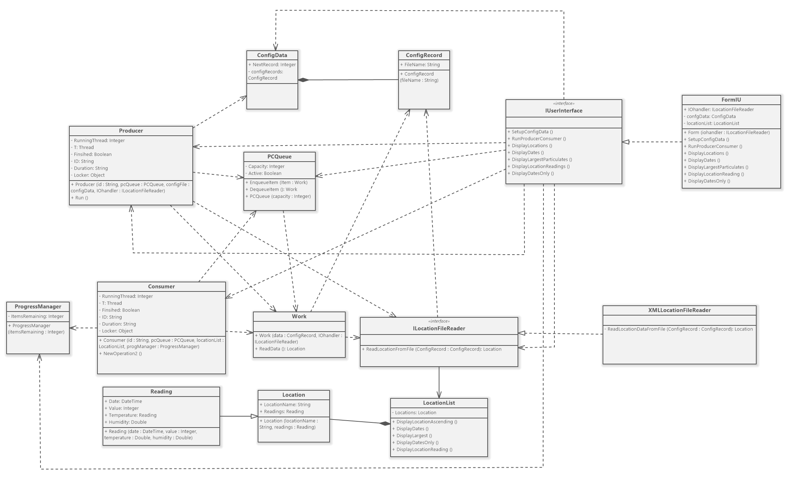

**Design Rationale**

This project is using Producer/Consumer pattern to run the system. System will get the XML files when SetupConfigData method is triggered. As a result, XMLLocationFileReader which contains multiple XML files will send them to the ConfigData via ILocationFileReader and ConfigRecord as there is a multiplicity association between ConfigData and ConfigRecord. After creating the config data, Producer will produce the data with identifier and create a list from LocationList via ILocationFileReader when RunProducerConsumer method runs in the IUInterface via FormIU. The data will pass to the PCQueue when Run method is triggered. PCQueue will enqueue the data before it dequeues to the Work. PCQueue is given 4 capacities to enqueue the data to lead system still robust if many data required to enqueue from the Producer. Work Class work as a medium between Consumer and PCQueue to receive the data from PCQueue and pass it to Consumer by using ReadData method. The Consumer will receive the data from the Work and consume them to the system. Consumer also report to the ProgressManager that how many items are remaining in the Consumer. ProgressManager will report it back to IUInterface. This process will undergo until all items are consumed and visible in FormIU.