User guide for DesktopApplication
1. Load up DesktopApplication.py in PyCharm Community after IoTSystem.py and DoorSystem.py are closed.
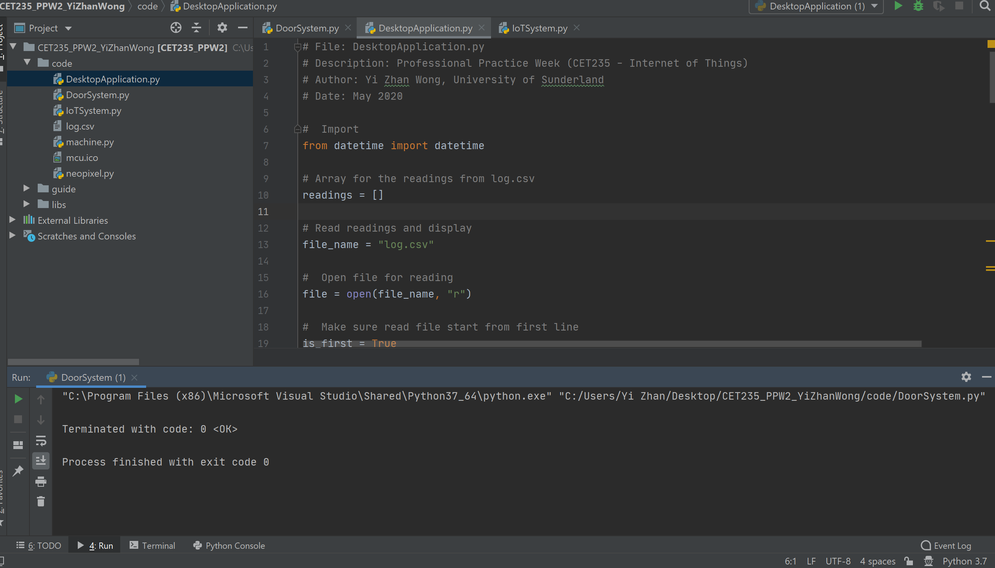

2. Right-click DesktopApplication.py and run it.
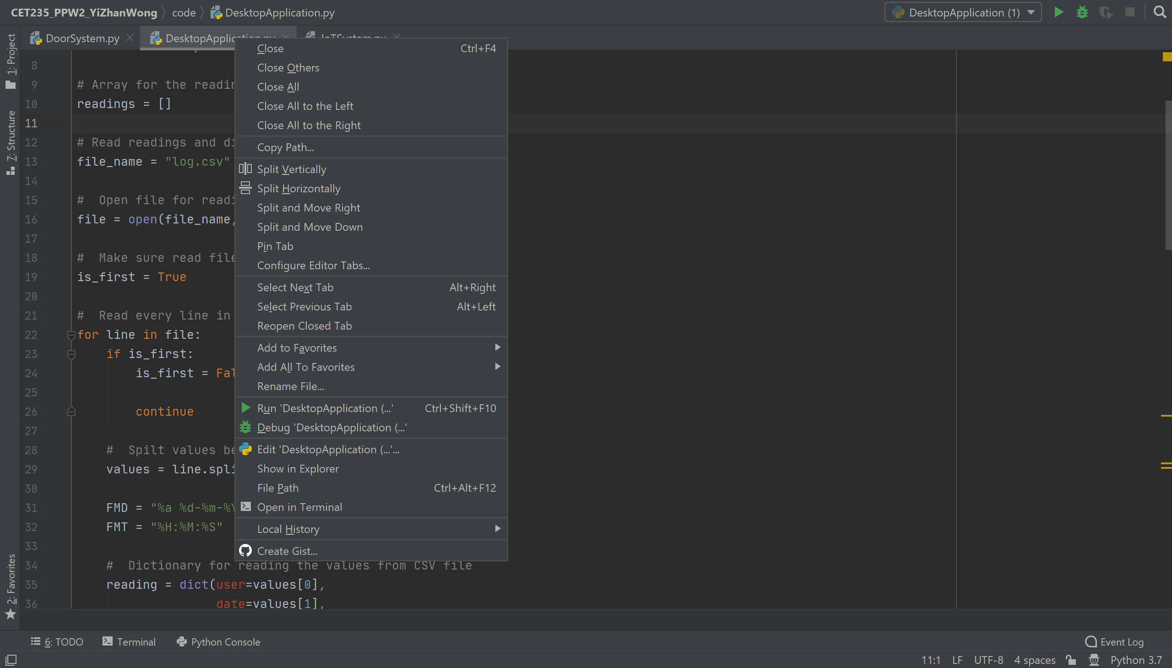

Output example:
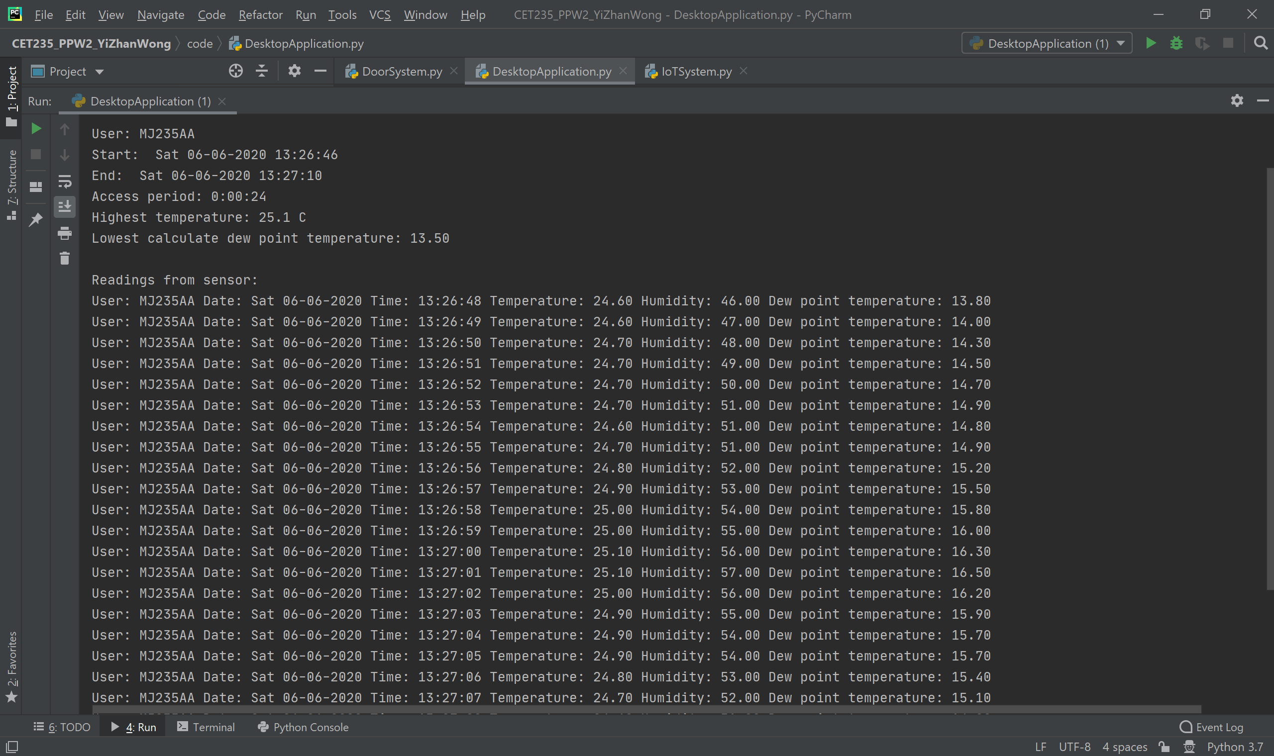

Notes for the output example
Log.csv provides identification of the user, start date, start time, end date, end time, access period, highest temperature recorded and all the readings taken during access period. Dew point temperature is calculated from temperature and humidity provided from log.csv and display in the readings list. Lowest dew point temperature is selected and displayed in the output terminal too. The first, second and third reading may not display user’s id as the system required 2 to 3 seconds to read the value from DoorSystem.py and may write empty user into the log.csv. However, it considered as the user is access in the first three seconds.

