1.Result

$$\hat{β_{j}}$$

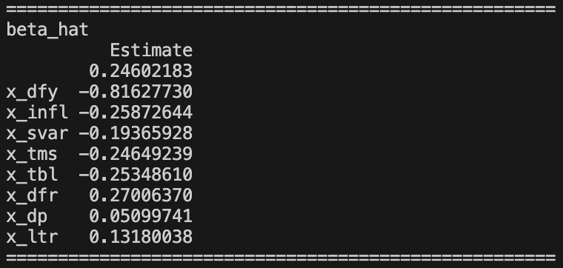

$$s(\hat{β_{j}})$$

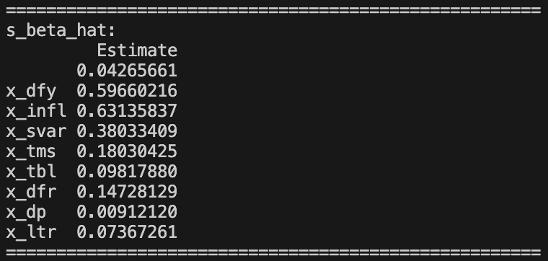

$$s^{W}(\hat{β_{j}})$$

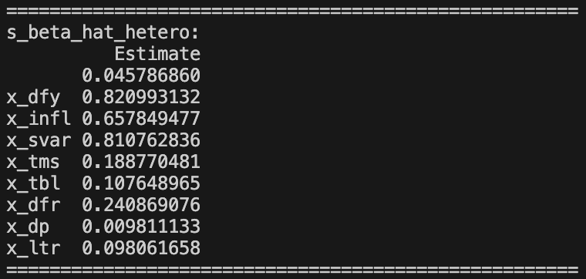

2.Results of each alpha

Critical value of each alpha

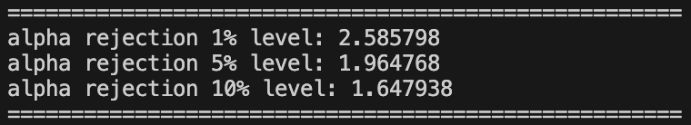

Alpha = 1%

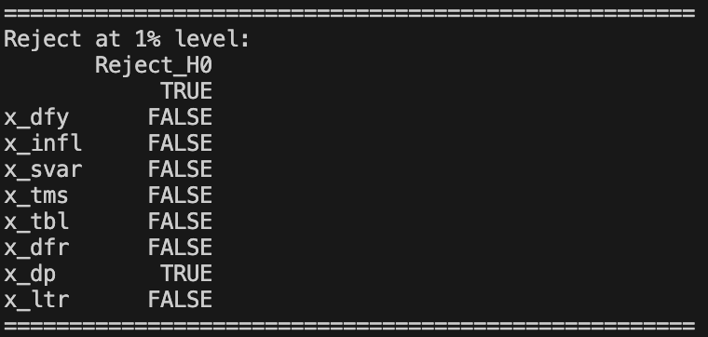

Alpha = 5%

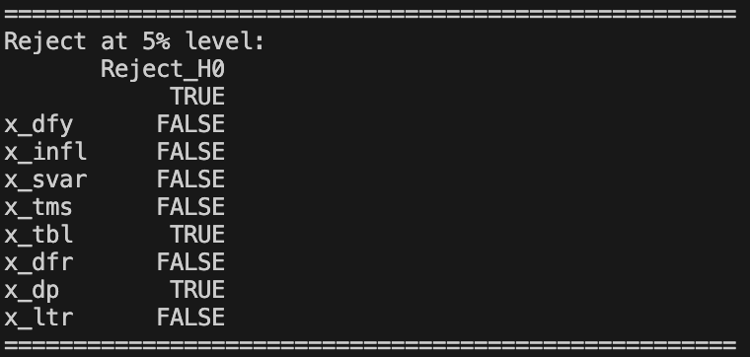

Alpha = 10%

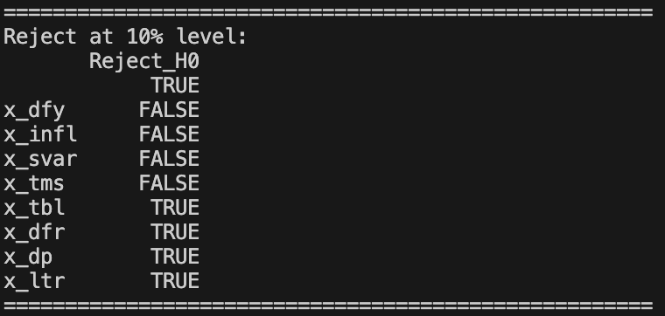

3.Results of Jarque-Bera test and Comparison between N(0, 1) and error-tern distribution

a.

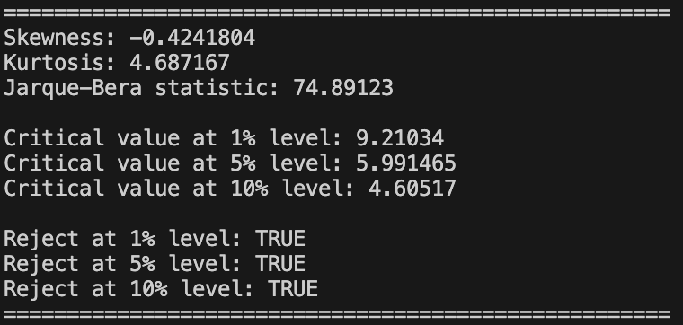

Refer to the outputs of the calculation, we can observe that H0 is rejected by all types of alpha, which indicates that the residuals are not normally distributed.

We can also find out that skewness is -0.42 and kurtosis is 4.86, where normal distribution is 0 and 3, respectively. The negative skewness means the distribution has a longer tail on the left side. On the other hand, kurtosis is over 3 , which convey the heavy tail property of this distribution(comparing to normal distribution).

b.

