**Problem 1.Outputs of the simulations**

**Case1: $Y_{i} \sim N(0, 1)$& n = 10**

$$\overline{Y}$$

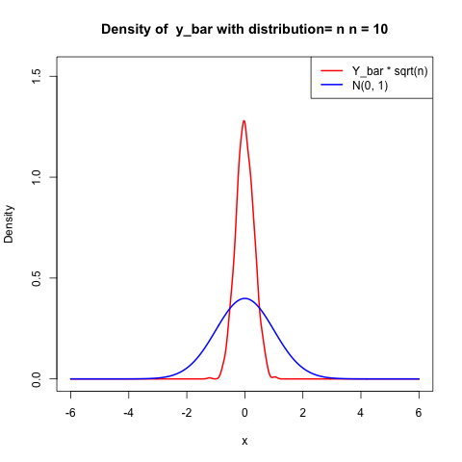

$$n^{1/2}\overline{Y}$$

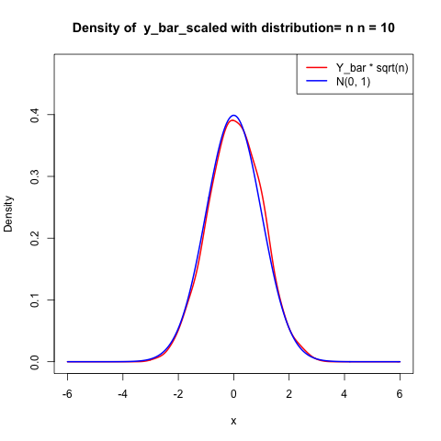

**Case2: $Y_{i} \sim N(0, 1)$& n = 50**

$$\overline{Y}$$

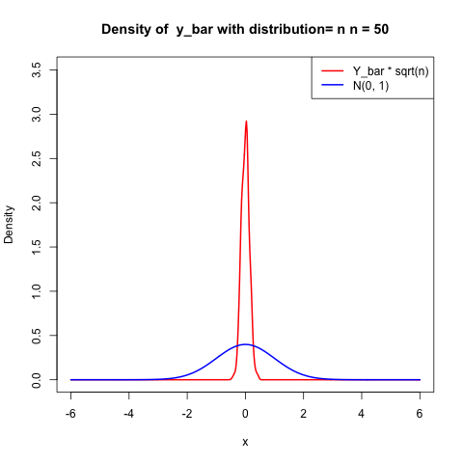

$$n^{1/2}\overline{Y}$$

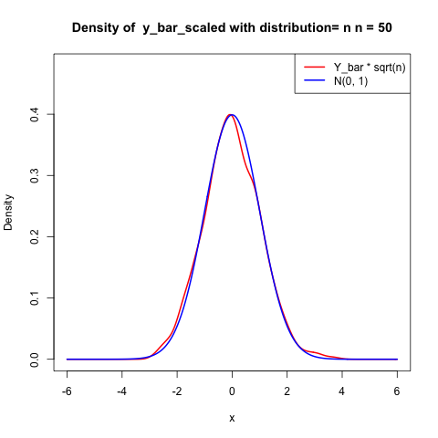

**Case3: $Y_{i} \sim N(0, 1)$& n = 100**

$$\overline{Y}$$

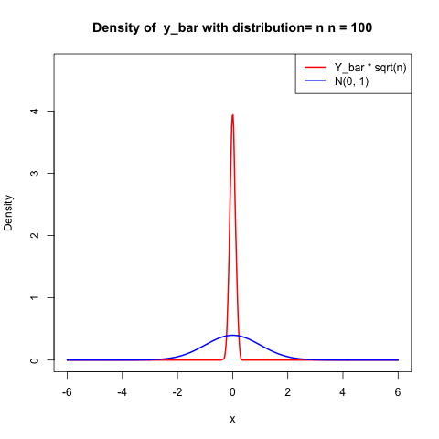

$$n^{1/2}\overline{Y}$$

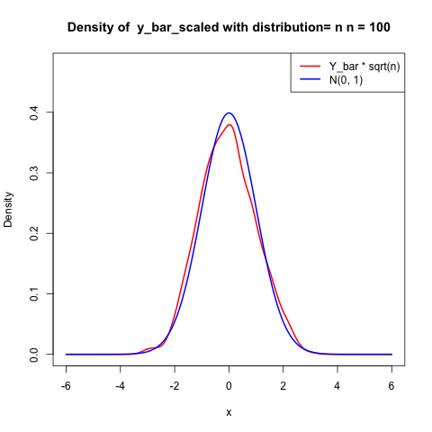

**Case4: $Y_{i} \sim t(2)$& n = 10**

$$\overline{Y}$$

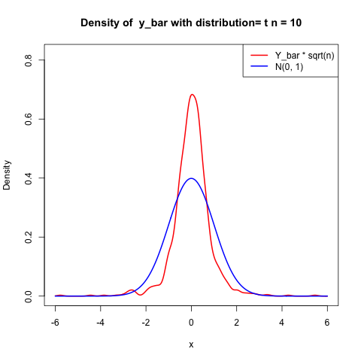

$$n^{1/2}\overline{Y}$$

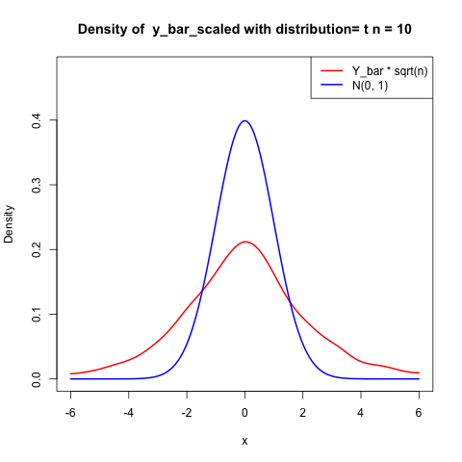

**Case5: $Y_{i} \sim t(2)$& n = 50**

$$\overline{Y}$$

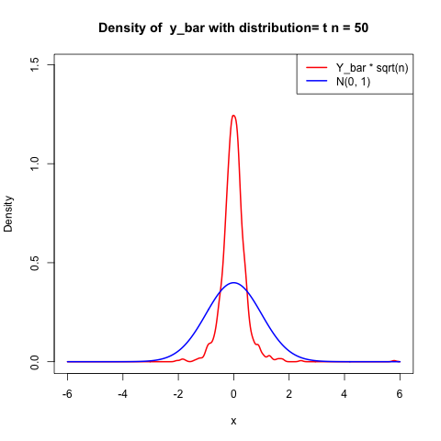

$$n^{1/2}\overline{Y}$$

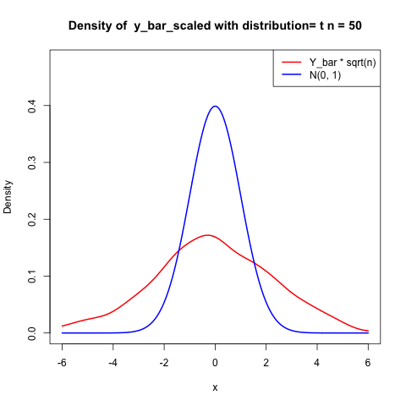

**Case6: $Y_{i} \sim t(2)$& n = 100**

$$\overline{Y}$$

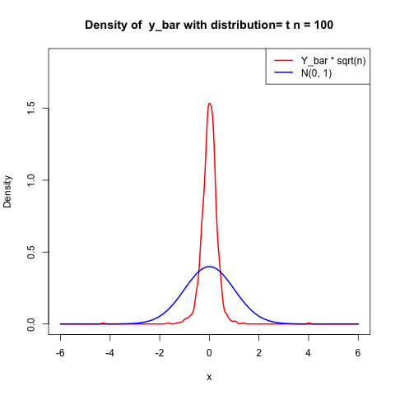

$$n^{1/2}\overline{Y}$$

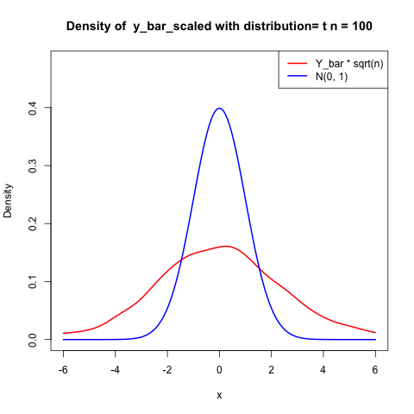

**Results observation and Analysis**

By the results above, we can easily find out that $\overline{Y}$ estimation of two types of random variables both converge to the expectation value of the $Y_{i}$ as n becomes larger, which is just matching the **Large Sample Theorem**.

In addition, observing the scaled distribution $\sqrt{n}*\overline{Y}$, the case of $Y_{i}\sim N\left(0, 1\right)$ successfully converge to normal distribution, just as central limit theorem expected. On the other hand, the case of $Y_{i}\sim t\left(2\right)$ just become flatter and flatter as n becomes larger, which is not matching to the **Central Limit Theorem**. In my inspection, It is due to the fact that the variance of the t-distribution is not defined when the degrees of freedom are 2 (according to the variance formula $\frac{q}{q-2}$, which yields an infinite result). Therefore, this distribution does not meet the conditions of the Central Limit Theorem, and hence the simulation results do not converge to a normal distribution.

**Problem 2**

1.By the code below, we can conduct the Wald’s test on each ${\hat{β}}_{j}$ with null hypothesis $H_{0}:{\hat{β}}_{j}=0$

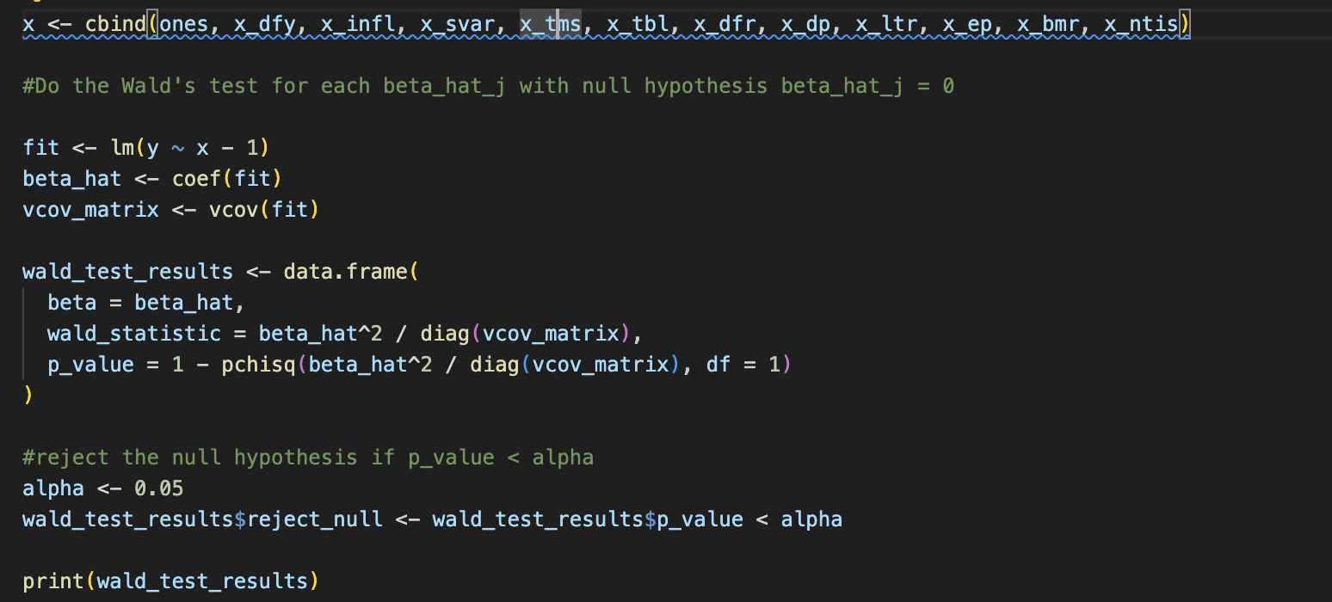

Results:

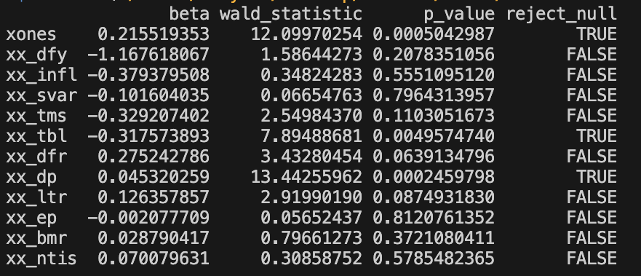

Result shows that we reject $H_{0}$ only for intercept, tbl and dp.

2. Joint Wald’s test on $H_{0}:{\hat{β}}_{1}=0 \& {\hat{β}}_{2}+{\hat{β}}_{3}=0$

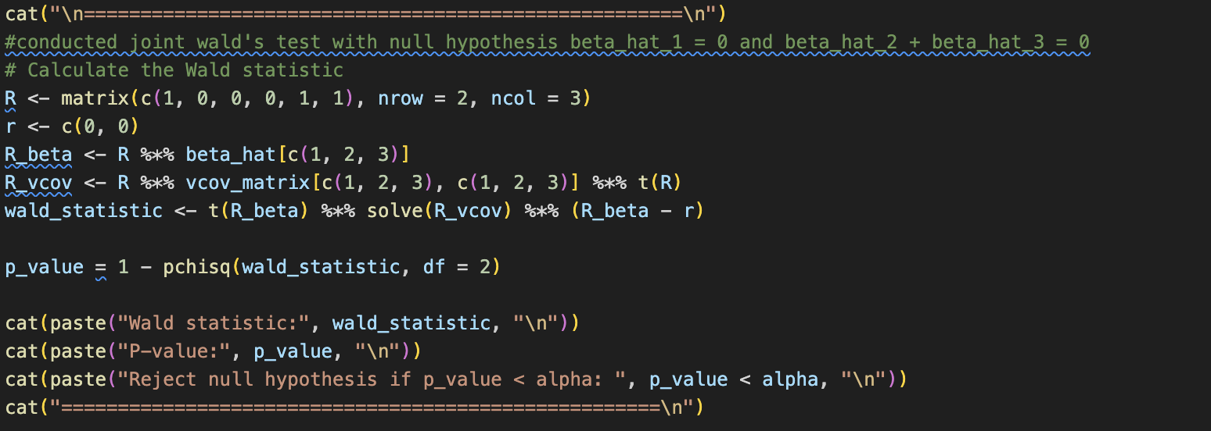

Results:

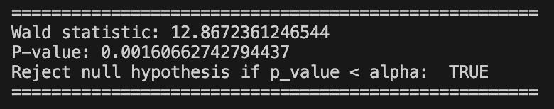

Result shows that we reject the null hypothesis.