2. Simulation results

Code for data setup

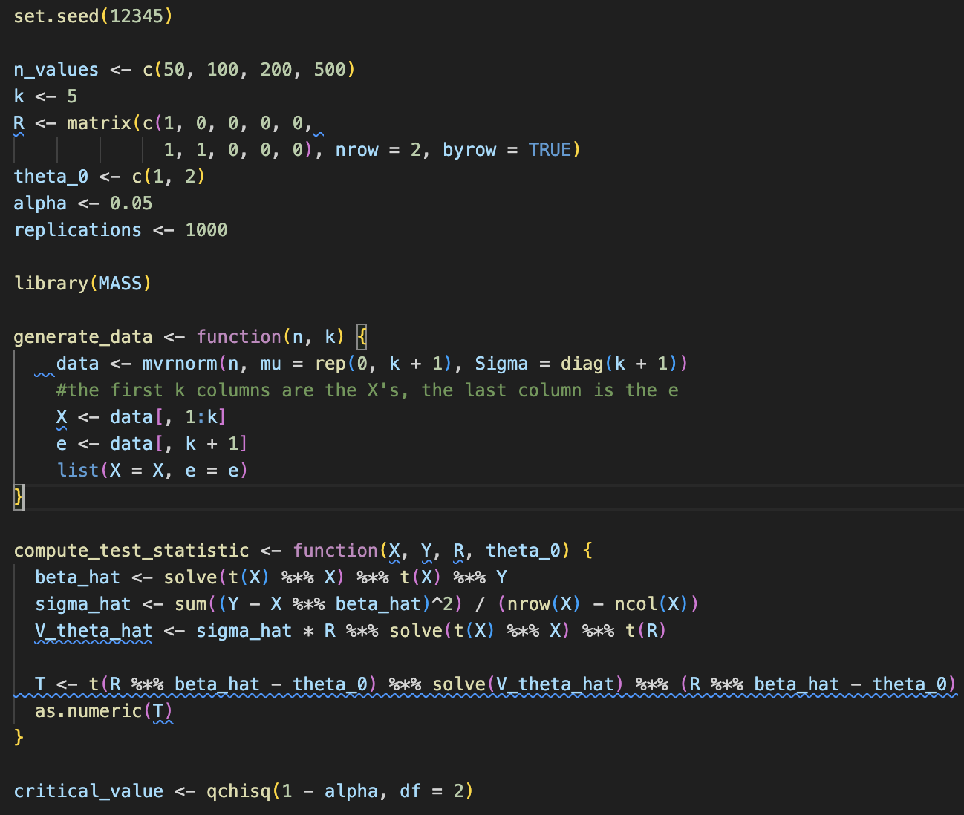

Simulation code

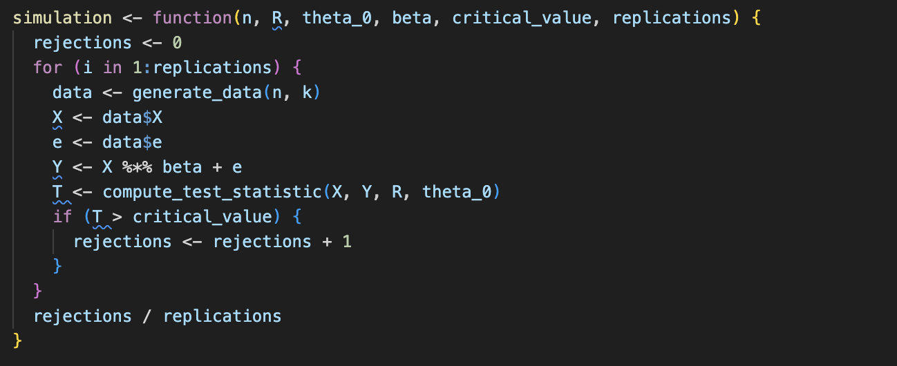

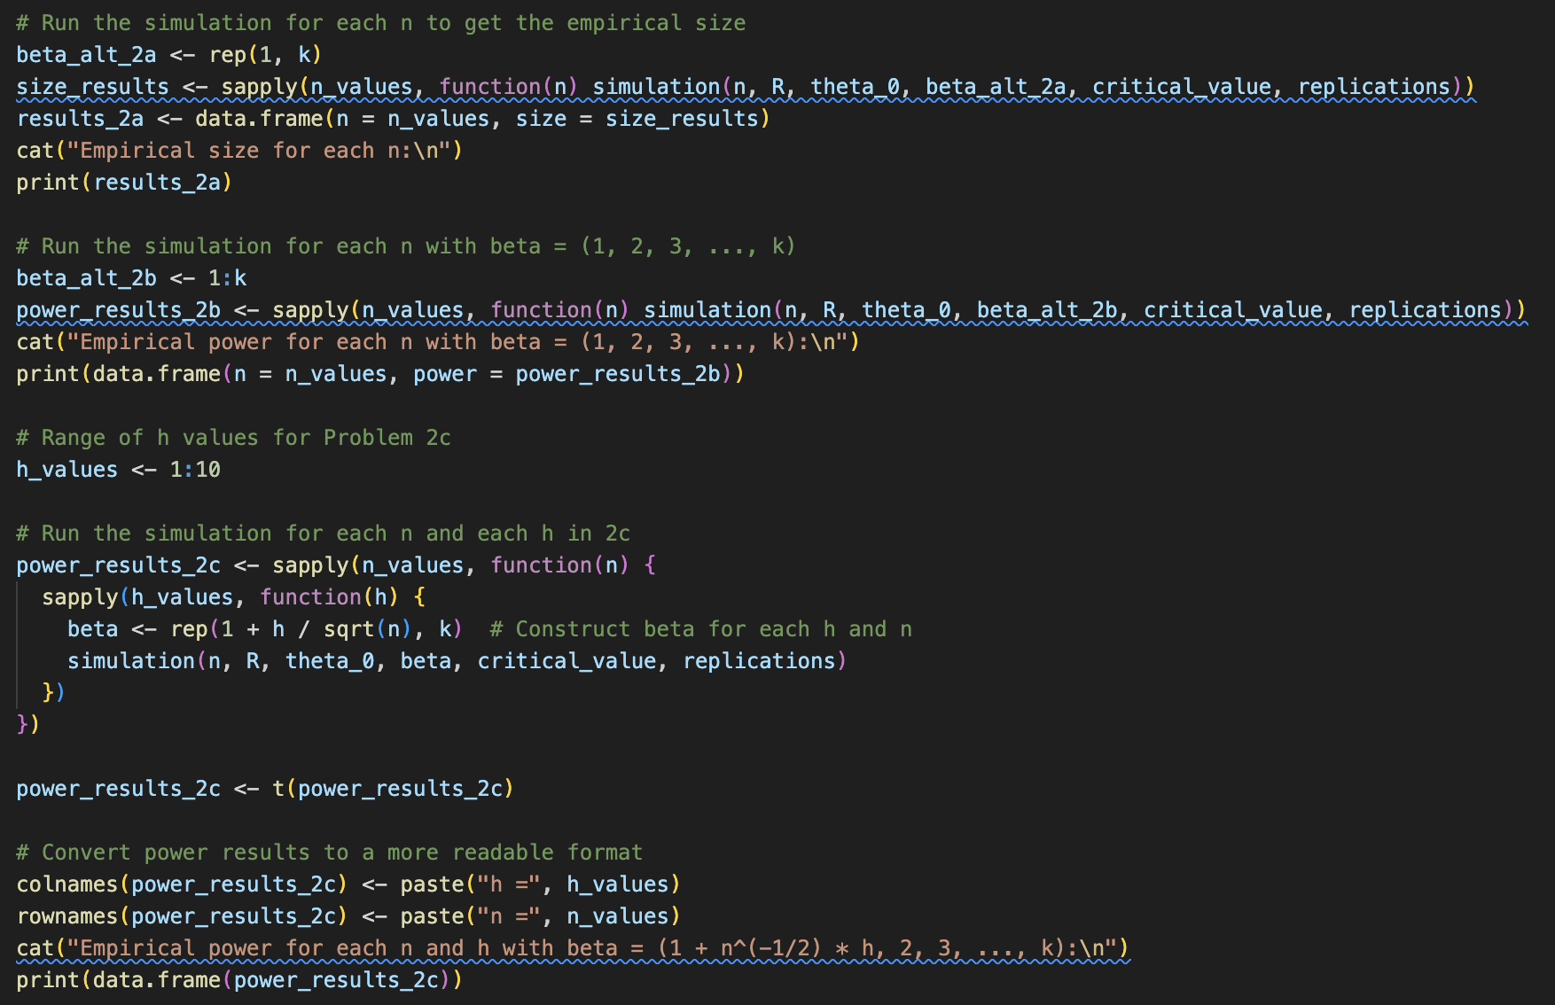

**Results**

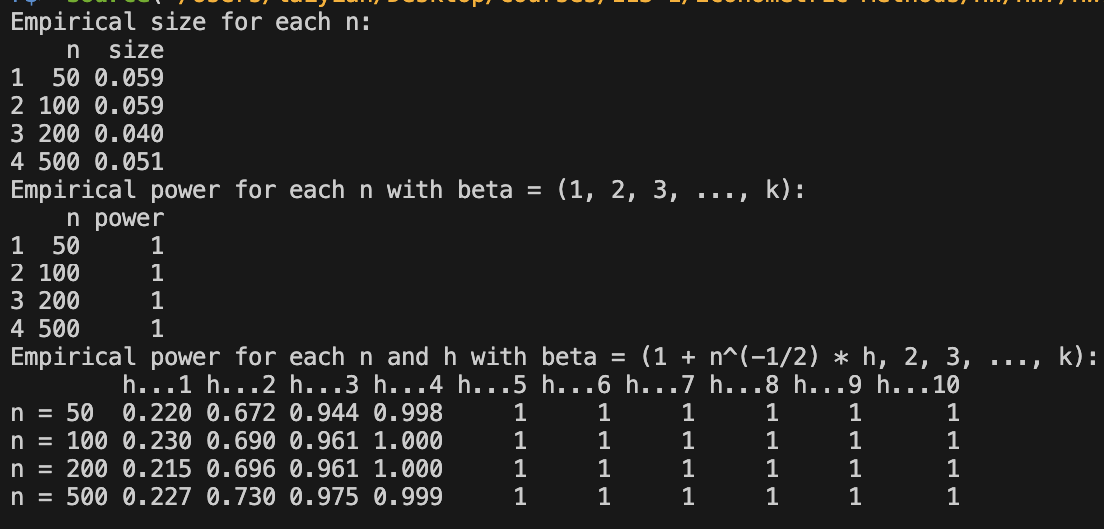

* The empirical size results show that the test maintains an appropriate Type I error rate across different sample sizes.
* The test has high power against a clear alternative hypothesis, suggesting it can reliably detect substantial deviations from the null hypothesis.
* For the local alternative, power depends on both h (the magnitude of the deviation) and n (sample size):
  + Small deviations (low h) result in low power, especially for smaller sample sizes.
  + As h or n increases, power improves, indicating that larger sample sizes allow the test to detect smaller deviations from the null.

These results are consistent with expectations in statistical hypothesis testing, where larger sample sizes increase the power to detect subtle differences.