P3

**Compute each model’s criterian**

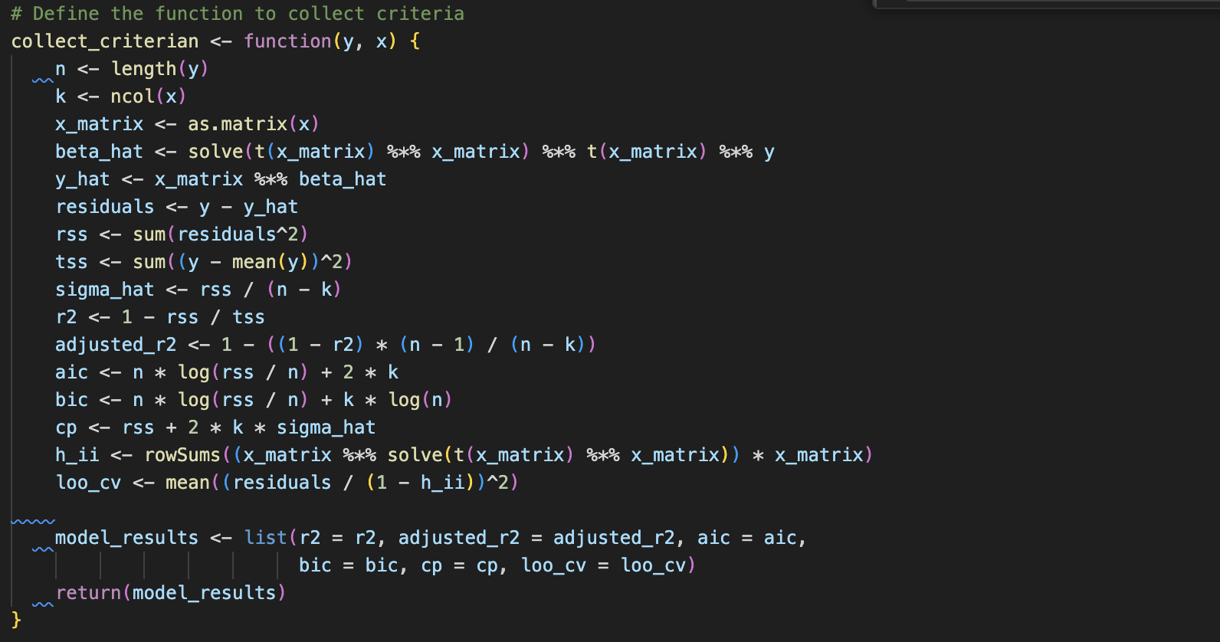

**Results**

**Value of the criteria vs model index**

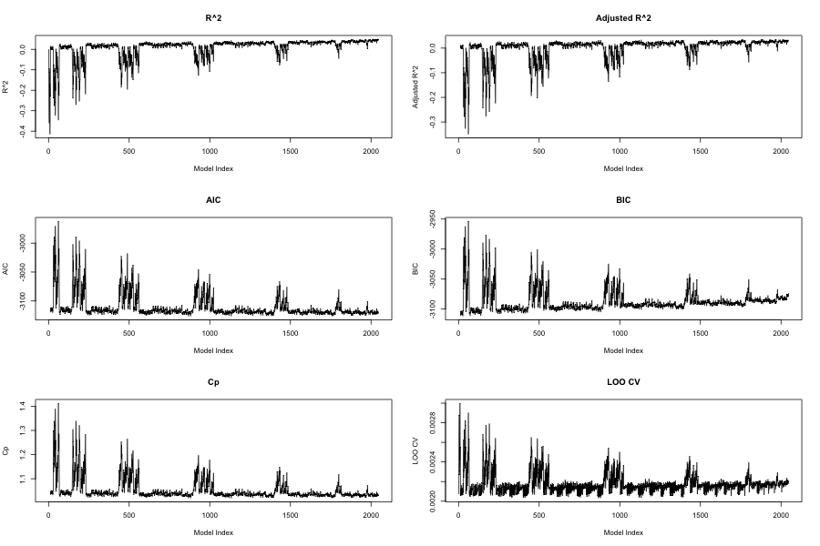

Model index is ordered by coverting the parameter selection type into binary number. For instance, the model selecting only “ones” has index 1 and the model selecting “ones”, “dfy”, “dfy_square” has index 1+2+64=67.

**Best model selected from each criteria**

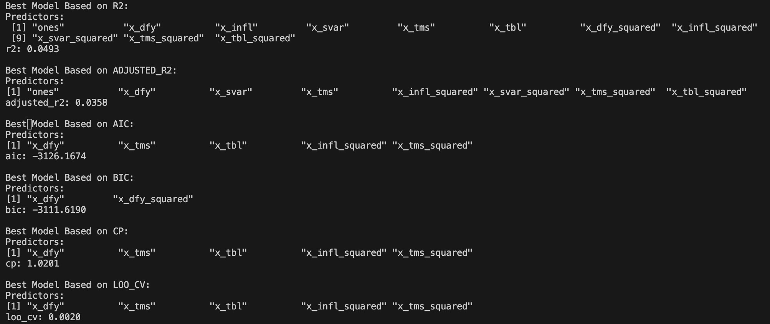

Noted that AIC, Cp, LOOCV choose the same model as the best model.

**Number of predictors that the best model selected**

r2: 11 (predictors)

sdjusted_r2: 8

AIC: 5

BIC: 2

Cp: 5

Loo_cv: 5