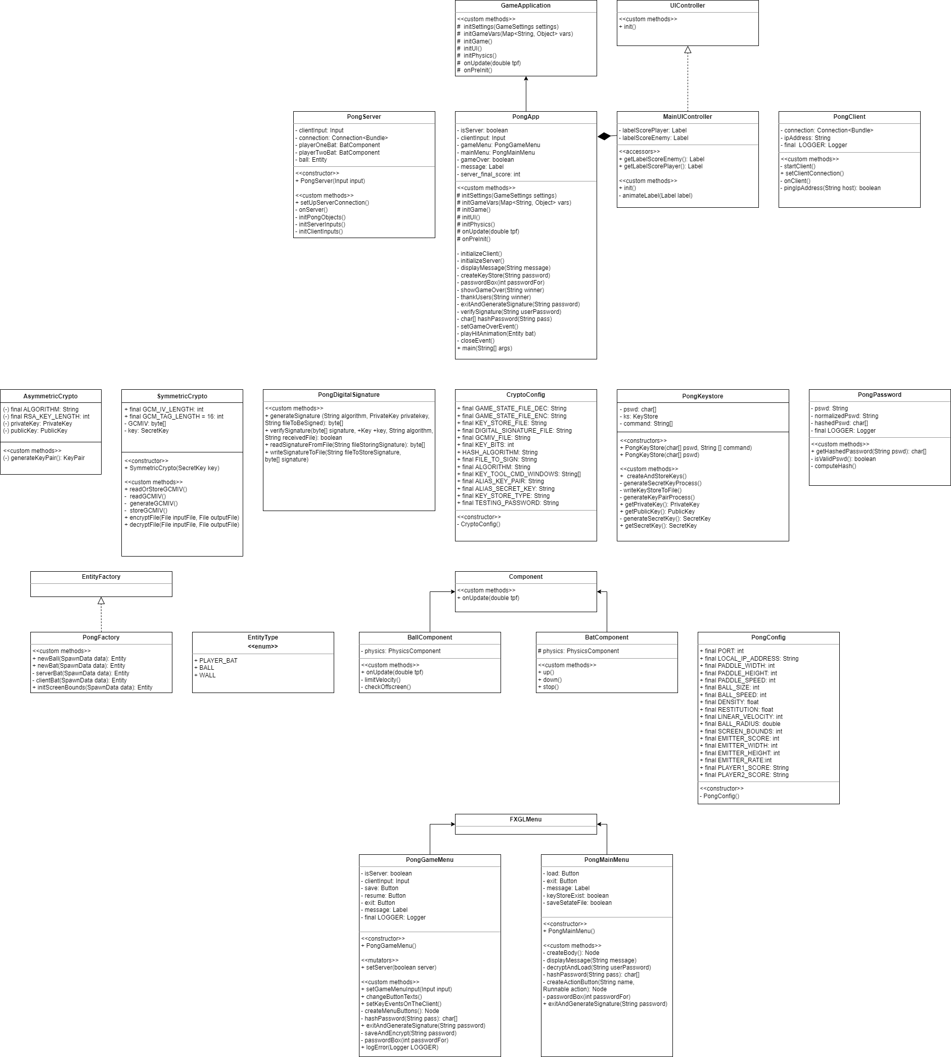UML Diagram

Project Narrative

Additional Features

The IP address, as well as the password are thoroughly normalized and validated. The client also has a custom menu to resume, pause or exit the game (does not need to click ESC to view it); all of which are synchronized with the server side. During the lifecycle of the program, a logger is used to log questionable activity, such as trying to access the keystore with an invalid password or modifying the source code in the PongApp file.

Build instructions

After cloning the project, open it with an IDE of your choice, preferably Netbeans. Clean and build the project and run it. When the program is first run, the server will have to create a password for the keystore and hold onto this password if they wish to continue the game later on. As for the client, they will need to remember the IP address of the server’s machine in order to establish a connection between them both. The menus provide many options for the two users, including to start a new game, load a previously saved game, save a current game, and pause and exit from the game. Feel free to try any of these options. Enjoy the game!

Other comments

We tested it on a Linux machine (Raspberry Pi) and on a Windows machine, and it worked on both computers. Therefore, we did not use an isWindows() method to check the operating system.