Hi Grace,
Here are some clarifications regarding the metrics and the stroke prediction guideline:
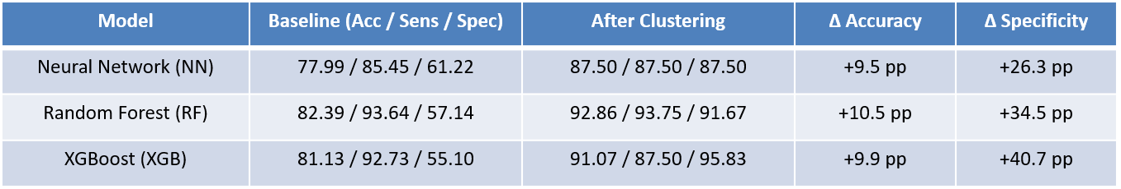
1. Source of the table metrics values
- For the baseline metrics, please refer to the code in
model_trainer_with_reports.py, located under the featureset_multimodels subfolder of the StrokePredictEngine project.
- For the after-clustering (Best Clustering) metrics, please refer to the code in
gravitational_kmeans.py, located under the processing subfolder of the StrokePredictEngine project.
2. Stroke prediction guideline
a. Please check the resources and subscription shown in the screenshot below. You will need to log in to this subscription.
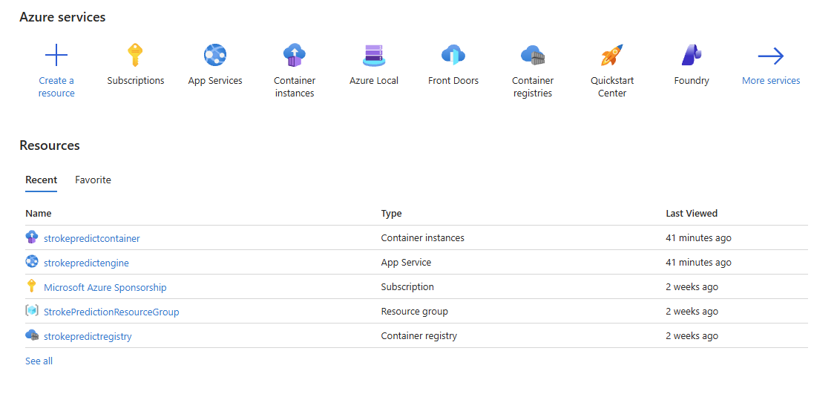
b. I have deployed the running code as a container instance named strokepredictcontainer under the resource group shown in (a), as illustrated in the screenshot below.
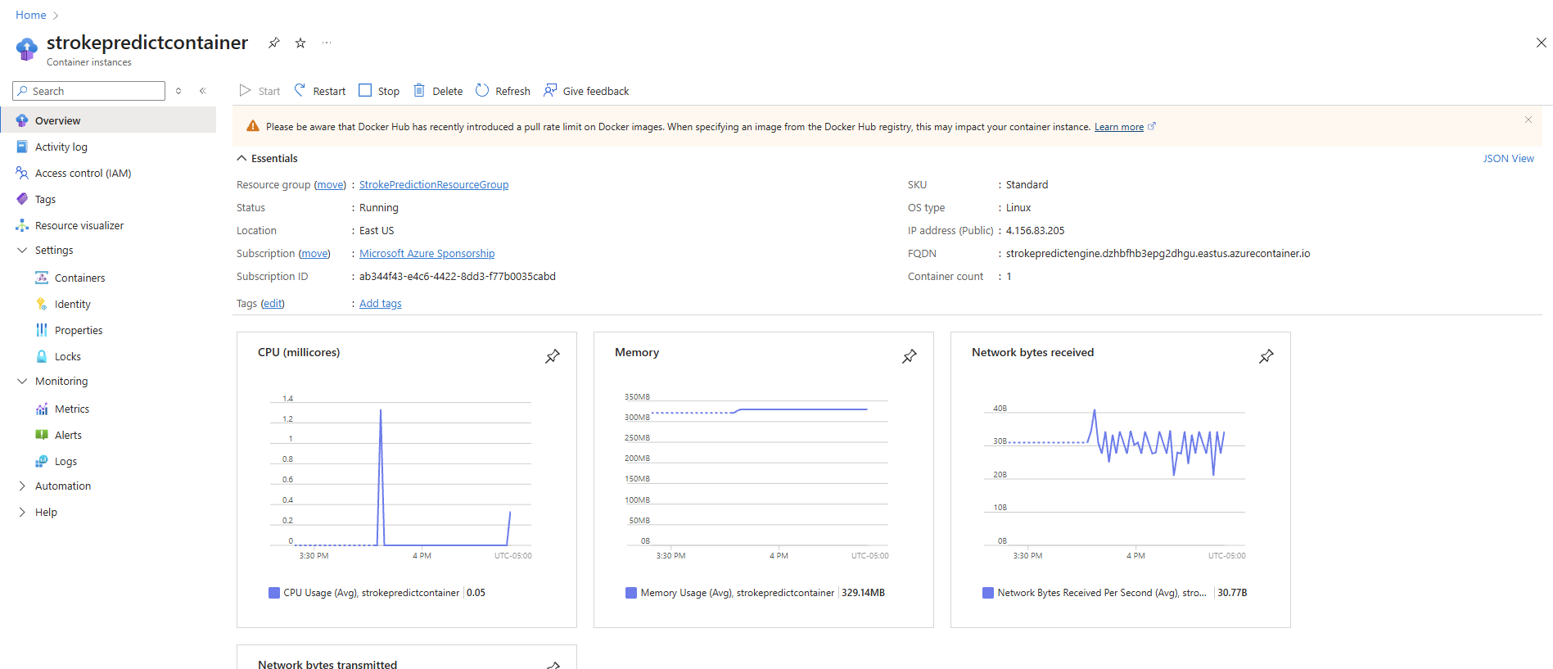
c. When you want to run the code, please log in to the Azure Portal, locate the container instance strokepredictcontainer, and click Start to launch the container. Once you are done, please remember to stop the instance.
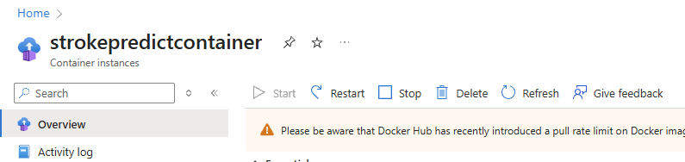
d. After the instance is running, please open any client or simulation frontend. In this guideline, I used Postman to simulate frontend web requests.
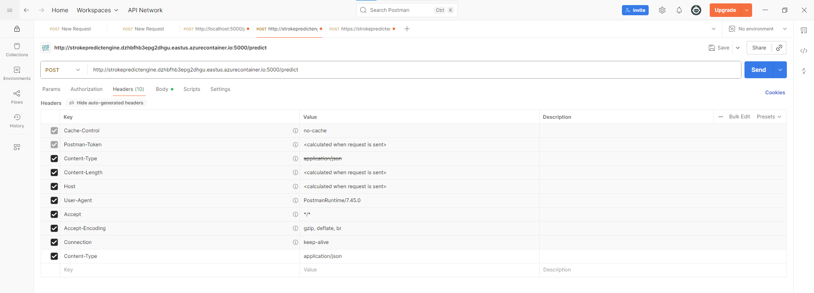
Make sure to select the POST method and send the request to the following URL:
http://strokepredictengine.dzhbfhb3epg2dhgu.eastus.azurecontainer.io:5000/predic
In the Body section, select raw, choose JSON, and enter the feature format and values as shown in the screenshot below.
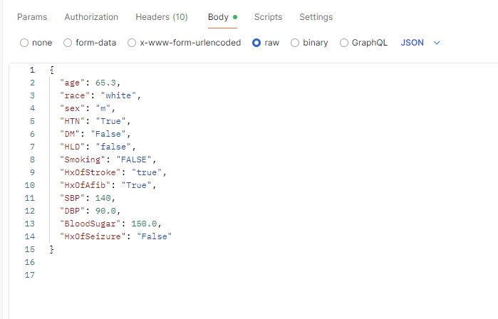
If everything runs correctly, you should receive a response similar to the one shown below.
