项目课程系列之Atcrowdfunding

尚硅谷JavaEE教研组

版本：V1.0

项目计划
- 给角色分配权限

第一章 给角色分配权限

1.1 模态框

1.1.1 业务分析
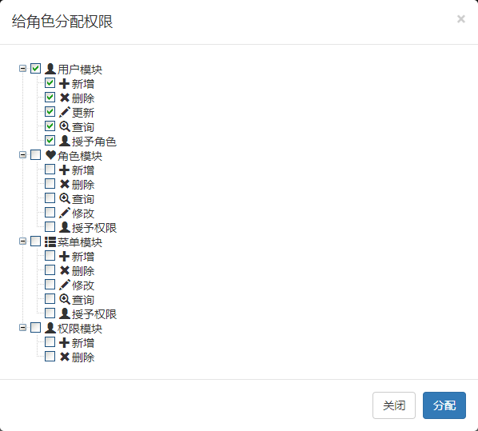

1.1.2 分配权限按钮
在角色列表的分配权限按钮上增加样式类：
<button roleid="'+e.id+'" type="button" class="permissionModalPopBtn btn btn-success btn-xs"><i class=" glyphicon glyphicon-check"></i></button>

1.1.3 绑定事件
var tempRid = 0;
$("tbody").on("click",".permissionModalPopBtn",function(){
//1.初始化权限树，带复选框
initPermissioinToRoleTree();
//2.显示模态框，展示权限树
$("#permissionModal").modal({show:true,backdrop:"static"});
//tempRid = $(this).attr("roleid");
//showRolePermissions(tempRid);//回显
});

function initPermissioinToRoleTree(){
var setting = {
data: {
simpleData: {
enable: true,
pIdKey: "pid"
},
key: {
url: "xUrl",
name:"title"
}
},
check: {
enable: true
},
view: {
addDiyDom: addDiyDom
}
};

//1.加载数据
$.get("${PATH}/permission/listAllPermissionTree",function(data){
//data.push({"id":0,"title":"系统权限","icon":"glyphicon glyphicon-asterisk"});//坑
var tree = $.fn.zTree.init($("#assignPermissionToRoleTree"), setting, data);
var treeObj = $.fn.zTree.getZTreeObj("assignPermissionToRoleTree");
treeObj.expandAll(true);
});
}
function addDiyDom(treeId,treeNode){
$("#"+treeNode.tId+"_ico").removeClass();
$("#"+treeNode.tId+"_span").before('<span class="'+treeNode.icon+'"></span>');
}

1.1.4 模态框
<div class="modal fade" id="permissionModal" tabindex="-1" role="dialog">
<div class="modal-dialog" role="document">
<div class="modal-content">
<div class="modal-header">
<button type="button" class="close" data-dismiss="modal">
<span>&times;</span>
</button>
<h4 class="modal-title">权限维护</h4>
</div>
<div class="modal-body">
<ul id="permissionTree" class="ztree"></ul>
</div>
<div class="modal-footer">
<button type="button" class="btn btn-default" data-dismiss="modal">关闭</button>
<button id="assignPermission" type="button" class="btn btn-primary">分配权限</button>
</div>
</div>
</div>
</div>

1.2 分配完成

1.2.1 事件绑定
//分配权限功能
$("#assignPermission").click(function(){
//1、获取到已经选中的所有权限的id
var treeObj = $.fn.zTree.getZTreeObj("permissionTree");
var ids = new Array();
$.each(treeObj.getCheckedNodes(true),function(){
ids.push(this.id);
});
var idsStr = ids.join();

//2、组装给后台提交的数据
var data = {rid:tempRid,perId:idsStr};
console.log(data);
//3、发请求，完成权限分配功能
$.post("${appPath}/permission/assign/assignPermissionToRole",data,function(){
layer.msg("权限分配完成...")
$("#permissionModal").modal('hide');
})
});

1.2.2 控制器处理请求
//{rid: "3", perId: "1,2,3"}
//为角色分配权限
@ResponseBody
@PostMapping("/assign/assignPermissionToRole")
public String assignPermissionToRole(@RequestParam("rid")Integer rid,@RequestParam("perId")String perIds){
List<Integer> perIdArray = new ArrayList<>();
String[] split = perIds.split(",");
for (String str : split) {
int id;
try {
id = Integer.parseInt(str);
perIdArray.add(id);
} catch (NumberFormatException e) {
}
}
permisionService.assignPermissionToRole(rid,perIdArray);
return "ok";
}

1.2.3 服务层
@Override
public void assignPermissionToRole(Integer rid, List<Integer> perIdArray) {
if(perIdArray.size()>0){
//1、先删除当前角色之前的所有权限
TRolePermissionExample example = new TRolePermissionExample();
example.createCriteria().andRoleidEqualTo(rid);
rolePermissionMapper.deleteByExample(example);

//2、将新传入的所有权限保存进来
rolePermissionMapper.insertBatch(rid,perIdArray);
}
}

1.2.4 Dao层
TRolePermissionMapper
void insertBatch(@Param("rid")Integer rid, @Param("perIds") List<Integer> perIdArray);
<insert id="insertBatch">
INSERT INTO `t_role_permission`(roleid,permissionid) VALUES
<foreach collection="perIds" item="perId" separator=",">
(#{rid},#{perId})
</foreach>
</insert>

1.3 回显已经分配权限

1.3.1 弹出模态框时回显数据

//回显权限树
function showRolePermissions(tempRid){
var rid = tempRid;
$.get("${appPath}/permission/role_permission?rid="+rid,function(data){
//1、遍历每一个权限，在ztree中选中对应的节点
$.each(data,function(){
console.log(this);
var treeObj = $.fn.zTree.getZTreeObj("permissionTree");
//根据指定的节点id搜索节点，null表示搜索整个树
var node = treeObj.getNodeByParam("id", this.id, null); //注意：不是getNodesByParam
//需要回显的节点，是否勾选复选框，父子节点勾选是否联动
treeObj.checkNode(node,true,false);
});
});
}
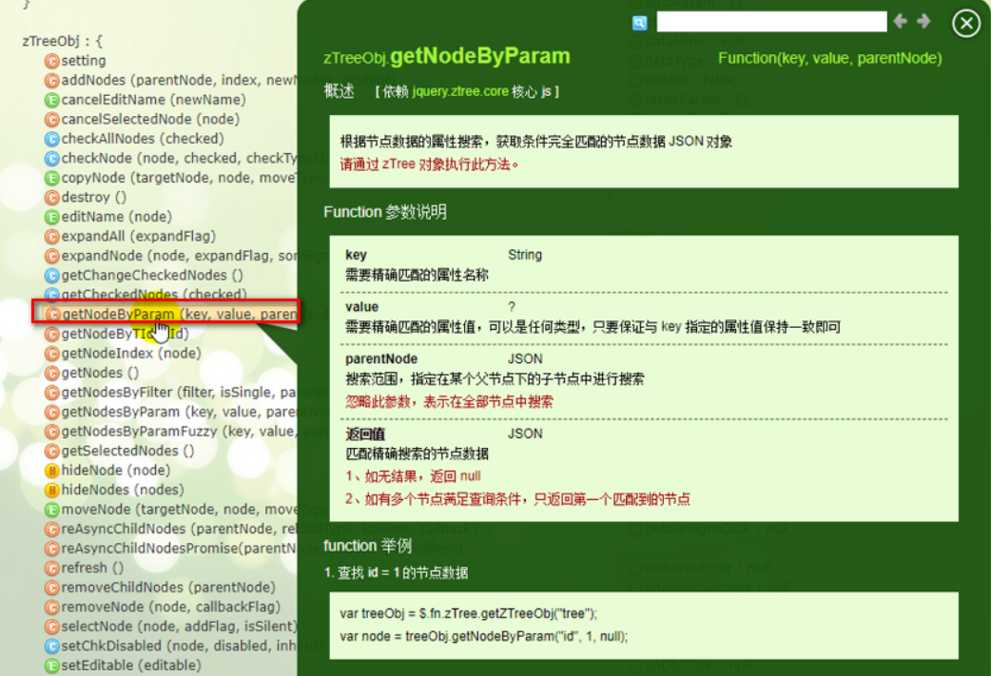

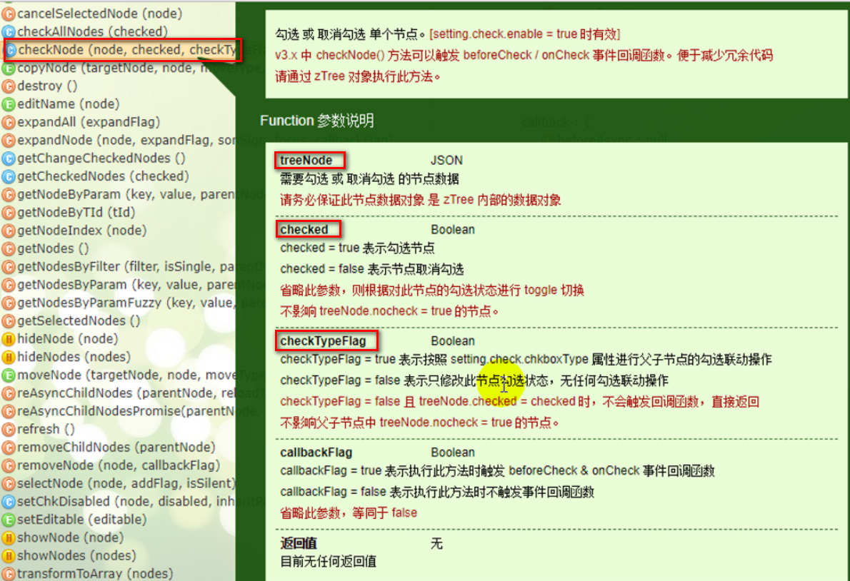

1.3.2 控制器处理
/**
* 回显角色对应的所有权限
* @param id 传入角色id
* @return
*/
@ResponseBody
@GetMapping("/role_permission")
public List<TPermission> getRolePermissions(@RequestParam("rid")Integer id){
return permisionService.getAllPermissionsByRoleid(id);
}

1.3.3 服务层
/**
* 查询某个角色的所有系统中的权限标识
* @param id 角色id
* @return
*/
List<TPermission> getAllPermissionsByRoleid(Integer id);
@Override
public List<TPermission> getAllPermissionsByRoleid(Integer id) {
return permissionMapper.getAllPermissionsByRoleid(id);
}

1.3.4 Dao层
/**获取当前角色对应的所有权限id*/
List<TPermission> getAllPermissionsByRoleid(Integer id);
<select id="getAllPermissionsByRoleid" resultMap="BaseResultMap">
SELECT p.* FROM `t_permission` p
LEFT JOIN `t_role_permission` rp ON rp.permissionid = p.id WHERE rp.roleid=#{id}
</select>

