项目课程系列之Atcrowdfunding

尚硅谷JavaEE教研组

版本：V1.0

项目计划
- 给菜单分配权限

给菜单分配权限

1.1 模态框

1.1.1 业务需求
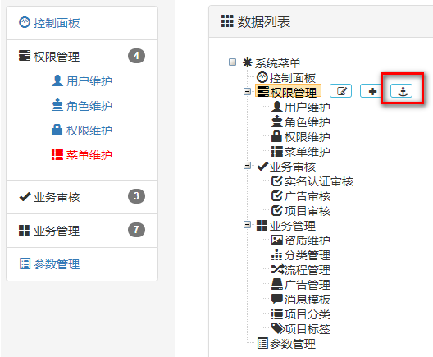
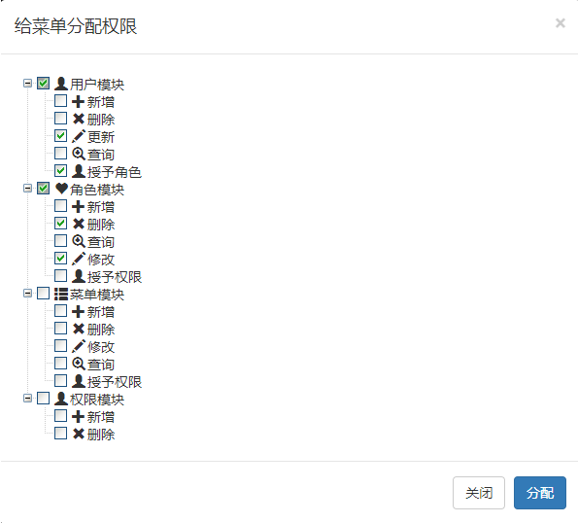

1.1.2 在菜单树页面，给菜单增加分配权限按钮
s += '<a class="btn btn-info dropdown-toggle btn-xs" style="margin-left:10px;padding-top:0px;" href="#" onclick="assignBtn('+treeNode.id+')" >&nbsp;&nbsp;<i class="fa fa-fw fa-anchor rbg "></i></a>';

1.1.3 处理事件请求
var tempMenuid = '';
function assignBtn(menuid){
tempMenuid = menuid;
//1.初始化权限树，带复选框
initPermissioinToMenuTree();
//2.显示模态框，展示权限树
$("#permissionModal").modal({show:true,backdrop:"static"});
//3.回显权限树（之前分配过的权限应该被勾选）
//showMenuPermissions(menuid);
}
function initPermissioinToMenuTree(){
var setting = {
data: {
simpleData: {
enable: true,
pIdKey: "pid"
},
key: {
url: "xUrl",
name:"title"
}
},
check: {
enable: true
},
view: {
addDiyDom: addDiyDom
}
};
//1.加载数据
$.get("${PATH}/permission/listAllPermissionTree",function(data){
//data.push({"id":0,"title":"系统权限","icon":"glyphicon glyphicon-asterisk"});
var tree = $.fn.zTree.init($("#assignPermissionTree"), setting, data);
var treeObj = $.fn.zTree.getZTreeObj("assignPermissionTree");
treeObj.expandAll(true);
});
}
function addDiyDom(treeId,treeNode){
$("#"+treeNode.tId+"_ico").removeClass();
$("#"+treeNode.tId+"_span").before('<span class="'+treeNode.icon+'"></span>');
}

1.1.4 增加分配权限的模态框
<!-- 分配权限Modal -->
<div class="modal fade" id="permissionModal" tabindex="-1" role="dialog" aria-labelledby="Modal">
<div class="modal-dialog" role="document">
<div class="modal-content">
<div class="modal-header">
<button type="button" class="close" data-dismiss="modal" aria-label="Close"><span aria-hidden="true">&times;</span></button>
<h4 class="modal-title" id="myModalLabel">给菜单分配权限</h4>
</div>
<div class="modal-body">
<ul id="assignPermissionTree" class="ztree"></ul>
</div>
<div class="modal-footer">
<button type="button" class="btn btn-default" data-dismiss="modal">关闭</button>
<button id="assignPermission" type="button" class="btn btn-primary">分配</button>
</div>
</div>
</div>
</div>

1.2 代码完成

1.2.1 提交分配请求
<button id="assignPermission " type="button" class="btn btn-primary">分配权限</button>
//分配权限功能
$("#assignPermission").click(function(){
//1、获取到已经选中的所有权限的id
var treeObj = $.fn.zTree.getZTreeObj("assignPermissionTree");
var ids = new Array();
$.each(treeObj.getCheckedNodes(true),function(){
ids.push(this.id);
});
var idsStr = ids.join();

//2、组装给后台提交的数据
var data = {mid:tempMenuid,perIds:idsStr};
console.log(data);
//3、发请求，完成权限分配功能
$.post("${PATH}/permission/assignPermissionToMenu",data,function(){
layer.msg("权限分配完成...")
$("#permissionModal").modal('hide');
})
});

1.2.2 控制器
/**
* 为菜单分配权限 {mid: "3", perIds: "1,2,4,5,6"}
*/
@ResponseBody
@PostMapping("/assignPermissionToMenu")
public String assignPermissionToMenu(@RequestParam("mid") Integer mid, @RequestParam("perIds") String perIds) {
// 权限id的集合
List<Integer> perIdArray = new ArrayList<>();
String[] split = perIds.split(",");
for (String str : split) {
int id;
try {
id = Integer.parseInt(str);
perIdArray.add(id);
} catch (NumberFormatException e) {
}
}
// 1、将菜单和权限id集合的关系保存起来
permissionService.assignPermissionToMenu(mid, perIdArray);
return "ok";
}

1.2.3 业务层
/**
* 给菜单分配权限。
* @param mid 菜单id
* @param perIdArray 权限id集合
*/
void assignPermissionToMenu(Integer mid, List<Integer> perIdArray);
@Override
public void assignPermissionToMenu(Integer mid, List<Integer> perIdArray) {
// 1、删除之前菜单对应的权限
TPermissionMenuExample example = new TPermissionMenuExample();
example.createCriteria().andMenuidEqualTo(mid);
permissionMenuMapper.deleteByExample(example);
// 2、插入提交过来的新的权限集合
permissionMenuMapper.insertBatch(mid, perIdArray);
}

1.2.4 Dao层
TPermissionMenuMapper
/**
* 插入菜单和权限集合的对应关系
* @param mid
* @param perIdArray
*/
void insertBatch(@Param("mid")Integer mid, @Param("perIds")List<Integer> perIdArray);
<insert id="insertBatch">
INSERT INTO `t_permission_menu`
(permissionid,menuid)
VALUES
<foreach collection="perIds" item="perId" separator=",">
(#{perId},#{mid})
</foreach>
</insert>

1.3 回显已分配权限

1.3.1 页面代码
//回显权限树
function showMenuPermissions(menuid){
$.get("${PATH}/menu/menu_permission?menuid="+menuid,function(data){
//1、遍历每一个权限，在ztree中选中对应的节点
$.each(data,function(){
console.log(this);
var treeObj = $.fn.zTree.getZTreeObj("assignPermissionTree");
var node = treeObj.getNodeByParam("id", this.id, 0); //根据指定的节点id搜索节点，null表示搜索整个树
treeObj.checkNode(node,true,false);//需要回显的节点，是否勾选复选框，父子节点勾选是否联动（例如：勾选父节点，要不要把它的所有子节点都勾上，取消父节点勾选，要不要把它的所有子节点也都取消勾选）
});
});
}

1.3.2 控制器代码
@ResponseBody
@GetMapping("/menu/menu_permission")
public List<TPermission> getPermissionByMenuid(@RequestParam("menuid") Integer mid) {
// 查询出当前菜单能被哪些权限（自定义标识）操作
return permissionService.getPermissionByMenuid(mid);
}

1.3.3 业务层
@Override
public List<TPermission> getPermissionByMenuid(Integer mid) {
return permissionMapper.getPermissionByMenuid(mid);
}

1.3.4 Dao层
/**
* 获取当前菜单能对应的所有权限
* @param mid 菜单id
* @return
*/
List<TPermission> getPermissionByMenuid(Integer mid);
<!-- List<TPermission> getPermissionByMenuid(Integer mid); -->
<select id="getPermissionByMenuid" resultMap="BaseResultMap">
SELECT p.* FROM `t_permission` p
LEFT JOIN `t_permission_menu` rpm
ON rpm.permissionid = p.id
WHERE rpm.menuid=#{mid}
</select>

