项目课程系列之Atcrowdfunding

尚硅谷JavaEE教研组

版本：V1.0

项目计划
- 业务分析
- 环境搭建
- 集成Redis
- 集成Slf4j
- Swagger
- Lombok
- 短信发送
- HttpClient
- 注册
- 登录

第一章 众筹-项目环境搭建（重构）

架构(需要整合redis)

创建注册中心：scw-register
@EnableEurekaServer //开启Eureka注册中心服务器功能
application.yml
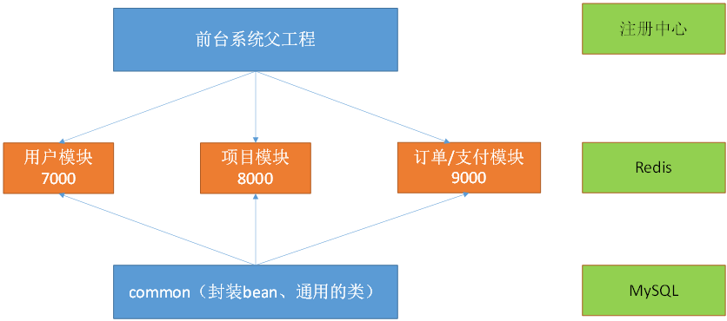
spring:
application:
name: SCW-REGISTER
server:
port: 8761

eureka:
instance:
hostname: localhost
client:
register-with-eureka: false #自己就是注册中心，不用注册自己
fetch-registry: false #要不要去注册中心获取其他服务的地址
service-url:
defaultZone: http://${eureka.instance.hostname}:${server.port}/eureka/

创建父工程：scw-parent
- Maven工程(pom)
- 继承SpringBoot父工程，其他自定义项目继承scw-parent项目
- 聚合其他自定义项目
- 依赖于common,注意不是依赖管理。其他项目就不用再配置对scw-common项目的依赖了

创建用户模块：scw-user(注册，登录，个人中心)
- 加上web,MySQL,JDBC,MyBatis,Eureka Discovery,Redis相关模块

创建项目模块：scw-project(项目发布,项目支持)
- 加上web,MySQL,JDBC,MyBatis,Eureka Discovery,Redis相关模块

创建订单模块：scw-order(订单与支付)
- 加上web,MySQL,JDBC,MyBatis,Eureka Discovery,Redis相关模块

创建公共模块：scw-common(工具类,bean)
- Maven工程(jar)
- 不继承父工程，因为父项目要依赖于当前项目，否则出现循环依赖。

第二章 众筹-集成Durid,mybatis,redis

在父工程中增加对druid数据源依赖
<!-- https://mvnrepository.com/artifact/com.alibaba/druid -->
<dependency>
<groupId>com.alibaba</groupId>
<artifactId>druid</artifactId>
<version>1.1.12</version>
</dependency>

user项目中配置数据源application.yml,其他项目也增加相关配置
spring:
datasource:
username: root
password: root
url: jdbc:mysql://192.168.137.3:3306/atcrowdfunding?useSSL=false&useUnicode=true&characterEncoding=UTF-8
driver-class-name: com.mysql.jdbc.Driver
# type: com.alibaba.druid.pool.DruidDataSource
# filters: stat

mybatis:
config-location: classpath:/mybatis/mybatis-config.xml
mapper-locations: classpath:/mybatis/mapper/*.xml

eureka:
client:
service-url:
defaultZone: http://localhost:8761/eureka/
instance:
appname: SCW-USER
prefer-ip-address: true

server:
port: 7000

编写配置类：AppDruidConfig
package com.atguigu.user.config;

import java.sql.SQLException;
import java.util.Arrays;
import java.util.HashMap;
import java.util.Map;

import javax.sql.DataSource;

import org.springframework.boot.context.properties.ConfigurationProperties;
import org.springframework.boot.web.servlet.FilterRegistrationBean;
import org.springframework.boot.web.servlet.ServletRegistrationBean;
import org.springframework.context.annotation.Bean;
import org.springframework.context.annotation.Configuration;

import com.alibaba.druid.pool.DruidDataSource;
import com.alibaba.druid.support.http.StatViewServlet;
import com.alibaba.druid.support.http.WebStatFilter;

@Configuration
public class AppDruidConfig {

@ConfigurationProperties(prefix = "spring.datasource")
@Bean
public DataSource dataSource() throws SQLException {
DruidDataSource dataSource = new DruidDataSource();
dataSource.setFilters("stat");
return dataSource;
}

@Bean
public ServletRegistrationBean statViewServlet() {
ServletRegistrationBean bean = new ServletRegistrationBean(new StatViewServlet(), "/druid/*");
Map<String, String> initParams = new HashMap<>();
initParams.put("loginUsername", "admin");
initParams.put("loginPassword", "123456");
initParams.put("allow", "");// 默认就是允许所有访问
//initParams.put("deny", "192.168.15.21");
bean.setInitParameters(initParams);
return bean;
}

@Bean
public FilterRegistrationBean webStatFilter() {
FilterRegistrationBean bean = new FilterRegistrationBean();
bean.setFilter(new WebStatFilter());
Map<String, String> initParams = new HashMap<>();
initParams.put("exclusions", "*.js,*.css,/druid/*");
bean.setInitParameters(initParams);
bean.setUrlPatterns(Arrays.asList("/*"));
return bean;
}
}

/mybatis/mybatis-config.xml
<?xml version="1.0" encoding="UTF-8" ?>
<!DOCTYPE configuration
PUBLIC "-//mybatis.org//DTD Config 3.0//EN"
"http://mybatis.org/dtd/mybatis-3-config.dtd">
<configuration>

</configuration>

在主程序上增加扫描注解
@EnableDiscoveryClient //开启服务注册发现 功能
@MapperScan("com.atguigu.scw.user.mapper")

SpringBoot底层默认使用slf4j+logback日志框架
查看 springboot父工程，我们发现引入spring-boot-starter-logging模块，
<dependency>
<groupId>org.springframework.boot</groupId>
<artifactId>spring-boot-starter-logging</artifactId>
<version>2.0.8.RELEASE</version>
</dependency>
点击进入查看，我们发现使用的是logback日志框架
<dependency>
<groupId>ch.qos.logback</groupId>
<artifactId>logback-classic</artifactId>
<version>1.2.3</version>
<scope>compile</scope>
</dependency>
<dependency>
<groupId>org.apache.logging.log4j</groupId>
<artifactId>log4j-to-slf4j</artifactId>
<version>2.10.0</version>
<scope>compile</scope>
</dependency>
<dependency>
<groupId>org.slf4j</groupId>
<artifactId>jul-to-slf4j</artifactId>
<version>1.7.25</version>
<scope>compile</scope>
</dependency>

整合Redis总结
org.springframework.boot.autoconfigure.data.redis.RedisAutoConfiguration
org.springframework.boot.autoconfigure.data.redis.RedisProperties
RedisTemplate(可以操作对象)、StringRedisTemplate(建议用这个,将对象整成json字符串对象)测试redis
1）、引入redis的starter
<dependency>
<groupId>org.springframework.boot</groupId>
<artifactId>spring-boot-starter-data-redis</artifactId>
</dependency>
2）、配置redis的地址
spring:
redis:
host: 192.168.137.3
3）、自动注入redisTemplate就行了
RedisTemplate<Object,Object>:k,v都是Object
StringRedisTemplate：操作String；k-v都可以转成String

测试
package com.atguigu;

import org.junit.Test;
import org.junit.runner.RunWith;
import org.slf4j.Logger;
import org.slf4j.LoggerFactory;
import org.springframework.beans.factory.annotation.Autowired;
import org.springframework.boot.test.context.SpringBootTest;
import org.springframework.data.redis.core.RedisTemplate;
import org.springframework.data.redis.core.StringRedisTemplate;
import org.springframework.test.context.junit4.SpringRunner;

@RunWith(SpringRunner.class)
@SpringBootTest
public class ScwUserApplicationTests {
Logger logger = LoggerFactory.getLogger(getClass()); //引入日志文件

@Autowired
RedisTemplate<Object,Object> redisTemplate;

@Autowired
StringRedisTemplate stringTemplate; //k,v都是字符串

@Test
public void contextLoads() {
/**
* string,list,set,zset,hash
* redisTemplate.opsForXXX（）
*/
//redisTemplate.opsForValue().set("haha", "2");
stringTemplate.opsForValue().set("msg", "哈哈");
logger.debug("操作成功.....");
}
}

第三章 众筹-日志系统使用

application.properties
logging.file=E:\scw.log
logging.level.com.atguigu=debug

注意问题
指定属性文件，就不需要引入logback.xml文件了
参考属性配置：官网
Part X. Appendices 来自
<https://docs.spring.io/spring-boot/docs/2.0.8.RELEASE/reference/htmlsingle/#production-ready-logger-configuration>

第四章 众筹-swagger2-实时生成接口文档
Swagger 是一个规范和完整的框架,用于生成、描述、调用和可视化 RESTful 风格的 Web 服务。总体目标是使客户端和文件系统作为服务器以同样的速度来更新。文件的方法,参数和模型紧密集成到服务器端的代码,允许API来始终保持同步。Swagger 让部署管理和使用功能强大的API从未如此简单。
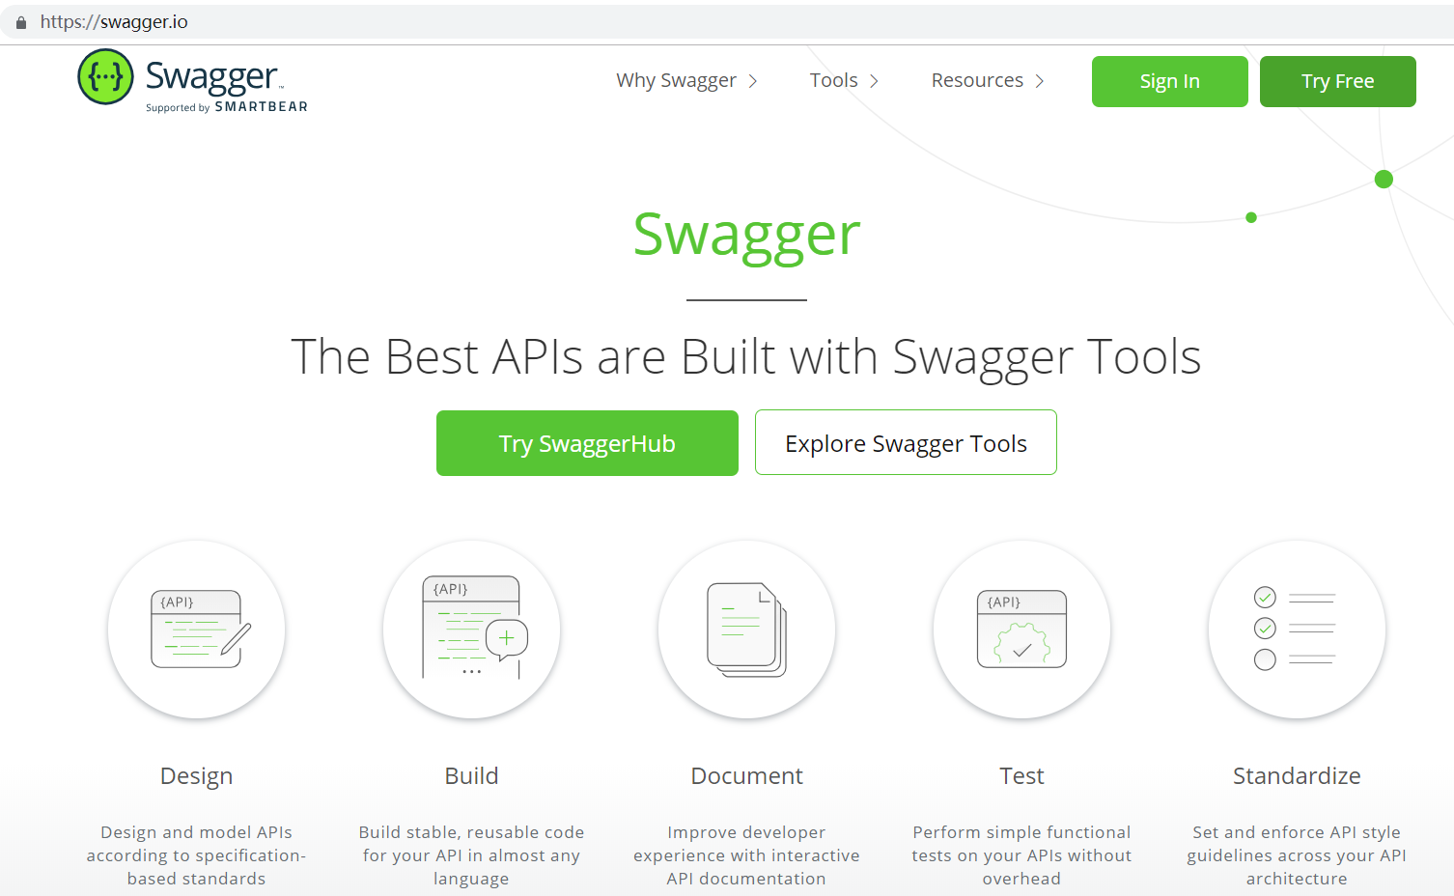

使用swagger生成实时接口文档
https://swagger.io/
- 引入Swagger2和swagger ui （在父工程中依赖）
<!-- https://mvnrepository.com/artifact/io.springfox/springfox-swagger2 -->
<dependency>
<groupId>io.springfox</groupId>
<artifactId>springfox-swagger2</artifactId>
<version>2.9.2</version>
</dependency>
<!-- https://mvnrepository.com/artifact/io.springfox/springfox-swagger-ui -->
<dependency>
<groupId>io.springfox</groupId>
<artifactId>springfox-swagger-ui</artifactId>
<version>2.9.2</version>
</dependency>
- 编写配置类（@EnableSwagger2 开启swagger2自动生成api文档功能）
package com.atguigu.user.config;

import org.springframework.context.annotation.Configuration;
import springfox.documentation.swagger2.annotations.EnableSwagger2;

@EnableSwagger2 //开启swagger2自动生成api文档的功能
@Configuration
public class AppSwaggerConfig {

}
- http://localhost:8080/swagger-ui.html
可以生成文档，可以直接进行服务接口调用测试。
package com.atguigu.scw.user.controller;

import org.springframework.web.bind.annotation.GetMapping;
import org.springframework.web.bind.annotation.RestController;

@RestController
public class HelloController {

@GetMapping("/hello")
public String hello(String name) {
return "OK:"+name;
}

}

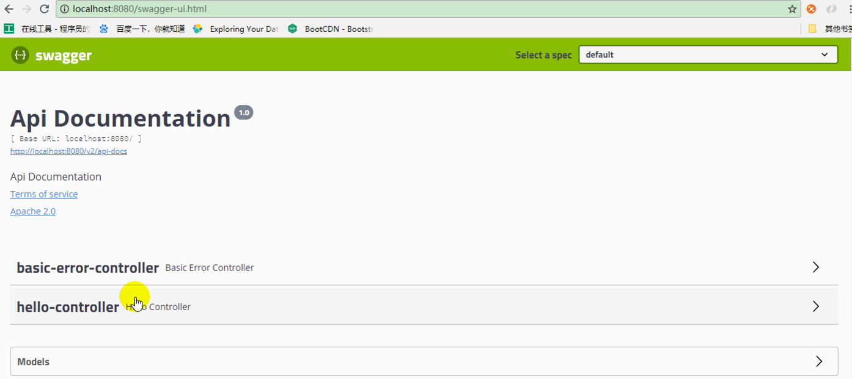

使用Swagger注解
  - @Api(tags="")
    - 用在请求的类上，表示对类的说明
    - tags"说明该类的作用，可以在UI界面上看到的注解"
  - @ApiOperation(value="")
    - 用在请求的方法上，说明方法的用途、作用
    - value="说明方法的用途、作用"
  - @ApiImplicitParams
    - 用在请求的方法上，表示一组参数说明
    - @ApiImplicitParam
      - @ApiImplicitParam:指定一个请求参数的各个方面
      - value：参数的汉字说明、解释
      - required：参数是否必须传
      - paramType：参数放在哪个地方
        - header –> 请求头的获取：@RequestHeader
        - query –> 请求参数的获取：@RequestParam
        - path（用于restful接口）–> 请求路径变量的获取：@PathVariable
        - body（不常用）
        - form（不常用）
      - dataType：参数类型，默认String，其它值dataType="Integer"
      - defaultValue：参数的默认值
  - @ApiResponses
    - 用在请求的方法上，表示一组响应
    - @ApiResponse
      - 用在@ApiResponses中，一般用于表达一个错误的响应信息
      - code：数字，例如400
      - message：信息，例如"请求参数没填好"
      - response：抛出异常的类
  - @ApiModel
    - 主要有两种用途：
    - 用于响应类上，表示一个返回响应数据的信息
    - 入参实体：使用@RequestBody这样的场景， 请求参数无法使用@ApiImplicitParam注解进行描述的时候
    - @ApiModelProperty
      - 用在属性上，描述响应类的属性

样例
package com.atguigu.scw.user.controller;

import org.springframework.web.bind.annotation.GetMapping;
import org.springframework.web.bind.annotation.PostMapping;
import org.springframework.web.bind.annotation.RestController;
import com.atguigu.scw.user.bean.User;
import io.swagger.annotations.Api;
import io.swagger.annotations.ApiImplicitParam;
import io.swagger.annotations.ApiImplicitParams;
import io.swagger.annotations.ApiOperation;

@Api(tags= {"第一个Swagger测试"}) //描述当前类是做什么的
@RestController
public class HelloController {

@ApiOperation("测试方法Hello")
@ApiImplicitParams(value= {
@ApiImplicitParam(name="name",value="姓名",required=true),
@ApiImplicitParam(name="age",value="年龄")
})
@GetMapping("/hello")
public String hello(String name,int age) {
return "OK:"+name;
}

@ApiOperation("测试方法Hello2")
@ApiImplicitParams(value= {
@ApiImplicitParam(name="name",value="姓名",required=true),
@ApiImplicitParam(name="email",value="电子邮件")
})
@PostMapping("/user")
public User user(String name ,String email) {
User user = new User();
user.setName(name);
user.setEmail(email);
return user;
}

}

package com.atguigu.scw.user.bean;

import io.swagger.annotations.ApiModel;
import io.swagger.annotations.ApiModelProperty;

@ApiModel
public class User {

@ApiModelProperty(value = "主键")
private int id;

@ApiModelProperty(value = "姓名")
private String name;

@ApiModelProperty(value = "电子邮件")
private String email;

public int getId() {
return id;
}

public void setId(int id) {
this.id = id;
}

public String getName() {
return name;
}

public void setName(String name) {
this.name = name;
}

public String getEmail() {
return email;
}

public void setEmail(String email) {
this.email = email;
}

}

第五章 众筹-项目功能与接口文档的设计(作业)

用户模块
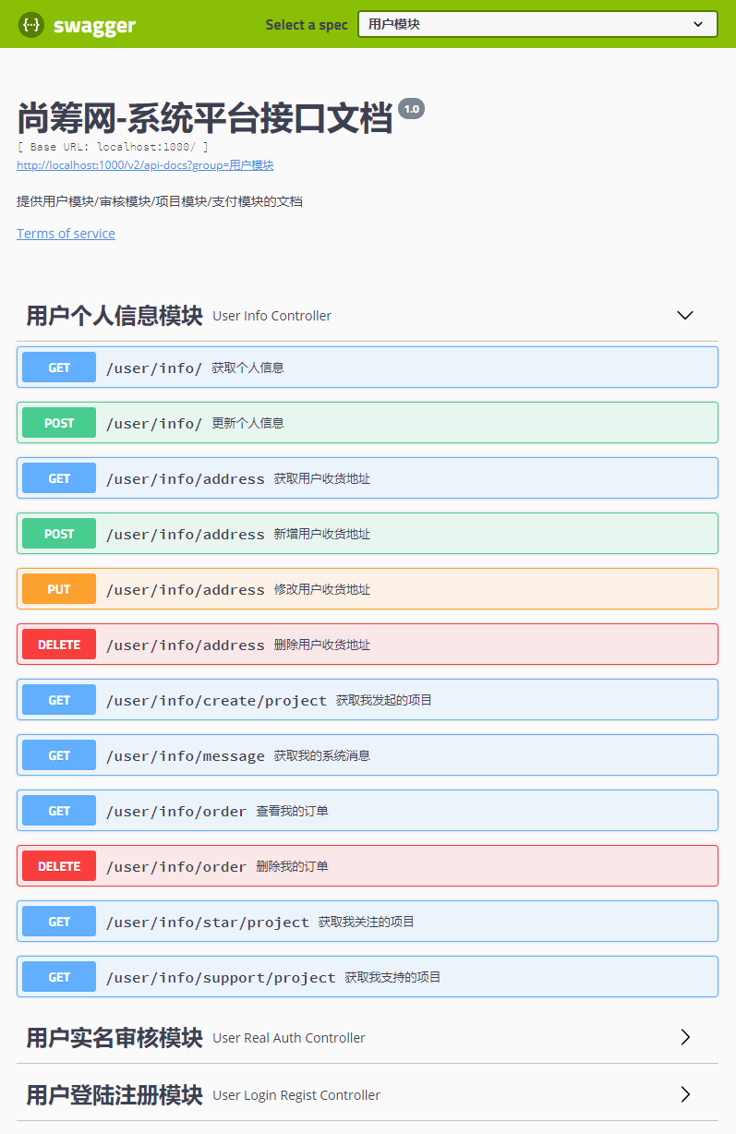
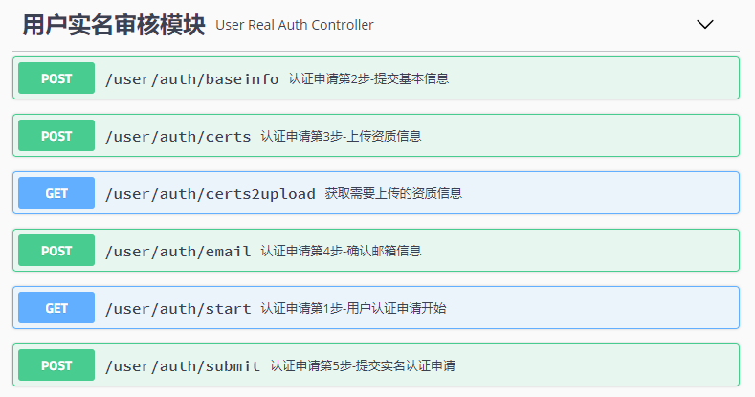

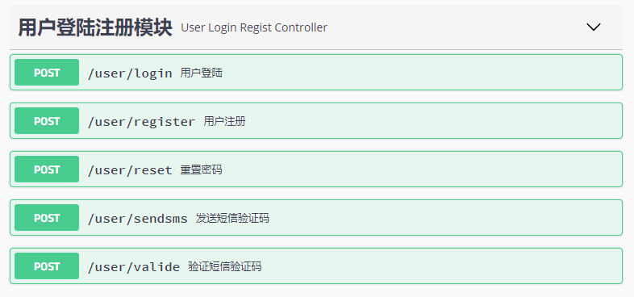

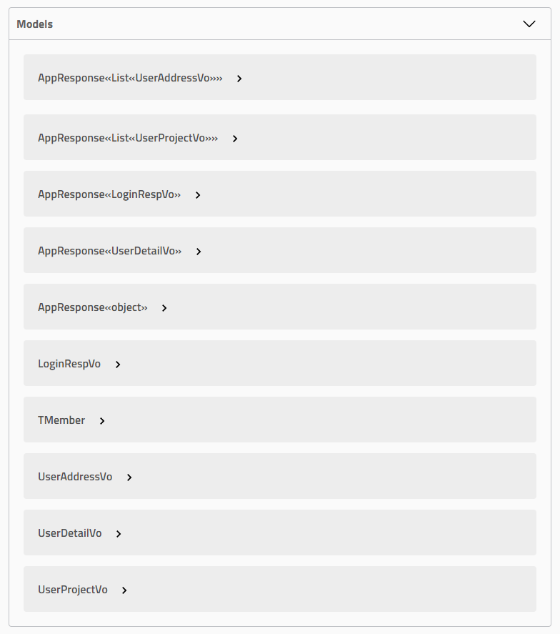

项目模块
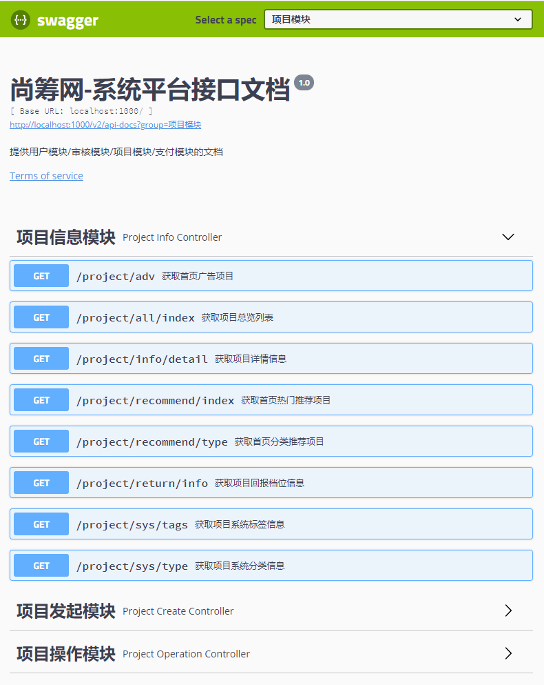

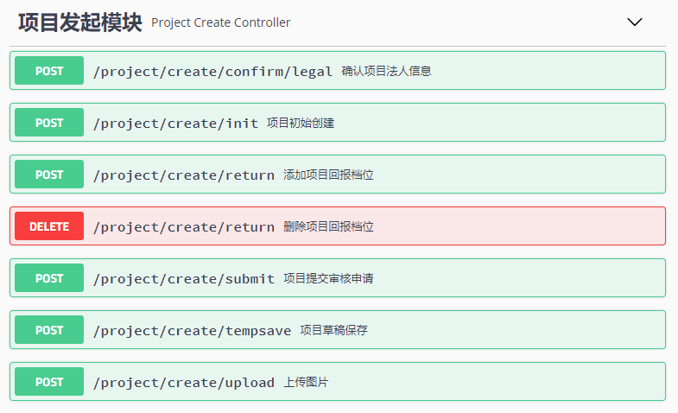

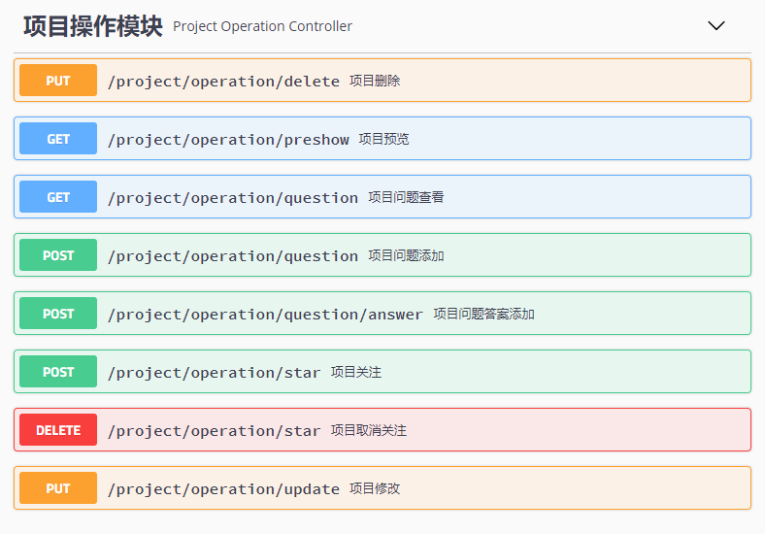
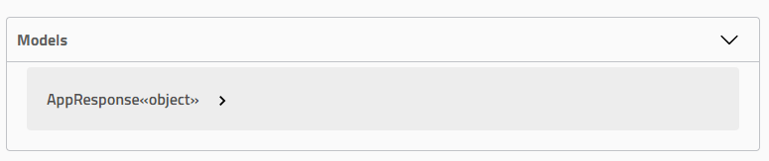

订单、支付模块
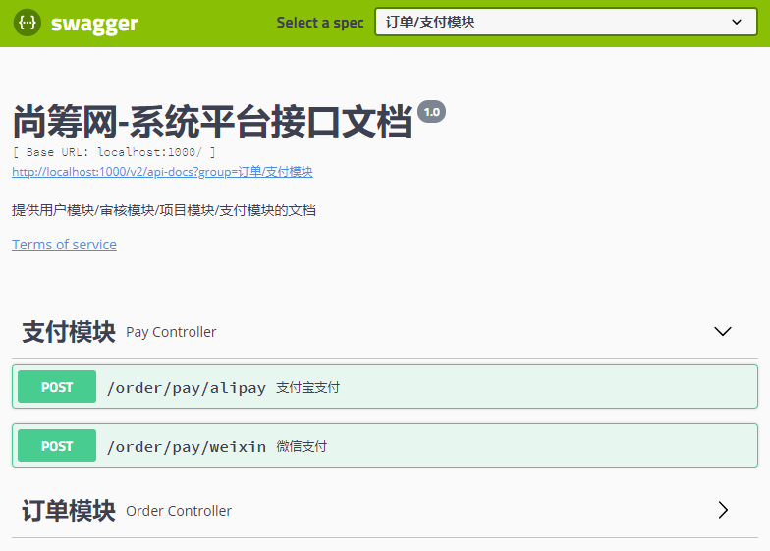

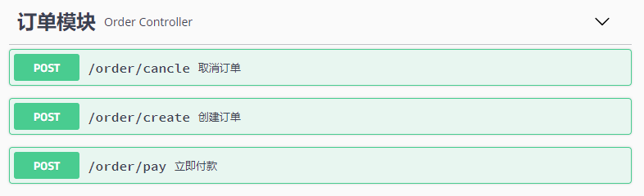

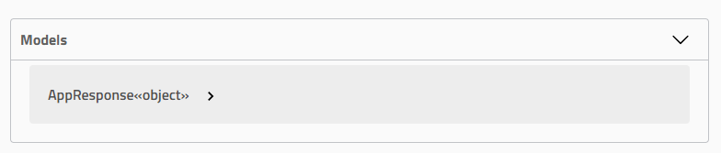

审核模块
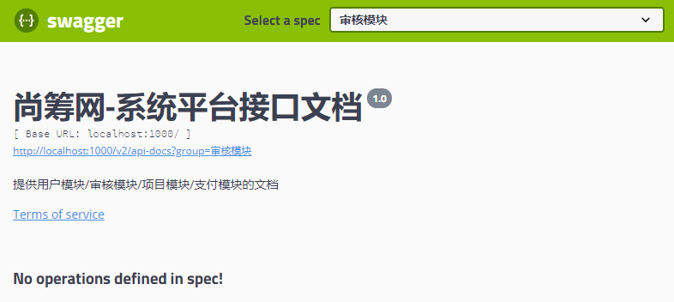

第六章 众筹-lombok
使用lombok简化开发

1、common项目中引入lombok（简化javaBean开发）
不用指定版本，SpringBoot底层也引入lombok包，1.16.22
<!-- https://mvnrepository.com/artifact/org.projectlombok/lombok -->
<dependency>
<groupId>org.projectlombok</groupId>
<artifactId>lombok</artifactId>
<!-- <version>1.18.6</version>--> <!—SpringBoot框架引用版本就是1.18.8-->
<scope>provided</scope>
</dependency>

2、安装lombok（双击安装到eclipse）&重启
- 双击：D:/RepMaven/org/projectlombok/lombok/1.16.22/lombok-1.16.22.jar
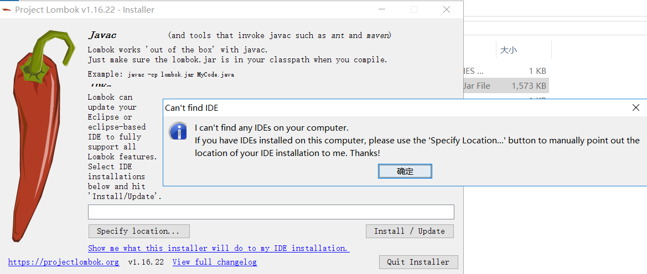
- 如果不能找到IDE，请点击：Show mewhat this installer will do to my IDE installation
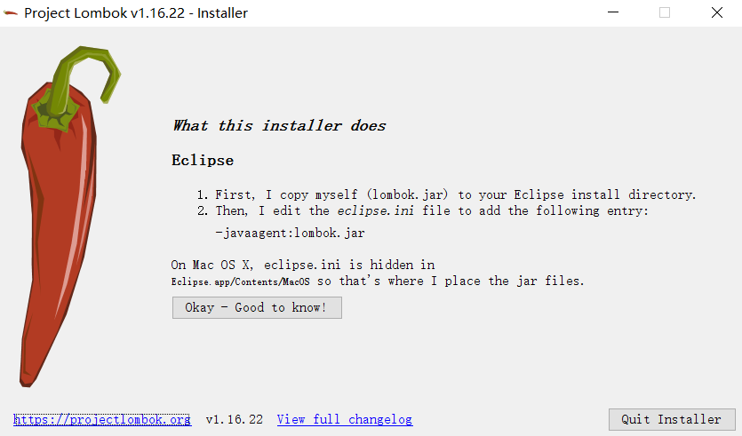
- STS
1、复制lombok.jar放在STS安装目录（去掉版本号）
2、给STS.ini（notepad++）最后一行添上-javaagent:lombok.jar
- 安装lombok需要做两件事
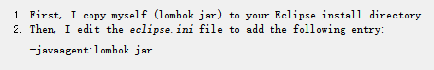

3、使用注解
- https://www.projectlombok.org/
- @Data：提供getter/setter
- @NoArgsConstructor, 无参构造器 @RequiredArgsConstructor @AllArgsConstructor 全参数构造器
- @EqualsAndHashCode：提供equals和hashCode方法
- @Log：快速的使用slf4j日志
- @Log4j：快速使用log4j日志
- @Log4j2：快速使用log4j2
- @Getter/@Setter
- @Slf4j 内置log对象，直接调用日志方法输出日志
- @ToString

第七章 阿里云-短信API的使用

联系运营商？

工具能发短信？
发短信的接口？第三方公司把这个功能写成REST API，让公众调用

购买付费API
以发送请求的方式来完成短信验证码功能

第八章 阿里云-使用java代码进行短信发送

8.1 阿里云，云市场，购买短信API
通过阿里云购买第三方短信发送，免费的即可（5次）
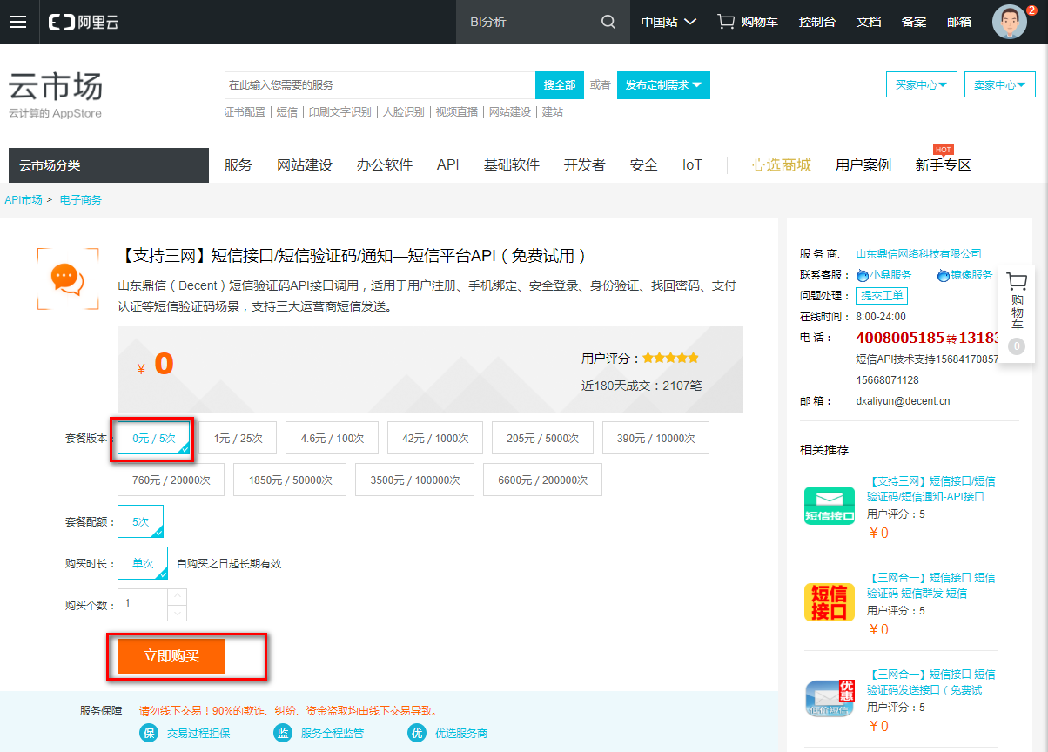

8.2 通过示例测试

8.2.1 通过【去调试】进行测试
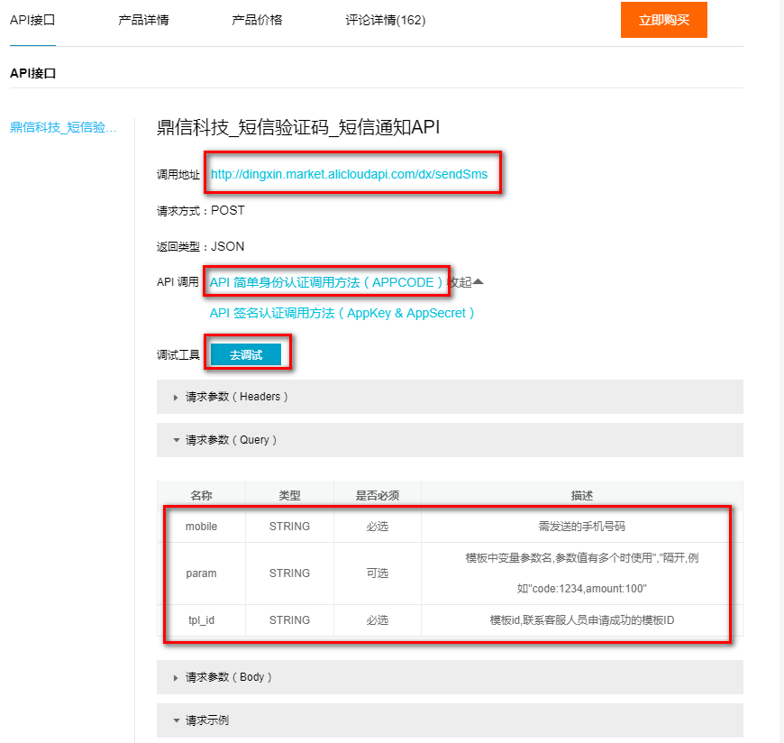
只需要填写手机号码即可
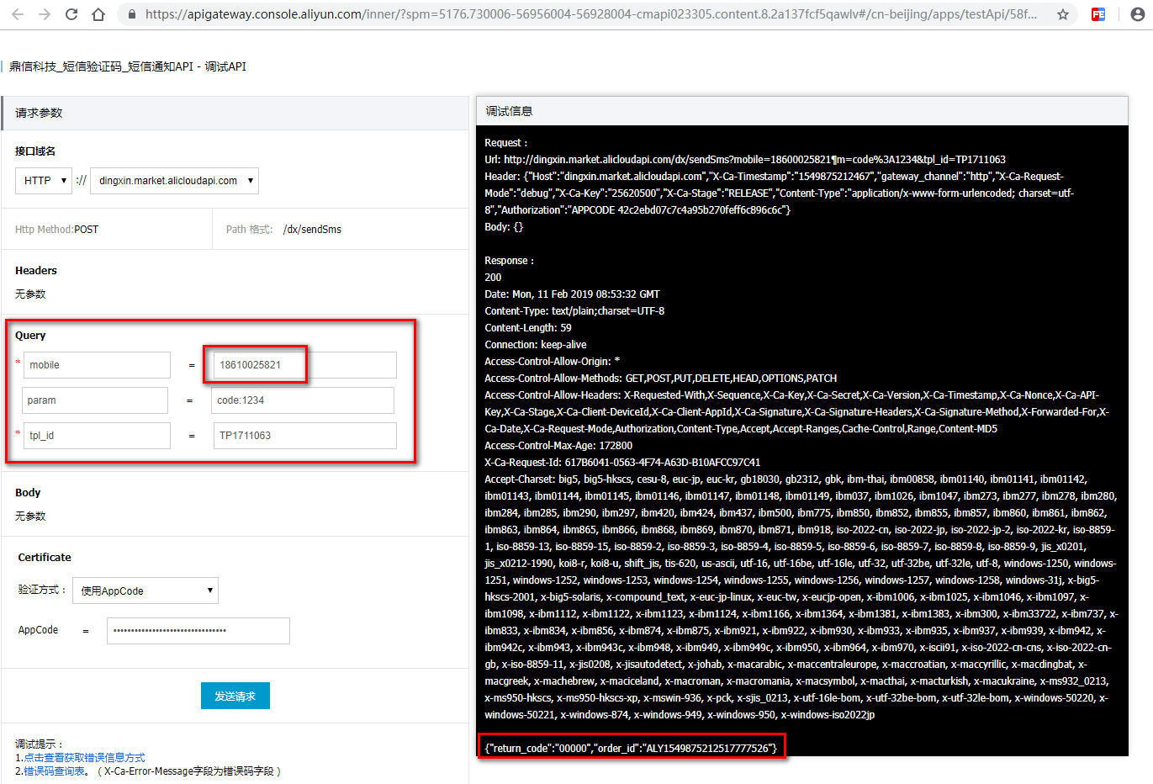

通过postman测试
输入请求地址，请求头信息
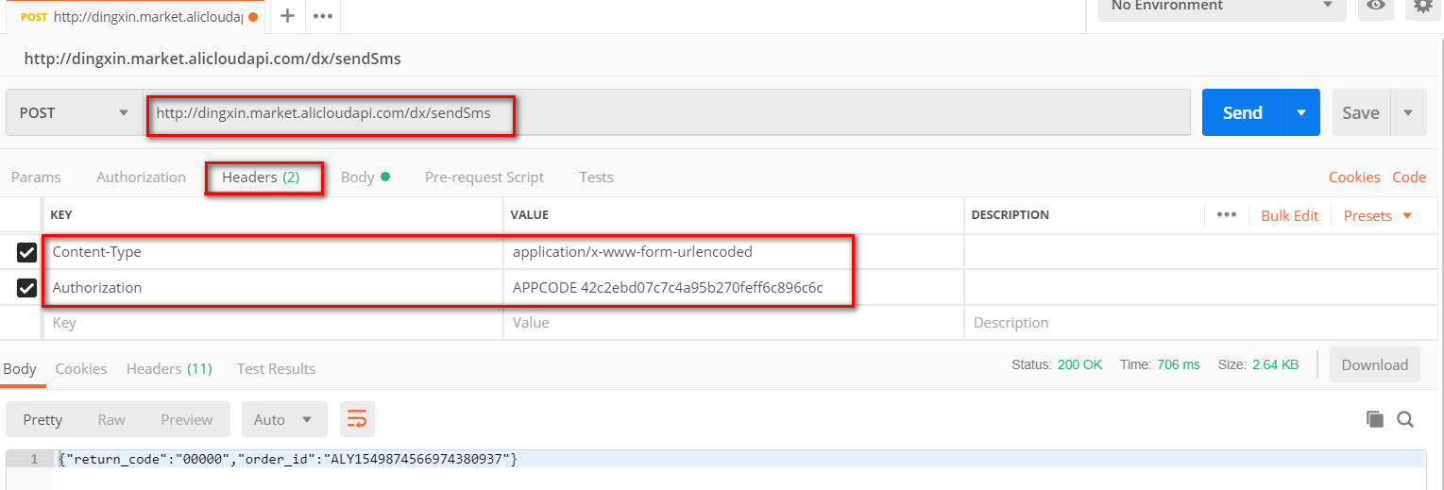
输入请求参数，点击【Send】按钮，查看返回结果
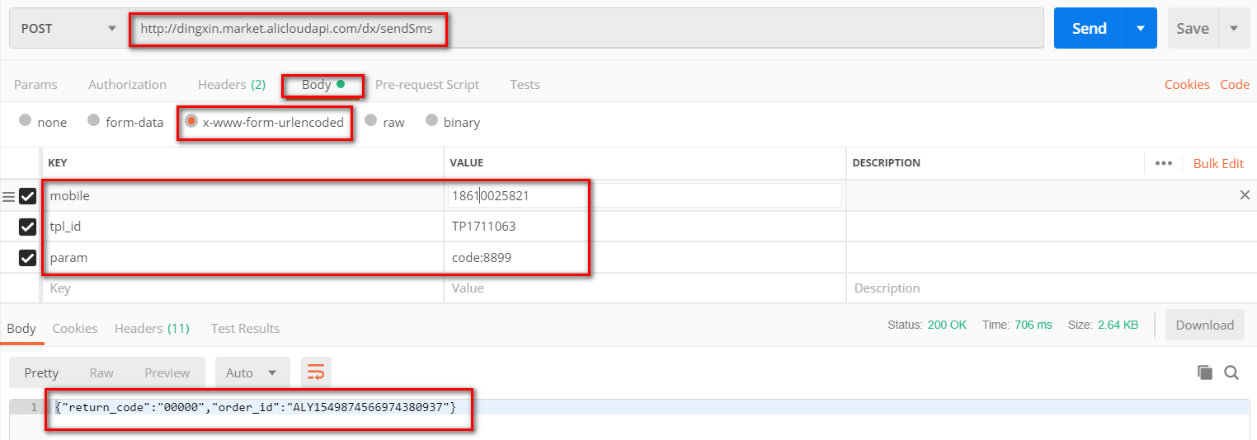

通过Java代码测试

1 SmsTest
参考：
https://market.aliyun.com/products/56928004/cmapi023305.html?spm=5176.2020520132.101.3.4b697218KUgzH1#sku=yuncode1730500007
package com.atguigu;

import java.util.HashMap;
import java.util.Map;

import org.apache.http.HttpResponse;

public class SmsTest {

public static void main(String[] args) {
String host = "http://dingxin.market.alicloudapi.com";
String path = "/dx/sendSms";
String method = "POST";
String appcode = "62c2ebd07c7c4a95b270feff6c896c6c";
Map<String, String> headers = new HashMap<String, String>();
// 最后在header中的格式(中间是英文空格)为Authorization:APPCODE 83359fd73fe94948385f570e3c139105
headers.put("Authorization", "APPCODE " + appcode);
Map<String, String> querys = new HashMap<String, String>();
querys.put("mobile", "18610025821");
querys.put("param", "code:9966");
querys.put("tpl_id", "TP1711063");
Map<String, String> bodys = new HashMap<String, String>();

try {
/**
* 重要提示如下: HttpUtils请从
* https://github.com/aliyun/api-gateway-demo-sign-java/blob/master/src/main/java/com/aliyun/api/gateway/demo/util/HttpUtils.java
* 下载
*
* 相应的依赖请参照
* https://github.com/aliyun/api-gateway-demo-sign-java/blob/master/pom.xml
*/
HttpResponse response = HttpUtils.doPost(host, path, method, headers, querys, bodys);
System.out.println(response.toString());
// 获取response的body
// System.out.println(EntityUtils.toString(response.getEntity()));
//{"return_code":"00000","order_id":"ALY1549881237643456814"}
} catch (Exception e) {
e.printStackTrace();
}
}

}

2 HttpUtils.java
参考：
https://github.com/aliyun/api-gateway-demo-sign-java/blob/master/src/main/java/com/aliyun/api/gateway/demo/util/HttpUtils.java
package com.atguigu.utils;

import java.io.UnsupportedEncodingException;
import java.net.URLEncoder;
import java.security.KeyManagementException;
import java.security.NoSuchAlgorithmException;
import java.security.cert.X509Certificate;
import java.util.ArrayList;
import java.util.List;
import java.util.Map;

import javax.net.ssl.SSLContext;
import javax.net.ssl.TrustManager;
import javax.net.ssl.X509TrustManager;

import org.apache.commons.lang.StringUtils;
import org.apache.http.HttpResponse;
import org.apache.http.NameValuePair;
import org.apache.http.client.HttpClient;
import org.apache.http.client.entity.UrlEncodedFormEntity;
import org.apache.http.client.methods.HttpDelete;
import org.apache.http.client.methods.HttpGet;
import org.apache.http.client.methods.HttpPost;
import org.apache.http.client.methods.HttpPut;
import org.apache.http.conn.ClientConnectionManager;
import org.apache.http.conn.scheme.Scheme;
import org.apache.http.conn.scheme.SchemeRegistry;
import org.apache.http.conn.ssl.SSLSocketFactory;
import org.apache.http.entity.ByteArrayEntity;
import org.apache.http.entity.StringEntity;
import org.apache.http.impl.client.DefaultHttpClient;
import org.apache.http.message.BasicNameValuePair;

public class HttpUtils {

/**
* get
*
* @param host
* @param path
* @param method
* @param headers
* @param querys
* @return
* @throws Exception
*/
public static HttpResponse doGet(String host, String path, String method, Map<String, String> headers,
Map<String, String> querys) throws Exception {
HttpClient httpClient = wrapClient(host);

HttpGet request = new HttpGet(buildUrl(host, path, querys));
for (Map.Entry<String, String> e : headers.entrySet()) {
request.addHeader(e.getKey(), e.getValue());
}

return httpClient.execute(request);
}

/**
* post form
*
* @param host
* @param path
* @param method
* @param headers
* @param querys
* @param bodys
* @return
* @throws Exception
*/
public static HttpResponse doPost(String host, String path, String method, Map<String, String> headers,
Map<String, String> querys, Map<String, String> bodys) throws Exception {
HttpClient httpClient = wrapClient(host);

HttpPost request = new HttpPost(buildUrl(host, path, querys));
for (Map.Entry<String, String> e : headers.entrySet()) {
request.addHeader(e.getKey(), e.getValue());
}

if (bodys != null) {
List<NameValuePair> nameValuePairList = new ArrayList<NameValuePair>();

for (String key : bodys.keySet()) {
nameValuePairList.add(new BasicNameValuePair(key, bodys.get(key)));
}
UrlEncodedFormEntity formEntity = new UrlEncodedFormEntity(nameValuePairList, "utf-8");
formEntity.setContentType("application/x-www-form-urlencoded; charset=UTF-8");
request.setEntity(formEntity);
}

return httpClient.execute(request);
}

/**
* Post String
*
* @param host
* @param path
* @param method
* @param headers
* @param querys
* @param body
* @return
* @throws Exception
*/
public static HttpResponse doPost(String host, String path, String method, Map<String, String> headers,
Map<String, String> querys, String body) throws Exception {
HttpClient httpClient = wrapClient(host);

HttpPost request = new HttpPost(buildUrl(host, path, querys));
for (Map.Entry<String, String> e : headers.entrySet()) {
request.addHeader(e.getKey(), e.getValue());
}

if (StringUtils.isNotBlank(body)) {
request.setEntity(new StringEntity(body, "utf-8"));
}

return httpClient.execute(request);
}

/**
* Post stream
*
* @param host
* @param path
* @param method
* @param headers
* @param querys
* @param body
* @return
* @throws Exception
*/
public static HttpResponse doPost(String host, String path, String method, Map<String, String> headers,
Map<String, String> querys, byte[] body) throws Exception {
HttpClient httpClient = wrapClient(host);

HttpPost request = new HttpPost(buildUrl(host, path, querys));
for (Map.Entry<String, String> e : headers.entrySet()) {
request.addHeader(e.getKey(), e.getValue());
}

if (body != null) {
request.setEntity(new ByteArrayEntity(body));
}

return httpClient.execute(request);
}

/**
* Put String
*
* @param host
* @param path
* @param method
* @param headers
* @param querys
* @param body
* @return
* @throws Exception
*/
public static HttpResponse doPut(String host, String path, String method, Map<String, String> headers,
Map<String, String> querys, String body) throws Exception {
HttpClient httpClient = wrapClient(host);

HttpPut request = new HttpPut(buildUrl(host, path, querys));
for (Map.Entry<String, String> e : headers.entrySet()) {
request.addHeader(e.getKey(), e.getValue());
}

if (StringUtils.isNotBlank(body)) {
request.setEntity(new StringEntity(body, "utf-8"));
}

return httpClient.execute(request);
}

/**
* Put stream
*
* @param host
* @param path
* @param method
* @param headers
* @param querys
* @param body
* @return
* @throws Exception
*/
public static HttpResponse doPut(String host, String path, String method, Map<String, String> headers,
Map<String, String> querys, byte[] body) throws Exception {
HttpClient httpClient = wrapClient(host);

HttpPut request = new HttpPut(buildUrl(host, path, querys));
for (Map.Entry<String, String> e : headers.entrySet()) {
request.addHeader(e.getKey(), e.getValue());
}

if (body != null) {
request.setEntity(new ByteArrayEntity(body));
}

return httpClient.execute(request);
}

/**
* Delete
*
* @param host
* @param path
* @param method
* @param headers
* @param querys
* @return
* @throws Exception
*/
public static HttpResponse doDelete(String host, String path, String method, Map<String, String> headers,
Map<String, String> querys) throws Exception {
HttpClient httpClient = wrapClient(host);

HttpDelete request = new HttpDelete(buildUrl(host, path, querys));
for (Map.Entry<String, String> e : headers.entrySet()) {
request.addHeader(e.getKey(), e.getValue());
}

return httpClient.execute(request);
}

private static String buildUrl(String host, String path, Map<String, String> querys)
throws UnsupportedEncodingException {
StringBuilder sbUrl = new StringBuilder();
sbUrl.append(host);
if (!StringUtils.isBlank(path)) {
sbUrl.append(path);
}
if (null != querys) {
StringBuilder sbQuery = new StringBuilder();
for (Map.Entry<String, String> query : querys.entrySet()) {
if (0 < sbQuery.length()) {
sbQuery.append("&");
}
if (StringUtils.isBlank(query.getKey()) && !StringUtils.isBlank(query.getValue())) {
sbQuery.append(query.getValue());
}
if (!StringUtils.isBlank(query.getKey())) {
sbQuery.append(query.getKey());
if (!StringUtils.isBlank(query.getValue())) {
sbQuery.append("=");
sbQuery.append(URLEncoder.encode(query.getValue(), "utf-8"));
}
}
}
if (0 < sbQuery.length()) {
sbUrl.append("?").append(sbQuery);
}
}

return sbUrl.toString();
}

private static HttpClient wrapClient(String host) {
HttpClient httpClient = new DefaultHttpClient();
if (host.startsWith("https://")) {
sslClient(httpClient);
}

return httpClient;
}

private static void sslClient(HttpClient httpClient) {
try {
SSLContext ctx = SSLContext.getInstance("TLS");
X509TrustManager tm = new X509TrustManager() {
public X509Certificate[] getAcceptedIssuers() {
return null;
}

public void checkClientTrusted(X509Certificate[] xcs, String str) {

}

public void checkServerTrusted(X509Certificate[] xcs, String str) {

}
};
ctx.init(null, new TrustManager[] { tm }, null);
SSLSocketFactory ssf = new SSLSocketFactory(ctx);
ssf.setHostnameVerifier(SSLSocketFactory.ALLOW_ALL_HOSTNAME_VERIFIER);
ClientConnectionManager ccm = httpClient.getConnectionManager();
SchemeRegistry registry = ccm.getSchemeRegistry();
registry.register(new Scheme("https", 443, ssf));
} catch (KeyManagementException ex) {
throw new RuntimeException(ex);
} catch (NoSuchAlgorithmException ex) {
throw new RuntimeException(ex);
}
}
}

3 common项目中配置pom.xml
参考：https://github.com/aliyun/api-gateway-demo-sign-java/blob/master/pom.xml
<dependency>
<groupId>com.alibaba</groupId>
<artifactId>fastjson</artifactId>
<version>1.2.15</version>
</dependency>
<dependency>
<groupId>org.apache.httpcomponents</groupId>
<artifactId>httpclient</artifactId>
<version>4.2.1</version>
</dependency>
<dependency>
<groupId>org.apache.httpcomponents</groupId>
<artifactId>httpcore</artifactId>
<version>4.2.1</version>
</dependency>
<dependency>
<groupId>commons-lang</groupId>
<artifactId>commons-lang</artifactId>
<version>2.6</version>
</dependency>
<dependency>
<groupId>org.eclipse.jetty</groupId>
<artifactId>jetty-util</artifactId>
<version>9.3.7.v20160115</version>
</dependency>

第九章 阿里云-HttpClient的简单使用

9.1 HttpClient版本已经停止使用，被HttpComponents取代
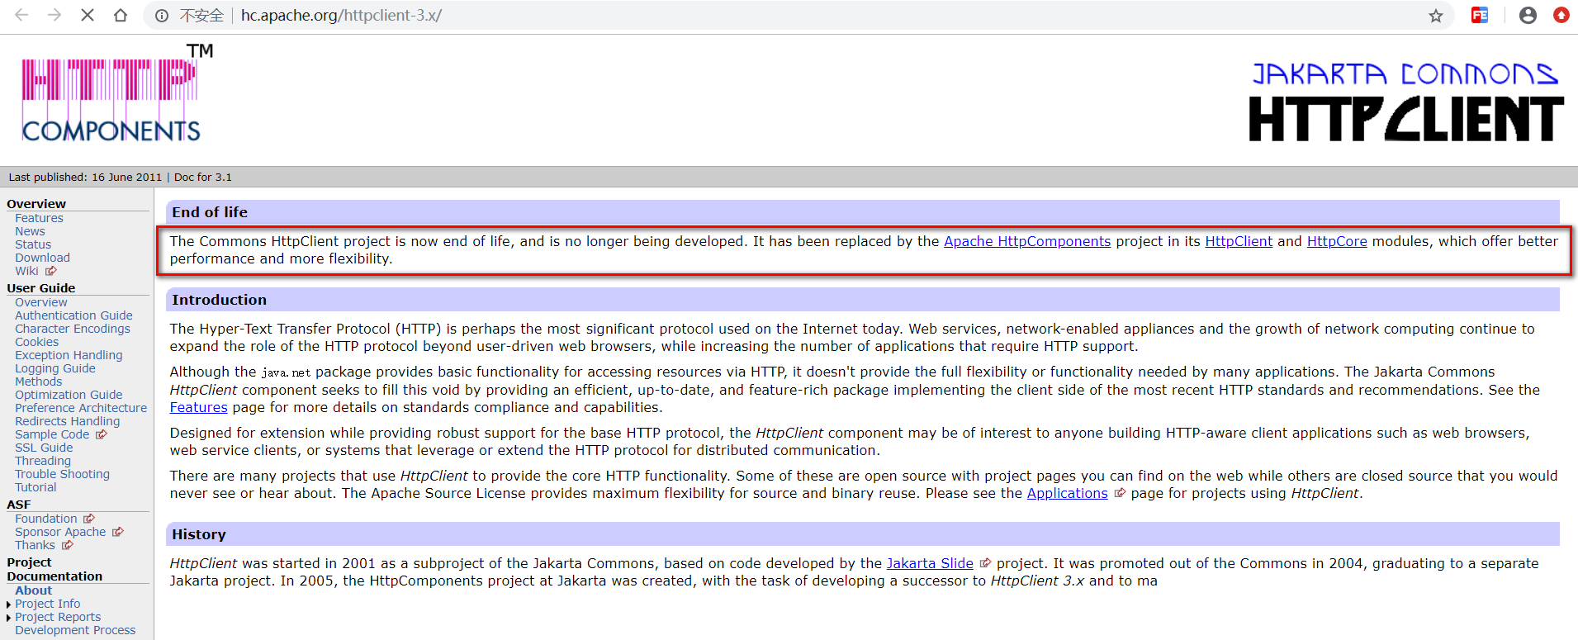

9.2 HttpClient的简单使用
public static void main(String[] args) throws ClientProtocolException, IOException {
//1、创建一个httpClient
HttpClient httpClient = new DefaultHttpClient();

//2、构造一个请求
HttpGet httpGet = new HttpGet("http://www.baidu.com");

//3、发送请求，并收到响应
HttpResponse response = httpClient.execute(httpGet);

//4、获取响应的数据
HttpEntity entity = response.getEntity();

//5、拿到响应的字符串数据
String string = EntityUtils.toString(entity);

System.out.println(string);
}

第十章 阿里云-用户注册-SmsTemplate抽取-发送手机验证码

1.用户注册功能，手机验证码验证功能
①导入AppResonse工具类，enums枚举通用类

2.SmsTemplate
package com.atguigu.user.component;

import java.util.HashMap;
import java.util.Map;
import org.apache.http.HttpResponse;
import org.apache.http.util.EntityUtils;
import org.springframework.beans.factory.annotation.Value;
import org.springframework.stereotype.Component;
import com.atguigu.utils.HttpUtils;
import lombok.extern.slf4j.Slf4j;

@Component
@Slf4j
public class SmsTemplate {

@Value("${sms.host}")
private String host;

@Value("${sms.path}")
private String path;

// :表示没配的默认值
@Value("${sms.method:POST}")
private String method;

@Value("${sms.appcode}")
private String appcode;

public String sendCode(Map<String, String> querys){
HttpResponse response = null;
Map<String, String> headers = new HashMap<String, String>();
// 授权头
headers.put("Authorization", "APPCODE " + appcode);
Map<String, String> bodys = new HashMap<String, String>();
try {
if(method.equalsIgnoreCase("get")){
response = HttpUtils.doGet(host, path, method, headers, querys);
}else{
response = HttpUtils.doPost(host, path, method, headers, querys, bodys);
}
String string = EntityUtils.toString(response.getEntity());
log.info("短信发送完成；响应数据是：{}",string);
return string;
//获取返回的响应数据
} catch (Exception e) {
log.error("短信发送失败；发送参数是：{}",querys);
return "fail";
}
}
}

3.配置
application.properties
sms.host=http://dingxin.market.alicloudapi.com
sms.path=/dx/sendSms
sms.method=POST
sms.appcode=93b7e19861a24c519a548b17dc16d75

4.发送验证码
@Api(tags="用户登录/注册模块(包括忘记密码等)") // 描述当前类是做什么的
@RequestMapping("/user")
@RestController
@Slf4j
public class UserLoginController {

@Autowired
SmsTemplate smsTemplate;

@Autowired
StringRedisTemplate redisTemplate;

@Autowired
UserService userService;

@ApiOperation("获取注册的验证码")
@ApiImplicitParams({
@ApiImplicitParam(name="phoneNo",value="手机号",required=true)
})//@ApiImplicitParams：描述所有参数；@ApiImplicitParam描述某个参数
@PostMapping("/sendCode")
public AppResponse<Object> sendCode(String phoneNo){
//1、生成验证码保存到服务器，准备用户提交上来进行对比
String code = UUID.randomUUID().toString().substring(0, 4);
//2、保存验证码和手机号的对应关系,设置验证码过期时间
redisTemplate.opsForValue().set(phoneNo, code, AppUserConstant.SMS_CODE_TIMEOUT, TimeUnit.MINUTES);
//2、短信发送构造参数
Map<String, String> querys = new HashMap<String, String>();
querys.put("mobile", phoneNo);
querys.put("param", "code:"+code);
querys.put("tpl_id", "TP1711063");//短信模板
//3、发送短信
String sendCode = smsTemplate.sendCode(querys);
if(sendCode.equals("")||sendCode.equals("fail")){
//短信失败
return AppResponse.fail("短信发送失败");
}
return AppResponse.ok(sendCode);
}
}

5.阿里云-用户注册-SmsTemplate封装与测试
Swagger2接口测试

第十一章 阿里云-用户注册-VO-逆向工程

用户注册
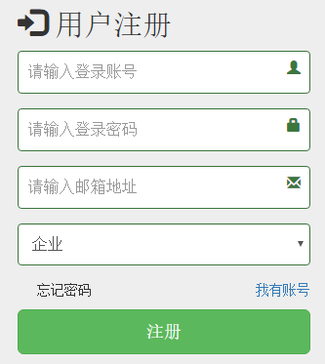

JavaBean&VO(Value Object)
抽取VO（value object）(view object)
Dao(处理Do简单的CRUD)、Pojo、TO（Transefer Object）、DTO、BO（Bussniess Object）【领域对象模型】
entity:实体类（和数据库进行对应的javaBean）
vo：Value Object（和页面等进行数据封装对接的类）
bean：自己写的一些临时的javaBean
package com.atguigu.user.vo.req;

import io.swagger.annotations.ApiModel;
import io.swagger.annotations.ApiModelProperty;
import lombok.Data;

/**
* 用户注册提交的数据VO
*/
@ApiModel
@Data
public class UserRegistVo {
@ApiModelProperty("手机号")
private String loginacct;
@ApiModelProperty("密码")
private String userpswd;
@ApiModelProperty("邮箱")
private String email;
@ApiModelProperty("验证码")
private String code;
}

User 项目逆向工程
与member相关的表逆向重新生成
mybatis-generator:generate
<table tableName="t_member"></table>
<table tableName="t_member_address"></table>
<table tableName="t_member_cert"></table>
<table tableName="t_member_project_follow"></table>
<table tableName="t_message"></table>

第十二章 阿里云-用户注册-逻辑-完成

注册
@ApiOperation("用户注册")
@PostMapping("/regist")
public AppResponse<Object> regist(UserRegistVo registVo){
//1、校验验证码
String code = redisTemplate.opsForValue().get(registVo.getLoginacct());
if(!StringUtils.isEmpty(code)){
//redis中有验证码
boolean b = code.equalsIgnoreCase(registVo.getCode());
if(b){
//3、将vo转业务能用的数据对象
TMember member = new TMember();
BeanUtils.copyProperties(registVo, member);
//4、将用户信息注册到数据库
try {
userService.registerUser(member);
log.debug("用户信息注册成功：{}",member.getLoginacct());
//2、删除验证码
redisTemplate.delete(registVo.getLoginacct());
return AppResponse.ok("注册成功...");
} catch (Exception e) {
log.error("用户信息注册失败：{}",member.getLoginacct());
return AppResponse.fail(e.getMessage());
}
}else{
return AppResponse.fail("验证码错误");
}
}else{
return AppResponse.fail("验证码过期，请重新获取");
}
}

com.atguigu.user.service.impl.UserServiceImpl
public interface UserService {
void registerUser(TMember member);
}
@Autowired
TMemberMapper memberMapper;

//注册会员信息
@Override
public void registerUser(TMember member) {
// 1、检查系统中此手机号是否存在
TMemberExample example = new TMemberExample();
example.createCriteria().andLoginacctEqualTo(member.getLoginacct());
long l = memberMapper.countByExample(example);
if (l > 0) {
throw new UserException(UserExceptionEnum.LOGINACCT_EXIST);
}

// 2、不存在，保存信息；设置默认信息
BCryptPasswordEncoder encoder = new BCryptPasswordEncoder();
String encode = encoder.encode(member.getUserpswd());
//设置密码
member.setUserpswd(encode);
member.setUsername(member.getLoginacct());
//检查邮箱是否已被占用
member.setEmail(member.getEmail());
member.setAuthstatus(AuthEnume.UN_AUTH.getCode());
member.setUsertype(UserTypeEnume.USER_VIP0.getCode());
member.setAccttype(AccttypeEnume.PERSON.getCode());

memberMapper.insertSelective(member);
}

自定义异常
package com.atguigu.user.exception;

import com.atguigu.user.enums.UserExceptionEnum;

/**
* 单表所有用户异常
* 邮箱
* 用户名
* 密码
*/
public class UserException extends RuntimeException {
public UserException(UserExceptionEnum exceptionEnum){
super(exceptionEnum.getMsg());
}
}

枚举
枚举类不能使用lombok的Data注解自动生成getter/setter。
package com.atguigu.user.enums;

public enum UserExceptionEnum {
LOGINACCT_EXIST(1,"登录账号已经存在"),
EMAIL_EXIST(2,"邮箱已经存在"),
LOGINACCT_LOCKED(3,"账号已经被锁定");

private int code;
private String msg;

private UserExceptionEnum(int code, String msg) {
this.code = code;
this.msg = msg;
}
public int getCode() {
return code;
}

public void setCode(int code) {
this.code = code;
}

public String getMsg() {
return msg;
}

public void setMsg(String msg) {
this.msg = msg;
}
}

第十三章 用户登录逻辑-令牌思想

登录分析
登录成功以后返回什么？
1）、用户的详细信息都返回(不要返回id,password)
2）、accessToken：访问令牌；以后发任何请求都要带上这个令牌，就是用来标识这是哪个用户
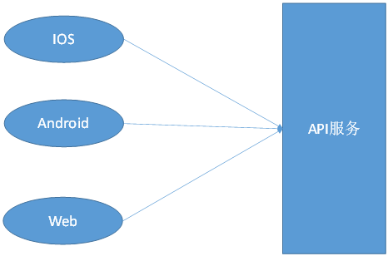

响应数据
package com.atguigu.user.vo.resp;

import io.swagger.annotations.Api;
import io.swagger.annotations.ApiModel;
import io.swagger.annotations.ApiModelProperty;
import lombok.Data;

/**用户登录成功以后返回的信息 */
@Data
@ApiModel
public class UserRespVo {
@ApiModelProperty("访问令牌，请妥善保管，以后每次请求都要带上")
private String accessToken;//访问令牌
private String loginacct; //存储手机号
private String username;
private String email;
private String authstatus;
private String usertype;
private String realname;
private String cardnum;
private String accttype;
}

登录处理
@ApiOperation("用户登录")
@ApiImplicitParams({
@ApiImplicitParam(name="username",value="用户名",required=true),
@ApiImplicitParam(name="password",value="密码",required=true)
})//@ApiImplicitParams：描述所有参数；@ApiImplicitParam描述某个参数
@PostMapping("/login")
public AppResponse<UserRespVo> login(String username,String password){
//1、尝试登录
TMember member = userService.login(username,password);
if(member == null){
//登录失败
AppResponse<UserRespVo> fail = AppResponse.fail(null);
fail.setMsg("用户名密码错误");
return fail;
}
//2、登录成功;生成令牌
String token = UUID.randomUUID().toString().replace("-", "");
UserRespVo vo = new UserRespVo();
BeanUtils.copyProperties(member, vo);
vo.setAccessToken(token);

//3、经常根据令牌查询用户的id信息
redisTemplate.opsForValue().set(token, member.getId()+"");//令牌和用户id对应
return AppResponse.ok(vo);
}

业务层
@Override
public TMember login(String username, String password) {
BCryptPasswordEncoder encoder = new BCryptPasswordEncoder();

TMemberExample example = new TMemberExample();
example.createCriteria().andLoginacctEqualTo(username);

List<TMember> list = memberMapper.selectByExample(example);
if(list!=null && list.size()==1){
TMember member = list.get(0);
boolean matches = encoder.matches(password, member.getUserpswd());
return matches?member:null;
}
return null;
}

