项目课程系列之Atcrowdfunding

尚硅谷JavaEE教研组

版本：V1.0

第一章 项目模块-OSS简介

1.1 系统分析(OSS - Object Storage Service)

1.1.1 单体应用系统需要共享数据
- 同一次请求：request.setAttribute
- 跨页面：session.setAttribute
- 整个项目：application.setAttribute

1.1.2 分布式系统需要共享数据
- 同一次请求：request.setAttribute（有页面）
  - 没页面只要数据，把数据写成json交给客户端
- 跨请求：缓存集群
- 整个项目：缓存集群

1.1.3 对象存储服务(静态资源存储方案)
- 自己搭服务器（FastDFS）
- 使用第三方（OSS）-阿里云

第二章 项目模块-阿里云OSS开通使用

2.1 注册阿里云

2.2 开通OSS存储

2.2.1 产品->精选->对象存储OSS
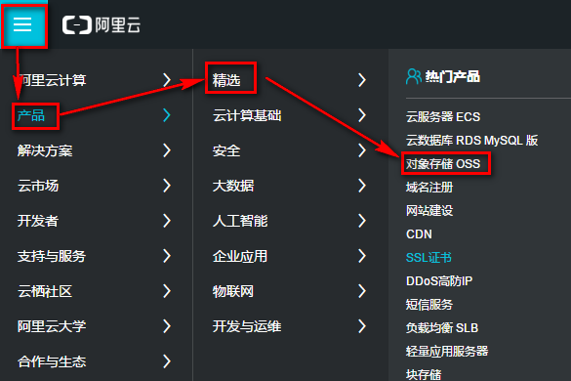

2.2.2 立即开通
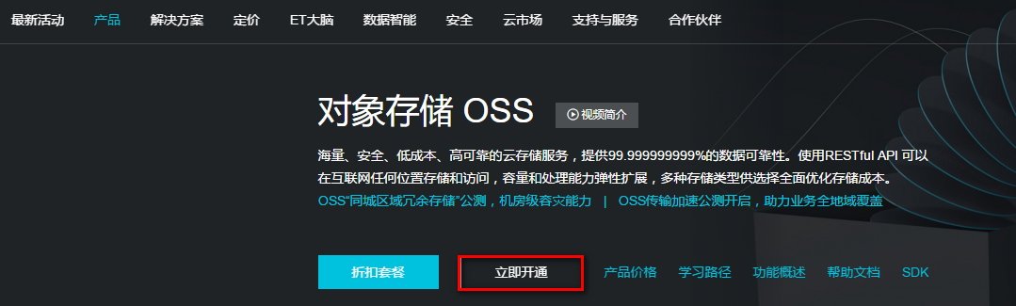

2.2.3 需要实名认证后才能开通
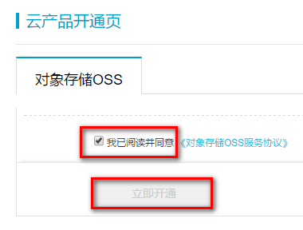

2.2.4 创建Bucket
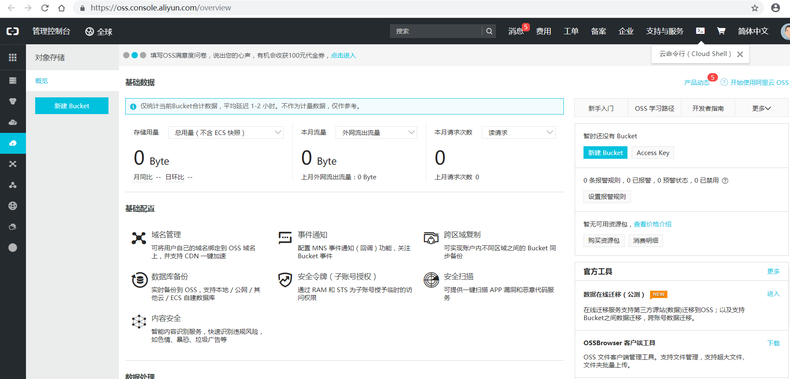

2.3 操作演示

2.3.1 新建Bucket
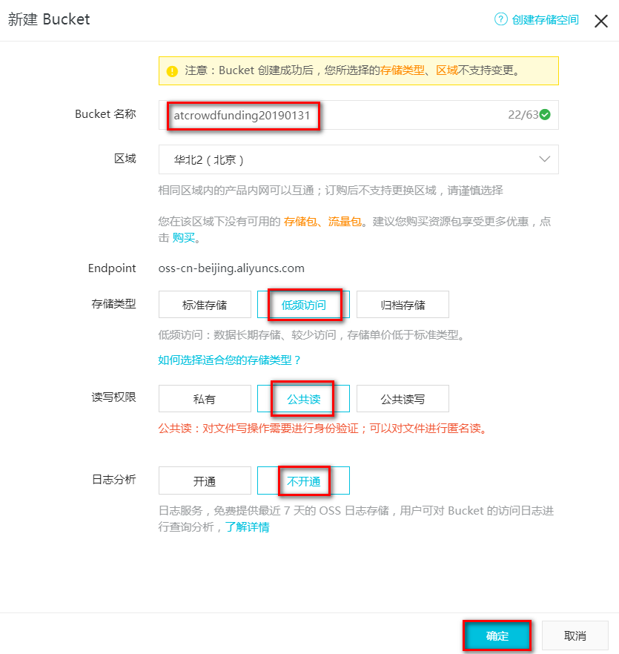

2.3.2 新建文件夹[pic,video],点击目录可以上传图片,并可以访问
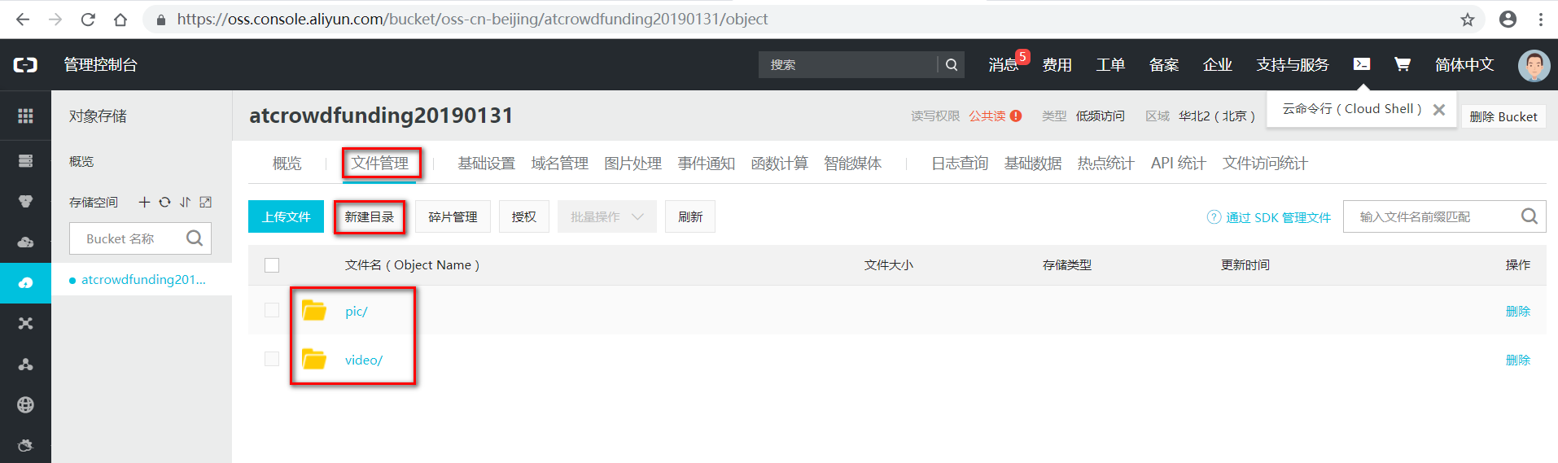

2.3.3 通过SDK管理文件
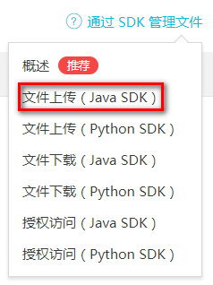

2.3.4 使用简单上传,基于流的方式
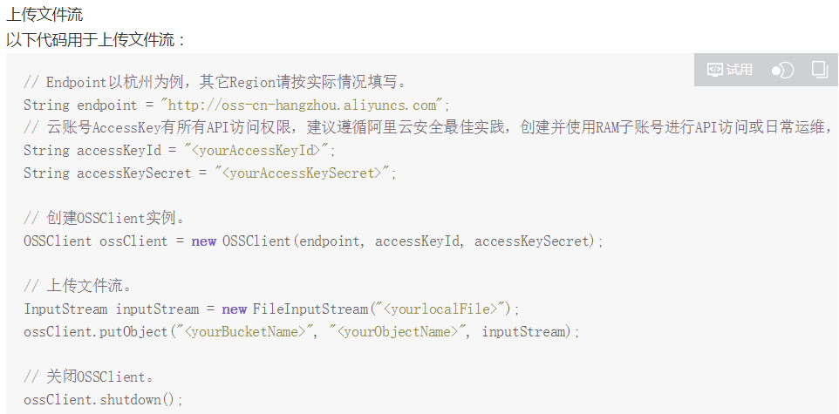

2.3.5 使用方式
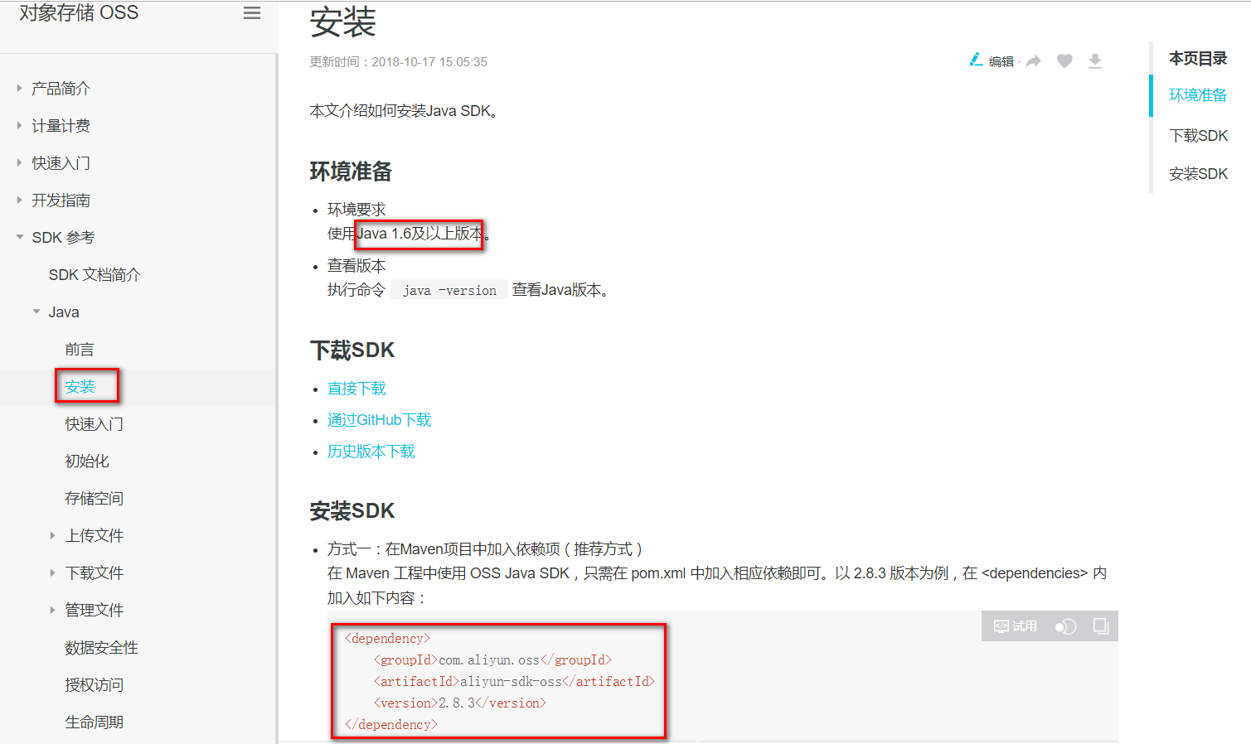

第三章 项目模块-创建OSS账号

3.1 项目中测试

3.1.1 在common项目中引入依赖
<dependency>
<groupId>com.aliyun.oss</groupId>
<artifactId>aliyun-sdk-oss</artifactId>
<version>2.8.3</version>
</dependency>
注意:sdk默认依赖httpclient4.4版本,而我们之前项目依赖的是 4.2.1的版本,需要去掉4.2.1的依赖
<dependency>
<groupId>org.apache.httpcomponents</groupId>
<artifactId>httpclient</artifactId>
<version>4.2.1</version>
</dependency>
<dependency>
<groupId>org.apache.httpcomponents</groupId>
<artifactId>httpcore</artifactId>
<version>4.2.1</version>
</dependency>

3.1.2 测试类
package com.atguigu.utils;

import java.io.File;
import java.io.FileInputStream;
import java.io.IOException;
import java.io.InputStream;
import com.aliyun.oss.OSSClient;
import com.aliyun.oss.model.PutObjectResult;

public class OSSTest {

/**
* OSS 使用步骤 阿里云/七牛
* 1）、引入SDK
* 2）、配置好相应的属性
*/
public static void main(String[] args) throws IOException {
// Endpoint以杭州为例，其它Region请按实际情况填写。
String endpoint = "http://oss-cn-beijing.aliyuncs.com";
// 云账号AccessKey有所有API访问权限，建议遵循阿里云安全最佳实践，创建并使用RAM子账号进行API访问或日常运维，请登录 https://ram.console.aliyun.com 创建。

String accessKeyId = "LTAInhfZZAHs83tW";
String accessKeySecret = "UaUbUJhOH6vu5dOtZSMod6HDYXV4Yr";

// 创建OSSClient实例。
OSSClient ossClient = new OSSClient(endpoint, accessKeyId, accessKeySecret);

// 上传文件流。
InputStream inputStream = new FileInputStream(new File("E:/temp/meinv.jpg")); //不能直接传递文件名,必须new File()对象,否则把文件找不到
// 指定bucket的名
PutObjectResult putObjectResult = ossClient.putObject("atcrowdfunding20190131", "pic/meinv.jpg", inputStream);//再次上传文件会被覆盖

// 图片的最终路径:https://atcrowdfunding20190131.oss-cn-beijing.aliyuncs.com/pic/meinv.jpg
// Bucket 域名 + 图片路径 + 文件名
// 关闭OSSClient。
ossClient.shutdown();

System.out.println("测试成....");
}
}

3.1.3 accesskey
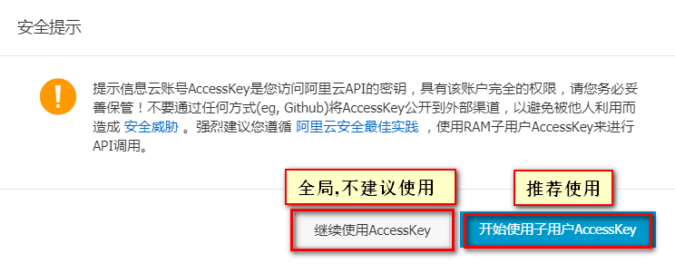
需要开通及快速创建子用户AccessKey
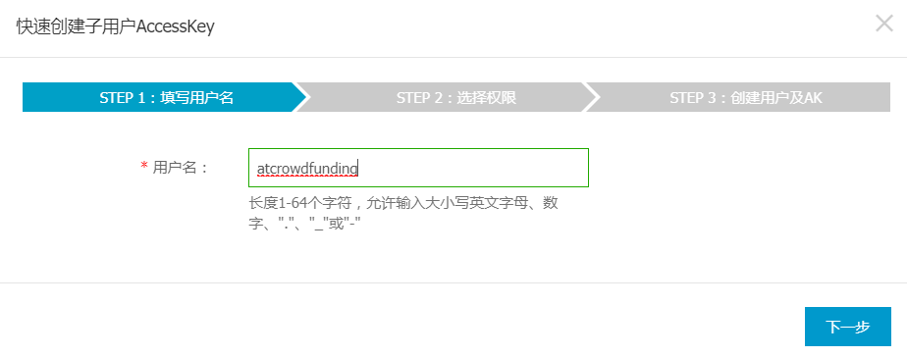
- 设置权限
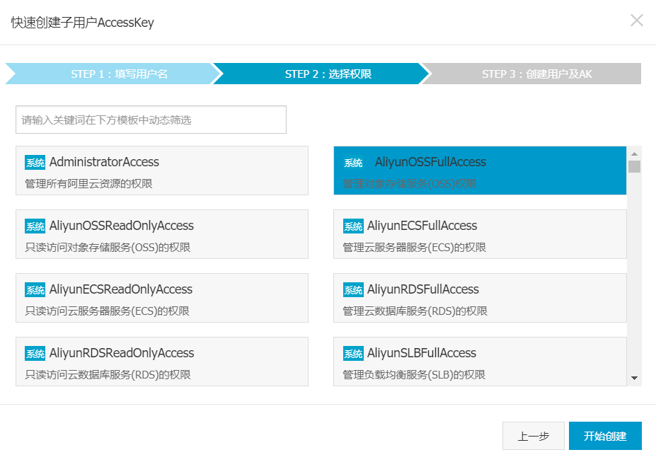
- 获取AccessKey
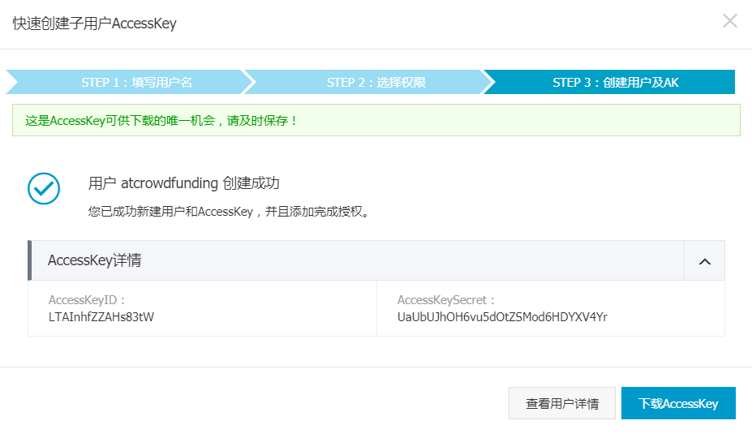

3.1.4 Bucket 域名 + 图片路径 + 文件名
https://atcrowdfunding20190131.oss-cn-beijing.aliyuncs.com/pic/meinv.jpg

第四章 项目模块-OssTemplate抽取和文件上传接口测试

4.1 抽取模板类,存放到common项目中
package com.atguigu.utils;

import java.io.IOException;
import java.io.InputStream;
import java.util.UUID;

import com.aliyun.oss.OSSClient;

import lombok.Data;
import lombok.ToString;

@ToString
@Data
public class OssTemplate {

private String endpoint;
private String bucketDomain;
private String accessKeyId;
private String accessKeySecret;
private String bucketName;

/**
* 返回上传后的文件的访问路径
*
* @param inputStream
* @param fileName
* @return
* @throws IOException
*/
public String upload(InputStream inputStream, String fileName) throws IOException {
// 加工文件夹和文件名
String folderName = AppDateUtils.getFormatTime("yyyy-MM-dd");
fileName = UUID.randomUUID().toString().replace("-", "") + "_" + fileName;

// Endpoint以杭州为例，其它Region请按实际情况填写。
// 云账号AccessKey有所有API访问权限，建议遵循阿里云安全最佳实践，创建并使用RAM子账号进行API访问或日常运维，请登录 https://ram.console.aliyun.com 创建。
// LTAInhfZZAHs83tW
// UaUbUJhOH6vu5dOtZSMod6HDYXV4Yr
// 创建OSSClient实例。
OSSClient ossClient = new OSSClient(endpoint, accessKeyId, accessKeySecret);
// 上传文件流。
// 指定bucket的名
ossClient.putObject(bucketName, "pic/" + folderName + "/" + fileName, inputStream);
inputStream.close();
ossClient.shutdown();
return "http://" +bucketDomain + "/pic/" + folderName + "/" + fileName;
}
}

4.2 在common项目中导入依赖
<!-- commons是apache的工具包集合项目 -->
<dependency>
<groupId>commons-lang</groupId>
<artifactId>commons-lang</artifactId>
<version>2.6</version>
</dependency>

<dependency>
<groupId>org.eclipse.jetty</groupId>
<artifactId>jetty-util</artifactId>
<version>9.3.7.v20160115</version>
</dependency>

<dependency>
<groupId>org.projectlombok</groupId>
<artifactId>lombok</artifactId>
<!-- <scope>provided</scope> -->
<!-- 非compile作用域的jar不能依赖传递 -->
<version>1.16.22</version>
</dependency>

4.3 在project项目中application.properties
oss.endpoint=oss-cn-beijing.aliyuncs.com
oss.bucketDomain=atcrowdfunding20190131.oss-cn-beijing.aliyuncs.com
oss.accessKeyId=LTAInhfZZAHs83tW
oss.accessKeySecret=UaUbUJhOH6vu5dOtZSMod6HDYXV4Yr
oss.bucketName=atcrowdfunding20190131

4.4 在project项目中application.yml
server:
port: 8000
spring:
datasource:
username: root
password: root
url: jdbc:mysql://192.168.137.3:3306/atcrowdfunding?useSSL=false&useUnicode=true&characterEncoding=UTF-8
driver-class-name: com.mysql.jdbc.Driver
application:
name: SCW-PROJECT
redis:
host: 192.168.137.3

mybatis:
config-location: classpath:/mybatis/mybatis-config.xml
mapper-locations: classpath:/mybatis/mapper/*.xml

eureka:
client:
service-url:
defaultZone: http://localhost:8761/eureka/
instance:
prefer-ip-address: true

4.5 在project项目中增加配置类:AppProjectConfig
package com.atguigu.project.config;

import org.springframework.boot.context.properties.ConfigurationProperties;
import org.springframework.context.annotation.Bean;
import org.springframework.context.annotation.Configuration;
import com.atguigu.utils.OssTemplate;

@Configuration
public class AppProjectConfig {
@ConfigurationProperties(prefix="oss")
@Bean
public OssTemplate ossTemplate(){
return new OssTemplate();
}
}

4.6 在project项目中增加控制器类-上传项目图片到OSS
采用postman进行测试
@Api(tags="项目基本功能模块（文件上传、项目信息获取等）")
@Slf4j
@RequestMapping("/project")
@RestController
public class ProjectInfoController {
/**
* <input type='file' name='file'/>
* @param file
* @return
* @throws IOException
*/
@ApiOperation("文件上传功能")
@PostMapping("/upload")
public AppResponse<Map<String,Object>> upload(@RequestParam("file")MultipartFile[] file) throws IOException{
Map<String,Object> map = new HashMap<>();
List<String> list = new ArrayList<>();
if(file!=null && file.length>0){
for (MultipartFile item : file) {
if(!item.isEmpty()){
String upload = ossTemplate.upload(item.getInputStream(), item.getOriginalFilename());
list.add(upload);
}
}
}
map.put("urls", list);
log.debug("ossTemplate信息：{},文件上传成功访问路径：{}",ossTemplate,list);

//文件上传
return AppResponse.ok(map);
}
}

4.7 逆向工程(mybatis-generator:generate)

4.7.1 项目图片表:t_project_images
CREATE TABLE t_project_images(
id INT AUTO_INCREMENT,
projectid INT ,
imgurl VARCHAR(255),
imgtype TINYINT(4) COMMENT '0-头部图片 1-详情图片',
PRIMARY KEY (id)
);
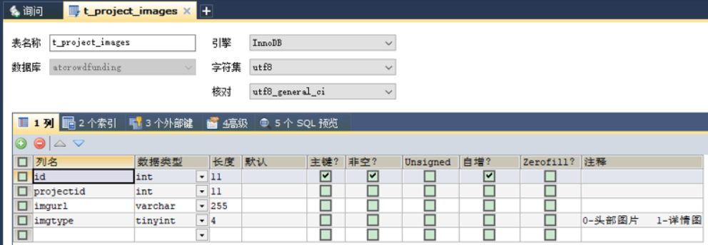

4.7.2 项目发起人表:t_project_initiator
CREATE TABLE t_project_initiator (
id INT AUTO_INCREMENT,
selfintroduction VARCHAR(255),
detailselfintroduction VARCHAR(255),
telphone VARCHAR(13),
hotline VARCHAR(13),
projectid int,
PRIMARY KEY (id)
);

<table tableName="t_project_images"></table>
<table tableName="t_project"></table>
<table tableName="t_project_tag"></table>
<table tableName="t_project_type"></table>
<table tableName="t_member_project_follow"></table>
<table tableName="t_type"></table>
<table tableName="t_tag"></table>
<table tableName="t_return"></table>
<table tableName="t_project_initiator"></table>

第五章 项目模块-swagger的配置

5.1 发布众筹项目,审核众筹项目业务介绍

5.2 配置类
package com.atguigu.project.config;

import org.springframework.beans.factory.annotation.Value;
import org.springframework.context.annotation.Bean;
import org.springframework.context.annotation.Configuration;

import io.swagger.annotations.Api;
import springfox.documentation.builders.ApiInfoBuilder;
import springfox.documentation.builders.PathSelectors;
import springfox.documentation.builders.RequestHandlerSelectors;
import springfox.documentation.service.ApiInfo;
import springfox.documentation.spi.DocumentationType;
import springfox.documentation.spring.web.plugins.Docket;
import springfox.documentation.swagger2.annotations.EnableSwagger2;

@EnableSwagger2 // 开启swagger2自动生成api文档的功能
@Configuration
public class AppSwaggerConfig {

@Value("${swagger2.enable:false}")
private boolean enable = false;

@Bean("项目模块")
public Docket projectApis() {
return new Docket(DocumentationType.SWAGGER_2)
.groupName("项目模块")
.select()
.apis(RequestHandlerSelectors.withClassAnnotation(Api.class))
.paths(PathSelectors.regex("/project.*"))
.build()
.apiInfo(apiInfo())
.enable(enable);
}

private ApiInfo apiInfo() {
return new ApiInfoBuilder()
.title("尚筹网-系统平台接口文档")
.description("提供用户模块/审核模块/项目模块/支付模块的文档")
.termsOfServiceUrl("http://www.atguigu.com/")
.version("1.0")
.build();
}
}

5.3 swagger2.enable=true

第六章 项目模块-项目初始化第一步，创建ProjectToken

6.1 在common项目中增加BaseVo
package com.atguigu.vo;
import lombok.Data;
@Data
public class BaseVo {
private String accessToken;
}

6.2 ProjectRedisStorageVo
package com.atguigu.project.vo.req;

import java.util.List;
import com.atguigu.project.entity.TReturn;
import com.atguigu.vo.BaseVo;
import lombok.Data;

@Data
public class ProjectRedisStorageVo extends BaseVo {
//全量 增量
private String projectToken;//项目的临时token
private Integer memberid;//会员id
private List<Integer> typeids; //项目的分类id
private List<Integer> tagids; //项目的标签id
private String name;//项目名称
private String remark;//项目简介
private Integer money;//筹资金额
private Integer day;//筹资天数
private String headerImage;//项目头部图片
private List<String> detailsImage;//项目详情图片
private List<TReturn> projectReturns;//项目回报
//发起人信息：自我介绍，详细自我介绍，联系电话，客服电话
}

6.3 常量类
com.atguigu.scw.project.contants.ProjectConstant
package com.atguigu.scw.project.contants;
public class ProjectConstant {
public static final String TEMP_PROJECT_PREFIX = "project:create:temp:"; //拼接在projectToken前。用于redis中的key
}

6.4 fastjson
//Vo转为json字符串
ProjectRedisStorageVo initVo = xxx ;
String jsonString = JSON.toJSONString(initVo);
// json字符串转为 Vo
ProjectRedisStorageVo parseObject = JSON.parseObject(jsonString, ProjectRedisStorageVo.class);

6.5 第一步：发布项目,同意协议

6.5.1 ProjectCreateController
com.atguigu.project.controller.ProjectCreateController
@ApiOperation("项目发起第1步-阅读同意协议")
@GetMapping("/init")
public AppResponse<String> init(BaseVo vo){
String accessToken = vo.getAccessToken();
String memberId = redisTemplate.opsForValue().get(accessToken);
if(StringUtils.isEmpty(memberId)){
return AppResponse.fail("无此权限，请先登录");
}
int id = Integer.parseInt(memberId);
//准备保存一个临时的项目信息进redis
String projectToken = projectCreateService.initCreateProject(id);
return AppResponse.ok(projectToken);
}

6.5.2 ProjectCreateServiceImpl
com.atguigu.project.service.impl.ProjectCreateServiceImpl
@Override
public String initCreateProject(Integer memberId) {
String token = UUID.randomUUID().toString().replace("-", "");
//项目的临时对象
ProjectRedisStorageVo initVo = new ProjectRedisStorageVo();
initVo.setMemberid(memberId);

//initVo转为json字符串
String jsonString = JSON.toJSONString(initVo);

log.debug("将要存储的project信息是：{}",jsonString);
//TEMP_PROJECT_PREFIX = "project:create:temp:";
redisTemplate.opsForValue().set(ProjectConstant.TEMP_PROJECT_PREFIX+token, jsonString);

return token;
}

第七章 项目模块-项目初始化第二步，收集页面基本数据

7.1 保存项目基本信息
项目的类别和标签都支持多选
@ApiOperation("项目发起第2步-保存项目的基本信息")
@PostMapping("/savebaseinfo")
public AppResponse<String> baseInfo(ProjectBaseInfoVo vo){
//1、redis中之前存储的项目信息
String orignal = redisTemplate.opsForValue()
.get(ProjectConstant.TEMP_PROJECT_PREFIX+vo.getProjectToken());

//2、和redis存储对应的do
ProjectRedisStorageVo parseObject = JSON.parseObject(orignal, ProjectRedisStorageVo.class);

//3、将页面收集来的数据，转移到和redis映射的do中
BeanUtils.copyProperties(vo, parseObject);

//4、将这个再转换为json字符串，更新到redis
String jsonString = JSON.toJSONString(parseObject);

//5、验证？验证accessToken对应的会员id，和之前redis中存储这个项目发起者的id是否一致
log.debug("项目基本信息保存：{}",jsonString);
redisTemplate.opsForValue()
.set(ProjectConstant.TEMP_PROJECT_PREFIX+vo.getProjectToken(), jsonString);
return AppResponse.ok("OK");
}

7.2 只搜集项目基本信息ProjectBaseInfoVo
com.atguigu.project.vo.req.ProjectBaseInfoVo
package com.atguigu.project.vo.req;

import java.util.List;
import com.atguigu.vo.BaseVo;
import io.swagger.annotations.ApiModel;
import io.swagger.annotations.ApiModelProperty;
import lombok.Data;

@ApiModel
@Data
public class ProjectBaseInfoVo extends BaseVo {

@ApiModelProperty("项目之前的临时token")
private String projectToken;// 项目的临时token

@ApiModelProperty("项目的分类id")
private List<Integer> typeids; // 项目的分类id

@ApiModelProperty("项目的标签id")
private List<Integer> tagids; // 项目的标签id

@ApiModelProperty("项目名称")
private String name;// 项目名称

@ApiModelProperty("项目简介")
private String remark;// 项目简介

@ApiModelProperty("筹资金额")
private Integer money;// 筹资金额

@ApiModelProperty("筹资天数")
private Integer day;// 筹资天数

@ApiModelProperty("项目头部图片")
private String headerImage;// 项目头部图片

@ApiModelProperty("项目详情图片")
private List<String> detailsImage;// 项目详情图片
}

第八章 项目模块-项目初始化第三步，提交回报增量保存

8.1 项目模块-SpringMVC复杂对象的封装

8.1.1 如何接收复杂对象

1 postman测试
前端：发ajax，在页面把这个数据转为json；将数据放在请求体中
[{name:’xxx’,age:23},{name:’yyy’,age:25}] 原样提交，可以以请求体方式提交。使用@RequestBody
Url?name=xxx&age=23&name=yyy&age=25 不要变成键值对方式提交。

Public String saveUser(String[] name,Integer[] age){} 这样接收是可以的，但是，不希望这样接收
Public String saveUser(@RequestBody List<User> user){}
Public String saveUser(User[] user){} 无法接收

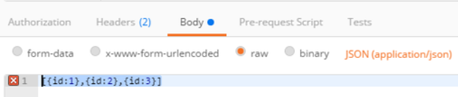

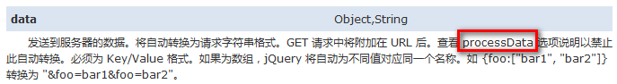

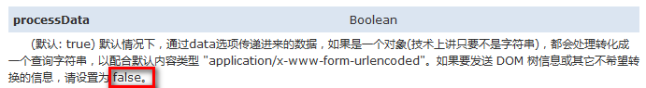
@PostMapping("/savereturn")
public AppResponse<Object> saveReturnInfo(@RequestBody List<ProjectReturnVo> pro){
return AppResponse.ok(null);
}

2 自定义POJO对象封装list集合,接收多个对象数据
- 自定义POJO对象
- Url? pro[0].name=xxx& pro[0].age=23& pro[1].name=yyy& pro[1].age=25
@PostMapping("/savereturn")
public AppResponse<Object> saveReturnInfo(Datas ds){
return AppResponse.ok(null);
}
class Datas(){
List<ProjectReturnVo> pro;
}
- 页面这样提交
<input name="pro[0].name" value="zhangsan"/>
<input name="pro[0].age" value="18"/>
<input name="pro[1].name" value="lisi"/>
<input name="pro[1].age" value="50"/>
<input name="..." value=""/>
<input name=".." value=""/>
<input name="pro[n].properties1" value="value1"/>
<input name="pro[n].properties2" value="value2"/>

8.2 封装回报信息ProjectReturnVo
com.atguigu.project.vo.req.ProjectReturnVo
package com.atguigu.project.vo.req;

import com.atguigu.vo.BaseVo;

import io.swagger.annotations.ApiModel;
import io.swagger.annotations.ApiModelProperty;
import lombok.Data;

@ApiModel
@Data
public class ProjectReturnVo extends BaseVo {

private String projectToken;// 项目的临时token

// type supportmoney content count signalpurchase purchase freight invoice
// rtndate
@ApiModelProperty(value = "回报类型： 0-虚拟回报 1-实物回报", required = true)
private byte type;

@ApiModelProperty(value = "支持金额", required = true)
private Integer supportmoney;

@ApiModelProperty(value = "回报内容", required = true)
private String content;

@ApiModelProperty(value = "回报数量", required = true)
private Integer count;

@ApiModelProperty(value = "单笔限购", required = true)
private Integer signalpurchase;

@ApiModelProperty(value = "限购数量", required = true)
private Integer purchase;

@ApiModelProperty(value = "运费", required = true)
private Integer freight;

@ApiModelProperty(value = "发票 0-不开发票 1-开发票", required = true)
private Byte invoice;

@ApiModelProperty(value = "回报时间，天数", required = true)
private Integer rtndate;

}

8.3 回报类型枚举ProjectReturnEnume
com.atguigu.enums.ProjectReturnEnume
package com.atguigu.enums;

public enum ProjectReturnEnume {

VIRTUAL((byte) 0, "虚拟物品"), REAL((byte) 1, "实物回报");

private byte code;
private String type;

private ProjectReturnEnume(byte code, String type) {
this.code = code;
this.type = type;
}

public byte getCode() {
return code;
}

public void setCode(byte code) {
this.code = code;
}

public String getType() {
return type;
}

public void setType(String type) {
this.type = type;
}

}

package com.atguigu.enums;

public enum ProjectInvoiceEnume {

NO_FP((byte) 0, "不开发票"), HAVE_FP((byte) 1, "开发票");

private byte code;
private String type;

private ProjectInvoiceEnume(byte code, String type) {
this.code = code;
this.type = type;
}

public byte getCode() {
return code;
}

public void setCode(byte code) {
this.code = code;
}

public String getType() {
return type;
}

public void setType(String type) {
this.type = type;
}

}

8.4 项目状态枚举ProjectStatusEnume
com.atguigu.enums.ProjectStatusEnume
package com.atguigu.enums;

/**项目状态*/
public enum ProjectStatusEnume {

DRAFT((byte)0,"草稿"),
SUBMIT_AUTH((byte)1,"提交审核申请"),
AUTHING((byte)2,"后台正在审核"),
AUTHED((byte)3,"后台审核通过"),
AUTHFAIL((byte)4,"审核失败"),
STARTING((byte)5,"开始众筹"),//新增众筹项目一些状态
SUCCESS((byte)6,"众筹成功"),
FINISHED((byte)7,"众筹完成"),
FAIL((byte)8,"众筹失败");

private byte code;
private String status;

public byte getCode() {
return code;
}
public void setCode(byte code) {
this.code = code;
}
public String getStatus() {
return status;
}
public void setStatus(String status) {
this.status = status;
}
private ProjectStatusEnume(byte code, String status) {
this.code = code;
this.status = status;
}

}

8.5 项目发票枚举ProjectInvoiceEnume
com.atguigu.enums.ProjectInvoiceEnume
package com.atguigu.enums;

public enum ProjectInvoiceEnume {

NO_FP((byte) 0, "不开发票"), HAVE_FP((byte) 1, "开发票");

private byte code;
private String type;

private ProjectInvoiceEnume(byte code, String type) {
this.code = code;
this.type = type;
}

public byte getCode() {
return code;
}

public void setCode(byte code) {
this.code = code;
}

public String getType() {
return type;
}

public void setType(String type) {
this.type = type;
}

}

8.6 保存回报详细ProjectCreateController
com.atguigu.project.controller.ProjectCreateController
@ApiOperation("项目发起第3步-项目保存项目回报信息")
@PostMapping("/savereturn")
public AppResponse<Object> saveReturnInfo(@RequestBody List<ProjectReturnVo> pro){
ProjectReturnVo projectReturnVo = pro.get(0);
String projectToken = projectReturnVo.getProjectToken();
//1、去redis中查询到之前项目的信息
String projectToken = redisTemplate.opsForValue()
.get(ProjectConstant.TEMP_PROJECT_PREFIX+projectToken);
//2、转换
ProjectRedisStorageVo storageVo = JSON.parseObject(projectToken, ProjectRedisStorageVo.class);
//3、将页面收集来的回报数据封装重新放入redis
List<TReturn> returns = new ArrayList<>();
for (ProjectReturnVo projectReturnVo2 : pro) {
TReturn tReturn = new TReturn();
BeanUtils.copyProperties(projectReturnVo2, tReturn);
returns.add(tReturn);
}
//更新了return集合
storageVo.setProjectReturns(returns);
//4、给redis中重新保存这个临时数据
String jsonString = JSON.toJSONString(storageVo);
redisTemplate.opsForValue().set(ProjectConstant.TEMP_PROJECT_PREFIX+projectToken, jsonString);
return AppResponse.ok("OK");
}

8.7 确认信息表(支付宝账号+法人身份证号)
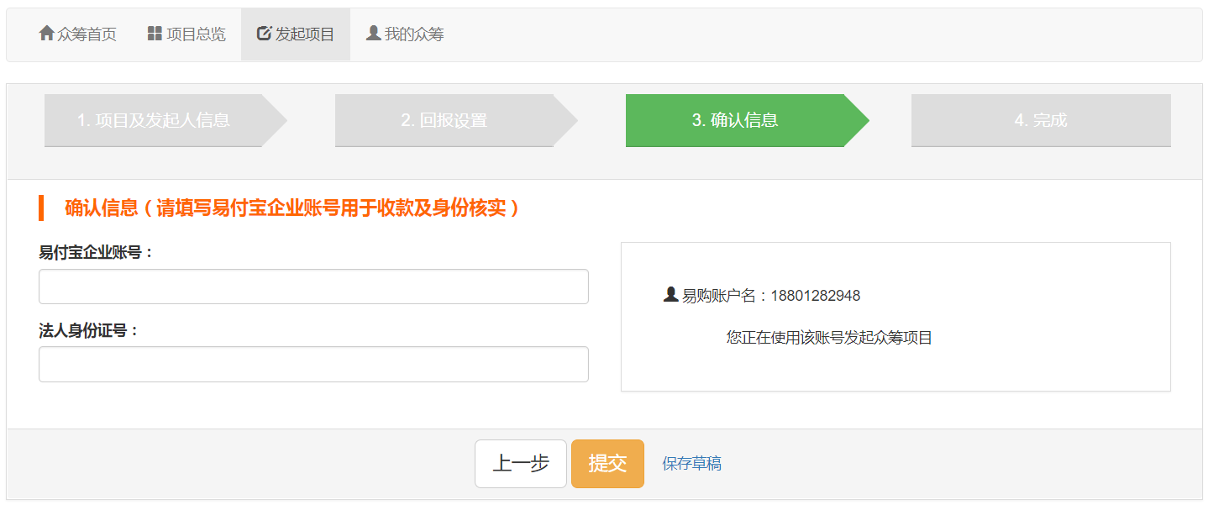

第九章 项目模块-项目初始化第四步，保存完成

9.1 项目图片类型枚举ProjectImageTypeEnume
com.atguigu.scw.project.enums.ProjectImageTypeEnume
package com.atguigu.scw.project.enums;
public enum ProjectImageTypeEnume {
HEADER((byte)0, "头图"),
DETAILS((byte)1, "详细图");
private byte code;
private String type;
private ProjectImageTypeEnume(byte code, String type) {
this.code = code;
this.type = type;
}
public byte getCode() {
return code;
}
public void setCode(byte code) {
this.code = code;
}
public String getType() {
return type;
}
public void setType(String type) {
this.type = type;
}
}

9.2 保存项目ProjectCreateController
com.atguigu.project.controller.ProjectCreateController
@ApiImplicitParams({
@ApiImplicitParam(name="accessToken",value="用户令牌",required=true),
@ApiImplicitParam(name="projectToken",value="项目标识",required=true),
@ApiImplicitParam(name="ops",value="用户操作类型 0-保存草稿 1-提交审核",required=true)
})
@ApiOperation("项目发起第4步-项目保存项目回报信息")
@PostMapping("/submit")
public AppResponse<Object> submit(String accessToken,String projectToken,String ops){

//1、前置校验
String projectToken = redisTemplate.opsForValue()
.get(ProjectConstant.TEMP_PROJECT_PREFIX+projectToken);
ProjectRedisStorageVo project = JSON.parseObject(projectToken, ProjectRedisStorageVo.class);

if(!StringUtils.isEmpty(ops)){
if("1".equals(ops)){
//保存到数据库，提交审核
ProjectStatusEnume auth = ProjectStatusEnume.SUBMIT_AUTH;
projectCreateService.saveProjectInfo(auth , project);
return AppResponse.ok(null);
}else if("0".equals(ops)){
//保存到数据库，草稿状态
ProjectStatusEnume draft = ProjectStatusEnume.DRAFT;
projectCreateService.saveProjectInfo(draft , project);
return AppResponse.ok(null);
}else{
AppResponse<Object> fail = AppResponse.fail(null);
fail.setMsg("不支持此操作");
return fail;
}
}
return AppResponse.fail(null);
}

9.3 业务层接口ProjectService
/**
* 保存项目信息
* @param auth 项目状态信息
* @param project 项目全部信息
*/
void saveProjectInfo(ProjectStatusEnume auth, ProjectRedisStorageVo project);

9.4 业务层实现ProjectServiceImpl
@Override
public void saveProjectInfo(ProjectStatusEnume auth, ProjectRedisStorageVo project) {
//1)、保存项目的基本信息，获取到数据库的id
//页面考过来的：name,remark,money,day,memberid
//我们自己后来操作：status,deploydate,createdate
//自动化修改：supportmoney（已支持的金额），supporter（支持人数） ,completion（完成度）,follower（关注者人数）
TProject projectBase = new TProject();
BeanUtils.copyProperties(project, projectBase);
projectBase.setCreatedate(AppDateUtils.getFormatTime());
//1.1)、基本的信息插入，获取到刚才保存好的项目的自增id
projectMapper.insertSelective(projectBase);

//1.2)、获取到刚才的id
Integer projectId = projectBase.getId();
/**
* <insert id="insertSelective" parameterType="com.atguigu.project.entity.TProject"
* useGeneratedKeys="true" keyProperty="id">
*/
//2、将项目上传的图片保存起来
//2.1）、保存头图
String headerImage = project.getHeaderImage();
TProjectImages images = new TProjectImages(null, projectId, headerImage, ProjectImageTypeEnume.HEADER.getCode());
projectImagesMapper.insertSelective(images);

//2.2)、保存详情图
List<String> detailsImage = project.getDetailsImage();
for (String string : detailsImage) {
TProjectImages img = new TProjectImages(null, projectId, string, ProjectImageTypeEnume.DETAILS.getCode());
projectImagesMapper.insertSelective(img);
}

//3、保存项目的标签信息
List<Integer> tagids = project.getTagids();
for (Integer tgid : tagids) {
TProjectTag tProjectTag = new TProjectTag(null, projectId, tgid);
projectTagMapper.insertSelective(tProjectTag);
}

//4、保存项目的分类信息
List<Integer> typeids = project.getTypeids();
for (Integer tid : typeids) {
TProjectType tProjectType = new TProjectType(null, projectId, tid);
projectTypeMapper.insertSelective(tProjectType);
}

//5、保存回报信息
List<TReturn> returns = project.getProjectReturns();
for (TReturn tReturn : returns) {
//设置项目的id
tReturn.setProjectid(projectId);
returnMapper.insertSelective(tReturn);
}

//6、删除临时数据
redisTemplate.delete(ProjectConstant.TEMP_PROJECT_PREFIX+project.getProjectToken());
}

