项目课程系列之Atcrowdfunding

尚硅谷JavaEE教研组

版本：V1.0

前端开发-项目首页展示
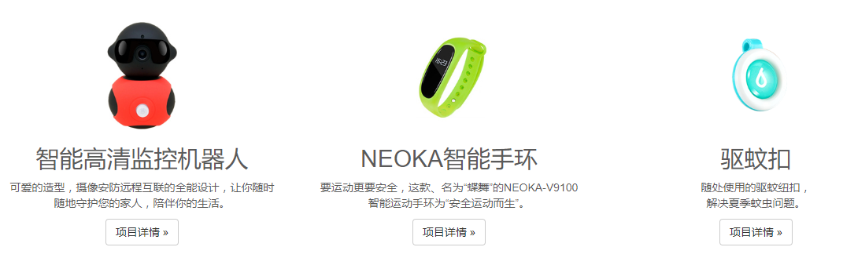

1.1 首页，查询所有项目
package com.atguigu.controller;

import java.util.List;
import org.springframework.beans.factory.annotation.Autowired;
import org.springframework.stereotype.Controller;
import org.springframework.ui.Model;
import org.springframework.web.bind.annotation.GetMapping;
import com.atguigu.bean.AppResponse;
import com.atguigu.feign.ProjectServiceFeign;
import com.atguigu.vo.TProjectVo;
import lombok.extern.slf4j.Slf4j;

@Slf4j
@Controller
public class IndexController {

@Autowired
ProjectServiceFeign projectService;

@GetMapping(value={"/index.html","/"})
public String index(Model model){
//1、查询项目信息
AppResponse<List<TProjectVo>> all = projectService.all();
List<TProjectVo> data = all.getData();
log.debug("查出了项目的内容：{}",data);
model.addAttribute("projects", data);
return "index";
}

}

1.2 Feign接口: ProjectServiceFeign
@FeignClient(value="SCW-PROJECT",fallback=ProjectServiceExceptionHandler.class)
public interface ProjectServiceFeign {
@GetMapping("/project/all")
public AppResponse<List<TProjectVo>> all();
}

1.3 异常处理: ProjectServiceExceptionHandler
package com.atguigu.feign.exception;

import java.util.List;
import org.springframework.stereotype.Component;
import com.atguigu.bean.AppResponse;
import com.atguigu.feign.ProjectServiceFeign;
import com.atguigu.vo.ReturnPayConfirmVo;
import com.atguigu.vo.TProjectVo;
import lombok.extern.slf4j.Slf4j;

@Slf4j
@Component
public class ProjectServiceExceptionHandler implements ProjectServiceFeign {
@Override
public AppResponse<List<TProjectVo>> all() {
log.debug("远程调用出现问题....");
return AppResponse.fail(null);
}
}

1.4 远程服务：查询所有项目，带上头部图片，和详情图片
@ApiOperation("[+]获取系统所有的项目")
@GetMapping("/all")
public AppResponse<List<ProjectVo>> all(){
//1、分步查询，先查出所有项目
//2、再查询这些项目图片
List<ProjectVo> prosVo = new ArrayList<>();

//1、连接查询，所有的项目left join 图片表，查出所有的图片
// left join：笛卡尔积 A*B 1000万*6 = 6000万
// 大表禁止连接查询；
List<TProject> pros = projectInfoService.getAllProjects();

for (TProject tProject : pros) {
Integer id = tProject.getId();
List<TProjectImages> images = projectInfoService.getProjectImages(id);
ProjectVo projectVo = new ProjectVo();
BeanUtils.copyProperties(tProject, projectVo);
for (TProjectImages tProjectImages : images) {
if(tProjectImages.getImgtype() == 0){
projectVo.setHeaderImage(tProjectImages.getImgurl());
}else{
List<String> detailsImage = projectVo.getDetailsImage();
detailsImage.add(tProjectImages.getImgurl());
}
}
prosVo.add(projectVo);
}
return AppResponse.ok(prosVo);
}

1.5 VO: TProjectVo
@Data
public class TProjectVo implements Serializable {
private Integer id;
private String name;
private String remark;
private Long money;
private Integer day;
private Byte status;
private String deploydate;
private Long supportmoney;
private Integer supporter;
private Integer completion;
private Integer memberid;
private String createdate;
private Integer follower;
private String headerImage;
private List<String> detailsImage = new ArrayList<>();
// 项目的所有支持档位
private List<TReturn> returns = new ArrayList<>();
}

1.6 首页,显示项目:index.html
<div class="container marketing">
<!-- Three columns of text below the carousel -->
<div class="col-lg-4" th:each="proj:${projects}">
<img class="img-circle" th:src="${proj.headerImage}" alt="Generic placeholder image" style="width: 140px; height: 140px;">
<h2 th:text="${proj.name}">智能高清监控机器人</h2>
<p th:text="${proj.remark}">可爱的造型，摄像安防远程互联的全能设计，让你随时随地守护您的家人，陪伴你的生活。</p>
<p><a class="btn btn-default" href="project.html" th:href="@{/project/}+${proj.id}" role="button">项目详情 &raquo;</a></p>
</div>
</div>

前端开发-项目详情展示
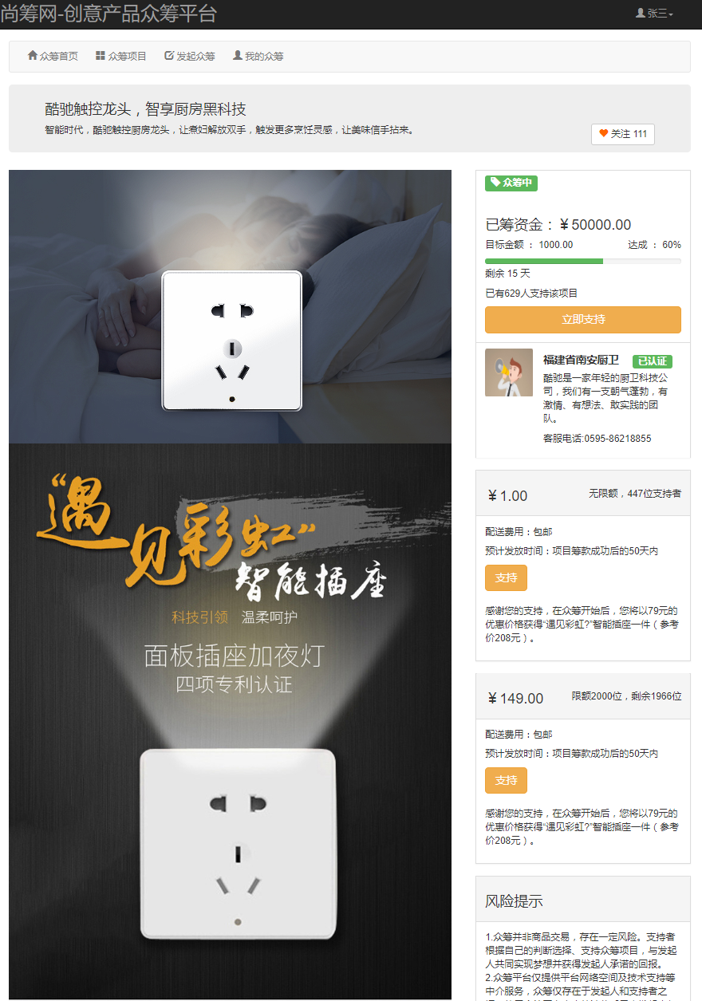

2.1 点击链接，去详情页project.html
<a class="btn btn-default" href="project.html"
th:href="@{/project/}+${proj.id}" role="button">项目详情 &raquo;</a>

2.2 客户端项目

2.2.1 控制器：ProjectController
@RequestMapping("/project")
@Controller
public class ProjectController {
@Autowired
ProjectServiceFeign projectServiceFeign;
@Autowired
UserServiceFeign userServiceFeign;

//查出某个项目的详情
@GetMapping("/{id}")
public String projectInfoPage(@PathVariable("id")Integer id,Model model){
AppResponse<TProjectVo> response = projectServiceFeign.detailsInfo(id);
TProjectVo data = response.getData();
model.addAttribute("project", data);
return "project/project";
}
}

2.2.2 Feign接口ProjectServiceFeign
@FeignClient(value = "SCW-PROJECT", fallback = ProjectServiceExceptionHandler.class)
public interface ProjectServiceFeign {
@GetMapping("/project/all")
public AppResponse<List<TProjectVo>> all();

// 查某个项目
@GetMapping("/project/details/info/{projectId}")
public AppResponse<TProjectVo> detailsInfo(@PathVariable("projectId") Integer projectId);
}

2.4 远程服务：给项目VO增加相关图片属性
package com.atguigu.project.vo.resp;

import java.util.ArrayList;
import java.util.List;
import com.atguigu.project.entity.TReturn;
import io.swagger.annotations.ApiModel;
import io.swagger.annotations.ApiModelProperty;
import lombok.Data;

@ApiModel
@Data
public class ProjectVo {
@ApiModelProperty("项目id")
private Integer id;
@ApiModelProperty("项目名")
private String name;
@ApiModelProperty("项目备注")
private String remark;
@ApiModelProperty("众筹金额")
private Long money;
@ApiModelProperty("天数")
private Integer day;
@ApiModelProperty("项目状态")
private Byte status;
@ApiModelProperty("项目部署日期")
private String deploydate;
@ApiModelProperty("已支持金额")
private Long supportmoney;
@ApiModelProperty("项目支持人数")
private Integer supporter;
@ApiModelProperty("完成度")
private Integer completion;
@ApiModelProperty("项目创建日期")
private String createdate;
@ApiModelProperty("关注人数")
private Integer follower;

@ApiModelProperty("项目头部图")
private String headerImage;
@ApiModelProperty("项目详情图")
private List<String> detailsImage = new ArrayList<>();

@ApiModelProperty("项目回报档位详情")
private List<TReturn> returns = new ArrayList<>();
}

2.5 远程服务：查询单个项目详情，带上头部图片，详情图片
@ApiOperation("[+]获取项目信息详情")
@GetMapping("/details/info/{projectId}")
public AppResponse<ProjectVo> detailsInfo(@PathVariable("projectId")Integer projectId){
TProject p = projectInfoService.getProjectInfo(projectId);
ProjectVo projectVo = new ProjectVo();

//1、查出这个项目的所有图片
List<TProjectImages> projectImages = projectInfoService.getProjectImages(p.getId());
for (TProjectImages tProjectImages : projectImages) {
if(tProjectImages.getImgtype() == 0){
projectVo.setHeaderImage(tProjectImages.getImgurl());
}else{
List<String> detailsImage = projectVo.getDetailsImage();
detailsImage.add(tProjectImages.getImgurl());
}
}

//2、项目的所有支持档位；
List<TReturn> returns = projectInfoService.getProjectReturns(p.getId());
projectVo.setReturns(returns);

BeanUtils.copyProperties(p, projectVo);
return AppResponse.ok(projectVo);
}

2.6 详情页project.html
------------------------------项目名称和简介 -----------------------------------------------------------------

<div class="container">
<div class="row clearfix">
<div class="col-md-12 column">
<div class="jumbotron nofollow" style="padding-top: 10px;">
<h3 th:text="${project.name}">酷驰触控龙头，智享厨房黑科技</h3>
<div style="float: left; width: 70%;" th:text="${project.remark}">
智能时代，酷驰触控厨房龙头，让煮妇解放双手，触发更多烹饪灵感，让美味信手拈来。</div>
<div style="float: right;">
<button type="button" class="btn btn-default">
<i style="color: #f60" class="glyphicon glyphicon-heart"></i> 关注
<label th:text="${project.follower}">111</label>
</button>
</div>
</div>
</div>
</div>
</div>
------------------------------头图和详情图--------------------------------------------------------------------

<div class="container">
<div class="row clearfix">
<div class="col-md-12 column">
<div class="row clearfix">
<div class="col-md-8 column">

<img alt="140x140" width="740" src="img/product_detail_head.jpg" th:src="${project.headerImage}" />
<img alt="140x140" width="740" th:each="img:${project.detailsImage}" th:src="${img}" />

</div>
------------------------------众筹资金情况--------------------------------------------------------------------

<div class="col-md-4 column">
<div class="panel panel-default" style="border-radius: 0px;">
<div class="panel-heading"
style="background-color: #fff; border-color: #fff;">
<span class="label label-success">
<i class="glyphicon glyphicon-tag"></i>
<span th:text="${detailsInfo.status} == 0? '草稿': ''">众筹中</span>
<span th:text="${detailsInfo.status} == 1? '提交审核申请': ''">众筹中</span>
<span th:text="${detailsInfo.status} == 5? '众筹中': ''">众筹中</span>
</span>
</div>
<div class="panel-body">
<h3>
已筹资金：￥
<label th:text="${project.supportmoney}" style="color: blue;"> 1000.00</label>
</h3>
<p>
<span>目标金额 ：<label th:text="${project.money}" style="color: blue;">652.00</label></span>

<span style="float: right;">达成 ： <label style="color: blue;">60%</label></span>
</p>
<div class="progress" style="height: 10px; margin-bottom: 5px;">
<div class="progress-bar progress-bar-success"
role="progressbar" aria-valuenow="60" aria-valuemin="0" aria-valuemax="100" style="width: 60%;"></div>
</div>
<p>
剩余 <label style="color: blue;" th:text="${project.day}">652</label>天
</p>
<div>
<p>
<span>已有 <label style="color: blue;" th:text="${project.supporter}">652</label> 人支持该项目
</p>
<button type="button"
class="btn btn-warning btn-lg btn-block" data-toggle="modal"
data-target="#myModal">立即支持</button>
</div>
</div>
----------------------------------发起人认证信息------------------------------------------------------------

<div class="panel-footer"
style="background-color: #fff; border-top: 1px solid #ddd; border-bottom-right-radius: 0px; border-bottom-left-radius: 0px;">
<div class="container-fluid">
<div class="row clearfix">
<div class="col-md-3 column" style="padding: 0;">
<img alt="140x140" src="img/services-box2.jpg"
data-holder-rendered="true" style="width: 80px; height: 80px;">
</div>
<div class="col-md-9 column">
<div class="">
<h4>
<b>福建省南安厨卫 [[${project.memberid}]]</b> <span
style="float: right; font-size: 12px;" class="label label-success">已认证</span>
</h4>
<p style="font-size: 12px">
酷驰是一家年轻的厨卫科技公司，我们有一支朝气蓬勃，有激情、有想法、敢实践的团队。</p>
<p style="font-size: 12px">客服电话:0595-86218855</p>
</div>
</div>
</div>
</div>
</div>
</div>
-----------------------------------------回报档位---------------------------------------------------------------
<div th:each="ret:${project.returns}" class="panel panel-default" style="border-radius: 0px;">
<div class="panel-heading">
<h3>
￥[[${ret.supportmoney}]]
<span style="float: right; font-size: 12px;">

<label th:if="${ret.purchase > 0}" th:text="'限额'+${ret.purchase}+'份'">限额100份</label>
<label th:if="${ret.purchase <= 0}" th:text="无限额"> </label>，447位支持者

</span>
</h3>
</div>
<div class="panel-body">

<p>配送费用：
<label th:if="${ret.freight>0}" th:text="'不包邮，邮费：'+${ret.freight}">包邮</label>
<label th:if="${ret.freight<=0}" th:text="包邮">包邮</label>
</p>

<p>预计发放时间：项目筹款成功后的
<label th:text=${ret.rtndate}>50</label>
天内</p>
<button type="button" class="suportReturnBtn btn btn-warning btn-lg" th:href="@{/project/return/confirm(projectId=${project.id},retId=${ret.id})}" >
支持</button>
<br>
<br>
<p th:text="${ret.content}">感谢您的支持，在众筹开始后，您将以79元的优惠价格获得“遇见彩虹?”智能插座一件（参考价208元）。</p>
</div>
</div>
------------------------风险提示-------------------------------------------------------------------------------

<div class=" panel panel-default" style="border-radius: 0px;">
<div class="panel-heading">
<h3>风险提示</h3>
</div>
<div class="panel-body">
<p>
1.众筹并非商品交易，存在一定风险。支持者根据自己的判断选择、支持众筹项目，与发起人共同实现梦想并获得发起人承诺的回报。<br>
2.众筹平台仅提供平台网络空间及技术支持等中介服务，众筹仅存在于发起人和支持者之间，使用众筹平台产生的法律后果由发起人与支持者自行承担。<br>
3.本项目必须在2017-06-09之前达到￥10000.00
的目标才算成功，否则已经支持的订单将取消。订单取消或募集失败的，您支持的金额将原支付路径退回。<br>
4.请在支持项目后15分钟内付款，否则您的支持请求会被自动关闭。<br>
5.众筹成功后由发起人统一进行发货，售后服务由发起人统一提供；如果发生发起人无法发放回报、延迟发放回报、不提供回报后续服务等情况，您需要直接和发起人协商解决。<br>
6.如您不同意上述风险提示内容，您有权选择不支持；一旦选择支持，视为您已确认并同意以上提示内容。
</p>
</div>
</div>
----------------------------为你推荐-------------------------------------------------------------------------------------
<div>
<h2>为你推荐</h2>
<hr>
</div>
<div class="prjtip panel panel-default"
style="border-radius: 0px;">
<div class="panel-body">
<img src="img/product-3.png" width="100%" height="100%">
</div>
</div>

<div class="prjtip panel panel-default"
style="border-radius: 0px;">
<div class="panel-body">
<img src="img/product-4.jpg" width="100%" height="100%">
</div>
</div>
-----------------------------------------------------------------------------------------------------------------
</div>
</div>
</div>
</div>
</div>
</div>
<!-- /container -->

<script>
$(".suportReturnBtn").click(function(){
window.location.href= $(this).attr('href');
});
</script>

第三章 前端开发-项目详情-立即支持-档位页【模态窗】
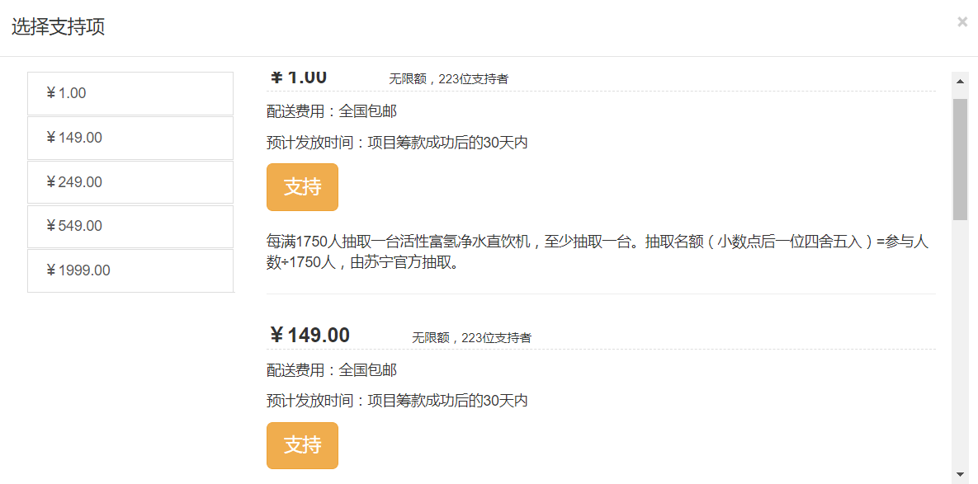

3.1 点击项目详情页【立即支持】按钮，来到投资档位页，展示数据
<button type="button"class="btn btn-warning btn-lg btn-block" data-toggle="modal"
data-target="#myModal">立即支持</button>

3.2 弹出模态窗口
<div class="modal fade" id="myModal" tabindex="-1" role="dialog" aria-labelledby="myModalLabel">
<div class="modal-dialog " style="width: 960px; height: 400px;" role="document">
<div class="modal-content" data-spy="scroll" data-target="#myScrollspy">

<div class="modal-header">
<button type="button" class="close" data-dismiss="modal" aria-label="Close">
<span aria-hidden="true">&times;</span>
</button>
<h4 class="modal-title" id="myModalLabel">选择支持项</h4>
</div>

<div class="modal-body">
<div class="container-fluid">
<div class="row clearfix">

<div class="col-sm-3 col-md-3 column" id="myScrollspy">
<ul class="nav nav-tabs nav-stacked">
<li class="active">
<a th:href="${'#section'+iterStat.index}" th:each="ret,iterStat:${project.returns}">
￥[[${ret.supportmoney}]]</a>
</li>
</ul>
</div>

<div id="navList" class="col-sm-9 col-md-9 column" style="height: 400px; overflow-y: auto;">

<div th:each="ret,iterStat:${project.returns}">
<h2 id="section-1" th:id="${'section'+iterStat.index}" style="border-bottom: 1px dashed #ddd;">
<span style="font-size: 20px; font-weight: bold;">￥[[${ret.supportmoney}]]</span><span
style="font-size: 12px; margin-left: 60px;">[[${ret.purchase > 0 ? '限额:' + ret.purchase : '不限额'}]]，
223位支持者</span>
</h2>
<p>配送费用：[[${ret.freight > 0 ? '邮费: '+ret.freight : '包邮'}]]</p>
<p>预计发放时间：项目筹款成功后的[[${ret.rtndate}]]天内</p>
<button type="button" class=" suportReturnBtn btn btn-warning btn-lg "
onclick="window.location.href='pay-step-1.html'"
th:href="@{/project/return/confirm(projectId=${project.id},retId=${ret.id})}">支持</button>
<br>
<br>
<p th:text="${ret.content}">每满1750人抽取一台活性富氢净水直饮机，至少抽取一台。抽取名额（小数点后一位四舍五入）=参与人数÷1750人，由苏宁官方抽取。</p>
<hr>
</div>
</div>
</div>
</div>
</div>
</div>
</div>
</div>

第四章 前端开发-项目回报确认页

4.1 项目回报确认页pay-step-1.html
点击支持按钮，会来到该页面。
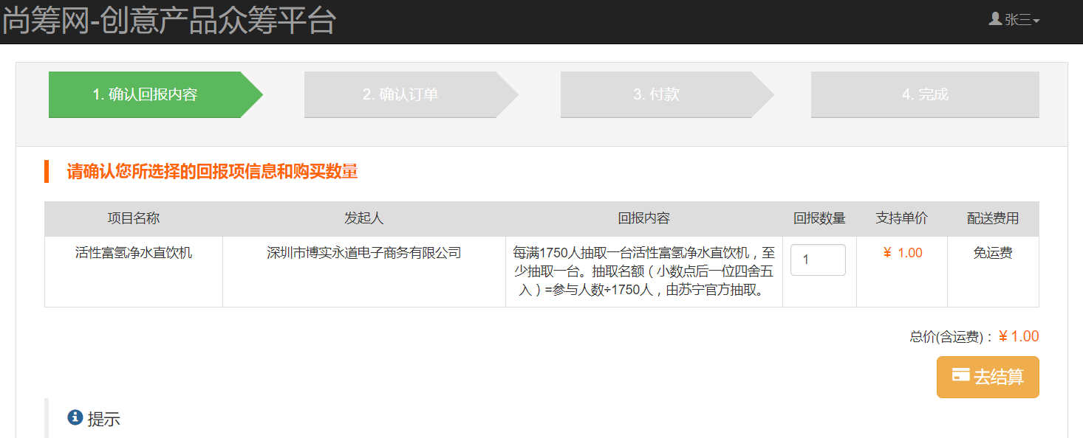

4.5 服务端：封装返回回报VO:ReturnPayConfirmVo
package com.atguigu.project.vo.resp;

import java.math.BigDecimal;
import lombok.Data;

/** 回报支付确认的vo */
@Data
public class ReturnPayConfirmVo {

// 项目信息
private Integer projectId;
private String projectName;
private String projectRemark;

// 发起人信息
private Integer memberId;
private String memberName;

// 回报的信息
private Integer returnId;
private String returnName;
private String returnContent;
private Integer num; // 支持数量，默认数量1，不能大于signalpurchase单笔限购数量
private Integer price;// 支持单价
private Integer freight; //运费
private Integer signalpurchase;// 单笔限购数量

// 所有的double和float的运算在任何情况下都会导致丢失精度，使用BigDecimal进行计算
private BigDecimal totalPrice;// 总价 totalPrice =price* num+ freight
}

4.2 客户端：点击【支持】按钮来到确认回报页面
如果买多个档位，数据该怎么处理？
<button type="button" class="suportReturnBtn btn btn-warning btn-lg"
th:href="@{/project/return/confirm(projectId=${project.id},retId=${ret.id})}" >支持</button>

// 支持购买某个档位；去回报确认页
@GetMapping("/return/confirm")
public String toReturnConfirmPage(@RequestParam("projectId") Integer projectId,
@RequestParam("retId") Integer retId, Model model, HttpSession session) {
AppResponse<ReturnPayConfirmVo> vo = projectServiceFeign.confirmProjectReturnPayInfo(projectId, retId);
ReturnPayConfirmVo data = vo.getData();
model.addAttribute("confirmReturn", data);
session.setAttribute("returnConfirm", data);//结算页也需要这个数据,采用session共享数据
return "project/pay-step-1";
}
Feign接口：ProjectServiceFeign

@GetMapping("/project/support/returnConfirm")
public AppResponse<ReturnPayConfirmVo> confirmProjectReturnPayInfo(@RequestParam("projectId") Integer projectId,@RequestParam("retId") Integer retId);

4.3 项目服务端：返回回报数据ProjectSupportController
@Api(tags = "项目支持模块")
@RequestMapping("/project/support")
@RestController
public class ProjectSupportController {

@Autowired
ProjectInfoService projectInfoService;

@Autowired
UserServiceFeign userServiceFeign;

@GetMapping("/returnConfirm")
public AppResponse<ReturnPayConfirmVo> confirmProjectReturnPayInfo(
@RequestParam("projectId") Integer projectId,@RequestParam("retId") Integer retId) {
// 1、项目的信息
TProject project = projectInfoService.getProjectInfo(projectId);

// 2、项目发起人的信息
Integer memberid = project.getMemberid();
AppResponse<TMember> memberInfo = userServiceFeign.getMemberInfo(memberid);
TMember member = memberInfo.getData();

// 3、回报的信息
TReturn returnInfo = projectInfoService.getProjectReturnById(retId);

// 4、封装数据并返回
ReturnPayConfirmVo confirmVo = new ReturnPayConfirmVo();
confirmVo.setFreight(returnInfo.getFreight());
confirmVo.setMemberId(member.getId());
confirmVo.setMemberName(member.getUsername());
confirmVo.setNum(1);
confirmVo.setPrice(returnInfo.getSupportmoney());
confirmVo.setProjectId(project.getId());
confirmVo.setProjectName(project.getName());
confirmVo.setProjectRemark(project.getRemark());
confirmVo.setReturnId(returnInfo.getId());
confirmVo.setReturnName(returnInfo.getContent());
confirmVo.setSignalpurchase(returnInfo.getSignalpurchase());

Integer totalMoney = returnInfo.getSupportmoney() * 1 + returnInfo.getFreight();
BigDecimal bigDecimal = new BigDecimal(totalMoney.toString());
confirmVo.setTotalPrice(bigDecimal);

return AppResponse.ok(confirmVo);
}
}

4.4 用户服务端：提供查询会员信息的Feign
这里涉及两个服务项目间调用问题
增加Feign依赖，开启远程调用@EnableCircuitBreaker @EnableFeignClients
@FeignClient(value="SCW-USER")
public interface UserServiceFeign {
@GetMapping("/user/info/{id}")
public AppResponse<TMember> getMemberInfo(@PathVariable("id")Integer memberid);
}

4.6 客户端：显示数据：pay-step-1.html
<div class="col-md-12 column">
<table class="table table-bordered"
style="text-align: center;">
<thead>
<tr style="background-color: #ddd;">
<td>项目名称</td>
<td>发起人</td>
<td width="300">回报内容</td>
<td width="80">回报数量</td>
<td>支持单价</td>
<td>配送费用</td>
</tr>
</thead>
<tbody>
<tr>
<!-- th：text：会转义特殊字符 -->
<td th:utext="${confirmReturn.projectName}">活性富氢净水直饮机</td>
<td th:text="${confirmReturn.memberName}">深圳市博实永道电子商务有限公司</td>
<td th:text="${confirmReturn.returnName}">每满1750人抽取一台活性富氢净水直饮机，至少抽取一台。抽取名额（小数点后一位四舍五入）=参与人数÷1750人，由苏宁官方抽取。</td>
<td>
<input type="number" min="1" th:max="${confirmReturn.signalpurchase}"
class="form-control" style="width: 60px;" value="1" th:value="${confirmReturn.num}">
</td>
<td style="color: #F60">￥ [[${confirmReturn.price}]]</td>
<td>[[${confirmReturn.freight>0?confirmReturn.freight:"免运费"}]]</td>
</tr>
</tbody>
</table>
<div style="float: right;">
<p>
总价(含运费)：<span style="font-size: 16px; color: #F60;">￥[[${confirmReturn.totalPrice}]]</span>
</p>
<button id="submitReturnInfoBtn" type="button" class="btn btn-warning btn-lg" style="float: right;"
th:href="@{/project/pay/confirm}">
<i class="glyphicon glyphicon-credit-card"></i> 去结算
</button>
</div>
</div>

