项目课程系列之Atcrowdfunding

尚硅谷JavaEE教研组

版本：V1.0

项目计划
- zTree
- 菜单树展示
- 菜单模块(增删改)

ztree介绍和使用

1.1 菜单树实现原理
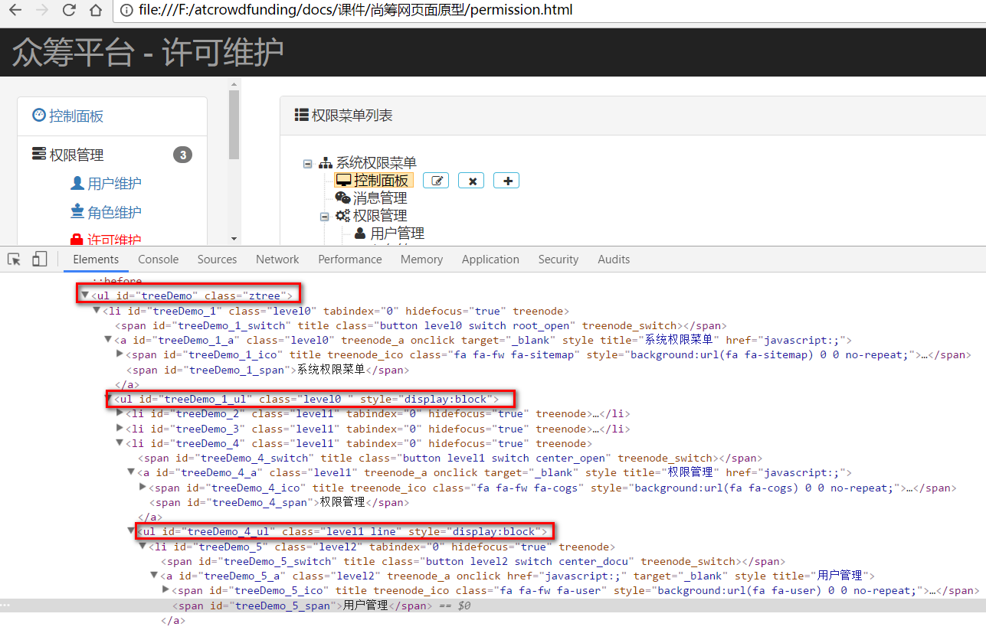

1.2 参考zTree-demo
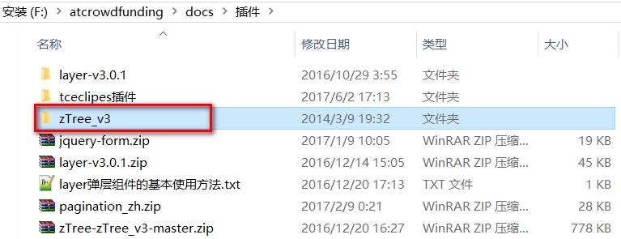

1.3 查看框架的源代码

1.3.1 本地文档
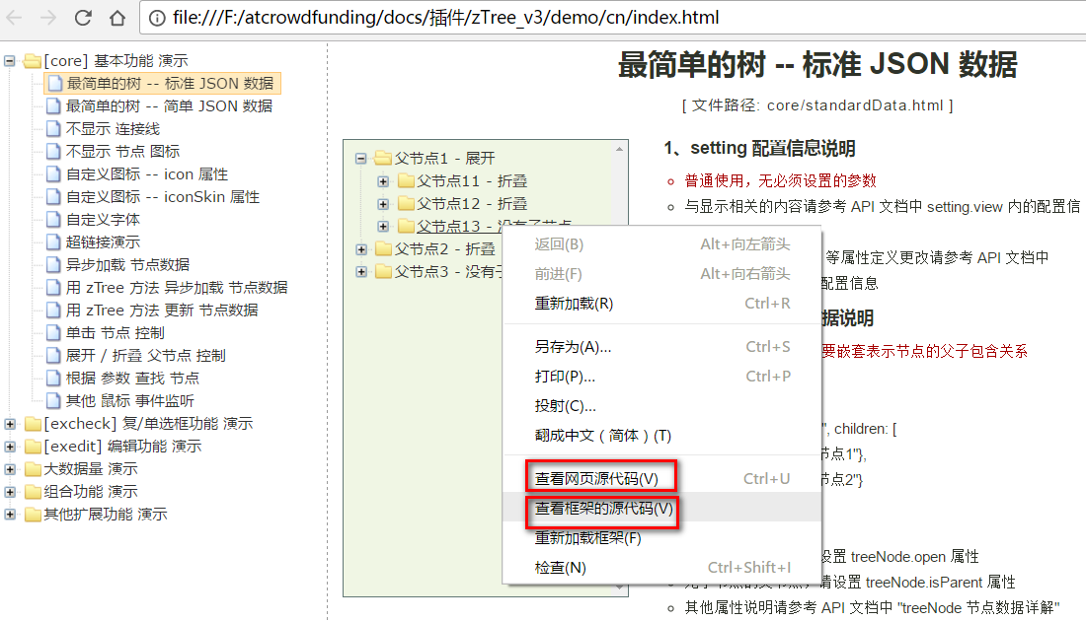

1.3.2 联网文档
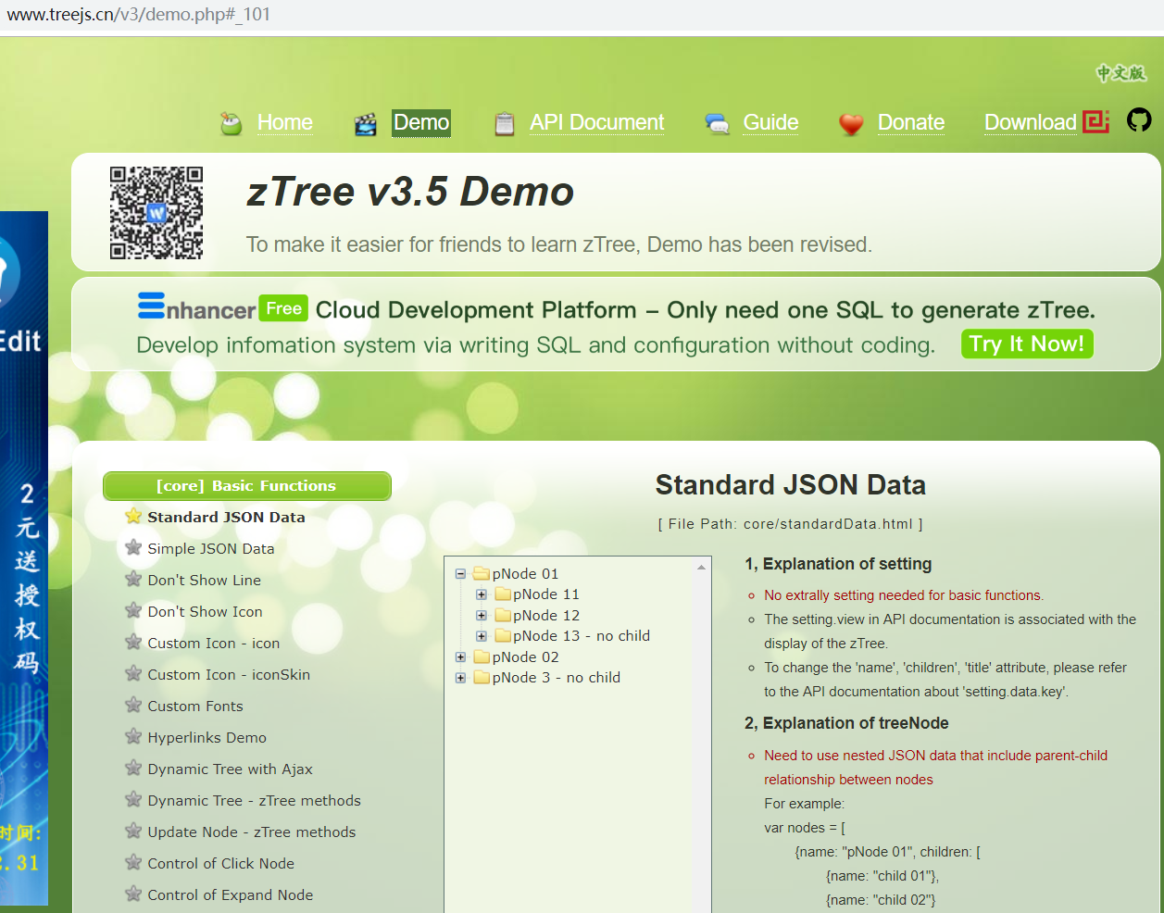

1.4 Demo演示

1.4.1 将ztree引入到项目中
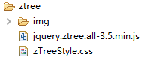

1.4.2 分析树结构
引入css和js，拷贝zTree案例代码，展示出树结构。
<link rel="stylesheet" href="${APP_PATH}/ztree/zTreeStyle.css">
<script src="${APP_PATH}/ztree/jquery.ztree.all-3.5.min.js"></script>

1.4.3 增加容器
<div class="panel-body">
<ul id="treeDemo" class="ztree"></ul>
</div>

1.4.4 增加模拟代码
var zNodes =[
{ name:"父节点1 - 展开", open:true,
children: [
{ name:"父节点11 - 折叠",
children: [
{ name:"叶子节点111"},
{ name:"叶子节点112"},
{ name:"叶子节点113"},
{ name:"叶子节点114"}
]},
{ name:"父节点12 - 折叠",
children: [
{ name:"叶子节点121"},
{ name:"叶子节点122"},
{ name:"叶子节点123"},
{ name:"叶子节点124"}
]},
{ name:"父节点13 - 没有子节点", isParent:true}
]},
{ name:"父节点2 - 折叠",
children: [
{ name:"父节点21 - 展开", open:true,
children: [
{ name:"叶子节点211"},
{ name:"叶子节点212"},
{ name:"叶子节点213"},
{ name:"叶子节点214"}
]},
{ name:"父节点22 - 折叠",
children: [
{ name:"叶子节点221"},
{ name:"叶子节点222"},
{ name:"叶子节点223"},
{ name:"叶子节点224"}
]},
{ name:"父节点23 - 折叠",
children: [
{ name:"叶子节点231"},
{ name:"叶子节点232"},
{ name:"叶子节点233"},
{ name:"叶子节点234"}
]}
]},
{ name:"父节点3 - 没有子节点", isParent:true}
];
var setting = { };
$.fn.zTree.init($("#treeDemo"), setting, zNodes);

1.4.5 简单JSON
var setting = {
data: {
simpleData: {
enable: true
}
}
};

var zNodes =[
{ id:1, pId:0, name:"pNode 1", open:true},
{ id:11, pId:1, name:"pNode 11"},
{ id:111, pId:11, name:"leaf node 111"},
{ id:112, pId:11, name:"leaf node 112"},
{ id:113, pId:11, name:"leaf node 113"},
{ id:114, pId:11, name:"leaf node 114"},
{ id:12, pId:1, name:"pNode 12"},
{ id:121, pId:12, name:"leaf node 121"},
{ id:122, pId:12, name:"leaf node 122"},
{ id:123, pId:12, name:"leaf node 123"},
{ id:124, pId:12, name:"leaf node 124"},
{ id:13, pId:1, name:"pNode 13 - no child", isParent:true},
{ id:2, pId:0, name:"pNode 2"},
{ id:21, pId:2, name:"pNode 21", open:true},
{ id:211, pId:21, name:"leaf node 211"},
{ id:212, pId:21, name:"leaf node 212"},
{ id:213, pId:21, name:"leaf node 213"},
{ id:214, pId:21, name:"leaf node 214"},
{ id:22, pId:2, name:"pNode 22"},
{ id:221, pId:22, name:"leaf node 221"},
{ id:222, pId:22, name:"leaf node 222"},
{ id:223, pId:22, name:"leaf node 223"},
{ id:224, pId:22, name:"leaf node 224"},
{ id:23, pId:2, name:"pNode 23"},
{ id:231, pId:23, name:"leaf node 231"},
{ id:232, pId:23, name:"leaf node 232"},
{ id:233, pId:23, name:"leaf node 233"},
{ id:234, pId:23, name:"leaf node 234"},
{ id:3, pId:0, name:"pNode 3 - no child", isParent:true}
];

$(document).ready(function(){
$.fn.zTree.init($("#treeDemo"), setting, zNodes);
});

加载菜单树

2.1 加载许可树

2.1.1 准备模拟数据
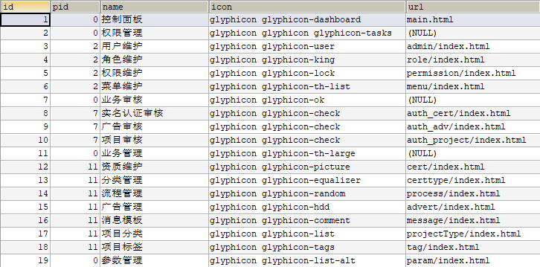

2.1.2 加载菜单树，导入 zTree
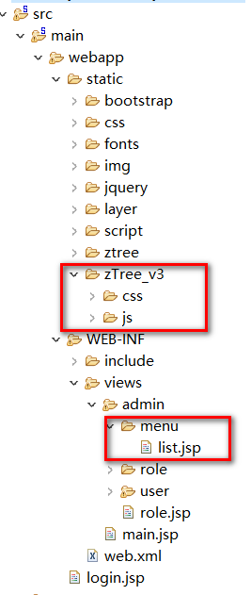

2.1.3 控制器
@ResponseBody
@GetMapping("/list")
public List<TMenu> menusList(){
List<TMenu> listMenus = systemMenuService.listMenusUnmerge();
return listMenus;
}

2.1.4 业务层
@Override
public List<TMenu> listMenusUnmerge() {
return menuMapper.selectByExample(null);
}

2.1.5 页面展示
<link rel="stylesheet" href="${appPath }/static/zTree_v3/css/zTreeStyle/zTreeStyle.css">
<script src="${appPath}/static/zTree_v3/js/jquery.ztree.all-3.5.js"></script>
<ul id="menuTree" class="ztree"></ul>
var ztreeObj = null;
$(function(){
//初始化所有菜单
initMenus();
});

function initMenus(){
//1、ztree配置项
var setting = {
data : {
simpleData : {
enable : true,
pIdKey: "pid" //指定哪个为父ID，默认查找名称为pId属性
},
key:{
url:"xxx"//指定一个不被识别的属性，这样点击菜单就不会执行url跳转了
}
}
};
//2、拿到menu的ztree数据
$.get("${appPath}/menu/list",function(data){
//3、展示节点
ztreeObj = $.fn.zTree.init($("#menuTree"), setting, data);
//展开所有节点
//var ztreeObj = $.fn.zTree.getZTreeObj("menuTree");
ztreeObj.expandAll(true);
});
}

2.2 增加根菜单
data.push({id:0,name:"系统菜单"});

2.3 增加图标
- 注意：设置图标时，如果字体出现乱码，需要将css映射引用放置在Bootstrap样式之前。
<link rel="stylesheet" href="${appPath }/static/zTree_v3/css/zTreeStyle/zTreeStyle.css">
<link rel="stylesheet" href="${appPath }/static/bootstrap/css/bootstrap.min.css">
<link rel="stylesheet" href="${appPath }/static/css/font-awesome.min.css">
- 自定义图标
//1、ztree配置项
var setting = {
view: { //定制显示效果
addDiyDom: customeIcon,//显示自定义图标
addHoverDom: addHoverDom, //显示按钮
removeHoverDom: removeHoverDom //移除按钮
}
};

//自定义图标
function customeIcon(treeId,treeNode){
//treeId：整个ztree树的id，treeNode：当前正在渲染的节点
console.log(treeNode)
//1、找到每一个ztree节点上用来显示图标的标签，删掉这个标签的原来的class。加上我们指定的class
//2、每一个节点展示的时候都会调用
//$("#"+treeNode.tId+"_span").text("111")
$("#"+treeNode.tId+"_ico").removeClass();//.addClass();
$("#"+treeNode.tId+"_span").before("<span class='"+treeNode.icon+"'></span>")
}
- data.push({id:0,name:"系统菜单",icon:"glyphicon glyphicon-asterisk"});
- 相关节点说明
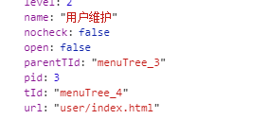
显示文字的标签 id=menuTree_4_span
显示图标的标签 id=menuTree_4_ico
整个子节点：idmenuTree_4_a 的a标签
tId+"_span"：就是用来显示文字的
tid+"_ico"：就是用来显示图标的

2.4 增加、移除按钮组

2.4.1 增加事件处理
view: { //定制显示效果
addDiyDom: customeIcon,//显示自定义图标
addHoverDom: addHoverDom, //显示按钮
removeHoverDom: removeHoverDom //移除按钮
}

2.4.2 增加按钮组
function addHoverDom(treeId,treeNode){
var aObj = $("#" + treeNode.tId + "_a");
aObj.attr("href", "javascript:;");
if (treeNode.editNameFlag || $("#btnGroup"+treeNode.tId).length>0) return;
var s = '<span id="btnGroup'+treeNode.tId+'">';
if ( treeNode.level == 0 ) {
s += '<a class="btn btn-info dropdown-toggle btn-xs" style="margin-left:10px;padding-top:0px;" href="#" >&nbsp;&nbsp;<i class="fa fa-fw fa-plus rbg "></i></a>';
} else if ( treeNode.level == 1 ) {
s += '<a class="btn btn-info dropdown-toggle btn-xs" style="margin-left:10px;padding-top:0px;" href="#" title="修改权限信息">&nbsp;&nbsp;<i class="fa fa-fw fa-edit rbg "></i></a>';
if (treeNode.children.length == 0) {
s += '<a class="btn btn-info dropdown-toggle btn-xs" style="margin-left:10px;padding-top:0px;" href="#" >&nbsp;&nbsp;<i class="fa fa-fw fa-times rbg "></i></a>';
}
s += '<a class="btn btn-info dropdown-toggle btn-xs" style="margin-left:10px;padding-top:0px;" href="#" >&nbsp;&nbsp;<i class="fa fa-fw fa-plus rbg "></i></a>';
} else if ( treeNode.level == 2 ) {
s += '<a class="btn btn-info dropdown-toggle btn-xs" style="margin-left:10px;padding-top:0px;" href="#" title="修改权限信息">&nbsp;&nbsp;<i class="fa fa-fw fa-edit rbg "></i></a>';
s += '<a class="btn btn-info dropdown-toggle btn-xs" style="margin-left:10px;padding-top:0px;" href="#">&nbsp;&nbsp;<i class="fa fa-fw fa-times rbg "></i></a>';
}

s += '</span>';
aObj.after(s);
}

2.4.3 移除按钮组
function removeHoverDom(treeId,treeNode){
$("#btnGroup"+treeNode.tId).remove();
}

2.5 按钮组事件绑定
给按钮增加事件绑定
function addBtn(id){
alert("add："+id);
}

function updateBtn(id){
alert("update:"+id);
}

function deleteBtn(id){
alert("delete:"+id);
}

第三章 菜单新增

3.1 事件处理
function addBtn(id){
$("#addFormPid").val(id);
$("#AddModal").modal({show:true,backdrop:'static',keyboard:false})
}
function saveMenu(){
var pid = $("#addFormPid").val();
var name = $("#addFormName").val();
var icon = $("#addFormIcon").val();
var url = $("#addFormUrl").val();
$.post("${PATH}/menu/add",{pid:pid,name:name,icon:icon,url:url},function(result){
if(result=="ok"){
$("#AddModal").modal("hide");
initTree();
}
});
/* $("#addFormPid").val("");
$("#addFormName").val("");
$("#addFormIcon").val("");
$("#addFormUrl").val(""); */
$("#addMenuForm")[0].reset();
}

模态框
<!-- Modal -->
<div class="modal fade" id="AddModal" tabindex="-1" role="dialog" aria-labelledby="AddModal">
<div class="modal-dialog" role="document">
<div class="modal-content">
<div class="modal-header">
<button type="button" class="close" data-dismiss="modal" aria-label="Close"><span aria-hidden="true">&times;</span></button>
<h4 class="modal-title" id="myModalLabel">添加菜单</h4>
</div>
<form id="addMenuForm">
<div class="modal-body">
<div class="form-group">
<label for="name">菜单名称</label>
<input type="hidden" id="addFormPid" name="pid">
<input type="text" class="form-control" id="addFormName" name="name" placeholder="请输入菜单名称">
</div>
</div>
<div class="modal-body">
<div class="form-group">
<label for="name">菜单图标</label>
<input type="text" class="form-control" id="addFormIcon" name="icon" placeholder="请输入菜单图标">
</div>
</div>
<div class="modal-body">
<div class="form-group">
<label for="name">菜单URL</label>
<input type="text" class="form-control" id="addFormUrl" name="url" placeholder="请输入菜单URL">
</div>
</div>
<div class="modal-footer">
<button type="button" class="btn btn-default" data-dismiss="modal">关闭</button>
<button type="button" class="btn btn-primary" onclick="saveMenu()">保存</button>
</div>
</form>
</div>
</div>
</div>

3.3 后台代码处理
- Controller
@ResponseBody
@PostMapping("/add")
public String addMenu(TMenu menu){
systemMenuService.saveMenu(menu);
return "ok";
}
- Service
void saveMenu(TMenu menu);
- ServiceImpl
@Override
public void saveMenu(TMenu menu) {
menuMapper.insertSelective(menu);
}

3.4 添加后效果
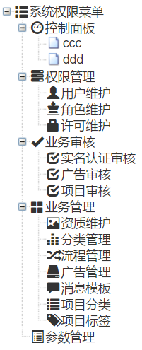

3.5 注意事项
- 只有根节点和分支节点可以添加
- 叶子节点不能添加

第四章 菜单修改

4.1 事件处理
function updateBtn(id){
$.get("${PATH}/menu/get",{id:id},function(result){
$("#UpdateModal input[name='id']").val(result.id);
$("#UpdateModal input[name='name']").val(result.name);
$("#UpdateModal input[name='icon']").val(result.icon);
$("#UpdateModal input[name='url']").val(result.url);
$("#UpdateModal").modal({show:true,backdrop:'static',keyboard:false})
});
}

function updateMenu(){
var id = $("#UpdateModal input[name='id']").val();
var name = $("#UpdateModal input[name='name']").val();
var icon = $("#UpdateModal input[name='icon']").val();
var url = $("#UpdateModal input[name='url']").val();
$.post("${PATH}/menu/edit",{id:id,name:name,icon:icon,url:url},function(result){
if(result=="ok"){
$("#UpdateModal").modal("hide");
initTree();
}
});
}

4.2 模态框
<!-- Modal -->
<div class="modal fade" id="UpdateModal" tabindex="-1" role="dialog" aria-labelledby="AddModal">
<div class="modal-dialog" role="document">
<div class="modal-content">
<div class="modal-header">
<button type="button" class="close" data-dismiss="modal" aria-label="Close"><span aria-hidden="true">&times;</span></button>
<h4 class="modal-title" id="myModalLabel">修改菜单</h4>
</div>
<form id="addMenuForm">
<div class="modal-body">
<div class="form-group">
<label for="name">菜单名称</label>
<input type="hidden" id="addFormId" name="id">
<input type="text" class="form-control" id="addFormName" name="name" placeholder="请输入菜单名称">
</div>
</div>
<div class="modal-body">
<div class="form-group">
<label for="name">菜单图标</label>
<input type="text" class="form-control" id="addFormIcon" name="icon" placeholder="请输入菜单图标">
</div>
</div>
<div class="modal-body">
<div class="form-group">
<label for="name">菜单URL</label>
<input type="text" class="form-control" id="addFormUrl" name="url" placeholder="请输入菜单URL">
</div>
</div>
<div class="modal-footer">
<button type="button" class="btn btn-default" data-dismiss="modal">关闭</button>
<button type="button" class="btn btn-primary" onclick="updateMenu()">修改</button>
</div>
</form>
</div>
</div>
</div>

4.3 后台代码处理
- Controller
@ResponseBody
@PostMapping("/edit")
public String editMenu(TMenu menu){
systemMenuService.editMenu(menu);
return "ok";
}

@ResponseBody
@GetMapping("/get")
public TMenu getMenu(Integer id){
return systemMenuService.getMenuById(id);
}
- Service
void editMenu(TMenu menu);
TMenu getMenuById(Integer id);
- ServiceImpl
@Override
public void editMenu(TMenu menu) {
menuMapper.updateByPrimaryKeySelective(menu);
}

@Override
public TMenu getMenuById(Integer id) {
return menuMapper.selectByPrimaryKey(id);
}

第五章 菜单删除

5.1 事件处理
function deleteBtn(id){
layer.confirm("确定要删除这个菜单吗?",{btn:["确定","取消"]},function(index){
$.post("${PATH}/menu/delete",{id:id,_method:"delete"},function(result){
if(result=="ok"){
initTree();
}
});
layer.close(index);
},function(index){
layer.close(index);
});
}

5.2 后台代码处理
- Controller
@ResponseBody
@GetMapping("/delete")
public String deleteMenu(Integer id){
systemMenuService.deleteMenu(id);
return "ok";
}
- Service
void deleteMenu(Integer id);
- ServiceImpl
@Override
public void deleteMenu(Integer id) {
menuMapper.deleteByPrimaryKey(id);
}

5.3 注意事项
- 只有叶子节点可以删除。
- 也可以采用级联删除节点（递归） （作业）

作业
1.完成菜单模块

