项目课程系列之Atcrowdfunding

尚硅谷JavaEE教研组

版本：V1.0

项目计划
- 给管理员分配角色

给管理员分配角色

3.1 页面设计及代码

3.1.1 给管理员分配角色的页面
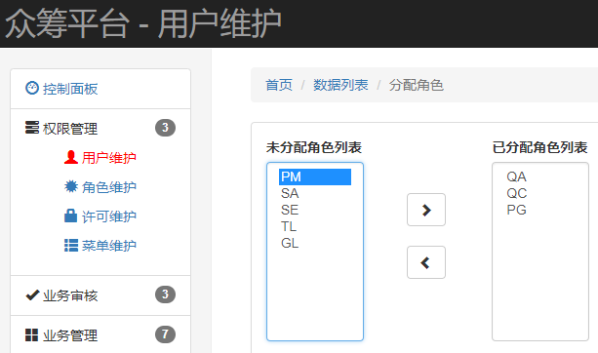

3.1.2 增加链接请求，跳转分配页面
<button type="button" class="btn btn-success btn-xs"
onclick="window.location.href='${PATH}/admin/toAssignRole.html?adminId=${admin.id}'">
<i class=" glyphicon glyphicon-check"></i></button>

3.1.3 控制器查询
@GetMapping("/toAssignRole")
public String toAssignRole(Integer adminId,Map<String,Object> map) {
// 查询所有角色
List<TRole> allRole = tRoleService.queryAll();
//查询已经分配给管理员的角色id
List<Integer> roleId = tAdminService.queryRoleIdsByAdminId(adminId);
// 未分配角色
List<TRole> unassign = new ArrayList<TRole>();
// 已分配角色
List<TRole> assign = new ArrayList<TRole>();
for (TRole role : allRole) {
if(roleId.contains(role.getId())){
assign.add(role);
}else{
unassign.add(role);
}
}
map.put("unassign", unassign);
map.put("assign", assign);
return "admin/assginRole";
}

3.1.4 业务层
List<TRole> queryAll();
List<Integer> queryRoleIdsByAdminId(Integer adminId);
@Override
public List<TRole> queryAll() {
return tRoleMapper.selectByExample(null);
}
@Override
public List<Integer> queryRoleIdsByAdminId(Integer adminId) {
return adminMapper.queryRoleIdsByAdminId(adminId);
}

3.1.5 dao层
<!-- List<Integer> queryRoleIdsByAdminId(Integer adminId); -->
<select id="queryRoleIdsByAdminId" resultType="int">
select roleid from t_admin_role where adminid = #{adminId}
</select>

3.1.6 页面数据展示
<form role="form" class="form-inline">
<div class="form-group">
<label for="exampleInputPassword1">未分配角色列表</label><br>
<select id="leftRoleList" class="form-control" multiple size="10" style="width:200px;overflow-y:auto;">
<c:forEach items="${unassign }" var="role">
<option value="${role.id }">${role.name }</option>
</c:forEach>
</select>
</div>
<div class="form-group">
<ul>
<li id="leftToRightBtn" class="btn btn-default glyphicon glyphicon-chevron-right"></li>
<br>
<li id="rightRightBtn" class="btn btn-default glyphicon glyphicon-chevron-left" style="margin-top:20px;"></li>
</ul>
</div>
<div class="form-group" style="margin-left:40px;">
<label for="exampleInputPassword1">已分配角色列表</label><br>
<select id="rightRoleList" class="form-control" multiple size="10" style="width:200px;overflow-y:auto;">
<c:forEach items="${assign }" var="role">
<option value="${role.id }">${role.name }</option>
</c:forEach>
</select>
</div>
</form>

3.2 给管理员分配角色-后台功能实现

3.2.1 Data类
public class Data {
private List<Integer> ids;
…

3.2.2 用户角色分配异步请求
$("#leftToRightBtn").click(function(){
var items = $("#leftRoleList :selected");
if(items.length==0){
layer.msg("请选择要分配的角色", {time:1000, icon:6});
}else{
var data = {adminId:"${param.adminId}"};
$.each(items,function(i,n){
data["ids["+i+"]"] = n.value ;
});
$.ajax({
url : "${PATH}/admin/assign",
type : "post",
data : data ,
success : function(result){
if(result=="ok"){
layer.msg("分配的角色成功", {time:1000, icon:6},function(){
$("#rightRoleList").append(items.clone());
items.remove();
});
}else{
layer.msg("分配的角色失败", {time:1000, icon:5});
}
}
});
}
});
$("#rightRightBtn").click(function(){
var items = $("#rightRoleList :selected");
if(items.length==0){
layer.msg("请选择要取消分配的角色", {time:1000, icon:6});
}else{
var data = {"adminId":"${param.adminId}"};
$.each(items,function(i,n){
data["ids["+i+"]"] = n.value ;
});
$.ajax({
url : "${PATH}/admin/unassign",
type : "post",
data : data ,
success : function(result){
if(result=="ok"){
layer.msg("取消分配角色成功", {time:1000, icon:6},function(){
$("#leftRoleList").append(items.clone());
items.remove();
});
}else{
layer.msg("取消分配角色失败", {time:1000, icon:5});
}
}
});
}
});

3.2.3 Controller
@ResponseBody
@RequestMapping("/unassign")
public String unassign(Integer adminId,Datas ds) {
tAdminService.deleteAdminRole(adminId,ds.getIds());
return "ok";
}
@ResponseBody
@RequestMapping("/assign")
public String assign(Integer adminId,Datas ds) {
tAdminService.insertAdminRole(adminId,ds.getIds());
return "ok";
}

3.2.4 Service
void deleteAdminRole(Integer adminId, List<Integer> ids);
void insertAdminRole(Integer adminId, List<Integer> ids);
@Override
public void deleteAdminRole(Integer adminId, List<Integer> ids) {
adminMapper.deleteAdminRole(adminId,ids);
}
@Override
public void insertAdminRole(Integer adminId, List<Integer> ids) {
adminMapper.insertAdminRole(adminId,ids);
}

3.2.5 Dao层
void deleteAdminRole(@Param("adminId") Integer adminId,@Param("roleIds") List<Integer> ids);
void insertAdminRole(@Param("adminId") Integer adminId,@Param("roleIds") List<Integer> ids);
<insert id="insertAdminRole" >
insert into t_admin_role (adminid,roleid) values
<foreach collection="roleIds" item="roleid" separator=",">
(#{adminId},#{roleid})
</foreach>
</insert>
<delete id="deleteAdminRole">
delete from t_admin_role where adminid=#{adminId} and roleid in
<foreach collection="roleIds" item="roleid" open="(" close=")" separator=",">
#{roleid}
</foreach>
</delete>

